Procollagen type 1 amino terminal propeptide (P1NP) - an overview

Abstract  There are about 200 million people suffering from osteoporosis in the word and approximately 8.9 million fractures are caused by osteoporotic fracture. Early diagnosis of osteoporosis is the key issue for efficient treatment and for identification of osteoporotic patient with high risk of fracture. Diagnosis of osteoporosis and assessment of fracture risk are based on the quantitative analysis of Bone Mass Density(BMD) by Dual energy X-ray absorptiometry (DXA). The gold standard method of BMD assessment of bone mass by DXA only partially provides the information about bone strength. Combinations with the measurement of bone mineral density, the clinical application of bone biomarkers have provided comprehensive information for diagnosis of osteoporosis. Bone is a dynamic tissue which undergoes constant remodelling throughout the life span. Bone biomarkers included formation, resorption and regulator are released during the bone remodelling processes. Various biomarkers are now available for specific and sensitive assessment of the rate for bone formation and bone resoption. Among the bone markers Procollagen type 1 amino- terminal propeptide (P1NP) has been demonstrated to be a more sensitive bone biomarker to measure the bone formation rate in osteoporosis. The measurement of P1NP is being developed for clinical application.  Key words: Osteoporosis, Bone mineral density, DXA ,Procollagen type 1 amino- terminal propeptide(P1NP), bone formation, bone resorption. | Dr. L. Kamala.  Senior Biochemist.  Department of Biochemistry, RIMS, Imphal.  e-mail kamalalamabam123@gmail.com  Dr. Davina Hijam.  Associate Professor.  Department of Biochemistry, RIMS, Imphal.  davina_hijam@yahoo.co.in

Introduction

The biomarkers of bone turnover have been investigated in the past decade. The mechanism of bone remodelling is composed by bone resorption and bone formation. Bone biomarkers are produced from the bone remodelling process included bone formation biomarkers, bone resorption biomarkers and regulators of bone turnover. Detections of bone metabolism have been studied with the biomarkers of enzymes, proteins and by products during the bone remodeling process. Various biomarkers are now available for specific and sensitive assessment of the rate of bone formation and resorption (Fig 1).
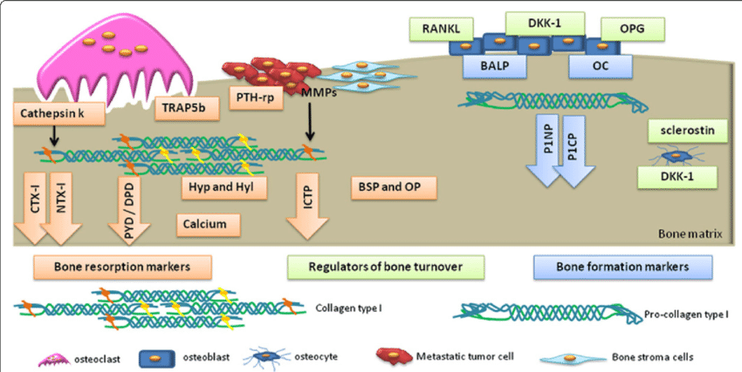
Fig 1 Biochemical biomarkers of bone turnover. Blue boxes/arrows represent bone formation markers: bone-specific alkaline phosphatase (BALP); osteocalcin (OC); propeptides of type I procollagen (P1NP and P1CP). Orange boxes/arrows represent bone resorption markers: pyridinoline (PYD); deoxypyridoline (DPD); carboxy-terminal crosslinked telopeptide of type 1 collagen (CTX-1); amino-terminal crosslinked telopeptide of type 1 collagen (NTX-1); hydroxyproline (HYP); hydroxylysine (HYL); bone sialoprotein (BSP); osteopontin (OP); tartrate-resistant acid phosphatase 5b (TRAP 5b); cathepsin K (CTSK). Green boxes represent regulators of bone turnover: receptor activator of NF-κB ligand (RANKL), osteoprotegerin (OPG), dickkopf-1 (DDK-1) and sclerostin.

The bone biomarkers are useful to provide the early assessment of osteoporosis when the Bone Mass Density (BMD) measurement of Dual energy X-ray absorptiometry (DXA) does not offer enough information to make the diagnosis. Therefore, the combination of BMD measurement by DXA and biomarker detections shows the great potential to improve the early assessment of people with high risk of osteoporosis.
Among these biomarkers, P1NP has shown the great potential as a sensitive and stable bone marker for the early detection of osteoporosis. P1NP is one of the bone formation biomarkers recommended by International osteoporotic foundation (IOF) and International Federation of Clinical Chemistry (IFCC). Major advantage of using P1NP as a bone biomarker is its low individual variability and good essay precision.

Physiologically, P1NP being bone formation biomarker reflects bone anabolic activity. Its levels decline with age but there is an incline in postmenopausal age and in osteoporosis because of increase bone resorption coupled with increase bone formation and consequently increase P1NP levels.P1NP expression level reflects the formation of new bone. P1NP is a by-product of type 1 collagen, which is the most prevalent protein in bone. About 65% of the bone matrix is inorganic, 35% is organic, and the organic component is mainly collagen type 1. In the study of bone formation, measuring by-products of collagen synthesis is an appealing approach. Following the synthesis of new type 1 collagen within the osteoblast, P1NP is cleaved from type 1 procollagen by proteases outside the osteoblast. Some P1NP deposit directly into the bone matrix, while others enter the blood circulation. When osteoblast synthesis decreased, collagen type 1 declined and so did P1NP. With the increasing popularity of bone metabolism research, the detection requirement of P1NP expression level also increases.

Type 1 collagen can be found in the organic bone matrix (>90%), which is developed in bone from procollagen type 1. Procollagen type 1 is synthesized by fibroblast and osteoblasts. Procollagen type 1 has N-terminal and C-terminal extensions, which are removed by specific proteases during conversion of procollagen to collagen. The procollagen type 1 included P1CP and P1NP are subsequently conjugated onto the bone matrix. The bone formation biomarker of P1NP is a specific indication of type 1 collagen deposition. P1NP is released during the formation of type 1 collagen into the intracellular space and P1NP eventually exist in the blood stream. P1NP is usually released in the trimeric structure (derived from the trimeric collagen structure) and then is rapidly broken down to a monomeric form by thermal degradation defects. Antibodies of P1NP are used to detect the trimeric structure of P1NP by enzyme-linked immunosorbent assay (ELIZA) or radioimmunoassay. P1NP has been demonstrated to be a more sensitive bone biomarker to measure the bone formation rate in osteoporosis. The measurement of P1NP is being developed for clinical application.

Type 1 collagen which is formed inside osteoblast in the main protein in bone. P1NP is formed by the effect of proteases on type 1 procollagen and thus serum P1NP concentration reflects the amount of the newly formed bone. So, serum levels of P1NP can be increased in diseases characterized by a high rate of bone turnover as osteomalacia and multiple myeloma. Teriparatide treatment can cause a dramatic increase in P1NP levels in the serum. Accordingly, P1NP had been suggested as a reference serum marker of bone formation.

Conclusion:
Currently, a large number of studies have shown that P1NP, a bone formation marker, is closely related to a variety of bone metabolic diseases, tumour bone metastasis and multiple myeloma. And its detection is not affected by food, circadian rhythm, hormones and other interference factors. Bone biomarkers have shown great potential to serve as powerful indicators to evaluate the osteoporosis therapy and even to assist the clinical diagnosis of osteoporosis in the early stage. Therefore, P1NP is a new and good diagnostic marker of bone for the early detection of osteoporosis.

References
- Tsung-rang Kuo and Chih –Hwa Chen. Bone biomarker for the clinical assessment of osteoporosis: recent developments and future perspectives. Biomarker research (2017)5:18 DOI 10, 1186/s40364-017-0097-4.
- Cloud-Clone Corp. PINP: A new clinical diagnostic marker of bone metabolism related diseases Cloud-Clone product reappeared on nature. Publish date 101-12-11.
- Afshan Iftikhar, Tayeb Asim et al. Diagnostic Accuracy of procollagen Type I N terminal propeptide (PINP) in women with Postmenopausal Osteoporosis PJMHS Vol.14, NO 1, Jan-Mar 2020.
- Vasikaran S, Eastell R, Bruyere O, et al. Markers of bone turnover for the prediction of fracture risk and monitoring of osteoporosis treatment: a need for international reference standards. Osteoporosis Int, 2011; 22(2):391-420.
- Krege JH, Lane NE, Harris JM, et al. PINP as a biological response marker during teriparatide treatment for osteoporosis. Osteoporosis Int, 2014:25(9):2159-71.
- www.researchgate.net. Biochemical biomarker.
- Saad et al. Egyptian Rheumatology and Rehabilitation (2021) 4:20 https//doi.org/10.1186/s43166-021-00069-y.
- https//www.nps.org.au. Bone turnover Markers

