RECENT ADVANCES IN ROOT CANAL SEALERS
Author: Dr. Aiswarya Ajith, Dr. Rajan Dhawan, Dr. Kirti Makan

ABSTRACT
One of the chief objectives of endodontic therapy is obturation of the prepared root canal system with an inert, dimensionally stable and biologically compatible sealer which will deliver a hermetic seal by binding to all walls of the canal. Sealer is an very important component of the root canal obturation in order to achieve three-dimensional sealing of the canal space ⁴. Sealers are used as a thin tacky paste which functions as a lubricant and luting agent during obturation, allowing the core obturation material, such as gutta-percha points or other rigid materials, to slide in and become fixed in the canal. New advancements have been used to develop sealers that have much better properties and are biocompatible with the dentin. Bioceramic sealers have changed the face of endodntics. The present review focuses on the recently introduced root canal sealers and its properties.
Keywords: Root canal sealers, NanoSeal-S, ThermaSeal Plus Ribbon Root Canal Sealer, BioRoot RCS, BIO-C SEALER, AH Plus Bioceramic Sealer, NeoSEALER Flo

INTRODUCTION
Aim of Endodontic treatment is to retain clinically compromised tooth, thereby preserving its physiological position with form and function. It has become prevalent due to better and predictable success rate of endodontic procedures ¹. Various essential factors such as proper instrumentation, cleaning and shaping, obturation, and ultimately the post-endodontic restoration is attributed to accomplishment of ideal root canal treatment ². One of the essential objectives of endodontic therapy is obturation of the prepared root canal system with an inert, dimensionally stable and biologically compatible material and inhibit the microbial entity and any future predilection of re-infection, thus provide a three dimensional fluid tight seal. Numerous materials have been used in root canal therapy but gutta-percha is universally accepted as the “gold standard” for the obturating materials ^{3.} Sealer is an exceptionally important component of the root canal obturation in order to achieve three-dimensional sealing of the canal space ⁴. Sealers are used as a thin tacky paste which functions as a lubricant and luting agent during obturation, allowing the core obturation material, such as gutta-percha points or other rigid materials, to slide in and become fixed in the canal. Sealer along with solid obturating material performs synergistically to create hermetic seal ⁴. Recently, many kinds of novel root canal sealers were introduced under various commercial names. Addition of various agents helps to achieve tissue-remineralization and antibacterial properties improving the biocompatibility and bioactivity characteristics of sealers ⁵. Knowledge of the qualities and characteristics of an endodontic sealer is critical to determine the best selection and application for each clinical case. Although few materials are capable enough to swap GP on multiple parameters, research continues to find alternatives that may seal better and mechanically reinforce compromised roots by forming monoblock, This reduces bacterial ingress pathways and strengthen the root to some extent ².
NanoSeal-S ⁶
NanoSeal-S (FIG 1) is a cold flowable polydimethylsiloxane based self-curing, antibacterial root canal sealer fortified with nano silver. Nano silver enhances the anti-bacterial efficiency and acts as a preservative. Composition includes polydimethylsiloxane, nano silver, silicone oil, platinum catalyst, nano zirconium dioxide and excipients. It expands by 0.2% to give a tight seal. Rod-shaped active nanoparticles can penetrate the dentinal tubules and enter accessory canals to confirm all the spaces are effectively sealed. Micro-silver particles are dispersed equally in the sealer and in chemical form and so it will not cause corrosion or color changes.
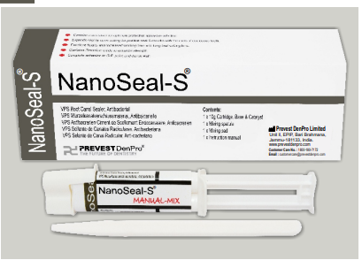
FIG 1: NanoSeal-S
ThermaSeal Plus Ribbon Root Canal Sealer ⁷
ThermaSeal Plus Ribbon root canal sealer is a two paste system based on epoxy-amine resin with long-term sealing and self-adhesive properties. Paste A (amber color) consist of Calcium tungstate, Bisphenol-A epoxy resin, Zirconium oxide, Bisphenol-F epoxy resin, Silica, Iron oxide pigments. Paste B (white color) consist of Calcium tungstate, Zirconium oxide, Dibenzyldiamine, Aminoadamantane, Silica, Silicone oil, Tricyclodecane-diamine. Advantges include high Radiopacity , low Micro-Leakage, high dimensional stability , low shrinkage, low expansion, low Solubility, excellent sealing properties, self-adhesive properties, biocompatibility .
BioRoot RCS ⁸
BioRoot RCS (FIG 2) is the newest endodontic mineral based root canal sealer containing tricalcic silicate materials benefiting from both Active Biosilicate Technology and Biodentine. It is a hydraulic tricalcium silicate based cement recommended for single cone technique or cold lateral condensation root filling. It consists of a powder and a liquid. The powder is composed of tricalcium silicate, zirconium dioxide, and povidone, and the liquid is composed of water, calcium chloride, and polycarboxylate. It continues the sealing process in presence of moisture. Dentin mineralization occurs through hydroxy-apatite formation. It has microleakage resistance over warm obturation technique. BioRoot RCS crystalizes inside dentinal tubules creating a 3-dimensional seal and leakage-free obturation . Its high pH (>11) creates a favorable alkaline environment. Pure mineral formulation will not stain teeth. Resin-free and monomer-free nature ensures zero shrinkage. Eugenol-free nature makes it compatible with all bonding systems. Great flowability fills auxilliary canals. Suitable for use in cold single cone or cold lateral condensation and allows rapid insertion of the gutta-percha points in permanent tooth.
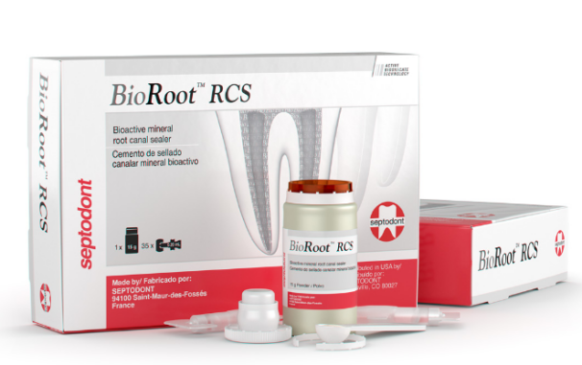
FIG 2: BioRoot RCS
GuttaFlow Bioseal ⁹
GuttaFlow bioseal is a silicone-based, cold filling sealer containing gutta percha powder and bioactive glass. Gutta percha combined with bioactive glass forms hydroxyapatite crystals on the surface. GuttaFlow is a 2-in-1 cold filling (obturater and sealer in one) obturation system that is used for the obturation of root canals. Composed of Gutta-percha powder, Polydimethylsiloxane, Platinum catalyst, Zirconium dioxide, Silver (preservative), coloring agent and Bioactive glass ceramic. GuttaFlow also shows excellent adhesion to the gutta-percha point (masterpoint) as well as to the dentine wall does not require condensation as it expands on its own.
BIO-C SEALER ¹⁰
BIO-C SEALER (FIG 3) is a ready-to-use bioceramic endodontic cement. Its ready-to-use presentation makes it easy to apply to the canal, simplifying the procedure with great time saving. In addition to the physical seal provided by the expansion of the cement, it promotes a biological seal by the formation of an intermediate layer of mineralization. It consists of Tricalcium Silicate (C3 S), Dicalcium Silicate (C2 S), Tricalcium Aluminate, Calcium Oxide, Zirconium Oxide, Silicon Oxide, Polyethylene Glycol, Iron Oxide. Its Radiopaque and has pH of 12. The contact of BIO-C SEALER with moisture and tissue fluids releases active ions that interact with the organic and inorganic matrix of the dentin, promoting the formation of an intermediate area, called the Mineral Infi ltration Zone (MIZ). This area of mineral infiltration in the dentin provides an excellent biological seal, minimizing possibilities of bacterial infiltration.
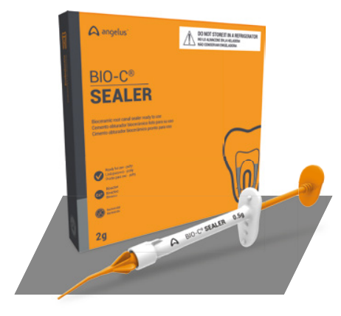
FIG 3: BIO-C SEALER
CeraSeal ¹¹
CeraSeal is a calcium silicate-based root canal sealer which provides optimal biocompatible environment to tissues in the root canal. It is obviously the next generation bioceramic-sealer which has excellent sealing ability and biocompatibility. Its composed of Calcium silicates, zirconium oxide, thickening agent. Calcium silicate produces CAH (Calcium Aluminate Hydrate) gel and CSH (Calsium Silicate Hydrate) gel by absorbing the moisture from surrounding tissues in the root canal and crystallization of Calcium Hydroxide (Ca(OH)₂). It is antimicrobial and highly biocompatibile due to the presence of Calcium Hydroxide (Ca (OH)₂)'s and its high pH. Odontoclasis by still keeping its volume in there as it does not expand or shrink in the root canal.
AH Plus Bioceramic Sealer ¹²
AH Plus Bioceramic Sealer (FIG 4) is a root canal sealer conforming to ISO 6876, in a pre-loaded syringe that does not require any pre-mixing and is set by absorbing moisture from the root canal environment. The sealer can be used either alone or in combination with gutta-percha obturating cones, injected gutta-percha material or core-carriers master cones. It’s composed of Zirconium Dioxide, Tricalcium silicate, Dimethyl sulfoxide and Lithium carbonate. Free of Bismuth Oxide, sealer does not discolor the tooth and guarantees a confident smile. Retreatability is good as its removable even after setting with a general hand file or NiTi file. It providing an ideal environment for hydroxyapatite formation paving the way for the body’s self-healing process.
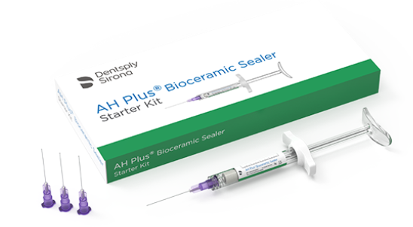
FIG 4: AH Plus Bioceramic Sealer
NeoSEALER Flo ¹³
NeoSEALER Flo is a bioactive bioceramic, root canal sealer with superior handling properties, promoting hydroxyapatite formation to support the healing process. Unlike conventional sealers, neosealer Flo is biocompatible, antimicrobial, dimensionally stable and resin-free consisting of consisting of an extremely fine, inorganic powder of tricalcium/dicalcium silicate in an organic medium. It releases calcium and hydroxide ions from the MTA, promoting hydroxyapatite formation on the MTA surfaces to enhance sealing and support healing. High pH to promote osteogenic response.
EDGE BIOCERAMIC SEALER ¹⁴
Edge BioCeramic Sealer (FIG 5) features a unique resin-free formula making it highly biocompatible and hydrophillic. Unlike conventional sealers, Edge Bioceramic Sealer does not shrink and therefore it does not have to be compacted. It is an insoluble, radiopaque and aluminum-free material based on a calcium silicate composition, which requires the presence of water to set and harden. Its composed of Zirconium oxide, Tricalcium silicate, Dicalcium silicate and Calcium hydroxide. EdgeBioCeramic features a high push-out bond strength and forms a tight seal within the root canal thereby reducing the likelihood of bacterial recolonization. Its Radiopaque and hydrophilic.

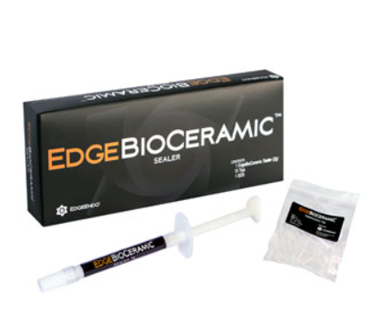

FIG 5: Edge BioCeramic Sealer

CONCLUSION
All these years, there has been an evolution of root canal sealers, starting from the conventional Zinc oxide eugonel to the contemporary ones like epoxy-resin based sealer, and to the most recent bioceramic sealer, which have the predilection to change the way sealers have been used in the near future ². However till date, no sealer has been shown to be totally satisfactory for clinical use. Novel endodontic root canal sealers reported in the recent literatures exhibits favourable biological features in comparison to conventional ones ³. Bioceramic sealers are more biocompatible and better tolerated by the root canals. Few of them are even able to promote osteoblastic differentiation. More in vitro and in vivo studies should be performed to confirm the sustainability of recently available sealers, for their clinical use, as further investigations would help us to clarify the mechanisms contributing to the observed beneficial results ⁵.

REFERENCE
- Cohen S, Burns Richard C. Text book of pathways of pulp: Obturation of cleaned and Shaped Root Canal System. 2002, the Mosby Company, 8th Edition; 293-95
- Tyagi S, Mishra P, Tyagi P. Evolution of root canal sealers: An insight story. Eur. J. Gen. Dent. 2013;2(03):199-218.
- Mishra P, Gupta S, Nikhil V, Jaiswal S, Raj S. Root canal sealers: A review. Indian J of Conserv Endod. 2020:15;3(3):69-74.
- Abu Zeid ST, Alamoudi RA, Mokeem Saleh AA. Impact of Water Solubility on Chemical Composition and Surface Structure of Two Generations of Bioceramic Root Canal Sealers. Appl. Sci.2022;12(2):873.
- Özdemir O, Kopac T. Cytotoxicity and biocompatibility of root canal sealers: A review on recent studies. J. Appl. Biomater. Funct. Mater. 2022;20:22-25.
- NanoSeal-S [pamphlet]. India: PREVEST DENPRO LIMITED; 2016
- Ribbon® Root Canal Sealer [pamphlet]. Germany: DENTSPLY Tulsa Dental Specialties DENTSPLY International, Inc; 2016
- BioRoot™ RCS [pamphlet]. France. SEPTODONT; 2016
- GuttaFlow® bioseal [pamphlet]. Germany. Coltène/Whaledent Ltd; 2016
- BIO-C® SEALER [pamphlet]. Brazil: Angelus dental; 2018
- CeraSeal [pamphlet]. Korea. Meta Biomed Co., Cheongju; 2020
- AH Plus® Bioceramic Sealer [pamphlet]. USA. DENTSPLY TULSA Dental; 2021
- NeoSEALER Flo [pamphlet].USA: Avalon biomed, Texas: 2021
- Edge BioCeramic [pamphlet].USA: Edge Endo: 2022

