Role of Chat GPT in Education System – Transforming the field of education with Artificial Intelligence
Authors
1. Mr. Aditya Mishra,
Research Scholar – Department of Management,
Tilak Maharashtra Vidyapeeth,
Pune, Maharashtra
Mobile - 9766117159
Email – 11adity@gmail.com

2. Dr. Pranati Tilak,
Dean - Department of Management,
Tilak Maharashtra Vidyapeeth,
Pune, Maharashtra
Mobile - 9923460607
Email – drpranatitilak@gmail.com
IIP ID: IIPER1682140826

Abstract
Although technology has always been vital to education, its application is now more widespread than before because of the growing accessibility of smart devices and web-based curricula. Artificial intelligence is being applied in education in a wide range of ways to support students' learning. AI makes it possible to access teachers and lessons around-the-clock, from anywhere. Based on AI algorithms, AI can be used as a teaching tool to help students reach their objectives by giving them tailored feedback on their assignments, quizzes, and other assignments. Everybody's life could be made easier by artificial intelligence through automation because it can perform menial jobs, saving people time on tedious chores like organising emails or retrieving files. The present paper discusses the role that is played by emerging technologies in artificial intelligence in the filed of education.

Keywords – ChatGPT, Education, student-centric, learning, creativity

Introduction
OpenAI created ChatGPT, a noteworthy language model that can provide responses to a variety of cues that resemble those of a human. Massive volumes of text data from the internet were put into the model during training in order to teach it language patterns and structures. This method is known as unsupervised learning. ChatGPT is a member of the OpenAI-developed GPT (Generative Pre-trained Transformer) family of language models. When GPT-1, the initial version, was released in 2018, it represented a significant advancement in the natural language processing (NLP) space. In 2019, OpenAI unveiled GPT-2, the result of their ongoing efforts to enhance and optimise the GPT model. This iteration of the model was trained on an even larger dataset of text data, and it was noticeably larger and more powerful than its predecessor. 2020 saw the introduction of GPT-3, the most potent iteration of the model to date, by OpenAI. GPT-3 can produce incredibly clear and contextually relevant answers to a broad range of questions because it has been trained on a massive amount of text material.

India's educational system's evolution
Over thousands of years, the Indian educational system has undergone a complicated and multidimensional evolution. It has been influenced by political, social, cultural, and historical elements. Below is a summary of the major turning points in the development of the Indian educational system:

1. Pre-sixth century BC to the 12th century CE, or Ancient India:
• The primary method of education in ancient India was oral transmission, where information was passed down from one generation to the next.
• A common educational approach was the Gurukul system, in which students lived with a guru (teacher) and got individualised instruction in a range of areas, including as science, arithmetic, philosophy, and the arts.
• Takshashila, Nalanda, and Vikramashila were significant ancient learning hubs that drew academics and pupils from all around Asia.

2. The Middle Ages (12th–18th century CE):
• Persian and Arabic elements entered the Indian educational system throughout the Islamic era.
• The purpose of madrasas, or Islamic schools, and maktabas, or elementary schools, is to provide both secular and religious instruction.
• The study of Sanskrit and Persian remained vital, and the importance of conventional knowledge systems persisted.

3. Colonial Era (from the late 1700s through 1947):
A new educational programme was developed by the British colonial authority with the intention of producing a class of Indians capable of acting as clerks and middlemen for the colonial government.
• Western-style schools and colleges were founded, including the University of Calcutta, which was founded in 1857, and the English language was pushed.
• During this time, conventional educational programmes like the Gurukula system began to erode.

4. Post-Independence Period (1947–present):
• Following its 1947 declaration of independence, India started a reform programme in education.
• The Sarva Shiksha Abhiyan and other government programmes were aimed at increasing access to education, particularly basic and secondary school.
• To support higher education, a number of prestigious colleges and universities were founded, including the Indian Institutes of Technology (IITs) and Indian Institutes of Management (IIMs).
• Ten years of formal schooling, two years of junior college, and three years of undergraduate study became the standard after the 10+2+3 system was adopted.
• The Right to Education Act of 2009 was passed in order to provide all children up to the age of 14 free and compulsory education.

5. Current Advancements:
A greater focus has been placed in recent years on enhancing educational quality, addressing issues of fairness and access, and advancing career- and skill-based learning.

• The delivery of education has undergone substantial changes as a result of the digital revolution, with e-learning and online learning platforms growing in popularity.
• The goal of programmes like "Make in India" and "Skill India" is to improve India's human capital, and attempts have been made to encourage research and innovation in higher education.
These days, technology plays a crucial role in education, changing both the way teachers and students are taught. With the use of technology in the classroom, learning may become more individualised, accessible, and engaging. But, in order to make sure that technological tools like augmented reality (AR), virtual reality (VR), gamification, and simulations, among others, improve rather than detract from the learning process, it's critical to use them carefully and deliberately. Furthermore, resolving accessibility concerns and guaranteeing fair access to technology are essential for the advancement of contemporary schooling.

ChatGPT
ChatGPT is an artificial intelligence chatbot that simulates human speech through natural language processing. The language model may write emails, articles, essays, code, social media postings, and other textual content in addition to responding to queries. OpenAI created the language model known as ChatGPT. It is predicated on the GPT (Generative Pre-trained Transformer) architecture, more precisely on GPT-3.5, a more sophisticated model than GPT-3. Based on the input it gets, ChatGPT may produce text that appears human. It is intended for tasks involving the understanding and creation of natural language. In addition to producing writing, giving explanations, and having discussions with users, it may be used for a wide range of tasks.

Because ChatGPT has been pre-trained on a large volume of text data from the internet, it is able to comprehend language and context in general. To further customise ChatGPT, users can fine-tune it for particular jobs or domains.
OpenAI's ChatGPT is an AI language model that can produce writing that appears human depending on the input it receives. After being trained on a sizable corpus of text data, the model can produce narratives, answer queries, and summarise lengthy texts, among other things. It is frequently used to mimic a human-like dialogue with users in conversational AI applications.

ChatGPT and AI's effects on the educational system

Our lives are increasingly impacted by artificial intelligence (AI), and education is no different. Students, professors, and educational institutions are going through a paradigm change as a result of the introduction of sophisticated language models like ChatGPT. The way we learn, teach, and interact with educational content could be completely transformed by ChatGPT, a potent AI-based conversational agent.

The potential of ChatGPT to improve student learning experiences is among its most important educational effects. Students can connect in real-time using ChatGPT, participate in personalised and engaging dialogues, and access learning materials that are catered to their individual needs. Thanks to ChatGPT's ability to adjust its responses to individual learners' preferences and learning styles, this technology facilitates adaptive learning, which makes the process of learning more effective and interesting.

Additionally, ChatGPT can help students grasp difficult ideas by offering clarifications, illustrations, and extra resources to help with their learning. It serves as a virtual tutor, available around-the-clock, giving advice, answering queries, and assisting students with their assignments.

Learning gaps can be filled by this approachable and individualised guidance, particularly for students who might not have access to conventional tutoring or resources.

Teachers can also be empowered by ChatGPT and other AI-powered tools that enhance their teaching abilities. As a teaching assistant, ChatGPT helps teachers create content, automate administrative procedures, and provide students tailored feedback.

Teachers can concentrate more on creating interesting lessons, fostering conversations, and giving targeted support to students who need it most when routine chores are delegated to others.

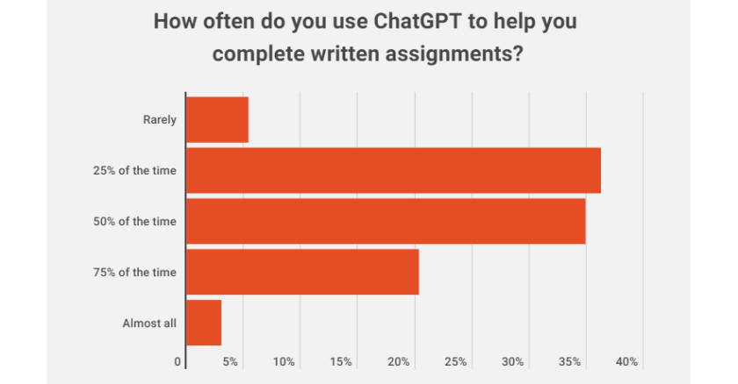
Source : https://www.govtech.com/education/higher-ed

Chat GPT's Potential in the Educational System

ChatGPT models could influence education in a number of ways, including:
1. Personalised Learning: Students can receive individualised instruction from tutoring programmes driven by AI. These systems provide customised feedback and resources based on each learner's unique learning style, pace, and ability. With the help of AI models like ChatGPT, learning can be more easily accessed and customised to meet individual needs. These models can help, respond to inquiries, and explain a variety of topics.

2. Inclusion and Accessibility: AI language models can aid in bridging the gap for students who have special needs or learning difficulties. They are able to provide substitute formats for instructional resources, like text-to-speech, audio description generation, and language translation support. AI can help create a more inclusive learning environment by facilitating greater access to education.

3. Research and Information Retrieval: ChatGPT and other AI models can help students find information and perform research. They can offer assistance with literature reviews, pertinent sources, research methodology suggestions, and query assistance. Students can increase the effectiveness of their research process and save time by doing this.

4. Language Learning: By presenting practise dialogues, giving immediate feedback on vocabulary and grammatical usage, and helping with translations, AI language models can help students learn languages. They can assist language learners become more proficient by simulating real-life language exchanges.

5. AI-powered virtual teaching assistants: These assistants can help teachers in a number of ways. They can help with typical student questions, lead online discussions, grade assignments automatically, provide comments, and make tailored study suggestions. This can assist teachers in concentrating on more difficult assignments and giving each student more individualised attention.

6. Tutoring and Support: Serves as a virtual mentor or tutor, offering students on-demand, instant assistance. It can clarify difficult ideas, provide examples to improve comprehension, and respond to inquiries. Students who need extra help outside of the classroom or those who live in rural places with little access to trained teachers may find this very helpful.

7. Content Generation: Helps educators create instructional resources including study guides, tests, and lesson plans. Teachers can devote more time to providing individualised education and spending quality time with pupils by automating some administrative activities.
8. Continual Learning: This can help people in their quest for knowledge outside of the realm of formal education by acting as a lifelong learning partner. It can offer learning paths, suggest pertinent resources, and lead discussions on a range of subjects. This may encourage a culture of lifelong learning and skill improvement.

9. Coding and Programming support: ChatGPT can help with coding issues, debugging, and explanations of algorithms in computer science and programming classes.

10. Promoting Curiosity: ChatGPT can respond to inquiries from students and motivate them to delve deeper, thereby cultivating a spirit of inquiry and a passion for education.

11. Peer cooperation: By serving as discussion partners or assisting students in ideation and idea sharing, AI chatbots such as ChatGPT can promote peer cooperation.

12. Teacher Professional Development: Teachers can obtain resources, lesson plan ideas, and pedagogical advice using AI platforms like ChatGPT.

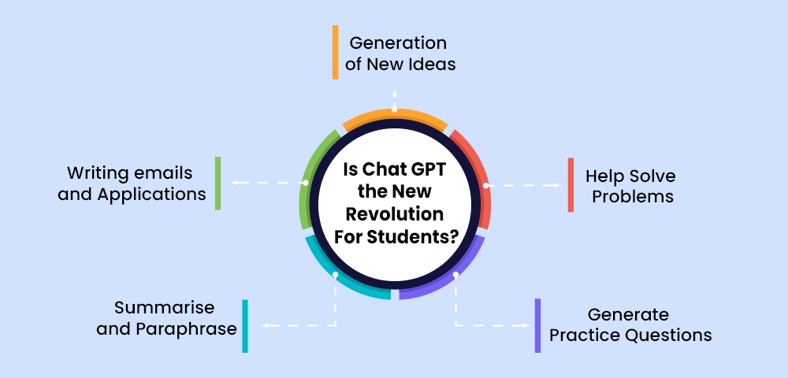
Source : https://collegevidya.com/blog/how-to-use-chat-gpt-for-students/

Conclusion
Education is about to undergo a transformation thanks to AI technologies like ChatGPT. They offer individualised learning opportunities, support with challenging subjects, and give quick access to a plethora of information. Technology has the potential to empower teachers and students alike. Even though ChatGPT and related AI technologies have many advantages, it's crucial to combine them with conventional teaching techniques and strike a balance in order to give students a well-rounded education. Furthermore, as these technologies are increasingly incorporated into the educational process, it is imperative to address concerns regarding data privacy and the ethical application of AI in education.
Using AI in education is the way of the future; it's not an option. AI will change education and learning in a similar way to how calculators changed maths lessons in the past. In order to improve education and get students ready for a world driven by AI, educators must adjust to and take use of AI's promise. The secret is striking the correct balance when it comes to education—combining AI's capabilities with human intervention to produce a more productive and captivating learning environment.

References
1. Deakin University (2014). IBM Watson now powering Deakin. A new partnership that aims to exceed students’ needs.
2. Gibney, E. (2017). Google secretly tested AI bot. Nature,541(7636), 142.
3. Kurzweil, R. (2010). The singularity is near. Gerald Duckworth & Co.,
4. Rainie, L., Anderson, J. (2017), The Future of Jobs and Jobs Training, Pew Research Center, http://www.pewinternet.org/2017/05/03/the-future-of-jobs-and-jobs-training/
5. Siau K. (2018) Education in the Age of Artificial Intelligence: How will Technology Shape Learning? The Global Analyst, Vol. 7, No. 3, pp. 22-24.
7, Siau, K. (2017) Impact of Artificial Intelligence, Robotics, and Automation on Higher Education. Americas Conference on Information Systems (AMCIS 2017), Boston, MA, August 10-12.
8. Voss, P. (2017), From Narrow to General AI, Institution Machine, Retrieve from
https://medium.com/intuitionmachine/from-narrow-to-general-ai-e21b568155b9
9. Woolf, B. P., Lane, H. C., Chaudhri, V. K., &Kolodner, J. L. (2013). AI grand challenges for education. AI magazine, 34(4), 66.
10. Dwedi,V.K, Hughes, Ismagilova E,Aarts, Coombs, C Crick, Mishra & Galanos,v(2019) International journal of information management
11. Walton P (2018) Artificial Intelligence and the limitation of information (Switzerland)
12. Schemlzer, R(2019) AI Application in education ,Forbes magazine
13. https://www.forbes.com/sites /cognitiveworld2019/07/12/ai-application-in -education/ #5f93548f62a3
14. Duan .Y. Edwards J.S& Dwedi Y.K (2019) Artificial intelligence for decision making in the era of Big –Data –Evolution,
15. Challenges and research agenda International journal of information Management ,48,63-71
16. Ritter, S., Anderson, J.R., Koedinger, K.R. & Corbett, A. (2007). Cognitive Tutor: Applied research in mathematics education. Psychonomic Bulletin & Review, 14, 249–255
17. Paris, D., & Alim, H.S. (Eds.). (2017). Culturally sustaining pedagogies: Teaching and learning for justice in a changing world. Teachers College Press. ISBN: 978-0807758342
18. Plass, J.L., & Pawar, S. (2020). Toward a taxonomy of adaptivity for learning. Journal of Research on Technology in Education, 52(3), 275–300.
19. Jensen, E., Dale, M., Donnelly, P.J., Stone, C., Kelly, S., Godley, A. & D'Mello, S.K. (2020). Toward automated feedback on teacher discourse to enhance teacher learning. In Proceedings of the 2020 CHI Conference on Human Factors in Computing Systems (CHI '20).
20. Kai, S., Almeda, M.V., Baker, R. S., Heffernan, C., & Heffernan, N. (2018). Decision tree modelling of wheel-spinning and productive persistence in skill builders. Journal of Educational Data Mining, 10(1), 36–71. h

