STATISTICAL PROCESS CONTROL TOOLS & APPLICATIONS

ABSTRACT:
The Statistical process control methodology has been successfully used in a variety of industrial and non-industrial domains. SPC charts are mostly utilised in manufacturing for process optimisation and control. It is a useful technique for solving issues related to process consistency and capability enhancement by reducing variability. SPC is a collection of tools used to monitor and assess the degree of quality of output produced by an organisation as well as to manage operations. The QC tools were initially emphasised by Dr. Kaoru Ishikawa. The initial set of seven QC tools included a control charts, check sheet, cause-and-effect diagram, Pareto chart, histogram, stratification and scatter diagram. This study provides an overview of these QC tools that plays an important role in obtaining, monitoring and analysing data for identifying and resolving process issues, which helps organisations attain high quality performance.
KEYWORDS: Statistical process control, QC tools, Control chart, Check sheet, Fishbone diagram, Histogram, Pareto chart, Stratification, Scatter diagram

INTRODUCTION:
A statistical method of quality control known as statistical process control (SPC) is used to manage and oversee a process and ensure that it operates to its full potential. It establishes a process's stability and predictability. It can be used in any process where it is possible to measure whether the output of the product complies with specifications [1]. Statistical process control is an effective problem-solving tool for achieving consistency in processes and enhancing capability by lowering variability. To ensure that the process operates as smoothly as feasible and yields a conforming result, systematic statistical monitoring and control is used. [2]. The rapid identification of assignable causes of operation shifts is a primary objective of SPC so that the process may be evaluated and corrective measures can be done before a substantial amount of nonconforming units are generated. [3]. SPC is a methodology that has been widely applied in many kinds of industrial and non-industrial fields. SPC charts are primarily used in manufacturing for process control and improvement. The success or failure of an SPC operation is not determined by the size or resources of the company, but rather by appropriate planning and immediate problem-solving actions taken by employees [4]. SPC is a collection of tools used to manage operations as well as assess and track the level of quality of an organization's outputs. SPC is necessary because there is and always will be variation in the qualities of materials, products, services, and people. SPC approaches can be used to measure, comprehend, and manage the level of variability in any acquired goods or services. If necessary, this variation can be compared to previously established specifications.
The seven QC methods were initially underlined by Dr. Kaoru Ishikawa, an engineering professor at the University of Tokyo and creator of quality circles. He issued a book in 1968 named Gemba no QC Shuho to educate Japanese workers on quality control methods and procedures. It was designed to be utilized in "self-study as well as personnel training" by foremen in Japanese workplaces or in QC reading groups. This book served as the initial introduction to the seven basic quality control tools. The English version of Dr. Ishikawa's publication, Guide to Quality Control, was published by the Asian Productivity Organisation in 1971. Despite its extensive usage, this book is still useful while using the seven fundamental tools. The initial set of seven tools included a cause-and-effect diagram, a check sheet, control charts, a histogram, a Pareto chart, a scatter diagram, and stratification. Some lists substitute a flowchart or run chart for stratification. Some of their alternative titles are the seven QC tools, the seven oldest tools and the seven basic tools [5,6].

BASIC QUALITY CONTROL TOOLS:
CONTROL CHARTS:
Control charts are also known as Shewhart chart. A control chart is a visual representation of monitoring a process and for generating a statistical based signal when a process change takes place. It is a fundamental statistical process control technique. In the control chart, a quality characteristic's average measurements in process samples are plotted against time. The chart has a lower control limit (LCL), upper control limit (UCL) and a centre line (CL). The control limits are chosen so that, if the process is in control, almost all of the experiment's values will fall between them. The mean amount of the quality feature related to the in-control condition is shown by the graph's centre line.

TYPES OF CONTROL CHART:
Control charts can be divided into two distinct types in general. They are variable and attribute control chart.
VARIABLE CHART:
If a quality attribute can be quantified and stated as an amount on a continuous unit of measurement, it is usually referred as a variable. In these situations, it is feasible to explain the quality attribute using both an estimation of central tendency & variation [2]. The chart is used to increase process quality, determine capability of process, decide when to make adjustments and when to leave the process alone, as well as to look into the root causes of marginal or unacceptable quality. Additionally, it is used to decide on a product's or service's specifications as well as the suitability of recently produced goods or services [9]. Variable control charts are frequently used because they allow for more effective control and give more details about how the processes are performing.
The most widely used ones are the control charts for individual measurements (x), mean (x bar), ranges (R), and standard deviation (s) [7].
A mean control chart, also known as the X-bar Chart, is widely used to regulate the process mean or average quality level. A control chart for the standard deviation (s) and range (R) can be used to track process variability [8].
ATTRIBUTE CHART:
Many quality criteria are not measured on a continuous or quantitative basis. In these cases, we can either tally the number of nonconformities on a product unit or assess if every unit of the product is either conforming or nonconforming depending on whether or not it exhibits particular features. Attributes control charts are control charts for these high-quality traits. [2]. Attributes charts are typically less informative than variables charts because a numerical measurement contains more information than simply classifying a unit as conforming or nonconforming. Attribute charts, on the other hand, possess significant applications. Due to the fact that so many of the quality features inherent in these settings are challenging to rate on a scale of 1 to 10, they are particularly useful in the service sector and in the non- manufacturing quality improvement initiatives. The most frequently used Attribute control chart are P chart, C chart and U chart [3].
The control chart for fraction nonconforming, often known as the P chart, illustrates the percentage of nonconforming or defective product generated by a manufacturing process. The control chart for nonconformities, also known as a C chart is more practical instead of focusing on the percentage of nonconforming, it emphasises the number of flaws or nonconformities that were found. When the average number of nonconformities per unit provides a more meaningful basis for process management, the U chart, which measures nonconformities per unit, is used [8].
APPLICATION OF CONTROL CHART:
Use a control chart,
- When monitoring ongoing operations, detecting problems as they happen and addressing them.
- When determining the possible outcomes of a process.
- When evaluating a process' stability using statistical control.
- When comparing changes in process variation due to uncommon versus frequent causes.
- When considering whether to concentrate your quality enhancement effort on preventing certain issues or making fundamental changes to the procedure.

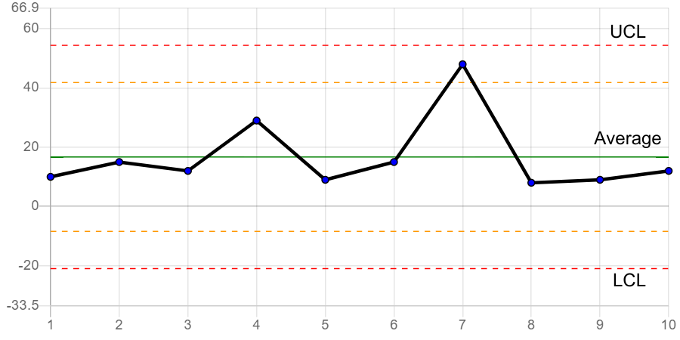
Figure 1 – control chart

CHECK SHEET:
A check sheet is a prepared, organized form for collecting and analysing data. This is a versatile tool that may be used for many different tasks [6]. It is frequently important to gather historical or real-time operational data regarding the process under investigation in the early stages of process improvement [2]. Forms called check sheets are employed to compile data in a methodical manner. They offer a "place to start" for the user and a framework for gathering the data. Additionally, they help the user organise the data for subsequent use. Creating histograms, Pareto charts, control charts, etc. can be done using the information acquired on a check sheet. Check sheets have several advantages, but their ease of use and comprehension and ability to create a clear image of the situation are their main advantages.
TYPES OF CHECK SHEET:
The three major categories are defect-location check sheets, tally check sheets, and defect-cause check sheets.
DEFECT-LOCATION CHECK SHEETS:
The sketch, drawing, or photo of the finished product is typically included on the defect-location check sheet. The diagram is labelled with the existence and type of issues or flaws [1]. This check sheet is also known as concentration diagram, defect map, defect concentration check sheet, location diagram [6].
TALLY CHECK SHEETS:
The tally check sheet is used for measuring the instances of various kinds of flaws. It is possible to lower the overall number of flaws by taking the proper action by understanding the most common types of defects.
DEFECT-CAUSE CHECK SHEETS:
The prior check sheets are used to identify specific faults, such as their general location or root cause. A defect-cause check sheet is utilised, though, when further details on a defect's cause are needed. To identify the causes of low quality, a defect-cause check sheet was used [1].
APPLICATION OF CHECK SHEETS:
Use check sheet,
- when data may be frequently gathered and observed by the very same individual or in the same location.
- When compiling data on accidents, problems, or flaws, their frequency or trends, as well as the reasons behind or locations of each.
- When acquiring information on a manufacturing operation [6].

FISHBONE DIAGRAM:
The Ishikawa diagram, commonly referred to as the Fishbone diagram, is a technique to detect the underlying causes of quality problems. In commemoration of the Japanese quality control statistician Kaoru Ishikawa, who developed this chart in the 1960s, it was given this name [10]. The fishbone diagram is an analytical tool that provides an organised framework to look at outcomes and the factors that cause or influence those effects. Due to its goal, the Fishbone diagram might be regarded as a cause-and-effect diagram [11]. A cause-and-effect diagram is employed to show the various types of product nonconformities and how they relate to one another. It is helpful in directing management, production engineers, and operators' attention to quality issues. The level of technological understanding of the process typically increases with the creation of a good cause-and-effect diagram [2]. One of the seven fundamental quality tools is this cause analysis tool. The fishbone illustration shows various potential causes of an impact or issue. It can be used to plan a brainstorming session. Ideas are immediately organised into useful groupings [6]. Making a Fishbone diagram has several benefits, such as promoting teamwork and using collective understanding of the method, discovering fields where information should be gathered for additional research, and assisting in the structured identification of the underlying causes of an issue or quality characteristic [12]. The diagram's layout closely resembles the skeleton of a fish. The distribution of the many causes and sub-causes that ultimately give rise to them can be suggested by employing bevel segments of lines that slope towards an axis that is horizontal to clarify the representation. It can be improved, however, with both quantitative and qualitative analyses, names and codes for potential hazards that define the causes and sub-causes, components that show their succession, in addition to other unique ways to risk management. The figure can be used to evaluate the risk of the effect's primary causes, secondary causes, and overall risk [13].
TYPES OF FISHBONE DIAGRAM:
The major types include cause enumeration diagram, CEDAC (cause-and-effect diagram with the addition of cards), desired-result fishbone, process fishbone, time-delay fishbone, reverse fishbone diagram.
APPLICATION OF FISHBONE DIAGRAM:
- Determining potential root causes of an issue.
- when a group's vision tends to become stale [6].

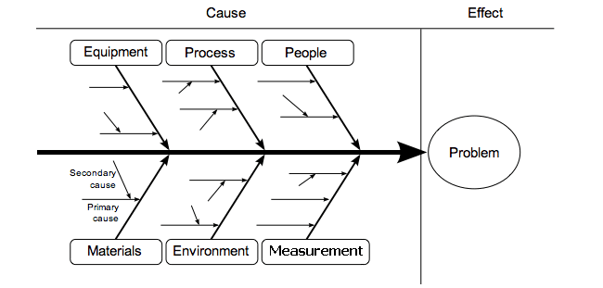
Figure 2 – Cause and effect diagram [16]

PARETO CHART:
The terms "Pareto chart" and "Pareto analysis" are frequently used terms. A Pareto analysis is a statistical tool for choosing a small number of actions that have a substantial overall influence. It is one of the most well-liked simple techniques. The Pareto analysis methodology is employed to identify the organisational components or activities that will have the biggest impact. It lists the information/factors in decreasing order of frequency of occurrence, starting with the highest frequency and ending with the lowest frequency. The results of a Pareto analysis are commonly illustrated with a Pareto chart. The chart displays the different considerations in prioritised order. The whole amount of all frequencies equals one hundred percent. According to the "80-20 rule," which was created by Italian Vilfredo Pareto, an economist, the "vital few" cover a sizeable share (around 80%) of cumulative events, whereas the "useful many" only fill the other 20 percent [14]. Bar graphs are used in Pareto charts. The bars are arranged from largest to shortest, with longest on the left. The bars lengths correspond to frequency and cost, respectively. This chart efficiently demonstrates which situations are more significant [6]. Pareto charts have numerous applications. They not only offer a way to study and enhance quality, but also a way to study and increase effectiveness, reduce waste material, conserve energy, address safety issues, and save money, etc. A Pareto chart can be useful in almost any area that a team wants to research [1]. Pareto analysis is an innovative way to look at the underlying causes of problems because of its capacity to organise and spark ideas. It might be limited, though, by its dismissal of possibly serious issues that might start out little but get worse over time. It should be used in combination with additional analytical methods, such as failure mode and effect analysis and fault tree analysis [15].
APPLICATION OF PARETO CHART:
Use a pareto chart,
- When researching data on the frequency of problems or their underlying causes in an operation.
- When there are several problems or causes, yet you want to focus on the main one.
- When evaluating specific elements of larger causes.
- When sharing the information, you have with others [6].

Figure 3 – Pareto chart

HISTOGRAM:
A "histogram" is a graphical depiction of the frequency distribution of the measured values for a variable. It is a form of bar chart that helps users visualise attribute and variable data of a product or process while also presenting the distribution of data and the level of variation within a process [17]. The histogram, a form of bar chart, is used to visually describe the of a product or process variability. It displays the mean, mode, and average central tendency measures. By placing the specifications on the histogram, it is possible to demonstrate whether the product specifications are being met. Another purpose for a histogram is to look at and determine the underlying distribution of a variable [1].
APPLICATION OF HISTOGRAM:
Use a histogram,
- In particular, you want to be able to examine how the data are distributed when determining if the result of an operation is fairly distributed.
- Determining whether a method can meet the demands of the client.
- Examining how a supplier's process appears in the finished product.
- When the information is numerical.
- Determining whether a process has altered over time.
- Finding out if the outcomes of more than two process vary.
- You want to let other people know about the rapid and simple sharing of data.
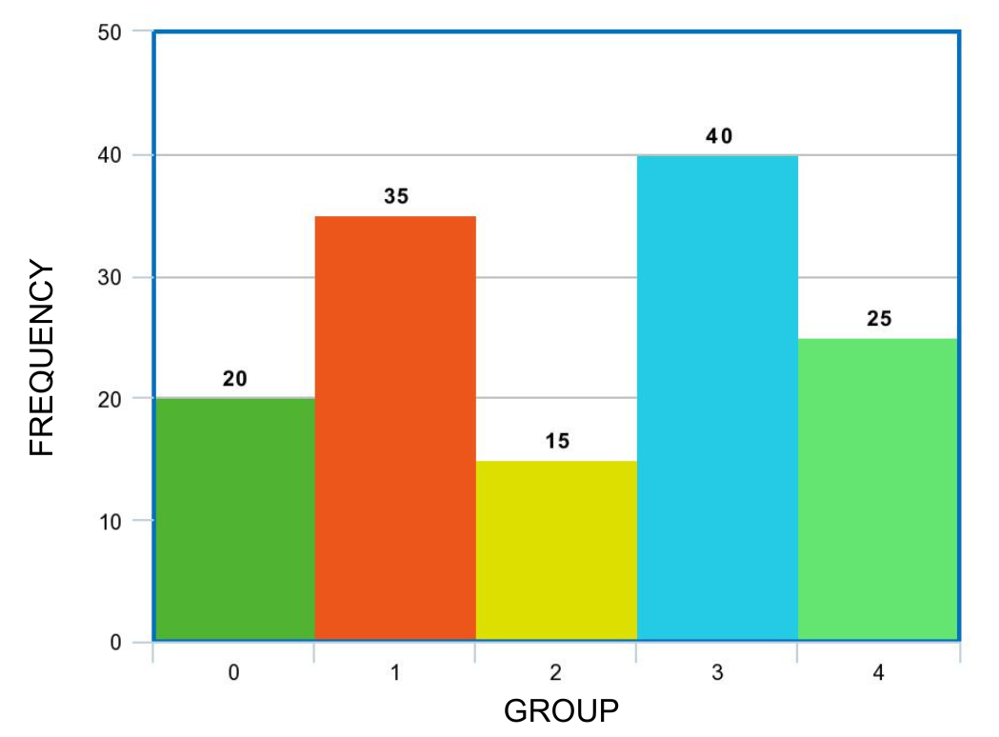
Figure 4 - Histogram
STARTIFICATION:
An approach used in combination with various additional data analysis tools is stratification. When data from many sources or categories are mixed, the relevance of the original data can become lost. The data is divided using this method, allowing patterns to be seen. One of the first seven QC tools was stratification.
APPLICATION OF STARIFICATION:
- Used before collecting data.
- Used when data from many sources or situations, such as a shift, days of the week, vendors, or groups of people.
- Used when isolating many sources or circumstances may be necessary for data analysis [6].
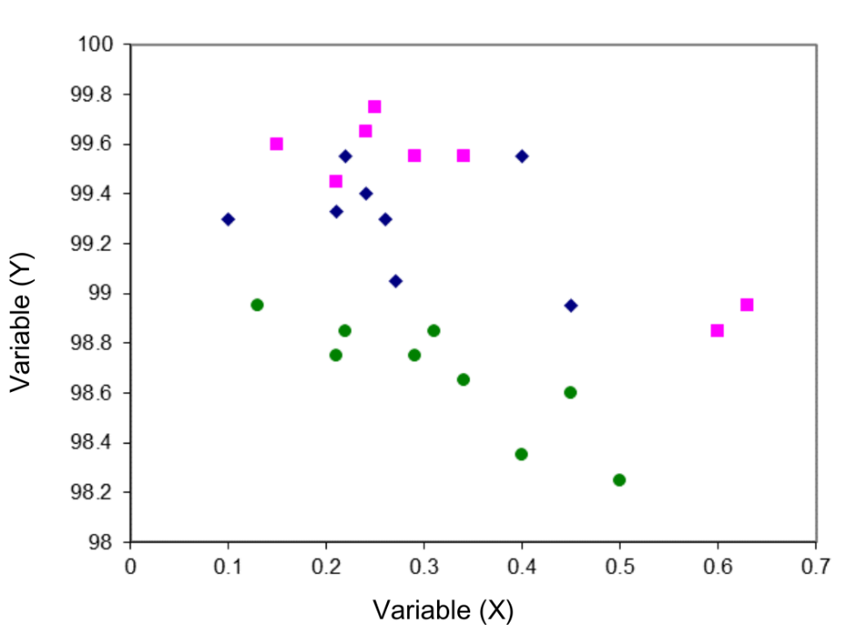
Figure 4 – Stratification

SCATTER DIAGRAM:
A scatter diagram, which compares two variables, is a graph of point plots. The distribution of the points reveals the existence or absence of a cause-and-effect connection between distinct operations. Pairs of data for the two variables under investigation must be provided in order to use a scatter diagram. In order to clearly show the existence or absence of a cause-and-effect link and provide insight into the quality of that connection, scatter diagrams are particularly helpful. A scatter plot does not automatically suggest that the observed association is statistically significant. It is necessary to conduct additional research, such as probability graphing or the calculation of the Pearson correlation coefficient, in order to understand statistical correlation. Additionally, it should be remembered that the interpretation of a scatter diagram is limited to the range of values that were really observed. X-Y graph and scatter plot are additional names for scatter diagrams [1].
APPLICATION OF SCATTER DIAGRAM:
Use scatter diagram,
- In the case of numerical data in pairs.
- When the dependent variable of the independent variable can take on a wide range of values.
- Use a fishbone diagram to determine whether a particular cause and effect are genuinely connected after considering potential effects and causes.
- When attempting to build a relationship between the two variables, take into account.
- When seeking to identify the fundamental causes of potential problems.
- When determining whether two phenomena that appear to be related have the same source.
- Look for autocorrelation before making a control chart [6].
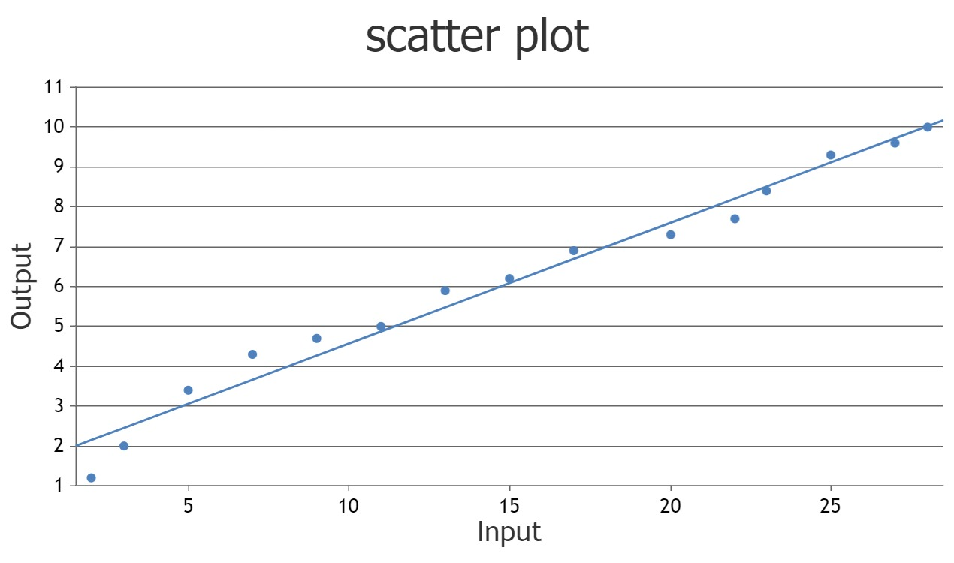
Figure 5 – Scatter diagram
CONCLUSION:
Statistical quality control is primarily concerned with ensuring that various procedures and functional arrangements are in place to provide for successful and effective statistical processes to minimise the probability of errors or issues in procedures or systems or in source material. Quality control tools are simple to use and comprehend. They are primarily helpful for resolving issues with quality control. It also aids in the ongoing improvement of manufacturing process. By using these tools product rejection and product rework is reduced.

REFERENCES:
[1] Omachonu, V.K., & Ross, J.E. (2004). Principles of Total Quality (3rd ed.). CRC Press. https://doi.org/10.1201/b12446
[2] Montgomery DC, Wiley J. Introduction to Statistical Quality Control. 7th Edition. New York: John Wiley & Sons; 2009
[3] Montgomery DC, Wiley J. Introduction to Statistical Quality Control. Sixth Edition. New York: John Wiley & Sons; 2009
[4] S. Subbulakshmi, A. Kachimohideen et al. An Essential Role of Statistical Process Control in Industries. International Journal of Statistics and Systems. 12, (2), 2017, 355-362.
[5] Oakland, J.S. (2002). Statistical Process Control (5th ed.). Routledge. https://doi.org/10.4324/9780080474458
[6] Tague N. R. (2005). The quality toolbox (2nd ed.). ASQ Quality Press.
[7] Sengoz, N.Gonul. (2018). Control Charts to Enhance Quality. 10.5772/intechopen.73237.
[8] Naiknaware Tushar, Gaikwad Sakshi et al. Using measurement system analysis and statistical process control for monitoring and reducing variation in the process. International Journal of Current Research. 14, (10);22485-22488.
[9] Besterfield DH. Total Quality Management. 3rd ed. Upper Saddle River N.J: Prentice Hall; 2003.
[10] Juran, J. M. (1999). Juran's Quality Handbook (5th Edition). McGraw-Hill.
[11] Watson, G. (2004). The Legacy of Ishikawa. Quality Progress 37(4); 54-47.
[12] Basic Tools for Process Improvement. (1995, May 3). Retrived December 20, 2009, from Balanced Scorecard Institute: http://www.balancedscorecard.org/Portals/0/PDF/c-ediag.pdf
[13] Ciocoiu, C. N. (2008). Managementul riscului. Teorii, practici, metodologii. Bucharest: ASE.
[14] Talib, Faisal & Rahman, Zillur & Qureshi, Mohamed Rafik. (2010). Pareto analysis of total quality management factors critical to success for service industries. International Journal for Quality Research. 4; 155-168.
[15] https://en.wikipedia.org/wiki/Pareto_analysis
[16] Fishbone tool of investigation in pharmaceuticals - Pharmaguideline.
[17] Neyestani, Behnam. (2017). Seven Basic Tools of Quality Control: The Appropriate Techniques for Solving Quality Problems in the Organizations. 10.5281/zenodo.400832.

