Humic acid: Sources,Extraction methods and it application effects on rice crop –A mini review
¹Catherine Pockisha,R., ¹Arivazhagan,K., ¹Senthilvalavan,P., and ²Natarajan,S
¹Department Soil Science and Agricultural Chemistry, Faculty of Agriculture, Annamalai University
²Department of Agronomy, Faculty of Agriculture, Annamalai University,
Annamalainagar, Tamil Nadu, India

Corresponding author email: pockshac@gmail.com ; senvalavan_m2002@yahoo.co.in

Abstract
Oryza sativa L., commonly known as rice, is a crop that is extensively cultivated worldwide and is recognized as the "global grain." In the current context, the pressing requirement for sustainable agricultural practices that ensure food production without compromising crop yield and producer income has become a significant objective. This is due to the escalating environmental pollution, augmented use of chemical fertilizers, and the gradual deterioration of cultivated soils. In order to mitigate the aforementioned environmental degradation, minimize the reliance on chemical fertilizers, reduce cultivation expenses, and achieve sustainable production, a viable and ecologically sound solution would involve the utilization of natural plant bio-stimulants (PBs). These PBs have the capacity to augment flowering, promote plant growth, facilitate fruit set, enhance crop productivity, and improve nutrient use efficiency (NUE). Additionally, they possess the ability to enhance tolerance against various abiotic stresses. Studies have demonstrated that bio-stimulants such as humic acid, which encompass an intricate blend of polysaccharides, micronutrients, and plant growth hormones, facilitate the growth of plants and enhance their ability to withstand abiotic stresses. Humic substances, being highly adaptable and indispensable constituents of the inherent soil-ecosystem, have endured for centuries. Foliar application of humic acid could increase osmotic regulators compared with other fertilizer resources, reducing the damage caused by drought stress to some functional traits of cultivars. Humic acid, in comparison with other nutritional systems at higher levels, lead to increase in chlorophyll levels. It also causes photosynthetic stability with increase in yield. Humic acid exerts a beneficial influence on the efficacy of enzymes and nutrients in plant metabolism. It improves the chemical, physical and biological characteristics of the soil. In this mini review, we detailed the humic acid sources, extraction methods and its benefits and effect of humic acid application combined with NPK fertilizer to rice.
Key words: Drought and saline stress, Humic acid, Rice, Yield
- Introduction
Humic substances are fundamental and multifaceted components of the natural soil-ecosystem, which have endured for centuries (Mayhew, 2004). Humic acid stands as the hindmost culmination of the natural breakdown of plant and animal substances. The genesis of humus arises from the combination of chemical and biological humification processes involving plant and animal matter, alongside the influential involvement of microorganisms. These substances are the most extensively dispersed organics of biosynthesis on the Earth's surface, exceeding the quantity of organic carbon found in all living organisms.
Humic substances offer a targeted and cost-effective alternative to traditional fertilization methods for replenishing depleted humus in soil. The incorporation of humic substances into soil has been shown to enhance plant growth beyond the effects of mineral nutrients alone. Due to their benefits in agricultural soils, particularly those with low organic content, humic materials are widely utilized worldwide. Sources of Humic Acid include lignite, coal, organic materials, soils. The application of humic acid can have a positive impact on various soil properties, including soil structure, soil texture, pH, CEC, nutrient availability, soil carbon, nitrogen cycling and enzymes.
2. Humic acid
2.1 Structure-function relationship of humic acids
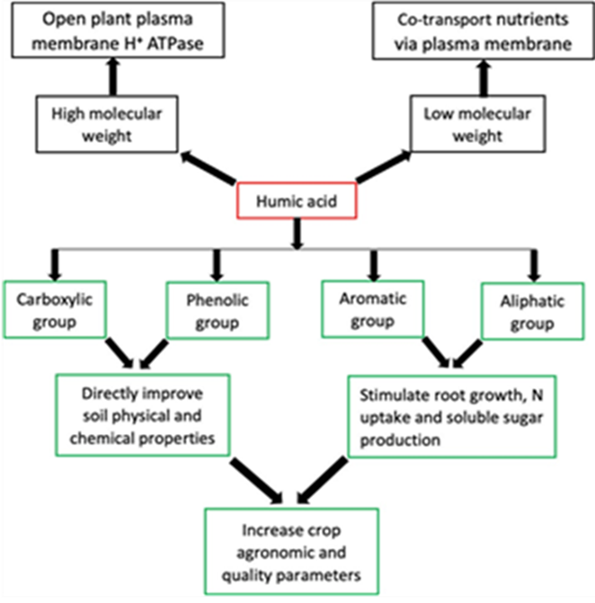
The characteristics of HA are correlated with their respective structures, which are contingent upon their sources. (Nardi et al., 2021).
Fig.1 Aromatic and Aliphatic functional groups of humic acid
2.1.1 Aromatic and Aliphatic functional groups of Humic acid
A recent study conducted by van Tol de Castro (2021) has demonstrated that the humic acid's aromatic and aliphatic functional groups are accountable for augmenting N uptake and soluble sugars, leading to a corresponding rise in rice yield. In contrast, an earlier discovery by Garciá (2016) has validated that the aliphatic and aromatic functional groups of Humic substances stimulate root growth in rice seedlings.
2.1.2 Phenolic and Carboxylic groups of Humic acid
The composition of humic acid encompasses a multitude of functional groups, among which the OH and COOH groups are the most prominent. The COOH and OH functional groups are primarily responsible for the functions of humic acid, including enhancing soil physical and chemical properties as well as promoting plant growth.
The disassociation of these functional groups leads to the creation of polar and non-polar terminations, which correspond to the hydrophilic and hydrophobic components. The hydrophilic end chiefly serves chelating functions, whereas the hydrophobic end is affiliated with repelling purposes.
2.1.3 Low molecular weight group and High molecular weight group of Humic acid
Humic acids characterized by low molecular weight exhibit a higher concentration of phenolic and carboxylic groups compared to those with high molecular weight. The ability to chelate Humic acid has also been attributed to Low molecular weight HA, which is effective in modifying soil biochemical properties. The High molecular weight humic acid is efficient in enhancing the soil physical conditions. Humic acid with high molecular weight has also been observed to stimulate plasma membrane H+ ATPase, allowing low molecular weight Humic acid to co-transit nutrients and perform different biological activities in plants.
2.2. Formation of Humic substances
Humification is a natural process whereby organic matter, such as leaves, undergoes transformation into humic substances through geo-microbiological mechanisms. This process initiates when organic residues from plants and animals come into contact with microbial life in the soil. During humification, microorganisms utilize carbon compounds for their own metabolic processes, while the undigested portion of the residue accumulates as humus. It is imperative to acknowledge that although diverse pathways are available for the production of humic substances in nature, their prevalence may differ across distinct environments. The initial stage of humus formation involves the assimilation of nutrients from organic residues by microorganisms. The aforementioned process ultimately culminates in the emergence of intricate chemical systems that exhibit greater stability compared to the original materials. Once the decomposed organic matter attains a certain degree of humification, it can be denoted as humus, which encompasses a combination of intricate organic compounds, including humic acid, fulvic acid, and humins.
Numerous theories have been postulated to elucidate the genesis and formation of humic substances during the decomposition of plant and animal matter in soil. Nevertheless, irrespective of the particular pathway that is favored, all pathways are deemed feasible for the natural synthesis of humic substances. However, the extent to which each pathway contributes may vary contingent upon the specific environmental conditions.
2.2.1. The lignin theory (pathway 1)
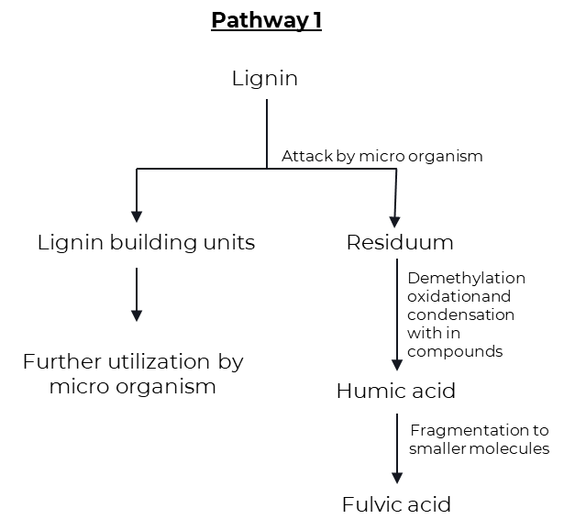
This theory posits that microorganisms do not fully utilize lignin, resulting in its residue becoming integrated into the soil humus. The modification of lignin involves the removal of methoxy groups (-OCH3), leading to the formation of o-hydroxyphenols (C6H5OH) and carboxyl groups (-COOH). It is this material that comprises humic and fulvic acids.
Fig.2 Lignin theory
The lignin theory of humic acid formation was supported by subsequent evidence cited by Waksman (1932), which included the following observations:
• The majority of fungi and bacteria struggle to decompose both lignin and humic acid.
• Both lignin and humic acid exhibit partial solubility in alcohol and pyridine.
• Both lignin and humic acid exhibit solubility in alkali solutions and can be precipitated by the addition of acids.
• Both lignin and humic acid possess acidic properties.
• The warming of lignins with aqueous alkali results in their conversion into methoxyl-containing humic acids.
• Humic acids share similarities with oxidized lignins.
2.2.2. The polyphenol theory (Pathway 2 and 3)
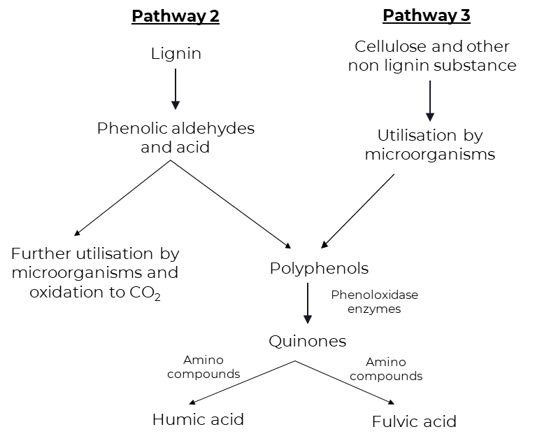
Pathways 2 and 3 exhibit a remarkable degree of similarity, with the exception that polyphenols in pathway 2 are synthesized by microorganisms utilizing non-lignin carbon (C) sources such as cellulose. The polyphenols undergo enzymatic oxidation, resulting in the formation of quinones. These quinones are subsequently converted into humic substances. In pathway 3, it is postulated that the primary building blocks of humic substances (humic and fulvic acids) are quinones of lignin origin, in conjunction with those synthesized by microorganisms. The starting materials for pathway 3 are cellulose and other non-lignin substances.
Fig.3 Polyphenol thoery
In this pathway, lignin continues to play a crucial role in the synthesis of humus, albeit in a distinct manner from the traditional understanding of lignin. When lignin (the starting material for pathway 2) is attacked by microbes, phenols, aldehydes, and acids are released and undergo enzymatic conversion into quinones. These quinones then polymerize, with or without the presence of amino compounds, to form micromolecules that resemble humic substances (Stevenson, 1982). During the decomposition of plant residues, lignin becomes detached from cellulose and undergoes oxidative splitting, resulting in the formation of primary structural units that are derivatives of phenyl propane.
The side chains of these lignin units are subsequently oxidized, leading to demethylation. Polyphenols resulting from this process are then converted into quinones by polyphenoloxidase enzymes. These quinones, originating from lignin and potentially other sources, react with nitrogen-containing compounds to produce dark-colored polymer humic materials, which are a combination of humic and fulvic acids.
2.2.3. Sugar amine condensation (Pathway 4)
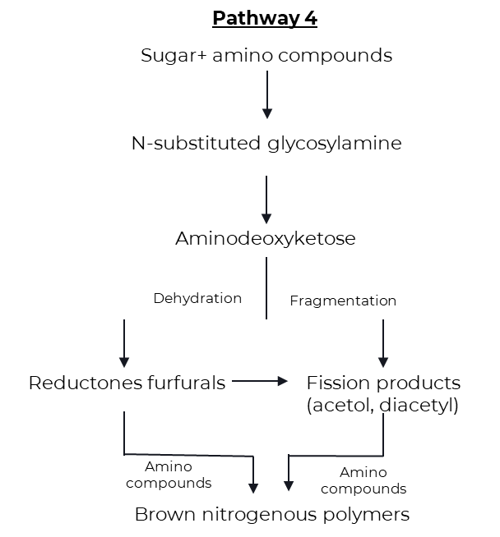
According to pathway 4, reducing sugars and amino acids, which are by-products of microbial metabolism, undergo nonenzymatic polymerization to form brown nitrogenous polymers similar to those produced during the dehydration of certain food products at moderate temperatures. Drastic and frequent changes in the soil environment (such as freezing and
Fig.4 Sugar amine condensation theory
and thawing, wetting and drying) along with the mixing of reactants and mineral substances with catalytic properties can also facilitate condensation.
An intriguing facet of this theory pertains to the copious production of reactants, such as sugars and amino acids, through the actions of microorganisms. The process of initial sugar and amine condensation involves the addition of the amine to the aldehyde group of the sugar, resulting in the formation of n-substituted glycosylamine. Subsequently, this glycosylamine undergoes oxidation to yield n-substituted-1-amino-deoxy-2-ketose. This compound undergoes fragmentation and dehydration processes. Fragmentation leads to the formation of 3-carbon chain aldehydes and ketones such as acetol and diacetyl, while dehydration results in the formation of reductones and hydroxymethyl furfurals. These compounds readily polymerize in the presence of amino compounds to form brown-colored products, particularly humic and fulvic acids (Stevenson, 1982).
2.3. Sources of humic acid
Humic substances can also derive from organic matter such as litter, roots, deceased organisms, and excretions of living organisms found in both terrestrial and aquatic environments. Historically, scholars have been segregating humic materials from soils and water. These humic substances have been regenerated within the soil through agricultural practices including crop rotation, cultivation of legumes, incorporation of green manure, and application of compost.
Table.1 Different sources of humic substances with different concentrations
Natural Source | % Humic acid /  Fulvic acid
Leonardite | 25 to 90
Compost | 5 to 25
Peat | 5 to 20
Lignite | 5 to 15
Manure | 1 to 3
Soft coal | 2 to 5
Hard coal | 0 to 1
2.4. Extraction of humic acid
2.4.1. Extraction of Humic acid from lignite by fractionation procedure by Stevenson (1982)
The Lignite is pulverized and subsequently filtered through a sieve with a mesh size of 0.25mm.

The lignite powder that has been passed through a sieve is dissolved in a solution of sodium hydroxide with a concentration of 0.5N. The ratio of lignite to sodium hydroxide is 1:10.

The dark brown solution is subjected to filtration using Whatman No.1 filter paper.

The filtrate is gathered, and subsequently, the pH of the solution is modified to 1.0 using concentrated hydrochloric acid (HCl). Following this adjustment, the precipitate (HA) is permitted to settle.

The liquid portion, known as the supernatant (FA), is extracted through siphoning, while the mixture is subjected to filtration.

The precipitate undergoes purification through redissolution in a solution of 0.5N NaOH, followed by reprecipitation using concentrated HCl. This process is repeated a total of five times.

Subsequently, the humic acid is subjected to a thorough rinsing process using distilled water until all traces of chloride are eliminated. Following this, the humic acid is dried and subsequently pulverized into a finely textured powder.

2.4.2. Extraction of Humic Acid from Lignite by KOH-Hydrothermal Method
The present study involves the treatment of a 20 g sample of lignite powder with potassium hydroxide (KOH) and distilled water while maintaining its air-dried state.

Subsequently, the amalgamation is introduced into an oven set at a temperature range of 130 to 190 degrees Celsius, and allowed to cool naturally until it reaches room temperature.

The supernatant is isolated from the residues through the process of centrifugation. Then, the residue is subjected to multiple washes with distilled water until it approaches a state of near-neutral pH.

The remaining substance is subjected to filtration and subsequently subjected to desiccation in a vacuum oven at a temperature of 105 ◦C.

The supernatant is acidified to a pH value below 2 using hydrochloric acid (HCl), subsequently subjected to centrifugation for further separation, and finally dried in a vacuum oven at a temperature of 60 ◦C.

The dried material acquired corresponds to Humic Acid.
2.4.3. Extraction of Humic Acid from Lignite by Ion Exchange Method
The extraction of humic acid from lignite involves the combination of two methods: nitric acid peroxidation and alkali solution and acid eduction.

Lignite undergoes a process of crushing and sieving, employing 80 mesh sieves.

The lignite sample, weighing 10 grams, is subjected to centrifugation for a duration of one hour in the presence of 0.5M NaOH.

The solution obtained is subjected to filtration using a Whatman filter paper.

In order to obtain a solid form of humic acid, the filtrate is subjected to treatment with resin cation.
2.5. Benefits of Humic acid
Physical benefits
1. Enhanced soil structure: Mitigates excessive water and nutrient depletion in sandy soils, thereby transforming them into fertile soils through decomposition.
2. Mitigates soil cracking, surface water runoff, and soil erosion by harnessing the cohesive properties of colloids.
3. Facilitates soil loosening and disintegration, thereby improving soil aeration and workability. Enhances water retention capacity, thereby aiding in drought resistance.
4. Deepens the soil's hue, thereby facilitating absorption of solar energy.
Chemical benefits
1. Enhances the soil's buffering properties.
2. Functions as a natural chelator for metal ions in alkaline conditions, facilitating their absorption through the roots.
3. Exhibits remarkably high cation-exchange capacities.
4. This process enables the transformation of essential nutrient elements, including nitrogen, phosphorus, potassium, iron, zinc, and other trace elements, into readily available forms that can be utilized by plants.
5. Enhances the uptake of nitrogen by plants.
6. Mitigates the interaction between phosphorus and calcium, iron, magnesium, and aluminum, releasing it in a form that is beneficial and accessible to plants.
7. Releases carbon dioxide from soil calcium carbonate, enabling its utilization in photosynthesis.
8. Diminishes the presence of toxic substances in soils.
Biological benefits
1. Functions as an organic catalyst in numerous biological processes.
2. Enhances the growth and proliferation of suitable microorganisms in soil.
3. Augments the plant's inherent resistance against diseases and pests.
4. Stimulates root growth, particularly in a vertical direction, and facilitates improved absorption of nutrients.
5. Enhances root respiration and promotes the formation of roots.
6. The process of photosynthesis in plants is facilitated by the presence of certain compounds that contribute to the development of essential components such as chlorophyll, sugars, and amino acids.
7. Promotes plant growth (resulting in higher biomass production) by expediting cell division, accelerating root system development, and increasing the yield of dry matter.
8. Enhances the quality of yields, improving their physical appearance and nutritional value.
2.6. Effect of humic acid on growth and yield of rice
The study conducted by Karennavar et al. (2022) investigated the effects of a humic-acid based bio-stimulant on the growth, yield, and yield attributing characters of kharif rice (oryza sativa L.). The results showed that soil application of the bio-stimulant at a rate of 20 kg ha-1, applied at 2-3 weeks after transplanting and at panicle initiation of rice, resulted in higher crop growth parameters such as plant height, number of leaves per hill, tillers per hill, and dry weight. Additionally, it also led to higher yield parameters including panicle length, number of panicles per hill, number of grains per panicle, grain yield, and straw yield. The rice grain yield was found to be increased by 30.5% compared to the control treatment.
Mitkar et al. (2022) also observed positive effects of bio-stimulants on the growth, yield, and yield attributing characters of kharif rice. They found significantly higher values of growth parameters at 60 days after transplanting (DAT), 90 DAT, and at harvest with the application of humic acid at a rate of 0.5%.
Armeylee Joneer and Lum Mok Sam (2022) demonstrated that the application of humic acid at a concentration of 2 g/mL, along with half of the recommended NPK, resulted in better vegetative growth and yield of Tadong upland rice. Moreover, it was discovered that the implementation of this approach resulted in a decrease in the utilization of chemical fertilizers during the cultivation of rice.
In a study by Kalyanasundaram et al. (2021) on yield maximization of direct sown rice under water constraint situations, it was concluded that the use of tensiometer-based irrigation with soil application of humic granules at a rate of 2.5 kg ha-1 can be a feasible approach for increasing grain yield and conserving water in the north eastern region of Tamil Nadu. This approach promotes water use efficiency in direct rice cultivation areas.
The acid humic plays a positive role in enhancing the effectiveness of enzymes and nutrients in plant metabolism, resulting in a higher production of carbohydrates for most plants. The application of humic acid has been found to result in an increase in plant yield. This effect is attributed to the significant impact of humic acid on various metabolic processes of the plant, including respiration and photosynthesis, as well as its antioxidant properties that aid in the preservation of chlorophyll content. (Ragheb hadi AL-bourky et al., 2021)
The application of humic acid 12% at a rate of 12.5 liters per hectare (T5) resulted in improved growth attributes. Based on the results of the experiment, it can be inferred that the application of humic acid at a concentration of 12% and a rate of 12.5 liters per hectare is a superior agronomic practice that is both economically sustainable and ecologically viable for rice cultivation. (Kumaravel et al., 2022)
The natural buffering group of humic acid, consisting of the amino and carboxylic groups, plays a crucial role in ion exchange in soil agriculture. The composition of humic acid includes carbon, oxygen, aluminum, silicon, and potassium chloride. Humic substances are commonly used to condition soils, either by direct application as soil fertilizer. This research focuses on the short-term impact of humic acid application on rice growth. The use of humic acid and leonardite proved to be beneficial for the growth of rice leaves and roots compared to the control group. (Buntita jomhataikool et al., 2019)
The study conducted by Wanti Mindari et al. (2018) investigated the impact of various sources and doses of humic acid on the physical and chemical properties of saline soil, as well as the growth and yield of rice. The findings revealed that peat humic acid exhibited superior effects compared to other substances, resulting in increased plant biomass, plant root weight, tiller number, and chlorophyll content. Moreover, the application of humic acid effectively enhanced rice yield by 10-20% through the adjustment of soil pH, nutrient availability, and soil salinity.
2.7. Effect of humic acid on growth of rice under drought and saline stress condition
In a separate study by Jaber Mehdiniya Afra et al. (2022), it was demonstrated that foliar application of humic acid led to higher levels of osmotic regulators when compared to other fertilizer resources. This, in turn, mitigated the detrimental effects of drought stress on certain functional traits of cultivars. Additionally, humic acid exhibited a greater capacity to increase chlorophyll levels and promote photosynthetic stability, resulting in improved yield.
Amira M. Okasha et al. (2019) found that the most effective treatment for enhancing rice grain quality, growth, and yields was the foliar spray of a mixture containing humic acid and K+ during the panicle initiation and mid-booting stages. This combination proved to be highly beneficial in improving rice quality and productivity, particularly under salt stress conditions, for the Giza 179 cultivar.
Furthermore, the application of gypsum, farmyard manure, and humic acid, as observed in the study conducted by M. Shaaban et al. (2013), contributed to the improvement of soil properties and the leaching of excessive ions to deeper layers. Consequently, the concentration of salts in the upper layers decreased, creating a favorable environment for plant growth and resulting in a significant increase in rice grain production.
2.8. Effect of humic acid on nutrient uptake of rice
Humic substances, specifically humic acid, possess the ability to attract positively charged ions. They form chelates with micronutrients and gradually release them as needed by plants. Additionally, these substances act as chelating agents, thereby preventing the formation of precipitation, fixation, leaching, and oxidation of micronutrients in the soil. Humic substances, including humic and fulvic acids, exhibit auxin activity and exert hormonal effects on catalytic activity, cell permeability, and nutrient uptake, ultimately leading to an increase in dry matter yield. This information was derived from a study conducted by M Eshwar et al. in 2017.
In a separate study conducted by Arnab Kundu et al. in 2020, the differential responses of rice (Oryza sativa L.) to foliar fertilization of organic potassium salts were examined. Among the various applications of potassium salts, potassium humate demonstrated the most favorable results. It significantly increased the number of leaves, root biomass, and nutrient uptake. This study provided confirmation of the growth-promoting properties of organic potassium salts, as they improved the yield and nutrient uptake of submerged rice.
Furthermore, the application of humic acid or compost extract through spraying resulted in significant increases in various yield parameters and components. It also enhanced the nitrogen, phosphorus, and potassium content of grains and straw compared to the absence of such organic compounds. This finding was reported by El-Gohary et al. in 2010.
2.9. Effect of humic acid on nutrient availability
The experimental results show that peat humic acid can increase the plant biomass, plant root weight, tiller number and chlorophyll content better than other humic acids. Humic acid efficiently can improve rice yields 10–20% supported by the suitability of soil pH, nutrient availability and soil salinity. (Wanti Mindari et al., 2019)
From the experiment on Effect of Lime, Humic Acid and Moisture Regime on the Availability of Zinc in Alfisol, Sushanta Kumar Naik and Dilip Kumar Das (2007) concluded that he application of humic acid has a positive impact on the availability of zinc under saturated conditions.
3.Summary and conclusions
The utilization of humic acid possesses the capacity to considerably influence the agronomic efficacy of crops and diverse parameters associated with soil quality. The impression of humic acid on crop behaviour is influenced by several factors, including its solubility, chemical composition, the specific soil & crop under treatment and application rate. Based on the aforesaid findings, it is noticeable that humic acid possesses a superior crop response, augmented yield, and enhanced yield attributing characteristics. Additionally, there is a notable enhancement in nutrient uptake and availability. In recent times, there is a growing trend in the utilization of organic compounds as fertilizers or soil amendments. This interest can be regarded as the desire to reduce the reliance on chemical fertilizers, concerns regarding the possible pollution caused by chemicals in soil, and the need for energy conservation. Thereupon, humic material develops as a valuable organic resource that has the potential to address some of these requirements.

References
Alan B., Hurst, H. M., Walkden, S. B., Dean, F. M., and Hirst, M. (1963). Nature of humic acids. Nature, 199(4894): 696-697.
Amira, M.O., Abbelhameed, M.M., and Elshayb, O.M. (2019). Improving rice grain quality and yield of Giza 179 rice cultivar using some chemical foliar spray at late growth stages under salt stress. Journal of Plant Production, 10(9): 769-775.
Ampong, K., Thilakaranthna, M.S., and Gorim, L.Y. (2022). Understanding the role of humic acids on crop performance and soil health. Frontiers Agronomy, 4: 848621.
Arnab, K., Raha, P., Dubey, A.N., Rani, M., Paul, A., and Patel, R. (2020). Differential responses of rice (Oryza sativa L.) to foliar fertilization of organic potassium salts. Journal of Plant Nutrition, 44(9): 1330-1348.
Barai, S., Islam, M.M., Parvin, S., Nizam, R., and Bithy, P.A. (2018). Influence of humic acid on morpho-physiology and yield of rice. Journal of Bioscience and Agriculture Research, 29(01): 2407-2415.
Beckley, V.A. (1921). The preparation and fractionation of humic acid. Journal of Agricultural Science, 11(1): 66-68.
Brattebø, H., Ødegaard, H., and Halle, O. (1987). Ion exchange for the removal of humic acids in water treatment. Water Research, 21(9): 1045-1052.
Bruna, A. G., Motta, F. L., and Santana, M. H. A. (2016). Humic acids: Structural properties and multiple functionalities for novel technological developments. Materials Science and Engineering, 62: 967-974.
Cheng, G., Niu, Z., Zhang, C., Zhang, X., and Li, X. (2019). Extraction of humic acid from lignite by KOH-hydrothermal method. Appl. Sci., 9(7): 1356.
Colla, G. and Rouphael, Y. (2015). Biostimulants in horticulture. Scientia Horticulturae, 196: 1-2.
Cornelius, S. (1963). What is humic acid?. Proceedings of the California associaton of chemistry teachers, 40(7): 379-384.
Davies, G., Ghabbour, E. A., and Steelink, C. (2001). Humic acids: Marvelous products of soil chemistry. Journal of Chemical Education, 78(12): 1609.
El-Gohary, A.A., Osman, E.A.M., and Khatab, K.A. (2010). Effect of nitrogen fertilization, humic acid and compost extract on yield and quality of rice plants. Journal of Soil Sciences and Agricultural Engineering, 1(1): 77-91.
Eshwar, M., Srilatha, M., Rekha, K.B., and Sharma, S.H.K. (2017). Effect of humic substances (humic, fulvic acid) and chemical fertilizers on nutrient uptake, dry matter production of aerobic rice (Oryza sativa L.). Journal of Pharmacognosy and Phytochemistry, 6(5): 1063-1066.
García, A.C., Berbara, R.L.L., Farías, L.P., Izquierdo, F.G., Hernández, O.L., Campos, R.H., and Castro, R.N. (2012). Humic acids of vermicompost as an ecological pathway to increase resistance of rice seedlings to water stress. African Journal of Biotechnology, 11(13): 3125-3134.
García, A.C., Santos, L.A., Izquierdo, F.G., Rumjanek, V.M., Castro, R.N., Dos, F.S. and Berbara, R.L.L. (2014). Potentialities of vermicompost humic acids to alleviate water stress in rice plants (Oryza sativa L.). Journal of Geochemical Exploration, 136: 48-54.
Herviyanti, Teguh, B.P., Fachri A. and Darmawan. (2018). The Properties of Humic Acids Extracted from Four Sources of Organic Matters and Their Ability to Bind Fe2+ at New Established Rice Field. Journal of Tropical Agriculture, 15(3): 237-244.
Jaber, M.A.Y., Niknejad, H., Fallah Amoli and Barari Tari. (2020). Effects of drought stress on some phytochemical characteristics of rice cultivars under different chemical and organic nutritional sources. Journal of Plant Nutrition, 44(8): 1193-1206.
Jomhataikool, B., Faungnawakij, K., Kuboon, S., Kraithong, W., Chutipaichit, S., Fuji, M., and Eiad-Ua, A. (2019). Effect of humic acid extracted from Thailand’s leonardite on rice growth. Journal of Metals, Materials and Minerals, 29(1): 1-7.
Kalyanasundaram, D., Arthi, E., Kumar, K.S., and Sri. S. H. (2021). Yield maximization of direct sown rice (Oryza sativa l.) under water constraint situation. Journal of Applied and Natural Science, 13(1): 373-376.
Karennavar, S.S., Chavan, V.G., More, V.G., Dhopavkar, R.V., Desai, S.S. and Bodake, P.S. (2022). Effect of humic acid-based bio-stimulant on growth, yield and yield attributing characters of kharif rice (Oryza sativa L.). The Pharma Innovation, 11(11):319-322.
Kononova, M. M., and Alexandrova, I. V. (1973). Formation of humic acids during plant residue humification and their nature. Geoderma, 9(3): 157-164.
Kumaravel, S., Nandakumar, P., and Maheshwaran, M.M.K. (2022). Effect of different plant growth regulators on the growth of transplanted rice (Oryza sativa L.). The Pharma Innovation, 11(12): 1461-1464.
Kumaravel, S., Nandakumar, P., and Maheshwaran, M.M.K. (2022). Effect of different plant growth regulators on the yield of transplanted rice (Oryza sativa L.). The Pharma Innovation, 11(12): 4005- 4008.
Kurniati, E., Muljani, S., Virgani, D. G., and Neno, B. P. (2018). Humic acid isolations from lignite by ion exchange method. In Journal of Physics: Conference Series, 953(1):012234. IOP Publishing.
Mayhew, L. (2004). Humic substances in biological agriculture. Acres, 34: 54-61.
Mikkelsen, R.L. (2005). Humic materials for agriculture. Better crops, 89(3): 6-10.
Mitkar, G.V., Sagvekar, V.V., Bodake, P.S., Thorat, T.N., Mahadik, S.G., Khobragade, N.H. and Ghodake, S.S. (2022). Effect of foliar application of bio stimulants on growth, yield attributing characters and yield of Kharif rice (Oryza sativa L.) under lateritic soils of Konkan. The Pharma Innovation, 11(11): 1788- 1791.
Mohammad, F., Moradi, H., Noori, M., Sobhkhizi, A., Adibian, M., Abdollahi, S., & Rigi, K. (2014). Influence of humic acid on increase yield of plants and soil properties. International Journal of Farming and Allied Sciences, 3(3): 339-341.
Moskalenko, T., Mikheev, V., and Vorsina, E. (2020). Intensification of humic acid extraction from lignites. EDP Sciences, 192: 02024.
Nagamitsu, M., Watanabe, A., and Kimura, M. (1997). Origin and properties of humus in the subsoil of irrigated rice paddies: I. Leaching of organic matter from plow layer soil and accumulation in subsoil. Soil science and plant nutrition, 43(4): 901-910.
Nethala nivalini ushadhree (1988). Humic acid and its influence on crop plants. M.Sc. (Agri.), Thesis, Annamalai University.
Niladri, P., Debarata, D., Ashin, D., Dipankar, S. (2017). Comparative Study of Organic Matter Vis-a-Vis Humic Acid on Change in Nutrients Availability in Rice-Mustard Cropping Sequence. International Journal of Agriculture Environment and Biotechnology, 10(3): 303-314.
Perumal, P., Ahmed, O.H., Majid, N.M., Jalloh, M.B., and Susilawati, K. (2015). Improving lowland rice (O. sativa L. cv. MR219) plant growth variables, nutrients uptake, and nutrients recovery using crude humic substances. The Scientific World Journal, 2015(906094):14.
Ravindra Prasad G. (1988). The influence of lignite humic acids in the growth, yield and nutrient content and uptake of paddy IR 20. M.Sc. (Agri.) Thesis, Annamalai university.
Ragheb, H.M.A. Manshood, M.R. Mahmoud, S.T. and Al-mousawy. (2021). Effect of Humic Acid on Growth and Yield of Several Genotypes of Rice (Oryza Sativa L.). Environmental Earth Sciences, 923(1): 012-059.
Ronald, L.M., and MacCarthy, P. (1986). Limitations in the use of commercial humic acids in water and soil research. Environmental Science & Technology, 20(9): 904-911.
Sai, M. K., Subbaiah, P.V., Prasad, P.R.K. and Rekha, M.S. (2021). Available Nutrient Status of Soil as Influenced by Combined Application of Humic Acid and Inorganic Nitrogen. International Journal of Plant and Soil Science, 33(22): 209-217.
Samir, P. and Sengupta, M. B. (1985). Nature and properties of humic acid prepared from different sources and its effect on nutrient availability. Plant and Soil, 88: 71-91.
Satish, Y.S., Nayak, S.B., Reddy, C.V.C.M., Arun, K.A., Vishnuvardhan, K.M., Kiranmayi, J. and Narayana, E.N. (2022). Effect of Potassium humate fertilizers on soil nutrients and productivity of Rice crop in vertisols of Southern India. Ecology, Environment and Conservation, 29(1): 43-48.
Senn, T.L., and Kingman, A.R. (1973). A review of humus and humic acids. Research series, 145: 1-5.
Senthil Kumar K. (1995). Studies on the effect of lignite derived humic substances and nitrogen on low land rice. M.Sc. (Agri.) Thesis, Annamalai university.
Shaaban, M., Abid, M., and Shanab, R.A.I. (2013). Amelioration of salt affected soils in rice paddy system by application of organic and inorganic amendments. Plant, Soil and Environment, 59(5): 227-233.
Shozo, K., Tsutsuki, K., and Kumada, K. (1978). Chemical studies on soil humic acids: 1. Elementary composition of humic acids. Soil Science and Plant Nutrition, 24(3): 337-347.
Sivakumar, K., Devarajan, L., Dhanasekaran, K., Venkatakrishnan, D., and Surendran, U. (2007). Effect of humic acid on the yield and nutrient uptake of rice. Oryza, 44(3): 277-279.
Suhardjadinata, Sunarya, Y., and Tedjaningsih, T., (2016). Increasing Nitrogen Fertilizer Efficiency on Wetland Rice by Using Humic Acid. Journal of Tropical Soils, 20(3): 143-148.
Sushanta, K.N. and Dilip, K.D. (2007). Effect of lime, humic acid and moisture regime on the availability of zinc in alfisol. The Scientific World Journal, 7: 1198-1206.
Tadeu, A.T.C., Ricardo, L. L.B., Orlando, C.H.T., Debora, F.G.M., Erinaldo, G.P., Camila, C.B.S., Luis, M.E. and Andres, C.G. (2021). Humic acids induce a eustress state via photosynthesis and nitrogen metabolism leading to a root growth improvement in rice plants. Plant Physiology and Biochemistry,162: 171-184.
Wanti, M., Sasongko, P.E., Kusuma, Z., Syekhfani, S., and Aini, N. (2018). Efficiency of various sources and doses of humic acid on physical and chemical properties of saline soil and growth and yield of rice. AIP Conference Proceedings, 2019(1):03000- 030008.
Zheng, E., Yinhao, Z., Jianyu, H. and Tiamyu, X. (2022). Effects of humic acid organic fertilizer on soil environment in black soil for paddy field under water saving irrigation. Nature Environment and Pollution Technology, 21(3): 1243-1249.

