Electric Vehicles: Scenario and Technological Developments in India

Mr. Aniruddha S. Joshi¹
Assistant Professor & HOD
Automobile Engineering Department
Rajendra Mane College of Engineering and Technology, Ambav, Maharashtra, India. joshias@rmcet.com

Mrs. Yugashri A. Joshi
Swami E-Wheels
AP. Gadmudshingi, Tal. Karveer,
Dist. Kolhapur-Maharashtra, India
Yugashri93@gmail.com

ABSTRACT
Government policies and standards play a key role in unlocking new technological potential and opening up new opportunities in Maharashtra. Similarly, technical standards play an important role in the technical development and compatibility of various systems and components used in the electric vehicle industry. In addition, the safety and reliability of new developments are guaranteed, increasing customer confidence. At the beginning of the 21st century, new companies took advantage of the absence of major automakers in the electric vehicle market. Globally, these start-ups have all launched one or more of his EV models, changing the auto industry scenario. Looking at the Indian scenario, there is still a long way to go. In such a scenario, all parties should work together in the coming years to ensure that the industry can make the right decisions to increase manufacturing capacity, and that the government can make positive decisions to support automotive growth. It will be important to understand the progress of EV penetration in Japan. EV industry.
This article provides an overview of the electric vehicle market, market players with recent technological developments, and current status. Also, this chapter focuses on highlighting various policy and regulatory measures taken jointly by several departments of state governments to promote the penetration of electric mobility market in India. Case study reports include cost analysis to understand the realities of the field.

Keywords— Costumer, Electric Vehicle Market, Policy, Case study etc.

INTRODUCTION
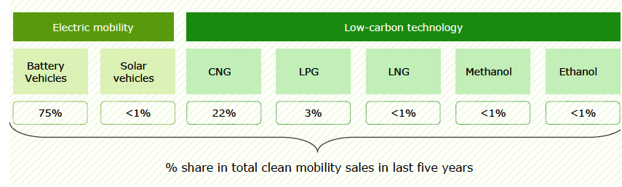
Electric vehicles are a newborn baby in India with a market share of 0.1% compared to major players such as China, Europe and the US. The government is aiming to go fully electric in India, and working with the government, the transition to electric vehicles may soon become a reality in India as well. By 2025, the electric vehicle storage capacity he plans to increase to 5.7 GW. Nearly 200 stations are planned to be built around Delhi, Jaipur and Chandigarh. Among the available clean/low carbon mobility technologies, electric vehicles and his CNG vehicles are the most preferred in India. The existence of tax incentives for electric vehicles and the low price of CNG compared to gasoline and diesel may explain why these technologies are so popular.

Fig. 1. Clean and low carbon technologies on road with share in sales (Source: Vahan Dashboard)
Maharashtra has the highest number of 2W electric vehicles among other Indian states. Electric vehicles are emerging as a promising alternative that can reduce the negative environmental impact of conventional vehicles. The number of electric vehicles in the country is increasing, but acceptance in various vehicle categories has been uneven. Although two-wheeled electric vehicles make up only 17% of the state's total electric vehicle population, it is likely to follow a similar trend to that seen in today's conventional vehicle market [06]. So far, there are concerns about new technology, the relatively high price of electric vehicles (same performance compared to vehicles with internal combustion engines), range concerns, and the availability of sufficient charging options. . It has hindered the introduction of two-wheeled electric vehicles. However, with the maturity of electric vehicle technology, the achievement of price parity, and the development of peripheral infrastructure, the proportion of electric two-wheeled vehicles is expected to increase. Also, OEMs are increasingly considering his 2WD EV market as an attractive market, which is why many startups such as Ather, Revolt, Okinawa and Evolet are entering the space.
Due to the high price of EVs compared to ICE vehicles, adoption remains a major challenge. A cost comparison between an EV and a 2W ICE vehicle with similar performance is shown in Figure 2. The Indian government is also supporting the introduction of two-wheelers as part of his FAME II programme. Under this scheme, the government will provide a subsidy of up to INR 30,000 for his purchase of a 2W electric vehicle. However, the system is for high-speed 2W vehicles, so the market is expected to shift to high-speed vehicles[09]. 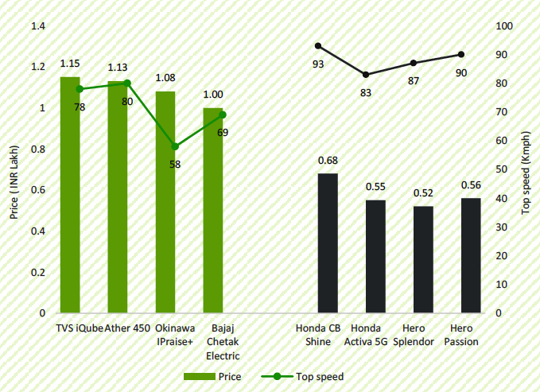
Fig. 2. Variation in cost of 2W EV and conventional vehicles (ICE)
The three-wheeled electric vehicle segment accounts for 79% of all electric vehicles in India. This segment is currently driving the electrification of the Indian automotive industry. The four-wheel electric vehicle segment accounts for just 3% of the total electric vehicle population in the country. A limited model will be available in the EV 4W segment. However, major OEMs are planning to launch more EV models suitable for the Indian market in the future, which could lead to increased market competition and increased penetration. As with the rest of the electric vehicle segment, large-scale deployment of 4W electric vehicles is subject to high price. One of the main reasons for the high price of electric vehicles is the limited presence of component manufacturers in India. Most of the auto parts for these cars are imported, and China is the main supplier of EV parts to India, leading to higher EV prices. Therefore, the development of local production centers for EV components could play an important role in reducing EV costs in the future and making the EV sector more resilient to supply disruptions due to geopolitical instability. Electric buses are the least common vehicle segment of electric vehicles in India. Looking at the sales trends of electric buses in Indian states, we can see that Maharashtra, West Bengal and Himachal Pradesh were the first states to introduce electric buses. The Indian government has set a target of achieving 30% market penetration of electric vehicles by 2030. Achieving this goal, however, will require transformative and drastic action by policymakers in this area. Electric vehicles (EV), hybrid electric vehicles (HEV) and plug-in hybrid electric vehicles (PHEV) are currently on sale in both India and Maharashtra. However, irrespective of whether EV/HEV/PHEV are more beneficial for road transport in India, EV sales are not very promising for the following reasons [11].
1. Hybrid or electric powertrains run much more efficiently than internal combustion engines (ICE) at low speeds in India.
2. In a hybrid electric vehicle (HEV) or electric vehicle (regenerative braking), braking consumes most of the energy per trip, and most of that energy is recovered.
3. HEVs and EVs consume no fuel when idling, and in Maharashtra the idling time percentage of traffic is much higher.
4. Since the average range in India is much lower than in the US or Europe, EVs are much more practical and range on a single charge is not an issue.
5. Vehicle utilization and vehicle distance – Urban driving cycles are characterized by frequent starts and stops and traffic advantages to ensure high efficiency of electric vehicles.
In this article, we will elaborate on the current situation, policies, challenges and market trends of EVs in India. In addition, technical standards and customer perspectives will be introduced with case studies.

EV Market Scenario
A detailed study of the specifications of the IC engine and electric two-wheelers available in the market (as in August 2022) was made. The vehicles were categorized in terms of their power and type of propulsion. The obtained representative results are given below in Table 1.
Table. 1. Specifications of available vehicles
Category Name | Vehicle Class | Ex-showroom Price (Rs.) | Traction Battery Kwh | Power (W) | Fuel Economy (kmpl) | Fuel Per km* | Range (km)
ICScooter110 | Scooter | 63000 | - | 6000 | 55.45 | 0.018 | 266
ICScooter125 | Scooter | 73000 | - | 6120 | 51.02 | 0.02 | 271
ICMotCycle100 | MotorCycle | 53000 | - | 5810 | 82.6 | 0.012 | 867
ICMotCycle110 | MotorCycle | 58000 | - | 6330 | 84.03 | 0.012 | 882
ICMotCycle125 | MotorCycle | 73000 | - | 8000 | 58.85 | 0.017 | 706
ICMotCycle150 | MotorCycle | 98000 | - | 10300 | 55.51 | 0.018 | 833
EVScooter1200 | Scooter | 60000 | 1.68 | 1200 | NA | 0.015 | 87
EVScooter2020 | Scooter | 94500 | 2.09 | 2020 | NA | 0.014 | 120
EVMotCycle1500 | Motorcycle | 95000 | 2.7 | 1500 | NA | 0.02 | 110
EVMotCycle3000 | MotorCycle | 90800 | 3.24 | 3000 | NA | 0.017 | 150

A. Status of EV Ecosystem and Electric Two-wheelers Production Plan
Efforts for introducing electric two-wheelers started in India in 1990s. Companies like Bajaj Auto, Scooters India Ltd. and Hero Motor Corporation etc. developed electric two-wheelers. The Ministry of New and Renewable Energy (MNRE) offered subsidy on electric vehicles during 2010-12. However, such efforts did not sustain and the sales of electric vehicles dropped significantly once subsidy was withdrawn.
After the launch of the FAME scheme, many new electric two-wheeler manufacturers have emerged and even the established ones have joined the race. Start-up companies such as Ather Energy, Okinawa, Pure EV and Ampere Vehicles etc. have established EV 2/3 wheeler manufacturing capacities and plan to expand them further. Ola has announced an ambitious plan for manufacturing and companies such as Hero Electric and Bajaj Auto etc. have also set up manufacturing facilities for the electric 2/3 wheelers. In terms of infrastructure, in March 2021, there were about 1800 charging stations in India. Sanction has been given for installation of 3300 more charging stations under the FAME scheme [14].
While this information provided an initial benchmark for constructing a few scenarios of possible roll out of charging facilities, it was also kept in mind that the announcements are mainly short-term ones and many more such plans may come up for the future years.
A number of variables influence the projections of the annual level of market penetration of electric two-wheelers and it is possible to create many scenarios using the Agent-based model. Among all the components, battery contributes the most to the manufacturing cost of the electric vehicles. Thus, battery cost is expected to have high impact on the adoption of electric two-wheelers in India. Lithium ion battery cost has come down significantly in the last decade. However, very recently, with the availability of lithium being a concern the downward trajectory of the lithium ion battery has been arrested to some extent. Even there is slight increase in the cost also. Enhanced adoption of electric vehicles can also be driven by enhanced performance due to technological improvements. Higher specific energy battery may improve the range of the vehicle and improved electric motors may offer higher power and speed, removing the gap between electric vehicles and conventional IC engine vehicles. Roll out of charging infrastructure is one such important factor for adoption of electric mobility, as it has a direct relevance to the so-called ‘Range Anxiety’ of the users. The readiness of the industry is another important influencing factor for market penetration of electric vehicles. However, as the electric mobility industry gains momentum in India, some more established vehicle manufacturers as well as the new entrants may come up with plans of further capacity addition. To consider such possibilities, three different production levels have been considered under each of the main scenarios. These are shown in Figure 3.
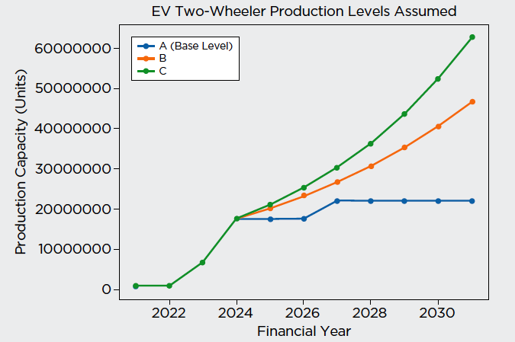
Fig. 3. Assumed production scenarios for EV two-wheelers
B. Cost of an electric vehicle
The cost of an electric vehicle is currently higher compared to a conventional vehicle with similar characteristics and performance. One of the major reasons for the same is the high price of the battery which accounts for nearly 40% of the total EV cost. Although the prices of batteries have fallen considerably in the last decade, they are still at a level which makes EVs difficult to attain cost parity with their conventional counterparts.
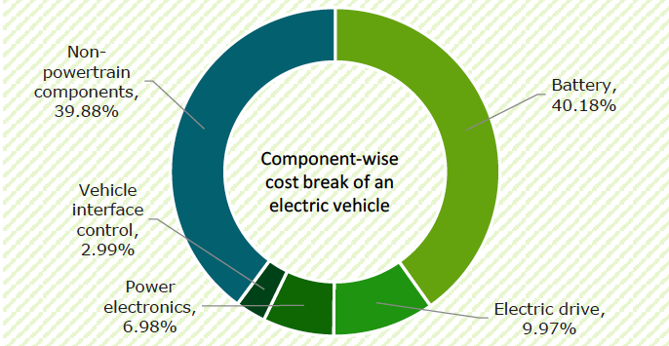

Fig.4. Category-wise cost breaking

III. Technological Development, Review of Policies and Technical Standards
Implementing policies and regulations will play a key role in unlocking the potential of new technologies and paving the way for new opportunities. In 2016, global sales of electric vehicles reached 1 million units, and in 2018, global sales of small electric vehicles and plug-in hybrid electric vehicles surpassed 5 million units. Famous automakers such as Volkswagen, Mercedes and Ford are carrying out their ambitions to promote electric vehicles. Electric vehicles mainly include pure electric vehicles (PEV), hybrid electric vehicles (HEV) and fuel cell electric vehicles (FCEV). As of the end of 2018, the global FCEV population reached 11,200 units. The literature of the last few years provides an overview of the technological development of electric vehicles, not only focusing on the technical difficulties of the main components, but also considering possible directions of future development to overcome these obstacles. Couldn't find. A detailed analysis and review of key electric vehicle technologies is listed below [04].
A. Battery Technology of EVs:
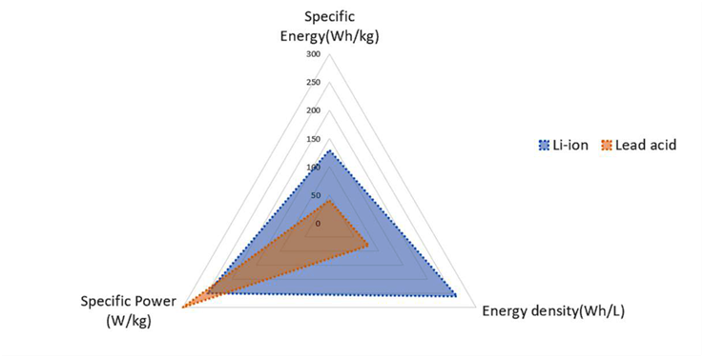
Traction battery technology developments have had a significant impact on the electric vehicle industry, as they are used to power the propulsion systems of electric vehicles. As soon as rechargeable lead-acid batteries became available, they were installed in electric vehicles. With the development of battery technology, more and more different types of power batteries are appearing on the battery market. Despite new battery technology, the requirements for traction batteries have not changed significantly. Unlike batteries for starters, lights and ignition, electric vehicle batteries need to be continuously powered. Therefore, higher energy capacity is very important. In addition, high specific power, high specific energy and high energy density are also important. Currently, electric vehicles mainly use lead-acid batteries, nickel-metal hydride (Ni-MH) batteries, and lithium-ion batteries.

Figure 5. Comparison of lithium-ion and lead-acid batteries.
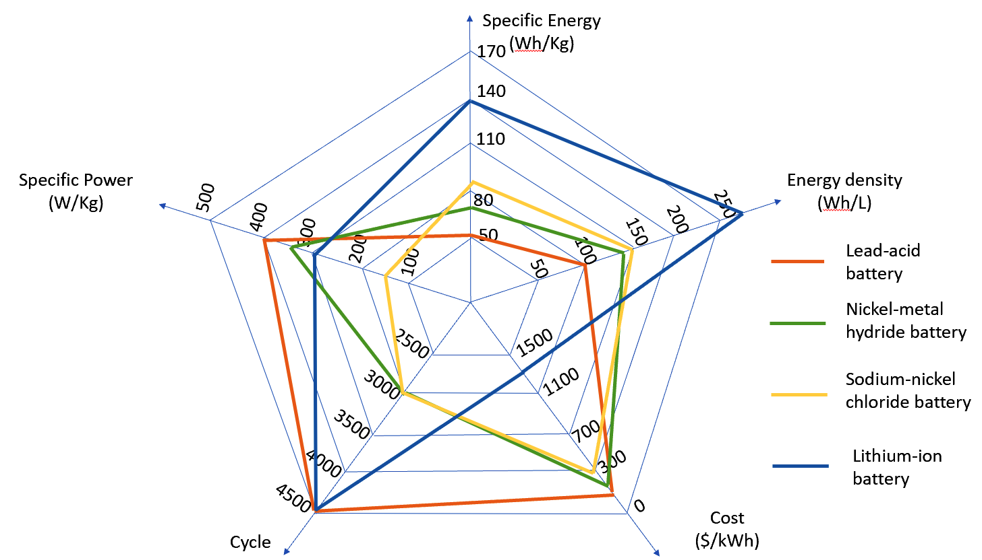

Figure 6. Comparison of the characteristics of various power batteries.

B. Charging Technology
In addition to the capacity of batteries, charging is another challenge for BEVs. Charging technology and battery technology are supplementary to each other. To release the “range anxiety” of EV drivers, charging technology is crucial and plays an important role in the BEV industry. With the rapid development of charging technology and the spread of charging infrastructure, charging is becoming more convenient and faster. Under different energy transfer modes, battery charging for EVs can be classified into conductive charging, inductive charging, and battery swapping. According to the charging methods EVs need different charging infrastructures and equipment. Conductive charging, inductive charging, and battery swapping are considered the three available charging options for BEV applications. With the development of charging technology, charging for EVs is becoming more efficient and convenient. Dynamic charging makes it possible to further extend the travel range and reduce the size of the battery pack. The smart grid eliminates the load impact of EV charging and provides a better electricity distribution concept. The smart grid integration of EVs and smart EV charging could offer a greater insight into the EV experience. As an important support of the EV application, the charging technology plays a crucial role [07].

C. Electric Motors
The electric motor sits at the core of the propulsion system in EVs, which converts the electrical energy of the battery into mechanical energy to power the vehicles. The main requirements listed in the references for propulsion motors are toughness, high torque, high power, high efficiency, a wide range of speed, robustness, ease of control, low cost, low noise, and small size. Several types of electric motors with different construction and technology have been used for EVs. These include induction motor (IM), permanent magnet (PM) and switched reluctance motors (SRMs). The most design to meet the demands of the automotive is the PM type. Permanent Magnet Brushless DC Motor (PMBLDC) are broadly employed in EVs because of their high-power density and high efficiency. High-quality rare earth permanent magnet materials, such as samarium cobalt (Sm–Co) and neodymium–iron–boron (Nd–Fe–B), have been used on its rotor. As the rotor has no windings, no rotor copper loss exists. Since the PMBLDC motor has the characteristics of a wide range of speed, high efficiency, controllability, and safety, it has drawn a significant amount of attention for EV applications, especially related to the in-wheel technology of electric propulsion systems.

D. Charging Infrastructure
Charging infrastructure plays an important role in the introduction of electric vehicles. Electromobility implementations must consider building a robust charging infrastructure network. Building a robust charging infrastructure network means adjusting the current state of the charging infrastructure, understanding the impact of charging on the grid, and considering the introduction of appropriate charging payment systems. To further promote electric vehicle charging networks, many countries have proposed various programs and projects that provide financial and political support for the development of charging infrastructure. The development of charging networks not only facilitates the introduction of electric vehicles, but also poses many challenges for public order. The main topics are the impact of charging on the grid and the placement of charging infrastructure. The potential for fair rewards for charging electric vehicles is also an important consideration for electric vehicles, as it depends on the condition and age of the battery. The battery management system "BMS" helps to obtain data on the state of the battery. Every driver should know how long they can use their car after charging. Other factors such as battery capacity, charging speed, and electricity costs should also be considered. Although EVs have received a great deal of interest recently, a number of key technical challenges remain in advancing EV development. One of the biggest obstacles is the research and mass production of batteries with high energy density, high power density and safety.

Case Study: EV Vs Conventional Vehicle

There are certain assumptions to be made;

1. On-road price of vehicle is subjective to owner, hence not taken into accounts.

2. One person having his Petrol Scooter with 100cc capacity
3. Costumer drive their vehicle 40 km per day (Approximately)

4. Cost of 1L petrol is Rs. 100 (Approximate)

5. The per km cost of running this petrol scooter is Rs 2.5 per km (40 kmpl, Rs 100 per liter)

A. Now for same condition the electric scooter gives extremely less operating costs;
- The per km cost of running an electric scooter is only Rs 0.25 per km.
- Cost of electricity is fairly cheap at Rs 10 per unit in the commercial location of cities and Rs 3 - 4 small
towns and villages.
Table. 2. Comparative Details of EV and Petrol Scooter
 | Electric Scooter | Petrol Scooter
Per Km Cost | Rs. 0.25 | Rs. 2.5
4 years | 40,000 Km | 40,000 Km
Fuel Cost | Rs. 10,000 | Rs. 1,00,000
Savings | Rs. 90000 for fuel use

B. Maintenance Expenses

About maintenance costs associated with this petrol scooter for a period of 5 years.

Petrol scooters have maintenance costs of Rs 6000 per annum, which results in Rs 30,000 for 5 year period.

Remember, petrol scooters also have a lot of parts - engine, transmission, gearbox, convertors, filters, engine parts etc. These can go wrong and will lead to replacement or repairs. Consider repair/replacement costs of Rs 10,000 over a 5 year period.

So total maintenance cost for your petrol scooter could be Rs 40,000 for period of 5 years.

About maintenance costs associated with this electric scooter for a period of 5 years.

Electric scooters have far less moving parts compared to petrol scooters.

Most electric scooters come with 3 years/60,000 km battery warranty, so there would be no battery related maintenance for 3 years.

After the warranty period, what maintenance costs can you expect, with respect to the battery in 4th and 5th year?

Internally battery pack might be damaged due to a physical damage

BMS board might need replacing or repairs

Lithium cells can go off balance. Some cells due to age might have less voltage when fully charged. So these cells will need cell boosting or in worse cases cell replacement. For the 4th and 5th year, let’s keep an amount of Rs 5000 as battery pack maintenance.

Electronic parts like controller, Motor, DC-DC converter, charger, wiring harness etc might get faulty and might need replacement or repairs. So let’s set aside Rs 15,000 for part replacements.

Regular annual service would cost Rs 5000 (Rs 1000 per year).

So total maintenance cost for your electric scooter could be around Rs 25,000.

So overall details mentioned in following table.
Table. 3. Total Costing with Saving Details
 | Electric Scooter | Petrol Scooter
Vehicle Cost | Rs. 80000 | Rs. 80000
General Servicing | Rs. 5000 | Rs. 30000
Part Replacements | Rs. 15000 | Rs. 10000
Battery Replacement | Rs. 30000 | Rs. 0
Fuel Cost | Rs. 10000 | Rs. 100000
TCO  (Total Cost of Ownership) | Rs. 140000 | Rs. 220000
Savings | Rs. 80000 Cost Saving by using Electric Scooter
It is observed from Table 2 & 3 that there is saving in using electric scooter.

IV. Conclusions
This article provides an overview of electric vehicle technology developments in key areas such as batteries, charging, electric motors, charging infrastructure and emerging technologies. The development of battery technology is very important for the market penetration of electric vehicles. Lithium-ion batteries are the most commonly used today. The heart of the drive system, the electric motor, is also of interest to many researchers. PMBLDC is attractive for EV applications, especially in the area of ​​in-wheel technology. Charging infrastructure plays an important role in EV applications. Charging Infrastructure Network is about the organization of the charging network, the technical challenges of the infrastructure and the possibility of fair payment for the charging process. Today, EVs are not only a means of transporting people and goods like traditional vehicles, but also serve as a communication bridge between EVs and all smart devices. Governments should focus on raising awareness about e-scooters by providing articles, sessions and subsidizing e-scooters. At some point in the future, a suitable ecosystem may emerge to tighten regulations on electro mobility and other clean modes of transport. However, as this analysis shows, there are many opportunities to accelerate the adoption of electric vehicles through technological improvements and other means. Although the development of electric vehicles is highly beneficial and cost-saving for customers, it faces many technical challenges, including: B. We believe that with the integration of battery technology, charging technology, electric motor technology and other new technologies, electric vehicles will play an important role in people's lives in the future.

REFERENCES
[1] BP. 2020. “BP Statistical Review of World Energy 2019”. 69th Edition, The British Petroleum Company. Accessed June 2020. http://www.bp.com/content/dam/bp/business
sites/en/global/corporate/pdfs/energyeconomics/statistical-review/bp-stats-review-2020-full-report.pdf
[2] Martins, F., Felgueiras, C., Smitkova, M., Caetano, N. 2019. “Analysis of Fossil Fuel Energy Consumption and Environmental Impacts in European Countries”. MDPI Energies. DOI: 10.3390/en12060964
[3] Maini, C., Gopal, K., Prakash, R. 2013. “Making of ‘all reason’ Electric vehicle”. In Proc. World electric vehicle Symposium and Exhibition, Barcelona, Spain. http://ieeexplore.ieee.org/abstract/document/6915015
[4] Tiwari, A., Jaga, O. P. 2017. “Component Selection for An Electric Vehicle”. A Review. In Proc. International Conference on Computation of Power, Energy, Information and Communication, 492-499, Melmaruvathur, India. http://ieeexplore.ieee.org/abstract/document/8290416
[5] Bhatta, P. N., Mehar, H., Sahajwani, M. 2019. “Electrical Motors for Electric Vehicle – A Comparative Study”. In Proc. International Conference on “Recent Advances in Interdisciplinary Trends in Engineering & Applications. DOI: 10.2139/ssrn.3364887
[6] Lulhe, A. M., Date, T. N. 2015. “A Technological review paper for drives used in electric vehicle (EV) and hybrid electric vehicles (HEV)”. In Proc. International Conference on Control, Instrumentation, Communication and Computational Technologies, 700-705, Kumaracoil, India. http://ieeexplore.ieee.org/document/7475355
[7] Ehsani, M., Gao, Y., Longo, S. and Ebrahimi, K. 2018. Modern electric, hybrid electric, and fuel cell vehicles. CRC press.
[8] Warake, K., Bhahulikar, S. R., Satpute, N. V. 2018. “Design & Development of Regenerative Braking System at Rear Axle”. International Journal of Advanced Mechanical Engineering, 8(2), 165-172. https://www.ripublication.com/ijame18/ijamev8n2_04.pdf.
[9] Bhalla, P., Ali, I. S., & Nazneen, A. (2018). A study of consumer perception and purchase intention of electric vehicles. European Journal of Scientific Research, 149(4), 362-368.
[10] Chan, C. C. (1993). An overview of electric vehicle technology. Proceedings of the IEEE, 81(9), 1202-1213.
[11] Chan, C. C., Chau, K. T., & Chau, K. T. (2001). Modern electric vehicle technology (Vol. 47). Oxford University Press on Demand.
[12] Ding, N., Prasad, K., & Lie, T. T. (2017). The electric vehicle: a review. International Journal of Electric and Hybrid Vehicles, 9(1), 49-66.
[13] Junquera, B., Moreno, B., & Álvarez, R. (2016). Analyzing consumer attitudes towards electric vehicle purchasing intentions in Spain: Technological limitations and vehicle confidence. Technological Forecasting and Social Change, 109, 6-14.
[14] Propelling Electric Vehicles in India: Technical study of Electric Vehicles and Charging Infrastructure (BEE)
[15] Ding, N., Prasad, K., & Lie, T. T. (2017). The electric vehicle: a review. International Journal of Electric and Hybrid Vehicles, 9(1), 49-66.
[16] Situ, L. (2009, May). Electric vehicle development: the past, present & future. In 2009 3rd International Conference on Power Electronics Systems and Applications (PESA) (pp. 1-3). IEEE.

