A Study on Prospective Retailers' marketing strategies in the Context of the Wheel of Retailing Theory

ABSTRACT
New entrants with a dynamic approach have made dynamic and rapid changes in the Indian retail industry. It contributes over 10% of GDP and 8% of employment. India is the fifth-largest retail market worldwide. International retail giants are drawn to India's large middle class and nearly untapped retail market, which will boost the country's retail sector. Branded apparel, cosmetics, footwear, watches, beverages, food, and jewellery are becoming popular with urban Indian consumers as their purchasing power rises. According to the Boston Consulting Group, India's retail sector will be worth US$2 trillion by 2032. (BCG).
With the advent of digitalization and the proliferation of devices, retailing sector is expanding exponentially. The wheel of retailing theory has also significantly undergone modification.
This paper throws light on the marketing strategies and factors identified by the researcher as an intervening variable in the model of the wheel of retailing in the context of Ansoff's model theory in the retailing sector.

Introduction

Retailing is a sub-system of the value chain. It plays a significant role in the modern era to cater not only to basic needs but also bring in customer delight and promote peace and happiness by promoting change in the lifestyle. (Rudrabasavaraj, 2010: 1). Kotler and Armstrong define retailing as all the activities to reach the ultimate consumers.
As a result, retailing is the final endpoint of the value chain in delivering products that the end consumers consume. Retailing is the function of any company which sells products directly to the end consumer. As a result, it covers all activities associated with selling goods and services to customers for their own individual, family, or household use. Retail is the last and most crucial stage of any economic activity (Arora, 2012: 10).
According to Dabholkar (1996), the retail environment of today is changing at a faster rate than it ever has before. There is widespread consensus that providing customers with high-quality service is one of the fundamental retailing strategies for developing a competitive advantage (e.g., Berry, 1986). Considering that services are it is not easy to objectively measure the quality of services because they are intangible, heterogeneous, and inseparable. Throughout the years, many researchers have put forth and evaluated various alternative service quality models and instruments to measure service quality. The SERVQUAL model, developed by Parasuraman, Zeithaml, and Berry in 1985, is the most well-known and is utilized the most frequently among these models. According to the definition offered by Parasuraman, Zeithaml, and Berry, "Service Quality" refers to "A global judgment or attitude relating to the overall superiority of the service." Because of qualities such as intangibility, perishability, inseparability, and heterogeneity, evaluating the quality of service is both indefinable and challenging to conceptualize. Both the theory and practice of marketing place a significant emphasis on the importance of service quality and customer satisfaction, and achieving this is the ultimate goal of all service providers. Thus, retailing covers 'Customer perception' of service, which ultimately determines service quality (Lewlyn et al., 2009). What matters is how the customers receive the quality; in other words, the customers are the only ones who can accurately judge the quality (Berry, 1980). Cronin and Taylor (1992, pages 55-68) devised a scale with a single question that asked customers how they felt about an organization. It is one of their method for measuring customer satisfaction. Wheel of Retailing, developed in the year 1957, gave a new dimension to retailers. Although the theory cannot itself exhaustive, it still gained popularity recently, and marketers started realizing the importance of Market penetration, Product development, exploring new markets, and Diversification in all phases of the product life cycle.
The objective of the study
- To understand the retailing strategies of the marketers in the context of the Wheel of Retailing.
- To study the impact of Ansoff's theory in the context of the wheel of retailing.
- To find out the application of Ansoff's theory in the wheel of retailing for the survival of the retail brand.

Research Methodology: The present study is based on secondary data. The theory includes the wheel of retailing and the Ansoff theory.
Introduction to Wheel of Retailing:
In 1958, McNair proposed a "wheel of retailing." The concept known as the "Wheel of Retailing" attempts to explain the strategies used by retailers to increase their share of the market and their contribution to the value of their brands. It describes how most retailers start at the bottom of the wheel with low prices, profits, and prestige and progressively work up to higher prices, profits, and prestige throughout their business.
The wheel of retailing is a theory that explains through certain types of retail establishments go through throughout their lifetime. It discusses the evolution of a somewhat sized bargain store into an upscale establishment.
Most brand-new shops open their doors with a business plan with low overhead costs and a thin profit margin to attract new clients. However, when their revenue starts to increase, they begin to invest in more elaborate property and gradually transition toward a business model with high expenses and large profits. The wheel of retailing is a circular graphic or chart that visually represents this upward journey in retailing.
The retailing cycle has four stages based on their respective segments in the wheel diagram:
In the first stage, a new merchant with a less-than-stellar reputation sets the prices of their goods and services significantly lower in order to entice customers and begin to construct a clientele.
Phase 2: As the business begins to gather traction, the owners expand and modernize their facilities while progressively raising their rates.
In the third stage, after establishing a solid reputation, the business broadens its product offerings while maintaining better profit margins and charging even more for its services.
Phase 4: A new rival enters the market with qualities identical to those in phase 1 of the cycle (i.e., low-costs and low-margin). Because of this, the current company returns to adapt the pricing strategy (phase 1) to maintain its market position. After completing each phase, the company has reached the "wheel of retailing."
However, it is essential to remember that the "wheel of retailing" is merely a concept and not an economic or universal rule. Although it does not apply to all companies, it explains a pattern prevalent among merchants in the economies of many countries.
Wheel of Retailing (1958)

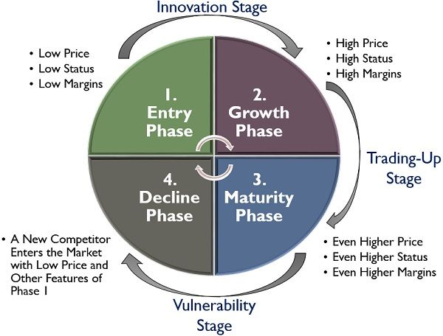

Concept of The Ansoff Matrix: It was invented by Igor Ansoff originally in the year 1957 because it is in a grid; the Ansoff Model is sometimes referred to by its other name, the Ansoff matrix. This model assists marketers in locating chances for their companies to increase their revenue by "tapping into" new markets or producing new products and services. Because of this, the 'Product-Market Matrix' is an alternate name for the 'Ansoff Matrix.'
The Ansoff Matrix is a legendary tool; the Ansoff Matrix is a familiar tool adopted by marketers from books and texts on marketing strategy and planning (Hollensen, 2010; McDonald & Wilson, 2011) and business planning and strategy (such as (Hollensen, 2010; McDonald & Wilson, 2011) have prominently covered it in the past The Matrix is a straightforward instrument for use in the process of strategic planning. It depicts the alternatives for business expansion as a two-by-two matrix, with the axes being existing and new products, as well as existing markets and new markets. Ansoff meant the product's mission when he referred to the market, which he defined as "the job which the product is supposed to do" (Ansoff, 1957, p. 113). By combining the two sets of axes results in four distinct possible tactics. The following summarizes these, with quotations and extra commentary from Ansoff (1957).

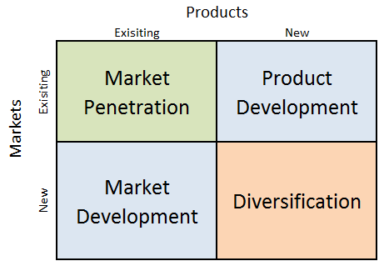
Ansoff theory (1957)

APPLICATION OF ANSOFF THEORY IN WHEEL OF RETAILING

Interpretation: Every cell in the matrix represents a different growth tactic. The researcher has identified, and They are as follows:
At Entry Phase: The process of growing a company's share of a given market through boosting sales of products already offered by that company is referred to as market penetration. Market penetration is done at low margins, growth, and price in retailing. Market Penetration Market penetration is the strategy with the lowest risk compared to the others. When using a market penetration strategy, management aims to increase the sales of existing items.
At Decline stage Market Development is centered on expanding sales of currently available products into untapped markets where retailers can enter an untapped market to regain their brand identity for market Development because it does not need a significant investment in research and development or product development; it is the following least risky method to consider. Instead, it enables a management team to harness existing items and take them to a different market, which can be beneficial. Methods consist of the following:
- Providing services geared for a specific group of customers or demographic target
- Making a foray into a new local market (regional expansion)
- Going into business in a foreign country (international expansion)

At the Maturity level, Product development is concerned with bringing previously unavailable goods to already established markets. In the Development of the Product, a company that has firmly established itself as having the edge over a specific market or target audience may attempt to increase its share of wallets from customers in that demographic. They can think of it as a play on brand loyalty for accomplishment. It includes the following:

- Putting money into research and development in order to create an entirely new product
- Purchasing the rights to manufacture and sell a product that belongs to another company
- It introduces a new product or service to the market by rebranding a white-label item that a different company manufactures.

At the growth stage, the idea of penetrating a new market with a wholly different range of goods is known as Diversification. In Diversification, because both product and market development are required, a diversification strategy is typically considered to be the activity with the highest level of risk relative to other endeavors. It is the approach that carries the most potential for loss. However, it also has tremendous potential for gain through entirely new revenue streams or a reduction in the company's dependence on a single product/market fit. The retailers can adopt the following two primary categories of diversification methods that a management team could take into consideration:
1. Related Diversification: This type of business expansion occurs when synergies between the existing company and the new product or market are possible.
Consider the case of a leather footwear manufacturer intending to manufacture leather vehicle seats. Although the product and the production process will require significant investments in research and development and production, there is an extremely high probability that synergies will gain over time in sourcing raw materials.
2. Diversification in an Unrelated Area occurs when it is doubtful that genuine synergies can be created between the present firm and the new product or market—from industrial goods to consumer goods.
The Ansoff matrix contains two logical inconsistencies that need to be addressed. The blend of new products and markets does not necessarily equalize a risky break from the past, as one must first acknowledge that new products can be introduced in stages rather than all at once. Ansoff (1957), in addition to the opinions of other authors (Gilligan & Wilson, 2009; Westwood, 2005). Suppose we reject the notion that new products can be incrementally new and insist that they must be genuinely new (to the company). In that case, it is highly likely that developing or adding such a new product simultaneously takes the company into a new market. In this scenario, there is no need for a separate strategy referred to as Diversification.

The blend of new products and markets does not necessarily equalize a risky break from the past, as one must first acknowledge that new products can be introduced in stages rather than all at once.
New products should be introduced in stages, and it has been proven that blend of new products and new markets needs to equalize. Ansoff (1957)
Conclusion: The wheel of retailing plays a significant role and has been subject to debate since its inception. Although there is criticism, this theory demonstrates a prominent role in retailing. Marketers can articulate the determining need for customer satisfaction. This theory is pervasive as it encompasses Psychology, Economics, and other related fields in an effective manner. (Sheth et al. 1988). Marketers can apply Ansoff's Theory in the context of the Wheel of Retailing appropriately at the right time so that in each phase, the retailers can overcome the crisis without much difficulty and keep the wheel moving in the right direction.

References
- Forsythe, S. & Kim, J. (1999). Product cue usage among consumers in two Asian Markets, Asian Pacific Journal of Management. Vol 16, Issue 2, 275‐292.
- Caine, C. & Forsythe, S. Consumer (1997). Consumer Choice of U.S. Brands in Foreign Markets: Opportunities for Alabama Textile and Apparel Manufacturers, Highlights of Agricultural Research, 44(3), 3‐4.
- Kim, J., Cavender, D., Forsythe, S., & Jeon, K. (1996). Cross‐Cultural Comparison of Consumer Attitudes of a U.S. Brand Product among Korean and Mexican Consumers, Journal of the Korean Society of Clothing and Textiles, 20(3),493‐501.
- Jeon, K. & Kim, J. (1966). Consumer Attitude Toward Purchasing U.S. Brand Jeans. The Journal of Korean Society of Costume, 28(3), 225‐237.
- Sinha, P.K. and S.K. Car (2007). "An Insight into the Growth of New Retail Formats in India," Indian Institute of Management Ahmedabad
- Pankajakshi, R. and S. Kavita (2014). "An Insight into Indian Retailing Industry- A Holistic Approach," International Journal of Business and Administration Research Review
- Prafulla, S. and B. Sivathanu (2013), “Challenges Affecting the Organized Retail Sector”, Arth Prabhand: A Journal of Economics and Man agement, 2(8): 103-112
- Kawazu, N. (2013). "Consumer Trends and Expansion of Retail Markets in Growing ASEAN Economies," Nomura Research
- https://blogs.siliconindia.com/ganeshantre/Retail-Marketing--its-Emerging-Trends-in--Perspective-of---India-bid-1WVp73wI53581513.html
- https://www.ibef.org/industry/retail-india.aspxhttps://economictimes.indiatimes.com/w/wheel-of-retailing/profileshow/19376988.cms
- What is the Wheel Of Retailing? Definition of Wheel Of Retailing, Wheel Of Retailing Meaning - The Economic Times. https://economictimes.indiatimes.com/definition/wheel-of-retailing

