Phanerogamic Plant Parasites: The deserted parasites
¹Dr. Patil Sneha Rashtrapal¹, Assistant Professor, Plant Pathology. School of Agricultural Sciences, Karunya Institute of Technology and Sciences. Coimbatore – 641114. snhpatil70@gmail.com
²Dr. C. Senthilraja², Postdoctoral Research Associate Texas A&M AgriLife Research6500 W. Amarillo Blvd.Amarillo, TX 79106 csenthilraja1991@gmail.com
³Dr. B. Sangeetha³, Assistant Professor, Plant Pathology. School of Agricultural Sciences, Karunya Institute of Technology and
Sciences. Coimbatore – 641114.sangeethaagri5@gmail.com
Abstract:

Plants are infected by a wide range of biotic and abiotic factors which reduces the yield. In addition to the various pests and pathogens associated with plants, there are certain plants which reduce the yield of plants. Such plants are called as phanerogamic parasites i.e. flowering plants which parasitize the plants. These phanerogamic parasites are the most ignored parameters of plant pathogens. A detailed knowledge of these phanerogamic parasites is essential as it can reduce the yield by 20-80%. Sometimes the phanerogamic parasites can destroy the entire cultivation. Thus it is essential to have detailed knowledge of these phanerogamic parasites.
Keyword: Phanerogamic parasite, total parasite, stem and root parasite.

Introduction:

Plants can be classified into two categories viz., Phanerogams and cryptogams. Phanerogams are flowering plants which produce seeds, while cryptogams are plants which reproduce by spores and do not produce any seed or flower. A phanerogam when parasitises another plant and depends upon the host for food and nutrition, it is called as phanerogamic parasite. Thus, phanerogamic parasite can be defined as a flowering plant which parasitises any healthy plant and derives nutrients and water from the host plant. The identification of plant parasite dates back to 1200 AD, when Alber Magnus identified Misteltoe as the first plant parasite and also recommended cultural management strategy for it. Phanerogamic parasites are spread across a range of families such as Loranthaceae (Loranthus), Convolvulaceae (Cussutta), Scrophulariaceae (Striga), Orobanchaceae (Orobanche), Lauraceae (Cassytha), Santalaceae (Santalum), Balanophoraceae (Thonningia) and Viscaceae (Viscum) [2].

Mechanism of nutrient absorption:

Phanerogams produce a specialized structure called haustoria which aids the phanerogams in absorbing nutrients and water from the host plant. The haustoria is sent deep into the vascular bundle of the host to derive / absorb water and nutrients. The haustoria will release certain enzymes predominantly pectolytic and cellulolytic enzymes which softens the host tissues. This process paves pathway for the haustoria to spread deep into the host tissues. Haustoria have higher osmotic pressure than that of host tissues which facilitates easy absorption of nutrients. This leads to stunted growth, chlorosis and death of the host plant. [1].

Classification of phanerogamic parasites:

Based on habitat and site of attachment of the parasite and host, the phanerogams are categorized into two categories. Based on habitat they are classified as Total parasite and Partial parasite and based on attachment to main host they are classified as Stem parasite and root parasite. Thus, overall the phanerogams can be classified as
- Total stem parasite
- Total root parasite
- Partial stem parasite
- Partial root parasite

Total parasite: These parasites depend completely on the host plant for food and water. These parasites cannot produce their own food and produce haustoria for absorption of food and nutrition from the host plant. These parasites are also called as complete or holo parasite.

Partial parasite: These parasites can synthesise their own food but depend on host plant for basic nutrient elements such as minerals. The host plant will provide the parasite with nutients. Using these nutrients the parasite will synthesize its food. These parasites are also called as hemi parasites.

Stem parasite: the parasite will parasitize the stem portion of host plant. It can be of two types total stem parasite or partial stem parasite.

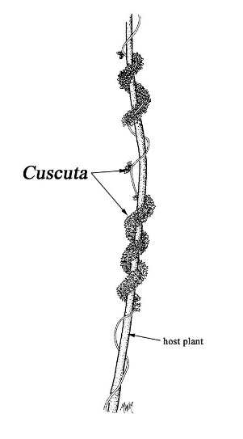
Figure 1. Stem parasite coiling around the host plant

Root parasite: the parasite will parasitize the root portion of the host plant. It can be of two types total root parasite or partial root parasite.

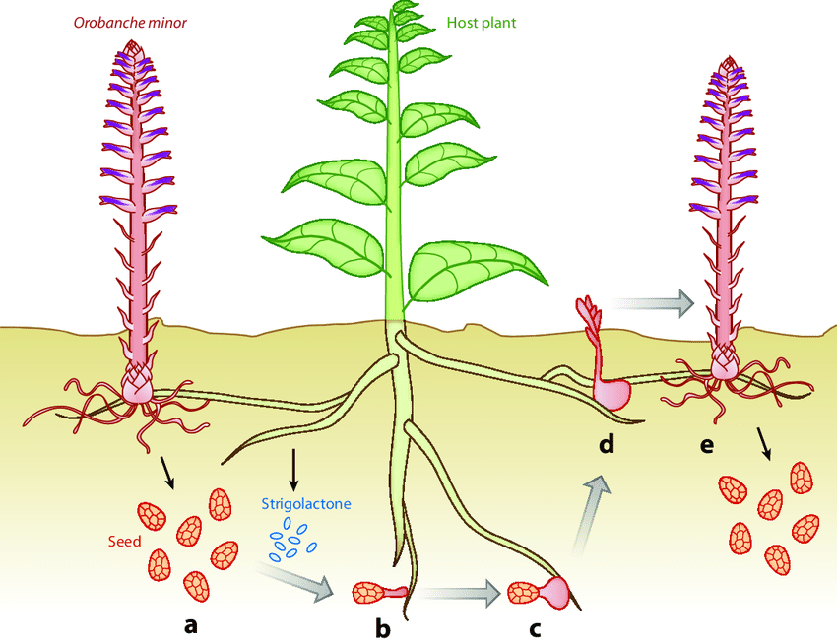
Figure 2. Stem parasite coiling around the host plant

Examples of various parasites:

S. No | Type of phanerogamic parasite | Example
 |  | Common name | Scientific name
1 | Total stem parasite | Dodder | Cuscutta sp
2 | Partial stem parasite | Loranthus / Giant Mistletoe | Dendrophthoe sp
3 | Total root parasite | Broom rape / Tokra | Orobanche sp
4 | Partial root parasite | Witch weed | Striga sp

1.Dodder (Cuscutta sp):
Total Root Parasite
Family: Convolvulaceae
Order: Solanales
Genus: Cuscutta
Species: C. campestris, C.trifoli, C. planiflora and C. indecora
Synonyms: Gold thread, Hell vine, Hair Weed, Devil’s Hair and Love Vine
Target crops: Alfalfa, Clover, Onion, Flax, Sugar beet, Potato, Chillies, Ornamentals, etc.

Morphology:

- It is a dicot plant.
- It is a yellow, sometimes orange vine strands which grow and coil around the plant.
- These phanerogams do not have leaves instead have minute scale leaves.
- It produces white, pink or yellow colour flowers which later produce seeds.
- It does not have roots.

Dissemination:
- Seeds are mainly disseminated by animals, water and implements and sometimes overwinter in infested soil.

Infection and symptom:

- The seeds also overwinter in infested soil and later germinate to produce a slender yellow shoot. This shoot creates contact with the susceptible host encircle or coil around the host and introduce haustoria into the vascular bundle of the host.
- Once the host and parasite connection is established, base of the stem shrivels, dries and cut off from the ground, weakening the host and reducing the yield.

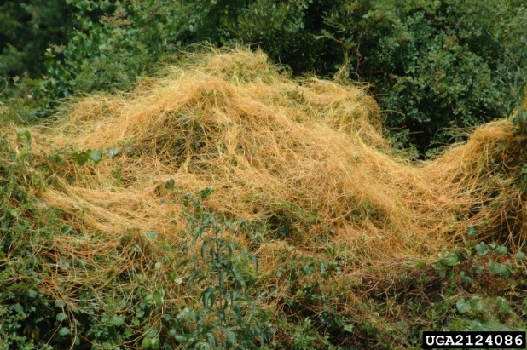
Figure 3. Dodder vine spreading across the plantation

2.Loranthus (Dendrophthoe sp):

Partial Stem Parasite
Family: Loranthaceae
Order: Santalales
Genus: Dendrophthoe
Species: D. falcate, D. longiflorus, D. parasiticus and D. ampullaceus
Synonyms: Giant misteltoe
Target crops: Mango, Citrus, Apple, Guava, Rubber, etc.

Morphology:

- It is a dicot plant.
- It lacks roots.
- The phanerogamic parasite has brown coloured stem, which is generally thick and flattened at the node and it appears in clusters.
- The flowers produced are long, tubular, greenish white or red and borne in clusters.
- Fleshy fruits with single seed are formed.

Dissemination:

- Seeds are mainly disseminated by birds and to some extent by animals.

Infection and symptom:

- The point of attachment of host and parasite, forms a visible swelling or tumorous growth. Inside this swollen structure, haustoria is produced.
- The affected plant becomes stunted and has very few small chlorotic leaves.

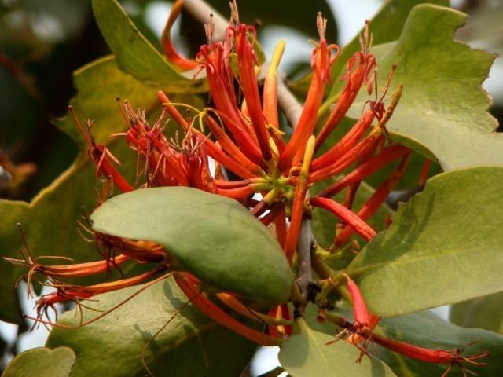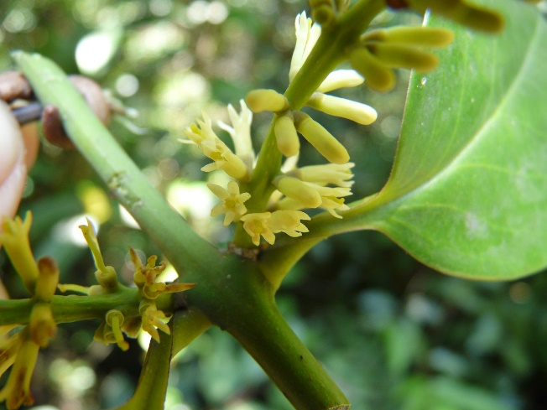
Figure 5. White flower of Loranthus
Figure 4. Red flower of Loranthus

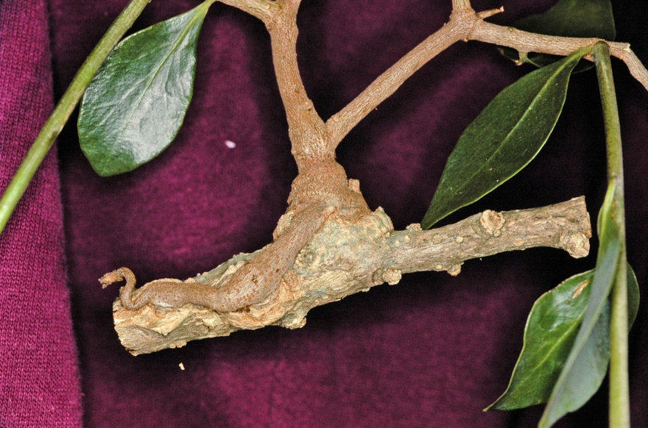
Figure 6. Swollen structure with parasite’s haustoria on citrus tree.

3.Broom Rape / Tokra (Orobanche sp):

Total Root Parasite
Family: Orobanchaceae
Order: Orchidales
Genus: Orobanche
Species: O. ramose, O. minor, O. crenata and O. cernua
Synonyms: Tokra / Broom rape
Target crops: Tobacco, Cabbage, Cauliflower, Tobacco, Tomato, Brinjal, etc

Morphology:

- It is an annual and monocot plant.
- It has a pale cylindrical stem which is thickened at the base and covered with brown scaly leaves that ends in spikes.
- Plants usually lack chlorophyll.
- Flowers arise from axills if the scale leaves, have a well-developed lobed calyx, tubular corolla, superior ovary, numerous ovules and large four lobed stigmas.
- Fruits are capsules containing small black reticulate and ovoid seed.
- Dissemination:
- Seeds survive as dormant structure in soil.
- It requires a chemical stimulant benzopyran released from the roots of the host plant, to germinate.

Infection and symptom:

- Infection occurs in patches.
- Affected plants are stunted, leaves wither off and droop of, leading to wilting.
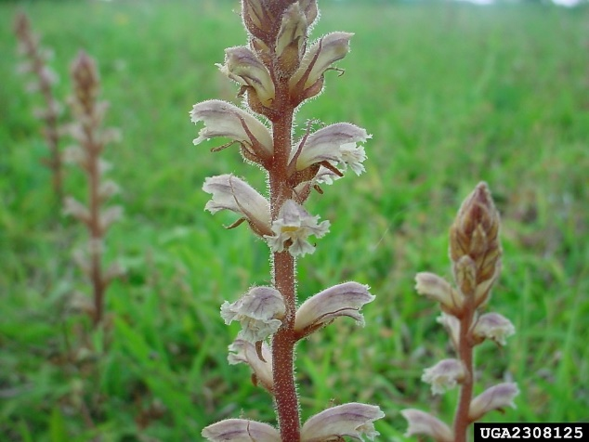
Figure 7. Orobanche sp. in field

4. Witch Weed (Striga sp):

Partial Root Parasite
Family: Scorphulariaceae
Order: Scorpholariales
Genus: Striga
Species: S. asiatica, S. densiflora
Synonyms: Witch weed
Target crops: Sorghum, Maize sugarcane, etc

Morphology:

- It is dicot plant.
- It is a small plant with bright green leaves.
- Height of the plant is around 15-30 cm.
- The plant can be observed in cluster of 10-20 plants / host plant.
- It lacks root hairs and root cap.
- Flowers of white and pink colour are produced based on the species. S. asiatica produces pink flower while S. densiflora produces white flowers.
- Fruit contains minute seeds in abundance
- Dissemination:
- Seeds survive as dormant structure in soil.
- Seeds germinate only in response to chemical stimulant viz., strigol ethylene, cytokinin, gibberellin and coumarin strigol released from host roots.

Infection and symptom:

- Infection appears in round patches.
- Severe infection causes yellowing and wilting of host leaves and sometimes may lead to death of plant.
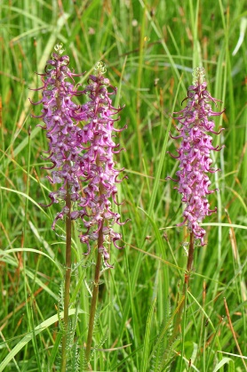
Figure 8. Striga sp. in field

Reference:
[1] Job Kuijt, Haustoria of Phanerogamic Parasites.” Annual Review of Phytopathology. 15(1), pp 91-118
[2] D Alice, C. Jeyalakhmi, A. S. Krishnamoorthy and M. Karthikeyan. “ Fundamentals of Phytopathology”. Shakthi Press. 2017. ISBN 978-93-84909-2-5

