CHAPTER NAME: RECENT TRENDS IN ROOT CANAL IRRIGANT ACTIVATION DEVICES
AUTHOR NAME: DR. K SATHYANARAYANAN, DR. PAVITRA P.S., DR. JAYAKRISHNAN P, DR. SUSHMITA SHIVANNA
ORGANIZATION NAME: SATHYABAMA DENTAL COLLEGE AND HOSPITAL
CONTENTS:
- INTRODUCTION
- CLASSIFICATION OF IRRIGANT ACTIVATION DEVICES
- MANUAL DYNAMIC AGITATION
- PASSIVE ULTRASONIC IRRIGATION
- SONIC DEVICES
- EDDY SYSTEM
- ENDOACTIVATOR
- PRESSURE ALTERATION DEVICES
- ENDOVAC
- LASER ACTIVATED IRRIGATION
- PHOTON-INDUCED PHOTOACOUSTIC STREAMING (PIPS)
- SHOCK WAVE ENHANCED EMISSION PHOTOACOUSTIC STREAMING (SWEEPS)
- CONCLUSION
- REFERENCES

INTRODUCTION
Successful endodontic treatment relies on the thorough removal of both living and decayed pulp tissue, as well as the elimination of microorganisms and their toxins from the intricate root canal system. This process, known as chemo-mechanical debridement, faces challenges due to the complex root canal anatomy, making complete cleaning and shaping difficult. Despite advancements like nickel-titanium instruments and rotary systems, these technologies primarily address the central part of the canal, leaving areas such as fins, isthmi, and cul-de-sacs insufficiently prepared. These untreated areas could potentially retain debris, microbes, and by-products, impeding the proper adaptation of the sealing material and leading to persistent inflammation around the root.
To address these issues, irrigation plays a crucial role in root canal cleaning. While there is no single perfect irrigant, modern root canal therapy typically employs a combination of two irrigants, such as sodium hypochlorite in conjunction with ethylenediaminetetraacetic acid or chlorhexidine, as initial and final rinses. This dual-irrigation approach helps compensate for the limitations of individual irrigants. It is essential that these irrigants come into direct contact with the entire canal wall, particularly the narrow apical segments of small canals, to ensure effective cleansing.
To achieve this comprehensive irrigation, two main categories of methods have been developed: manual techniques and machine-assisted agitation devices.

CLASSIFICATION OF ROOT CANAL IRRIGATION DEVICE
According to Gu, S., et al in 2009, (1)

MANUAL DYNAMIC AGITATION
The Manual Dynamic Activation (MDA) technique is effective for eliminating the smear layer and achieving clean canals in the apical region. This method offers a swift, affordable, secure, and practical approach to conducting irrigant agitation during the final stages of root canal preparation (1). Additionally, it aids in the thorough blending of newly introduced solution with any stagnant solution present in the apical portion of the canal (2).
Procedure
Effective agitation of the master cone plays a pivotal role in distributing and replacing the solution throughout the canal's inner space, thus amplifying the efficacy of antiseptics and solvents (Figure 1). Through the Manual Dynamic Activation (MDA) technique, the irrigant makes direct contact with the canal walls, extending to the canal's apex, thereby dislodging the vapor lock effect (3).
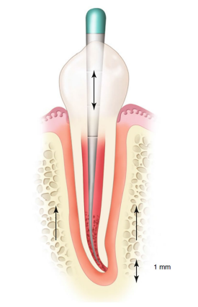
Figure 1. Manual Dynamic Agitation (MDA)
This technique generates increased intracanal pressure fluctuations when the gutta-percha cone is moved in and out, and the frequency of these movements generates disturbances that promote diffusion through shear stresses.
- Begin by preparing the root canal. The Manual Dynamic Activation (MDA) technique commences early, coinciding with the introduction of the initial scouting hand file into the canal. As the instrument advances apically, the irrigant extends beyond the tip. Upon reaching the working length, a vertical reciprocating motion is employed to ensure the comprehensive involvement of the entire canal space.
- Choose a gutta-percha master cone with a slightly smaller taper than that of the canal. The master cone should fit snugly at the working length.
- Grasp the master cone using tweezers, positioning them one millimeter away from the working length.
- After aspirating the primary irrigant, sodium hypochlorite (NaOCl), introduce 1 ml of ethylenediaminetetraacetic acid (EDTA) into the canal using a 30-gauge NiTi needle.
- Commence the manual agitation of the master cone using an upward and downward motion, achieving a 2 mm amplitude, and repeating this motion for approximately 1 minute.
- Deliver another 1 ml of EDTA using the irrigating needle to flush out debris.
- Utilize suction to remove the remaining EDTA solution.
- Thoroughly flush the canal with 1 ml of NaOCl, and repeat the same process, employing 50 in-and-out strokes within a span of 30 seconds. Conclude by performing a final flush with 3 ml of NaOCl.

MACHINE ASSISTED IRRIGANT ACTIVATION
ULTRASONIC AND SONIC DEVICES
Sonic and ultrasonic instrumentation involves the transfer of energy from a vibrating instrument to the fluid used for irrigation within a root canal. This energy transmission occurs through the utilization of either sonic or ultrasonic waves. As a result of this process, the fluid experiences acoustic streaming and cavitation effects (4).
Cavitation refers to the formation, expansion, and forceful implosion of tiny gas bubbles generated due to a decrease in pressure within the fluid (5). It could potentially result in a transient reduction in the strength of the cell membrane, thereby enhancing its permeability to NaOCl (6).
Acoustic streaming (Figure 2) characterizes the collective motion of a fluid in response to the propagation of pressure waves within it. This process results in the creation of a circular or vortex-type movement surrounding a vibrating entity (7). The phenomenon of acoustic streaming has the capability to generate significant shear forces, which are capable of removing debris from instrumented canals. Additionally, it induces the breakdown of bacterial biofilms, leading to the dispersion of bacteria clusters. As a result of this process, the individual planktonic bacteria become more receptive to the effects of NaOCl (8).
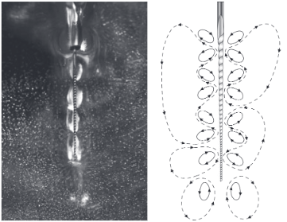
Figure 2. Acoustic streaming around the file in free water and a schematic drawing.
Beyond the influence of acoustic streaming and cavitation, ultrasonic instruments also generate heat, causing a rise in temperature within the irrigant (9). This increase in temperature enhances the efficacy of NaOCl, resulting in improved tissue dissolution capabilities and an augmented antibacterial impact (10).
PASSIVE ULTRASONIC IRRIGATION
Ultrasonic units are categorized into two types: piezoelectric and magnetostrictive systems. The piezoelectric system is known for its efficient energy transmission to the files while producing minimal heat, eliminating the need for handpiece cooling. Specially designed tips are accessible for piezoelectric systems, facilitating the careful elimination of dentine or pulp stones from pulp chambers and canals. These tips offer the benefit of small size, significantly improving visibility compared to conventional bur methods. Moreover, ultrasonic units can be applied for activated irrigation through a range of tools like files, plastic inserts, smooth wires, or irrigation needles (1).
Ultrasonic irrigation is termed "passive" due to the objective of preventing the file from coming into contact with the canal walls, which might result in uncontrolled and uneven dentine removal. Passive ultrasonic irrigation (PUI) has demonstrated its effectiveness in eliminating the smear layer and pulp tissue. This effectiveness is maximized when the file is positioned loosely, enabling unrestricted oscillation within the canal. Therefore, it is advisable to perform PUI subsequent to canal preparation and enlargement, ensuring that the file can move freely (11).
Two irrigation techniques have been explored in conjunction with PUI:
- A constant flow of irrigant from the ultrasonic handpiece.
- A periodic flush using a syringe between activations, resembling the method employed between files during traditional root treatment procedures (4).
Van der Sluis et al. (12) found that both methods were equally effective at removing dentine debris from artificially created grooves in canal walls during laboratory experiments. In the intermittent flush technique, they exposed a 2% NaOCl solution to ultrasonic activation for a period of 3 minutes, delivering 2 mL of the solution using a syringe every 30 seconds.
Carver et al. (13) developed a continuous flush system, which essentially consists of an irrigation needle connected to an ultrasonic tip using a clamp. This setup allows for the transmission of ultrasonic vibrations to the irrigation needle. Their device exhibited significant ultrasonic power, resulting in the formation of cavitation within the treated root canals.
Observations have indicated that this method yielded notably cleaner canals, marked by significant decrease in colony-forming units and positive cultures. A contributing factor to this success could be the ongoing supply of fresh and active irrigating solution into the canals. Since the tissue dissolution capabilities of NaOCl diminish swiftly, maintaining a constant supply is crucial for optimal outcomes. However, a notable concern associated with this technique is the potential for irrigant extrusion beyond the apex of the tooth.
An important aspect to consider regarding ultrasonic activation is that the phenomena of cavitation and acoustic streaming exclusively manifest in liquids. Therefore, if a gas bubble is present in the apical region and the ultrasonic tip enters it, no observable effects will take place within this particular area (4).
To address this air bubble concern, it is advisable to eliminate the bubble by employing a properly fitting master GP point, as previously detailed (14). There are specialized non-cutting nickel-titanium inserts available that can be affixed to conventional ultrasonic devices, such as the ESI ENDO SOFT or Irrisafe Tips (Figure 3), as well as the Saltelec piezoelectric scaling unit.
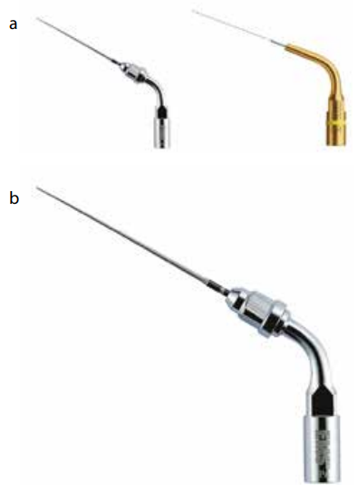
Figure 3. Endodontic irrigation ultrasonic inserts:
(a) ESI ENDO SOFT ultrasonic insert; (b) Irrisafe Tips ultrasonic insert.
Alternatively, standard endodontic instruments like irrigation needles and files can be "engaged" and indirectly set into motion through an ultrasonic scaler tip, thereby transmitting the ultrasonic effects to the instrument.
There are also specifically produced devices, such as the EndoActivator and the ProUltra® PiezoFlow™. Additionally, the MiniEndo II is a purpose-built ultrasonic unit tailored for endodontic procedures (4).
SONIC DEVICES
EDDY SYSTEM
EDDY (VDW in Munich, Germany) is an innovative sonic irrigation activation system crafted from flexible polyamide (Figure 4). This device boasts a size of 25.04 and offers a promising solution for efficiently cleaning complex root canal systems, all while avoiding the limitations associated with ultrasound-activated tools (15).
EDDY operates through activation at a frequency range of 5000 to 6000 Hz, driven by an air-driven handpiece known as the Air Scaler. The manufacturer claims that this instrument generates a unique three-dimensional movement that triggers two physical effects called "cavitation" and "acoustic streaming." These effects were previously only achieved by passive ultrasonic irrigation (PUI), which is recognized for its enhanced cleaning efficiency in dental procedures (16).
It's important to note that EDDY is a non-cutting, sterile, and single-use instrument, emphasizing its commitment to maintaining a high level of hygiene and safety in dental practices (15).

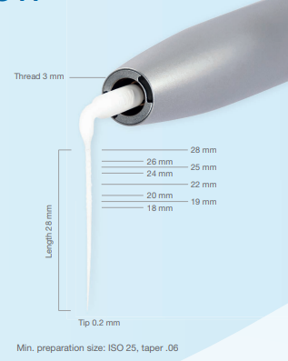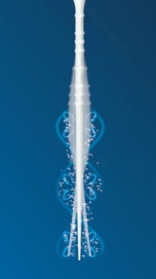
Figure 4. EDDY system (VWD, Germany)

ENDOACTIVATOR
The EndoActivator (Figure 5) constitutes a canal irrigation system driven by sonic technology. This system is composed of a portable handpiece and disposable 22 mm polymer tips that are designed not to cut. Specialized features include: Practical snap-on/snap-off design, color-coded by size for easy identification and convenient depth gauge marks at 18, 19 and 20mm. The tips are available in three sizes: Yellow (#15/.02), Red (#25/.04) and Blue (#30/.04). This activation occurs within a frequency range of 2000 to 10,000 cycles per minute (cpm), equivalent to 33 to 167 Hertz (Hz) (17).
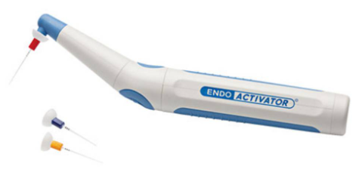
Figure 5. Endoactivator (Dentsply Sirona)
In terms of frequency, it's important to note that there is a substantial difference of at least a factor of 36 between the two sonic devices, EDDY and EA. This significant contrast in frequency range suggests that it is reasonable to expect that this difference could potentially impact the clinical performance of these two sonic instruments (15).
Comparative studies have demonstrated sonic irrigation’s efficacy in removing debris and accessing lateral canals, surpassing the performance of conventional syringe irrigation and passive ultrasonic irrigation (18).
An advantage of the smooth polymer tips is their non-cutting nature, minimizing the risk of inadvertent damage. The knowledge that these tips are non-cutting allows operators to incorporate additional vertical strokes in combination with the sonic motion. This aspect could elucidate why certain studies have indicated that this sonic technique, despite being less powerful than ultrasonic alternatives, delivers superior outcomes. However, it's worth noting that the tips have faced criticism for being radiolucent, which could pose a concern in cases of potential fracture (1).
PRESSURE ALTRATION DEVICES
Positive and negative pressure irrigation systems strive to address the delicate equilibrium between ensuring the comprehensive immersion of the canal in irrigant, thus eliminating any trapped air, while simultaneously preventing excessive irrigation that could lead to irrigant extrusion beyond the apex (4).
Lussi et al. (19) were pioneers in this field, conducting initial experiments and creating an 'alternate pressure' device that didn't involve instrumentation. This device demonstrated the capability to achieve cleaner root canals when compared to the traditional step-back preparation method coupled with static irrigation. Regrettably, this promising approach was deemed unsafe for in vivo animal studies and consequently wasn't pursued further.
The key challenge associated with positive pressure (PP) irrigation and incidents involving NaOCl lies in its unpredictable nature. This lack of predictability appears to be linked to the condition of the apical region and various anatomical factors (20). In clinical practice, promptly diagnosing the occurrence of significant irrigant extrusion into apical tissues is challenging, and foreseeing these undesirable NaOCl accidents is virtually impossible (21). An additional disadvantage of positive pressure irrigation is the establishment of an apical stagnation plane (22). This specific configuration facilitates the entrapment of gas, resulting from the breakdown of organic tissue. This, referred to as vapor lock, hinders effective debridement of the canal's apical termination (23). To address these limitations comprehensively, the Apical Negative Pressure (ANP) technique for irrigation was introduced (24).
ENDOVAC SYSTEM
The development of the EndoVac system aimed to provide a secure and consistent method of conveying irrigants to the apical endpoint (25). The irrigant’s effectiveness primarily relies on its volume and successful diffusion into the root canal system. The depth at which the needle is placed, along with irrigant penetration and the delivery of substantial irrigant quantities, have been linked to elevated pressures (26). This is a fundamental reason why conventional irrigation systems often fall short of achieving comprehensive root canal debridement. This deficiency is particularly notable because these systems are typically positioned safely at a depth of 2-3 mm from the working length to mitigate the risk of hypochlorite accidents (27). However, this constraint doesn't apply to Apical Negative Pressure (ANP) systems. Due to their underlying philosophy, ANP systems possess the capability to administer irrigants specifically up to the working length while eliminating any risk of apical extrusion (28). Moreover, research have evidenced the efficacy of apical negative pressure systems in delivering irrigants to the WL, offering a contrast to traditional irrigation methods. This efficacy also ties in with the phenomenon of apical vapor lock (23,29).
First commercial ANP system, the EndoVac system (SybronEndo, Orange, CA), was introduced in 2007. Subsequently, another ANP system known as INP (ASI Medical, Englewood, CO) was also introduced. Notably, the INP system employs distinct materials and methods in comparison to the EndoVac system. However, there is a dearth of research validating its effectiveness, thus precluding the provision of evidence-based insights into its efficacy (24).
The Device
EndoVac (SybronEndo, Orange, CA) system comprises four key components: hand and finger pieces, macro- and microcannula, multiport adapter, and master delivery tip.
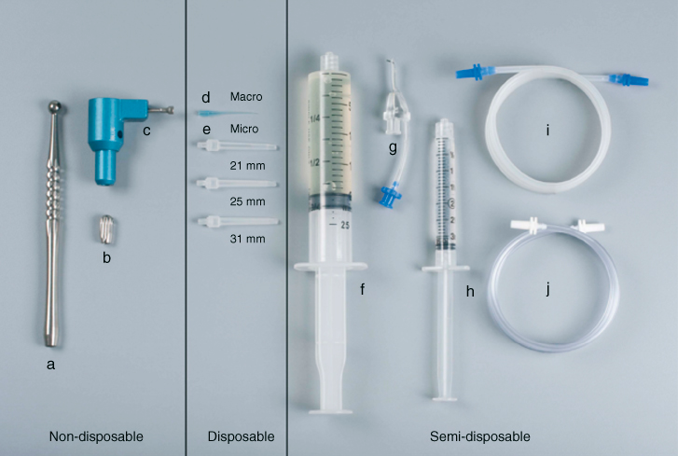
Figure 6.1 EndoVac (SybronEndo, Orange, CA) (a) Handpiece (b) fingerpiece (c) multiport adapter (d) macrocannula (e) microcannula (21, 25, 31 mm) (f) syringe 2cc (for NaOCl); (g) master delivery tip (MDT) (h) syringe 3cc (for EDTA) (i) MDT evacuation tube (blue) (j) handpiece/fingerpiece evacuation tube (white).
Multiport Adapter (MPA): is directly connected to the Hi-Vac system and functions as a holder for the EndoVac tubing. This design allows for effortless detachment and reattachment of other components, facilitating optimal portability between different operatories (24).
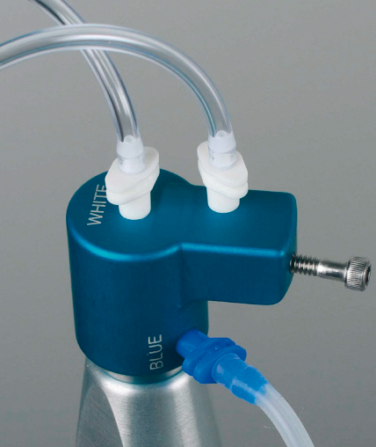
Figure 6.2 Multiport Adapter (MPA)
Master Delivery Tip (MDT): provides space for an irrigant-filled syringe, which dispenses the irrigant via a 20-gauge needle. Surrounding this needle, a plastic suction hood is affixed, linked to clear plastic tubing. This tubing is connected to a multiport adaptor and subsequently connected to a high-volume suction. This configuration enables the MDT to effectively administer the irrigant while also evacuating any surplus irrigant that might spill over from the pulp chamber (25).
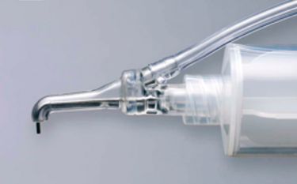
Figure 6.3 Master Delivery Tip (MDT)
The macro cannula serves a dual purpose: it employs suction to remove irrigant from the pulp chamber, directing it towards the upper and middle regions of the root canal. At the same time, it delivers irrigant into the pulp chamber, guiding the flow toward one of the canal walls while intentionally avoiding direct flow into the canal orifice.
Either the macro cannula or micro cannula can be connected to the high-speed suction of the dental unit through clear plastic tubing, facilitated by the multiport adaptor. The plastic macro cannula, characterized by an external diameter equivalent to ISO size 0.55 mm and an internal diameter of ISO size 0.35 mm, is constructed from blue translucent plastic material. This cannula features a 0.02 taper and is designed for single-patient use only. It securely attaches to an autoclavable aluminum handpiece and is utilized in an up-and-down pecking motion. Simultaneously, irrigant is passively directed into the pulp chamber following the previously mentioned method. The primary role of the macro cannula is to effectively remove significant debris and residual tissue that may remain after the instrumentation process (25).
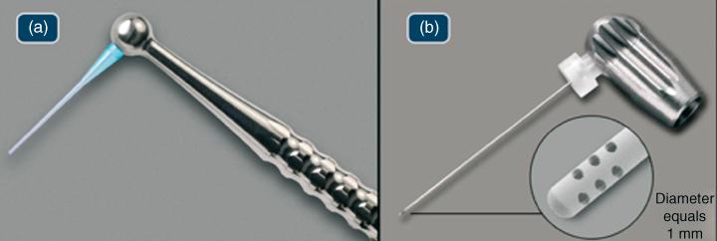
Figure 6.4 (a) Macrocannula; (b) Microcannula
The micro cannula features 12 microscopic holes that enable the effective evacuation of debris to the complete working length. Constructed with an external diameter of 0.32 mm, this stainless-steel micro cannula lacks taper and incorporates four clusters of three laterally positioned holes that are laser-cut. These holes, situated adjacent to the closed end, each measure 100 µ in diameter and are spaced at intervals of 100 µ. This configuration serves as a filtering mechanism, preventing blockages within the micro cannula's internal lumen, which possesses an ISO size internal diameter of 0.20 mm.
The micro cannula connects to an autoclavable aluminum finger piece and is utilized for irrigating the apical segment of the canal while positioned at the working length. Notably, the micro cannula terminates in a closed end, necessitating insertion to the full working length to aspirate irrigants and debris effectively. This tool is suitable for use in canals that have been expanded with endodontic files to ISO size 0.35 mm with a taper of 0.04 or larger. Alternatively, a non-tapered preparation can be considered, wherein the manufacturer recommends enlarging the root canal to 40/0.02.
During irrigation, the MDT channels irrigant towards the pulp chamber wall to prevent overflow. Meanwhile, macro and micro cannulas use negative pressure to draw in fresh irrigant. This new irrigant flows through the cannula, exits via clear tubing, and maintains a steady flow through suction (25).
Clinical Technique
Instrumentation of the canal:
During the whole instrumenting process, the Mater Delivery tip method involves using a Microcannula to deliver 1 ml of 5-6% NaOCl before and after changing instruments. This helps clear debris from the pulp chamber and introduces fresh irrigant for the next instrument to use in the canal (25). Research by Cohenca et al. (30) found that different instrument types didn't affect the effectiveness of the EndoVac irrigation technique. However, a apical preparation size of atleast 0.32 mm is needed to accommodate the microcannula, requiring a minimum #35/0.02 hand instrument to reach working length after using smaller NiTi instruments.
Macroevacuation is used to remove large debris from the canal space. It's done for 30 seconds in each canal with rapid movement while delivering 5-6% NaOCl. After this, the canal is "charged" with NaOCl for 60 seconds (24).
Microevacuation starts after the macro procedure. Positioning the microcannula correctly is crucial to avoid clogging. The MDT maintains a continuous irrigant flow, and the exhaust tube is monitored for consistency (24).
Microevacuation consists of three "microcycles" using NaOCl, EDTA, and NaOCl again. Each cycle has specific times and purposes, including clearing debris, smear layer removal, and treating irregularities. The canals are then purged, dried, and prepared for further steps (24).
Efficacy
The effectiveness of the EndoVac system lies in its ability to create approximately -30 to -260 mm Hg negative pressure throughout the entire root canal system. This negative pressure begins at the access opening and extends to the major diameter's apical limit (31). This unique feature enables the efficient removal of irrigants in sufficient quantities, which flow downward and across the canal walls, even through complex canal structures like fins and isthumus. Simultaneously, as irrigants are introduced at the top, they are continuously pulled down to the root apex.
Depending on the type of irrigant used, this process involves actions such as hydrolysis, chelation, or removal of both organic and inorganic debris from the root canal system mechanically, followed by their evacuation. Furthermore, this consistent irrigation process goes beyond simple fluid dynamics of delivery and removal. It helps create a diffusion gradient, allowing highly concentrated solutions like 5% sodium hypochlorite to penetrate into confined spaces effectively (32).
Penetration
In 2010, de Gregorio and colleagues (33) conducted an initial investigation into the EndoVac system's ability to deliver irrigant into the main canal and canal irregularities. They compared it with positive pressure irrigation, passive ultrasonic irrigation or sonic, and EndoVac. This study simultaneously measured the irrigant depth into the main canal and its penetration into simulated non-instrumented lateral canals positioned at different distances from the apex.
For ISO #40 instrumented root canals, EndoVac achieved complete penetration to the apex, surpassing other methods significantly. This demonstrated the microcannula's effectiveness in overcoming challenges like the "stagnation zone" (22) or "vapor lock" (34). However, when it came to filling artificial lateral canals, EndoVac wasn't as effective as PUI, which is designed specifically for lateral canal activation.
Goode and his colleagues (31) showed that EndoVac outperformed manual dynamic, positive pressure, ultrasonic and sonic activation in debris removal. However, ultrasonic activation struggled to clean multiplanar canals. Cohenca's research on oval canals also confirmed EndoVac's advantages over self-adjusting file system and positive pressure irrigation (35). Spoorthy et al. (36) introduced a new experimental group combining apical negative pressure and passive ultrasonic irrigation, which demonstrated superior results at the apex, highlighting the synergistic effect of both techniques, regardless of root canal curvature.
In a clinical evaluation by Munoz and Camacho-Cuadra (29), EndoVac's flexibility proved its effectiveness in mesial curved canals of mandibular molars. It showed a significant difference in irrigant penetration along the entire canal length compared to positive pressure irrigation and similar outcomes to passive ultrasonic irrigation.
Debridement
Conventionally, to improve the process of debridement, it has been suggested to enlarge the diameter and taper of the apical preparation (37). Nevertheless, the effective design of EndoVac allows for ample and secure delivery of irrigants even when the apical preparation is as narrow as a ISO size #35 (28). Hockett and his colleagues (38) emphasized that the action of ANP plays a more vital role in thoroughly cleansing and disinfecting the canals compared to relying on larger tapers.
Susin et al. investigated the effectiveness of two irrigant agitation methods (MDA and ANP) in a closed system for canal and isthmus debridement. While there wasn't a notable difference between the groups in the main canal, ANP proved more efficient at removing organic debris in isthmus areas (Figure 5.6). These findings align with Siu and Baumgartner's research (39), which demonstrated superior debridement with ANP compared to the PP group, particularly in the final millimeters.
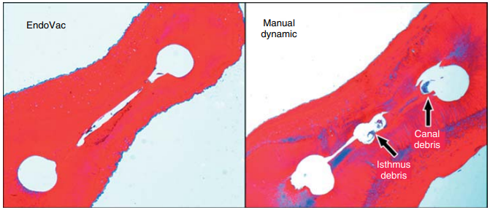
Figure 6.5 Images were taken at working length—1 mm. Greater isthmus debris was apparent in MDA group.
Notably, Howard et al. (40) yielded contrasting outcomes compared to earlier mentioned research. Their study, focused on mesial roots of mandibular molars, revealed no significant distinctions among Apical Negative Pressure (ANP), Positive Pressure (PP), and Continuous Ultrasonic Irrigation (CUI) using the PiezoFlow device.
Smear Layer removal
Saber Sel and Hashem (41) suggested that using 17% EDTA with Manual dynamic agitation or Apical negative pressure resulted in much better smear layer removal compared to Positive pressure or Passive ultrasonic irrigation. Fukumoto (42) and Gómez-Pérez also confirmed that ANP, especially when used with the EndoVac system, effectively eliminated the smear layer.
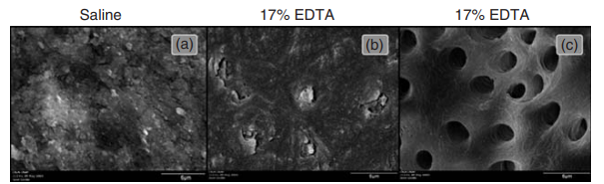
Figure 6.6 Scanning Electron Microscopic examination at WL—1 mm (a) Saline (b) conventional irrigation and (c) EndoVac

Antimicrobial activity
Hockett et al. (38) evaluated the effectiveness of Apical Negative Pressure and Positive Pressure irrigation in Enterococcus faecalis biofilms elimination in already prepared canals, including mature 30-day biofilms. They found that ANP worked well in both groups, with and without taper. A clinical trial by Cohenca et al. (30) on mandibular molars supported these findings, with the EndoVac group having no positive cultures after final irrigation, while the Positive pressure group had 33% positive cultures. Pawar et al. (43) also conducted clinical tests on the EndoVac and found similar outcomes between ANP and traditional irrigation.
Safety
The primary advantage of the ANP technique is its focus on safety. Comparative studies, including one by Desai and Himel (28), demonstrated that ANP does not lead to irrigant extrusion, which can cause irritation and toxicity to the apical tissues. In contrast, other systems like Max-i-Probe, Rinsendo, and CUI needles were found to exhibit significant irrigant extrusion, potentially leading to considerable postoperative pain. Gondim et al. (44) also reported reduced postoperative pain levels among patients treated with Apical negative pressure compared to conventional needle irrigation.
THE SELF-ADJUSTING FILE (SAF) SYSTEM
The SAF System is a minimally invasive endodontic treatment tool, including a self-adjusting file operated with an RDT handpiece-head and an irrigation pump (VATEA or EndoStation). It maintains a continuous irrigant flow without generating pressure in the file due to its lattice-walled design (45).
The Self-Adjusting File (SAF)
The SAF file is unique because it doesn't have a solid metal shaft (46); instead, it's a flexible, compressible hollow tube made of nickel titanium lattice.
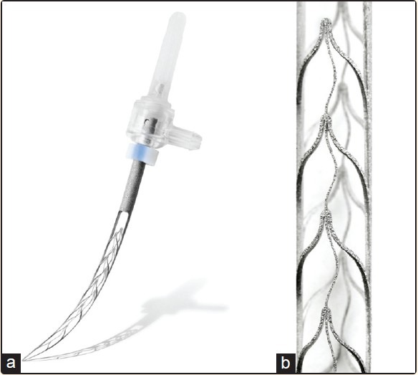
Figure 7.1 (a) Self-adjusting File (b) Lattice structure
Unlike traditional files, it has an off-center tip and can adapt to different canal shapes. The SAF adapts to oval-shaped canals by becoming narrower in the buccolingual projection and wider in the mesiodistal projection when inserted. For instance, when a 1.5 mm diameter SAF is placed into a canal with a 0.2 mm mesiodistal dimension, it will naturally spread out buccally and lingually, reaching a buccolingual dimension of 2.4 mm (Figure 7.2). This happens automatically, even if the operator is unaware of the canal's oval shape, which is why it's called the "Self-adjusting File (269). Naturally, such a flattened file cannot rotate within the canal. Instead, it is maneuvered using in-and-out vibrations generated by the RDT handpiece-head (45).
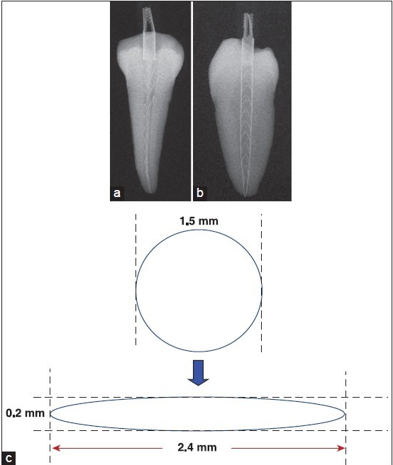
Figure7.2 Adaptation of the SAF
RDT handpiece-head
The RDT handpiece-head (Figure 7.3) serves two functions: converting micro-motor rotation into 0.4 mm linear vibration and featuring a clutch to stop file rotation upon canal engagement. The micro-motor runs at 5000 rpm, creating 5000 vibrations/min. Operators use pecking motions with free file rotation during outward strokes to ensure random entry positions for uniform canal treatment and navigation of curvatures. RDT heads are adaptable to various endodontic motors/handpieces in multiple configurations (46).
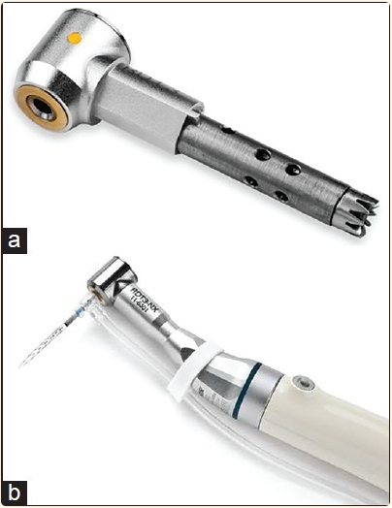
Figure 7.3 Head of RDT handpiece (a) RDT3 head. (b) RDT3-NX head with an NSK adaptor, attached to an X-Smart endomotor
VATEA irrigation pump
The VATEA (ReDent), is a self-contained peristaltic pump that includes a 500 mL irrigant reservoir. It's operated using a foot switch and powered by a rechargeable battery (46). The SAF file has a hub that can freely rotate and connects to a polyethylene tube (Figure b), allowing irrigant to flow through the hollow file and into the root canal. This pump can deliver irrigant at a rate between 1-10 mL per minute, with the recommended setting being 4 mL per minute.
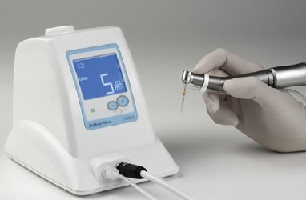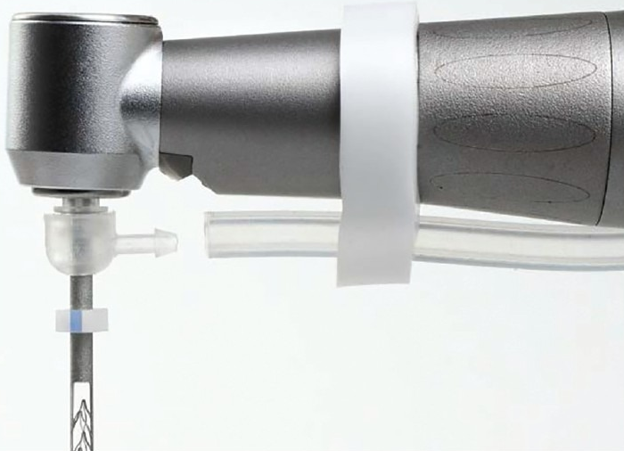
Figure 7.4 (a) VATEA Irrigation Pump (b) SAF features freely rotating hub with a connector for the irrigation tube
The all-in-one Endostation machine
The EndoStation (ReDent and Acteon), is a versatile machine tailored for SAF usage with a specialized RDT handpiece. It can also work with standard handpieces for rotary or reciprocating files. In "SAF mode," it uses a peristaltic pump to ensure continuous irrigation by drawing irrigant from an external bottle into the tube and through the attached file. A single foot pedal operation simultaneously activates both the micromotor and the irrigation pump (45).
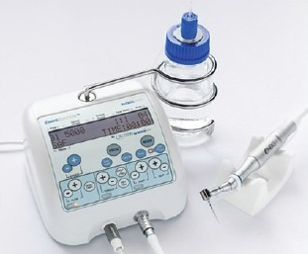
Figure 7.5 EndoStation: An all-in-one endodontic unit
THE SAF SYSTEM
No-pressure irrigation system: The SAF System is characterized as a no-pressure irrigation system. This means that it does not rely on high-pressure delivery of irrigating solutions into the root canal.
Applied throughout the instrumentation process: The SAF System is used in conjunction with root canal instrumentation, which involves cleaning and shaping the root canal to remove infection or debris.
Elimination of pressure: Once the irrigant (a fluid used to clean and disinfect the root canal) is introduced into the SAF System, any pressure that might have existed in the delivery tube is eliminated. This could be due to the structure of the file used in the system.
Continuous delivery of irrigant: The SAF System ensures a continuous and consistent delivery of the irrigant into the root canal. This is important for effective cleaning and disinfection.
Mixing of irrigant: The vibrations of the file and the pecking motion applied by the operator result in the continuous mixing of the irrigant already present in the root canal with fresh, fully active irrigant. This mixing action helps ensure that the irrigant is evenly distributed throughout the root canal space, improving its efficacy in disinfection (45).
Smear Layer and Debris removal
In the study conducted by Metzger and colleagues (47), it was demonstrated that the self-adjusting file (SAF) operation effectively cleared debris from the root canal walls, achieving debris-free conditions in every third of the canal for all samples, totaling 100% success. Moreover, in the coronal third, all samples (100%) exhibited smear layer-free surfaces, while in the middle third, this condition was observed in 80% of the canals. In the apical third, smear layer-free surfaces were identified in 65% of the examined root canals (48).
Limitation
One limitation to consider is the necessity to create a glide path equivalent to a size 20 K-file before utilizing the self-adjusting file (SAF). Despite this limitation, the SAF appears to offer advantages when it comes to effectively cleaning and shaping oval-shaped canals. It also holds the potential to complement and enhance the capabilities of existing Nickel Titanium (NiTi) rotary instrumentation technologies (49).
In summary, the SAF System is a specialized irrigation system used in endodontics that focuses on delivering irrigant without pressure, continuously, and with efficient mixing to aid in the cleaning and disinfection of the root canal during the instrumentation process. This system aims to improve the overall quality of root canal treatment (45).
LASER-ACTIVATED IRRIGATION
Laser-activated irrigation (LAI) involves using lasers to irradiate common irrigant solutions within the root canal.
Considerations for LAI
- The key feature of LAI is the use of specific wavelengths, primarily Erbium lasers (Er, Cr:YSGG [2,780nm] and Er:YAG [2,940nm]), which are absorbed by water, a primary component of these irrigants. Higher absorption coefficients for a wavelength mean less energy is needed for effective absorption. The Er:YAG laser, in particular, has three times the water absorption compared to Er:Cr:YSGG, requiring less power to achieve the same results (50).
- Laser settings like energy, fluency, pulse duration, pulse repetition rate and peak power.
- Proper selection of the laser fiber or tip, including design and diameter, and its positioning within the tooth (51).
Laser setting
Laser-assisted irrigation involves the absorption of laser energy by the water in the solution. This absorption results in a swift elevation of the water's temperature to the boiling point, which is 100°C. This phenomenon creates distinct explosive bubbles, which represent the primary photothermal and photoacoustic effects. Moreover, it triggers rapid cavitation within the canal, constituting a secondary phenomenon (Figure 8.1a-e) (52).
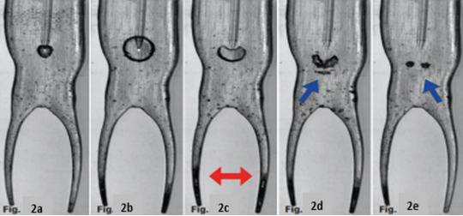
Figure 8.1 (a & b): Depict the explosion of bubbles, (c–e): Illustrate the implosion of bubbles and the occurrence of primary cavitation (indicated by blue arrows), (c): Indicates secondary cavitation in the apical third, highlighted by red arrows.
The bubbles size and the efficiency of generating cavitation depend on the amount of energy applied. When using high energy setting with the laser tip positioned inside the canal, there can be drawbacks due to rapid vaporization of the liquid, resulting in dry irradiation and potentially harmful thermal effects on the dentinal walls.
Peak power, which is calculated as energy divided by pulse length, is a crucial factor in explaining the effectiveness of a laser system. To avoid ablative or thermal damage, the goal is to achieve high peak power (e.g., 400W) while delivering very low energy (e.g., 20mJ) at subablative levels. Effective photoacoustic effects are achievable with extremely brief pulses (e.g., 50µs). The greater the maximum strength of each pulse, the more significant the pressure wave generated by the initial bubble burst (Figure 8.2a & b).
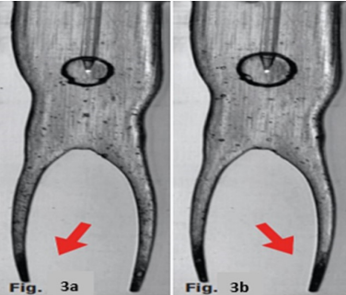
Figure 8.2 (a): single pulse of 50µs, at 20mJ in water: bubble bursts
at extremity, (b): single pulse in water for 25µs pulse at 20mJ: larger
bubble bursts at the tip extremity.
The duration of laser pulses and their maximum power vary depending on the technology employed in different laser devices. Furthermore, the efficiency of streaming irrigation hinges on the selection of the tip and how it is positioned within the endodontic space (51).
Laser tip
During laser-activated irrigation, the laser tip can be maneuvered in several ways within the canal. It can be advanced inward, moved upward, directed downward, gently retracted towards the pulp chamber, or maintained in a stationary position, typically in the apical third or mid-third of the canal with minimal movement. These varying positions of the laser fiber-tip directly influence the peak power generated.
For example, in the case of PIPS using the Er:YAG laser LightWalker by Fotona, which emits a 20mJ pulse lasting just 50µs (super-short pulse), it produces a high peak power of 400W. This leads to both primary explosion and secondary cavitation phenomena, even at a considerable distance from the activation area (the access cavity). This process occurs approximately ten times faster than passive ultrasonic irrigation.
Consequently, the PIPS procedure demands precise and straightforward placement of the laser tip in the pulp chamber. In this approach, the irrigant solution is administered through a syringe rather than being directly inserted into the canal. This technology has been further enhanced and refined, now referred to as Shock wave-enhanced emission photoacoustic streaming technology (51).
Available currently as two variants
- LightWalker®: Renowned for its outstanding performance, the LightWalker system offers both Er:YAG and Nd:YAG dental lasers. It provides a broad range of dual-wavelength treatment possibilities, including exclusive treatments like TwinLight® Endodontic and Periodontal Treatments. The LightWalker AT model is remarkably convenient and ergonomic, and it stands as the sole dental laser system equipped with built-in scanner-ready technology.
- SkyPulse®: Representing the latest generation of compact and portable Fotona dental lasers tailored for use in individual dental practices, SkyPulse boasts a user-friendly interface that is highly customizable and intuitive. It permits the use of pre-set treatment options with a simple touch or the fine-tuning of treatment parameters with a single swipe, thus ensuring that advanced technology is both accessible and uncomplicated (51).
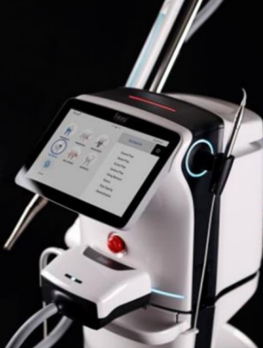
Figure 8.3 Er:YAG laser system of SkyPulse

PHOTON-INDUCED PHOTOACOUSTIC STREAMING (PIPS)
Photon-induced photoacoustic streaming utilizes laser impulses of subablative energy (20 mJ at 15 Hz) to interact with water molecules in a radial firing stripped tip. This interaction, with peak powers reaching 400 W, generates expansion, shock waves, and powerful fluid streaming within the root canal, all without raising the temperature (53).
Mechanism of Action
PIPS, a laser-activated irrigation method, indirectly stimulates irrigants without heat. It generates a potent photoacoustic shockwave, spreading irrigants within the root canal system three-dimensionally. Unlike conventional laser methods, PIPS employs a distinctive tapered tip, placed only in the chamber, avoiding the need for bigger instruments and files. This enables efficient delivery of irrigants to delicate areas like the fins, apical one-third, isthmuses, and lateral canals. The nonthermal pressure wave effectively eliminates living and dead tissues, eradicates bacteria, removes biofilm, and disinfects dentin tubules (53).
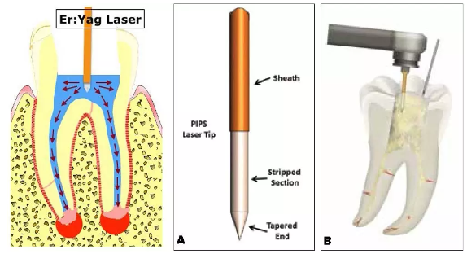
Figure 8.4 Photon-Induced Photoacoustic Streaming
Protocol
- The PIPS tip stays within the pulp chamber, rather than entering the root canal, and remains immobile during the activation process.
- A consistent flow of solution from an irrigating syringe is administered throughout laser activation.
- Maintaining an adequate supply of irrigating solution to immerse the PIPS tip within the pulp chamber is essential.
- PIPS activation takes place in 30-second cycles..
- The current protocol involves six cycles of laser activation, with three 30-second rest phases in between, using NaOCl.
- Following 3 cycles of LAI with NaOCl, an additional 30-second irrigation with water using PIPS takes place.
- The chamber is emptied, and 17% EDTA used with PIPS and consistent flow for 30 seconds.
- The final step is another 30 seconds of laser activation with water alone.
- After these steps, the canal system is prepared for obturation (53).
In a study by Peters (54), the effectiveness of disinfection and biofilm disruption in the canal's apical third was evaluated. PIPS didn't eliminate bacteria from infected dentinal tubules entirely; however, it exhibited superior performance in reducing infection and removing biofilm compared to the passive ultrasonic irrigation technique group.
In a study by Ordinola and his team (55), the impact of PIPS was explored using a 6% NaOCl solution to eliminate ex vivo biofilm in a unique dentin bovine model. The researchers observed better cleansing of infected dentin in the PIPS groups compared to the Passive ultrasonic irrigation group. Notably, the remarkable outcome of this experiment was that the PIPS tip was positioned 22 mm from the target area, while ultrasonic, sonic, and passive irrigation methods were applied directly to the target area.
In an in-vitro study by Jaramillo et al. (53), infected single-rooted teeth with E. faecalis were subjected to PIPS and compared to traditional needle irrigation. The results demonstrated 100% disinfection in the PIPS group after just 1 minute of irrigation, compared to 83% disinfection in the traditional group after 20 minutes of continuous irrigation with a buffred 0.5% NaOCl solution.
In their study, Alshahrani and colleagues (56) discovered that the effectiveness of PIPS was significantly enhanced when combined with 6% NaOCl compared to using PIPS with water or irrigating exclusively with 6% NaOCl. According to Ordinola and Alshahrani, the most favorable disinfection outcomes are attained by using a combination of PIPS and 6% NaOCl.
In a study conducted by Lloyd et al. (57), they utilized high-resolution micro CT to assess the impact of PIPS on the removal of debris from mesial canals in lower molars, including isthmuses, fins, and lateral canals. Their findings demonstrated that PIPS outperformed standard needle irrigation (SNI), achieving approximately 2.6 times greater debris removal compared to the SNI group.
In a separate investigation by Jaramillo et al. (58), they evaluated the efficacy of the photoacoustic delivery system PIPS, combined with 20 seconds of Er:YAG laser irradiation and 6% sodium hypochlorite, in inhibiting the growth of Enterococcus faecalis. The results showed that this combination was highly effective in suppressing bacterial growth.
The management of heat generation is a critical consideration in dental laser applications. CO2 and Nd:YAG lasers are commonly used for photothermal effects, where laser energy is absorbed by the surrounding hard tissues and converted into heat. As noted by Saunders (59), maintaining a temperature increase of over 10°C for more than 1 minute could potentially result in damage to bone tissue.
Er:YAG lasers are known for their high absorption by water, leading to minimal penetration into enamel and dentin. The process of mechanical ablation involves micro-explosions without a notable increase in temperature. Sonntag (53) observed that the histological response of the pulp to Er:YAG laser treatment resembled that of a high-speed handpiece.
In a comparison conducted by Armengol (60), different tools including a high-speed carbide bur, Er:YAG laser (140 mJ, 4 Hz), and Nd:YAP laser (240 mJ, 10 Hz) were assessed both with and without a water spray. As expected, the Nd:YAP laser generated higher temperature increases than the Er:YAG laser and high-speed handpiece. However, both approaches exhibited similar temperature rise patterns when a water spray was used.
SHOCK WAVE ENHANCED EMISSION PHOTO ACOUSTIC STREAMING (SWEEPS)
SWEEPS laser-assisted irrigation employs an Er:YAG laser with short pulses to enhance root canal cleaning. It generates photon-induced photoacoustic streaming of irrigants throughout the intricate three-dimensional root canal system (51).
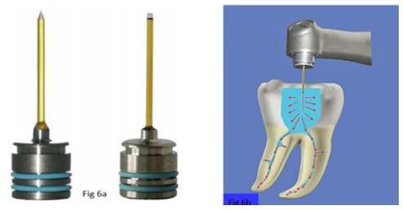
Figure 8.5 (a) Tips for SWEEPS: conical & flat end (b) In the Er:YAG LAI technique, the laser fiber tip is positioned in the coronal area of the pulpal chamber and held still. This allows photoacoustic waves to radiate into each canal opening. Mainly, the tip is only inserted into the coronal area of the tooth being treated. This method reduces the need for over canal preparation and minimises the risk of thermal damage compared to procedures that involve placing the laser tip inside the canal system.
Mechanism of action
Bubble Formation: The laser pulses create cavitation bubbles in confined root canal spaces.
Shock Wave Generation: The collapse of these bubbles, triggered by a second laser pulse, emits shock waves.
Secondary Cavitation Bubbles: Secondary cavitation bubbles form naturally along the canal's length during laser-induced irrigation.
Debris Removal: These secondary bubbles, situated close to canal walls, create shear flows that help remove debris from the canal's surface.
Enhanced Cleaning: The shock waves, still moving at high speeds when they encounter the smear layer, may further enhance the cleaning process.
In short, SWEEPS laser-assisted irrigation uses short-pulse Er:YAG laser technology to generate cavitation bubbles and shock waves, facilitating the effective removal of debris from root canals, especially in complex three-dimensional systems (61).
Benefits of SWEEPS
- SWEEPS laser-assisted irrigation has demonstrated superior effectiveness in comparison to conventional irrigation methods. It shows promise in significantly improving the removal of smear layer, debris, pulp tissues, and bacteria within the root canal. Studies by Bago et al. (62) and Widbiller et al. (63) found that SWEEPS achieved complete removal of pulp tissues and was particularly successful in clearing hard tissue debris in the apical third of the canal.
- SWEEPS is highly effective even when dealing with fractured files, enhancing cleaning in the apical area despite their presence. This is achieved through the generation of high shear stress on root canal walls via collapsing bubbles in the irrigants. SWEEPS can extend 2-3 mm beyond the ultrasonic tip, ensuring cleanliness beyond the fractured files. Root canal curvature has minimal impact on its performance, and there's no need to place the laser tip in the apical area; positioning it in the pulp chamber is sufficient for its function (64).
- SWEEPS offers the benefit of reducing the concentration of sodium hypochlorite (NaOCl) to a safer level. This minimizes the potential risk of tissue damage associated with high NaOCl concentrations. The study mentioned in Lei et al. (65) found that SWEEPS, when used with lower concentrations of NaOCl, effectively increased chlorine content in irrigants, ensuring satisfactory root canal decontamination.
- Moreover, SWEEPS amplifies the interaction between bacteria and chlorine by means of photomechanical, photoacoustic, and activation effects. This, in turn, facilitates the mechanical cleansing of the root canal walls and enhances the penetration of irrigants into dentin tubules (66).
In conclusion, SWEEPS provides numerous advantages over conventional irrigation by enhancing the elimination of the smear layer, debris, pulp tissues, and bacteria within the root canal. It achieves this through potent photodynamic streaming and improved penetration of irrigants into the primary and lateral canals, particularly in the apical region.
For future research, it is advisable to explore the benefits of SWEEPS over conventional irrigation through in vivo experimental designs. This approach will offer a more dependable assessment of SWEEPS' efficacy in clinical root canal irrigation scenarios (66).

CONCLUSION
Effective irrigation plays a pivotal role in successful endodontic treatment. Despite sodium hypochlorite (NaOCl) being a crucial irrigant, no single solution can fulfill all irrigation requirements. Advancements like positive and negative irrigation have introduced novel devices that employ diverse methods for delivering irrigants, debriding soft tissues, and, depending on the treatment approach, eliminating smear layers. Negative irrigation stands out due to its superiority over positive pressure methods. It prevents the extrusion of irrigants into periapical areas, enhances cleansing, eliminates vapor lock concerns, and ensures sufficient irrigant volume. Nevertheless, more research is needed to fully explore its potential benefits.

REFERENCES
- Gu L sha, Kim JR, Ling J, Choi KK, Pashley DH, Tay FR. Review of contemporary irrigant agitation techniques and devices. J Endod. 2009 Jun;35(6):791–804.
- Machtou PP. Manual dynamic activation technique. Clin Dent Rev. 2018 Sep 20;2(1):21.
- Basrani B, Malkhassian G. Update of Endodontic Irrigating Solutions. In: Basrani B, editor. Endodontic Irrigation [Internet]. Cham: Springer International Publishing; 2015 [cited 2023 Jun 16]. p. 99–115. Available from: https://link.springer.com/10.1007/978-3-319-16456-4_5.
- Holliday R, Alani A. Traditional and contemporary techniques for optimizing root canal irrigation. Dent Update. 2014;41(1):51–2, 54, 56-58 passim.
- Ahmad M, Pitt Ford TR, Crum LA, Walton AJ. Ultrasonic debridement of root canals: acoustic cavitation and its relevance. J Endod. 1988 Oct;14(10):486–93.
- Huang TY, Gulabivala K, Ng YL. A bio-molecular film ex-vivo model to evaluate the influence of canal dimensions and irrigation variables on the efficacy of irrigation. Int Endod J. 2008 Jan;41(1):60–71.
- Walmsley AD. Ultrasound and root canal treatment: the need for scientific evaluation. Int Endod J. 1987 May;20(3):105–11.
- Joyce E, Phull SS, Lorimer JP, Mason TJ. The development and evaluation of ultrasound for the treatment of bacterial suspensions. A study of frequency, power and sonication time on cultured Bacillus species. Ultrason Sonochem. 2003 Oct;10(6):315–8.
- Zeltner M, Peters OA, Paqué F. Temperature changes during ultrasonic irrigation with different inserts and modes of activation. J Endod. 2009 Apr;35(4):573–7.
- Pashley DH, Tao L, Boyd L, King GE, Horner JA. Scanning electron microscopy of the substructure of smear layers in human dentine. Arch Oral Biol. 1988;33(4):265–70.
- Ahmad M, Pitt Ford TR, Crum LA. Ultrasonic debridement of root canals: an insight into the mechanisms involved. J Endod. 1987 Mar;13(3):93–101.
- Van der Sluis LWM, Gambarini G, Wu MK, Wesselink PR. The influence of volume, type of irrigant and flushing method on removing artificially placed dentine debris from the apical root canal during passive ultrasonic irrigation. Int Endod J. 2006 Jun;39(6):472–6.
- Carver K, Nusstein J, Reader A, Beck M. In vivo antibacterial efficacy of ultrasound after hand and rotary instrumentation in human mandibular molars. J Endod. 2007 Sep;33(9):1038–43.
- Boutsioukis C, Lambrianidis T, Verhaagen B, Versluis M, Kastrinakis E, Wesselink PR, et al. The effect of needle-insertion depth on the irrigant flow in the root canal: evaluation using an unsteady computational fluid dynamics model. J Endod. 2010 Oct;36(10):1664–8.
- Urban K, Donnermeyer D, Schäfer E, Bürklein S. Canal cleanliness using different irrigation activation systems: a SEM evaluation. Clin Oral Investig. 2017 Dec;21(9):2681–7.
- Van der Sluis LWM, Versluis M, Wu MK, Wesselink PR. Passive ultrasonic irrigation of the root canal: a review of the literature. Int Endod J. 2007 Jun;40(6):415–26.
- Jensen SA, Walker TL, Hutter JW, Nicoll BK. Comparison of the cleaning efficacy of passive sonic activation and passive ultrasonic activation after hand instrumentation in molar root canals. J Endod. 1999 Nov;25(11):735–8.
- Kanter V, Weldon E, Nair U, Varella C, Kanter K, Anusavice K, et al. A quantitative and qualitative analysis of ultrasonic versus sonic endodontic systems on canal cleanliness and obturation. Oral Surg Oral Med Oral Pathol Oral Radiol Endod. 2011 Dec;112(6):809–13.
- Lussi A, Nussbächer U, Grosrey J. A novel noninstrumented technique for cleansing the root canal system. J Endod. 1993 Nov;19(11):549–53.
- Behrents KT, Speer ML, Noujeim M. Sodium hypochlorite accident with evaluation by cone beam computed tomography. Int Endod J. 2012 May;45(5):492–8.
- Papageorge MB, Oreadi D. A clinico-pathologic correlation. J Mass Dent Soc. 2005;54(2):38–40, 42–3.
- Boutsioukis C, Lambrianidis T, Kastrinakis E. Irrigant flow within a prepared root canal using various flow rates: a Computational Fluid Dynamics study. Int Endod J. 2009 Feb;42(2):144–55.
- Schoeffel GJ. The EndoVac method of endodontic irrigation, part 2--efficacy. Dent Today. 2008 Jan;27(1):82, 84, 86–7.
- Cohenca N. Disinfection of Root Canal Systems: The Treatment of Apical Periodontitis. John Wiley & Sons; 2014. 899 p.
- EndoVac Apical Negative Pressure: Safe and Effective Endodontic Irrigation from Beginning to END [Internet]. Oral Health Group. 2015 [cited 2023 Aug 27]. Available from: https://www.oralhealthgroup.com/features/endovact-apical-negative-pressure-safe-and-effective-endodontic-irrigation-from-beginning-to-end/
- Abou-Rass M, Piccinino MV. The effectiveness of four clinical irrigation methods on the removal of root canal debris. Oral Surg Oral Med Oral Pathol. 1982 Sep;54(3):323–8.
- Chow TW. Mechanical effectiveness of root canal irrigation. J Endod. 1983 Nov;9(11):475–9.
- Desai P, Himel V. Comparative safety of various intracanal irrigation systems. J Endod. 2009 Apr;35(4):545–9.
- Munoz HR, Camacho-Cuadra K. In vivo efficacy of three different endodontic irrigation systems for irrigant delivery to working length of mesial canals of mandibular molars. J Endod. 2012 Apr;38(4):445–8.
- Cohenca N, Paranjpe A, Heilborn C, Johnson JD. Antimicrobial efficacy of two irrigation techniques in tapered and non-tapered canal preparations. A randomized controlled clinical trial. Quintessence Int Berl Ger 1985. 2013 Mar;44(3):217–28.
- Goode N, Khan S, Eid AA, Niu L na, Gosier J, Susin LF, et al. Wall shear stress effects of different endodontic irrigation techniques and systems. J Dent. 2013 Jul;41(7):636–41.
- Malentacca A, Uccioli U, Zangari D, Lajolo C, Fabiani C. Efficacy and safety of various active irrigation devices when used with either positive or negative pressure: an in vitro study. J Endod. 2012 Dec;38(12):1622–6.
- de Gregorio C, Estevez R, Cisneros R, Paranjpe A, Cohenca N. Efficacy of different irrigation and activation systems on the penetration of sodium hypochlorite into simulated lateral canals and up to working length: an in vitro study. J Endod. 2010 Jul;36(7):1216–21.
- Tay FR, Gu LS, Schoeffel GJ, Wimmer C, Susin L, Zhang K, et al. Effect of vapor lock on root canal debridement by using a side-vented needle for positive-pressure irrigant delivery. J Endod. 2010 Apr;36(4):745–50.
- Paranjpe A, de Gregorio C, Gonzalez AM, Gomez A, Silva Herzog D, Piña AA, et al. Efficacy of the self-adjusting file system on cleaning and shaping oval canals: a microbiological and microscopic evaluation. J Endod. 2012 Feb;38(2):226–31.
- 259. Spoorthy E, Velmurugan N, Ballal S, Nandini S. Comparison of irrigant penetration up to working length and into simulated lateral canals using various irrigating techniques. Int Endod J. 2013 Sep;46(9):815–22.
- 260. Usman N, Baumgartner JC, Marshall JG. Influence of instrument size on root canal debridement. J Endod. 2004 Feb;30(2):110–2.
- 261. Hockett JL, Dommisch JK, Johnson JD, Cohenca N. Antimicrobial efficacy of two irrigation techniques in tapered and nontapered canal preparations: an in vitro study. J Endod. 2008 Nov;34(11):1374–7.
- 262. Siu C, Baumgartner JC. Comparison of the debridement efficacy of the EndoVac irrigation system and conventional needle root canal irrigation in vivo. J Endod. 2010 Nov;36(11):1782–5.
- 263. Howard RK, Kirkpatrick TC, Rutledge RE, Yaccino JM. Comparison of debris removal with three different irrigation techniques. J Endod. 2011 Sep;37(9):1301–5.
- 264. Saber SED, Hashem AAR. Efficacy of different final irrigation activation techniques on smear layer removal. J Endod. 2011 Sep;37(9):1272–5.
- 265. Fukumoto Y, Kikuchi I, Yoshioka T, Kobayashi C, Suda H. An ex vivo evaluation of a new root canal irrigation technique with intracanal aspiration. Int Endod J. 2006 Feb;39(2):93–9.
- 266. Pawar R, Alqaied A, Safavi K, Boyko J, Kaufman B. Influence of an apical negative pressure irrigation system on bacterial elimination during endodontic therapy: a prospective randomized clinical study. J Endod. 2012 Sep;38(9):1177–81.
- 267. Gondim E, Setzer FC, Dos Carmo CB, Kim S. Postoperative pain after the application of two different irrigation devices in a prospective randomized clinical trial. J Endod. 2010 Aug;36(8):1295–301.
- 268. Metzger Z. The self-adjusting file (SAF) system: An evidence-based update. J Conserv Dent JCD. 2014 Sep;17(5):401–19.
- 269. Metzger Z, Teperovich E, Zary R, Cohen R, Hof R. The Self-adjusting File (SAF). Part 1: Respecting the Root Canal Anatomy—A New Concept of Endodontic Files and Its Implementation. J Endod. 2010 Apr 1;36(4):679–90.
- 270. R H, V P, M E, R Z, Z M. The self-adjusting file (SAF). Part 2: mechanical analysis. J Endod [Internet]. 2010 Apr [cited 2023 Sep 27];36(4). Available from: https://pubmed.ncbi.nlm.nih.gov/20307745/
- 271. Z M, E T, R C, R Z, F P, M H. The self-adjusting file (SAF). Part 3: removal of debris and smear layer-A scanning electron microscope study. J Endod [Internet]. 2010 Apr [cited 2023 Sep 27];36(4). Available from: https://pubmed.ncbi.nlm.nih.gov/20307746/
- 272. Mortman RE. Technologic advances in endodontics. Dent Clin North Am. 2011 Jul;55(3):461–80, vii–viii.
- 273. Scribd [Internet]. [cited 2023 Sep 27]. Lasers in Endodontics 2016 | PDF | Mouth | Animal Anatomy. Available from: https://www.scribd.com/document/430302208/Lasers-in-Endodontics-2016
- 274. Panthangi S, Vishwaja U, Reddy CLC, Babu MB, Podili S. Novel sweeps technology in endodontics — A review. IP Indian J Conserv Endod. 2021 Sep 15;6(3):134–42.
- 275. Matsumoto H, Yoshimine Y, Akamine A. Visualization of irrigant flow and cavitation induced by Er:YAG laser within a root canal model. J Endod. 2011 Jun;37(6):839–43.
- 276. Irrigation of the Root Canal System by Laser Activation (LAI): PIPS Photon-Induced Photoacoustic Streaming | SpringerLink [Internet]. [cited 2023 Aug 28]. Available from: https://link.springer.com/chapter/10.1007/978-3-319-16456-4_13
- 277. Peters OA, Bardsley S, Fong J, Pandher G, Divito E. Disinfection of root canals with photon-initiated photoacoustic streaming. J Endod. 2011 Jul;37(7):1008–12.
- 278. Ordinola-Zapata R, Bramante CM, Aprecio RM, Handysides R, Jaramillo DE. Biofilm removal by 6% sodium hypochlorite activated by different irrigation techniques. Int Endod J. 2014 Jul;47(7):659–66.
- 279. Al Shahrani M, DiVito E, Hughes CV, Nathanson D, Huang GTJ. Enhanced Removal of Enterococcus faecalis Biofilms in the Root Canal Using Sodium Hypochlorite Plus Photon-Induced Photoacoustic Streaming: An In Vitro Study. Photomed Laser Surg. 2014 May 1;32(5):260–6.
- 280. Lloyd A, Uhles JP, Clement DJ, Garcia-Godoy F. Elimination of intracanal tissue and debris through a novel laser-activated system assessed using high-resolution micro-computed tomography: a pilot study. J Endod. 2014 Apr;40(4):584–7.
- 281. Jaramillo DE, Aprecio R, Angelov N, Divito E, McClammy TV. Efficacy of photon induced photoacoustic streaming (PIPS) on root canals infected with Enterococcus faecalis: A pilot study. Endod Pr. 2012 Jan 1;5:28–32.
- 282. Saunders EM. In vivo findings associated with heat generation during thermomechanical compaction of gutta-percha. 1. Temperature levels at the external surface of the root. Int Endod J. 1990 Sep;23(5):263–7.
- 283. Armengol V, Jean A, Marion D. Temperature rise during Er:YAG and Nd:YAP laser ablation of dentin. J Endod. 2000 Mar;26(3):138–41.
- 284. Lukač N, Jezeršek M. Amplification of pressure waves in laser-assisted endodontics with synchronized delivery of Er:YAG laser pulses. Lasers Med Sci. 2018 May;33(4):823–33.
- 285. Bago I, Batelja-Vuletić L, Tarle A, Sesar A, Anić I. Novel laser activated photoacoustic streaming for removing pulp remnants from round root canals after single file reciprocating instrumentation. Photodiagnosis Photodyn Ther. 2022 Mar;37:102631.
- 286. Widbiller M, Keim L, Schlichting R, Striegl B, Hiller KA, Jungbauer R, et al. Debris Removal by Activation of Endodontic Irrigants in Complex Root Canal Systems: A Standardized In-Vitro-Study. Appl Sci. 2021 Jan;11(16):7331.
- 287. Vatanpour M, Toursavadkouhi S, Sajjad S. Comparison of three irrigation methods: SWEEPS, ultrasonic, and traditional irrigation, in smear layer and debris removal abilities in the root canal, beyond the fractured instrument. Photodiagnosis Photodyn Ther. 2022 Mar;37:102707.
- 288. Lei L, Wang F, Wang Y, Li Y, Huang X. Laser activated irrigation with SWEEPS modality reduces concentration of sodium hypochlorite in root canal irrigation. Photodiagnosis Photodyn Ther. 2022 Sep;39:102873.
- 289. Jordana J, Tandean J, Salim J, Cahyani F, Sampoerno G. Shock wave enhanced emission photoacoustic streaming (SWEEPS): An alternative to conventional irrigation in endodontic treatment. Conserv Dent J. 2022 Dec 2;12:68–72.

