Title- ECG signals and their implications in significant heart pathologies.

Sheeba Kalam¹ , Mohd Faiz Saifi² and #Neha Gupta³

¹Dr. B.R. Ambedkar Centre for Biomedical Research (ACBR), University of Delhi

(North Campus), India.
² Department of Gastroenterology and Human Nutrition Unit, All India Institute of Medical Sciences, New Delhi, India.
³Department of Biosciences, Faculty of Natural Sciences, Jamia Millia Islamia, New Delhi,

India.

- E-mail: nehaguptalifesciences@gmail.com

Abstract

Electrocardiography- the process of producing an electrogram (ECG) involving the non-invasive transthoracic interpretation for bio-potential variation of the heart over a period of time, is used to provide insight into the structure of the diseased population by giving useful data about functional morphology of heart in the waveform PQRSTU. ECG plays a foremost role in diagnosing cardiovascular disorders, distinguishing normal sinus rhythm from the arrhythmia (abnormal) class. ECG framework includes parameters such as heart rate, duration, amplitude, and morphology of wave comprising QRS complex, PR interval, ST segment, and ST interval, which are used to analyze different disorders like atrial flutter, fibrillation, sinus bradycardia, tachycardia, myocardial ischemia, infarction, WPW syndrome, torsades de pointes, and premature ventricular contraction. Research advances show the importance of ECG in identifying massive acute PE (pulmonary embolism) and serving as a prognostic indicator for pulmonary thromboembolism. ECG analysis coupled with coronary angiography helps to diagnose coronary thrombo-embolism due to chronic atrial fibrillation without any underlying disease. The current chapter provides an introduction to ECG and its clinical implications in identifying patients with significant heart pathologies.

1. Introduction
Cardiovascular diseases remain a major cause of mortality worldwide and are often associated with arrhythmias arising as a result of irregularities in the cardiac conduction system. Pathologies involving dysfunction of the cardiac conduction system are an added source of morbidity and mortality worldwide [1,2]. The cardiac cells comprising the cardiovascular system can generate an electrical impulse without any external stimulus. Electrical impulses are originated in the sinoatrial (SA) node known as the pacemaker of the heart and travel down the internodal pathways, propagating through the right and left atria to the atrioventricular (AV) node[3]. This electrical activity of the heart is measured by electrocardiography – the process of producing an electrocardiogram (ECG), a non-invasive transthoracic interpretation for bio-potential variation of the heart over a period of time, is used to provide insight into the structure of diseased population by giving useful data (about morphological and functional details) of heart in the waveform PQRSTU. Fluctuations seen in the cardiac conduction system caused by various factors may lead to cardiac arrhythmias and an abnormal ECG [3]. These alterations in the frequency or morphology of the electrical signals can be analyzed and used to identify the underlying cardiac abnormalities and related pathologies. For instance, various types of arrhythmias can be evaluated and correlated to the underlying conditions [4]. The current chapter thus provides the fundamentals of ECG and its clinical implications in identifying patients with significant heart pathologies.

2. Conduction system of the heart
The first functional organ system to develop during the embryonic stage is the cardiovascular system, which evolves into a four-chambered muscular organ - the heart with a synchronized contraction that maintains double circulation during embryogenesis. The specialized cells of the cardiac conduction system (CCS) allow the initiation and conduction of impulses responsible for myocardium-synchronized contraction and heart rate maintenance [2]. The coordinated excitatory and conductive component of the cardiovascular system includes the SA node, internodal pathways, AV node, a bundle of His, bundle branches (right and left), and the Purkinje fibers.[2]

2.1 Components of the cardiac conduction system.
Each of the components is described below with its location and function. Figure 1 represents the cardiac conduction system of humans.
- The sinoatrial node (SAN or natural pacemaker)
Location: At the junction of the superior vena cava and the myocardium wall of the right atrium within the terminalis groove [2,3]
Function: To generate an action potential, SAN produces changes in membrane potential leading to spontaneous depolarization of the cell membrane accountable for atrial contraction via internodal pathways [3].
- Internodal pathways
Location: Among the four main internodal pathways three pathways (anterior, middle, and posterior) operate in the right atrium and one which is actually a branch of the anterior pathway known as Bachmann’s bundle is found in the left atrium[3].
Function: It carries away the cardiac impulses from the sinoatrial node to the atrioventricular node due to the presence of specialized myocytes cells present in this pathway system [3].
- The atrioventricular node
Location: At the lower section of the inter-atrial septum or the apex of Koch’s triangle
Function: Delays cardiac impulse(approximately 0.09s) from atrial to ventricular myocardium. The slow conduction velocity is due to poor electrical coupling between the myocytes of the AV node. The delay is important for ensuring ventricular filling before ventricular contraction [2,3].

- Ventricular conduction pathway (VCP) [3]

Location: Based on location VCP is divided into the following sections:
- Bundle of his: emerges from AV node near the atrial septum above the atrioventricular groove, which proceeds up to the ventricular septum upper margin.
- Bundle branches: a bundle of his bifurcate and becomes bundle branches which on the basis of descending side of the ventricular septum particularly classified as left and right bundle branches.
- Purkinje fibers: left and right bundle branches end by terminating into small network-like fibers, which particularly lie just beneath the cardiac endothelial surface.
Function: Cause activation (depolarization) of the ventricles from apex to base by enabling quick impulse conduction from the atrioventricular bundle into the contractile ventricular myocardium [3] to impact the output of the cardiac conduction system.

3. ECG and cardiac conduction system

ECG is used to record the functioning of the cardiac conduction system, thereby helping in the monitoring and interpretation/detection of any disease interfering with normal sinus generation or conduction. ECG records from the body surface and deduces the electrical activity of the heart in the form of a graphical representation (as shown in the diagram in Figure 3). These electrical activities produced are due to variations in transmembrane potentials of the muscle fibers during each cardiac cycle [3]. Hence, ECG is very sensitive and can amplify even tiny electrical changes on the skin [3,5]. The key principle for processing and analysis of ECG signals involves the generation and amplification of signals, acquisition of real-time data, and signal filtering with a role of effective denoising and feature extraction, followed by wave classification, thereby, signal analysis helps to detect various cardiovascular disorders [6-8].
A 12-lead electrocardiogram is commonly the most used method to record an electrocardiograph of the heart (Figure 2). [5] Through this method, we can obtain and analyze various views of the heart. The 12 lead-based ECG uses electrodes to look at the heart from two different planes as described below [5].

- Frontal or coronal plane: The heart is divided into anterior and posterior halves The electrical activity of the heart is recorded across a 360-degree span in the frontal plane, by affixing six lead electrodes on the supine resting patient[9]. The 6 leads are comprised of -

3 Bipolar limb leads are described below:

  - Bipolar lead I: It records the potential difference between the left and right arm, where the left arm carries out the function of the standard positive pole. It shows positive upward deflection when the electric current moves away from the right and toward the left arm[9].

  - Bipolar Lead II: It records the potential difference between the right arm and left leg, where the left leg carries out the function of the standard positive pole [9].

  - Bipolar Lead III: It records the potential difference between the left arm and left leg, where the left leg again carries out the function of the standard positive pole [9].
(note: According to Einthoven's law: Lead I + lead III = lead II) [5].

3 Goldberger augmented unipolar limb leads (aVF, aVR, aVL) which record the potential difference between the right arm/left arm,/leg and a ground lead set up by summing the two other unused limb leads. The positive pole is the designated limb in each case.[9].

- Transversal or horizontal plane: Divide the heart into superior and inferior ends. In contrast to the frontal plane, here vectors move in the horizontal plane and are contemplated/reflected in the precordial leads[9]. The six precordial/chest leads consist of positive electrodes only, from V1 – V₆ as described below:
      - V₁- 1st chest lead positioned on the fourth intercostal space on the parasternal side.
      - V₂- 2nd chest lead positioned symmetrically to V₁ but on the opposite side i.e. left intercostal space adjacent to the sternum.
      - V₃- 3rd chest lead positioned at the midpoint between V₂ and V₄.

- V₄- 4th chest lead positioned on the left fifth intercostal space at the midclavicular line.
- V₅- 5th chest lead positioned at left fifth intercostal space nearly about the anterior axillary line.
- V₆- 6th chest lead positioned at the same level as V₄ and V₅ i.e. at the fifth left intercostal space nearly about the midaxillary line.
Figure 2 represents the 12 lead-based electrode placement system for ECG.

4. Measurement of a waveform

The measurement of waveform depends upon the direction in which electrical activity (wave of depolarization) travels with respect to leads. The following deflections can be interpreted depending on the same [5,9]:

- Positive deflection- when the electrical activity (depolarization wave ) of cardiac tissue moves toward a recording lead(positive electrode) results in a positive or upward deflection.

- Negative deflection- when the electrical activity (depolarization wave)of cardiac tissue moves away from a recording lead(positive electrode) results in a negative deflection.

- No deflection/biphasic deflection- when the electrical activity (depolarization waveform) of cardiac tissue moves very slowly or in the perpendicular direction to the axis of the two electrodes.
4.1 Vector and mean electrical axis

A vector is represented by an arrow and tells about both magnitudes as well as the direction of the quantity. By convention length of the arrow is proportional to the magnitude and the head of the arrow shows the direction. Hence in the case of the heart, the electrical activity voltage of the potential is shown by arrow length whereas the arrowhead points toward the electro-potential direction or mean/resultant direction of two vectors also known as the mean vector/electrical axis. [5,9] Based on vector length and direction concerning the electrode we deduce the magnitude of signals and deflections within the cardiac tissue[9].

4.2 Electrical activity of the normal heart and ECG

The normal ECG records the rhythmic pulses/electrical activity of the heart generated by several currents: the pacemaker current If, the calcium current I CaL and I CaT, the background current I Ca/Na, the current I Kr that leads to depolarization and repolarization of atriums/ventricles [10-14].

- Current If: It’s a mixed current carried by sodium and potassium ions, however, the mainstream is due to Na+ due to its greater permeability. It initiates diastolic depolarization by bringing resting membrane potential to threshold potential and stimulating voltage-gated Na+ channel and calcium channels (type T and L). It is also activated by membrane hyperpolarization at the end of the repolarization phase
- Calcium currents (I CaL, I CaT): L-type calcium channels contribute to the phase final diastolic depolarization and potential action by a powerful inflow of Ca²⁺ ion inside the cell whereas T-type calcium channels’ role is less known and limited to diastolic depolarization with no effect on the action potential.
- Delayed potassium current (IKr): Though its deactivation is necessary for the depolarization of spontaneous diastole its activation is way more important for repolarization, hence delayed activation of potassium current.
- Other currents: They participate in the modulation of diastolic potential i.e. the background current incoming sodium, from the incoming Na⁺/Ca²⁺ exchange stream.

5 Normal ECG waves, intervals, and segments

To recognize normal ECG or to analyze different heart abnormalities, first, the range of normal wave patterns in the electrocardiogram of a healthy individual must be understood. Figure 3 represents the electrical events of a normal cardiac cycle and Figure 4 represents a normal ECG waveform. A classic ECG trace of the cardiac cycle (heartbeat) of a healthy individual is comprised of the following [9,15-18]:

- WAVES- Waves are comprised of a P wave, QRS complex, T wave, and U wave ( Hidden by the T wave and upcoming new P wave, hence normally invisible)[17]. We will now discuss them in detail[18].

P wave:
- It reflects atrial depolarization or activation from right to left, and inferiorly.
- Positive and upright in leads I and II due to the direction of depolarization inferiorly towards the left.
- Sinus P waves are best seen in leads II and V1.
- Biphasic in precordial lead V1 due to initial positive deflection by early right atrial forces followed by a later negative deflection by left atrial forces.
- < 3 small squares in duration i.e.it should not exceed 0.12 sec or < 2.5 small squares in amplitude i.e. it should not exceed 2.5mm(0.25mv).
- Asynchronization between right and left depolarization particularly results in a slight notch in the P wave, which is reflected in precordial leads and is indicative of left atrial abnormality for example in mitral stenosis where a notch with the peak-to-peak interval >1mm.

QRS complex:
- It represents ventricular depolarization.
- Widest complex with duration <2.5 sec i.e. 0.10 sec.
- Divided into :
    - Q wave- an initial negative deflection with duration <0.03 and depth <3mm recorded when the left side of the septum depolarizes first and travels toward the right and slightly upward away from the recording electrode.

    - R wave- a positive deflection with a depth less than 25mm recorded when depolarization of the right and left ventricles produces opposing electrical vectors but the left ventricle has the larger muscle mass and hence its depolarization dominates the electrocardiogram thereby traveling towards the recording electrode.

    - S wave- a negative deflection with depth <30mm recorded due to depolarization of ventricle bases having electric vector opposite to the recording electrode.)

T wave: [18]
- It reflects ventricular repolarization.
- The asymmetrical morphology of the wave is seen due to a more gradual slope of 1st half than the second half.
- The amplitude of the T wave should be <10mm and 2/3rd of the corresponding R wave amplitude.
U wave: [18]
- Repolarization of the mid myocardial cell represents a U wave.
- It is a small positive deflection succeeding the T wave.
- Except in aVR augmented unipolar lead it is generally upright in other leads.
- Most frequent in V₂ and V₄ precordial leads.
- Normally invisible or hidden by upcoming new P wave in 50% to 70% of ECG.
INTERVALS- comprising of RR-interval, PR-interval, ST-interval, QT-interval [17,18]

RR INTERVAL:
- The interval between the R wave and the subsequent R wave of the next cardiac cycle.
- RR interval is between 60-100 beats per minute for a healthy patient at rest.
- The duration of the RR interval is 0.16 to 1.2 sec.

PR INTERVAL:
- A brief return to the isoelectronic line after the P wave results in the PR segment.
- It is the time from the beginning of atrial depolarization (P wave) to the beginning of ventricular depolarization(QRS complex).
- Duration <2-5 small squares (0.12-0.20 sec).

ST INTERVAL:
- It is measured from the J point to the end of the T wave.
- Duration is 320ms.

QT INTERVAL:
- The QT interval is the total duration measured from the beginning of ventricular depolarization( QRS complex) to the ventricular repolarization(denoted by the end of the T wave).
- The QT interval is inversely proportional to heart rate (it lengthens as the heart rate slows) and increases slightly with age.
- It should be 0.35-0.45 s and should not be more than half of the interval between the RR interval.
- Bazett’s formula used for the calculation and correction of QT interval (QTc):
QTc= QT/ √ R-R (sec) (here QTc refers to the corrected QT interval, at the adjusted heart rate).

SEGMENTS containing PR-segment, ST-segment.

PR SEGMENT:
- It connects the P wave and the QRS complex.
- The electrical activity does not produce contraction directly and is merely traveling down towards the ventricles.
- Clinically relevant in identifying important arrhythmia,
- Generally, the PR-segment duration is around 50 to 120ms.

ST SEGMENT:
- ST-segment lies between the J point (where the QRS complex terminates) and the beginning of the T wave.
- Represents the period between depolarization and repolarization of ventricles.
- The duration of the ST segment is 80 to 120 ms.
- It is isoelectronic, hence normal ECG shows a flat ST segment, though before merging with the T wave a slight upward slope can be seen.

6. Arrhythmia

An irregular/abnormal heartbeat results in dysrhythmia also called an arrhythmia which mainly occurs due to a disorder in impulse production or conduction [17,19]. Many different types of abnormalities can be detected by analysis of heart electrical activity.

In most cases, it’s related to underlying heart conditions (cardiomyopathy, valve disorder, etc.) or other medical conditions (coronary artery disease, high blood pressure, electrolyte imbalances in the blood) but can also be caused by certain substances (nicotine, alcohol, cocaine, etc.), medications (inhaled aerosols, diet pills) and emotional states (shock, fright, stress, )[16,17].

6.1 Types of Arrhythmias

- Arrhythmias due to the disorder of impulse production- Impulse production can be altered due to various disturbances seen in nodal tissues[20,21] and in rhythmic conditions of atria and ventricle[22], based on which can be classified as follows:

a) Disturbances of sinus mechanism [20,23]:
i. Sinus tachycardia [4,16,]:
- Causes- physiological(exertion,stress),pathological(hypoxia,anaemia,hypovolemia), endocrinal(thyrotoxicosis) and pharmacological(Caffeine, salbutamol ,Nicotine)
- Characteristics-

  - Heart rate is >100 beat per min (bpm) and rarely exceed 200 bpm.
  - A gradual increase in rate, and chances of beat-to-beat variation.
  - P wave amplitude may increase with the heart rate.
  - Normal QRS complex
  - PR interval shortens (120–200 milliseconds, generally closer to 120 milliseconds).
  - P wave may become lost in the preceding T wave in case of fast tachycardia.

ii. Sinus bradycardia[4,9]:
- Causes- physiological (increased vagal tone in athletes), normal aging or inherent pathological conditions (ischemia, rheumatic, neuromuscular, anorexia) and medicine/drugs (beta-blockers, reserpine, digoxin, narcotics)
  - Characteristics-
    - Heart rate is <50-60 beat per minute
    - Regular rhythm
    - Normal P wave, PR interval, and QRS complex.

iii. Sinus arrhythmia[24,25]:

  - Causes-
Respiratory cycle change and vagal agents (digitalis, morphine)
    - Characteristics-
      - Heart rate 60-100 beats per minute.
      - Irregular PP interval.
      - Normal P, PR interval, and QRS complex.

b) Disturbance of atria [26]:

- Premature atrial contractions (PACs):
- Causes- Structural causes (valvular/ septal defects, congenital heart malformations, etc.)

Chemical causes (beta-agonists, sympathomimetics, etc.), biochemical causes (sodium channel malformations and bone morphogenetic protein 2(BMP2) mutations, etc.), and pharmacological causes (Digoxin toxicity, excess caffeine).

- Characteristics-
  - Can be unifocal or multifocal depending on similar or different P wave morphologies for Premature atrial contractions
  - P wave generally occurs with variations in amplitude( height), duration(length), and morphology (shape).
  - Typically normal QRS complex though no QRS complex seen in non-conducted PACs.
  - Depending on the location of the generation known as the focus/foci PR interval can be shorter or longer.

- Atrial fibrillation [16]
- Causes- It is caused due to multiple re-entrant “wavelets” of atrial automaticity. Many cases are idiopathic though underlying heart conditions are a major cause. Other causes include Thyrotoxicosis, chronic pulmonary disease, and alcohol misuse.

  - Characteristics-
- P waves absent; oscillating baseline f (fibrillatory ) waves
    - Atrial rate 350-600 beats/min
    - Irregular ventricular rhythm
    - Ventricular rate 100-180 beats/min.

iii. Atrial flutter[16]
- Causes- Typically due to the re-entrant mechanism (macro re-entry circuit in the right atrium with left atrium passive activation. Other causes include Rheumatic heart disease with valvular lesions (mitral stenosis), Hypertension, Thyrotoxicosis, and idiopathic causes.
- Characteristics-
  - Undulating saw-toothed baseline F (flutter) waves are best seen in inferior bipolar II, III and unipolar aVF (negative deflections), and precordial V₁ lead.
  - Atrial rate 250-350 beats/min
  - Regular ventricular rhythm
  - Ventricular rate is typically150 beats/min (with 2:1 atrio-ventricular block) 4:1 is also common (3:1 and 1:1 block uncommon)

iv. Paroxysmal supraventricular tachycardia[27]
- Causes- Ordinarily due to different re-entrant circuit mechanisms abnormal automaticity, and triggered activity. Whereas other cases include causes due to certain medicine, drugs, and underlying heart conditions or disease (myocardial infarction, pneumonia, pulmonary embolism, cocaine, amphetamines, digoxin. etc.) Other factors include alcohol misuse, anxiety, etc.)
  - Characteristics-
    - Accounts for intermittent episodes of supraventricular tachycardia
    - Regular heart rhythm arises from atria
    - Rapid rhythm due to instant start and termination of the electrical activity of the heart.
    - Presence of Narrow QRS complex.

- Disturbance of the AV node

- Junctional escape rhythm[23,28]

- Causes – Less automaticity of the sinoatrial node (SAN) in contrast to the AV node/His bundle which may or may not be due to blockage of SAN. Increase vagal tone which lowers the automaticity in the SA node, generally seen in athletes.
- Characteristics-
  - Heart rate 40-60 beats per minute.
  - Inverted P wave just before, within or after QRS complex, based on which it is divided into 3 types: High nodal rhythm (Inverted P wave before QRS), Mid nodal rhythm (P wave is not seen, it is buried in QRS) and Low nodal rhythm (P wave appears just after QRS).
- Junctional ectopic tachycardia[29,30]
- Causes –

- Usually, due to abnormal conduction caused by direct trauma to the AV node and bundle of His, Other major causes include underlying heart diseases (Myocardial infarction, myocarditis, etc.), injury due to intracardiac surgery, hemodynamic instability, biochemical causes (electrolyte imbalance, hypomagnesemia), drugs and psychological factors.
- Characteristics-
  - Rapid regular ventricular rate of 170 to 260 beats per minute.
  - Baseline and narrow QRS complex tachycardia but broad or wide in case of right bundle branch block (RBBB).
  - P waves not detected by usual ECG (12 leads). (Note-when similar junctional tachycardia occurs in adults it is known as nonparoxysmal junctional tachycardia).

- Disturbance of ventricles:[9, 31-33]
- Ventricular tachycardia:

- Causes – Acute Myocardial Infarction, Myocarditis, Chronic Ischemic heart disease with poor left ventricular function, Ventricular aneurism, Electrolyte imbalance mainly hypokalemia and hypomagnesemia.
- Characteristics-
  - Heart rate 100-200 beats per minute
- Wide/prolonged QRS complex (> 120ms). Generally regular, but can be irregular sometimes P wave is absent. Consist of capture beats (Appearance of the normal QRS complex in the middle of Ventricular tachycardia) and fusion beats (fusion between the supraventricular capture and the ventricular complex). (Note: Idioventricular Rhythm is slow ventricular tachycardia with similar characteristics differing with heart rate 20-40 beats per minute).

- Ventricular Flutter[34,36]:
o Causes- Underlying heart conditions, psychological factors, and due to certain drugs/medicines.

o Characteristics-
  - An extreme form of ventricular tachycardia
  - Consistent irregular rhythm due to premature ventricular contraction (ectopic ventricular rhythm) can be seen with fluctuations of equal amplitude.
  - Usually transforms to Ventricular Fibrillation.
  - Rapid heartbeats around 180-250 beats per minute.
  - No distinction among the QRS complex, ST segment, and T wave.

- Ventricular fibrillation (fatal condition) [34-37]
- Causes – Underlying cardiac and respiratory conditions (Brugada syndrome, aortic stenosis, cardiomyopathy, myocardial ischemia/infarction, pulmonary embolism, sleep apnoea, bronchospasm, etc.). Other factors include Toxic and metabolic (drugs that induce QT prolongation), Environmental (electric shocks, hypothermia, drowning, sepsis), and Neurological factors (seizures).
    - Characteristics-
      - Disorganized rhythm is caused due to irregular ventricular contraction varying with duration and amplitude.
      - progressive transformation of a wave into smaller waves immediately before death.
      - Very rapid heartbeats around 150-500 beats per minute.
      - No identifiable P waves, QRS complexes, or T waves

- Arrhythmias due to disorder of impulse conduction

- Sinoatrial blocks[24]:
- Characteristics- Sinus arrest occurs when sinus pause >1.5 sec or exceeds the basic PP cycle by 1.5 times.
- Classified as-
- Sinus arrest with atrial escape beat (Altered P wave with normal QRS complex)
- Sinus arrest with nodal or junctional escape beat (inverted P wave with normal QRS complex or absent P wave may occur after a pause).
- Sinus arrest with ventricular escape beat (broad QRS complex and T wave inversion after a pause)
- Types :
      - First-degree sinoatrial blocks-Generally is invisible on ECG trace.
      - Second-degree sinoatrial blocks –
- Type I sinoatrial block– identified by shorter PP interval with cumulative cardiac cycle until or unless blockage occurs.
- Type II sinoatrial block is identified by the same PP interval with a cumulative cardiac cycle where sinus pause mainly corresponds to two previous PP cycles.

      - Third-degree sinoatrial blocks- Complete absence of P waves due to no transmission of impulses from the sinus to the atrium. Rhythm may or may not be maintained by junctional escape rhythm

- AV nodal blocks: It denotes a delay in impulse conduction from the atria to the ventricles caused due to functional anatomy impairment in the conduction system of the heart[30].
i. First-degree block
- Characteristics- P waves always precede the QRS complexes.
- Prolong PR interval (> 200 millisecond without dropped beats).
- PR interval >300 millisecond is indicative of a “marked” first-degree AV block where marked may be characterized by the presence of hidden P wave under T wave.

- Second-degree block
Wenckebach (Mobitz type I) block
o Characteristics:
- Prolong PR interval (>between first two beats of the cycle), progresses until QRS drops out signifying non-conduction of the previous P wave to the ventricles.
- Subsequent PR lengthening is progressively shorter PP interval remains relatively unchanged

Mobitz type II block
- Characteristics:
- Constant P wave, P-P interval, and P-R interval with the cumulative cardiac cycle.
- The R-R interval which surrounds the QRS dropped beat is a multiple of the previous R-R interval and hence it remains unchanged.
- Intermittent non-conducted P waves may be seen. (Note - Second-degree, high-grade- confused with third-degree (complete) heart block (two or more consecutively blocked P waves, P: QRS is 3:1 or higher and the ventricular rate is typically very slow) can also be seen many times.

- Complete or third-degree block
o Characteristics:
- A complete absence of AV nodal conduction.
- P waves are never related to the QRS complexes.
- The atria and ventricles conduct independently of each other though simultaneously (P waves occur at a regular fast rate while QRS occurs at a slow rate).

- Bundle blocks [23,24]
  - Right bundle branch block
- Characteristics:
- QRS complex duration is ≥120 millisecond.
- T wave is in the direction of the QRS complex in precordial lead V₆ and inverted in the precordial lead (V₁ ) and bipolar lead(I).
- Dominant R wave in precordial lead V1, bipolar lead I, and slurred wave in precordial lead V₆is viewed.

- Left bundle branch block
o Characteristics:
- QRS complex duration is ≥120 milliseconds.
- T wave is viewed in the opposite direction, in contrast to the right bundle branch in precordial lead V₁ and the same in V₆.
- The dominant R wave in precordial lead V6 and dominant S wave in precordial lead V1 are viewed.

6.2 Other additional clinical disorders diagnosed by ECG. Some of the major clinical cardiac abnormalities diagnosed by ECG are described below:
- Myocardial ischemia[23, 33,38]
- Characteristics:
- Flat or down-sloping ST-segment (≥1mm depression).
- T wave inversion
- J point is displaced below the baseline
b) Myocardial infarction(MI)[23,39]
o Characteristics:
- ST-segment elevation (that’s why also known as STEMI )
- J point is displaced above baseline.
c) Wolff-Parkinson-White (WPW) syndrome[40,41]
o Characteristics:
- Short PR interval (< 0.12 seconds).
- Presence of delta wave.
- Wide QRS (more than 0.10 seconds).
d) Torsades de pointes (congenital or acquired)[25]
o Characteristics:
- Polymorphic ventricular tachycardia
- Long QT interval
- Gradual change is seen in the amplitude and twisting of the QRS complexes around the isoelectric line.
e) Pulmonary embolism(PE) [42,43]
o Characteristics:
- S₁Q₃T₃ pattern is an indication of acute PE (where a prominent S wave in bipolar lead I, with Q and T wave inversion in bipolar lead III ) is viewed).
- T wave inversions in precordial leads (V₁-V₄) and inferior bipolar/unipolar leads (II, III, aVF) is an indicator of right ventricular strain caused by PE.
- A recent specific finding of PE shows a dominant R wave in V₁.
- In some cases, the right bundle branch block during PE shows a low amplitude QRS shift towards the right and ST-segment elevation on ECG trace along with the above characteristics.
- COVID-19 and ECG: Newly emerging worldwide pandemic causing infectious disease COVID-19 has been studied and found to be associated with numerous cardiovascular severities including arrhythmias. Even though the mechanism of the ventricular arrhythmia is uncertain in COVID-19 patients but ECG plays an important role to diagnose COVID-19 by evaluating ventricular repolarization which differs in contrast to a normal healthy individual[44,45].
- Characteristics:[46,47]
- Prolong/elongated Tp-e interval( where tp-e is denoted as the interval from T wave peak to the end of T wave).
- Prolong/elongated Tp-e/QT ratio- (where this ratio is also known as arrhythmogenesis index).
- Prolong/elongated Tp-e/QT ratio-(significant marker of ventricular arrhythmias in COVID19 patient).

- Studies on COVID-19 patients have shown that several ECG alterations, including QT prolongation, ST shifts, disruption of the conduction system, and ventricular arrhythmias, are diagnostic of cardiac involvement. The ECG shows abnormalities such as SIQIIITIII, which indicates acute right ventricular overload, reversible atrioventricular block, and ST-segment elevation coupled with multi-focal ventricular tachycardia. There are also findings of other abnormalities, including wide QRS atrial tachycardia and non-specific T-wave inversions. According to research, 11.5% of COVID-19 patients had malignant arrhythmias and 16.7% of patients have cardiac arrhythmias. Patients with severe critical illnesses displayed a higher prevalence of arrhythmias. As a result, it was determined that the prognostic importance of ECG alterations was highlighted even though they were independent of baseline. Additionally, according to COVID-19 study reports, irregular ECGs are linked to mortality. Researchers discovered that patients with irregular ECGs seemed to occur more frequently in non-survivors: 71.4% of patients. There were several prevalent anomalies linked to mortality, including left bundle branch block, left and right bundle branch blocks, and S1Q3 pattern. The association with the left bundle branch block, the S1Q3 pattern, and anomalies in repolarization upon admission with higher mortality was confirmed by multivariate analysis [48-53]. Indeed, a holistic method is used to categorize COVID-19 from chest radiographs, ECG, and CT Scan images using a shuffle Net Convolutional Neural Network in order to improve the relationship and accuracy of interpretation of the ECG association with COVID-19. In order to analyze ECG data and determine how COVID-19 impacts cardiac functions, scientists are currently researching these questions [54-55].
- Other important clinical conditions like HIV, acute Myocarditis, and Hypertrophic cardiomyopathy can also be diagnosed by Tp-e interval, Tp-e/QT ratio, and Tp-e/QTc ratio of electrocardiagraph[44,46,47,56].

6.3 Systematic Interpretation of arrhythmias. Interpretation of arrhythmias involves a sequential systematic approach[57-58] as represented in Figure 5.

6.4 Differential Diagnosis [49]
Based upon the waves, intervals, and segments we discussed many arrhythmias in detail, however, now, in brief, we will describe in a tabular form, some other arrhythmias that we can diagnose based on them. Table 1 enlists the differentially diagnosed clinical conditions/diseases based on ECG waveforms.

7. Conclusion

ECG is a widely used simple and non-invasive technique used in various healthcare settings. Analysis and interpretation of ECG signals, rhythm, quantification of heart rate, duration, amplitude, and morphology of waves /intervals/segments is used to diagnose patients with significant heart pathologies in clinical as well as in experimental conditions thus contributing towards patient management and treatment.

8. Acknowledgements

Dr. Neha Gupta, acknowledges the Department of Science and Technology (DST), Government of India, for providing support through the INSPIRE FACULTY Fellowship scheme.

9 References

- Mitchell, G.F., Hwang, S.J., Vasan, R.S., Larson, M.G., Pencina, M.J., Hamburg, N.M., Vita, J.A., Levy, D., and Benjamin, E.J., 2010. Arterial stiffness and cardiovascular events: the Framingham Heart Study. Circulation 121(4), p.505.
- Boullin, J., and Morgan, J.M., 2005. The development of cardiac rhythm. Heart 91(7), pp.874-875.
- Kennedy, A., Finlay, D.D., Guldenring, D., Bond, R., Moran, K., and McLaughlin, J., 2016. The cardiac conduction system: generation and conduction of the cardiac impulse. Critical Care Nursing Clinics 28(3), pp.269-279.
- Shen, Q., Gao, H., Li, Y., Sun, Q., Chen, M., Li, J., and Liu, C., 2020. An Open-Access Arrhythmia Database of Wearable Electrocardiogram. Journal of Medical and Biological Engineering 40(4), pp.564-574.
- Okutucu, S. and Oto, A., 2018. Fundamentals of ECG. In Interpreting ECGs in Clinical Practice (pp. 1-18). Springer, Cham.
- Serhani, M.A., T El Kassab, H., Ismail, H., and Nujum Navaz, A., 2020. ECG Monitoring Systems: Review, Architecture, Processes, and Key Challenges. Sensors 20(6), p.1796.
- Jain, S., Bajaj, V., and Kumar, A., 2018. Effective de-noising of ECG by optimized adaptive thresholding on noisy modes. IET Science, Measurement & Technology, 12(5), pp.640-644.
- Jain, S., Bajaj, V., and Kumar, A., 2017. Riemann Liouvelle fractional integral based empirical mode decomposition for ECG denoising. IEEE Journal of Biomedical and Health Informatics, 22(4), pp.1133-1139.
- Noble, R. J., Hillis, J. S., & Rothbaum, D. A. 1990. Electrocardiography. In H. K. Walker (Eds.) et. al., Clinical Methods: The History, Physical, and Laboratory Examinations. (3rd ed.). Butterworths.
- Hall, J.E., 2016. Guyton and Hall Textbook of Medical Physiology, Jordanian Edition E-Book. Elsevier.
- Brown, H.F., 1982. Electrophysiology of the sinoatrial node. Physiological Reviews, 62(2), pp.505-530.
- Brown, H. and DiFrancesco, D., 1980. Voltage‐clamp investigations of membrane currents underlying pace‐maker activity in rabbit sino‐atrial node. The Journal of physiology, 308(1), pp.331-351.
- Brown, H.F., Kimura, J., Noble, D., Noble, S.J. and Taupignon, A., 1984. The ionic currents underlying pacemaker activity in rabbit sino-atrial node: experimental results and computer simulations. Proceedings of the Royal society of London. Series B. Biological sciences, 222(1228), pp.329-347.
- Oei, H.I., Van Ginneken, A.C.G., Jongsma, H.J. and Bouman, L.N., 1989. Mechanisms of impulse generation in isolated cells from the rabbit sinoatrial node. Journal of molecular and cellular cardiology, 21(11), pp.1137-1149.
- Hagiwara, N.O.B.U.H.I.S.A., Irisawa, H.I.R.O.S.H.I. and Kameyama, M., 1988. Contribution of two types of calcium currents to the pacemaker potentials of rabbit sino‐atrial node cells. The Journal of physiology, 395(1), pp.233-253.
- Goodacre, S. and Irons, R., ABC of clinical electrocardiography: Atrial.
- Joshi, A.K., Tomar, A., and Tomar, M., 2014. A review paper on analysis of electrocardiograph (ECG) signal for the detection of arrhythmia abnormalities. International Journal of Advanced Research in Electrical, Electronics and Instrumentation Engineering, 3(10), pp.12466-12475.
- Meek, S., and Morris, F., 2002. Introduction. II—Basic terminology. BMJ, 324(7335), pp.470-473.
- Kim, J., Bocek, J. and Lovett, E.G., Cardiac Pacemakers Inc, 2011. Arrhythmia classification and therapy selection. U.S. Patent 7,894,893.
- Luz, E.J.D.S., Schwartz, W.R., Cámara-Chávez, G., and Menotti, D., 2016. ECG-based heartbeat classification for arrhythmia detection: A survey. Computer methods and programs in biomedicine 127, pp.144-164.
- Kashou, A.H., Basit, H. and Chhabra, L., 2017. Physiology, sinoatrial node (SA node).
- Kashou, A.H., Basit, H., and Malik, A., 2020. ST-Segment. StatPearls [Internet].
- Bhattacharyya, S., and Snekhalatha, U., 2015. Classification of right bundle branch block and left bundle branch block cardiac arrhythmias based on ECG analysis. In Artificial Intelligence and Evolutionary Algorithms in Engineering Systems (pp. 331-341). Springer, New Delhi.
- Pastore, C.A., Samesima, N., and Pereira-Filho, H.G., 2016. III SBC Guidelines on the Analysis and Issuance of Electrocardiographic Reports-Executive Summary. Arquivos Brasileiros de cardiologia 107(5), pp.392-402.
- Drew, B.J., Ackerman, M.J., Funk, M., Gibler, W.B., Kligfield, P., Menon, V., Philippides, G.J., Roden, D.M. and Zareba, W., Council on Cardiovascular Nursing, American College of Cardiology Foundation (2010) Prevention of torsade de pointes in hospital settings: a scientific statement from the American Heart Association and the American College of Cardiology Foundation. J Am Coll Cardiol, 55(9), pp.934-947.
- Heaton, J., and Yandrapalli, S., 2020. Premature Atrial Contractions (PAC). StatPearls [Internet].
- Hafeez Y, Grossman SA. Paroxysmal Supraventricular Tachycardia. [Updated 2020 Nov 7]. In: StatPearls [Internet].
- Surawicz, B., and Knilans, T.K., 2001. Chou’s Electrocardiography in Clinical Practice: Adult & Pediatric. Philadelphia, PA: Sauders, pp.540-553
- Abdelaziz, O., and Deraz, S., 2014. Anticipation and management of junctional ectopic tachycardia in postoperative cardiac surgery: Single-center experience with high incidence. Annals of pediatric cardiology, 7(1), p.19.
- Kylat, R.I., and Samson, R.A., 2020. Junctional ectopic tachycardia in infants and children. Journal of Arrhythmia, 36(1), pp.59-66.
- Francis, G.S., 1986. Development of arrhythmias in the patient with congestive heart failure: pathophysiology, prevalence, and prognosis. The American journal of cardiology 57(3), pp.B3-B7.
- Zipes DP, Camm A, Borggrefe M, et al. ACC/AHA/ESC 2006 Guidelines for Management of Patients With Ventricular Arrhythmias and the Prevention of Sudden Cardiac Death—Executive Summary: A Report of the American College of Cardiology/American Heart Association Task Force and the European Society of Cardiology Committee for Practice Guidelines (Writing Committee to Develop Guidelines for Management of Patients With Ventricular Arrhythmias and the Prevention of Sudden Cardiac Death). J Am Coll Cardiol. 2006;48(5):1064 -1108.
- Belie, N., and Gardin, J.M., 1980. ECG manifestations of myocardial ischemia. Archives of internal medicine, 140(9), pp.1162-1165.
- Toda, I., Kawahara, T., Murakawa, Y., Nozaki, A., Kawakubo, K., Inoue, H. And Sugimoto, T., 1989. supraventricular tachycardia. Br Heart J, 61, pp.268-73.
- Foreman, B., 2011. Common Atrial and Ventricular Arrhythmias. In Comprehensive Cardiovascular Medicine in the Primary Care Setting (pp. 459-496). Humana Press, Totowa, NJ.
- Kristal-Boneh, E., Raifel, M., Froom, P. and Ribak, J., 1995. Heart rate variability in health and disease. Scandinavian journal of work, environment & health, pp.85-95.
- Ludhwani, D., Goyal, A., and Jagtap, M., 2019. Ventricular Fibrillation. In StatPearls [Internet]. StatPearls Publishing
- Di Diego, J.M., and Antzelevitch, C., 2014. Acute myocardial ischemia: cellular mechanisms underlying ST-segment elevation. Journal of electrocardiology 47(4), pp.486-490.
- Kashou, A.H., Basit, H., and Malik, A., 2020. ST-Segment. StatPearls [Internet].
- Marrakchi, S., Kammoun, I., and Kachboura, S., 2014. Wolff-Parkinson-White syndrome mimics a conduction disease. Case reports in medicine 2014.
- Wolff Parkinson White Syndrome - StatPearls - NCBI Bookshelf: Chhabra, L., Goyal, A., and Benham, M.D., 2020. Wolff Parkinson White Syndrome (WPW). In StatPearls [Internet]. StatPearls Publishing.
- Levis, J.T., 2011. ECG diagnosis: Pulmonary embolism. The Permanente Journal 15(4), p.75.
- Rodger, M., Makropoulos, D., Turek, M., Quevillon, J., Raymond, F., Rasuli, P., and Wells, P.S., 2000. Diagnostic value of the electrocardiogram in suspected pulmonary embolism. American Journal of Cardiology, 86(7), pp.807-809.
- Yenerçağ, M., Arslan, U., Doğduş, M., Günal, Ö., Öztürk, Ç.E., Aksan, G., Erdoğan, G., Gül, S., Yontar, O.C. and Şen, A., 2020. Evaluation of electrocardiographic ventricular repolarization variables in patients with newly diagnosed COVID-19. Journal of electrocardiology, 62, pp.5-9.
- Mehraeen, E., SeyedAlinaghi, S., Nowroozi, A., Dadras, O., Alilou, S., Shobeiri, P., Behnezhad, F. and Karimi, A., 2020. A systematic review of ECG findings in patients with COVID-19. Indian Heart Journal.
- Ucar, F.M., Ozturk, C., and Yılmaztepe, M.A., 2019. Evaluation of Tp-e interval, Tp-e/QT ratio, and Tp-e/QTc ratio in patients with acute myocarditis. BMC cardiovascular disorders, 19(1), p.232.
- Gupta, P., Patel, C., Patel, H., Narayanaswamy, S., Malhotra, B., Green, J.T. and Yan, G.X., 2008. Tp-e/QT ratio as an index of arrhythmogenesis. Journal of electrocardiology, 41(6), pp.567-574.
- Chevrot, Gabriel, et al. "Electrocardiogram abnormalities and prognosis in COVID-19." Frontiers in cardiovascular medicine 9 (2022): 993479.
- Gomes, Juliana Carneiro, et al. "COVID-19’s influence on cardiac function: a machine learning perspective on ECG analysis." Medical & Biological Engineering & Computing 61.5 (2023): 1057-1081.
- Hassan, K. . “ECG INTERPRETATION AMONG COVID-19 PATIENTS”. International Journal of Medical and Biomedical Studies, vol. 5, no. 8, Aug. 2021, doi:10.32553/ijmbs.v5i8.2060.
- Martins Pinto Filho, M., et al. "ECG abnormalities and their relation to COVID-19 outcomes–a WHF study." European Heart Journal 43.Supplement_2 (2022): ehac544-390
- Deniz, H., and F. Deniz. "Effects of COVID-19 infection on ECG parameters in outpatients." European Heart Journal 43.Supplement_2 (2022): ehac544-393
- Bergamaschi, Luca, et al. "The value of ECG changes in risk stratification of COVID‐19 patients." Annals of Noninvasive Electrocardiology 26.3 (2021): e12815
- Gomes, Juliana Carneiro, et al. "COVID-19’s influence on cardiac function: a machine learning perspective on ECG analysis." Medical & Biological Engineering & Computing 61.5 (2023): 1057-1081.
- Ullah, Naeem, et al. "A holistic approach to identify and classify COVID-19 from chest radiographs, ECG, and CT-scan images using shufflenet convolutional neural network." Diagnostics 13.1 (2023): 162.

- Ünal, S., Yayla, Ç., Açar, B., Ertem, A.G., Akboğa, M.K., Gökaslan, S., Erdöl, M.A., Sönmezer, M.Ç., Kiliç, E.K., Hatipoğlu, Ç.A. and Tulek, N., 2018. Tp–e interval and Tp–e/QT ratio in patients with Human Immunodeficiency Virus. Journal of infection and public health, 11(1), pp.35-38
- Sajjan, M., 2012. Learn ECG in a day: A systematic approach. JP Medical Ltd.
- Antzelevitch, C., and Burashnikov, A., 2011. Overview of basic mechanisms of cardiac arrhythmia. Cardiac electrophysiology clinics 3(1), pp.23-45.
- https://smart.servier.com.

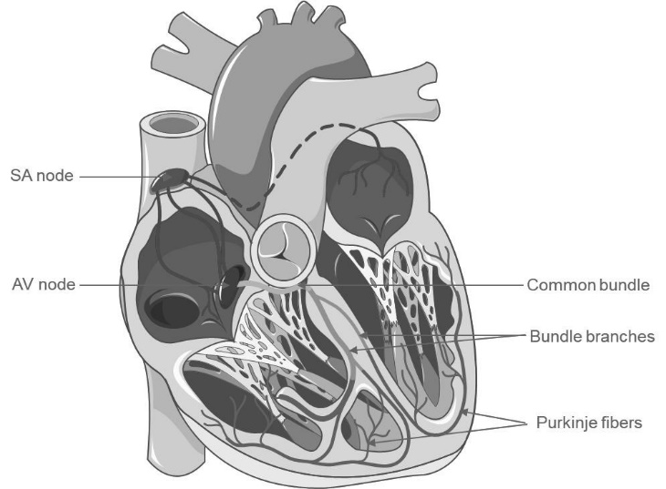

Figure 1: The cardiac conduction system in humans [51].

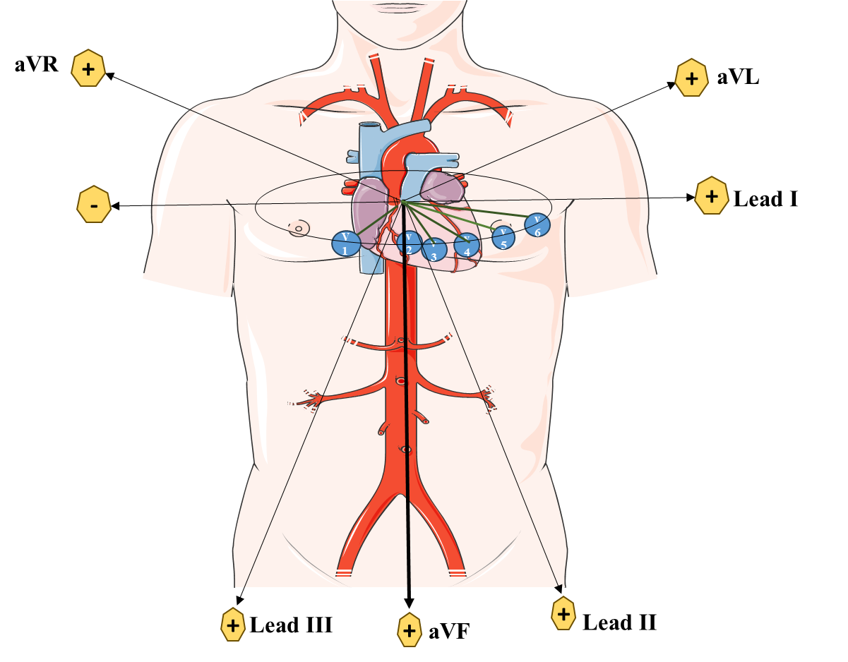

Figure 2: The 12 lead-based electrode placement system for ECG.

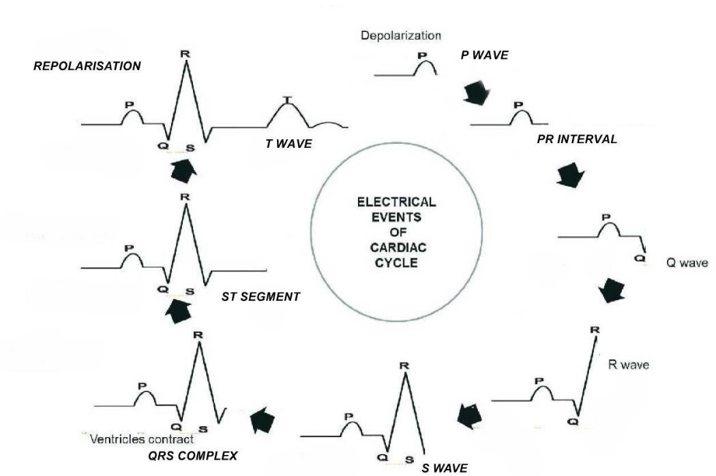

Figure 3: Electrical events of a normal cardiac cycle.

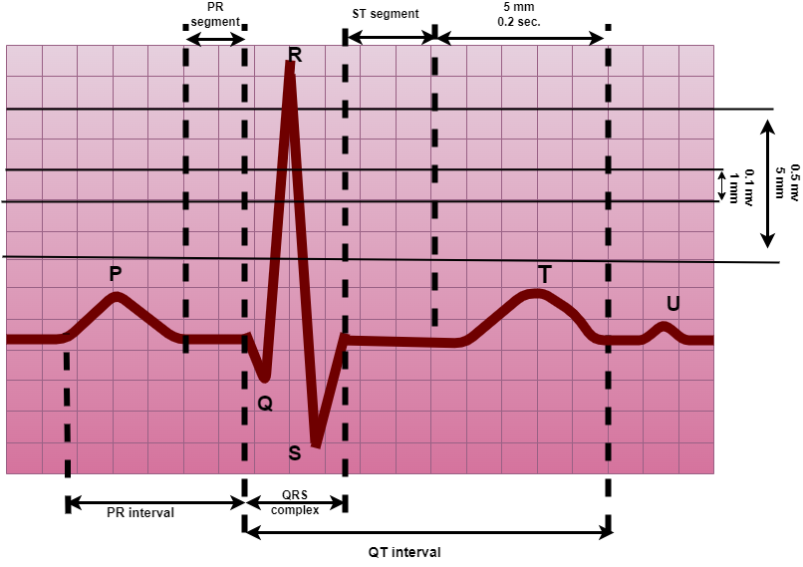

Figure 4: Representation of a normal ECG waveform.
Figure 3: Represents a normal cardiac cycle

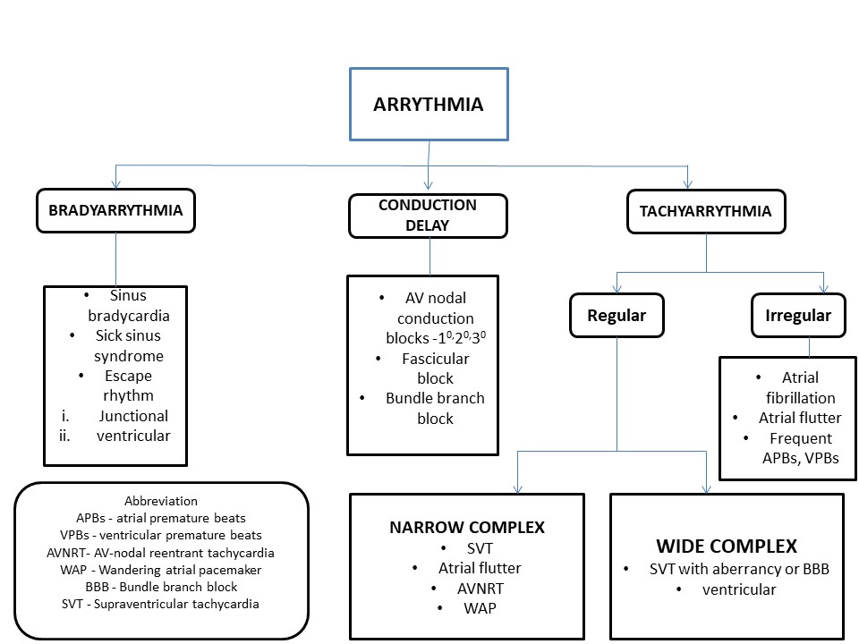
Figure 5: Systematic interpretation of arrhythmias [57].

Table 1: Differentially diagnosed clinical conditions/diseases based on ECG waveforms.

Waves | Deflection in waves | Clinical condition
P waves | Wide P wave | Left atrial hypertrophy or enlargement
 | Tall P wave | Right atrial hypertrophy or enlargement
 | Small P wave | High nodal rhythm, High nodal ectopic, Atrial tachycardia, and Atrial ectopics
 | Inverted P wave | Nodal rhythm with retrograde conduction,  Low atrial and high nodal ectopic beats, Dextrocardia
 | Variable P wave shape | Wandering pacemaker
 | Multiple P waves | Third-degree heart block
 | Absent P waves | Atrial fibrillation & flutter, Mid nodal rhythm, Ventricular ectopic & Ventricular tachycardia, Supraventricular tachycardia, Idioventricular rhythm, Hyperkalemia
PR waves | Prolonged P-R interval | First-degree heart block
 | Short P-R interval | WPW syndrome, Nodal rhythm, High nodal ectopic
Q waves | Pathological Q wave | Myocardial Infarction, left ventricular hypertrophy, Pulmonary embolism (only in lead III, WPW syndrome (in lead III and AvF)
R waves | Tall R wave in V1 | Right ventricular hypertrophy, WPW syndrome, Dextrocardia, True posterior MI, Right bundle branch block (BBB),
 | Small R wave | Obesity, Emphysema, PericardiaI effusion, Hypothyroidism, Hypothermia
 | Poor progression of R wave | Anterior or antiseptal MI, Left bundle branch block, Dextrocardia
QRS waves | High voltage QRS | Improper standardization, thin chest wall, Ventricular hypertrophy, WPW
 | Low voltage QRS | Thick chest wall, Pericardia effusion, emphysema, hypothyroidism, hypothermia
 | Wide ORS | BBB, Ventricular ectopic & tachycardia, WPW syndrome, Hyperkalemia
 | Change in QRS shape | BBB (left & Right), Ventricular fibrillation & tachycardia, WPW syndrome
 | Variable ORS | Torsades de pointes, Multifocal ventricular ectopics, ventricular fibrillation
ST waves | ST elevation | Acute myocardial (MI) Infarction or pericarditis, Ventricular aneurysm
 | ST depression | Acute MI, Angina pectoris Ventricular hypertrophy, Digoxin toxicity

