Waterlogged Soils: Causes, Challenges, and Management Strategies
Abhik Patra¹, R. P. Singh^{1,}*, B. K. Singh^{1,}*, M. S. Kundu², Subhashisa Praharaj³, Sayon Mukherjee⁴, Gagan Kumar¹, Pankaj Malkani¹
¹Krishi Vigyan Kendra, Narkatiaganj, West Champaran – 845455, Bihar, India (Dr. Rajendra Prasad Central Agricultural University, Pusa – 848125, Bihar, India)
²Directorate of Extension Education, Dr. Rajendra Prasad Central Agricultural University, Pusa – 848125, Bihar, India
³Krishi Vigyan Kendra, Madhopur, West Champaran – 845454, Bihar, India, (Dr. Rajendra Prasad Central Agricultural University, Pusa – 848125, Bihar, India)
⁴Department of Soil Science and Agricultural Chemistry, Institute of Agricultural Sciences, Banaras Hindu University, Varanasi – 221005, Uttar Pradesh, India
*Correspondence e-mail: rpskvk.22@gmail.com and drbksvet2k9@gmail.com
Introduction
Waterlogging is simply the temporary or permanent soaking of soil with water. When there is an excess of water in a region, the soil is unable to absorb it as it should. Waterlogging due to rain or floods has long been a natural occurrence that has resulted in the largest loss of human life and economic devastation around the planet. In case of over irrigation, waterlogging occurs when the water table rises to the root zone - repeated incorrect irrigation creates a shallow impermeable layer that prevents water from infiltrating down. Waterlogging limits plant development and output under anaerobic circumstances, causing certain crops and plants to die (Najeeb et al. 2015). Furthermore, as a result of the excess water in the soil profile, plant roots become weak and die or fall (Pan et al. 2021). Thus, management of excess water either due to rain or over irrigation in agriculture is a major challenge globally as well as in India, where about 11.6 million ha area is waterlogged. Waterlogging or severe soil drainage restrictions impact an estimated 10-12% of agricultural land worldwide (Shabala 2011). Many forecasts indicate that flood risk for many river basins will grow significantly in the twenty-first century, owing not just to climate change but also to industrial expansion and land use changes (O’Donnell et al. 2020; Tariq et al. 2021). Waterlogging inhibits gaseous exchange with the atmosphere, and biological activity uses up available oxygen in the soil air and water – also called anaerobiosis, anoxia or oxygen deficiency. Such conditions have a number of effects on agricultural plants e.g., toxicities or nutrition deficits, slow root death, in the winter it can cause deeper roots to die, resulting in spring dryness and early senescence of annual crops.
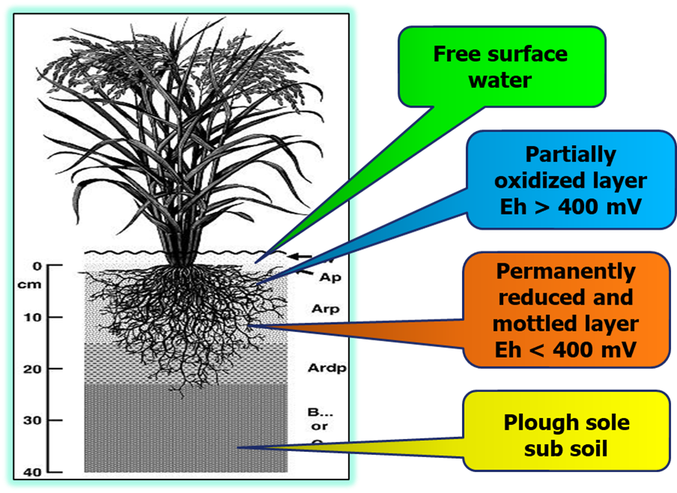
Most of the field crops such as wheat, rice, maize, and barley get affected by the waterlogging conditions. Waterlogging during the seedling, flowering, and grain filling phases of wheat reduced grain yield by 50-70% due to poor seed development and fewer spikes per unit area (Misra et al. 1992; Ding et al. 2020).
Figure 1. Different layers under waterlogged soils
Water logging in maize reduces output in tropical and subtropical areas. Waterlogging affects 15% of South-East Asia's maize growing regions, resulting in annual output losses ranging from 25-70% (Rathore et al. 2000; Tian et al. 2019). It promotes chlorophyll, protein, and RNA degradation in barley, as well as a decrease in the concentration of nutrients such as nitrogen, phosphorus, metal ions, and minerals in the shoot. After the commencement of flood leaf chlorosis (Wang et al. 1996; Buchanan et al. 2003), root and shoot development was also impaired, resulting in a drop in dry matter accumulation and, ultimately, yield (Malik et al. 2002). Based on plant damage, an average yield loss of 20-25% can occur; it may exceed 70% due to waterlogging (Setter et al. 1999). In present scenario, when climate is variable and incidences of flood have been increased, it is important to understand the mechanism of crop to be resilient towards this stress and other management practices that help the crops to perform better. With the above-mentioned aim, this review article has been designed in different sections that will discuss the problem, causes, and impact of waterlogging in major field crops with the future prospects and scope in water management for these crops.
Causes of waterlogging
Climatological
Excessive rainfall in a short span of time that exceeds the soil storage capacity and makes the area waterlogged. Climate change scenario has made such incidences more frequent and hence leading to frequent waterlogging situations. Higher air temperatures encourage evaporation of water in rivers and seas and, as a result, cloud formation. Higher temperatures allow the air to store more moisture and that may cause an increase in precipitation intensity, duration and/or frequency. As global warming raises the chance of additional extreme weather occurrences, dangers will spread beyond the established high-risk zones. More severe flooding is to be predicted, and for towns and cities where flooding has already occurred, it will no longer be a "once in a lifetime" risk, but will become considerably more often. The truth is that we live in a planet that is warming by 1.1º C. These record temperatures and floods are not anomalies; they represent the start of new standards, and the new records will be broken year after year.
Irrigation
Irrigation of soil without considering the soil infiltration capacity, soil storage ability and soil structure often leads to accumulation of water beyond desired, making the soil unsuitable for agricultural activity. Excessive irrigation often leads to accumulation of water above the soil surface creating anaerobic environment (Irmak et al. 2014).
Drainage
Drainage can be considered as the single most important factor that can lead to waterlogging (Balun 2020). Lack of proper drainage allows the excess water to remain on the soil surface for a longer period of time. The use of heavy machinery, a lack of organic matter addition, and other factors contribute to the formation of compacted layers in the subsurface region, resulting in poor drainage (Gurovich and Oyarce 2015; Kaur et al. 2020).
Topography
Topography has a significant effect on occurrence of flood in an area (Valeo and Rasmussen 2000; Sendek et al. 2021). Lowland soils are more prone to waterlogging than upland soil where free drainage is available. Uneven or unlevelled land creates waterlogged patches across the field as the water remains accumulated in small patches for longer period of time.
Ground water table
Shallow ground water table regions are more prone to waterlogging as high rainfall brings the water level close to the plant roots quickly resulting longer period of anaerobic environment around the root regions.
Problems of waterlogging
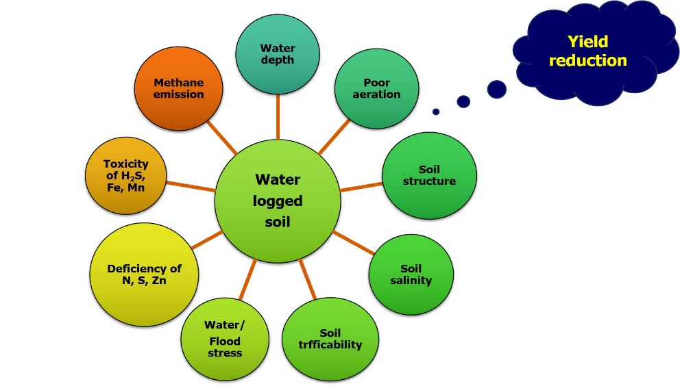
Waterlogging can cause multiple problems which have been discussed briefly under the following heads:

Figure 2. Effects of waterlogging on soil physicochemical and biochemical properties
Poor crop performance
Waterlogged soil causes anaerobic environment in the root zones which leads to lower root respiration. Lower root respiration generates less ATP, which is required for regular crop metabolic activity such as photosynthesis, absorption of nutrients etc. poor generation of ATP makes nutrient absorption poorer which leads to lower crop growth and productivity. Production of some toxic gases under anaerobic environment also lowers root permeability making both nutrient and water absorption increasingly difficult.
Destruction of soil structure
Excess soil moisture makes soil aggregates weaker. Tillage during excessive moisture as practiced by many farmers especially under paddy cultivation destroys the soil structure and creates subsurface compaction that restricts root movement of subsequent crops.
Emission of greenhouse gas
Anaerobic environment lowers redox potential that results in the formation of greenhouse gases such methane and nitrous oxide. Lowering redox potential also increases the toxicity of iron and manganese as their availability increases under reduced conditions.
Table 1. Different chemical species and their transformation under waterlogging condition and their redox potentials
Reduction reactions under waterlogging
Oxidized species | Reduced species | Redox potential (mV)
O₂ | H₂O | +380 to +320
NO ⁻₃ | N₂ | +280 to +220
Mn⁴⁺ | Mn²⁺ | +280 to +220
Fe³⁺ | Fe²⁺ | +180 to +150
SO ₄²⁻ | S²⁻ | -120 to -180
CO₂ | CH₄ | -200 to -280
H₂O | H₂ | -200 to -420
Deficiency of nutrients
Waterlogging leads to deficiency of nutrients through different mechanism. Leaching of nutrient is one of the most common mechanisms of nutrient loss under waterlogged environment in which the soluble nutrients move beyond the root zone with water. Nutrients like nitrogen may also be lost through denitrification under waterlogged anaerobic environment. Zinc is the most limiting micronutrient under water logged condition as the availability is reduced because of the formation of sparingly soluble salt.
Diseases and pest incidence
Rising humidity developed under waterlogged condition provides congenial environment for development of diseases and pest incidence.
Table 2. Effect of waterlogging on different crops
Crop | Effect due to waterlogging | References
Corn | Cause of disease like Smut, Leaf spot and downy mildew | Urban et al. (2015)
Corn | Yield reduction | Singh et al. (2016)
Cotton | Effect on growth and yield attributes | Wang et al. (2017)
Cotton | Yield reduction | Zhang et al. (2016)
Wheat | Wheat scab disease | Urban et al. (2015)
Wheat | Yield loss | Arguello et al. (2016)
Soybean | Sudden death | Urban et al. (2015)
Soybean | Yield reduction | Singh et al. (2016)
Arabidopsis | Root cell death | Guan et al. (2019)
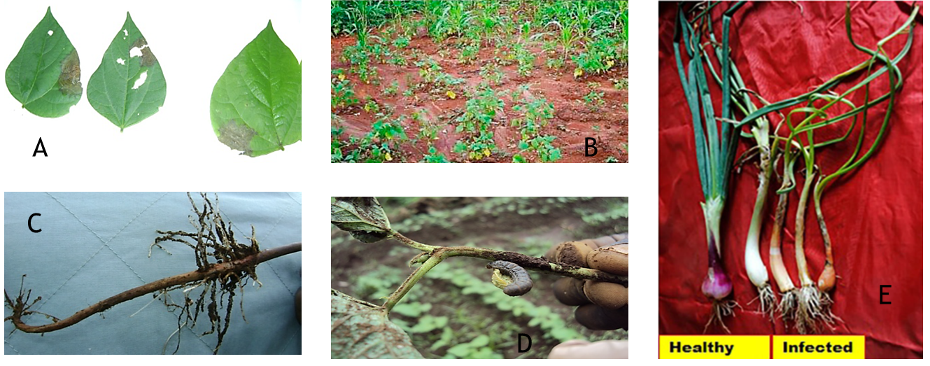
Figure 3. Incidence of diseases and pest under waterlogging in crops (A) Ascochyta blight of common bean (Athanase et al. 2013), (B) Phythium root rot of common bean (Eke et al. 2020), (C) Rhizoctonia root rot of common bean (Athanase et al. 2013), (D) Cutworm in common bean (Athanase et al. 2013), and (E) Anthracnose twister in onion (Salunkhe et al. 2022)
Effect of water logging on plant physiological parameters
Plants can suffer significant damage from the excessive synthesis of several ROS (reactive oxygen species) in waterlogged conditions, such as superoxide radicals, hydroxyl radicals, hydrogen peroxide, and singlet oxygen observed in hypoxia-stressed leaf and root tissues. In wet soil, ethylene is a potentially hazardous compound that inhibits root extension development. Additionally, the leftover ethanol in anoxic cells will be converted into acetaldehyde during the reintroduction of oxygen during the recovery phase, which may result in cell damage. All of them result in constrained root development, early leaf withering, and the formation of sterile florets, which all reduce yield. Due to a combination of factors including a decreased photosynthetic rate, a decreased stomatal conductance, a decreased root hydraulic conductivity, and a decreased translocation of photo assimilates, carbohydrate production was drastically reduced during complete submersion or subsequent de-submergence. The decrease in stomata conductance is one of the earliest reactions of plants to waterlogging. Abscisic acid (ABA) transit from older to younger leaves or the hormone’s de novo synthesis was suggested as the causes of the stomata closing. Waterlogging also lowers the chlorophyll concentration of leaves (Manik et al. 2019). The capacity of plants to photosynthesize is either directly or indirectly impacted by this decrease in chlorophyll. Stomata closure, which limits CO₂ flow, is to blame for the decline in transpiration and photosynthesis.
Management practices
Alternate crop
Growing crop suitable under waterlogged condition can be the single most effective strategy to tackle issue of yield reduction under waterlogged environment. Varieties of particular crop suitable for waterlogged condition can be further effective in reducing the negative impact of waterlogging.
Alteration in cropping pattern
Developing cropping pattern that facilitates growing water logging tolerant crops or growing crops in such a time that can escape waterlogging at critical stages can be an effective strategy in alleviating waterlogging issue.
Sowing time
Adjusting the sowing time can be useful in escaping waterlogging. Sowing rice in late April or early may can help rice in escaping early season flood. Moreover, this facilitates the early sowing of wheat. Adjusting the planting time should be done in such a way that, the most susceptible stage of the crop does not coincide with the peak waterlogging period.
Raised bed planting
Growing crop such as maize, wheat, mustard etc. on raised bed has been found effective in minimizing the negative effect of waterlogging to a great extent. Crop planted on raised bed are less exposed to waterlogging. Moreover, the furrows formed between the raised bed serves as a channel for the drainage of excess water.
Drainage
Provision of surface and subsurface drainage can help minimizing waterlogging issue. Subsurface drainage is especially useful in alleviating the issue of rising water table. Surface drainage can be useful for condition where excess water accumulates over the soil surface. Bio-drainage can also be effective in lowering the water table. This can especially useful where the water table is shallow resulting in frequent issues of waterlogging.
Genetic approach
Breeding for water logging tolerance can be an effective strategy for better adaptation under waterlogging condition. Varieties such as Sarjoo – 52 and Swarna sub 1 have been highly effective under waterlogged condition. Finding land races or germplasm and screening for their waterlogging tolerance ability can be the first step in developing such varieties. Bringing water logging tolerant genes from wild parents can also be useful in this aspect.
Conclusion
Flood/waterlogging is an important and serious threat to agriculture as it is evident with many research works. These are need to develop a comprehensive and spatially explicit risk evaluation framework to predict and investigate how floods impact crop production. Also, it is required to develop climate resilient agriculture techniques that not only save the crops but also protect soil from erosion. A risk-based approach should be frame that would lead to an economic, social, and environmental balance between gains and losses.
References
Arguello, M. N., Mason, R. E., Roberts, T. L., Subramanian, N., Acuna, A., Addison, C. K., & Gbur, E. (2016). Performance of soft red winter wheat subjected to field soil waterlogging: grain yield and yield components. Field Crops Research, 194, 57-64.
Athanase, C. R., Tenywa, J. S., Makooma, M. T., Okiror, J. J., Leonidas, D., Mupenzi, M., & Augustine, M. (2013). Farmers’ coping mechanisms for common bean production under water-logged soil conditions in Uganda-Rwanda boarder region.
Balun, O. V. (2020). Effectiveness of drainage of agricultural land by closed drainage in climatic conditions of the Novgorod Region. In IOP Conference Series: Earth and Environmental Science (Vol. 613, No. 1, p. 012011). IOP Publishing.
Ding, J., Liang, P., Wu, P., Zhu, M., Li, C., Zhu, X., & Guo, W. (2020). Effects of waterlogging on grain yield and associated traits of historic wheat cultivars in the middle and lower reaches of the Yangtze River, China. Field Crops Research, 246, 107695.
Eke, P., Wakam, L. N., Fokom, R., Ekounda, T. V., Boat, M. A. B., & Boyom, F. F. (2020). Common bean (Phaseolus vulgaris L.) root rot in humid lowland: Occurrence, and assessment of biotic and agronomic factors for mitigation prospects. Rhizosphere, 16, 100256.
Guan, B., Lin, Z., Liu, D., Li, C., Zhou, Z., Mei, F., & Deng, X. (2019). Effect of waterlogging-induced autophagy on programmed cell death in Arabidopsis roots. Frontiers in Plant Science, 10, 468.
Gurovich, L., & Oyarce, P. (2015). New approaches to agricultural land drainage: a review. Irrigat Drainage Sys Eng, 4(135), 2.
Irmak, S., Specht, J. E., Odhiambo, L. O., Rees, J. M., & Cassman, K. G. (2014). Soybean yield, evapotranspiration, water productivity, and soil water extraction response to subsurface drip irrigation and fertigation. Transactions of the ASABE, 57(3), 729-748.
Kaur, G., Singh, G., Motavalli, P. P., Nelson, K. A., Orlowski, J. M., & Golden, B. R. (2020). Impacts and management strategies for crop production in waterlogged or flooded soils: A review. Agronomy Journal, 112(3), 1475-1501.
Malik, A. I., Colmer, T. D., Lambers, H., Setter, T. L., & Schortemeyer, M. (2002). Short‐term waterlogging has long‐term effects on the growth and physiology of wheat. New Phytologist, 153(2), 225-236.
Manik, S. N., Pengilley, G., Dean, G., Field, B., Shabala, S., & Zhou, M. (2019). Soil and crop management practices to minimize the impact of waterlogging on crop productivity. Frontiers in Plant Science, 10, 140.
Misra, R., Munankarmi, R. C., Pandey, S. P., & Hobbs, P. R. (1992). Sterility work in wheat at Tarahara in the Eastern Tarai of Nepal. Boron deficiency in wheat, 65-71.
Najeeb, U., Bange, M. P., Tan, D. K., & Atwell, B. J. (2015). Consequences of waterlogging in cotton and opportunities for mitigation of yield losses. AoB Plants, 7.
O'Donnell, E. C., & Thorne, C. R. (2020). Drivers of future urban flood risk. Philosophical Transactions of the Royal Society A, 378(2168), 20190216.
Pan, J., Sharif, R., Xu, X., & Chen, X. (2021). Mechanisms of waterlogging tolerance in plants: Research progress and prospects. Frontiers in Plant Science, 11, 627331.
Rathore, T. R., Warsi, M. Z. K., Singh, N. N., & Vasal, S. K. (2000). Production of maize under excess soil moisture (waterlogging) conditions. Asian Regional Maize Workshop, 7: Strengthening hybrid maize technology and public-private partnership to accelerate maize production in the Asian region. In ^ TAsian Regional Maize Workshop, 7: Strengthening hybrid maize technology and public-private partnership to accelerate maize production in the Asian region^ AVasal, SK Gonzalez Ceniceros, F. XiongMing, F.^ ALos Baños, Laguna (Philippines)^ BPCARRD^ C2000 (No. CIS-3384. CIMMYT.).
Salunkhe, V. N., Gedam, P., Pradhan, A., Gaikwad, B., Kale, R., & Gawande, S. (2022). Concurrent Waterlogging and Anthracnose-Twister disease in Rainy Season Onion (Allium cepa): Impacts and Management. Frontiers in Microbiology, 4866.
Sendek, A., Kretz, L., van der Plas, F., Seele-Dilbat, C., Schulz-Zunkel, C., Vieweg, M., & Wirth, C. (2021). Topographical factors related to flooding frequency promote ecosystem multifunctionality of riparian floodplains. Ecological Indicators, 132, 108312.
Setter, T. L., Burgess, P., Waters, I., & Kuo, J. (1999, September). Genetic diversity of barley and wheat for waterlogging tolerance in Western Australia. In Proceedings of the 9th Australian Barley Technical Symposium (pp. 1-7). Melbourne: Australian Barley Technical Symposium Inc.
Shabala, S. (2011). Physiological and cellular aspects of phytotoxicity tolerance in plants: the role of membrane transporters and implications for crop breeding for waterlogging tolerance. New Phytologist, 190(2), 289-298.
Shangen, W., Liren, H., & Zhengwei, L. (1996). A comparative study on the resistance of barley and wheat to waterlogging. Acta Agronomica Sinica (China).
Singh, G., Williard, K. W., & Schoonover, J. E. (2016). Spatial relation of apparent soil electrical conductivity with crop yields and soil properties at different topographic positions in a small agricultural watershed. Agronomy, 6(4), 57.
Tariq, M. A. U. R., Rajabi, Z., & Muttil, N. (2021). An evaluation of risk-based agricultural land-use adjustments under a flood management strategy in a floodplain. Hydrology, 8(1), 53.
Tian, L., Li, J., Bi, W., Zuo, S., Li, L., Li, W., & Sun, L. (2019). Effects of waterlogging stress at different growth stages on the photosynthetic characteristics and grain yield of spring maize (Zea mays L.) under field conditions. Agricultural Water Management, 218, 250-258.
Urban, D. W., Roberts, M. J., Schlenker, W., & Lobell, D. B. (2015). The effects of extremely wet planting conditions on maize and soybean yields. Climatic Change, 130, 247-260.
Valeo, C., & Rasmussen, P. (2000). Topographic influences on flood frequency analyses. Canadian water resources journal, 25(4), 387-406.
Wang, X., Deng, Z., Zhang, W., Meng, Z., Chang, X., & Lv, M. (2017). Effect of waterlogging duration at different growth stages on the growth, yield and quality of cotton. PloS one, 12(1), e0169029.
Zhang, Y., Chen, Y., Lu, H., Kong, X., Dai, J., Li, Z., & Dong, H. (2016). Growth, lint yield and changes in physiological attributes of cotton under temporal waterlogging. Field Crops Research, 194, 83-93.

