Solar Tracking System

1st Shreyas Manoj Baviskar Dept. of Electrical Engineering G.H Raisoni Institute of Engineering & Business Management, Jalgaon, India shreyasbaviskar66@gmail.com
4th Dinesh Kishor Khairnar Dept. of Electrical Engineering G.H Raisoni Institute of Engineering & Business Management, Jalgaon, India dineshkk1609@gmail.com
2nd Deepak Parag Patil Dept. of Electrical Engineering G.H Raisoni Institute of Engineering & Business Management, Jalgaon, India deepakpatil830820@gmail.com

5th Jayesh Sanjay Tayade Dept. of Electrical Engineering G.H Raisoni Institute of Engineering & Business Management, Jalgaon, India jayeshtayade9503@gmail.com
3rd Prathamesh Sambhaji Shinde Dept. of Electrical Engineering G.H Raisoni Institute of Engineering & Business Management, Jalgaon, India prathmesh050803@gmail.com

6th Pratik.S Chirmade Dept. of Electrical Engineering G.H Raisoni Institute of Engineering & Business Management, Jalgaon, India pratik.chirmade@raisoni.net

Abstract— This study focuses on a new method for efficiently managing electrical power generation from renewable sources, specifically solar energy. In today's world, one of the most pressing issues is the global energy crisis, exacerbated by the fact that fossil fuels are in limited supply, and their excessive use over the past few decades has depleted these resources even further. As a result, we are increasingly turning to renewable energy sources, such as wind, solar, and geothermal energy, to fulfill our energy needs.

Among these renewable sources, solar energy stands out as one of the most cost-effective options. Solar energy not only has the potential to meet our current energy demands but also offers a clean and affordable alternative. Once solar panels are installed, they can generate energy for many years without incurring significant maintenance costs. However, there is a challenge with solar photovoltaic systems – they can only capture solar energy during specific times of the day due to the Earth's rotation around the sun.
Keywords— Photovoltaic, solar Tracker, Renewable Energy Sources (RES), STS (Solar Tracker System)

I. INTRODUCTION
The transition from traditional fossil fuels to various solar power resources like geothermal energy, wind energy, bio-energy, and solar power has become increasingly important. Solar energy, in particular, plays a significant role in addressing global warming and offers a sustainable energy source. It can also serve as a cost-effective alternative to fossil fuels. Solar energy can be harnessed through photovoltaic and thermal methods, using solar panels and solar collectors, respectively. There are various applications for both photovoltaic and solar thermal systems. At moderate temperatures, solar energy can be used for tasks such as water heating, desalination, and industrial processes that require heat. At high temperatures, concentrating solar power plants are gaining a lot of attention worldwide. Additionally, for very high-temperature applications, such as hydrogen production and methanol reforming, solar irradiation can be utilized. Solar energy systems, particularly solar photovoltaic (SPV) systems, have gained significant recognition and investment due to their potential to provide clean energy on a global scale in a relatively short time. In the years to come, SPV systems are expected to play a major role in energy production among all renewable energy sources. SPV modules produce direct current (DC) electricity, with the output depending on factors like sunlight availability and temperature under standard test conditions (STC), which include 25°C and a solar constant of 1 kW/m². It's important to note that SPV modules have a unidirectional characteristic, meaning they consistently produce DC power. Therefore, their power output remains stable despite changes in atmospheric and room temperatures. Additionally, SPV generators typically have only one maximum power point tracking (MPPT) under full sunlight exposure. In this context, the primary goal of using MPPT tracking methods is to precisely locate and utilize the global MPPT, thereby maximizing power generation. Various MPPT algorithms have been developed and documented in scientific literature to efficiently manage the system. Properly orienting these devices in terms of azimuth and inclination angles can enhance the intensity of incident solar radiation and, consequently, their energy capture.

II. SOLAR ENERGY
Solar energy is the captured energy from the sun's radiant light and heat. Various technologies, such as solar heating, solar cells, solar thermal thermoelectric, solar architecture, and artificial photosynthesis, harness this energy. Earth receives approximately 1 kilowatt per square meter of solar energy at high noon. The conversion of this photon energy into electricity is already being successfully accomplished, with large-scale solar power plants being established. However, the efficiency of solar energy production needs improvement to minimize energy losses. Solar energy offers several advantages over other energy sources. One key advantage is that, aside from the initial installation cost and minimal maintenance, solar energy is essentially free and limitless. Unlike other energy sources, it doesn't emit heat, carbon dioxide, or radioactive particles, making it highly environmentally friendly. Solar energy is particularly valuable in remote or hilly areas where setting up power transmission lines is expensive or impractical. Photovoltaic panels are commonly used in remote regions for generating electricity, and urban areas are adopting photovoltaic panels for street lighting. Modern electronic devices can also operate using solar power. Electric vehicles, building-integrated solar systems, and smart grid systems are increasingly incorporating solar energy. Spacecraft and satellites that operate in space for extended periods rely solely on solar energy as their power source.
Photovoltaic Technology
Solar cells are a well-known method for generating electrical power using silicon cells enclosed within photovoltaic modules. To make it simpler to understand how photovoltaic solar panels work, here's a breakdown:
Photon Absorption: When sunlight hits the solar panel, it contains tiny particles of light called photons. These photons carry energy.
Energy Boost: The photons from sunlight provide energy to the electrons within the solar cells, boosting them to a higher energy level.
Electron Movement: These energized electrons move from their higher energy state to a lower one, creating an electrical flow in the process.
Electricity Generation: As the electrons move, they create an electric current. This flow of electricity is harnessed and can be used to power various devices or stored in a battery for later use.
The term "photovoltaic" essentially means that the solar panel operates as a special kind of diode (a semiconductor device) in a way that allows it to generate electric current when exposed to light. Solar cells produce direct current (DC) electricity, which is suitable for recharging batteries or powering electrical devices.

III. SOLAR MODULE
In the field of solar energy, a photovoltaic module or solar panel is essentially a package that contains interconnected solar cells, which are also called solar cells. When multiple of these modules are set up together, it's referred to as a photovoltaic array. Since solar cells need protection from the elements, they are often combined and enclosed within a module.
For practical and cost-efficient reasons, these modules are connected electrically and then packaged together. These packages, sometimes equipped with a glass cover and a frame and backing made of materials like metal, plastic, or fiberglass, are what we commonly call solar panels.
Initially, photovoltaics were primarily used to provide power for satellites and spacecraft. However, in today's context, the majority of solar modules are used for generating electricity connected to the grid. This means that to make this electricity usable in homes and businesses, it needs to be converted from direct current (dc) to alternating current (ac) using a device called an inverter.
There is also a smaller market for using solar power in remote locations, like outbuildings without easy access to the main power grid, communication equipment in remote areas, meteorological instruments, and even for protecting pipelines through a process called cathodic protection. In these cases, solar panels are used to generate power independently from the grid.
- Solar Tracker Fundamentals A solar tracker is a device used to align daylight reflectors, solar photovoltaic panels, or concentrating solar reflectors or lenses towards the sun. The position of the sun in the sky changes with the seasons (elevation) and throughout the day as it moves across the sky. Solar-powered devices perform best when they are constantly pointed at the sun, so a solar tracker increases the effectiveness of these devices. However, it comes at the cost of added complexity to the system.
There are various types of solar trackers available, differing in cost, quality, and performance. One well-known type of solar tracker is the heliostat, which is a movable mirror that reflects the sun's movement to a fixed position. Other techniques can also be used for solar tracking.
The efficiency of a solar tracker depends on its specific application. Concentrating systems, especially in solar cell processes, require precise alignment to ensure that concentrated sunlight is directed accurately onto the device, typically at or near the focal point of the reflector. In most cases, concentrator systems cannot function effectively without tracking, making at least single-axis tracking necessary. For larger power plants or high-temperature research facilities that use multiple ground-mounted mirrors to focus sunlight onto a central point, high-precision tracking similar to that used in solar telescopes is essential.

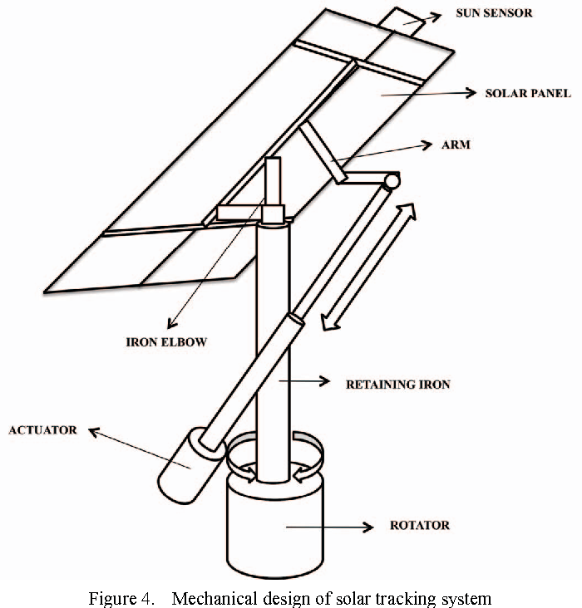
1.5 Sun Path, Azimuth & Altitude Angle
The shifting position of the moving sun changes throughout the day and across different seasons, primarily because of the Earth's constant rotation on its axis and its yearly orbit around the sun. Consequently, it has become essential to determine the precise direction of the sun at any given moment. To accomplish this, we use a specialized chart known as a Sun Path Diagram. This diagram provides valuable information such as the sun's azimuth angle (its horizontal direction), elevation angle (its height above the horizon), the paths the sun takes across the sky throughout the year, as well as the times of sunrise and sunset.
In simpler terms, a Sun Path Diagram is a visual tool that helps us understand where the sun will be in the sky at different times and seasons, making it useful for tasks like positioning solar panels or understanding daylight patterns in a specific location.
Methods of Solar Tracking
There are three methods of solar tracking.
• Active Tracking
• Passive Tracking
• Chronological Tracking
- Active Tracking
Throughout the day, sensors continuously track the sun's position to ensure that solar panels always face it. These sensors are crucial for accurate active tracking. However, a significant challenge arises when these sensors struggle to differentiate between measurements, leading to false triggers or missing the original trigger, especially on cloudy days.
- Chronological Tracking
A chronological tracker is essentially a tracking system that relies on timers and fixed rates to adjust the position of a solar panel or structure throughout the day. This is based on the fact that the sun moves across the sky at a consistent rate of about 15 degrees per hour. This method works well for single-axis tracking systems without the need for sensors. However, for dual-axis tracking, a modified version can be used.
Here's a breakdown of how it works: The system calculates the sun's position throughout the day and adjusts the solar tracker accordingly. This adjustment is based on data stored in the controller module's memory or calculated using specific formulas. This approach is known for its accuracy and reliability, as mentioned in reference [11]. However, it does have its drawbacks, such as high power consumption due to data storage, calculations, and continuous data transmission. Additionally, it may result in unnecessary tracker movement when sunlight levels are too low.
It's important to note that all three methods (sensor-controlled, sensorless, and chronological) can be applied to both single-axis and dual-axis tracking systems. The choice of method depends on factors like the installation location, the purpose of solar power generation, and the power demand.
In modern solar tracking systems, a more efficient approach is often used by combining both sensor-controlled and sensorless methods simultaneously. This hybrid approach helps optimize the system's efficiency by taking advantage of both sensor data and calculated tracking adjustments.

IV. BASIC COMPONENTS OF SOLAR TRACKING SYSTEM
A Solar tracker has several basic components. The major components are described here

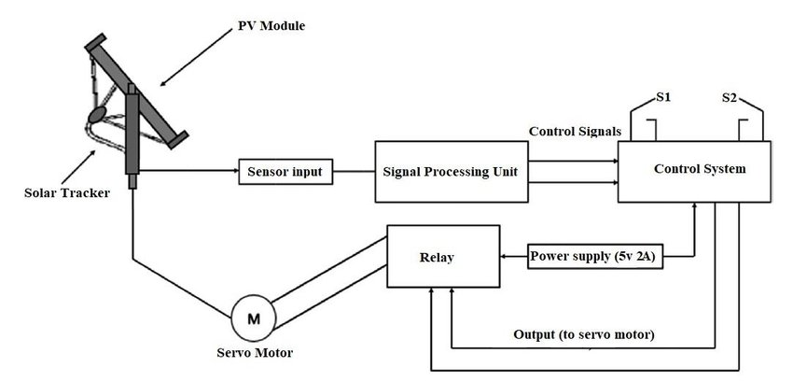
- Sun Tracking Algorithm:
Solar tracking systems can use either open-loop control or closed-loop control algorithms. Open-loop control relies on mathematical calculations based on astronomical data to determine the sun's azimuth and altitude angles. It's like a theoretical prediction of where the sun should be in the sky. Open-loop control is necessary because factors like clouds can obscure the sun, making real-time feedback unreliable. On the other hand, closed-loop control uses real-time light sensors to detect the sun's actual position in the sky. This method helps correct errors that can occur during the installation, assembly, calibration, and encoder mounting processes. In simple terms, closed-loop control ensures the solar tracking system stays accurate and adjusts to the sun's real position.
Sometimes, a combination of both open-loop and closed-loop control methods is used to strike a balance between cost-effectiveness and efficiency in the design of solar tracking systems. This means using mathematical calculations as a base while incorporating real-time feedback to fine-tune the system's performance.
Tracker Control Unit:
The control unit is responsible for running the sun tracking program and performing the required calculations. It also manages the positioning system's movements. Typically, a microprocessor or a computer serves as the brain of the control unit. It's equipped with interfaces for receiving commands and sending out data. When it comes to solar trackers located in distant areas, having an automatic tracking control system is the most effective choice.
The control unit is responsible for running the sun tracking program and performing the required calculations. It also manages the positioning system's movements. Typically, a microprocessor or a computer serves as the brain of the control unit. It's equipped with interfaces for receiving commands and sending out data. When it comes to solar trackers located in distant areas, having an automatic tracking control system is the most effective choice.
- Positioning System and Drive Mechanism:
A positioning system is responsible for adjusting the direction of a solar tracker based on instructions from a control unit. This system can be powered either electronically or hydraulically. When it's electronically powered, it employs components like encoders, variable frequency drives, or linear actuators to keep track of where the solar panel is currently positioned and then moves it to the desired location.
The mechanism responsible for this movement consists of various mechanical devices such as rotary motors, linear actuators, linear drives, hydraulic cylinders, swivel drives, worm gears, planetary gears, and threaded spindles. These drives can vary in type and design based on specific requirements [13].
- Sensors:
Sensors play a crucial role in accurately determining the position of the sun in various systems. In open-loop systems, these sensors are employed to correct any errors that may arise due to calculations or mechanical issues. On the other hand, closed-loop systems rely heavily on multiple light-sensing devices. These devices can measure the intensity of light and include components like photoresistors, phototransistors, and solar cells. In addition to light intensity sensors, solar power stations also utilize monitoring systems that keep track of essential environmental parameters. These parameters include temperature, pressure, humidity, wind speed, and solar irradiance. These monitoring systems are vital for ensuring the efficient operation of solar power stations, allowing them to make necessary adjustments based on real-time data from the sensors.
V. FACTORS LIMITING THE EFFICIENCY AND UTILIZATION OF SOLAR TRACKERS
In general, most researchers agree that solar trackers can enhance the overall efficiency of photovoltaic (PV) panels and Concentrated Solar Power (CSP) systems. However, it's crucial to provide clear guidelines on when and where these trackers are most effective and how to achieve maximum power efficiency. Along these lines, many issues have been identified and addressed individually, including problems like misalignment and failures in the control systems and electronic components of the trackers, among others.
Furthermore, studies have confirmed that many of the issues affecting the efficiency of both fixed and tracking PV systems are similar. Still, some problems are unique to solar tracking systems, as mentioned earlier. It's worth noting that different types of solar trackers come with distinct advantages and challenges when it comes to their performance and efficiency. Research has demonstrated that tracking the sun's position can significantly boost efficiency, especially on cloudy days. Consequently, using solar trackers could be an excellent way to enhance the efficiency and performance of both PV panels and CSP systems, regardless of weather conditions.
Additionally, studies have shown that the number of axes used to track the sun has a significant impact on the overall efficiency of solar radiation capture by the modules. Researchers have investigated the effect of tracking on PV module performance based on the number of tracking axes in the system. Their findings indicate that two-axis tracking systems have a greater ability to maintain their position, even in the presence of clouds or adverse environmental conditions. In fact, a double-axis tracker produced an average output power that was 13.25% higher than that of a fixed system in one study. Another earlier study compared the efficiencies of single-axis and double-axis solar trackers and concluded that double-axis trackers are more efficient, typically showing a 3% gain difference between the two types.
It's essential to note that these studies were conducted in various regions with varying climate conditions. Nevertheless, a common consensus emerges: the overall efficiency of a solar tracker depends on the number of axes used. However, it's important to consider that both climate conditions and the specific technology employed can significantly affect the performance of these systems, especially in hot weather regions.
ADVANTAGES OF SOLAR TRACKER
The primary benefit of using a solar tracker is that it boosts the amount of solar energy that can be harnessed from a specific location. To confirm this advantage, a feasibility study was conducted, including an experiment, before the solar tracker's design phase. The experiment revealed a significant increase in power generation [15].
For this experiment, a 10 Watt solar panel was employed. Various parameters, such as open circuit voltage, closed circuit current, and voltage under different loads, were measured. These measurements allowed us to pinpoint the maximum power output at different times throughout a typical sunny day. We will then organize and present these values on a graph for comparison.

VI. RESULT
Solar trackers are devices used to enhance the efficiency of solar energy collection from photovoltaic (PV) systems by constantly adjusting their position to follow the sun's path across the sky during the day. These systems offer several advantages, including visual appeal, environmental friendliness, and cost-effectiveness, thanks to advances in computer and control system technologies. These integrated features make solar tracking systems suitable for large-scale residential and industrial power generation, aligning with green energy initiatives.
This article provides a summary of various types of solar tracking systems, discussing their designs, thermal and electrical performance, and the factors affecting heat loss during their operation.
CONCLUSIONS
The study clearly indicates that incorporating solar trackers can significantly enhance the performance of solar photovoltaic (SPV) systems. However, it is crucial to exercise caution during the installation of these solar trackers. Issues like the potential failure of the solar tracker mechanism should be addressed with the same level of importance as their installation.
Furthermore, the choice between active and passive solar trackers is a decision that merits further investigation. This study also aimed to thoroughly assess all the key factors essential for optimizing the performance of solar trackers.

References
- F. Z. Peng, H. Akagi, and A. Nabae, “Study of active power filters using quad series voltage source PWM converters for harmonic compensation,” IEEE Transactions on Power Electronics, vol. 5, no. 1, Jan. 1990, pp. 9 –15.
- H. Fujita, and H. Akagi, “A practical approach to harmonics compensation in power systems series connection of passive and active filters,” IEEE Transactions on Industry Applications, vol. 27, no. 6, pp. 1020-1025, Nov. 1991.
- H. Fujita, and H. Akagi, “Design strategy for the combined system of shunt passive and series active filters,” in Industry Applications Society Annual Meeting, 1991, pp. 898-903
- Guruprasad P. Sali, Mohini J. Deshmukh, Mrunalini S. Wankhede, Bipasa B. Patra, "Smart IOT Automation for Advanced Home Security”, International Journal of Engineering Research in Electrical and Electronic Engineering (IJEREEE), Vol 6, Issue 4, IFERP, April 2020, ISSN (Online) - 2395-2717, pp.1-6, doi: 01.1617/vol7/iss4/pid4582
- Patil, Divyang R., Harish U. Jawale, Paresh D. Shirsath, and Bipasa Patra. "UV FLOOR SANITIZATION." (2021). IRJET ISSN – 2395-0057Vol 08, Issue 03, mar 2021, pp.419-422.
- Aditi Shinde, Toshita Nehete, Bipasa Patra, “Robot Navigation system with RFID and sensors” (2021). IRJET ISSN – 2395-0057Vol 08, Issue 04, Apr 2021, pp. 249-252.
- Mondal, G.. Gopakumar, K. Tekwani, P.N., Levi, E. "A reduced N. Gupta, N. Patel, R. Ladha, and D. P. Saini, “A novel autoscaling variable perturbation size maximum power point tracker applied to photovoltaic (PV) system,” Int. Trans. Electr. Energy Syst., no. June 2019, pp. 1–17, 2020.
- P. A. C. Rocha, S. P. Mendonça, T. T. G. Watanabe, M. E. V. da Silva, and R. J. P. Lima, “Analysis of different tracking intervals for Parabolic Trough Collectors for water disinfestation in agricultural applications,” Semin. Ciências Agrárias, vol. 41, no. 1, p. 7, 2020.
- A. A. A. Radwan and Y. A. R. I. Mohamed, “Grid-Connected WindSolar Cogeneration Using Back-to-Back Voltage-Source Converters,” IEEE Trans. Sustain. Energy, vol. 11, no. 1, pp. 315–325, 2020.
- A. K. Mishra and B. Singh, “Self-governing single-stage photovoltaic water pumping system with voltage balancing control for a four-phase SRM drive,” IET Electr. Power Appl., vol. 14, no. 1, pp. 119–130, 2020
- L. M. Fernández-Ahumada, J. Ramírez-Faz, R. López-Luque, M. VaroMartínez, I. M. Moreno-García, and F. Casares de la Torre, “A novel backtracking approach for two-axis solar PV tracking plants,” Renew. Energy, vol. 145, pp. 1214–1221, 2020
- S. Ahmadnia, E. Tafehi, and F. Shakhsi Dastgahian, “Optimal Placement and Sizing for Solar Farm with Economic Evaluation, Power Line Loss and Energy Consumption Reduction,” IETE J. Res., vol. 0, no. 0, pp. 1–16, 2019.
- A. Chaysaz, S. R. M. Seyedi, and A. Motevali, “Effects of different greenhouse coverings on energy parameters of a photovoltaic–thermal solar system,” Sol. Energy, vol. 194, no. November, pp. 519–529, 2019.
- R. Sharma and A. Das, “Enhanced Active Power Balancing Capability of Grid-Connected Solar PV Fed Cascaded H-Bridge Converter,” IEEE J. Emerg. Sel. Top. Power Electron., vol. 7, no. 4, pp. 2281–2291, 2019
- X. Qian et al., “Artificial phototropism for omnidirectional tracking and harvesting of light,” Nat. Nanotechnol., vol. 14, no. 11, pp. 1048– 1055, 2019.
- D. T. Cotfas and P. A. Cotfas, “Multiconcept Methods to Enhance Photovoltaic System Efficiency,” Int. J. Photoenergy, vol. 2019, 2019.
- T. Zheng, F. Zheng, X. Rui, X. Ji, and K. Niu, “A novel ultralight dish system based on a three-extensible-rod solar tracker,” Sol. Energy, vol. 193, no. June, pp. 335–359, 2019.
- S. Chauhan and B. Singh, “Grid-interfaced solar PV powered electric vehicle battery system with novel adaptive digital control algorithm,” IET Power Electron., vol. 12, no. 13, pp. 3470–3478, 2019
- T. Lee, J. Kim, S. Cho, S. Pyo, K. Song, and J. Lee, “Planar-type concentrating photovoltaics with cylindrical lenses directly integrated with thin flexible GaAs solar cells,” Prog. Photovoltaics Res. Appl., vol. 28, no. 1, pp. 71–78, 2020
- M. Premkumar and R. Sowmya, “An effective maximum power point tracker for partially shaded solar photovoltaic systems,” Energy Reports, vol. 5, pp. 1445–1462, 2019.
- Patra, Bipasa, et al. "Optimization of solar energy using MPPT techniques and industry 4.0 modelling." Sustainable Operations and Computers 4 (2023): 22-28.
- Bipasa Patra and Dr. Pragya Nema, "Analysis of Solar Integrated Multilevel Inverter for Smart Grid Power Filters"- Published in IEEE Xplore on 06 April 2021 Proceedings of ICAECT 2021, Bhilai, Chhattisgarh. Doi: 1109/ICAECT49130.2021.9392527
- B. Patra, P. Nema, et al., "Eleven-Level Inverter Topology with Photovoltaic Interface," Published in IEEE Xplore on 04 Feb 2022 Proceedings of ICEPES 2021 MANIT, Bhopal, pp. 1-5, doi: 10.1109/ICEPES52894.2021.9699805.
- Patra, Bipasa, and Pragya Nema. "Comprehensive topological analysis of solar integrated multilevel inverter for power filters." Smart Technologies for Energy, Environment and Sustainable Development, Vol 1: Select Proceedings of ICSTEESD 2020. Singapore: Springer Nature Singapore, 2022. 475-485.
- Patra, Bipasa Bimalendu. "Necessity for Future Smarter Nation with a Sustainable Trend-Smart Grid." BUSINESS AND TECHNOLOGY (IJSSBT), Volume 6, No. 2, September 2018 ISSN (Print) 2277-7261: 35.

