**A STUDY ON THE BIOCHEMICAL & MORPHOLOGICAL CHANGES ON GROUNDNUT *(Arachis hypogaea)* SEEDS EXPOSED YO PULSED MAGNETIC FIELD**

**D. Saravanan* and KR. Velunachiyar Department of Biochemistry** Department of Biochemistry, Dwaraka Doss Goverdhan Doss Vaishnav College,Arumbakkam,Chennai-600106

**\***Corresponding author:

**Dr. D.Saravanan**

Assistant Professor,

Department of Biochemistry,

Dwaraka Doss Goverdhan Doss Vaishnav College,

Arumbakkam,Chennai-600106.

saravanan@dgvaishnavcollege.edu.in

**ABSTRACT:**

***Arachis hypogeae*** seeds were exposed to a pulsed magnetic field of sine wave form with varying frequencies as 100, 500, 1000 Hz and constant intensity of about 1500 nT. The seeds were exposed to frequency of 100 Hz is taken as Test-1, 500 Hz as Test – 2, 1000 Hz as Test – 3. Seeds are subjected to the high pulsed magnetic field for a time interval of 5 hours per day for 15 days. After the exposure time over, on the 16th day, the estimations are carried out for carbohydrates, proteins, amino acids, nucleic acids (DNA & RNA), enzymes (Amylase & Protease).It is seen from the experiment that the magnetic field has enhanced the morphological and biochemical parameters of the seeds.From our investigation, it was studied that, Test 3 has maximum stimulating effect on the enzyme activity, Test 1 has shown increase in the biochemical parameters and Test 2 shows an increase in some biochemical parameters, but it is not steady as above two.Thus, this frequency might provide a feasible non – chemical solution for seeds germination. Therefore, it is evident that the use of varying magnetic field frequency will definitely proves to be a pretreatment catalyst in agriculture promoting vigor growth and good yield of crops. This is a best alternative way in place of pesticides will definitely help in protecting environment.

**KEYWORD**: Magnetic field,frequency,parameters,growth,crops

**INTRODUCTION**

The Earth behaves like a very large bar magnet with a north pole and a south pole. It is now believed that the Earth's magnetism is due to the magnetic effect of current which is flowing in the liquid core at the center of the Earth. Thus, the Earth is a huge electromagnet.The origin of our knowledge of Magnetism has been lost in antiquity, only vague reference being available during years of the Christian era. It is claimed that Chinese scholars were aware of the mysterious property of Magnetism as early as 2600. The possibility that magnetic field might have an influence on the biological process has been long discussed. It has been well established that magnetic field has an influence on the germination of seeds, activation of protein formation and root growth. A survey of the plant life near high voltage transmission lines suggested that electric field caused a slight enhancement of growth.The first studies were conducted by P.W.Savostin in 1930 who observed increase in the rate of elongation of wheat seedling under magnetic condition. Later, Murphy in 1942 reported changes in seed germination due to a magnetic field. Until the 19th century electricity and magnetism was treated as two different branches of physics. It was Ampere who theorized the influence of electricity and Magnetism on each other.

**MAGNETIC FIELD**

Magnetic fields surround magnetic materials and electric currents and are detected by the force they exert on other magnetic materials and moving electric charges .The magnetic field at any given point is specified by both a direction and a magnitude (or strength).Magnetized region of space: A region of space surrounding a magnetized body or current carrying circuit in which the resulting magnetic force can be detected. A condition found in the region around a magnet or an electric current, characterized by the existence of a detectable magnetic force at every point in the region and by the existence of magnetic poles.

**DEFINITION**

The force of magnetism coming from the magnet is called the “magnetic field” and is illustrated by lines . The magnetic field is strongest where lines of force come together (turned) and is weakest when the lines of force are far apart (turn blue).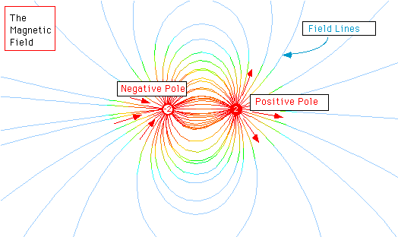

**MAGNETIC FORCE**

A magnetic field exerts a magnetic force, also called Lorentz-force, *Fm*char7E on a charged particle moving with velocity *v*char7E

*Fm*char7E=*qv*char7Echar02*B*char7Echar3B

where the product of the arrows results in a new arrow directed perpendicularly to the directions of the magnetic field as well as velocity. This equation defines the magnetic field (force exerted on a unit charge moving with unit velocity) and leads to its SI unit: which is called 1 Tesla (1 T).

Around a permanent magnet or a wire carrying a steady electric current in one direction, the magnetic field is stationary and referred to as a magnetostatic field. At any given point its magnitude and direction remain the same. Around an alternating current or a fluctuating direct current, the magnetic field is continuously changing its magnitude and direction. Magnetic fields may be represented by continuous lines of force or [magnetic flux](http://www.britannica.com/EBchecked/topic/357147/magnetic-flux) that emerge from north-seeking [magnetic poles](http://www.britannica.com/EBchecked/topic/357247/magnetic-pole) and enter south-seeking magnetic poles. The density of the lines indicates the magnitude of the magnetic field. At the poles of a magnet, for example, where the magnetic field is strong, the field lines are crowded together, or more dense. Farther away, where the magnetic field is weak, they fan out, becoming less dense. A uniform magnetic field is represented by equally spaced parallel straight lines. The SI unit for magnetic flux is the [weber](http://www.britannica.com/EBchecked/topic/638524/weber). The number of webers is a measure of the total number of field lines that cross a given area. Magnetic fields may be represented mathematically by quantities called vectors that have direction as well as magnitude.

**SOURCES OF MAGNETIC FIELD**

* The poles (north and south) create the magnetic fields.
* Magnetic fields are, the result of the movement of electrostatic charges
* Any charged particle will create a magnetic field around its path of travel. (And, conversely, it can be affected by an external magnetic field).
* It could be the separation of charges that creates a magnetic dipole, as in an atom. (Positive nucleus with the negative electron cloud about it).
* It could be the movement of electrons in a conductor. (Electric current flow in a wire).
* One of the four basic forces in the universe is the electromagnetic force. Not the magnetic force, but the electromagnetic force. If there's no moving charge, there's no magnetic field. The two phenomenon are intrinsically connected.

**ELECTROMAGNETIC FIELD**

Electromagnetic field, a property of space caused by the motion of an [electric charge](http://www.britannica.com/EBchecked/topic/182416/electric-charge). A stationary charge will produce only an [electric field](http://www.britannica.com/EBchecked/topic/182554/electric-field) in the surrounding space. If the charge is moving, a [magnetic field](http://www.britannica.com/EBchecked/topic/357048/magnetic-field) is also produced. An electric field can be produced also by a changing magnetic field. The mutual interaction of electric and magnetic fields produces an electromagnetic field, which is considered as having its own existence in space apart from the charges or currents (a stream of moving charges) with which it may be related.Under certain circumstances, this electromagnetic field can be described as a wave transporting electromagnetic energy, electromagnetic fields, waves and impulses have different regions based on the frequency.

1. ELF- occupy frequency band between 3 Hz and 3kHz (extremely low frequency region)
2. VLF-occupy region between 3Hz to 30kHz(very low frequency region)
3. ULF-occupy region of < 3Hz(ultra low frequency region)

poles. Two magnets will be attracted by their opposite poles, and each will repel the like pole of the other magnet. Magnetism has many uses in modern life.

**Generation of Magnetic Fields**

* Static Magnetic Field: A simple bar magnet has got the magnetic lines of force travelling from its north (N) pole to its south (S) pole.
* DC Magnetic Field: If in the place of a magnet, we have a coil of wire carrying a Direct Current (DC) from a battery.
* Pulsed Magnetic Field: With an Alternating Current (AC) generator in the place of a battery, we have a current surging forward and backward in the coil windings generating a magnetic field surging back and forth in the coil along its axis.

**Parameters**

There are 4 important parameters for PMF. They are,

* Amplitude
* Frequency
* Wave Shape
* Duration of Exposure

Four different wave forms are

* Sine wave
* Square wave
* Ramp wave
* Pulse group

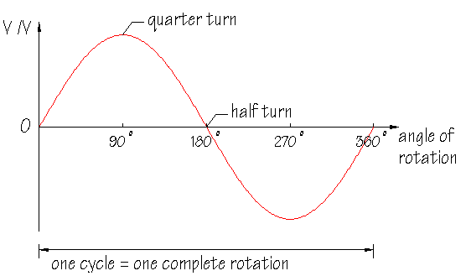

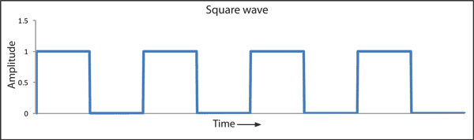

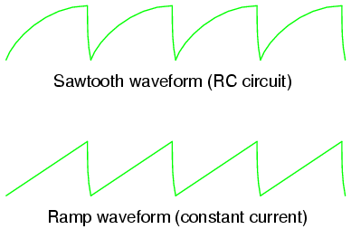

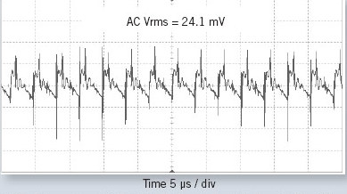

**BIOLOGICAL SAMPLE**

***Arachis hypogaea* (GROUND NUT)**

This is one of the applications of pulsed magnetic field. By treating the seeds in PMF, it results in speed seed germination, stimulates further plant growth and increases grain and vegetable yield and can therefore be used to increase the field germination rates of seeds.

Here we are going to take groundnut as our sample to introduce in pulsed magnetic field. Peanuts are a legume; in other words, they have a symbiotic relationship with specific Rhizobium bacteria that help them fix, or produce, their own nitrogen. The scientific name of peanut is Arachis hypogaea L., and it is a self-pollinated plant species

**BINOMIAL CLASSIFICATION**

* Domain : Eukarya
* Kingdom : Plantae
* Phylum : Magnoliphyta
* Class : Magnoliopsida
* Order : Fabales
* Family : Leguminosae
* Sub-family : Papilionaceae
* Genus : Arachis
* Species : hypogaea

Peanuts are divided into two subspecies,hypogaea  and fastigiata. The hypogaea  sub species do not flower on the main stem and, in general terms, mature later, have a high water requirement, have alternate branching patterns, and produce large seed. The fastigiata subspecies produce flowers on the main stem, have sequential branching, and, relative to the other subspecies, mature earlier, have a lower water requirement and produce smaller seed.

[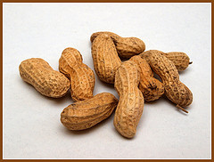](http://www.flickr.com/photos/verzo/5197568316/)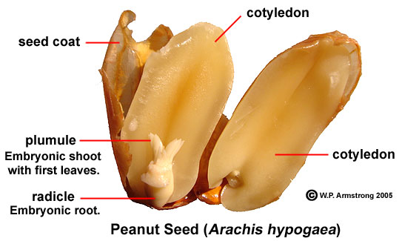

**FIG: 1 PEANUT SEEDS**

**NUTRIENTS IN GROUNDNUT**

Peanuts are rich in nutrients, providing over 30 essential nutrients and [phytonutrients](http://en.wikipedia.org/wiki/Phytonutrient" \o "Phytonutrient). Peanuts are a good source of [niacin](http://en.wikipedia.org/wiki/Niacin" \o "Niacin), [folate](http://en.wikipedia.org/wiki/Folate" \o "Folate), [fiber](http://en.wikipedia.org/wiki/Fiber" \o "Fiber), [magnesium](http://en.wikipedia.org/wiki/Magnesium" \o "Magnesium), [vitamin E](http://en.wikipedia.org/wiki/Vitamin_E" \o "Vitamin E), [magnesium](http://en.wikipedia.org/wiki/Magnesium" \o "Magnesium) and [phosphorus](http://en.wikipedia.org/wiki/Phosphorus" \o "Phosphorus). They also are naturally free of [trans-fats](http://en.wikipedia.org/wiki/Trans-fat" \o "Trans-fat) and sodium, and contain about 25% protein (a higher proportion than in any true nut.

**Nutritional value per 100g**

Energy 2,385 KJ (570Kcal)

Carbohydrate 21g

Sugar 0.0g

Dietary fiber 9g

Fat 48g

**Fatty acid**

Saturated 3g

Monounsaturated 24g

Polyunsaturated 16g

Protein 25g

Water 4.26g

Vitamins

Thiamine (vit.B1) 0.6 mg(52%)

Niacin(vit.B3) 12.9mg(86%)

Pantothenicacid 1.8mg(36%)

Vit. B6 0.3mg(23%)

Folate(vit.B9) 246μg(62%)

Vit.C 0.0g

Calcium 62mg(6%)

Iron 2mg(15%)

Magnesium 184mg(52%)

Phosphorus 336mg(48%)

Potassium 332mg(7%)

Zinc 3.3mg(35%)

**AIM AND OBJECTIVE**

**AIM**

To determine the biochemical and morphological changes on groundnut seeds exposed to pulsed magnetic field.

**OBJECTIVE**

To evaluate if there is any changes in seeds after exposed to pulsed magnetic field of beneficial parameters such as carbohydrate, protein, amino acid, nucleic acid, and enzyme activities

**MATERIALS**

**Pulsed Magnetic Field Exposure**

The pulsed magnetic field (PMF) used in the experiments were generated in a specially fabricated Controlled magnetic Field (CMF) enclosure. The 3 member coil system of the CMF enclosure, designed after the primary equations of Fansleau and Braunbeck, is made up of 2 sets of circular coils the inner two is being of large diameter and the outer two are of smaller diameter, all the four being mounted co- planar and co – axial. The four coils are wound with the same number of turns of enamelled copper wire, all the coils being electrically connected in ‘series-aiding’ configuration. The ratio of the diameter of the 2 sets of coils and also the separation (or spacing) in between them are so adjusted that the entire disc – shaped volume between the inner (larger) coils offers the most uniform (ie.Homogenous) magnetic field. This configuration gives an estimated degree of homogeneity of about one part in 5000.

This coil system of Fansleau and Braunbeck is a refined version of classical Helmholtz 2 – coil system offering the most practical advantage of large volume of highly uniform magnetic field of the order 20 to 30 times that offered by a Helmholtz coil of identical physical dimensions.

The coil system is energized by pulsed electric current from a function generator (PLATE: 3) in which the strength, frequency and waveform of output current can be controlled to any desired values. Thus, offering along the axis of the coil system on highly uniform or homogeneous pulsating magnetic field.

To ensure that the alternating current power supply to the function generator (domestic electric power) is not interrupted during the PMF exposure by possible power failure, an **UPS** system is built into the supply circuit, which delivers uninterrupted power regardless of any power failure. As regards the geometry of presentation of PMF the controlled magnetic field (CMF) coil assemblies were kept all with their axis vertical so that the axis of PMF passes through the test objects vertically.

The coil assemblies, designed and fabricated at Madras Institute of Magnetobiology are carefully calibrated using high precision Magnetometers and current measuring devices in the magnetic standardization lab of the institute. The Magnetometer used for these measurements is a magnetic observatory standard called “Zero Balance Magnetometer” manufactured by Danish Meteorological Institute, Denmark. The sets of equations for reducing the observations have the provision for incorporating the correction for temperature changes so that the final field determinant is free of any distorting contribution arising from temperature changes. Most importantly, the intrinsic method of measurement used is “Null method” which ensures high precision.

The PMF for exposure of dry seeds is obtained from a standard function generator, wherein a “carrier wave” of frequency 100 Hz is “frequency - modulated” by another wave of 0.3 Hz. In principle with the above system the input pulsating magnetic field will be a constant intensity where whose frequency pulses at 0.3 sec frequency.

**Exposure Details**

50g of Ground nut seeds are taken in 3 packets. The seeds are exposed to pulsed magnetic field of frequency [T1- 100 Hz, T2 – 500 Hz, T3 – 1000 Hz] with intensity ±1500 nT, current of 30mA using sine wave for 5hrs duration per day for a period of 15 days. Seeds without exposure to pulsed magnetic field served as control. The seeds exposed to PMF are in dry condition.

* **Control** - Seeds not exposed to magnetic field
* **Test 1(T1)** - Seeds exposed to 100 Hz
* **Test 2(T2)** - Seeds exposed to 500 Hz
* **Test 3(T3)** - Seeds exposed to 1000 Hz

**PLATE 1**

**Arachis hypogeae (GROUND NUT) Seeds Exposed to Pulsed Magnetic Field** 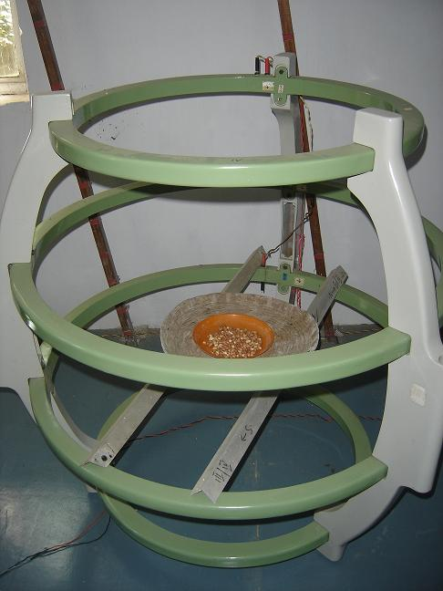

**PLATE 2**

**FUNCTION GENERATOR**

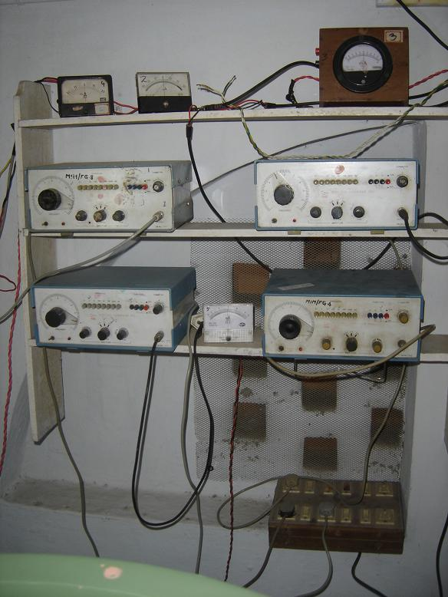

**RESULTS & DISCUSSIONS**

**MORPHOLOGICAL ANALYSIS**

**25** seeds from each exposed samples were counted and soaked separately for overnight. After the seeds were soaked overnight the seeds were sown in three different pots. The unexposed control seeds were also sown in separate pot. The seeds were allowed to germinate and the studies of their growth parameters like there root and shoot length, fresh and dry weights were studied on the 15th day of germination. The seeds started emerging on the 4 th day of germination. On the 7th day, under control - 2 plants, in T1 – 4 plants, T2 – 5 plants and in T3 - 3 plants were grown.

|  |  |  |  |  |  |
| --- | --- | --- | --- | --- | --- |
| **S.NO** | **PARAMETER** | **CONTROL** | **TEST - 1** | **TEST - 2** | **TEST - 3** |
| 1 | **Percentage of Germination** | 60 | 28 | **84** | 32 |
| 2 | **Shoot Length** | 9.00 | 14.00 | **23.50** | 19.00 |
| 3 | **Root Length** | 2.00 | 4.00 | **5.50** | 5.00 |
| 4 | **Fresh Weight** | 3.34 | 3.10 | **4.81** | 4.17 |
| 5 | **Dry Weight** | 1.68 | 1.26 | **2.36** | 1.91 |
| 6 | **Moisture content** | 49.64 | 59.28 | 50.94 | **54.16** |

**MOISTURE CONTENT**

By obtaining the fresh and dry weight of the samples, the moisture content of the samples, control, T1, T2, T3 were calculated using formula:

$$Moisture Content=\frac{\left(Fresh Weight\right)− (Dry Weight)}{Fresh Weight}∗100$$

**PLATE: 3**

**GERMINATION OF PEANUTS**

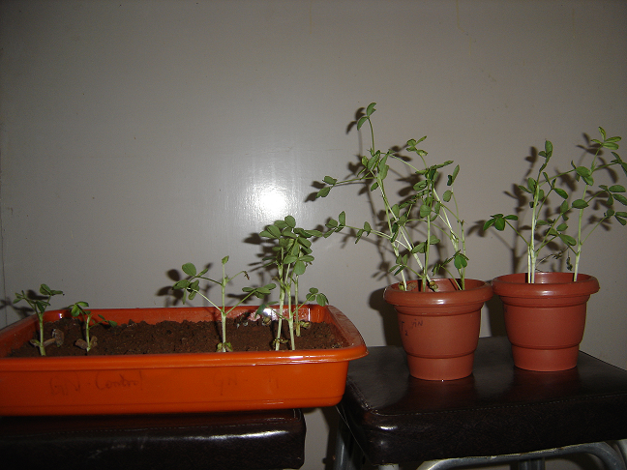

**PLATE: 4**

**ANALYSIS OF SEEDLINGS**

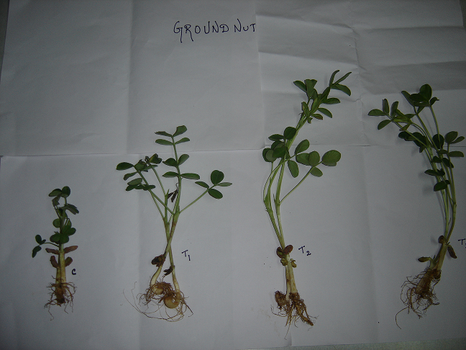

The technique of pre sowing treatment of seeds is based on their irradiation by pulsed magnetic field. It speeds seed germination, stimulates further plant growth, and increases grain and vegetable yields. Magnetic field vary with time alters the permeability of cell membrane by affecting the bio-electric field in or around the cell. The beneficial effects observed on seedlings magnetically treated under different conditions, which depends on the specific magnetic treatment applied such as time of exposure, magnetic field strength, stationary or alternating frequency. During plant development, plants convert physical and chemical signals (e.g., light, gravity, phytohormones, etc) into specific growth response. The pathway for these environmental or physiological studies leads to a new development program involving biochemical and molecular changes in the cells. Research efforts are mainly addressed to the basic principle of coupling between electromagnetic energy and bio-molecular structures. In plants, the PMF can be used for crop development to increase morphological and biochemical parameters.

**ANALYSIS OF BIOCHEMICAL PARAMETERS**

|  |  |  |  |  |  |
| --- | --- | --- | --- | --- | --- |
| **S.NO** | **PARAMETER** | **CONTROL** | **TEST - 1** | **TEST - 2** | **TEST - 3** |
| 1 | **CARBOHYDRATES** | 22 | **46** | 40 | 28 |
| 2 | **PROTEIN** | 80 | 88 | 14 | **100** |
| 3 | **AMINO ACIDS** | 3.9 | 3 | **4** | 3.4 |
| 4 | **PROTEASE** | **3.5** | 0.7 | **2.6** | 0.5 |
| 5 | **DNA** | 80 | **224** | 168 | 136 |
| 6 | **RNA** | 360 | 368 | **376** | 160 |
| 7 | **α - Amylase** | 40 | 32 | 56 | **88** |
| 8 | **β - Amylase** | 0.04 | 0.08 | **0.11** | 0.04 |

**The present study has been framed with the objective to study the effect of pulsed magnetic fields on various biochemical parameters of** Arachis hypogaea **seeds.**

**FIGURE: 1 ESTIMATION OF CARBOHYDRATES**

In experiments conducted to estimate the amount of **carbohydrate** showed a gradual increase in Test-1, Test-2 and Test-3 when compared to control. Analysis of the total content of carbohydrates present in the given samples shows that there is only a slight variance in the level of carbohydrates compared to that of the control. The results obtained are supported by the work of **Yu. I. Novitsky et al.(36)**(November 2001)in the paper “**Growth of Green Onions in a Weak Permanent Magnetic Field”** Novitsky et al. studied the effect of a weak permanent magnetic field (PMF) with a strength of 403 A/m on *Allium cepa*L. Two onion varieties to produce green onions (cv. Arzamasskii) and bulb onions (cv. Ryazanskii) were examined. In addition, the content of chlorophyll, carbohydrates, and protein in the leaves of the control and PMF-treated plants were determined. The plants of the control group were grown under a natural geomagnetic field. PMF elevated had no drastic effect on the total content of carbohydrates. (Yu. I. Novitsky *et al.,* November 2001).

**FIGURE: 2 ESTIMATION OF PROTEINS**

The amount of **protein** present in the given sample was estimated by the Lowry’s method. There is an increase in the Test 2, Test 1 and Test 3 values as compared to the control. The increase in the protein content is supported by the works of SemaAlikamanoglu and Ayse Sen, “stimulation of growth and some biochemical parameters by magnetic field in wheat tissue cultures”.**Sema Alikamanoglu (37)** (2011) studied the effects of magnetic field (2.9 to 4.8 mT by 1ms-1) applied to mature embryos of wheat variety.They determined the various physiological and biochemical parameters(protein ,enzyme activities) .Protein content in mature embryo culture exposed to magnetic field showed increase by compared to control respectively.

**FIGURE:3 ESTIMATION OF AMINOACIDS**

The **amino acid** content of our samples has been determined. There is only slight variations with control and Test-2 .Test-1 and Test-3 are less compared to control (unexposed seeds). These results are supported in the paper **“ELF magnetic fields increase amino acid uptake into *Vicia faba* L. Roots and Alter Ion movement across the plasma membrane**” **B.C. Stange *et al* (38)***.* (2002) showed that *Vicia faba* seedlings, subjected to a 10 μT 50 Hz square wave magnetic field for 40 min together with a radioactive pulse, showed a marked increase in amino acid uptake into intact roots. A more modest increase was observed with a 100 μT 50 Hz square wave. An increase in media conductivity at low field intensities from 10 μT 50 Hz square wave, 100 μT 50 Hz sine wave, and 100 μT 60 Hz square wave fields, indicated an alteration in the movement of ions across the plasma membrane, most likely due to an increase in net outflow of ions from the root cells. (B.C. Stange *et al,* 2002)

**FIGURE:4 ESTIMATION OF PROTEASE**

In the present study, there is an decreased activity of the **enzyme protease** in the exposed seeds compared to the unexposed control seeds. Protease is an enzyme that conduct proteolysis, that is, it is involved in digesting protein chains into short fragments, splitting the peptide bonds that links amino acid residue. **P. Rajendra, (39)**l, in his studies, “effects of power frequency electromagnetic field on growth of germinating Vicia faba L., the broad bean”. The experimental investigations were carried out to evaluate the effect of continuous and delayed exposure of power frequency electromagnetic field at 5, 50 and 100 μT on germinating Vicia faba seedling as a model system. Their study includes physiological parameters, biochemical constituents and enzyme activities on the 2nd and 4th days of growth. Significantly, there was a decreased protease activity on 100 μT.

**FIGURE:5 ESTIMATION OF DNA**

**FIGURE: 6 ESTIMATION OF RNA**

In the experiments conducted to estimate the **Nucleic acid content**  it is seen that there is an increase in all the test values in the amount of DNA as compared to the control. Similarly there is an increase in Test-2 as compared to control in the amount of RNA .Test-1 showed equal value of control were Test-3 is less than control preliminary studies by **M.Racuciu et.al,(40)** 2006, applied five different values of magnetic induction of static magnetic field , ranging between 50mT and 250mT for 14 days(Zea mays) .They investigated the biochemical changes of chlorophyll, cartenoid, nucleic acid. low magnetic field energy density the average nucleic acid level is enhanced in comparison to the control sample, while for the increasing magnetic field energy density an inhibitory effect for average nucleic acid levelwasnoticed. **FIGURE: 7 ESTIMATION OF α – AMYLASE**

**FIGURE: 8 ESTIMATION OF β – AMYLASE**

In experiments conducted to estimate the **enzyme activity***,***α-Amylase** showed a marked gradual increase in Test 1, Test 2 as compared to the control. Test 3 decreased drastically compared to that of control, Test 1 and Test 2. In the case of **β-Amylase,** the enzyme activity is seen increased in Test-1 and Test-2 compared to control. Jyotsna Bhardwaj et.al (41), Biochemical and biophysical changes associated with magneto priming in germinating cucumber seeds. The activity of hydrolytic enzymes were greater than untreated control (2012).

**SUMMARY**

***Arachis hypogeae*** seeds were exposed to a pulsed magnetic field of sine wave form with varying frequencies as 100, 500, 1000 Hz and constant intensity of about 1500 nT. The seeds were exposed to frequency of 100 Hz is taken as Test-1, 500 Hz as Test – 2, 1000 Hz as Test – 3. Seeds are subjected to the high pulsed magnetic field for a time interval of 5 hours per day for 15 days. After the exposure time over, on the 16th day, the estimations are carried out for carbohydrates, proteins, amino acids, nucleic acids (DNA & RNA), enzymes (Amylase & Protease). It is seen from the experiment that the magnetic field has enhanced the morphological and biochemical parameters of the seeds.From our investigation, it was studied that, Test 3 has maximum stimulating effect on the enzyme activity, Test 1 has shown increase in the biochemical parameters and Test 2 shows an increase in some biochemical parameters, but it is not steady as above two.Thus, this frequency might provide a feasible non – chemical solution for seeds germination. Therefore, it is evident that the use of varying magnetic field frequency will definitely proves to be a pre treatment catalyst in agriculture promoting vigor growth and good yield of crops. This is a best alternative way in place of pesticides will definitely helps in protecting environment.

**REFERENCE**

1. Abdelrahim A, et.al, **“effects of pulsed magnetic field on healing of Mandibular fracture”,** Joural of oral ad maxillofacial surgery, Vol – 69, issue 6, page – 1708 – 17.
2. Mert.T, et-al, “**Neurobiological effects of pulsed magnetic field on diabetes – induced neuropathy”**, Bioelectromagetics, Vol – 31, issue – 1, page – 39 – 47, 2010.
3. Pan.W, et.al, **“Effects of pulsed magnetic field on the formation of magnetosomes in the Magnetospirillum Sp.strain AMB 1”**, Bioelectromagnetics, Vol – 31, issue – 3, page – 246 – 51, 2010.
4. Ch. Dahmani, et.al, **“Rotational Magnetic pulses enhance the magnetofection efficiency in vitro in adherent and suspension cells”,** Journal of Magnetism and Magnetic Materials., Volume 332, page 1 – 204, 2012.
5. Sarah. W, et.al, **“Enhancement of the efficiency of non-viral gene delivery by application of pulsed magnetic field,”** Oxford Joural, nucleic acid research, Vol 34, Issue – 5, 2006.
6. L.Zhang, et.al, **“Effects of pulsed magnetic field microstructures and morphology of the primary phase in semisolid A 356 A1 Slurry,”** Materials letters, vol 66, issue -1, page 190 – 192, 2012.
7. Hunt RW, **“Electromagetic biostimulation of living cultures for biotechnology, bio fuel and bio energy applications,”** It. Journal Molecular Science, vol.10, issue 10, page 4515 -58, 2009.
8. I.I. Nagy, et.al, **“effects of pulsed variable magnetic fields over plant seeds”,** Romanian, Journal of Biophysics, vol.15, page 133 – 139, 2005.
9. Alegre RM, et.al, **“Growth of Escherichia Coli, under extremely low frequency electromagnetic field”,** Appl. Biochem Biotechnol, vol.134, issue 2 , page 155 – 163, 2006.
10. Pilla A.A, et.al, **“Pulsed magnetic fields accelerate Cutaneous waind healing in rats”,** Plast Reconstr. Surg, vol.120, issue 2, page 425 430, 2007.
11. Vashisth. A, et.al, **“Exposure of seeds to static magnetic field enhances germination and early growth characteristics in chickpea”,** Bioelectromagnetics, Vol.29, issue 7, page 571 – 578.
12. Hunt. R.W., et.al, **“Electromagnetic biostimulation of living cultures for biotech- nology, biofuel and bioenergy applications”**, Internatioal journal of Molecular science, vol.10, issue 10, page 4515 – 58, 2009.
13. Ananta Vashisth, et.al, **“Effect of germination and early growth characteristics in sunflower (Helianthus annuces) seeds exposed to static magnetic field”,** Journal of plantPhysiology, vol.167, issue 2, page 149 – 156, 2009.
14. V.Nimmi, et.al, **“Effect of pre-sowing treatment with permanent magnetic field on germination and growth of chilli”**, International Agrophysics, vol.23, page 195 – 198, 2009.
15. J.A. Odhiambo, et.al, **“Effect of Static electromagnetic fields art 24 hours incubation on the germination of rose coco beans”,** Romanian journal of Biophysics, vol.19, No.2, page 135 -147, 2009.
16. Hanna Dorna, et.al, **“Effects of permanent magnetic field together with the shielding of an alternating electric field on carrot seed vigour and germination”**, Ecological chemistry and engineering , vol.17, No:1 ,2010.
17. Radhakrishnan. R, et.al, **“Pulsed magnetic field, a contemporary approach offers to enhance plant growth and yield of soybean”**, Plant Physiol Biochem, vol.51, page 139 – 44, 2011.
18. Hyun Sook Lee , **“Effect of pulsed magnetic field stimulus o electroencephalogram Alpha activity”**, Magnetics, vol.47, issue 10, page 3060 – 62, 2011.
19. Shine M.B. , et.al, **“Enhancement of germination, growth, and photosynthesis in soybean by pre-treatment of seeds with magnetic field”,** Bioelectromagnetics, vol.32, issue 6, page 474 – 84, 2011.
20. Iqbal, et.al, **“Effect of pre-sowing magnetic treatment on properties of Pea”,** International Agrophysics, vol.26, page 25 31, 2011.
21. Anjali Anand, et.al, **“Pre-treatment of seeds with static magnetic field ameliorates soil water stress in seedling of maize”,** Indian Journal of Biochemistry and Biophysics , vol.49, page 63 – 70, 2011.
22. Leelapriya. T, et.al, **“Effect of pulsed magnetic field treatment of soybean seeds on Calli growth, Cell damage and biochemical changes under salt stress”,** Bioelectromagnetics, vol.33, issue 8, page 670 81.
23. Naz.A, et.al, **“Enhancement in the germination, growth and yield of Okra using pre-sowing magnetic treatment of seeds,** “Indian Journal of Biochem, Biophysics, vol.49, issue 3, page 211 – 14 , 2012.
24. Mihaela Racuciu, **“Influence of extremely lowfrequenmcy magnetic field on assimilatory pigments and nucleic acid in Zea mays, and curcubita pepo seedlings”,** Romanian Biotechnological Letters, vol.17., No.5, 2012.
25. K.Venkateswar Reddy, et.al, **“Exposure of green gram seeds, to static magnetic field, effects on germination and α amylase activity”,** Research Journal of seed science, vol.5, issue 3, page 106 – 114, 2012.
26. Maroua Akacha Touat, et.al, **“Effects of moderate SMF presowing treatment on seedling growth and oxidative status in two Raphanus sativus L varieties”**, African journal of biotechnology , vol.12, issue.3, page 275 to 283 , 2012.
27. Santosh kumar Tripathi, **“Protein level changes under magnetic exposure of Larvae in Bombyx mori : A multivoltine mulberry silkworm,** Academic journal of entomology, vol.5, issue.2 , page 73 to 80, 2012
28. Dimitroios. J, et.al, **“Magnetic field pre-sowing treatment as an organic friendly technique to promote plant growth and chemical elements accumulation in early stage of cotton”** , Australian Journal of Crop Science, vol.7, issue 1, page 46-50,2013.
29. **Lowry O.H., Rose Borough N.J Farr A.L Randell R.J. (1951),** Journal of biological chemistry, Volume 196, Pg. no:- 265.
30. **Carrol. N.V, Longley.N, and Reo.J.A (1956),** Journal of Biological chemistry, Volume. 250, Pg.No. 283
31. **Lee X.P. and Thakaski T (1966),** Estimation of Amino acids, Analytical Biochemistry. Volume 4: 152
32. **Burton.K (1956),** Journal of Bio-chemistry, Volume 24, Pg.no:- 315.
33. **Ashwell.G (1957),** Methods in Enzymology, Volume 3, Academic press, Newyork, Pg.no:-87
34. **Mc.Clearly.B.V., Gibson.J.S., Solah.V., and Mugford.D.C. (1994),** Cereal chemistry, Volume 71, Pg.no:- 501 - 508.
35. **Nihon Naika Gakkai zasshi (1986),** The Journal of the Japanese Society of Internal Medicine. Nippon Jinzo Gakkai shi. 28(4): 447- 454
36. u.I. Novitsky, et.al, **“Growth of green onions in a weak permanent magnetic field”** Russian journal of plant physiology, vol.48, issue 6, page 709-716,2001.
37. Alikamanoglu and Ayse sen, **“stimulation of growth some biochemical parameters by magnetic field in wheat tissue culture”,** African journal of biotechnology, vol.10, issue 53, page 10957210963, 2011.
38. C.Stange,et.al, **“ELF magnetic field increase amino acid uptake into vicia faba L. Roots and alter ion movement across the plasma membrane,”** Bioelectro magnetics, vol.23, issue 5, page 347 to 354, 2002.
39. Rajendra, et.al, **“effects of power frequency electromagnetic fields on growth of germinating Vicia faba L., the broad bean”.** Electro magnetic biology and medicine, vol.24, No.1, page 39 to 54, 2005.
40. Racuciu, et.al, **“Plant growth under static magnetic field influence”,** Rom.Journal of physics, vol.53, page 353 to 359, 2006.
41. yotsna Bardwaj. et.al. **“Biochemical and Biophysical cxhanges associated with magneto priming in germinating cucumber seeds.”** Plant physiological Biochemistry, vol.57, page 67 to 73, 2012.