Food Processing Techniques and Nutritive Value of Finger millet (Ragi, Eleusine coracana L.) Plant
Hema Deupa^{1*}; Priyanka Shankar²
¹Department of Food and Nutrition, Babasaheb Bhimrao Ambedkar University, Lucknow, Uttar Pradesh, India; Email- hemadeopaa@gmail.com
²Department of Human development and family studies, Babasaheb Bhimrao Ambedkar University, Lucknow, Uttar Pradesh, India
Introduction
Finger millet/ragi (Eleusine coracana L.) is one of the oldest crops in India. In ancient Sanskrit literature, finger millet is referred to as “nrtta-konkdaka” which means “Dancing grain”, and also “rajika” or “markataka” (Achaya, 2009). The initial history of finger millet was reported from Hallur in Karnataka, India near about 2300BC (Singh, 2008). The origin of finger millet has been debated widely, although the archeological study carried out in India and outside report that from the origin, it was grown in Africa and provide linguistic evidence for “ragi” from the root term-degi in numerous Bantu languages of northern Malawi and southern Tanzania and its other species from Indian subcontinent (Fuller 2002, 2003).
Finger millet plant was well cultivated and harvested in many different states of India, also popularly known as “nanchi” in the part of Maharashtra, and “umi” in Bihar, etc. The grains of ragi were gently roasted (sometime sprouted or dried), grounded and sieved. The pinkish color flour was eaten as gruel or ball, and at times sweeten and salted. It was a popular weaning food (Achaya, 2009). In Tamil literature Sangam (600BC-200AD), “Purananuru” specify the process of drying, dehusking, and cooking of finger millet.
Structural composition of finger millet
The seed coat, embryo and the endosperm are the three main component of millet kernel. Finger millets are available in varieties of color such as white, tan, red, yellow or brown; however, red-colored ones are most inclusively cultivated. The outer most covering i.e., the pericarp layer is of little significance. The testa or seed coat is of multiple layers, which is unique in association to pearl millet, sorghum, foxtail and proso millet (FAO, 1995) and may possibly a reason behind high dietary fiber content in the finger millet. The seed coat is closely bound to the aleurone layer and starchy endosperm, which are segregated into corneous and floury regions. The corneous endosperm has compactly arranged starch granules inside the cell walls and floury endosperm has roughly arranged starch granules (McDonough et al., 1986). The size of starch granules varies in different regions of finger millet kernel ranging from 3 to 21mm in relation to proso and pearl millet (Serna-Saldiver et al., 1994). The floury starch granules have larger structure in comparison to corneous endosperm and therefore are more liable to enzymatic digestion. Though, more literature is required to understand the enzyme susceptibility of starch present in floury and corneous endosperm regions of finger millet separately.
Usually, finger millet is milled along with the seed coat (rich in micronutrient and dietary fiber) to produce flour and whole meal is used in the preparation of different food product. The seed coat layers contain certain anti-nutritional factors tannins, phytates, cyanide, oxalate, saponins and polyphenols which contribute to astringent flavor in its products and causes chelation of minerals in the gastrointestinal tract, thereby lead into micronutrient loss (Harris et al., 1978). Certain pre-treatment like boiling, soaking, roasting, parboiling, germination, fermentation, decortication, extrusion cooking and milling can reduce the amount of anti-nutritional component to an acceptable level. By applying such processing techniques, this under-utilised crop can be converted into diverse commercial and traditional value-added food products.
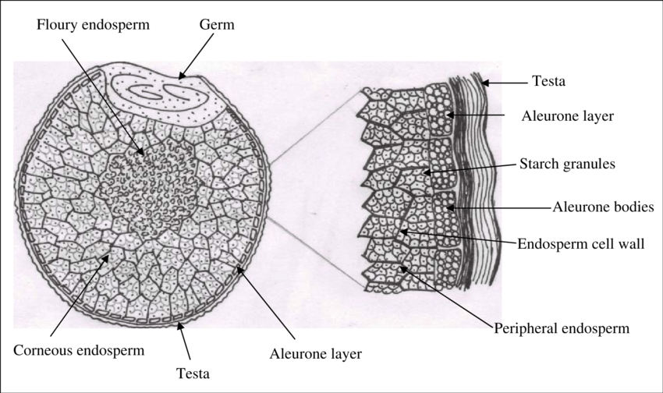
Figure1: Shows the structural diagram of finger millet (Source: https://ir.cftri.res.in/9955/ )

Anti-nutritional factors
Finger millet has highest content of tannin (0.04-3.47%) than compare to any other millet (Subhash et al., 2015). The content of tannin varies across finger millet in which brown variety have 0.61% while white variety has 0.05%. Excess amount of tannin lowers the iron levels in diet which eventually decrease nutritional profile of the grains and it further reduce protein digestibility, growth rate, feed intake, and net metabolic energy in an animal model (Gull et al., 2016). Tannins also led to sound effects on microbial enzyme activities even gastro-intestinal digestion & cellulose activity is depressed. Tannins are also identified as antioxidant as it protects our body against cell damage and further neutralising chemicals. The phytate content present in finger millet is 0.48%, it is a phosphorus compound which hinder the absorption of calcium and zinc in the small intestine (Doherty et al., 1982). Phytate form complex compound with multivalent cations and protein molecules as it has strong binding activity. Saponins (0.36%) are also present in finger millet which cause hemolytic (destruction of red blood cells) activity. It affects the central nervous system, digestive system and cardiovascular disease (CVD). It also decreases protein digestibility and absorption in intestine. Saponins lower the occurrence of cancer and assist in lowering cholesterol and after meal blood glucose level (Gull et al., 2016). In addition, oxalate (0.27%) an anti-nutritional factor affects calcium & magnesium absorption and form complexes with protein and interfere in peptic digestion (Subhash et al., 2015). Oxalate also causes kidney stones. Healthy people can safely consume oxalate rich food however, people with altered gut function required to limit their intake. The permissible range of oxalate in human diet is <50mg per day.
Nutritional composition of Finger millet
Finger millet has excellent nutritive value as it encompasses 6-8% of protein, 65-75% of starch, 1-1.7% fat, 2-2.5% minerals and 18-20% of dietary fiber. The proximate composition of finger millet is superior than maize, sorghum, rice and wheat in respect to calcium, fiber, and some micronutrients (Shobana et al., 2009).
- Carbohydrates
The carbohydrate present in finger millet constitute of starch (65.5%) & non-starch polysaccharides, free sugars (1.04%), and dietary fiber (11.5%) (Gopalan et al., 2009). Some studies report few varieties of finger millet has 59.5-61.2% of starch,1.4-1.8% cellulose, 6.2-7.2% of pentosans, and 0.4-0.6% lignins (Wankhede et al., 1979a). The dietary fiber content of finger millet is 11.5% which is more than that of polished rice, brown rice, foxtail, kodo, little and barnyard millet. Although, the fiber content of finger millet is similar to that of wheat and pearl millet. Overall, the carbohydrate content of finger millet is similar to wheat but lower in comparison to polished rice. The starch in finger millet is made up of amylose and amylopectin, wherein the amylose content is lower (16%) (Wankhede et al., 1979b) in relation to proso (28.2%), sorghum (24.0%), pearl (21.0%), foxtail (17.5%), and kodo millet (24.0%).

- Proteins
Protein content of finger millet varies widely in which prolamin has major portions (Virupaksha et al., 1975). In general, millets and cereals have lesser amount of Lysine in respect to legumes and animal sources (ICMR, 2010). Albumin and globulin protein compose of several essential amino acids, though prolamin contain higher portion of proline, valine, isoleucine, leucine, glutamic acid, and phenylalanine but lower lysine, arginine and glycine. The chemical score (a measure of protein quality) of finger millet is 52 in comparison to pearl millet (63) and sorghum (37) (FAO, 1995). Methionine and cystine content of finger millets are also higher in relation to milled rice. Anti-nutritional activity of grain such as protein digestibility is affected by tannin. Although, Subrahmanyan et al., (1955) stated intake of finger millet and pulses in diet can sufficiently regulate positive nitrogen (10.4%), calcium (3.0%) and phosphorus (8.7%) balance in adults. Other studies also suggest that consumption of finger millet and lysine or leaf protein (lucerne) can elevate protein digestibility, nitrogen retention, and overall nutritional status among children (Doraiswamy et al., 1969).

- Fat
The total lipids count reported to be approx. 1.85-2.10% in seven major varieties of finger millets (Mahadevappa et al., 1978). The lipid composition of finger millet composes of 70-72% of neutral lipid, wherein triglycerides is mainly present and some traces of sterols, glycolipids (10-12%), and phospholipids (5-6%). In general, finger millet lipid also contains 8-27% of linoleic acid, 46 to 62% oleic acid, 20 to 35% palmitic, and some traces of linolenic acid. The fat content of finger millet is lesser in comparison to pearl, barnyard, little and foxtail millet, however, this factor is one of the most promising contributing factor in maintaining the storage as well as the shelf life of the finger millet.
Table 1: Nutritive composition of various millets (all values as per 100g of edible portion)

Nutrients | Finger millet | Pearl millet | Foxtail millet | Porso millet | Wheat | Rice (white, milled) | Rice (brown, milled) | Corn grain | Sorghum | Oats | Barley (pearled raw)
Proximate composition
Moisture (g) | 13.1 | 12.4 | 11.2 | 11.9 | 12.8 | 13.7 | 12.4 | 10.4 | 12.4 | 8.2 | 10.4
Energy (kcal) | 336 | 361 | 331 | 341 | 346 | 345 | 362 | 365 | 329 | 389 | 352
Protein (g) | 7.7 | 11.6 | 12.3 | 12.5 | 11.8 | 6.8 | 7.5 | 9.4 | 10.6 | 16.9 | 9.9
Carbohydrate (g) | 72.6 | 67.5 | 60.9 | 70.4 | 71.2 | 78.2 | 76.2 | 74.3 | 72.1 | 66.3 | 77.7
Total dietary fiber (g) | 11.5 | 11.3 | 2.4 | - | 12.5 | 4.1 | 3.4 | 7.3 | 6.7 | 10.6 | 15.6
Fat (g) | 1.5 | 5 | 4.3 | 1.1 | 1.5 | 0.5 | 2.7 | 4.7 | 3.5 | 6.9 | 1.2
Minerals (g) | 2.7 | 2.3 | 3.3 | 1.9 | 1.5 | 0.6 | - | - | 1.6 | - | -
Vitamins
Thiamine (mg) | 0.42 | 0.33 | 0.59 | 0.2 | 0.45 | 0.06 | 0.41 | 0.39 | 0.33 | 0.76 | 0.19
Riboflavin (mg) | 0.19 | 0.25 | 0.11 | 0.18 | 0.17 | 0.06 | 0.04 | 0.2 | 0.096 | 0.14 | 0.11
Niacin (mg) | 1.1 | 2.3 | 3.2 | 2.3 | 5.5 | 1.9 | 4.3 | 3.6 | 3.7 | 0.96 | 4.6
Total Folic acid (µg) | 18.3 | 45.5 | 15 | - | 36.6 | 8 | 20 | - | 20 | 56 | 23
Vitamin E (mg) | 22 | - | - | - | - | - | - | - | 0.5 | - | 0.02
Source: Gopalan et al., (2004) and USDA National Database for Standard Reference, Release 28 (2016)

- Micronutrients
Finger millet is excellent source of calcium 334mg % in comparison to cereals and millet sources, and contain 283mg % of phosphorus and 3.9mg % of iron (Gopalan et al., 2009), and other trace elements. Potassium content (408mg %) in finger millet is higher than any other cereal and millets. “Hamsa” variety of finger millet has reported unexceptional source of calcium content i.e., 660mg% (Umapathy et al., 1976). The phytic acid content is inferior than that of common millet & foxtail millet and the values varies across different variety of finger millet (0.45 to 0.49g %). Some studies report that roughly ~49% of total calcium content is present in the husk of the finger millet. The bioavailability of minerals increases by germination and fermentation also it lowers the phytate content to around 60% in finger millet. Bio-accessibility of mineral (iron, zinc and magnesium) can also increase by malting (Platel et al., 2010). Decortication (removing fibrous seed coat of grain) reduce the total mineral constituent but elevate the bio-accessibility of iron, calcium and zinc, however, popping of finger millet lower the bio-accessibility of calcium but inversely increase that of iron and zinc.
Phytochemical or phytonutrients
The phenolic content of finger millets varietally vary and is higher among brown variety than white variety (Chethan et al., 2007a). In general, finger millet seed coat contains various phytochemicals which have many health benefits. Finger millet are rich in phenolic compound especially both free and bounded form (Subba et al., 2002). Caffeic acid lower the fasting glucose levels and decrease the plasma glucose level in an intravenous glucose tolerance test in mice model. Further, catechin was found to improve the glucose tolerance and quercitin inhibited glucose transport in transfected oocyte model and glucose absorption in animal model (Matsumoto et al., 1993 & Scalbert et al., 2005). Although, the bioavailability of phenolic compound based on finger millet are less, and therefore it is necessary to investigate more literature based on in vivo antioxidant activity, long-term consequences of finger millet phenolics in human models.
Post harvesting operation
The harvesting period of finger millet is mainly through October to November. There are two methods for harvesting crop-
- Harvesting of only panicles (ear heads): Once the crops are mature, the panicles are cut with the help of sickle and leaving the standing plant stalks in the field. The operation is conducted at one time all together or at different interval based on uniformity and maturity. The harvested panicles are collected in a container or basket before piling them in a suitable place. The panicles staked are left for sun drying process form one week to few months, as the heat produced within the heap will assist in easy separation of millets during threshing technique.
- Harvesting of stalk and panicles: This is a most common method of harvesting. In which the harvested stalks are spread in row wise direction for sun drying for some days in the field. After sun drying, they are hurried and staked near the threshing area. In rainy days the heap is arranged in the bundle form in the closed line and in slanting position covered with dried straw to prevent it from dampening. After some days the covering is remove and dried in the sun for 1 to 2 days before staking in the field.
- Threshing of grains: The process of separation grain from panicles is done by spreading stalk or panicle in the morning hours & threshing usually begin from 10 o’clock. Threshing is done by mostly bullocks (4 to 5 in number) for trampling or stone roller driven by pair of bullocks. For small scale threshing bamboo sticks are used whereas, in large scale production in some places’ tractors are used by farm people for separation of grains.
- Storage of grains: Before storing the grain, finger millets are sun dry. Farmers use different type of structures for storage of finger millet. Closed structure is mostly preferred for storing. At present time nylon woven sacs or gunny bags are used by farmers for storage, although the duration of storage varies vividly in different region.
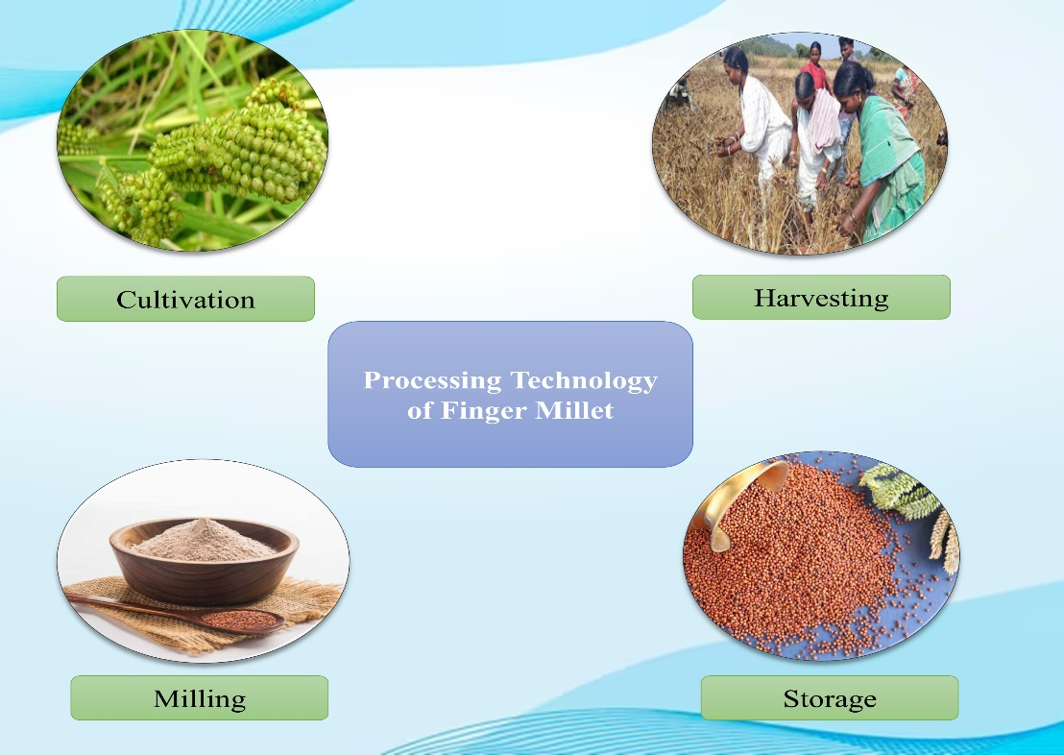
Figure 2: Shows the processing of finger millet grains
Processing of finger millet
Milling
Finger millets are usually crushed and grounded into flour for preparation of food products. In the beginning the grains are cleaned to get rid of foreign materials such as stalks, stones, chaffs, brick, etc. and moved to the friction mills to remove glumes (non- edible cellulose part) and then grounded. Typically, the pulverization is done in stone mills, iron disc or emery coated disc. Decortication or pearling are sometime used to dehusking of finger millets which result in grinding of endosperm and seed coat. Therefore, finger millets are usually pulverize along seed to prepare whole meal. Centrifugal sheller are also used in dehulling and decortication of millets.
Decortication
The decortication or “debranning” is process of removal of seed pods or outer covering so that only the kernel remains after processing. This is most recent process developed for finger millet (Malleshi, 2006). This method is applied in all the cereals, but it is not functional in case of finger millet as its seed coat is intactly link to fragile endosperm. Though hydrothermal processing i.e., hydration, steaming and drying is used to decorticate finger millet which strengthen the endosperm and allow it to withstand mechanical pressure. After decortication finger millet can be cooked as a rice.
Malting
Malting is a controlled process of germination of grains under moist air, which results in mobilization of enzymes (amylase, proteases and other) and further hydrolyze & modify the structural component. For specialty food, malting is commonly practiced. With the help of this process bioavailability of carbohydrate, protein, minerals and some B-vitamins is improved, inversely decrease in anti-nutritional factor is also seen. Malting starts with the soaking of seeds in the water which facilitate sprouting, and these sprots are then dried in kiln or firing pottery. At last, the rootlets are detached from the finger millet grain manually by hand rubbing. All these processes influence the quality of malted products. Germination is the most essential step during malting operation as it produces hydrolytic enzyme which cause modification in the endosperm and enhance nutritional property of the grains. Malting of finger millet has been effectively applied in various foodstuffs such as infant food, weaning food, confectionary items and milk-based beverage industry (Malleshi, 2007).
Popping
It is a common traditional practice used in preparing popped millet flour. In this method, finger millet is added with additional 3-5% of water to increase the moisture content and left for tempering for about 2-4 hours, after that popping is done under high temperature and short time (HTST) by brisking in sand at around 230°C. Highly desirable aroma is produced due to millard reaction between sugars and amino acids. Popped finger millet is a ready to eat food product and it can also be grinded and combined with protein rich foodstuffs to develop supplementary foods (Premavalli et al., 2003). Though the popping method can contaminate the food product with sand while heating and can affect the eating quality. To overcome this limitation air popping can be significantly employed, however, it lacks the characteristic aroma which is prior produce by sand.
Conclusion
Consumption of whole grains are associated to the reduce risk of cardiovascular disease, type 2 diabetes, therefore, consumption of whole-grain finger millets may have a potential role against varied health conditions. Finger millet-based products usually lower the glycemic index (GI) in combination with vegetable and pulses may help in controlling chronic diseases in particular. Further, different processing technologies has been found and utilised in enhancing nutritional features of millets. Although, consumption of millet grains is still a taboo among rural community of our population, due to the unavailability of processing tool and techniques. Thus, this book chapter provides a scientific justification for the use of finger millet as a therapeutic as well as health promoting food.
In addition, recognising the massive potential of millets to empower livelihoods, socio-economic income of farmers, food and nutritional security across world, Government of India (GoI) has promoted millets. In April 2018, millets are rebranded as “Nutri Cereals”, and the following year was stated as the National Year of Millets, with the objective to enhance the demand and supply of millets. United Nation declared 2023 as International Year of Millet (IYM) when a proposal moved by the India in 5th march 2021 and supported by 72 countries. It is necessary to give gratitude and honour to the traditional wisdom of humanity. The department of Agriculture and Farmers Welfare has come up with muti-stakeholders from all the central government ministries, state/ union territories, farmers, retail businesses, start-ups, hotels, etc. to accomplish the objective of IYM 2023 and popularising Indian millets world-widely. Ministries from the state and central government have also focused to carry out several activities to promote and aware the consumers as well as cultivators about the potential health benefits of millets.
Reference
- Achaya, K. T. (2009). The illustrated food of India A–Z. New Delhi, India: Oxford University Press.
- Singh, P. (2008). History of millet cultivation in India. In L. Gopal & V. C. Srivastava (Eds.), History of science, philosophy and culture in Indian civilisation, Volume V, Part I, History of Agriculture in India (up to c.1200 AD) (pp. 107–119). New Delhi: PHISPC, Centre for Studies in Civilisations. Concept Publishing Company.
- Fuller, D. Q. (2002). Fifty years of archeaobotanical studies in India: Laying a solid foundation. In S. Settar & R. Korisettar (Eds.), Indian archealogy in retrospect Archeology and interactive disciplines: Vol. III. (pp. 247–364). Delhi: Manohar.
- Fuller, D. Q. (2003). African crops in prehistoric South Asia: A critical review. In K. Neumann, A. Butler & S. Kahlheber (Eds.), Food, fuel and fields. Progress in African archaeobotany (pp. 239–271). Koln: Heinrich-Barth Institute.
- Food and Agricultural Organisation (FAO) of the United Nations. (1995). Sorghum and millets in human nutrition (FAO Food and Nutrition Series, No. 27). ISBN 92-5- 103381-1.
- McDonough, C. M., Rooney, L. W., & Earp, C. F. (1986). Structural characteristics of Eleusine coracana (Finger millet) using scanning electron and fluorescence microscopy. Food Microstructure, 5, 247–256.
- Serna-Saldiver, S. O., McDonough, C. M., & Rooney, L. W. (1994). The millets. In K. J. Lorenz & K. Kulp (Eds.), Hand book of cereal science and technology (pp. 271–300). New York: Marcel Dekker.
- Harris HB, Burns RE. Influence of tannin content on preharvest germination in Sorghum Agron. Journal. 1970; 62:835-836.
- Subhash B, Kakade, Hathan BS. Finger Millet Processing: Review. International Journal of Agriculture Innovations and Research. 2015; 2319-1473.
- Gull A, Gulzar Ahmad N, Prasad K, Kumar P. Technological, processing and nutritional approach of finger millet (Eleusine coracana) - A mini review. Journal of Food Processing and Technology. 2016; 7:593
- Doherty J, Faubian M, Roney LW. Semi-automated determination of phytate in Sorghum and Sorghum products. Cereal Chemistry. 1982; 59:373-378.
- Shobana S, Sreerama YN, Malleshi NG (2009) Composition and enzyme inhibitory properties of finger millet (Eleusine coracana L.) seed coat phenolics: mode of inhibition of a-glucosidase and pancreatic amylase. Food Chem 115: 1268-1273.
- Gopalan, C., Rama Sastri, B. V., & Balasubramanian, S. C. (2009). Nutritive value of Indian foods. Hyderabad, India: National Institute of Nutrition, Indian Council of Medical Research.
- Wankhede, D. B., Shehnaj, A., & Raghavendra Rao, M. R. (1979a). Carbohydrate composition of finger millet (Eleusine coracana) and foxtail millet (Setaria italica). Qualitas Plantarum Plant Foods for Human Nutrition, 28, 293–303.
- Wankhede, D. B., Shehnaj, A., & Raghavendra Rao, M. R. (1979b). Preparation and physicochemical properties of starches and their fractions from finger millet (Eleusine coracana) and foxtail millet (Setaria italica). Starch, 31, 153–159.
- Virupaksha, T. K., Ramachandra, G., & Nagaraju, D. (1975). Seed proteins of finger millet and their amino acid composition. Journal of the Science of Food and Agriculture, 26, 1237–1246.
- Indian Council of Medical Research (ICMR). (2010). Nutrient requirements and recommended dietary allowances for Indians. A report of the Expert Group of the Indian Council of Medical Research.
- Subrahmanyan, V., Narayana Rao, M., Rama Rao, G., & Swaminathan, M. (1955). The metabolism of nitrogen, calcium and phosphorus in human adults on a poor vegetarian diet containing ragi (Eleusine coracana). British Journal of Nutrition, 9, 350–357.
- Doraiswamy, T. R., Singh, N., & Daniel, V. A. (1969). Effects of supplementing ragi (Eleusine coracana) diets with lysine or leaf protein on the growth and nitrogen metabolism of children. British Journal of Nutrition, 23, 737–743.
- Mahadevappa, V. G., & Raina, P. L. (1978). Lipid profile and fatty acid composition of finger millet (Eleusine coracana). Journal of Food Science and Technology, 15(3), 100–102.
- Gopalan, C., Ramashastri, B. V., and Balasubramanium, S. C. (2004). Nutritive Value of Indian Foods. Hyderabad: National Institute of Nutrition (NIN), Indian Council of Medical Research, 59–67.
- USDA National Nutrient Database for Standard Reference, Release 28 (2016). US Department of Agriculture, Agricultural Research Service, Nutrient Data Laboratory. Available at: https://data.nal.usda.gov/dataset/composition-foods-raw-processed-prepared-usda-national-nutrient-database-standard-reference-release-28-0
- Gopalan, C., Rama Sastri, B. V., & Balasubramanian, S. C. (2009). Nutritive value of Indian foods. Hyderabad, India: National Institute of Nutrition, Indian Council of Medical Research.
- Umapathy, P. K., & Kulsum, A. (1976). Ragi—A poor man’s millet. Journal of the Mysore University Section A, XXXVII, 45–48.
- Platel, K., Eipeson, S. W., & Srinivasan, K. (2010). Bioaccessible mineral content of malted finger millet (Eleusine coracana), wheat (Triticum aestivum), and barley (Hordeum vulgare). Journal of Agricultural and Food Chemistry, 58, 8100–8103.
- Chethan, S., & Malleshi, N. G. (2007a). Finger millet polyphenols: Characterization and their nutraceutical potential. American Journal of Food Technology, 2(7), 582–592.
- Subba Rao, M. V. S. S. T., & Muralikrishna, G. (2002). Evaluation of the antioxidant properties of free and bound phenolic acids from native and malted finger millet (Ragi, Eleusine coracana Indaf-15). Journal of Agricultural and Food Chemistry, 50, 889–892.
- Matsumoto, N., Ishigaki, F., Ishigaki, A., Iwashina, H., & Hara, Y. (1993). Reduction of blood glucose levels by tea catechin. Bioscience, Biotechnology, and Biochemistry, 57, 525–527.
- Scalbert, A., Manach, C., Morand, C., Remesy, C., & Jimenez, L. (2005). Dietary polyphenols and the prevention of diseases. Critical Reviews in Food Science and Nutrition, 45, 287–306.
- Malleshi NG (2006) Decorticated finger millet (Eleusine coracana) and process for preparation of decorticated finger millet. United States Patent 2006/7029720 B2.
- Malleshi NG (2007) Nutritional and technological features of ragi (finger millet) and processing for value addition. In: Krishne Gowda KT, Seetharam A (eds.) Food Uses of Small Millets and Avenues for Further Processing and Value Addition. Project Coordination Cell, All India Coordinated Small Millets Improvement Project, ICAR, UAS, GKVK, Banglore, India.
- Premavalli KS, Majumdar TK, Madhura CV, Bawa AS (2003). Development of traditional products.V ragi based convenience mixes. J Food Sci Technol 40: 361-365.

