**CHAPTER 1: Quantum Mechanics at a Glance for Beginners**

1. Dr. Arvind Kumar Sharma, Professor (Department of Physics), Swami Vivekanand Subharti University, Meerut- 250005

Email: arvindsharmaphy@gmail.com

2. Dr. Mohd. Israil, Associate Professor (Department of Physics), Swami Vivekanand Subharti University, Meerut- 250005

Email: israilsaifi@gmail.com

3. Dr. Nirdesh Kumar Singh, Associate Professor (Department of Physics), Swami Vivekanand Subharti University, Meerut- 250005

Email:[k_nirdeshsingh@rediffmail.com](mailto:k_nirdeshsingh@rediffmail.com)

##### 1.0 Introduction-As we know thatMechanics is a branch of physics which deals the motion of objects. It is mainly divided into four types on the basis of size and speed of objects given in (Table- 1):

**Table 1-**

|  |  |  |  |  |
| --- | --- | --- | --- | --- |
| **S.No.** | **Mechanics** | **Size of object** | **Speed of object v** | **Examples** |
| 1 | Classical or Newtonian Mechanics | Macroscopic (i.e. size greater than that of atoms) | $$v≪Speed of light c$$ $$(≈3×{10}^{8}m/s)$$ | Motion of bicycle, scooter, car, train. Aeroplane etc. |
| 2 | Quantum Mechanics | Microscopic (i.e. size comparable to atoms) | $$v≪c$$ | Motion of atom, molecule, electron, proton, neutron etc. |
| 3 | Relativistic Mechanics | Macroscopic | $$v ≈c$$ | Motion of photon, meson etc. |
| 4 | Relativistic Quantum Mechanics or Quantum Field Theory | Microscopic | $$v ≈c$$ | Motion of EM radiations |

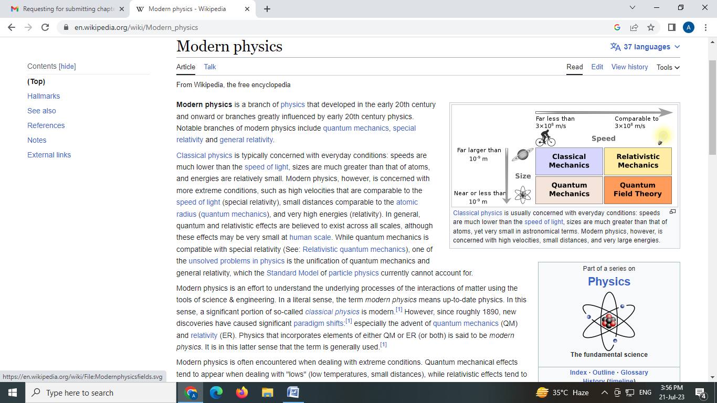

**(Courtesy to Google website)**

The Latin term for "how much" is where the word "quantum" originates. The study of atomic particle existence and interaction is known as quantum mechanics. In all quantum theories, discrete amounts of anything are always present. e.g. energy $E=n hν$, where $n=0, 1, 2,3, ⋯$ where $h (=6.67×{10}^{-34}Jsor{6.67×{10}^{-34}}/{1.6×{10}^{-19}=}4.1356677×{10}^{-15} eV⋅s )$ is the Planck constant, a fundamental physical constant that appears in quantum mechanics. Also referred to as the decreased Planck constant, the Dirac constant has the sign = h/2. For their studies on quanta, Niels Bohr and Max Planck—the two individuals who invented quantum physics—each received the Nobel Prize in Physics.

Between 1900 and 1930, physics experiences a significant change. Quantum mechanics is the study of matter and its interactions with energy at the atomic and subatomic particle levels. The Quantum Mechanics (QM) era was during this time. Microparticle behavior, including that of electrons, protons, neutrons, hydrogen atoms, potential wells, potential barriers, tunneling, etc., is explained using quantum mechanics (QM). Max Planck first proposed the concept of quantization in 1900 to describe the entire black-body spectrum. Albert Einstein (Photoelectric Effect), Arthur Holly Compton (Compton Effect), Werner Heisenberg (Heisenberg's uncertainty relations), Louis Victor de Broglie (Matter Waves or de Broglie Waves), Erwin Schrödinger (Schrödinger wave equations), Max Born (Wave functions), Paul Adrien Maurice Dirac (Dirac equation), and others are among the physicists who are credited with the majority of inventions. When a particle reaches a macroscopic size, quantum theory transforms into classical physics. According to quantum physics, particles behave like waves, and the Schrödinger equation, a particular wave equation, describes how these waves would behave in different scenarios.

The first law of quantum physics asserts that everything is constituted of matter and energy and that the barrier between them is never stable or infinite. Different atomic levels show the interaction between matter and energy. The four main concepts of quantum mechanics that have been experimentally proven and are pertinent to the behaviour of nuclear particles at close ranges are the quanta of electromagnetic energy, the uncertainty principle, the Pauli exclusion principle, and the wave theory of matter particles.

Lasers and integrated circuits are two examples of quantum phenomena that are used in quantum mechanics applications. Understanding how individual atoms are united by covalent bonds to form molecules relies heavily on quantum mechanics. Lasers, solar cells, electron microscopes, atomic clocks used in GPS, and MRI scanners for medical imaging are all examples of practical applications of quantum mechanics, it is used to describe microscopic systems like molecules, atoms, and subatomic particles. The study of atomic and subatomic systems is known as quantum mechanics, and it was sparked by the discovery that waves could be quantized into small energy packets called quanta that resembled particles.

Therefore, the study of matter and energy on a scale smaller than that of atoms, subatomic particles, or waves is the focus of the branch of physics known as quantum mechanics. Max Born initially used the term "quantum mechanics" in 1924.We'll talk about the Black Body radiation spectrum, the Compton effect, the photoelectric effect, and their interpretations based on Max Planck's quantum theory in this chapter. Louis de Broglie's theory of matter waves and its experimental confirmation by the experiments conducted by Davisson-Germer and Thomson.

##### In the honour of Max Planck the whole world celebrate World Quantum Day on 14 April, i.e. a reference to 4.14due to $h \left(4.1356677×{10}^{-15} eV⋅s \right).$ World Quantum Day is an annual celebration for promoting public awareness and understanding of quantum science and technology around the world. Quantum Mechanics or Relativity (or both) is said to be Modern Physics.

**Particle entanglement, also called Entangle Photons, is the phenomenon that occurs when a collection of particles are produced, interact, or share spatial proximity in such a way that the quantum states of each member of the group cannot be described independently of the states of the others, even when the particles are separated by a large distance.A system experiences quantum entanglement when it is in a "superposition" of many states. Entanglement is a fundamental feature of quantum physics set apart from classical mechanics.Two separate points in space are involved in a specific kind of superposition known as entanglement.**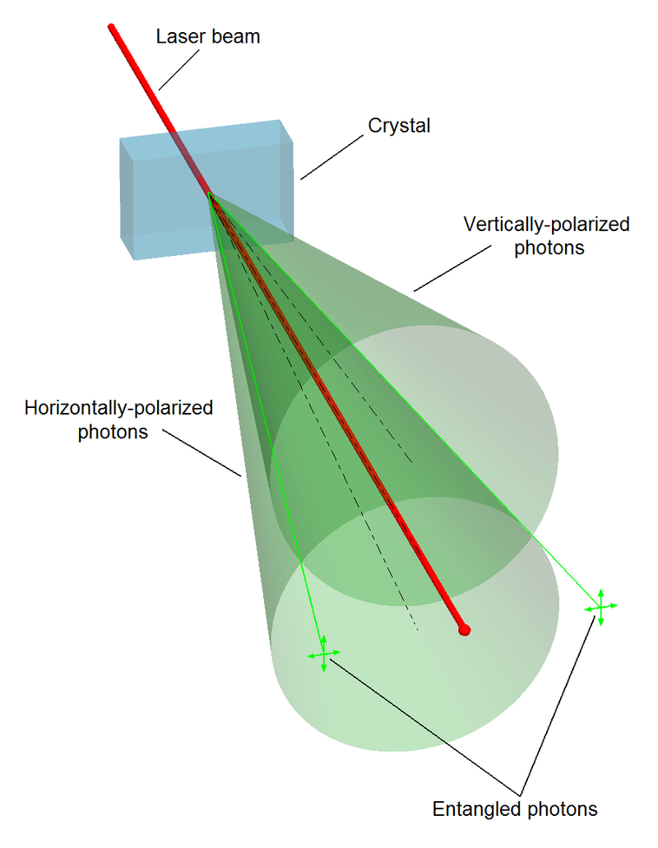

**(Courtesy to Google website)**

Measurements of the physical properties of entangled particles, including location, momentum, spin, and polarisation, can be found to be totally coupled in certain cases. When two particles are generated and their total spin is known to be zero, for example, and one of the particles is found to have a clockwise spin on a first axis, the other particle's spin on the same axis is determined to be anticlockwise.

**Examples-**

1-if a coin is tossed (or flipped) without being watched for the outcome. The man is aware that it will either be heads or tails. Simply put, the man is unsure which is which. Superposition indicates that until you look at it (take a measurement), it is not just unknown to the other person; it is also not even in its heads or tails condition. Similar to this, a photon might collide with a 50/50 splitter to cause the entanglement (superposition of two different places) of a collection of images. Either path A or path B could be followed by the photon after the splitter. There is a photon in path A and no photon in path B, or there is no photon in path A and a photon in path B, in this case, representing the superposition. Like any other normal human, the person thinks that there is only one path to go and that nobody is aware of it. However, until you really measure it, it is in both. Once more, the average person wants to assert that if I measured it and discovered it along path A.

|  |  |  |
| --- | --- | --- |
| **S.N**. | **EM Wave** | **Matter Wave** |
| 1 | An oscillating charged particle gives rise to the EM wave. | A matter wave is associated with a moving microscopic particle. |
| 2 | The speed of an EM wave is constant in a medium. Its speed is  in vacuum. | Its speed is always greater than the speed of light. |
| 3 | Its wave length is inversely proportional to the energy of photon, i.e. . | Its wave length is inversely proportional to the momentum of microscopic particle, i.e. . |
| 4 | An EM wave can be radiated into space by an oscillating charged particle. | A Matter wave cannot be emitted by a moving microscopic particle. |
| 5 | In an EM wave its electric and magnetic fields oscillate  to the direction of motion. | A de- Broglie wave is associated with neutral and charged microscopic particles. A charged moving microscopic particle has electric and magnetic fields. |

1.1 **de-Broglie concept of matter waves-**

|  |  |
| --- | --- |
| Louis de Broglie | **From August 15, 1892, through March 19, 1987, Prince Louis-Victor de Broglie-The concept of a matter wave, also known as a de Broglie wave, was initially presented by a French physicist in 1924. For his discovery of "the wave nature of electron," de Broglie was granted the Nobel Prize in 1929.(Image courtesy of Google, Inc.)** |

A matter was regarded as a particle in nature up until 1923.All minuscule particles, such as electrons, protons, neutrons, alpha particles, etc., were covered in the development of the dual nature of light by de Broglie. As per the quantum hypothesis, light is stated to consist of photons or its elements. Einstein's energy-mass connection for electromagnetic (EM) waves and Planck's energy formula were the sources from which De Broglie deduced the link between particle and wave natures.



where h is Planck’s constant, is frequency of EM wave and  is wavelength of EM wave





or, ⇒

In contrast to and, which are characteristics of waves, E and P are characteristics of particles. Thus, the Planck's constant h establishes a relationship between the particle and wave natures, giving rise to the EM wave's (or light's) dual nature.

The de Broglie hypothesis, put out by Louis de Broglie, states that a moving particle is connected to a wave known as the de Broglie or matter wave. The mechanical motion of a moving macroscopic particle is represented by the symbol and the motion of a matter wave is represented by the symbol u.

From eqs. (1.201) and (1.202) we put the value of  and from the formula of matter wave in equation.



**Properties of matter waves-**

1. These waves are generated only when microscopic particles are in motion. If speed  of the particle is zero (i.e.) then the wavelength of matter wave  on the other hand if  then.
2. These waves are independent of nature of microscopic particles, i.e. either the particles are charged or neutral.

3. Matter waves travel faster than light at all times , i.e.  .

**Note- A matter wave cannot be split as electromagnetic waves do this.**

**Davisson-Germer and G.P. Thomson provided the experimental evidence for the de Broglie wave for slow electrons, respectively. G.P. Thomson and C.J. Davisson split the 1937 Nobel Prize for their work using experiments to prove matter waves exist.**

**Application of de-Broglie wave- Bohr’s condition for the quantization of angular momentum**

Let's say that an electron of mass is moving rapidly in the nth circular orbit of radius around the atom's nucleus (for example, a hydrogen atom). One can compute the wavelength of the de Broglie wave using the following formula:



Here, the motion of the electron can be thought as the wave of  traveling along the circumference of the orbit. Thus, for a circular path its circumference is integral multiple of the wavelength, i.e.





⇒

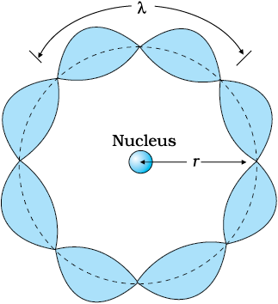**(Courtesy to Google website)**

It representsBohr’s condition for the quantization of angular momentum

**1.2 Phase velocity (or wave velocity)** **-** The velocity with which a point of constant phase moves is referred to as the phase velocity when a single wave with a fixed wavelength passes through a medium.

The formula for wave propagation along the positive x-axis is:



where is amplitude of the wave,  is wave vector,  is position vector and  is angular frequency of the wave.

The phase of the wave is 

When the phase is constant at a point then 

Or, 

Thus, phase velocity  is given by:

⇒

$$V_{p}= \frac{ω}{k}$$

The term "non-dispersive" (or "dispersive") media" refers to a medium in which a wave's wavelength is higher (or lower) than the distance between two adjacent particles in that medium. It is constant in a non-dispersive medium, meaning that waves of various frequencies and wavelengths move at the same speed. Examples- (i) Electromagnetic waves cannot disperse in empty space. (ii) Sound waves cannot disperse in the air. (iii) Transverse waves generated in a continuous string cannot disperse in it. Not continuous in a non-dispersive medium.

**Group velocity (or particle velocity****)** **-**From the relation between particle velocity  and de Broglie wave velocity  we have:



The above term makes it very evident that a material particle cannot be compared to a single wave. Erwin Schrödinger was able to overcome this challenge. He made the assumption that the moving material particle is equivalent to a wave packet rather than a single waveA packet of waves is referred to as a wave packet. The wavelength and speed of each wave are marginally different. Each wave's amplitude is selected in such a way that, within a limited area of space where the particle can be localized, they interfere constructively, and outside of this area, they interfere destructively. As a result, the amplitude of the resulting waves rapidly decreases to zero.

A wave packet is a discrete area of constructive interference created by superimposing two or more waves with similar amplitudes but slightly differing angular frequencies. Assume that these waves are traveling along the x-axis while having the same amplitude but slightly varying angular frequencies and wave numbers. Suppose that these two waves are represented mathematically as:





Applying the principle of superposition we have:







Since  and  are very small quantities, then and. Thus, above equation becomes as:



whereis the amplitude of the wave packet. It changes both in space and time by a very slow-moving envelope of frequency  and wave numberIf two similar waves travelling in opposite directions are combined, it creates a standing wave, which is visualised. This stands for beats. The wave packet's phase is 

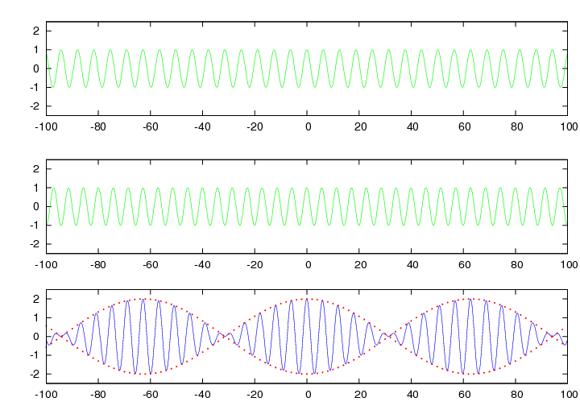

**(Courtesy to Google website)**

Group velocity is the observable velocity of the wave group or wave packet. As defined, it is: 

(i) Relation between phase and group velocities- From the formula of phase velocity, we have the angular frequency.





⇒

For normal dispersive medium is positive. This shows that .

For anomalous dispersive medium is negative. This shows that .

For non- dispersive medium is zero. This shows that .

(ii) Relation between particle, phase  and group  velocities- According to de Broglie hypothesis, a moving microscopic particle consists of a group of waves. The particle's momentum (p) and total energy (E) are provided.

Case (i) relativistic mechanics: Total energy  is given by

or, 

Angular frequency  is given as:

, where 





Wave number  is given as:







On dividing eq. (1.211) from eq. (1.212), we havephase velocity





⇒



Case (ii) In Non- relativistic mechanics: Total energy  is given by



From de Broglie concept, we have:



The phase velocity is given by:

⇒



**Ex. 1.201- Calculate the phase velocity given by $E_{x}= E_{0}\cos\left(ωt-kz\right) A/m$ with a frequency of 5 GHz and a wavelength in the material medium of 3.0 cm is**

**Sol. 1.201- Given: $v=5 GHz= {5 X10}^{9}Hz, λ=3.0 cm \& c= {3 X10}^{8} m/s$**

$$v_{p}= \frac{ω (=2πv)}{k (=\frac{2π}{λ})}=vλ= {5X10}^{9} X .03=1.5 {X10}^{8}m/s=c/2$$

**Ex. 1.202- Estimate the phase velocity of a wave having a group velocity of 6 x 106**is   
**Sol. 1.202- Given: $v_{g}=6X {10}^{6} m/s$**

$$v_{p}v_{g}= c^{2} or v_{p}= \frac{c^{2}}{v_{g}}=\frac{{\left(3X {10}^{8}\right)}^{2}}{6X {10}^{6}}= \frac{3X {10}^{10}}{2}=1.5 X {10}^{10}=150 X {10}^{8} m/s$$

**Q.1.203 1 MHz plane wave travelling in a dispersive medium has a phase velocity $3×{10}^{8}m/s$. The phase velocity as a function of wavelength is given by $v_{p}=K \sqrt{λ}$, where K is a constant. Calculate the group velocity.**

**Sol. 1.203 -**Given: f = 1 MHz, $v_{p}= 3×{10}^{8} m/s$& $v_{p}=K \sqrt{λ}$

$$v_{g}= v_{p}-λ\frac{dv_{p}}{dλ}= K \sqrt{λ}- λ \frac{dK \sqrt{λ}}{dλ} = K \sqrt{λ}- λK\frac{1}{2}\frac{1}{\sqrt{λ}}= \frac{K \sqrt{λ}}{2}$$

$$= \frac{v_{p}}{2}= \frac{3×{10}^{8}}{2}= 1.5×{10}^{8} m/s$$

**1.3 The uncertainty principle of Heisenberg (sometimes known as the principle of indeterminacy) –**

|  |  |
| --- | --- |
|  | **[December 5, 1901 – February 1, 1976] Werner Karl Heisenberg* In 1925, German philosopher and theoretical physicist Werner Karl Heisenberg made a breakthrough by developing a matrix-based formulation of quantum mechanics.His Uncertainty Principle was published in 1927. For this accomplishment, he was awarded the 1932 Nobel Prize in Physics.(Photo by Google)** |

**It is impossible to precisely determine a particle's position and momentum at the same time when it is tiny.**

Heisenberg's approach was to quantum mechanics as being matrixalgebra.Similarly, some others canonical variables (e.g. energy and time; angular momentumand angular displacement ) cannot be determined simultaneously.Heisenberg’s uncertainty relations are: **, &**where $∆$ denotes uncertainty

There is an interesting story of Heisenberg, when he was driving a vehicle very fast and suddenly the beaked his at red light, he is stopped by a policeman then his answer is quoted in fellow as:

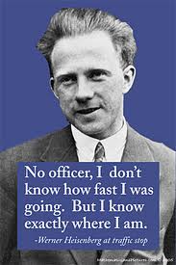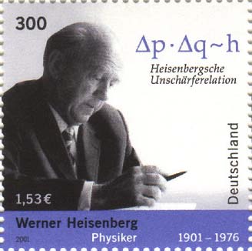**(Curtsey of Google)**

**Applications of Heisenberg’s uncertainty principle-**

* 1. 1. In a nucleus, electrons cannot exist.
  2. 2. The presence of protons and neutrons in an atom's nucleus
  3. The radius of Bohr's initial orbit
  4. 4. The energy at which an electron binds to an atom
  5. 5. A harmonic oscillator's zero point energy
  6. In one-dimensional box, the zero point energy of a particle
  7. 7. The natural width of a spectral line has a finite value.

|  |  |
| --- | --- |
|  | **German mathematician and scientist Max Born (11 December 1882 – 5 January 1970) is credited with creating quantum mechanics. His "fundamental research in quantum mechanics, especially in the statistical interpretation of the wave function" earned him the 1954 Nobel Prize in Physics. The originator of the term "quantum mechanics" is Born. Along with supervising the work of several eminent physicists in the 1920s and 1930s, he also made contributions to solid-state physics and optics.(Source: Google)** |

**1.4 Wave function and its Physical interpretation-**

The height of the water surface (or level) fluctuates periodically in a water wave. The quantity that changes on a regular basis in a sound wave is the medium's pressure. Similar to this, a variable quantity in a matter wave is referred to as a wave function. Greek letter is used to indicate it. phi. Finding the probability at a given position and time is dependent on the value of the wave function associated with the moving tiny particle.

Thus, displacement of a de Broglie wave is a wave function of space and time, i.e. . In general, a wave function  is a complex quantity (real and imaginary parts). Let  is represented as:

$$ψ\left(\overset{→}{r,t}\right) = A + iB = ψ_{0}e^{i\left(\overset{→}{k}⋅\overset{→}{r} - ωt\right)} .....\left(\text{1.4}01\right)$$

where, A and B are real functions;  is amplitude of the wave;  is wave vector;  is position vector. The complex conjugate of  is given as:





It implies that probability is always real and positive quantity.

Wave function  itself is not a measurable quantity but its probability density is measurable. **Note-**The displacement of any matter wave may be positive, negative or zero at any time but its **probability can never negative**.

The complex nature of the wave functionis no concern to us. Here, we are interested only in a single dimension (say x- axis) along the observing direction and for a given time.

A particle's probability of existing in a specific location and time must fall between 0 and 1, meaning that the particle is either present or absent. Consider the case where the particle has a 30% chance of being found in the specified location and time, or an intermediate probability of 0.3. The integral of the probability density across the region yields the likelihood that the particle will be detected in that region, which is expressed as follows:



For a microscopic object, if the probability of finding the object over all space is finite then it is somewhere, i.e.

⇒ Normalization condition of a wave function

In addition to not being able to be minimised by the wave function, it needs to be single-valued because the probability density is continuous and only has one specific value at a given location and time. Every wave function can be normalized by multiplying it by a proper constant.

is not normalized. It can be normalized if  is divided by the square root of the constant K, i.e..



This shows that the particle does not exist there.

**• A wave function must meet the following requirements in order to be considered acceptable across a certain interval:**

1. It needs to be constant and one value everywhere.
2. All of its partial derivatives, i.e., must be continuous and have a single value.

(3)  Must be nonmalleablei.e. it must has a finite value 1.

(4)  Must be a solution of Schrödinger’s wave equation.

**Physical significance of a wave function**- A wave function describes how a particle behaves at a specific place (r) and time (t). Where there is a high likelihood of discovering the particle, the wave function has a big magnitude, and the opposite is also true. Consequently, the probability of a particle existing at a given position is determined by a wave function.

**Applications of wave functions-**

(i) to calculate the likelihood of discovering a particle in a specific area.

(ii) To determine average or expectation value of a physical observable quantity f is given as:

$<f> = \frac{\int_{-∞}^{∞}{{}^{*}\left(r, t\right)f_{op}(r, t) dτ}}{\int_{-∞}^{∞}{{}^{*}(r, t)(r, t) dτ}} ⋯⋯(1.404 ii)$ where $dτ=dx dydz$

In case of normalized wave function $\int_{-∞}^{∞}{{}^{*}(r, t)(r, t) dτ}=1$ the denominator of the above expression becomes unity, then

$$<f> = \int_{-∞}^{∞}{{}^{*}{\left(r, t\right) f}_{op}(r, t) dτ}$$

**Examples:** (i) Expectation value of position vector $r$**:**

$$<r> = \int_{-∞}^{∞}{{}^{*}\left(r, t\right) r (r, t) dτ}= = \int_{-∞}^{∞}{{}^{*}\left(r, t\right) (x\hat{i}+y\hat{j}+z\hat{k}) (r, t) dτ}$$

(ii) Expectation value of momentum or velocity $p$ **or v:**

$$<p> = \int_{-∞}^{∞}{{}^{*}{\left(r, t\right)p}_{op}\left(r, t\right)dτ=\int_{-∞}^{∞}{{}^{*}\left(r, t\right)\left(-iℏ∇\right)\left(r, t\right)dτ}}$$

$$= -iℏ \int_{-∞}^{∞}{{}^{*}\left(r, t\right)\left(\frac{∂}{∂x}\hat{i}+ \frac{∂}{∂y}\hat{j}+\frac{∂}{∂z}\hat{k}\right)(r, t) dτ}$$

(iii) Expectation value of total energy E:

$$<E> = \int_{-∞}^{∞}{{}^{*}{\left(r, t\right) E}_{op}\left(r, t\right) dτ=\int_{-∞}^{∞}{{}^{*}\left(r, t\right)\left(iℏ\frac{∂}{∂t}\right)\left(r, t\right)dτ}}$$

$$= iℏ\int_{-∞}^{∞}{{}^{*}\left(r, t\right)\left(\frac{∂}{∂t}\right)(r, t) dτ}$$

(iv) Expectation value of potential V: $<V> = \int_{-∞}^{∞}{{}^{*}\left(r, t\right) V(r) (r, t) dτ}$

**1.5Time-dependent Schrödinger wave equation-**

|  |  |
| --- | --- |
| After the cat: Celebrating Schrödinger's 75-year influence on biology | New  Scientist | **German theorist Erwin Rudolf Josef Alexander Schrödinger (born in Austria on August 12, 1887, and died on January 4, 1961) For their contributions to quantum mechanics, Schrödinger and Paul Dirac shared the 1933 Nobel Prize in Physics. The "Schrödinger's cat or Quantum Cat" thought experiment is the one for which he is most known. He's regarded as the father of cosmology and wave function.(Photo by Google)** |
| https://upload.wikimedia.org/wikipedia/commons/thumb/9/91/Schrodingers_cat.svg/330px-Schrodingers_cat.svg.png | [**Schrödinger's cat**](https://en.wikipedia.org/wiki/Schr%C3%B6dinger%27s_cat) **or Quantum Cat-** It is not a reality but a paradox that after consuming the poison by the cat there is certain probability of the live or alive. This concept is used in case of probability of finding a particle: across a barrier, outside the finitely deep potential well etc. which is impossible in real sense. (**Curtsey of Google)** |

According to de- Broglie concept a matter wave is associated to a moving particle. The wavelength of the matter wave is given as:

$$λ= \frac{h}{p} or, p= \frac{h}{λ}=\frac{ h}{2π}\frac{2π}{ λ}= ℏk$$

Where  is momentum of the particle,  is Planck’s constant,  wave number and.

The particle's total energy (E) is determined by the Planck-Einstein energy relation, which is as follows:

$E=hv= \frac{ h}{2π} 2πv= ℏω$ where is angular frequency of the wave.

Motion of the particle along positive x-axis is given as:

$$Ψ\left(\vec{x},t\right)= Ψ_{0}e^{i\left(\vec{k_{x}} . \vec{x}- ωt\right)}⋯⋯\left(i\right)$$

Putting the value of k and ω from equation (1.501) and equation (1502) in equation(i), we get.

$$Ψ\left(\vec{x},t\right)= Ψ_{0}e^{\frac{i}{ℏ}\left(\vec{p_{x}} . \vec{x}- Et\right)}$$

where is **wave function** which is a complex and measurable quantity taken in quantum mechanics,  is initial amplitude of the wave and i = √-1

On partially differentiating equation (1.0703) w.r.t. ‘’, we get.



On multiplying by ‘i’ on both sides in above equation and arrange it, we have.

$iℏ\frac{∂Ψ\left(\vec{x},t\right)}{∂x}= -p_{x}Ψ\left(\vec{x},t\right)⇒$ Operator form of momentum

On partially differentiating equation (1.0803) w.r.t.‘t’, we get:

$$\frac{∂Ψ\left(\vec{x},t\right)}{∂t}=Ψ_{0}\left(-\frac{i}{ℏ}E\right)e^{\frac{i}{ℏ}\left(\vec{p_{x}} . \vec{x}- Et\right)}=-\frac{i}{ℏ}E Ψ\left(\vec{x},t\right)⋯⋯(1.505)$$

On multiplying by ‘i’ on both sides in above equation and arrange it, we have:

$iℏ\frac{∂Ψ\left(\vec{x},t\right)}{∂x}= E Ψ\left(\vec{x},t\right)⇒$ Operator form of energy

In non-relativistic case total energy of the particle is the sum of kinetic energy (K.E.) plus potential energy (P.E. or U) given as:

$$E=K.E. +P.E. = \frac{p^{2}}{2m}+U \left(x, t\right)⋯(ii)$$

Multiplying on both sides in above equation, we have:

$$EΨ\left(\vec{x},t\right)= \frac{p^{2}}{2m}Ψ\left(\vec{x},t\right)+U Ψ\left(\vec{x},t\right) ⋯⋯(1.507)$$

Now, putting the value of E and p in operator form in above equation we have:



It is Schrödinger’s time dependent equation in one dimensional motion of the particle. It can be given in three-dimensional motion of the particle by replacing  and then above equation becomes as:

**It is 3-D time dependent Schrödinger Wave Equation**

**Time-independent Schrödinger wave equation-**

If the potential energy is a function of position only, i.e. , then the time dependent SWE is separable. Thus, a plane monochromatic wave can be written as:



where,  and 

Using eq. (1.508) in3-D time dependent Schrödinger Wave Equation, we get:



Or, 

On dividing in above equation by, we get:



or, 



**Applications of Time independent**

1. **Motion of a particle in one dimensional infinitely deep potential well-**

A particle is restricted to one dimensional motion between the barriers of length. The height of the potential barriers goes to infinity. The one dimensional region can be divided into three parts (I, II and III) (Fig. 1.5 a). To solve this problem we use initial and boundary conditions.

Initial conditions-

II

III

U = 0

∞↑U



Boundary conditions-



Free Electron

* In regions I and III the **time independent** SWE is given as:



x= a

x= 0

**Fig. 1.5 a- Motion of a free electron in infinitely deep potential well**

As  at the boundaries of the potential well then. Therefore, LHS also becomes zero so the above equation is ignored because its both sides become zero.

In region II the time independent SWE is given as:





or, 

Here, it is convenient to write the solution of eq. (1.602) as a sum of sines and cosines than as a sum of exponential terms, i.e.



On applying boundary condition (eq. iii) in the wave function, we have:

, or 

$Ψ_{3}\left(x\right)= \sqrt{\frac{2}{a}}\sin{\frac{3π}{a}}x$ I



$$E_{1}= \frac{h^{2}}{8ma^{2}}$$

$$E_{2}=4 E_{1}$$

$$E_{2}=9 E_{1}$$

$$Ψ_{2}\left(x\right)= \sqrt{\frac{2}{a}}\sin{\frac{2π}{a}}x$$

$$Ψ_{1}\left(x\right)= \sqrt{\frac{2}{a}}\sin{\frac{π}{a}}x$$

On applying boundary condition (eq. iv) in the wave function, we have:



or,  Otherwise wave function will be zero.



or, , where, 

Substituting the value of k from eq. (1.504) in eq. (1.503), we have:



Substituting the value of k from eq. (2.604) in eq. (v), we have:

⇒



**Fig.1.6 bEigen functions & Eigen values in infinitely deep potential well**

To calculate the wave function, we must normalize the wave function, i.e.



or,  or, 

Substituting the value of B from eq. (1.606) in eq. (1.604), we get:



⇒



**Wave or Eigen** function corresponding to nth energy level is given by:

**2. Motion of a particle in three dimensional infinitely deep potential wells-**

It is the application of time independent SWE. Here, the wave function must be a function of three spatial coordinates, i.e.  only. Thus, the SWE is given as:



Here, we assume that a particle can only move in three dimensions between obstacles of length, and along the x, y, and z axes, respectively, or it can move freely inside a box with the dimensions (a, b, and c). We utilize the same method as when we used a one-dimensional infinitely deep potential well to solve this problem (identify wave functions and energy levels). The wave functions must be 0 at the walls and beyond because the box's closed walls are infinite potential barriers. So, with U = 0, we resolve the SWE inside the box. The particle is free inside the box. As a result, the wave functions' x, y, and z dependent portions must be independent of one another. The result of the equation above is:



Its solution is given as:



A is a normalization constant in this case. Boundary conditions are applied in order to ascertain the quantities.

at,  and , we have:

,  and 

where ,  and  are integers whose values varies 1,2,3 ……

Thus, we have



On partially differentiating eq. (1.509) w.r.t. x, we get:



and

Similarly we get:









For cubical box  we have  and.

For ground state we have: and.

For first excited state;  or  we have  and 





As a result, the first excited state, which is a threefold degenerate state, corresponds to three wave functions. When there are several wave functions for a given energy, an energy state or level is said to be degenerate. The symmetry of the cube in this instance is what causes the degeneracy. Degeneracy is caused by specific features of the potential energy function.  which explain the system. The degeneracy can be eliminated by a perturbation of potential energy. Degeneracy can also be eliminated by adding external magnetic (Zeeman effect) or electric (Stark effect) fields. If the box had three unequal sides, such as a cuboid, the degeneracy would also be eliminated because the three quantum numbers (211, 121, and 112) would produce three distinct energies. Degeneracy can also be found in classical systems, such as planetary motion, where orbits with varying eccentricities may have the same energy.

**Qualitative analysis of finite potential well-**

A potential well with a finite depth is called a finite potential well. An infinite square well potential is analogous to a one-dimensional one, with the exception that in this instance, the potential is allowed to be zero in regions II and to be finite in regions I and III. The following is the time-independent SWE for regions I and III:



or, where is a constant. It  is positive because. The solution of eq. (1.513) has exponential forms  and. The positive exponential must be rejected in region III where  to keep  finite as; similarly the negative exponential must be rejected in region I where  to keep  finite as. Thus we have and. The coefficients A and B are determined by matching these wave functions smoothly onto the wave function in the interior of the well. We require  and its first derivative  to be continuous at and. This can be done only for certain value of  which corresponds to allowed energies for the bound particles. The wave functions join smoothly at the boundaries of the potential well. Figure 2.7 b shows the wave functions and probability densities corresponding to three lowest allowed particle energies. The de Broglie wave outside the well is increased when the wave function at the walls is nonzero.

In the region II, time independent SWE is given as:



where

Instead of sinusoidal solution of solution of eq. (2.702), we write it in term of exponential as:



On applying boundary conditions, i.e.  Quantized energy quantities and specific wave functions are obtained. There is a limited chance that the particle will be outside the well. In this case, the wave functions exponentially approach zero outside the well and connect seamlessly at its edge. In quantum mechanics, the particle can exist outside of the well, even though it is not allowed in classical mechanics. owing to the wave functions' exponential decline in both and. The likelihood that the particle will go farther than to drastically reduce.



The distance  is known as **penetration depth**.

⇒ $δ ∝ \frac{1}{\sqrt{U-E}}$

If then , i.e. the wave function will not come out in case of infinitely deep potential well. For first energy state ,  is very large therefore  is small. For second energy state ,  is smaller than  therefore  is larger than .



The penetration length is directly related to Planck's constant, as the preceding equation makes evident, which undermines the idea of classical physics. Since the particle needs a very high energy uncertainty in order to be in the well, this result is likewise consistent—or favorable—with the uncertainty principle. Heisenberg's uncertainty relation states that this can only happen for extremely brief periods of time. (i.e.  ). The wave function's amplitude has decreased to some distance beyond the well's limits and, in regions I and III, it is approaching zero exponentially. On either side of the potential well, the outer wave is therefore inescapably zero beyond penetration depth. In case of electrons tunneling through semiconductors and nuclear alpha decay the value of penetration depth is  and.

Here, the allowed energies are given by the expression of energy by replacing, i.e.





It is clear from eq. (2.703) and eq. (2.704) is energy dependent and smaller than length  of the well. When it gets closer to, where becomes infinite, the approximation entirely breaks down and is most effective for lower-lying states. The particles possessing energies are therefore not restricted to the well; rather, they have a similar likelihood of being discovered in the external areas I and III.

**Eigen Functions and Eigen values in various cases are shown in below figure-**

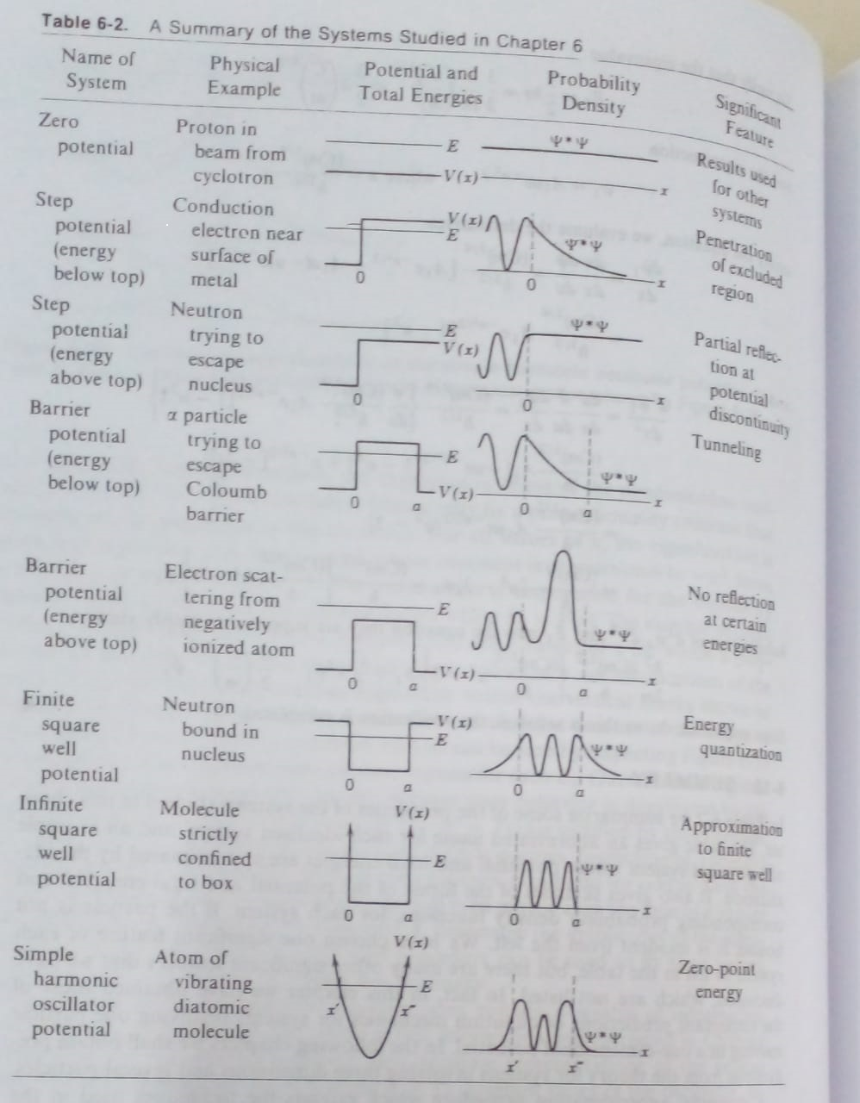

(From Quantum Physics of Atom, Molecules, Solids, Nuclei & Particles**Robert Eisberg& Robert Resnick)**

**References:**

1. Quantum Physics of Atom, Molecules, Solids, Nuclei & Particles-by **Robert Eisberg& Robert Resnick**; Wiley

2. Quantum Physics (Vol. 4) by **Eyvind H Wichman**; McGraw Hill

3. Modern Physics by **Raymond A. Sevey, Clement Moses and Curl Moyer,**Tomson Brooks/ Cole, Cengage Learning

4. Modern Physics by**Stephen T. Thornton and Andrew Rex**; Tomson Brooks/ Cole, Cengage Learning