IoT & Smart Home System: A New Way of Management
Mrs. Sushma M. Pingale
Assistant Professor, Department of Computer Science, SNBP College of ACS & MS, Pune, India
Abstract- A smart home system makes our life quite easy. We can monitor and control our household devices or home appliances remotely. The Internet of Thins (IoT) is a network of different physical devices, vehicles, appliances that are embedded with sensors, software and network connectivity and it allows them to collect and share data. A smart home system is a major application of IoT. This paper represents the integration of IoT technologies with smart home systems to ease out the home automation tasks. Also discusses various problems and challenges in IoT and home automation systems.
Keywords: IoT (Internet of Things), smart home, home automation system, security.
- Introduction
Today’s world becomes smarter day by day due to the internet. As it provides connectivity with anyone, anywhere at any time. Now on the market many advanced technologies such as sensors, transmitters, receivers, processors etc. are available at reasonable rates. We can access and use these things in our daily life.
Nowadays the internet is expanding towards the Internet of Things (IoT). Things like home appliances/household equipment when connecting to the internet using standard protocols, then the system is called Internet of Things. Today in day-to-day life we are using IoT. It becomes an integral part of our life. Here, we have taken an example of smartphones. In smartphones there are various different features like face recognition, brightness setting, voice recognition, GPS Tracking System etc. when these features communicate with each other, then it provides a better environment to user. For example, our smartphones give us weather information based on our device’s location. So, without our interaction/human interference when we connect everyday things with software, hardware (sensors) to internet for collecting and exchanging data then it is called as Internet of Things (IoT).
A home having the advanced technology to allow all home appliances to be controlled or monitored remotely then it becomes a Smart Home. It makes our life easier and smarter. There are different services such as Door Management System, Energy Management System, Water Management System, Security Management System etc. Fig.1 shows some smart home automation services.
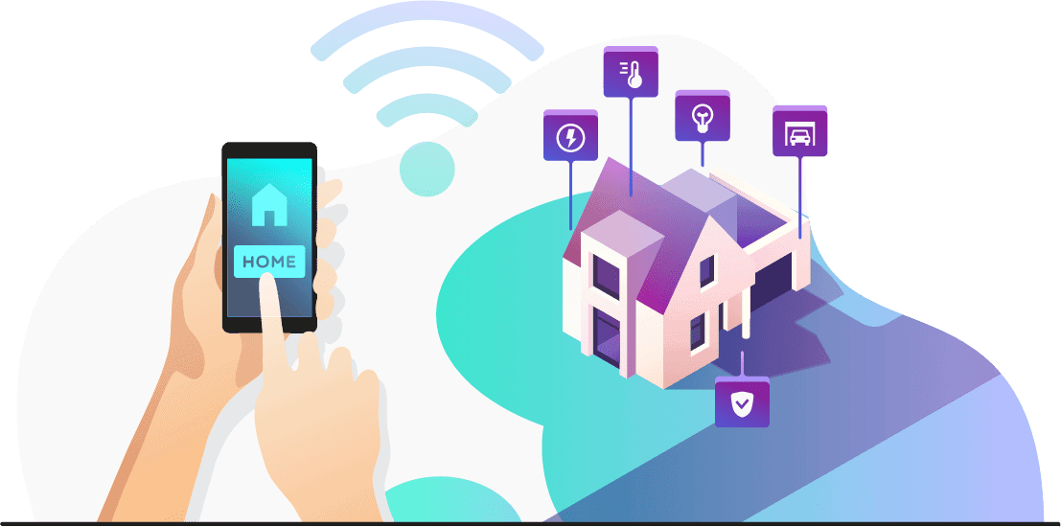
Fig. 1 Smart home automation services
- Review of Literature

Baoan Lia, Jianjun Yub, discussed the current situation of IoT in detail. They presented IoT based smart home system and different service component technologies with the help of software architecture and main modules.
Brijendra Singh, Muhammad Zubir Khan, Senthil J. found most of the home appliances are based on home security, energy efficient and cost effective. They analyzed various applications and challenges in the development of smart home environment using IoT. Also, they identified other challenges such as privacy, scalability, global standards, reasonable cost, device connectivity etc.
Jyotsna Gabhane, Shradha Thakare, Monika Craig presented various problems and challenges in IoT as well as IoT based smart home system. They highlighted some solutions to overcome those problems and challenges.
Mohamed Abd EI-Latif Mowad, Ahmed Fathy, Ahmed hafez presented the hardware design of home automation system and combines both hardware and software technologies. The result of the system showed the classification as comfortable, private, secure and economic system with great flexibility and reliability.
Rohit Kadam, Pranav Mahamunj, Yash Parikh presented a domestic energy management in which different sensors are used to minimize the home energy waste according to our habits. By calculating the home power consumption and simulation of rooms lighting, they found a satisfactory result.

- Applications of Internet of Things (IoT)

A. Agriculture: In the agricultural field, with the help of weather data, smart irrigation and smart fertilizer systems, IoT based devices can sense soil moisture and nutrients. If the sprinkler systems dispense water only when needed, it prevents wasting a precious resource.

B. Consumer Use: IoT devices in the form of wearable and home automation makes our life easier. Wearable accessories such as smartwatches, health monitors, headphones, etc. are being used for entertainment, network connectivity, health and fitness. Smart homes appliances take care of activating environmental controls, privacy and security controls so that our home becomes a comfortable place when we are at home.

C. Healthcare: Even the medical field can benefit from the IoT revolution. IoT based hospitals provide the minute real time information about the patient’s health from home. It helps to monitor their patient’s health at home to reduce hospital stays. In smart hospitals, smart beds keep the information of availability of beds so that patients wait time for free space is cut down.

D. Insurance: Even the IoT technology plays a significant role in the insurance industry. Insurance companies can offer their policyholders discounts for IoT wearable accessories such as Fitbit, health monitors etc. By implementing fitness tracking, the insurer can offer customized policies and encourage healthier habits.

E. Manufacturing: IoT technology expanding towards the world of manufacturing and industrial automation. A manufacturer can track a product from its start in the factory to its dispatchment in the destination store with the help of GPS and RFID techniques. These smart sensors keep track of information about travel time, product and environmental conditions. It also helps to identify congestion in the product line, so it reduces time and waste. Other sensors mounted on those same machines can also monitor the performance of the machine, predicting when the machine will require maintenance, to prevent costly breakdowns.

- Applications of Smart Home System

- Lights: As per requirements, the user can control or adjust the lights of their house. For example, with the help of motion sensors only a part of the house will get lit and lights will turn off after a few minutes of inactivity in that area of the house. This will lead to energy conservation. While watching a movie, people can change the light intensity with the help of their smartphones to their liking.
- Smart Bathrooms: In smart bathrooms, smart sensors and smart shower controllers play vital role to make our daily routine more convenient. For Example, Smart sensors detect people’s movement and switch off the water automatically, if no one is present in bathroom. Smart shower controllers recognize people and set their preferred temperature and pressure of water. People can set the time in shower to save water.
- Smart Kitchen: IoT technology makes our kitchen into a smart kitchen. In smart kitchen, smart sensors detect the gas leakage, monitors the oxygen level and temperature of room continuously. Whenever it detects the gas, an alert message is sent to the user and the exhaust fan will be automatically switched ON. With the help of special built-in applications, we can track the availability of enough food in the fridge and also make a record of it, if necessary.
- Security Systems: Security is the main aspect of IoT based home system. People may use the apps on their devices to check on their homes, whether the door is properly locked, all electronics gadgets inside the house are switched off or not and ensure that our home is safe from natural hazards or human and animal intruders. Using the app, users can manage the temperature, humidity and lighting remotely.
- Home Appliances: Smart home appliances such as dishwashers, washing machines/dryers can be controlled remotely and also send us notifications whenever the tasks are complete. Smart refrigerators can keep track of storage items and send notifications to the user when the item is out of stock or in less quantity.
- Smart Gardens: Smart sensors are useful in smart gardens where people want to cultivate their own vegetables and fruits at home. Using the app, users can check water content to see whether the plant is sufficiently hydrated. Users can check whether the temperature is correct and if it is receiving sufficient sunlight. The app can track the present status of soil in terms of adequate moisture. Users may activate smart irrigation systems. The sensor recognizes when the amount of moisture reaches the reference level and turns off the watering system, to save water.
- Smart Doors and Windows: In future, keys will not be required for door control. The smart door may utilize face recognition and fingerprint to unlock the home. The doors may also be set to open as you approach your house and close as you depart. Any visitor will be restricted inside the building, if they are not recognized as a resident. Users may not bother about closing the windows while leaving the house. Windows can be programmed to act according to weather conditions such as rain, snow, storms and other triggering conditions. Windows may be closed or open at specific times, and shutters can open or close based on the time of day. As a result, the shutters may be raised in the morning and closed at night.

- Technical Approach

Proposed System: In today's innovation-driven environment, mobile devices have become an integral part of our daily life. We are not using mobile phones just for talking but we can attempt better monitoring or controlling on other local devices. The proposed system is to be administrated by our mobile phone system to all devices.
Proposed System Functionality:
1. To observe the ongoing events with alerts
2. To manage lights and fans remotely
3. To Switch On/Off various apparatus

Procedure:
The first stage is to create a sequence of events and analyze related works. After checking the advantages and disadvantages of previous studies on the issues of home automation system, we can begin to execute the layout and automation approach.
1. If a user wants to switch on or off any household device, he first needs to open the application incorporated with that device and then press the button as displayed on the screen.
2. Once the button is pressed the application will send a message to the server containing the details about the action performed by the user.
3. The server will then send the required commands to the Microcontroller with the help of IOT techniques and will wait for the execution of the commands.
4. Microcontroller is programmable device having all instructions already loaded by the programmer according to different actions performed by the user.
5. Relay board is an array of relays and switches having both input and output terminals and are independently programmable. It receives the signals and helps to switch household devices by controlling the flow of signal (voltage) through them.

VI. Problems and Challenges

With all the benefits of smart home technology, there are some problems and challenges in the IoT based smart home system.
Privacy and Security: As the IoT applications are growing vastly, more devices are connected to the internet in a home automation system. Therefore, there is a higher risk of malicious attack. Accessibility, secrecy, integrity, authenticity, authorization are major requirements of smart home security and privacy. The devices available in the market are mostly focused on connectivity but having a lack of security. So, they are easily hacked by attacker. A hacker can get easy access to home and the entire smart home system will break down. Therefore, to protect the smart home system from hackers, authentication of user is necessary and only authenticated users should get access of smart home system.
Connectivity: Connectivity is also a problem in any IoT system. It is a challenge to achieve connectivity to anyone, anywhere, at any time. Sometimes it could have signal problem due to internet 4G services so it will not be connected every time, everywhere.
Lack of Global Standards: Since IoT environment is expanding globally, standardization is very necessary. Lack of standards in IoT based smart home system is a key challenge because of diversity of connecting devices.
Interoperability: Interoperability means two or more devices can exchange information without any disturbance. It is a significant challenge in smart home systems in terms of communication and connectivity. Also, it leads to the creation of some problems like development of cross-platform IoT based architecture, incompatibility of devices with other devices etc.
Affordable cost: As the number of devices increases in smart home systems, cost of sensory networks and ssresource utilization is also increases. Reasonable price plays a significant role in converting traditional homes into smart homes.

VII. Conclusion

This paper is based on the meaning of smart home and IoT. This article aims to analyze various applications and challenges in the development of IoT based smart home environments. We found that most of the applications are based on home security and home management to reduce human efforts or domestic energy waste according to human efforts. Also, it provides cost effective solutions for home management. There are some problems and challenges found in IoT and Smart Homes. We have identified security and privacy as a major challenge in most smart home applications. New technologies and methodologies would help to minimize them.

REFERENCES
[1] J.Gabhane, S.Thakare, M. Craig, “Smart Homes System using Internet of Things: Issues, Solutions and Recent Research Directions”, International Research Journal of Engineering and Technology, Vol. 04, Issue:05, May 2017
[2] Mohamed Abd EI-Latif Mowad, Ahmed Fathy, Ahmed Hafez, “Smart home automated control system using android application and microcontroller”, International Journal of Scientific & engineering Research, vol.5, issue 5, May-2014.
[3] Z. Shouran, A. Ashari and T. Priyambobo, “Internet of things (IoT) of smart home: privacy and security”, International Journal of Computer Applications, vol.182,no.39,pp.3-8,2019.
[4] Brijendra Singh, Muhammad Zubair Khan, Senthil J.,” Applications and challenges in IoT based smart homes”, International Journal of Mechanical Engineering,vol. 6 no.3 December,2021.
[5]Rohit Kadam, Pranav Mahamunj, Yash Parikh,” Smart Home System”, International Journal of Innovative Research in advanced Engineering(IJIRAE),vol.2 Issue 1January 2015.
[6] https://www.simform.com/blog/home-automation-using-internet-of-things
[7] https://www.analyticssteps.com/blogs/9-applications-iot-home-automation

