Managing Solid Waste in a Way the fact Is Environmentally Sustainable: a Case Study of Plasticizer-Concrete-Brick-Interlocking
Sivasankara Raju RALLABANDI^{1*}, Apparao DAMARASINGU¹, Ramakrishna BONDALA¹, Venkata Ramana MENDA¹ , Sreeramulu DOWLURU¹, Srihari PALLI¹
¹Department of Mechanical Engineering, Aditya Institute of Technology and Management, Tekkali-532201, Andhra Pradesh, India.
Corresponding Author: Sivasankara Raju RALLABANDI, Email: sivaraju80@gmail.com
Abstract:
The goal of this initiative is to reduce plastic trash and recycle it into valuable items like bricks and in construction. Plastic waste is piling up and harming the environment, especially in high mountain communities where there is no infrastructure for garbage collection. A sizeable amount of plastic is brought into popular hiking locations, where it is thrown away or burned, damaging the environment and the air. These used plastics will therefore be put to good use. High-density polyethylene (HDPE) and polyethylene (PE) bags are cleaned and mixed with sand and gravel at variable ratios to create high-strength bricks with the ability to insulate sound and heat. This reduces pollution and overall expenses. This avoids the amount of sand/clay that would otherwise be extracted from valuable river beds/mines. Since there is a lot of plastic trash, the cost factor is lower. Colourants can also be added to the mix to get the colour you want. In this study, an effort is made to examine the properties of a brick formed from plastic waste as well as to contrast geopolymer and plastic bricks with more conventional bricks such fly ash, clay, and CLC bricks. Also, by adopting the interlocking idea, cement in the construction area may be replaced to minimise use.

1. Introduction
To preserve critical natural resources, decrease excessive carbon emissions, and protect the public, sustainable industrial processes and garbage disposal are applied. The major objectives are to address environmental concerns while also offering economic opportunity. The solid-state recycling method has demonstrated to be an excellent and strong means of achieving a green state by transforming recyclable waste into useable parts. The proposed method might be classified as a green natural method of production or an eco friendly method. It has a number of benefits, including being simple, cost-effective, and energy-efficient, as well as the capacity to be recycled cleanly without affecting the environment[1]. The use of polymeric products and combinations is rapidly rising relatively low cost and ease of fabrication. As a consequence, a great number of people have been affected. As a result, a large volume of waste plastic has collected, posing a significant disposal difficulty. Organizations are faced with the growing difficulty of finding alternative solutions for dumping a significant number of trash packaging due to the sustainability of plastic for a broad variety of applications. Because of its low biodegradability and abundance, the disposal of plastic garbage in the environment is considered a major issue[2], [3].
Furthermore, during the fabrication of metal items, many types and sizes of metal chips are created. Because of their size and weight, the created chips were recycled using traditional methods like as remitting and casting, which resulted in the loss of sections of chips owing to oxidation. Because it required a lot of energy and produced a lot of pollution, the conventional recycling process became an expensive approach. Furthermore, energy saving and environmental protection are difficult tasks all over the world. As a result, by creating and enhancing lightweight materials, the sustainable manufacturing method is a promising technique for decreasing waste and expense, as well as minimising the use of primary natural resources. Due to its capacity to generate solid pieces directly from solid chips, solid-state metal conversion is one of the most essential technologies for reducing the amount of energy required for melting. Sustainable development is defined as development that meets current needs without endangering populations' ability to meet their own[4]–[6].
The National environmental, Forest & Global Warming announced the suggested Uniform Structure for Product Stewardship (Under Plastic Waste Management Rules 2016) on June 26, 2020, with a July 31 deadline for stakeholder input. India Spend wrote to the Environmental Protection Agency, asking however many suggestions was already received and once the rules would be finalised. On September 10, India's environmental court, the Green Growth Tribunal, requested the environment ministry to finalise and implement the EPR guidelines "as much as practical within three months" in a long-running dispute over plastic waste management. India was the first country to deploy EPR to manage electronic waste in 2012. It was announced in 2016 that the Plastic Waste Management Rules 2016 (PWMR) would be implemented[5], [7]. Various forms of plastics available in the sea shore vide in Figure 1.
Figure 1 Categories of plastic waste forms
One of the key reasons of India's plastic disaster, according to a supplement to the September 2020 global report, Talking Smack: The Corporate Handbook of Faux Remedies to the Plastic Issue, is that the nation's plastic enhanced productivity a variety of techniques to divert, postpone, dilute, and derail proactive plastic control laws that is adverse to them. The article's India chapter was researched and written by Shah, who was previously mentioned in Figure 2. Natural resource usage has increased while resource availability has decreased as a result of urbanisation, rapid industrialisation, and changing lifestyles. Humans, on either hand, have always produced rubbish and dealt of it in some way, causing environmental damage[8].

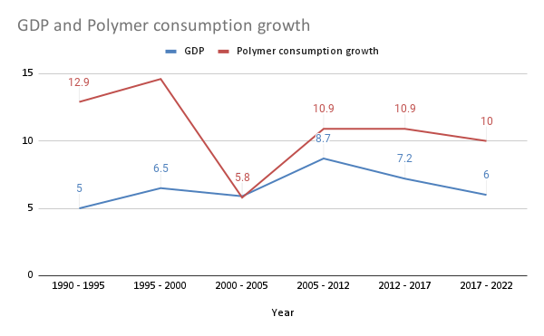
Figure 2 Economical growth of polymers in the nation
As a consequence, research has revealed new types of technology, such as eco-friendly engineering, to aid in the conservation of energy and other resources. The concept of sustainability is based on three principles: societal, environmental, and economic factors[9], [10]. They lead to environmental policies, which eventually leading reducing waste, reuse, and recycling as a way to help close the materials use loop all through the industry by providing waste derived commodities as manufacturing inputs as shown in Figure 3.

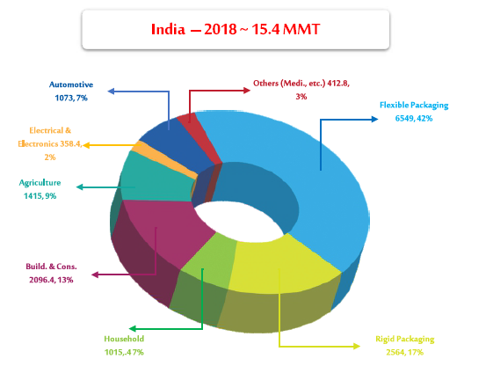
Figure 3 various commodities of manufacturing used polymers
Under this model, plastic companies are not required to recycle their own plastic waste. The model suggests that in order to satisfy waste management legal requirements, manufacturers should instead buy plastic credits from "fully accredited processors" to prove that an equivalent amount of "packaging garbage" has been recovered and recycled. The proposal stipulates that manufacturers "must receive documentation of recycling or recovery" from suitably trained processors. Plastic makers and processors/exporters can trade plastic credits for money at a price and other terms that they agree on. Therefore, approved processors increase their profits per tonne of reprocessed packaging waste [11].
The main goal of this project is to emphasise the key objective of green manufacturing processes, as well as their impact on greatly reducing production wastes using environmentally friendly ways, and to encourage the use of innovative green science. As a result, this chapter includes a brief review of durability, ecological manufacturing methods, solid waste disposal, and 2 case studies, including innovative studies for recovering plastic trash and nonferrous trash using sustainable manufacturing techniques to reduce waste itself and effect on the environment. The key strategies for saving energy and materials, minimising garbage, and eliminating pollution, and the process of transforming waste into useful products and its consequences, will also be explained.

2. Restrictions on Overproduction and the Use of Alternative Materials
An effective EPR strategy, according to Sambyal, should emphasise methods to minimise plastic waste through changes in packaging design and the development of substitute product packaging. The slogan should be "Refuse > Reduce > Reuse > Recycle > Recover > Dispose". Shah [3]says that the guidelines' main objective should be to decrease wasteful production. "Rather than decrease, targets remain focused on collection and dispose in incineration plants and cement plants," he stated. "Instead, the objective should be to eliminate single-use plastic manufacturing".

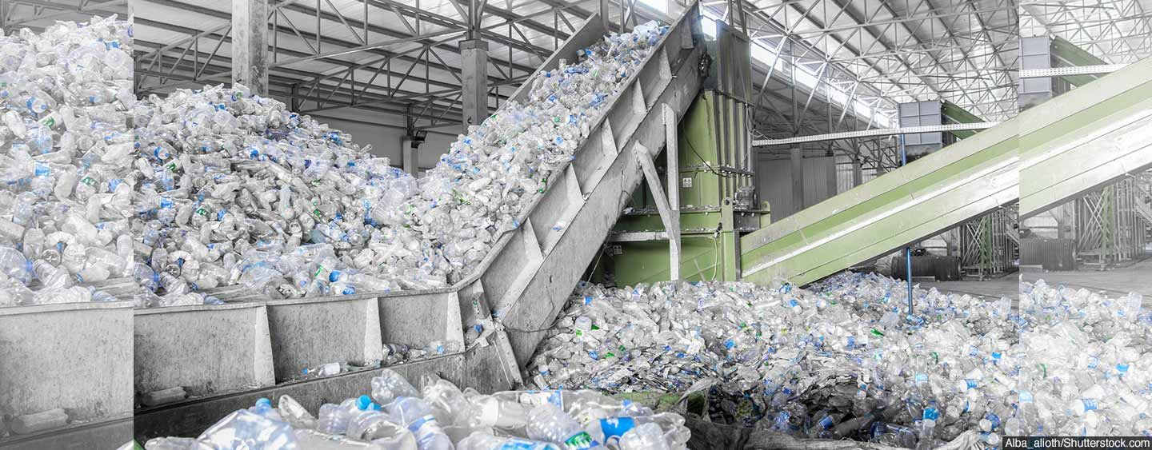
Figure 4 An effective EPR strategy used by Ministry of Environment[3]
2.1 Plastic Waste Burning
Garbage is found in places that are damaging to the environment due to a lack of adequate waste management. "According to my observations, the majority of the waste was found near school boundaries and comparably less surrounding residential areas," Arya added. I also wanted to point out that the majority of the plastic waste material contained items that are typically considered taboo in society, such as pregnancy test kits, various contraception and tobacco packs. Perhaps individuals are uncomfortable disposing of things at home, and as a result, they end up littering the streets outside!" Due to a lack of trash management in the city, all debris is left on the highways, posing a serious environmental threat. Plastic is left in the soil to decay or is burned as a result of a lack of segregation and recycling, which has negative environmental consequences[3], [4], [8].

3. Case studies on Waste Management
3.1 Waste plastic cement made of polyethylene
To increase the mechanical qualities and usability of products, plastic cement can be made from solid polyethylene waste materials. To test the viability of making plastic cement, high-density polyethylene (HDPE) waste is mixed with Portland cement. The impact of replacing sand with different ratios of fine plastic debris is also explored. Due to anthropogenic factors, high-density polyethylene containers or crates have been gathered from municipal and garbage sites. Then, using a specific cutting and grinding equipment, they are shattered into little fragments to obtain tiny particles. The small particles are filtrated to remove them from the granular materials after grinding polyethylene wastes, and then combined with Portland cement as shown in Figure 5.
To examine the impact of substituting sand with identical twin HDPE waste, Concretes and fine plastic waste are combined with water to make a concrete mix that does not require sand. Plastic cement is created from a variety of identical twin polyethylene waste in varied proportions. With level lower water content of 25%, polyethylene was used in the amounts of 15 to 80% with variation of 5% of the blending components. Portland cement and leftover polyethylene are mixed with water to make a single substance that can be poured into the small mould. After samples have dried in the mould, they are immersed in water for two to four days to congeal and cure, which improves cohesiveness.
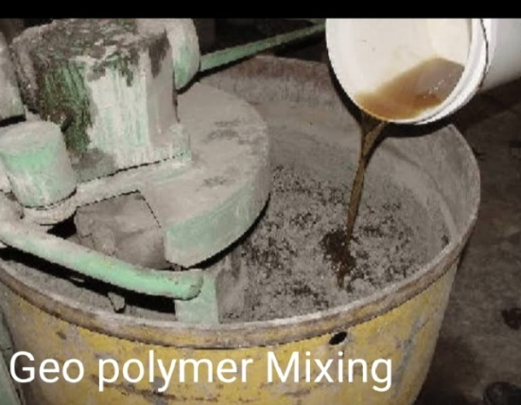  (a) | (b)
Figure 5 process of making polymer concrete (a) geo polymer mixing (b) plastic cement made of polyethylene

The samples are then taken out of the water and analysed. The next step is to immerse these samples in water for 7 and 28 days to see how stable they are and how water affects their properties. Polyethylene is a semi-crystalline polymer with excellent chemical, corrosion, fatigue, and wear resistant properties. It has a low moisture absorption rate and a strong resistance to organic solvents. It's also a lightweight, quasi, stain-resistant material with high tensile strength and impact resistance. The shape of wet plastic cement is formed by mixing and casting components instead of using motion or a pressing. The items are in good shape and have a low density, which is defined by the percentage of fine polyethylene used.
The plastic cement produced in this investigation has a density with between 1.972 and 1.375 gm/cm³. It is 1.375 gm/cm³ when the proportion of polyethylene is 60%. After soaking for 7 and 28 days, the relative humidity of the plastic cemented produced in this study was assessed. The results show that the moisture content of the plastic cement will be lesser after 28 days than after 7 days of immersion. The moisture content after 7 days of immersion ranges from 23.4 to 6.3 percent, and after 28 days, it varies from 11.6 to 3.60 percent. When the amount of fine polyethylene in concrete would be between 25 to 30 percent with a 28-day immerged duration, the results are excellent[6], [12].
As the plastic waste ratio grows, the compressive of recycled plastic cement falls with each curing age. The decrease in interfacial interaction between the recycled plastic barrier and the composite resin can be attributable to this development[13]. The plastic particles appear to have a poor connection with the cement mix. It was discovered that waste polyethylene materials made by human activities, such as food packages or crates, may be used to make plastic cement. The quantity of discarded polyethylene used in the concrete mix determines the density of the created plastic cement. It expanded as the proportion of waste in the environment increased to 30%, then gradually decreased. The density of the product is 1.972 gm/cm³, which is lower than that of sand and Portland cement mortar. The density of plastic cement generated from high-density polyethylene waste materials is 15% lower than that of traditional concrete. Furthermore, the relative humidity of polymer cement varies between 10.5 and 23.4 percent for items over pressurized for seven days[12], [14].

3.2 Recycling of non-ferrous metal waste
Several recycling processes, classified as conventional and non-conventional, have been employed to convert chips into useable parts in recent years. There is little increase in mechanical characteristics when using traditional recycling methods and substantial amounts of slag are produced during the reheating and solidification processes. Furthermore, 20 percent of the components will be lost during the reheating process, which is unavoidable. Thin chips, on the other hand, can result in losses of up to 50%; as a result, energy usage and labour costs will rise, as will expenditures for environmental protection. Non-conventional recycling, on the other hand, uses an extrusion and sintered process, which saves 95 percent of the energy, used in traditional recycling and can minimise solid waste disposal and CO2 emissions[1], [15].
Direct conversion is a non-traditional recycling approach that is relatively straightforward, cost-effective, and environmentally benign, and can be considered a long-term manufacturing process. One of the most important strategies for minimising waste, cost, and energy required for recycling non-ferrous metal waste is the solid-state metal direct conversion that is key to sustainable production process. Its capacity to produce solid pieces directly from solid state while reheating, reducing waste and costs, making it a potential approach for replacing remitting and casting procedures. During industrial activities such as turning, milling, and sawing, chips of various shapes and sizes were created[16], [17].
In order to really be formed as a functioning item, these chips must be extracted and remitted in workshops and factories. The normal recycling process is expensive since it necessitates a big number of workers, consumes a lot, and generates a lot of waste, all of which are important issues across the world. A solid-state recycling approach for nonferrous materials such as aluminium, copper, zinc, and related alloy chips was recently developed to address the drawbacks of the current technology. As a consequence, scientists have created new forms of design, such as sustainable responsible and green engineering, that aim to minimise negative impacts while increasing economic, societal, and environmental advantages[18].
As a sustainable making technology, this work used a solid-state recycling method to get aluminium oxide chips and copper chips to be used right away. Without melting them from their solid state, it is utilised to generate solid components. Al-Zn alloy, zinc, and copper chips that are produced in cutting or production facilities have been recycled directly (see Figures 6a and 6b). Chips 12 mm thick were produced by a cold pressing process using 10, 20, and 30 tonnes of pressure. There was a lot of distortion, which led to good bonding of materials. Following the cutting process, pieces of copper and an Al-Zn alloy in a variety of shapes and sizes are gathered from the factory and sieved with a mesh size ranging from 0.300 to 3.00 mm, as shown in Figure 5. They were combined so that 30% of the chips had a width of less than 1 mm, and 70% of the chips have a width of 1-3 mm. The dimensions of a chip were 11.85 mm in length and 0.39 mm to 0.33 mm in width. These chips didn't need to be heated or reheated in order to be compressed and extruded[19]–[21]. Increased cold-pressing pressure resulted in increased cold-pressed sample density and hardeners, according to experiments. Furthermore, crushing from opposite wings is preferred to pressing from one side since it results in uniform dispersion and high homogeneity. The pieces generated have nearly the same hardness and density throughout. When pushing from one side, the typical components become brittle and incoherent. As seen in Figure 6(c), crushing from two sides resulted in strong and coherent parts with strength and hardness faithful to the actual components. Furthermore, the findings show that smaller, easier chips are greater rates resources for cold compression than larger, more complicated chips; otherwise, warming chips prior to or even during the pressing process is necessary.

(a) | (b)
Figure 6 Obtained Chips/powder from scrape of (a) Copper (b) Al-Zn alloy (c) Prepared samples with forming and powder metallurgical route

3.3 Making of Plastic Brick with Interlocking
Plastic is a substance that is both beneficial and dangerous on a daily basis. Plastic is proven to be highly useful when it is needed, yet it is simply tossed away after usage, posing a variety of risks. Plastic is a non-biodegradable polymer that has remained a dangerous material for decades. Plastic garbage is becoming increasingly prevalent in solid wastes (MSW). Every ten years, the pace of expansion is anticipated to double. This is owing to fast population increase, urbanisation, development activities, and lifestyle changes, all of which contribute to pervasive littering just on environment[22].
They cannot break down in the environment, and research suggests that some plastics could remain intact for up to 4,500 years. According to estimates, the amount of municipal solid waste produced in India each year is over 40 million tonnes, and it is increasing at a rate of 1.5 to 2% annually. These used plastics will therefore be put to good use. Today, it is challenging for any significant sector to operate efficiently without the usage of plastic, from industry to agriculture. Therefore, even though we cannot outlaw the use of plastic, we think that recycling plastic waste in the building and manufacturing industries is the most sensible usage.
The author is aware of three distinct types of interlocking blocks used in India, and notes that this approach is far from conventional.
1. Stabilised earth blocks, also known as SEBs, and fly ash blocks, also known as Hydroform Interlocking Blocks
2. Fly ash bricks that are connected to one another
3. Cement concrete bricks that interlock
The report details the author's sole practical experience with Hydra form linking blocks in practise. However, the same applies to any interlocking blocks and is not limited to any one type. The native sandy loam soil is used to create stabilised earth blocks (SEB), which are then stabilised with cement, lime, or gypsum. They are hydraulically pressed into a mould, crushed, and allowed to cure for seven days before being used as masonry blocks.

3.3.1 Plastic Sand Bricks Casting Procedure
Plastic soil bricks with high compressive strength are manufactured with varied control mix and evaluated using a compression test rig [CTM] in order to locate them. The proportions of the mix were in the ratio as shown in Table 1. These are the proportions for plastic and river sand, respectively. The making procedure is shown in Figure 7.

3.3.1.1 Batching
The collected garbage bags are washed with water, dried to eliminate any remaining moisture, and then weighed. A 600 micron sieve was used to sift the sand. Sand and carrier bags were mixed in different amounts, with the plastic being used in the burning process.

Table 1 Batching of Plastic Sand Brick
Mix ratio | 1:3 | 1:4 | 1:5
For 1 brick (Kg) | 1:3 | 0.8:3.2 | 0.67:3.35
For 4 brick (Kg) | 4:12 | 4:12 | 2.68:1.3

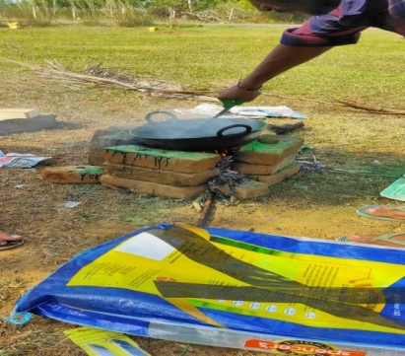 | 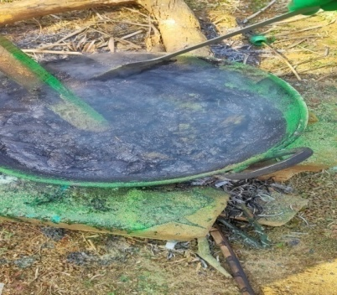 | 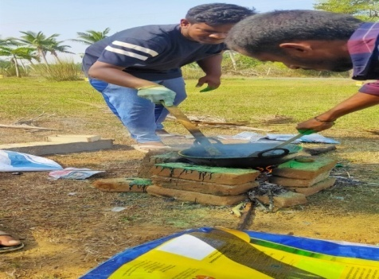
Figure 7 Process of making interlocking plastic brick with a least expensive method

3.3.1.2 Burning :
After batching, the plastic items were carried to be burned, where they were tossed into the drum one by one and left to melt. The placement of stones, drum, and needed fuel is the initial step in the burning process. The drum is held in place by the stones, and the timber is deposited in the gap here between stones and lit. The drum is put so over arrangement and heated to eliminate any remaining moisture.

3.3.1.3 Mixing :
One by one, the plastic items are poured into the drum until it has all of the plastic needed to make bricks among one mix proportion. Before the plastic solidifies, carefully scrape it with a trowel. The combination has a very quick setting time, therefore the bags are transformed to a molten condition before adding the river sand. The sand is blended at the appropriate moment. As a result, the mixing procedure should not take too long.

3.3.1.4 Moulding :
After that, the slurry is put into the brickwork mould and crushed using a tamping rod or steel rod. Trowel is used to polish the surface. The sides of the mould are greased before filling it with the slurry to make brick removal easier. After 24 hours, the mould was removed and final form shape as shown in Figure 8.

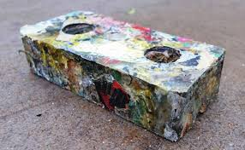
Figure 8 Interlocking brick made with waste plastic

Table 2 Mechanical properties of bricks, comparison purpose
Types of bricks | Load (KN) | Compressive strength  (KN/mm²)
Clay brick | 32 | 3.047
Fly ash brick | 62 | 5.90
Clc block | 181 | 17.23
Geo polymer brick | 28 | 2.66
Plastic brick | 54 | 5.14

The load was applied to several bricks for comparative purposes while the cube specimens were in a compression testing machine, and the results are recorded in Table 2. Without stress, the pressure was applied to the specimen and escalated at a rate of about 140 kg/cm2 min until the specimen's ability to withstand the mounting pressure failed and no more force could be applied. It is important to record the sample's maximum applied force, the way the brickwork appears, and any unforeseen failure symptoms.
Table 3 Water absorption values for bricks
Types of bricks | Dry weight | Wet weight | percentage
Clay brick | 0.570 | 0.700 | 22.8%
Fly ash brick | 0.880 | 0.970 | 10.22%
Clc block | 1.030 | 1.070 | 3.88%
Geo polymer brick | 0.960 | 1.09 | 13.54%
Plastic brick | 0.970 | 1.010 | 4.12%

Table 3 shows the results of a water absorption test, in which bricks are first dry-weighed and then submerged in cool water for a set amount of time. After 24 hours, these are taken out of the water and dried with a cloth. After that, the brick is weighed while still damp. Bricks vary in weight because they absorb different amounts of water. The percentage of water absorption is then calculated. Less water is absorbed by bricks of greater quality. A brick of good quality won't absorb more water than 20% of its own weight.
4. Conclusion

By converting recyclable rubbish into usable parts, the solid-state recycling industry has shown to be an effective and appropriate means to achieve a green state. The approach developed may be regarded as both a clean recycling technology and a traditional green-forming or ecologically friendly lightweight alloy production process. Moulding and sintered the items do not necessitate the use of powders. Plastic sand brick and Geo polymer brick provide a number of advantages, including economic efficiency, resource efficiency, and reduced greenhouse gas emissions, among others. The amount of alkalis in the water was greatly reduced by using plastic sand bricks. Further study would increase the quality and longevity of these bricks due to their multiple advantages. In comparison to traditional bricks, these plastic and geo-polymer bricks offer a high compressive strength. The use of cement in building can be reduced by incorporating the interlocking principle into the fabrication of these bricks. As a result, the entire cost will be lower.

5. References
[1] A. K. Jassim, “Sustainable Solid Waste Recycling,” Skills Development for Sustainable Manufacturing, pp. 1–16, 2017. doi: 10.5772/intechopen.70046.
[2] S. Erik, “Single-use Plastics: A Roadmap for Sustainability,” United Nations Environ. Program., vol. 1, no. 1, pp. 57–104, 2018.
[3] B. Tripathi, “India Wants Manufacturers To Manage Plastic Waste,” Indiaspend, 2020. https://www.indiaspend.com/india-wants-manufacturers-to-manage-plastic-waste-heres-how-proposed-rules-fall-short/ (accessed Jun. 10, 2022).
[4] S. M. Gawande, V. Gholap, M. Dimble, M. Gondkar, and V. Jamdar, “Waste Plastic Bottles Offering Innovative Material with Sustainable Application in Safe Guard Tree,” Int. J. Innov. Res. Sci. Eng. Technol., vol. 6, no. 5, pp. 6844–6852, 2017, doi: 10.15680/IJIRSET.2017.0605227.
[5] R. R. N. S. Bhattacharya, K. Chandrasekhar, M. V Deepthi, P. Roy, and A. Khan, “Fact Sheet on Plastic Waste in India,” World Environmental Day, p. 4pages, 2018. [Online]. Available: http://www.teriin.org/sites/default/files/files/factsheet.pdf
[6] D. JivanPati and S. PragyanDash, “Strategy for promoting utilization of non-biodegradable wastes in affordable housing in India,” Mater. Today Proc., vol. 60, no. 1, pp. 26–32, 2022, doi: 10.1016/j.matpr.2021.11.026.
[7] P. Kumbhare, “Recycling as a solution to better plastic waste management at Kolkata, India – Earth5R,” Sustanable Developement Goals, 2021. https://earth5r.org/recycling-as-a-solution-to-the-plastic-waste-management-at-kolkata-india/ (accessed Jun. 10, 2022).
[8] A. O. Sojobi, S. E. Nwobodo, and O. J. Aladegboye, “Recycling of polyethylene terephthalate (PET) plastic bottle wastes in bituminous asphaltic concrete,” Cogent Eng., vol. 3, no. 1, 2016, doi: 10.1080/23311916.2015.1133480.
[9] K. Ramanaiah, S. P. Sanaka, A. V. R. Prasad, and K. H. Reddy, “Thermo-physical and fire properties of sustainable bio composites: Experimental and computational analysis,” J. Nat. Fibers, vol. 20, no. 1, p. 2162653, 2023, doi: 10.1080/15440478.2022.2162653.
[10] R. Siva Sankara Raju, B. Venkata Siva, and S. R. G., “Quantitative Analysis of Tribological Performance on Al–CSA Composite Using Orthogonal Array,” in Advances in Applied Mechanical Engineering (Lecture Notes in Mechanical Engineering (LNME)), Lecture No., H. K. Voruganti, K. Kiran Kumar, P. Vamsi Krishna, and J. Xiaoliang, Eds. Springer Nature Singapore Pte Ltd, 2020, pp. 381–388. doi: https://doi.org/10.1007/978-981-15-1201-8_43.
[11] D. J. Pati, R. Homma, and Kazuhisaikt, “Plastic Bottles Masonry As Alternate Solution To Housing Problems In Urban Area Of India,” Int. J. Archit. Plan. Build. Eng., vol. 2, no. 2, pp. 12–15, 2015.
[12] T. Ahmad Dar and F. Azam, “Development of Fly Ash Based Geo-polymer Concrete,” Int. J. Sci. Res., vol. 6, no. 6, pp. 1539–1560, 2017, [Online]. Available: https://www.ijsr.net/archive/v6i6/ART20174551.pdf
[13] D. Pati, R. Homma, and K. Iki, “Proposing the Use of Plastic Bottle Waste for Low-Cost Housing under Government Guidelines in India,” Am. J. Eng. Sci. Technol. Res., vol. 4, no. 1, pp. 1–10, 2016, [Online]. Available: https://www.researchgate.net/publication/301947862_Proposing_the_Use_of_Plastic_Bottle_Waste_for_Low-_Cost_Housing_under_Government_Guidelines_in_India
[14] S. R. Rallabandi, G. Srinivasa Rao, S. S. R. R, S. R. G, S. R. Rallabandi, and G. Srinivasa Rao, “Assessment of Tribological Performance of Al-Coconut Shell Ash Particulate—MMCs using Grey-Fuzzy Approach,” J. Inst. Eng. Ser. C, vol. 100, no. 1, pp. 13–22, Feb. 2019, doi: 10.1007/s40032-017-0388-4.
[15] G. V, B. K. N, and T. AE, “Direct recycling of 1050 aluminum alloy scrap material mixed with 6060 aluminum alloy chips by hot extrusion,” Int. J. Mater. Form., vol. 3, pp. 853–856, 2010.
[16] B. Panda, A. K. Mahato, C. Varun, and S. S. R. R, “Wear Behavior of Aluminum Based Composite Reinforced With Coconut Shell Ash,” Imp. J. Interdiscip. Res., vol. 2, no. 5, pp. 890–895, 2016.
[17] R. S. S. Raju and G. S. Rao, “Assessment of Tribological performance of Coconut Shell Ash Particle Reinforced Al-Si-Fe Composites using Grey-Fuzzy Approach,” Tribol. Ind., vol. 39, no. 3, pp. 364–377, Oct. 2017, doi: 10.24874/ti.2017.39.03.12.
[18] T. Wall, “Responsible consumption and production,” in Encyclopedia of the UN Sustainable Development Goals, 1st ed., W. L. Filho, A. M. Azul, L. Brandli, P. G. Özuyar, and W. Tony, Eds. Switzerland AG 2020: Springer Nature Switzerland AG 2020, 2021, pp. 32–33. doi: 10.18356/9789213618851c016.
[19] S. Rallabandi, G. Srinivasa Rao, L. Srinivas, S. Dowluru, S. Palli, and A. Duppala, “Sustainable Waste Management for Solid Waste Dominance in Metals, Concrete Brick Mix of Plasticizer with Interlocking - A Case Study,” in Application of Engineering, Technology, Management for Sustainable Manufacturing Sector, 1st ed., M. Brojo Kishore, K. C. Rath, and H. G. Sharma, Eds. World Leadership Academy, 2022, pp. 155–177. Accessed: Jan. 19, 2023. [Online]. Available: https://www.worldleadershipacademy.live/book-series1/index.php/ojs2/article/view/10/10
[20] R. S. Sankara Raju, M. K. Panigrahi, R. I. Ganguly, and G. Srinivasa Rao, “Tribological behaviour of Al-1100-coconut shell ash (CSA) composite at elevated temperature,” Tribol. Int., vol. 129, pp. 55–66, 2019, doi: 10.1016/j.triboint.2018.08.011.
[21] Y. Alemdaǧ and M. Beder, “Microstructural, mechanical and tribological properties of Al-7Si-(0-5)Zn alloys,” Materials and Design, vol. 63. pp. 159–167, 2014. doi: 10.1016/j.matdes.2014.06.006.
[22] R. MA and K. HA, “Sustainable manufacturing and design concepts, practices and needs,” Sustainability, vol. 4, no. 1, pp. 154–174, 2012.

