REVIEW ON HERBAL TREATMENT FOR ACNE VULGARIS
J. Yeshwanth¹, Mrs. Jothi Lakshmi², Mrs. Devi², Dr.R. Srinivasan³, H. Surya Narayanan¹, S.Shaheed Aziz¹, S. Sheron Kevin¹, E. Chandru¹
1- B.Pharm IV Sem, 2 – Associate Professor,3- Dean & Professor
Bharath Institute of Higher Education and Research – Chennai.

ABSTRACT:
This systematic review aims to assess the evidence supporting the efficacy and security of the external application of herbal medicines (EAHM) for acne vulgaris (AV) by critically analyzing the available data. Medicinal uses of a plant's seed, berries, roots, leaves, bark, or flowers are known as herbal medicine, sometimes known as botanical medicine or phytomedicine. Outside of traditional medicine, herbal remedies have a long history of use. Plants are utilized to create herbal treatments. Herbal medicines are used by people to treat or prevent disease. They employ them to relieve symptoms, increase energy, unwind, or reduce weight. Herbal supplements are available in a variety of forms, including dried, chopped, powdered, liquid, and capsules. The body's skin is the most delicate organ. It is well knowledge that daily skin exposure causes a variety of issues, including acne, pimples, pigmentation, and sunburn-like lesions. These days, acne is the most prevalent skin condition. Interest in using phytochemicals and medicinal plants to treat skin conditions like acne vulgaris has increased over the past few decades. A chronic skin inflammatory condition known as acne, it can affect both young people and adults of all ages. Its etiology is complex and causes everything from minor lesions to comedogenic lesions, which can sometimes leave scars that are ugly. It may continue into adulthood and affects roughly 85% of youngsters. Teenagers make over two million doctor visits a year, and the direct medical expenses associated with treating acne in the US surpass $1 billion annually. With numerous conventional treatments available, acne vulgaris is still a frequent problem in industrialized cultures. None of these treatments is totally effective, and they all have hazards. Natural remedies are gaining more scientific backing and have a lot to offer in terms of clinical benefits. The bioactive components found in plants with the ability to treat acne include calendula, chamomile, lavender, rosemary, and manjistha. This comprehensive study offers proof that phytochemicals and medicinal plants are effective therapies for mild to moderate acne vulgaris. This study found that the use of rosemary, calendula, lavender, chamomile, and manjistha greatly sped up the recovery of acne vulgaris symptoms and suggested that these plants could be used as viable treatments for the condition.
KEYWORDS: Herbal medicine, Acne Vulgaris, skin, teenagers, calendula, rosemary.
INTRODUCTION:
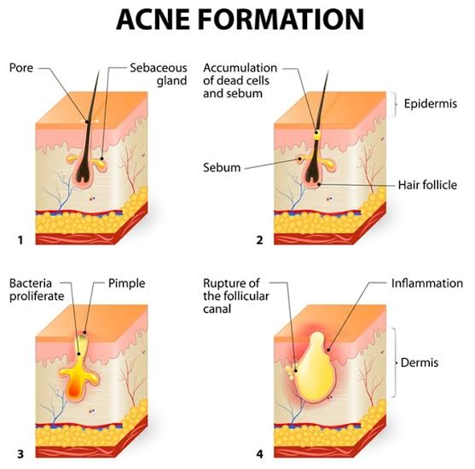
As a group of skin conditions, acne is among the most common dermatologic conditions in the globe. Almost everyone experiences it at some point in their lives. The four main factors that contribute to the pathogenesis of acne are inflammation, follicular hyper keratinization, colonization of the anaerobic bacterium Propionibacterium acnes, which is a normal part of the skin microbial flora, and androgen-mediated stimulation of sebaceous gland activity. Acne lesions contain Pityrosporum ovale and Staphylococcus epidermidis in addition to P. acnes, the primary pathogenic bacteria. Acne can be classified as comedonal, nodular, or papulopustular. Nodular and papulopustular lesions are inflammatory, whereas comedonal lesions are not. Topical drugs, oral antibiotics, oral retinoids, and oral hormonal therapy are only a few of the different treatments available for acne vulgaris. Natural cures, especially herbal therapy, have been used for thousands of years. Interest in medicinal herbs has steadily grown over the past ten years as a result of rising antimicrobial resistance, side effects, and often exorbitant treatment costs. These medicinal herbs' four anti-acne mechanisms include their antibacterial, anti-inflammatory, antioxidant, and anti-androgen actions.
Figure 1: Acne formation
EPIDEMIOLOGY:
The frequency of acne among adolescents is 80% or more, making it an extremely prevalent skin condition. 80 percent of them are teenagers. Although this curiosity is regarded as a normal part of puberty, between 80% and 90% of teenagers in the West have behavioral/emotional, physical/psychological, and other problems brought on by acne. About 60% of affected teenagers use over-the-counter medications without seeking medical advice since they have mild acne. The population of acne sufferers seen in medical settings comprises the remaining 40%. Asians and African-Americans are less likely to experience it than Caucasians. 20% of those who are impacted experience severe acne that leaves scars. Obesity and overweight are dose-dependently inversely correlated with acne in children. Acne is linked to being overweight and obese in females between the ages of 18 and 19, but not in boys. In the late luteal phase of the menstrual cycle, inflammatory acne lesions appeared more frequently in more than 60% of women. Black people are more likely to develop post-inflammatory hyperpigmentation and certain subtypes such as "pomade acne." In first-degree relatives, the heritability of acne is over 80% [60]. According to George et al.'s 2018 research, 47.3% of patients and 40% of patients, respectively, attributed food products and cosmetics to aggravation. A first-degree relative with acne now or in the past was present in 48% of individuals [61]. The incidence of moderate-to-severe acne in adolescents is dramatically increased by daily soft drink use, especially when the daily sugar intake from any type of soft drink reaches 100 g.
PATHOPHYSIOLOGY:
According to some theories, diets and smoking increase insulin/IGF1 signaling, which in turn modifies acne as an IGF 1-mediated illness. Androgens, insulin, and insulin-like growth factor are the major hormones in charge of the AV development. Substance P, -melanocyte-stimulating hormone, and corticotropin-releasing hormone are other components in this process. Inflammation and the development of various forms of acne lesions occur throughout puberty as a result of dysmenorrhea, a change in the sebaceous lipid composition, stress, irritation, cosmetic use, and maybe nutritional variables. The dermis becomes inflamed when distended follicles burst and release proinflammatory chemicals. The skin's barrier function is similarly impacted by androgens, and disruptions of this function can promote the creation of epidermal DNA. Epidermal hyperplasia results from this, which may potentially be a factor in the development of follicular hyperkeratosis in acne. Foam cells are produced when a large amount of oxidised lipid is taken up by neutrophils and macrophages that are loaded with lipid. A pathological indicator of atherosclerosis, foam cells have also been observed in acne lesions. Complement activation, humoral immunity, and cell-mediated immunity are all components of the immune response to P. acnes.
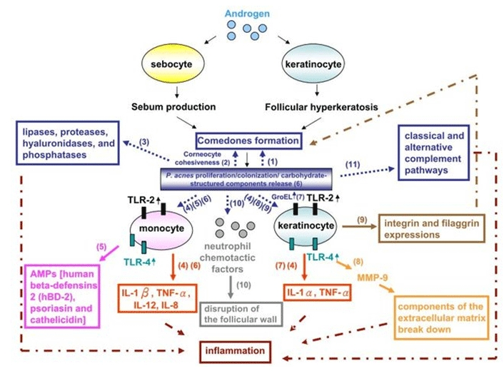
Figure 2: Molecular mechanisms by which P. acnes may contribute to
the pathogenesis of AV

Microcomedone development is aided by P. acnes. When comedones are formed as a result of P. acnes colonization, corneocyte cohesiveness increases; in vitro studies have revealed that P. acnes produces lipases, proteases, hyaluronidases, and phosphatases that may damage tissue. Through the TLR2-dependent pathway, P. acnes stimulates the expression of the proinflammatory cytokines IL-8, IL-12, IL-1, IL-1, and tumor necrosis factor-alpha by innate cells such keratinocytes and monocytes .Antimicrobial lipids, AMPs (human beta-defensin 2, psoriasis, and cathelicidin), which exhibit synergistic actions and induce proinflammatory cytokines/chemokines via TLR4- and CD14-dependent processes, have been generated by host cells as a protective antimicrobial response to P. acnes.
In individuals with severe acne, the peptidoglycan-polysaccharide complexes and lipoteichoic acids of P. acnes induce the production of proinflammatory cytokines from monocytes, revealing their high antigenicity. For the detection of peptidoglycans and lipopolysaccharides (LPSs), respectively, increased expression of TLR2 and TLR4 was discovered in vivo in the epidermal layers of acne lesions P. acnes uses a heat-shock GroEL protein to stimulate keratinocyte development in vitro and increase the production of proinflammatory cytokines. MPs have a significant part in the inflammation of acne, the degradation of the dermal matrix, and hyperproliferative skin disorders. They are produced by a variety of cells, including keratinocytes and sebocytes. MMPs also result in pilosebaceous follicle rupture, which worsens inflammation. For instance, MMP-9 expression is stimulated by P. acnes in keratinocytes to cause inflammation.
By increasing the expression of the integrins b1, a3, a6s, and aVb6 when comedones form, P. acnes lysates can directly affect the differentiation of keratinocytes. In the sebaceous follicle, P. acnes creates extra neutrophil chemotactic factors that are consumed by neutrophils, who then release hydrolases to damage the follicular wall. Both the traditional and alternative complement pathways are activated by P. acnes, which causes C5a to develop in inflammatory acne lesions.

HERBAL MEDICINES FOR ACNE VULGARIS TREATMENTS:

CALENDULA:

Kingdom: Plantae

Order: Asterales

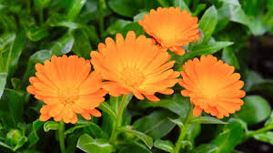
Family: Asteraceae
Figure 3: Calendula

The marigold plant is the common name for the Asteraceae family member Calendula officinalis. It is applied topically as a suspension or tincture to treat acne, lessen swelling, stop bleeding, and soothe sensitive skin. Radiation dermatitis can be effectively treated with calendula cream or ointment. Calendula is a native of Canada and the lower 48 states, according to the United States Department of Agriculture (USDA). An annual flower, calendula is simple to grow on ordinary, moderately fertile, well-drained soils that receive direct sunlight. It is suitable for planting in flower beds, borders, cottage gardens, cutting gardens, as well as pots and containers. The plant's fragrant leaves in a garden draw butterfly. The petals are a common ingredient in floral arrangements and potpourri mixtures. They can be prepared and consumed as well.

PREPARATION OF CALENDULA OIL:
The blossoms from calendula plants are infused with carrier oils like olive or coconut oil to create calendula oil. The oil can be used on its own or as a component of creams, lotions, ointments, and balms. It can also be converted as a tincture, tea, or pill, among other things.
USES:
There are numerous skin disorders that can be treated with calendula. Calendula may help with diaper rash wounds, vaginal yeast infections, and other diseases, according to research. Calendula has also been used to alleviate cancer patients' treatment-related adverse effects and reduce pain and inflammation. While some studies have suggested that calendula has good effects, additional research is required to understand the long-term consequences of calendula use. Before beginning to use any medication or dietary supplement, even one that is natural, always consult your doctor. Flavonoids, which are naturally occurring substances, are abundant in calendula petals. These substances allegedly:
- Reduce inflammation (anti-inflammatory)
- Prevent blood from clotting too much (anti-thrombogenic)
- Have positive effects on blood sugar level (antidiabetic)
- Help fight cancer (anticancer)
- Protect the brain (neuroprotective effects)
The chemical compounds that make up the calendula flower's active components include:
- Triterpene saponins (glycosides of oleic acid)
- Triterpene alcohols (faradiol, -amyrins)
- Quercetin and isorhamnetin are flavonoids.

CHAMOMILE:
Any of the several daisy-like plants belonging to the aster family (Asteraceae), are also spelt as chamomile. English, or Roman, chamomile (Chamaemelum nobile), or German chamomile (Matricaria chamomilla), are the two varieties used to make chamomile tea, which is used as a tonic, an antibacterial, and in many herbal treatments. Numerous kinds, particularly golden marguerite or yellow chamomile (Cota tinctoria), are used as garden ornamentals. Acne outbreaks can be treated with chamomile. It reduces inflammation brought on by acne by acting as an anti-inflammatory. Long used as a main component in calming skin care products, chamomile. Even the ancient Greeks and Egyptians used crushed chamomile flowers to soothe their skin's redness and dryness caused by the weather. Many plants belonging to the Anthemics genus, which includes more than 100 species of Eurasian herbs, are also referred to as chamomile. They have yellow or white disc blooms and yellow ray flowers in small flower heads as a distinguishing feature. Mayweed, often known as stinking chamomile (A. cotula), is a pungent weed that has been employed as an insecticide and a drug.

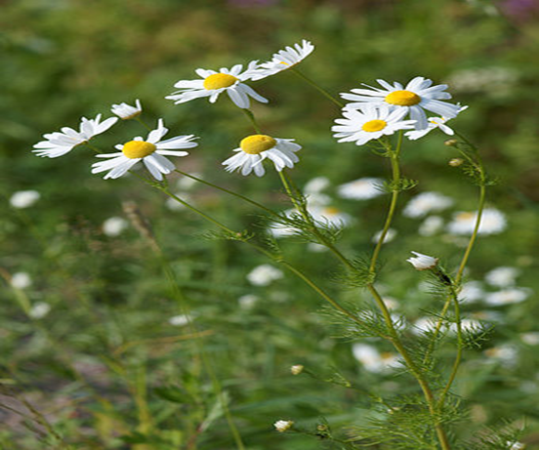

Figure 4: Chamomile.
Uses:
Many of the chamomile skin care benefits are caused by the same anti-inflammatory characteristics that make chamomile helpful for a variety of physical and psychological problems. It is a very mild astringent as well as a beneficial antioxidant. It is a fantastic option for skincare because of this. There are a lot of advantages to applying chamomile to your skin. But first, we wanted to discuss the advantage that chamomile is probably best known for promoting sleep. This has significant advantages for skin care. The most crucial component of your beauty routine is probably getting a good night's sleep. You can easily enter the Land of Nod thanks to its calming soporific effects, ensuring you obtain the beautiful sleep you need. Chamomile has additional relaxing psychological effects. A calming cup of chamomile tea will also help you fall asleep if anxiety is keeping you awake at night, without having the same jolting effects as caffeinated black tea.
Other benefits for the skin include:
- Reducing redness and irritation.
- Acne.
- Treating eczema, psoriasis, and rosacea.
- Soothing sunburn and scalds.

- Treating wounds.

ROSEMARY:
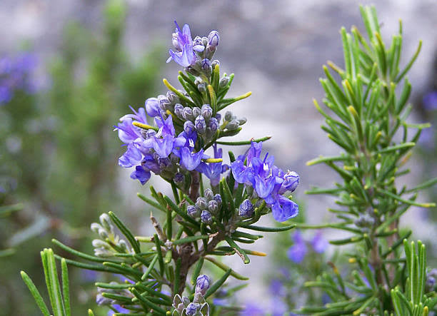
An aromatic evergreen herb, rosemary is indigenous to the Mediterranean. In addition to being used as a culinary seasoning, it is also used to manufacture body fragrances and may have health advantages. It belongs to the Lamiaceae mint family, which also includes many other herbs like oregano, thyme, basil, and lavender. The essential oil from the rosemary plant is rosemary extract. In addition to being used in aromatherapy and beauty items, rosemary essential oil is also employed in dietary supplements. For generations, people have used rosemary as a natural remedy for conditions like arthritis, asthma, stomach cramps, and many more. It is employed by people as a natural antiseptic and antifungal. It is used to improve the state of the skin and is thought to have anti-aging qualities. Because it can withstand droughts, rosemary thrives in warm climates like its native Mediterranean coasts. Under these circumstances, rosemary can develop into a 5 to 10-foot-tall bush. In fact, rosemary requires annual trimming to keep it bushy since it grows so quickly under optimal circumstances. You can grow this herb either in the ground or in a pot. It grows readily as a perennial evergreen shrub that lasts for many years if you reside in Zones 7 and warmer. Although rosemary is hardy down to 15 to 23°F (-10 to -5°C), it could need protection throughout the winter. Rosemary should be planted in a pot and taken indoors for the winter in colder climates.
Figure 5: Rosemary

Uses:
Rosemary possesses strong antibacterial, anti-inflammatory, antioxidant, anti-tumorigenic, anti-apoptotic, anti-nociceptive, and neuroprotective effects. Additionally, it demonstrates critical clinical benefits on mood, cognition, memory, pain, anxiety, and sleep.
Some benefits of rosemary include:
- A perennial plant, rosemary has a lifespan of over two years.
- The leaves are frequently utilized in recipes.
- Possible health advantages include better digestion, better focus, and slower aging of the brain.
- Vomiting, coma, and pulmonary edema may be brought on by extremely high d
Benefits of rosemary in acne:
Rosemary essential oil aids in preventing acne-causing germs from entering your pores because to its strong antibacterial properties. This characteristic, coupled with the non-comedogenic qualities of rosemary oil, prevents acne from taking root because the oil unclogs pores and creates a barrier against subsequent breakouts. It is a natural acne treatment, a good source of vitamin E, and it protects the skin from aging when applied to the face. It improves the appearance of the skin by clearing pores and promoting healing. Due to its high antioxidant content, rosemary is a natural astringent and is therefore good for aging skin. Broken capillaries, a condition in which capillary walls tear and blood leaks to the skin's surface, are a typical sign of skin damage and aging skin. As a result, tiny red lines under the skin's surface start to develop, giving the skin an unpleasant appearance. It is known that rosemary can lessen the appearance of broken capillaries. It works well in anti-aging products since it increases circulation and lessens the visibility of red lines. Because it can improve circulation and aid in removing toxins that build up beneath the eyes, rosemary is also beneficial in decreasing under-eye puffiness.
LAVENDER:
The mint family's flowering plant known as lavender is instantly recognized by its alluring floral aroma. It is thought to have originated in the Mediterranean, the Middle East, and India, and it has a 2,500-year history. Lavender was considered a sacred herb in the past. It was frequently used to freshen and add a subtle aroma to a variety of personal goods, including clothes and hair. The lavender plant yields lavender oil, an essential oil. It helps people unwind and sleep better, and it might also be used to treat some skin diseases. Essential oils must first be blended with carrier oil because they might be irritating to the skin. A person may combine lavender oil with other oils, such as argan, coconut, or jojoba, depending on the intended use. Fine lines and wrinkles on the face are partially caused by free radicals. Antioxidants included in lavender oil help shield you from free radicals. Use a few drops of lavender essential oil mixed with coconut oil to treat wrinkles. Once or twice a day, the mixture can be applied as a moisturizer. Lavender oil is effective in treating painful inflammation. The oil's analgesic and numbing properties aid in reducing inflammation, and its beta-caryophyllene content functions as a natural anti-inflammatory.
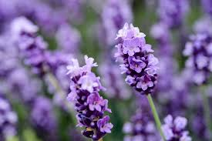
Figure 6: lavender
USES:
People frequently use lavender to treat a variety of ailments, but there isn't enough reliable scientific data to back many of these claims.
Some benefits include:
- Symptoms of premenstrual tension.
- Increased sleep quality.
- Reduced anxiety.
- Promotes hair growth.
- Assists in wound healing.
- Migraine headache relief.
- Treatment of head lice.
- Antimicrobial action.
Benefits of lavender in acne:
Due to its known ability to destroy bacteria, lavender oil has the potential to both prevent and treat acne. Because lavender oil is non-comedogenic, it won't clog pores. It can be used as a daily toner when mixed with witch hazel, or as a spot treatment when paired with argan oil or tea tree oil. By combining 2 drops of lavender oil with 1 teaspoon of witch hazel, you may also use it as a facial toner. After soaking a cotton ball in the mixture, gently wipe your face with it. Argan oil helps lessen inflammation for a pimple that is especially difficult to get rid of. Apply a mixture of 1 drop each of lavender and argan oil directly to a pimple twice day. it has an incredibly calming smell for the skin. Here are all the applications for skin care with lavender oil.
- Fights acne.
- Soothes eczema and dry skin condition.
- Anti-inflammatory superstar.
- Detoxifies skin.
- Heals injured skin.
Preparation of lavender oil:
The fields of lavender are often plucked by hand. The bouquets of flowers are knotted together and left out to dry for a few weeks. In addition to keeping the oil from getting rancid, drying the buds makes it easier to extract them from the stems. Once the flowers have dried completely, it's time to start the steam distillation process. Because acetone or hexane are employed in solvent extraction techniques, steam distillation ensures that you receive the greatest advantages from lavender while avoiding contamination. Lavender buds are placed above boiling water to begin the distillation process. As the lavender softly steams, the high pressure and heat force the oil from the blossoms. The steam transports the steam and oil mixture to a condenser, where it is cooled and transformed back into a liquid. A hydrosol is created from the steam, and the priceless lavender oil drops are naturally separated.

MANJISTHA:
Indian madder, also known as manjistha herb, is a perennial climber with reddish-colored bark. Herpes, haemorrhoids, snake bites, eye illnesses, menstruation disorders, etc. have all been treated with it in Ayurveda. Manjistha has numerous advantages for conditions of the skin and blood. It is believed to be the best remedy for acne because of its varnya (complexion enhancing), raktashodhak (blood purifying), vishaghna (toxin eliminating), rasayana (rejuvenating), and krimighna (anthelmintic - that removes worms) characteristics.
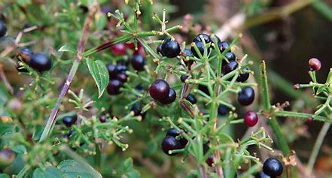
Figure 7: Manjistha.
Manjistha's Role in Fighting Acne.
- Combats Bacteria That Cause Acne According to studies, the herb manjistha has the ability to suppress Propionibacterium acnes, a bacterium that is essential to the etiology of acne. This bacterium acts as a catalyst for oxidative stress, which causes inflammation in acne. Therefore, the manjistha for acne's antibacterial characteristics may aid in your quest to get rid of those unattractive zits.
- Eliminates Inflammation. The herb manjistha is renowned for having strong anti-inflammatory effects. It has been discovered that it has an impact on two key inflammatory mediators involved in the aetiology of acne. It reduces the inflammation-causing free radicals that Propionibacterium acnes causes. That's not all, though. Pro-inflammatory cytokines, which are proteins crucial to the immune system, have also been discovered to be suppressed by it.
- Aids in Acne Spot Fading. Dark patches and scarring are possible side effects of acne. Melanin, the pigment responsible for skin colour, is overproduced or has an uneven dispersion, which is the cause of this. The darker your skin is, the more melanin you have. Acne-related skin irritation can lead to hyperpigmentation. But the herb manjistha might be able to lighten those blotches. After all, its "varya" quality has made it famous in Ayurveda. In other words, it evens out your tone and improves your complexion. Manjistha advantages for skin include lightening skin tone, according to research. This is because it prevents the activity of an enzyme called tyrosinase, which is crucial for the creation of melanin.
CONCLUSION:
Finally, herbal remedies for vulgar acne have been investigated as alternatives or complements to conventional therapy. While several herbal therapies show promise owing to their anti-inflammatory and antibacterial qualities, scientific data supporting their efficacy is sparse and ambiguous. Before utilizing herbal therapies for acne, it is critical to use caution and contact with a healthcare expert, since individual reactions might vary and possible risks may occur, especially when taken with other drugs or health problems. Herbal therapies should not be used in place of conventional treatments, but they can be used as part of a comprehensive approach to acne care when used under competent medical supervision.
While some people may find comfort and progress in their symptoms of acne through herbal remedies, others may not, emphasizing the need of customized and evidence-based acne care.
Integrating herbal medicines into an extensive skincare regimen, in addition to a balanced diet, stress management, and proper cleanliness, may help to take a more comprehensive approach to acne control.
It is important to note, however, that herbal therapies are not a replacement for expert medical guidance, and serious instances of pimples should be evaluated and treated by experienced medical professionals to avoid potential consequences and scarring.

REFERENCES:
  - Cheung, S., & Tai, J. Anti-proliferative and antioxidant properties of rosemary Rosmarinus officinalis [Abstract]. Oncology Reports, 2007 Jun;17(6):1525-31.
  - Moss, M., Oliver, L. Plasma 1,8-cineole correlates with cognitive performance following exposure to rosemary essential oil aroma. Therapeutic Advances in Psychopharmology, (2012, June). 2(3), 103-113
  - Seyedemadi, P., Rahnema, M., Bigdeli, M. R., Oryan, S., & Rafati, H. The neuroprotective effect of rosemary (Rosmarinus officinalis L.). Hydro-alcoholic extract on cerebral ischemic tolerance in experimental stroke. Iranian Journal of Pharmaceutical Research, (2016). 15(4), 875-883
  - Hamid nasri,Mahmoud Bahmani,Medicinal plants for the treatment of acne vulgaris:A review of recent evidences.jundishapur journal of microbiology,Nov 2015,8(11)
  - Stephen C Barker, Phillip M Altman, An ex vivo, assessor blind, randomized, parallel group, comparative efficacy trial of the ovicidal activity of three pediculicides after a single application — melaleuca oil and lavender oil, eucalyptus oil and lemon tea tree oil, and a “suffocation” pediculicide.(2011),article number:14.
  - Or Givol , Rachel Kornhaber , Denis Visentin , A systematic review of Calendula officinalis extract for wound healing, Wound repair regan, Sep 2019,27(5):548-561. doi: 10.1111/wrr.12737.
  - Rittapalli Bhagya Jyothi, Lakshmi Naganathan , Boya Chaitanya, Various Pharmacological Actions of Calendula officinalis, Tagetes erecta, Carica papaya, Hypericum perforatum and Salvia officinalis, Int. J. Pharm. Sci. Rev. Res., 59(1),Dec 2019. Article No. 08, Pages: 42-51.
  - Anna Hwee Sing Heng, Fook Tim Chew, Systematic review of the epidemiology of acne vulgaris,Scientific reports, 10(Apr 2020), Article number: 5754 .
  - Isha Kumari, Hemlata Kaurav, Gitika Choudhary, Rubia cordifolia (Manjishtha): A review based upon its Ayurvedic and Medicinal uses,Himalayan journal of health sciences,(2021),volume 6,2582-0737.
  - Dr. Bharti Sadabal, Dr. T.A.Pansare, and Dr Sachin Govindrao Tike, A COMPREHENSIVE REVIEW ON MANJISHTHA (RUBIA CORDIFOLIA L.) WITH SPECIAL REFERENCE TO AYURVEDIC AND MODERN ASPECT, International Journal of Recent Scientific Research,(2020) Vol. 11, Issue, 04 (A), pp. 37958-37968.
  - Yan HM, Zhao HJ, Guo DY, Zhu PQ, Zhang CL, Jiang W. Gut microbiota alterations in moderate to severe acne vulgaris patients. J Dermatol. 2018 Oct;45(10):1166-1171.
  - Juhl CR, Bergholdt HKM, Miller IM, Jemec GBE, Kanters JK, Ellervik C. Dairy Intake and Acne Vulgaris: A Systematic Review and Meta-Analysis of 78,529 Children, Adolescents, and Young Adults. Nutrients. 2018 Aug 09;10(8)
  - Isvy-Joubert A, Nguyen JM, Gaultier A, Saint-Jean M, Le Moigne M, Boisrobert E, Khammari A, Dreno B. Adult female acne treated with spironolactone: a retrospective data review of 70 cases. Eur J Dermatol. 2017 Aug 01;27(4):393-398.
  - Goulden V, Clark SM, Cunliffe WJ. Post-adolescent acne: a review of clinical features. Br J Dermatol. 1997 Jan;136(1):66-70.
  - El-Naggar SA, Abdel-Farid IB, Germoush MO, Elgebaly HA, Alm-Eldeen AA. Efficacy of Rosmarinus officinalis leaves extract against cyclophosphamide-induced hepatotoxicity. Pharm Biol. 2016; 1:1–10.
  - Okamura N, Haraguchi H, Hashimoto K, Yagi A. Flavonoidsin Rosmarinus officinalis leaves. Phytochemistry. 1994 a; 37:1463–1466.
  - Okamura N, Fujimoto Y, Kuwabara S, Yagi A. High-performance liquid chromatographic determination of carnosic acid and carnosol in Rosmarinus officinalis and Salvia officinalis. J Chromatogr A. 1994 B; 679:381–386.
  - Birtic S, Dussort P, Pierre FX, Bily AC, Roller M. Carnosic acid. Phytochemistry. 2015; 115:9–19.
  - Okamura N, Fujimoto Y, Kuwabara S, Yagi A. High-performance liquid chromatographic determination of carnosic acid and carnosol in Rosmarinus officinalis and Salvia officinalis. J Chromatogr A. 1994 B; 679:381–386.
  - Tal Friedman ND. The effect of rosmarinic acid on immunological and neurological systems: a basic science and clinical review. JRM. 2015; 4:50–60.
  - Aguilar F, Autrup H, Barlow S, Castle L, Crebelli R, Dekrant W, et al. Use of rosemary extracts as a16 food additive–scientific opinion of the panel on food additives, flavorings, processing aids and materials in contact with food. EFSA J. 2008; 721:1–29.

