DIGITAL HEALTHCARE: THE CHANGE IN TRADITION (AN OVERVIEW)- BASED ON NURSING AND PHARMACY

Mr. Chandan Nayak
Assistant Professor, Berhampur University
Accredited By NAAC
Bhanja Bihar, Berhampur, India.
nayakchandan279@gmail.com
Gita Dash
Lecturer, BLM School of Pharmacy
(Run under Durga Soren University)
Deoghar, Jharkhand, India.
gitadash96@gmail.com

ABSTRACT
The report in this chapter are the possibilities and scopes that can be drawn with the help of technologies to improvise the medical or clinical healthcare needs. Advances in the recent technologies combinely has given a high performance to change the paternal traditions into a digital tradition. To answer the question whether digital healthcare has changed or not, we had performed an overview review about the acceptance of digital healthcare whether it has excelled of failed. The major aspect is to know the ubiquity of the literature review on technologies and evolving dynamics of digital healthcare.
1. INTRODUCTION
As the name itself suggests digital means tools or technologies that can be used for the innovation. So in together digital healthcare stands for health innovation with the help of technos that can provide patient assistance, care and can evaluate the conditions. In this era where population is a huge problem digitalisation can reduce and change the mindset of being so populated. Digital communication due to data base knowledges can evaluate the purpose of medication needed at most crucial time can analyse the demand and supply health care needed. Digital healthcare can reduce communicable diseases, as it can reduce the contact. The most recent and huge example is the pandemic where every single suffering is due to the contact and so digital caring would have change the situation in every aspect. In this 5G era speed if health care is done digitally then the chronic diseases treatment can be done easily.
The chapter is all about the focus on technical equipment or processes like digital pills, that can be introduced in the cycle of old health care management which will modify the state of healthcare system in this era with a digital transformation.
The main and foremost focus of the chapter are as follows:
- Acceptance in the big established firms that can recognize that healthcare can be benefited digitally.
- The analysation of the patient history through the data analysis which is easier if the health care is done digitally.
- E-communication can also be count as an integral part for the treatment which can be lead successively with the help of digital healthcare.
In this chapter we can visualise the future of health care in a very sci-fi state, where every step of the upcoming generation is in an automated form with just one voice assistance. The future vision could be seen as:
- Improved patient outcomes that is more systematic and high-quality care.
- Utilisation of time to improve the core competency.
- Every crucial state of treatment will be in an ubiquitous stage which is less visible but with high impact i.e. more pro-active and targeted care.
- Improved preventions and remote monitoring can be done with wide space of consulting and coaching skills i.e. more coordinated care.
- In the field of genomics and diagnostics also an advance technology with less complications can be seen.
2. BACKGROUND LITERATURE
2.1 DIGITAL HEALTHCARE THE GROWING PHASE
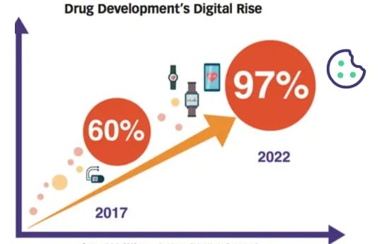
To understand the current context, first we have to study about how a narrow spectrum has been changed to broad and unique spectrum phase development. Before starting any steps there must be some breakthroughs in them but it is hard to find a true breakthrough. Without any footsteps before it is very hard to carry forward where limitations are more and understanding is less. From a traditionally technology to a totally modern technology tends to port legacy rather than enable fundamentally new architecture. “Mike Maples, partner at floodgate, suggests that breakthroughs are derived from living in an environment that is somehow futuristic and then “backcasting” to the present.”
Source: Validic 2016 Survey: “Insights on Digital Health Technology”

2.2 DIGITAL HEALTHCARE AND THE OBSTACLES
“Chris Dixon, partner at a a16z, has found that visionary entrepreneurs spend many years deeply immersed in an underlying technology before achieving a breakthrough insight.”
The majore obstacles are
2.2.1. THE BUSINESS
Superior technologies are not the only key factor to compare the win or loss. There are some root line non-technical parameters that includes designing, integrity easiness, partnerships, stakeholders, developed ecosystem, timings and other networking that cummulatively decides to which technologies are universally assimilate.
2.2.2. THE INTEGRATION
Technologies doesn’t come out from the envelopes. Before implementing any new technology first and foremost thing is to conquer the mindset of absorption in the society. Novel innovation in this emerging time is in search of practical volunteering. A broad adoption is a success when new technologies integrate together with the existing production and manufacturers.

2.2.3. THE FUNDING
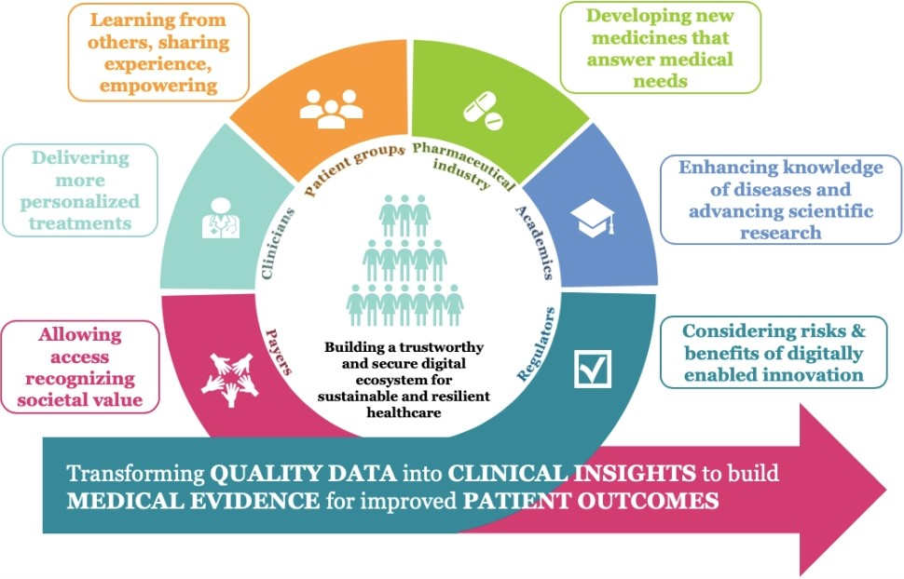
New innovating technologies requires longer time for development. In this funding plays an important role before revenue generating opportunities materialize. It can be funded by the public sector or by the private sector where both the funding parties can rely upon for the innovational profits and also on meaningful revenue generation can be more relative to traditional software startups.
Source:https://www.efpia.eu/about-medicines/development-of-medicines/digital-health

2.2.4. THE PHASES AND TIMING
The phases are in four stages that are phase I, phase II, phase III and phase IV. In which phase iv is the final stage and all the other are trial phases. But in phase the volunteering is very important part which is only possible when adoption and acceptance is not the issue. Technologies that are too early in market often has chances to fail early and health is a term that needs a targeted treatment with better results so time to cure and invention will definitely take more time and expenditures.
2.2.5. THE ACCEPTANCE (SHIFTS)
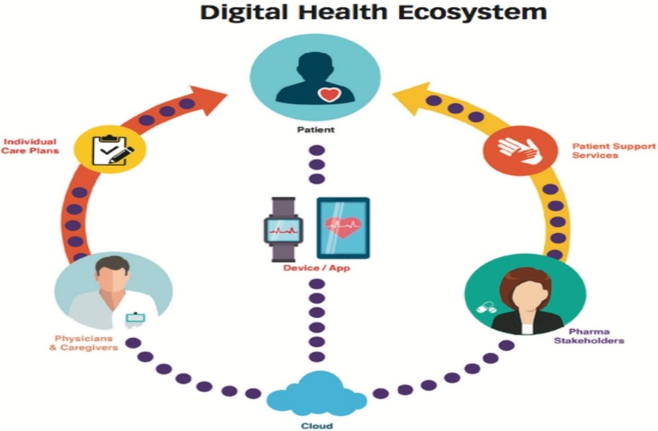
New innovations are not the next day morning wake up things that will be accepted as early as it gets launched. The behavioural changes need time when it comes to legacy. Sometimes acceptance is all about putting all your reputation on stake or on the verge of losing everything if it doesn’t work.
Source: Validic 2016 Survey: “Insights on Digital Health Technology”

3. CURRENT DIGITAL HEALTHCARE AND OPPORTUNITIES
This book is written after and in midst of the pandemic that is COVID-19 or coronavirus where we get to know about the digitalization in a vast circumstances. So we can conclude that technologies will be accepted and are already accepted by each and every generations. The opportunities where the digital healthcare is rising up are
- In discovering new medicines
- Monitoring of the medicine and patient support
- Making an distributing the medicines
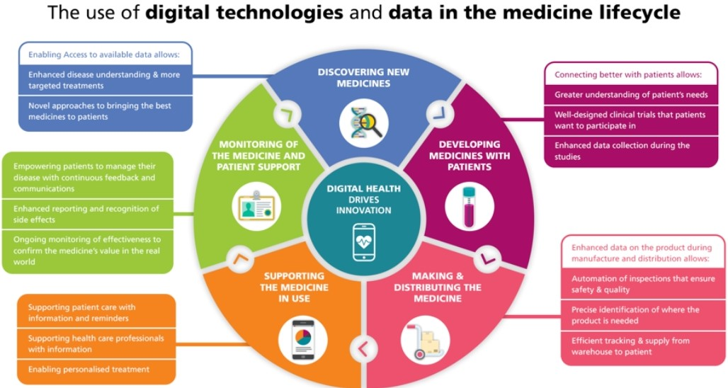
- Enhances monitoring and tracking diseases
Source:https://www.efpia.eu/about-medicines/development-of-medicines/digital-health
- Remote patient monitoring
- Cybersecurity
- Virtual visits
- Health digital symptom checkers
- Digital pharmacies
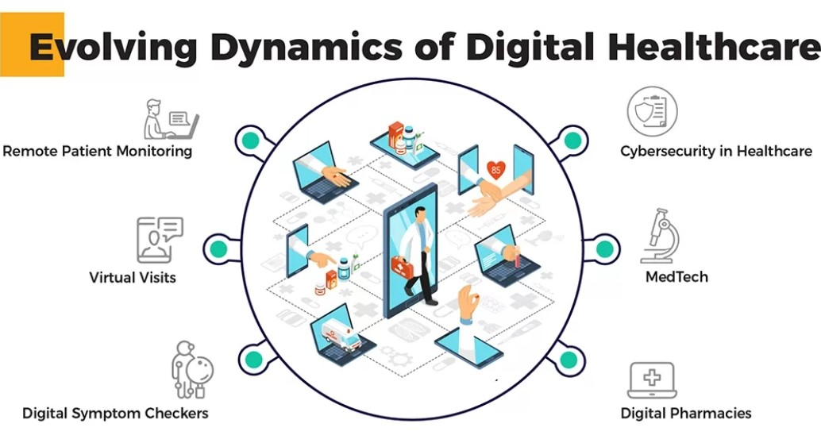
- MEDTECH
Source: https://www.thegatewaydigital.com/how-covid-19-is-changing-the-face-of-digital-healthcare

- Wearable devices
- Electronic health records (EHRs)
- Clinical trials
- Visualisations
These all above are the new opportunities and research that are currently in growing stage and still developing with new functions and changes.
Except all this above digital healthcare is also about health informatics. There are many theories and statements regarding health informatics but the most silver-tongued definition is by prof. Bill Hersch: “My definition of informatics is the discipline focused on the acquisition, storage and use of information in a specific setting or domain.”
4. UBIQUITY AND CONCLUSION
Ultimately these technologies will achieve ubiquity which will finally strive to hard tech and we can achieve a new innovated stage with a maturation. This will make a fine line difference between development and recession, between incredible and hopeless and between ubiquity and desuetude.
CONCLUSION
The world is rapidly growing with more digital innovations and the strength to focus, through which this market is growing should be incorporated furiously or otherwise the business will fall. India has the extent potential for digital health growth given its current technology penetration that is unsurprisingly the technical innovation will get adopted in everyday life of the societies, advancing economy so that the per capita income rate goes high and the global finance will rise, growing population and accelerating healthcare industry. The rise of digital technology is pushing the countries to achieve Health for All, putting the country at the spearhead for foreign investment. With these opportunities, India and other countries are emerging as the Global leader in digital health. The digital health though in the form of digital pills or as the form of other technologies the world should give a kick start and make this a friendly and affordable platform so that needy or the wealthy both can use the technologies according to their needs.
REFERENCES
- https://medium.com/@m2jr/how-to-build-a-breakthrough-3071b6415b06
- http://www.michaeldempsey.me/blog/2020/07/29/inflection-points/
- https://a16z.com/2020/10/18/doing-old-things-better-vs-doing-brand-new-things/
- https://www.amazon.com/Most-Important-Thing-Uncommon-Thoughtful/dp/151138347X
- https://hbswk.hbs.edu/item/government-funded-research-is-increasingly-funding-corporate-innovation
- https://twitter.com/aashaysanghvi_/status/1340794670293512192
- https://medium.com/prime-movers-lab/physics-powered-startups-inventing-the-future-6aa629fa7dd0
- https://medium.com/lux-capital/do-good-things-32b3e9365913
- https://vimeo.com/464835556 Originals
- https://www.forbes.com/sites/georgebradt/2018/04/10/what-it-takes-to-accelerate-through-a-strategic-inflection-point/?sh=2c26209a5cee
- https://twitter.com/katie_haun/status/1340521235264860161
- http://www.theindy.org/2235
- http://paulgraham.com/nov.html
- https://hardwarelottery.github.io/
- https://www.efpia.eu/about-medicines/development-of-medicines/digital-health
- Paton, C. & Kobayashi, S. An Open Science Approach to Artificial Intelligence in Healthcare: A Contribution from the International Medical Informatics Association Open Source Working …. Yearb. Med. Inform. (2019)
- Indian-healthcare-on-the-cusp-of-a-digital-transformation.
- Ali S, Coletta J and Pope R (2011) ‘QIPP and care plans for long term conditions: revisited’, HSJ, 19 May.
- American Telemedicine Association (2015) Operationalizing Telemedicine in Managed Care: Lessons from Kaiser Permanente. 2015 Annual Meeting. American Telemedicine Association. www.americantelemed.org/docs/default-source/ata2015/operationalizing-telemedicine-inmanaged-care-full-compressed1.pdf?sfvrsn=2 . Accessed November 2015.
- Barbieri JS, French B and Umscheid CA (2015) ‘Uptake and impact of a clinical diagnostic decision support tool at an academic medical centre’, Diagnosis 2(2), 123–7.
- Bell G and Ebert M (2015) Health Care and Cyber Security: Increasing threats require increased capabilities. KPMG. http://advisory.kpmg.us/content/dam/kpmg-advisory/PDFs/ ManagementConsulting/2015/KPMG-2015-Cyber-Healthcare-Survey.pdf . Accessed January 2016.
- www.nuffieldtrust.org.uk/publications.uk

