On-Road Charging of Vehicles Using Contact- Less Power Transfer by Solar Power
Curated By: Sayam Tomar, Neeraj Kumar, Jay Yadav, Utsav Kashyap.

Table of Content

S.No. | Title
1. | Abstract
2. | Introduction
3. | Electric Vehicles and Battery Chargers
4. | Present and future scenario of Electric Vehicles
5. | Wired charging vs CPT for EVs
6. | Wireless Charging system for EVs
7. | WPT using Solar Cells for EVs
8. | Evolution of WPT Static and Dynamic Models
9. | On Road Charging Simulated Output
10. | Conclusion
11. | Reference

ABSTRACT
Major transportation sectors will electrify in the future years, necessitating the need for more readily available and simple methods of charging electric vehicles (EVs). One of the best and simplest ways to charge EVs anywhere, including while driving, is wireless charging. Advanced mathematical models are required to appropriately portray the charging power when charging wirelessly in order to obtain accurate charging power rates.
This paper reviews the basic terminologies of charging stations, such as charging station types. The benefits of electric vehicles over conventional fuel-powered vehicles have been described. This essay also highlights the prospects and difficulties associated with current technologies for effective wireless charging systems.
With solar-based wireless power transmission, users may operate their vehicles faultlessly and data can be exchanged across the air just as easily. Due to rising energy demand, resource scarcity, and environmental pollution from current resources like wood, coal, fossil fuels, etc., alternative energy sources and creative energy production methods that are efficient, affordable, and produce the fewest losses are expected to become increasingly important in the near future. As a research topic, wireless power transfer (WPT) has gained attention. In this study, we discuss the idea of wireless power transmission by solar power.
INTRODUCTION
For years, researchers have been working nonstop to get rid of the wires from our daily lives. Electric vehicles (EVs) can be charged using contactless power transfer (CPT) technology without a physical connection. Higher criteria for the convenience, safety, and effectiveness of electric car charging are necessary with the ongoing development of the EVs of a modern technological sector. Electric vehicles can lower environmental noise and greenhouse emissions—the electric vehicle (EV) powered by one or even more electric motors and traction motors. The following shortcomings hinder the adoption of EVs in the supply chain when compared to normally distributed combustion engine vehicles: independence, a lack of infrastructure for public access, fast charging, a shorter battery life, high battery prices, and compatible weight.
Wireless charging of (EVs) has been in development for several years. The latest Wireless charging systems offer an efficient means of charging EVs from different tiers, at a range of high to low levels of power from the same ground source. EVs existing today can be fuelled by a battery, solar panels, or even an electric generator to transmit fuel into electric power. Fuelled by solar power, the ability to charge EVs on-the-go with attached batteries allows them to be driven off-road. On-road charging can be very helpful for this. Copper and aluminum-based electrical wiring is not as frequently required when using wireless power transfer technology. Metals now used to make electrical wire won't be used anymore. If wireless power transmission technology is adopted, there will be less need for electrical cable. The ability to transport power wirelessly from a power plant to any area would be helpful if wireless power transfer technology could be used in the future. Autonomous vehicle fleets offer yet another strong argument in favour of wireless charging. Wireless charging becomes into more of a requirement when there is nothing to plug in, but the car is capable of driving itself to a charging location.
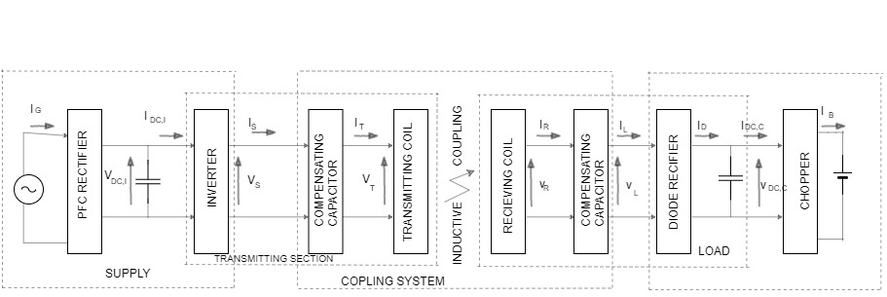
Figure 1 General scheme of a CPT system

The term "wireless power transfer" (WPT) refers to a variety of techniques and technologies that use time-varying electric, magnetic, or electromagnetic fields to transmit electrical power without needing wires. The development of various wireless power transmission methods is progressing significantly in the power electronics sector. Uses for wireless power transfer include the resonance of electromagnetic waves, microwaves, solar cells, and lasers. Without a power cord, electrical equipment can be continuously charged thanks to wireless power transfer. Three main types of wireless power transfer systems that can be explained are microwaves, resonance, and solar cells. Microwaves can be used to send electromagnetic radiation from the power source to a receiver inside an electrical device or gadget.
Wireless power transfer transmission for EVs developed to address the shortcomings of cable chargers and eliminate some particular barriers to vehicle electrification and long-term mobility. In addition to being more practical than wired charging, WPT enables significant onboard EV battery size reductions. The main objective of this case study is to provide an overview of the wireless charging technology for EVs used for this application and a discussion of various obstacles still standing in the way of wider adoption and offer suggestions for potential solar-powered vehicle applications.
ELECTRIC VEHICLES AND BATTERY CHARGERS
Batteries or fuel cells can power pure electric vehicles. When a battery is used, grid power is used to recharge it. Due to their assurance of zero emissions, cheaper operating and maintenance costs, and ability to utilise recovered energy during regenerative braking for range extension, EVs enjoy the most encouraging backing in the current global environment. On-board batteries in electric vehicles store the energy needed for propulsion and other on-board functions, which has a significant impact on the vehicle's performance and design.
Battery chargers are crucial to the advancement of EVs. The parameters of the battery charger have an impact on both charging time and battery life. A battery charger needs to be dependable and efficient, with low cost, low volume, and low weight. Components, switching and control methods, particular integrated circuits, rating, price, and converter kinds all affect how it operates. A utility current must be extracted from an outlet with low distortion and a high power factor for an EV charger to ensure that the impact on power quality is minimized and that the real power available from the outlet is maximized. It is obvious that fossil fuels have an order of magnitude higher energy density than the battery technology used today for energy storage. Since it is advised to keep the depth of discharge at 80% of the nominal battery capacity in order to achieve an acceptable life, usage factors must be taken into account for the batteries.
Compared to internal combustion engines powered by gasoline or diesel, all-electric vehicles are approximately four times more efficient. The current state of battery chargers and electric vehicles leads to a number of significant findings. New electric car development and research are now being conducted by numerous well-known automakers. According to Pearre, et al, the majority of drivers' driving needs can already be satisfied by current EV technology, although Franke points out that range restrictions of existing EV models remain a psychological roadblock to widespread public acceptance.
The transmission losses and the potentially fatal effects of electric short circuits are one of the main problems in the power system. As demand rises, so does power generation, power loss, and the number of fatalities brought on by electrical short circuits. About 26% of the power is lost during transmission and distribution, and 2.4% of all accidental deaths are caused by electric short circuits. Solar-based wireless power transmission is used to reduce power loss, improve vehicle aesthetics, and ensure human safety. Energy is transferred using electromagnetic coupling through a process called mutual induction.

PRESENT & FUTURE SCENARIO OF ELECTRIC VEHICLE
Electric vehicles already account for a small percentage of all passenger vehicles in the vast majority of nations worldwide. But it is already widely understood that the market for electric cars will grow significantly over the coming decades. Currently, there are 250 electric automobiles on the road worldwide, which translates to a market share of 2.2% for electric vehicles. Sales of electric vehicles totaled 0.8 million units in 2016; by 2023, it is expected that they will reach 5.3 million units, growing at a CAGR of 33.6% for the forecast period (2017-2023). According to the Net Zero Emissions by 2050 Scenario, there will be more than 300 million electric vehicles on the road by 2030, and they will make up 60% of all new car sales. Their sales share must rise by less than 6% percentage points annually to be on track with the Net Zero Scenario.
The global market for electric cars is experiencing significant growth due to the falling price of the batteries used in them. Between 2010 and 2017, the cost of battery packs for electric vehicles decreased by more than 77%, to an average of $227/kWh. In the next five to six years, it is anticipated that lithium-ion battery costs will further drop, to roughly $110/kWh, which will significantly aid the market's expansion.
Even though EVs have a minimal impact on the environment and high energy efficiency, public acceptance of them has not yet been very strong. One of the causes is a lack of infrastructure for charging. Both the public and private sectors must make large investments in the infrastructure for charging. Codes and standards, installation costs, utility infrastructure design, building, consumer understanding, metering, contractor roles, permitting processes, etc. are some of the obstacles to infrastructure installation. The effects of the smart grid on EV batteries and EV charging infrastructure are yet quite unclear.

WIRED CHARGING VERSUS CPT FOR EVs

WIRED CHARGING | CPT
Efficiency  Without a doubt, wired charging is quicker and more effective than wireless charging. On average, wireless charging takes twice as long as cable charging to fully power a vehicle. | Convenience  The advantage of wireless charging that sticks out the most is convenience. Wireless charging is by far more convenient than wired charging, which is understandable given that there are no long charging cords involved. Additionally, wireless charging technologies have rendered redundant the need for certain charging pin types for specific device types. To use wireless charging technology, all you have to do is set the device you wish to charge on the charging pad.
Cost  Due to the relatively recent development of wireless charging technology, it is more expensive than conventional charging, which is less expensive because charging cables are so inexpensive. | No Wear and Tear  The fact that wireless charging does not require charging chords essentially eliminates the issue of wear and tear of these charging chords and charging ports. As a result of the increased lifespan of the electronic item, wireless charging is preferred to cable charging.
Battery  Battery damage has occasionally been attributed to overcharging and overheating while utilising wireless charging technologies. Even though this issue is mentioned while using wired charging, it is considerably less severe than when using wireless technology. However, early battery deterioration has been documented when employing wireless technology, even when the wear and tear of charging ports is reduced. | Simultaneous Charging of Multiple Vehicles  The ability to charge many vehicles at once is another advantage of wireless charging. Because there are several charging port types for different automobiles, carrying different cables for these pin types becomes challenging. Due to the numerous cords, these devices cannot be charged at the same time. Wireless charging, which gives a universal answer, resolves this problem. Many vehicles, including ones with different pin types, may be charged simultaneously at one charging station.
Safety
Their absence also reduces the possibility of electric shocks and exposure to electrical connectors and sockets connected to charging cables. In the event of an electrical failure, the problem with wired charging methods is that they can provide unauthorized electric currents outside of their designated "zones." Wireless charging is 100 percent secure in this sense.

WIRELESS CHARGING SYSTEMS FOR EVs
The primary goals of the development of EV charging technologies and systems were to address the issues of poor vehicle autonomy and increased range anxiety. To assist in charging EVs while they travel, major EV manufacturers have created a variety of options, including installing charging stations, charging points, and even wireless charging pads buried under the roadways. The EVs must stop for several minutes or hours to charge using physical connection wires in several attempts to remove connected charging options. In order to improve EV owners' contentment and lessen their tension while waiting for their cars to charge, it is vital to switch to wireless charging methods.
By utilizing induction charging technology, manufacturers of electric cars intend to make battery charging for future owners of these vehicles simpler. The system is designed around a first plate that sits on the ground and contains a primary coil that emits an alternating magnetic field to a second plate that sits below the electric or plug-in hybrid car. When the car is parked over the primary coil and the two plates are exactly aligned, wireless charging allows a battery to be safely recharged in any conditions. The efficiency of this method of charging is between 80% and 90% when compared to devices that use standard charging cables. Because of this, charging is slower than it would be if the car were plugged in.
The Magne Charger, also known as J1773, which General Motors used in its 1996 and 1997 electric vehicle models, the EV1 and Chevrolet S-10, worked on the inductive power transfer theory. Instead of a plug, a "pad" containing the primary coil is put into the EV's slot. The pad and slot, which house the secondary coil, were combined to produce a Wireless Power Transfer (CPT) transformer. The performance of these pads was not particularly promising. These pads required manual insertion into the EV, making them equally as problematic as standard plugs. However, a lot of research is being done to make EVs a practical option for transportation in the future as e-mobility has recently grown in popularity.

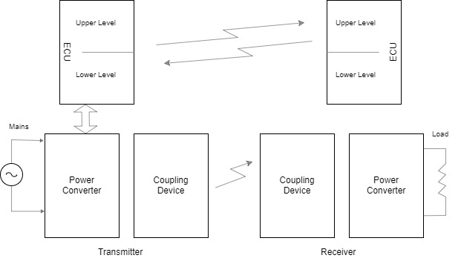
Figure 2 CPT system structure
The CPT system is composed of two electrically insulated power sections called the transmitter and receiver. The receiver is built into the electric car and provides power to the battery pack within. The latter is represented by a resistor and serves as the CPTS's load. The transmitter is powered by the mains and is embedded in the pavement. The development of CPT charging technology may improve public perceptions of EVs. It is expensive, has a limited driving range, and takes a while to charge. However, as CPT technology for charge replenishment develops, EVs might start to appeal to consumers. The benefit of CPT charging is its ability to automate, simplify the charging procedure for consumers, and make charging secure. The widespread implementation of CPT charging infrastructure may also assist lower the size of the battery pack, which will increase the efficiency of EVs.

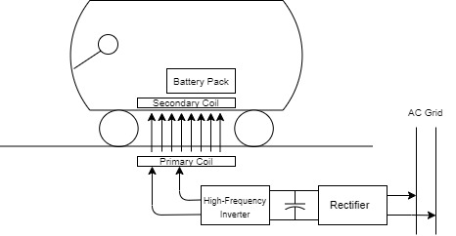
Figure 3 Scheme of CPT for electrical vehicle battery charging

Due to the inability of conventional inductive chargers to accommodate all of this, CPT charging with large air spaces and little human contact is required. Qualcomm recently introduced CPT technology to EVs, and some of the biggest manufacturers, like GM, Qualcomm Halo, Delphi, Toyota, and others, have lately showed interest in wireless charging technology. Numerous research teams from other institutions are also engaged in this effort. The CPT charging scheme is displayed for an EV application. The primary winding of the CPT system, which is buried in the ground and connected to the grid via a converter system, transfers power to the system's secondary winding. The secondary is where the charging circuit charges the battery in an electric vehicle.

The transmission device of WPTSs frequently energises the surrounding area. The energy for capacitive and inductive power transfers stored in a unitary volume of space is
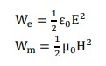
Due to the values of and, as well as the permitted voltages across and current into the coupling devices, the magnetic field can produce an energy density in free space that is around 104 times greater than that produced by the electric field. When radiant power is transferred, the electromagnetic field intensifies to extremely high levels along the transmission route.
Based on the greatest distance over which electricity may be transported, the first and most important classification is created. Some devices can wirelessly power loads at great distances, while others can only transmit power to loads that are a few centimeters from the source. As a result, the first divide is made according to whether the procedure is near-field or far-field.
WPT USING SOLAR CELLS FOR EVs
Solar cells are semiconductor devices that enable incident sunlight to release electrical charges, enabling them to freely flow across the semiconductor and generating an electric field that can power a motor or light a bulb. The process that causes a voltage and current field to form across the solar cell is known as the photovoltaic effect. Solar cells may generate incident light for free and in large quantities from the sun. The intensity of sunlight that reaches the planet's surface reaches up to 1,000 watts per square meter. When calculating the cost of the electricity produced by solar cells, the cost of the photovoltaic module power-producing system must be taken into account because it may require a significant amount of space.

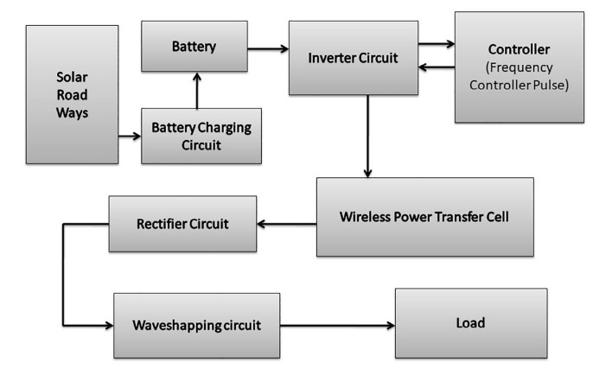

The technique for remote transmission known as inductive coupling is utilized to take force and separation boundary barriers into account. The oscillator yield is used to trigger a copper loop that serves as a transmitter. The coil then produces enticing motion that joins with an implanted benefit loop in the car. The connected loop shows effective use of force at that location by creating air conditioning yield at its ends. Because the alternating current cannot be softly stored in the battery, this rectifier, whose output is delivered to the battery in the electric vehicle, is utilized.
- The primary classification, which is also the most important, is based on the maximum distance over which energy may be transmitted. Some devices can wirelessly power loads at great distances, while others can only transmit power to loads that are a few centimetres from the source. The first division is therefore created based on whether the technique is near-field or far-field.
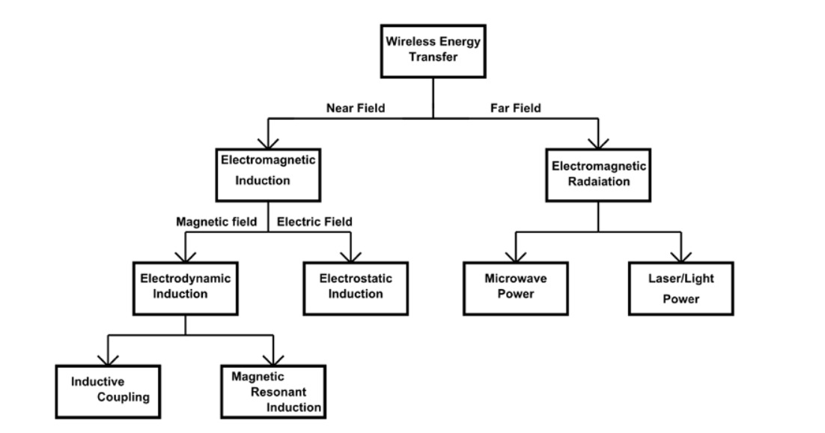

- NEAR FIELD
Induction: The mutual induction concept between two coils can be utilised to convey wireless electrical power. The energy is transferred by magnetic coupling between the two coils. The transformer serves as the simplest illustration of mutual induction in action because the primary and secondary coils do not come into direct contact.
- Electrodynamic Induction: The receiver in this setup has a revolving permanent magnet. One or more electromechanical transduction systems transform the resonant magnet's mechanical motion into electricity when a magnetic field is applied. For wireless power transfer, resonant inductive coupling provides a key solution to the problem of non-resonant inductive coupling. The transmission distance affects the efficacy. By adjusting the transmitter and receiver inductors to a common frequency, resonant coupling transforms the driving current's sinusoidal waveform into a non-sinusoidal transient waveform. Multiple cycles are involved in pulse wireless power transfer. With this method, significant wireless power can be transmitted over a distance that can be as great as the transmitter itself.

- Electrostatic Induction: Capacitive WPTSs use two plane capacitors as coupling devices, with the plates on the transmitter side facing the plates on the receiving side. The dielectric is the gap between the transmitter and receiver electrodes, which together create a capacitor. Capacitive WPTSs' main advantages are their low losses, little electromagnetic emissions, and ability to transmit power through metal shields without generating eddy currents. utilizing capacitive coupling, high frequency alternating current potential fluctuations are transmitted between two plates or nodes utilizing electric field gradients or differential capacitance between two elevated electrodes placed on top of a conductive ground plane.
- FAR FIELD:

- Radio and microwave: Radio waves, which typically have shorter wavelengths and a more directed component, are frequently used in the microwave range for wireless power transfer. It is possible to convert microwave energy back into electrical energy by using a rectenna. Conversion efficiencies of over 95% have been attained by Rectenna. The transfer of electricity from solar-powered satellites in orbit to Earth and the beaming of power to spacecraft departing from orbit have both been proposed.

- Laser power transfer: Laser power transfer (LPT) uses visible or near-infrared frequencies to transfer power. It uses laser light that is directed towards the energy receiver and is highly concentrated to successfully distribute electricity over long distances. The laser powering receiver converts the received laser light into electricity using specialized photovoltaic cells. Concentrated energy is a benefit of LPT. However, laser radiation has the potential to be harmful and requires both accurate pointing at the receiver and a Line of Sight (LOS) link, both of which may be challenging to obtain in actual use. In addition, several devices and complex tracking systems are required. Laser beaming is more susceptible to atmospheric absorption and dispersion by clouds, fog, and rain than microwave WPT, which significantly limits its practical applications.

EVOLUTION OF WPT STATIC & DYNAMIC MODELS
The control of energy from wireless charging models needs to be investigated in light of the load location and requirements. There are, in general, two sorts. The first is connected to a fixed place, whereas the second is connected to a moving position. The position of the receiver in relation to the transmitter affects whether the signal is static or dynamic in this case. To fully analyse the charging system, it is crucial to provide the mathematical models and equations that correspond to each scenario, as well as to demonstrate the connections between various characteristics and variables that can impact the system's operation.
Static WPT: The static wireless charging system for EV specifies the situation in which the road-mounted transmitter coil and reception coil are lined together. The same is true with stationary EVs. The obtained power can then be classified as maximum or low. It depends on where the two coils' centres are located. The conveyed power is zero if the receiver radius is greater than the separation between the two middles.
Dynamic WPT: The vehicle can be charged even while it is moving along the road, according to the dynamic model of the wireless charging mode. As the vehicle's speed characteristics are taken into account due to the vehicle's movement, the dynamism of the charging mode enhances the complexity of its mathematical model and topology. As a result, a sophisticated mathematical model is produced that shows how the power obtained changes with the vehicle speed, coil settings, and compensation topology. Regarding the position and circumstances of the transmitter coil, there are two different variations of this scenario.

ON ROAD CHARGING SIMULATED OUTPUT
This includes typical wireless EV charging system, general two coil WPT system, power electronics, converter and power control, exposure limit boundary for a WPT system.
The system contains transmitting and receiving coils, AC power (single phase and 3 phase), primary and secondary compensation, DC to high frequency converter, Lithium-ion battery, induction coils.
• It has various steps for wirelessly charging an EV. An ac to dc converter with power factor correction converts the utility's ac power first into a dc power source.
• After that, a compensation network drives the transmitting coil by converting the dc power to a high-frequency ac.
• By resonating with the secondary compensation network, the transferred power and efficiency are greatly enhanced. • The high-frequency current in the transmitting coil generates an alternating magnetic field, which induces an ac voltage on the receiving coil.
• The battery is finally charged after the ac power has been rectified.
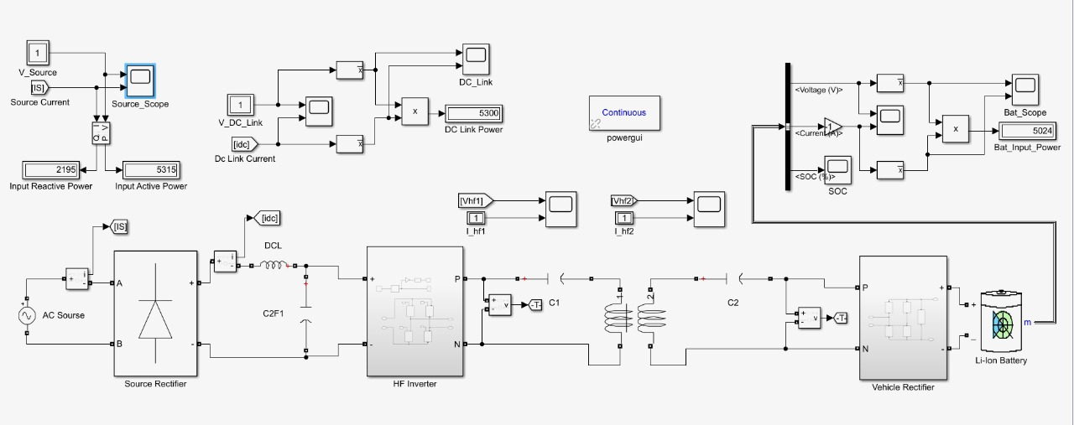
Figure 4 On-road charging circuit

The graphs in the lower and upper left shows input voltage and current and the graphs in graphs in the lower and upper right shows battery voltage and current and state of charge of battery, the SOC graph shows that the battery is charging.
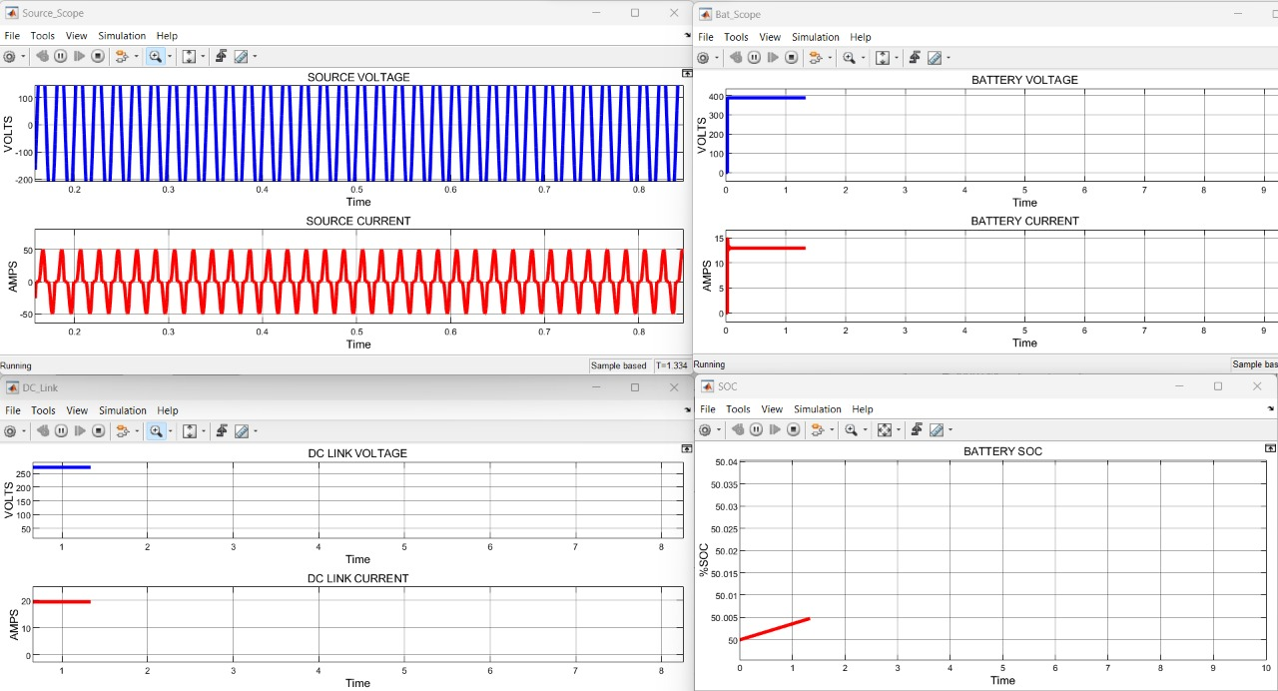
Figure 5 Input (left)-Output (right) graph
CONCLUSION
This case study offers an overview of the modern technology that is most frequently discussed. In this essay, we not only attempted to address the problems we currently face but also went over the benefits and drawbacks of CPT technology.
Through this paper, we have tried to introduce the concept of wireless electricity. Readers are led to believe that by utilizing this technology's full potential, we may build a space that is efficient, affordable, wireless (that is, without cables), and loss-free. The greenhouse gases that contribute to global warming are produced by electric power plants that burn fossil fuels. Wireless electrical transfer can be used to successfully overcome these problems. Essentially, this technology will change the way we perceive electricity.
Although there has been a lot of research on wireless power transfer and solar panels, these technologies have not yet reached their full potential in terms of transfer power and distance, frequency, and coil dimensions. This is because the current transmitter and receiver coil designs are too large to be integrated into consumer devices and cannot be considered portable because the coil would take up too much space. As a result, there is a need for continued research in this field because wireless power transfer has several noteworthy uses.

REFERENCES:
- N. Mohamed, F. Aymen, Z. M. Ali, A. F. Zobaa, and S. H. E. A. Aleem, ‘‘Efficient power management strategy of electric vehicles based hybrid renewable energy,’’ Sustainability, vol. 13, no. 13, p. 7351, Jun. 2021,
- V. Vu Pham V.and Choi W Tran, D. . H, “Design and implementation of high efficiency wireless power transfer system for on-board charger of electric vehicle”. 2016 IEEE 8th International Power Electronics and Motion Control Conference (IPEMC-ECCE Asia), Hefei, pages 24662469, 2018.
- P. García, L. M. Fernández, J. P. Torreglosa, and F. Jurado, ‘‘Operation mode control of a hybrid power system based on fuel cell/battery/ultracapacitor for an electric tramway,’’ Comput. Electr. Eng., vol. 39, no. 7, pp. 1993–2004, Oct. 2013,
- Zheng Wang Jie Liu, Yue Zhang and Ming Cheng “Design of a high-efficiency wireless charging system for electric vehicle”. 2018 1st Workshop on Wide Bandgap Power Devices and Applications in Asia (WiPDA Asia), pages 4044, 2018.
- T. M. Fisher, K. B. Farley, Y. Gao, H. Bai, and Z. T. Tse, ‘‘Electric vehicle wireless charging technology: A state-of-the-art review of magnetic coupling systems,’’ Wireless Power Transf., vol. 1, no. 2, pp. 87–96, 2014.
- C.-S. Wang, O.H. Stielau, G.A. Covic, Design considerations for a contactless electric vehicle battery charger, IEEE Trans. Ind. Electron. 52 (5) (2005) 1308– 1314.
- Brenna.M, Foiadell F, Mussetta M, Shadmehr H, Charging electrical vehicle with wireless power transmission, Clean Electrical Power, Page(s):698-702.
- M. Mathankumar, K. Tamilarasu Viswanathan, S.S. Balachander, Design and implementation of improved sliding mode control for electric vehicle voltage stabilization, Mater. Today: Proceed. in press (2020).
- S. Keerthana, C.Uthranarayan, V. Rajalakshmi, A. Ramya, Wireless Power Transfer Using Rectenna, International Conference on Physics and Photonics Processes in Nano Sciences International Conference on Physics and Photonics Processes in Nano Sciences, Journal of Physics: Conference Series Journal of Physics: Conference Series 1362 (2019) 012037
- Wenzhen Fu, Bo Zhang, Dongyuan Qiu, “Study on Frequency-tracking Wireless Power Transfer System by Resonant Coupling,” Power Electronics and Motion Control Conference, pp. 2658-2663, May 2009.

