THE STATE OF KIDNEY TRANSPLANTATION: A REVIEW
Dr Juveria Badar^{1*}, Atika Amrooz¹, Adiba Mehrooz¹, Dr Syed Mohammed Kazim², Dr M A Aleem², Dr Nabeela Fatima²
¹Department of Pharmacy, Nizam Institute of Pharmacy, Deshmukhi, Telangana, India-508284
²Department of Pharmacy Practice, Nizam Institute of Pharmacy, Deshmukhi, Telangana, India-508284
Corresponding Author:
Dr Juveria Badar,
Department of Pharmacy Practice,
Nizam Institute of Pharmacy, Deshmukhi.
Email: juveriabadar23@gmail.com
Phone: +91-8688611200

ABSTRACT:
Treatment of choice for those with end-stage renal illness is frequently a kidney transplant. Over the past 50 years, the field of kidney transplantation has expanded significantly. End-stage renal disease patients who are put on the waiting list and subsequently receive a kidney transplant have a higher chance of long-term survival than those who continue receiving dialysis. In addition, transplant recipients frequently have higher quality of life and have a 10-year survival advantage over dialysis recipients. The likelihood of surviving kidney compatibility is frequently highest among family members. Successful living-donor transplants, however, are also frequently performed using kidneys from unrelated donors, such as acquaintances, coworkers, or members of a religious community. Preemptive kidney transplantation, often known as a transplant before dialysis is required, may also be advantageous for some patients. The health concerns connected to a kidney transplant include those directly related to the procedure and organ rejection. The adverse consequences of taking immunosuppressive drugs, which are used to stop the body from rejecting a given kidney, are another risk.
- INTRODUCTION:
People with end-stage renal disease can live longer and have better quality of life because to kidney transplantation. The two surgical techniques used for both procurement and transplanting are open and laparoscopic. End-stage renal disease is the primary surgical indication.
The ideal therapy strategy for people with end-stage renal illness is kidney transplantation. However, there are still many issues to be resolved, such as the scarcity of organ donors, immunological challenges, and the requirement for long-term immunosuppression, which is linked to an elevated risk of infections and cancers.
- ANATOMY OF KIDNEY:
The feathers are located on either side of the chine, in the retroperitoneal space. The left order is positioned a little advanced than the right one, because of the liver on the right side of the abdominal depression, above the right order. Structure Each of the two bean- shaped organs weighs about 125 to 175 grams and 115 to 155 grams in males and ladies independently. The order generally measures roughly 11 to 14 centimeters in length, 6 centimeters in range and is about 4 centimeters thick. The feathers are defended by fat, muscles, and caricatures of the reverse. Perirenal fat, also called the renal fat pad, protects the feathers from external force or damage. The feathers have a medium dimple called the renal hilum, which is the entry and exit point for structures that supply or drain the feathers similar as the jitters, ureters, vessels, and lymphatics.
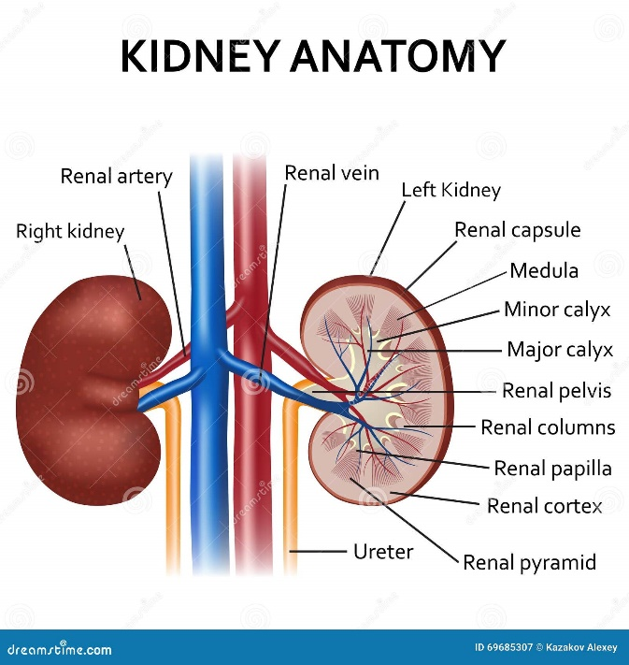
Fig-1: Anatomy of kidney [Adapted from dreamstime.com]
- INDICATIONS FOR KIDNEY TRANSPLANTATION:
End-stage renal disease (ESRD) is becoming more prevalent. Diabetes and hypertension are the two most typical etiologies of renal failure. [1] Prerenal (chronic or acute ischemia), intrinsic renal (glomerulonephritis, focal-segmental glomerulosclerosis), or postrenal (reflux nephropathy, obstruction) categories are used to classify other causes of CKD/ESRD. When a patient's chronic kidney disease (CKD) progresses to stage 4, which is indicated by a glomerular filtration rate (GFR) of less than 30 mL/min/1.73 m, they should consult a nephrologist and receive information regarding kidney failure and treatment options, including transplantation.[2]
- ANASTOMOSIS:
Complications associated with ureteral anastomosis in order transplantation are largely current, despite the development of colorful types of stents. The current stent accoutrements and placement styles have several limitations. This study attempts to give a volition by probing ureteral anastomosis with a polyimide stent and a modified placement system in a rat model of order transplantation. Methods Sprague- Dawley rats were aimlessly divided into Group I sham operation, Group II autologous ureteral anastomosis, and Group III isogenic order transplantation with ureteral anastomosis. For the anastomosis, a polyimide stent with a preliminarily placed 11- 0 silk was fitted into the ureter. The stent and ureter were fixed with 11- 0 silk sutures. The order weight and serum creatinine were recorded. The ureteral and renal sections were taken for histological analysis.
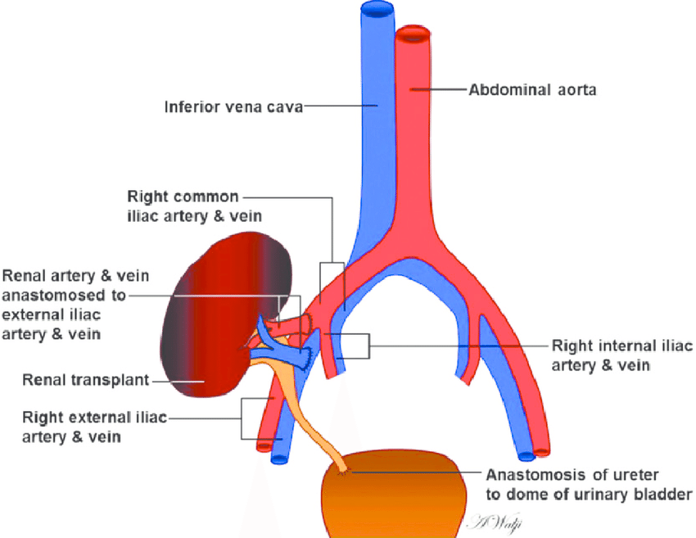
Figure-2: Schematic representation of a renal transplant shows the location of vascular and urologic anastomoses [Adapted from Low G et al[3]]

This approach involves swapping benefactors who are inharmonious with their intended donors so that, rather, each donates a order to a compatible philanthropist. [4] The exchange derives the benefit of live donation but avoids the threat of incompatibility. [5] Benefactors travel to the philanthropist centers and suffer nephrectomy contemporaneously indeed when performed in different centers and at distant locales. Live- patron exchange procedures now have been performed worldwide. [6,7]
- TYPES OF TRANSPLANTS:
There are two different types of transplant:
- Live
- Diseased or cadaveric
Living related renal transplantation provides a significant graft survival benefit over cadaveric transplants. Historically, this advantage has been ascribed to better matching between living related grafts, which are shared between first-degree relatives, versus relatively poor histocompatibility matching in cadaveric transplantation. This view is supported by evidence showing that the frequency of graft loss caused by chronic rejection is lower among recipients of living related donor grafts than among recipients of cadaveric transplants. [8,9]
Most agree that an acute rejection episode is the most important risk factor for the development of chronic rejection. [10] Recently, a single-center study indicated that, for living donor grafts, an episode of acute rejection is the only significant risk factor for long-term graft loss; whereas, for cadaveric recipients, nonimmunologic factors play an important role. [11] In this regard, good long-term outcomes with living nonrelated grafts have highlighted the important effect of alloantigen-independent factors in the progression to chronic rejection. [12] Such factors include cold ischemic preservation injury and older donor age, which seem to act in concert with early acute rejection episodes in accelerating the progression to long-term graft loss in cadaveric transplantation. [13,14]
- TYPES OF DONORS:
The ideal departed organ patron is a youngish person who dies from traumatic head injury that's insulated to the brain and leaves the thoracic and abdominal organ function complete. Such a departed patron provides excellent transplantable organs with an occasion to achieve immediate allograft function and long- term case survival. As the size of the philanthropist staying list and the number of staying list deaths increase, aged benefactors and benefactors with characteristics once allowed
to avert organ donation are being used more and more constantly.[15] The clinical characteristics that separate ‘ borderline ’ renal allografts are deduced from the social and medical history of the patron( age, history of hypertension or diabetes, the threat of transmitting contagious complaint and/ or malice), the cause of patron death( traumas. cerebrovascular accident), the medium of patron death( brain deaths. cardiac death), the deconstruction of the allograft( vessel abnormalities), the morphology on vivisection( glomerulosclerosis, interstitial nephritis and/ or fibrosis), and the functional profile( serum creatinine or calculated glomerular filtration rate) previous to transplantation. [16,17] Kauffman suggests that the term ‘ expanded ’ be used to relate to the patron whose organs may be associated with poorer outgrowth because the term ‘ borderline ’ may be considered denigratory by the cases who admit them, as well as by the programs that plant them.[18] feathers scattered from aged benefactors are considered to be from the expanded pool because these allografts have a advanced rate of delayed graft function, further acute rejection occurrences, and dropped long- term graft function. Several factors, including dragged cold ischemia time (CIT), increased immunogenicity, bloodied capability to repair towel, and bloodied function with dropped nephron mass may contribute to this. [19] But lately, Ojo etal. demonstrated that the donors of expanded feathers admit the benefit of redundant life- times when compared to stay- listed dialysis cases. [20] Still, placement of these organs is frequently delicate and delayed, and some centers continue to prefer not to use them.
- USE OF ANTI THYMOCYTE GLOBULIN (ATG):
Due to its capacity to deplete T and B cells, to inhibit B and T cell cooperation as well as leucocyte adhesion and to induce certain ‘ tolerogenic ’ nonsupervisory T cell and dendritic cell( DC) populations, antithymocyte globulin( ATG) is a good seeker medicine to help and treat both acute T cell( TCMR) and antibody- intermediated rejection( ABMR). Despite limited substantiation from randomized clinical trials, ATGs have been extensively used as an induction remedy in renal transplantation for high- threat immunological cases for numerous decades. ATG has also been used as a first- line remedy for TCMR, in particular, those with severe acute TCMR including vascular lesions( ≥ Banff II orders) and as deliverance remedy for steroid- resistant acute TCMR. None the less, its superiority to other curatives(e.g. steroid gelcap, violent tacrolimus remedy) in those suggestions remains a matter of debate. Again, there's a lack of adequately powered clinical trials with contemporary immunosuppression. While efficacity isn't disputed, the multitudinous short- and long- term side goods make a threat – benefit assessment versus other lower poisonous curatives delicate, and unfortunately some of the side goods are associated with inferior long- term issues with regard to case and graft survival. Indeed, ATG results in a profound reduction and revision of the philanthropist's vulnerable system, which presumably explains the advanced threat of opportunistic infections and cancer. [21]
7.1 WARM ISCHEMIC TIME:
Warm ischemia time is a potentially adjustable personality to transplanted feathers, but little is known about its effect on long- term issues. Then we conducted a study of United States order transplant donors to determine the association between warm ischemia time (the time from organ junking from cold storehouse to reperfusion with warm blood) and death/ graft failure. Times under 10 twinkles were potentially attributed to rendering error. Thus, the 10- to- under-20-minute interval was chosen as the reference group. The primary outgrowth was mortality and graft failure (return to habitual dialysis or preemptive retransplantation) acclimated for philanthropist, patron, immunologic, and surgical factors.
Transplantation has been an important donation to drug and the care of cases with terminal organ failure. Given the relative failure of organs, strategies to outstretch graft and case survival are an important area of exploration. One of the further intensively studied areas is the ischemia – reperfusion injury that all solid organs develop after implantation. Previous studies have shown that maladaptive responses to ischemia vitiate organ recovery. Apparent molecular mechanisms include generation of reactive oxygen species, induction of apoptosis, and stimulation of the ingrain and adaptive vulnerable system. [22,23,24] These mechanisms may lead to order transplants that don't serve incontinently after surgery( delayed graft function), which in turn is associated with poor long- term graft and case survival. [25,26]
7.2 COLD ISCHEMIC TIME:
After surgical junking for transplantation, a order is stored in cold result to save the viability of its cells. still, cold ischemia can devaluate but cannot fully help cellular injury. In response to hypoxia, mitochondria increase the product of reactive oxygen species. Because oxygen is needed to induce adenosine triphosphate (ATP), ischemic cells tend to supply ATP by glycolysis, with posterior product of lactic acid, leading to intracellular acidosis. This anaerobic energy generation stops after glycolytic substrates are exhausted. Because of poor ATP generation, the exertion of the Na/ K ATPase pump is crazed, and this disrupts the equilibrium between intracellular potassium ions and extracellular sodium ions necessary to help cell lump. These changes can beget damage to all cellular factors up to cell- cycle arrest and indeed cell death. The reperfusion of an ischemic order may affect in inflammation and oxidative damage, a paradoxical miracle nominated ischemia – reperfusion injury. The microvascular injury caused by ischemia enhances fluid filtration and leukocyte plugging in capillaries and in postcapillary venules. The damaged endothelial cells cache fresh reactive oxygen species and favor the release of seditious intercessors and proteolytic enzymes. Among them, caspases can intervene apoptosis in a significant number of sublethally injured cells. In addition to endothelial cells, proximal tubular epithelial cells are particularly vulnerable to the poisonous goods of reperfusion and tend to suffer further necrosis in comparison with the less sensitive parts, because they've large metabolic demands.
In order transplantation, these changes may affect in delayed graft function (DGF). In cases with DGF, the clinical opinion of acute rejection may be delicate. In a number of cases rejection may be detected too late, after the development of unrecoverable lesions. On the other hand, this peculiar form of acute order injury may be associated with a poor graft outgrowth singly of rejection. When the order injury is mild and the bestowed order isn't affected by natural morbidity, the form process can be adaptive with many consequences. When injury is more severe or in the presence of antedating order abnormalities, the form process can be maladaptive and may affect in the development of tubulointerstitial fibrosis. There's an raised product of transubstantiating growth factor- β and other profibrotic factors that can stimulate fibroblast proliferation, extracellular matrix conflation, and epithelial- to- mesenchymal transition.[27]
- COMPLICATIONS:
8.1 Hemorrhage: In any surgery, hemorrhage is always a possibility, both during surgery and in the immediate aftermath. There may be no classic bleeding symptoms. Patients who frequently take beta-blockers may not have characteristic tachycardia in reaction to hypovolemia. Furthermore, due to parenchymal compression, they may be hypertensive rather than hypotensive. There may be a palpable tumor or protrusion close to the incision, and they frequently report of sudden, severe flank pain. Maintaining a high level of clinical suspicion is important and can call for another operation. It's crucial to keep in mind that bleeding may be tamponaded by the compartmentalized area of the kidney in the retroperitoneum, an effect that would not be anticipated after the allograft was placed intraperitoneally. [29]
8.2 Thrombosis: Although very uncommon, renal vein thrombosis carries a substantial risk of transplant loss. This phenomena may show up as new-onset hematuria, abrupt-onset oliguria/anuria, and/or graft failure in the early postoperative phase. Even rarer, but frequently just as damaging, and manifesting identically in the receiver, is arterial thrombosis. In the event of a rapid fall in UOP in a previously working allograft, ultrasound should be requested as it is frequently diagnostic. Due to technical faults and/or clamp injury, a high suspicion for vascular problems should be kept during the early postoperative phase. [29]
8.3 Infection: Since patients are immediately put on immunosuppression following surgery, infections are frequent. They are most severely immunosuppressed in the first three to six months following surgery, which increases their risk of infection at that time. UTIs and surgical site infections (SSI) are the two conventional nosocomial and bacterial infections that are most frequently seen in the first month following transplantation. For unusual or opportunistic pathogens, high suspicion must be maintained, especially in the months that follow. The cytomegalovirus, Epstein-Barr virus, and polyomavirus (BK-type) are among the viral infections that are frequently tested. In order to reduce the chance of infection in the first three to six months, patients are frequently prescribed preventive doses of antibiotics and antivirals, most frequently Bactrim for PCP and Valcyte for CMV, as well as some kind of anti-fungal protection[29]
8.4 Arterial stenosis: This late consequence frequently has no symptoms. When there is decreased graft function (higher serum creatinine), ultrasonography examination frequently leads to its identification. Angiography can be used for transluminal angioplasty and is both diagnostic and therapeutic. [29]
8.5 Lymphocele: During the exposure of the iliac vessels, the concomitant lymphatics are disrupted, which results in this complication. When doing this dissection, lymphatic tissue should be ligated carefully whenever possible. Patients could exhibit swelling and soreness above the transplanted kidney. As an alternative, the collection can infect the graft, compress it, and impair its function. Percutaneous drainage is used to treat lymphoceles that are symptomatic. To rule out a urine leak, fluid creatinine in the drain aspirate should also be evaluated. Peritoneal window drainage surgery may be used to treat persistent lymphocele. [29]
8.6 Urinoma: This condition typically develops within the first week after transplantation. Patients may experience pain and edema where the incision is made, reduced graft function from compression, or infection, similar to lymphocele. Usually, an increased creatinine level in the fluid aspirate supports the diagnosis. To prevent this risk as well as the delayed complication of ureteral stenosis, several centers preemptively insert a ureteral stent at the moment of anastomosis. Urine leaks usually only require bladder decompression and the insertion of a Foley catheter. However, ureteroneocystostomy correction and surgical intervention may be required. [29]
- GRAFT REJECTION AND APOPTOSIS:
Recently, several studies have investigated whether apoptosis is involved in the process of organ destruction during acute and/or chronic rejection of allografts. Generally, apoptotic cells have been identified by the TUNEL technique, and the presence of Fas and/or Fas-L expression was monitored additionally in some studies. A role for the Fas/Fas-L system in graft destruction can be assumed if apoptotic and Fas-expressing cells are present in the transplanted organ. A possible scenario proposes that mononuclear cells (including T cells) infiltrating the allograft express Fas-L and could thereby induce apoptosis in Fas-positive graft cells. In agreement with such a model, Wang and co-workers, working in a rat model of renal allograft rejection, detected Fas-L mRNA by reverse transcriptase-polymerase chain reaction during acute rejection, but not in normal kidneys. In contrast, Fas was constitutively expressed in allografts as well as in normal kidneys. [30] In biopsies of human kidney allografts, TUNEL-positive (i.e., apoptotic) cells have been detected during rejection episodes. There is some controversy, however, as to the appearance of such cells during acute versus chronic rejection. Although apoptosis of tubular epithelial cells was preferentially observed during acute rejection in some studies [31,32], it was primarily seen during chronic kidney allograft rejection in other studies. [33] In line with experimental studies, Fas-L mRNA is detected by reverse transcriptase-polymerase chain reaction also in acute but not chronic rejection of human kidney transplants. [30,34]
- MAINTENANCE THERAPY:
Presently, the first- time results of order transplantation are significantly better and early acute rejection rates are dramatically lower than only a many decades ago.[35,36] (30,31) These advancements primarily affect from treatment protocols combining potent oral immunosuppressant specifics. [37](32) still, graft survival rates beyond the first time haven't proportionately bettered.[36](31) Alloimmunity manifesting as late rejection, clinical and subclinical, primarily associated with patron-specific antibodies( DSAs) is now honored as the dominant cause of late graft loss.4 The top independent supplements of late rejection and de novo DSAs are class 2 HLA mismatching, youngish age, and drug nonadherence( MNA). [38,39](33, 34) Indeed, a model has surfaced that HLA mismatching, particularly class 2 mismatching, sets the stage for T cell – intermediated rejection( TCMR) and/ or de novo DSA conformation.[40]-(35)After a de novo DSA forms, in> 50 of cases, it results in antibody- intermediated rejection( ABMR) that smolders over time and ultimately results in habitual ABMR reflected in the vivisection as transplant glomerulopathy. The interstitial fibrosis and tubular atrophy that are detected in latepost-transplant necropsies for cause are identified with early TCMR andMNA. [39] The model suggests that alloimmune- intermediated late graft loss ensues as a result of ongoing ABMR and/ or TCMR, and both of these processes are accelerated in the presence of patient MNA or croaker- guided immunosuppressive minimization. From this model, two major strategies crop to ameliorate long- term graft issues — class 2 HLA matching and early discovery/ reversal of patient MNA. [40]
REFERENCES:
- Leichtman AB, Cohen D, Keith D, O'Connor K, Goldstein M, McBride V, Gould CJ, Christensen LL, Ashby VB. Kidney and pancreas transplantation in the United States, 1997-2006: the HRSA Breakthrough Collaboratives and the 58 DSA Challenge. Am J Transplant. 2008 Apr;8(4 Pt 2):946-57.
- National Kidney Foundation. KDOQI Clinical Practice Guideline for Hemodialysis Adequacy: 2015 update. Am J Kidney Dis. 2015 Nov;66(5):884-930.
- Low G, Crockett AM, Leung K, Walji AH, Patel VH, Shapiro AJ, Lomas DJ, Coulden RA. Imaging of vascular complications and their consequences following transplantation in the abdomen. Radiographics. 2013 May;33(3):633-52.
- Delmonico FL: Exchanging kidneys—Advances in living-donor transplantation. N Engl J Med 350: 1812 –1814, 2004
- Roth AE, Sonmez T, Unver MU: Kidney exchange. Q J Economics 119: 457 –488, 2004
- Park K, Moon JI, Kim SI, Kim YS: Exchange donor program in kidney transplantation. Transplantation 67: 336 –338, 1999
- Kranenburg LW, Visak T, Weimar W, Zuidema W, de Klerk M, Hilhorst M, Passchier J, IJzermans JN, Busschbach JJ: Starting a crossover kidney transplantation program in the Netherlands: Ethical and psychological considerations. Transplantation 78: 194 –197, 2004
- Knight RJ, Kerman RH, Welsh M, et al. Chronic rejection in primary renal allograft recipients under cyclosporine-prednisone immunosuppressive therapy. Transplantation 1991; 51: 355.
- Matas AJ, Humar A, Payne WD, et al. Decreased acute rejection in kidney transplant recipients is associated with decreased chronic rejection. Ann Surg. 1999; 230: 493.
- Almond PS, Matas A, Gillingham K, et al. Risk factors for chronic rejection in renal allograft recipients. Transplantation 1993; 55: 752.
- Matas AJ, Gillingham KF, Humar A, Dunn DL, Sutherland DER, Najarian JS. Immunologic and nonimmunologic factors: different risks for cadaver and living donor transplantation. Transplantation 2000; 69: 54.
- Terasaki PI, Cecka JM, Gjertson DW, Takemoto S. High survival rates of kidney transplants from spousal and living unrelated donors. N Engl J Med 1995; 333: 333.
- Troppmann C, Gillingham KJ, Benedetti E, Almond PS, Gruessner RW, Najarian JS, Matas AJ. Delayed graft function, acute rejection, and outcome after cadaver renal transplantation. The multivariate analysis. Transplantation. 1995 Apr 1;59(7):962-8.
- Knight RJ, Burrows L. The combined impact of donor age and acute rejection on long-term cadaver renal allograft survival. Surgery. 1999 Mar 1;125(3):318-24.
- Kauffman HM, Bennett LE, McBride MA, Ellison MD. The expanded donor. Transplantation Reviews. 1997 Oct 1;11(4):165-90.
- Becker YT. Use of marginal donors in kidney transplantation. Graft. 2000;3:216-0.
- Randhawa P. Role of donor kidney biopsies in renal transplantation. Transplantation. 2001 May 27;71(10):1361-5.
- DE FIJTER JW, Mallat MJ, Doxiadis II, Ringers J, Rosendaal FR, Claas FH, Paul LC. Increased immunogenicity and cause of graft loss of old donor kidneys. Journal of the American Society of Nephrology. 2001 Jul 1;12(7):1538-46.
- Ojo AO, Hanson JA, Meier-Kriesche HU, Okechukwu CN, Wolfe RA, Leichtman AB, Agodoa LY, Kaplan B, Port FK. Survival in recipients of marginal cadaveric donor kidneys compared with other recipients and wait-listed transplant candidates. Journal of the American Society of Nephrology. 2001 Mar 1;12(3):589-97.
- Lee CM, Scandling JD, Pavlakis M, Markezich AJ, Dafoe DC, Alfrey EJ. A REVIEW OF THE KIDNEYS THAT NOBODY WANTED: Determinants of Optimal Outcome: 1. Transplantation. 1998 Jan 27;65(2):213-9.
- Couvrat-Desvergnes G, Salama A, Le Berre L, Evanno G, Viklicky O, Hruba P, Vesely P, Guerif P, Dejoie T, Rousse J, Nicot A. Rabbit antithymocyte globulin–induced serum sickness disease and human kidney graft survival. The Journal of Clinical Investigation. 2015 Dec 1;125(12):4655-65.
- A. Siedlecki, W. Irish, D.C. Brennan. Delayed graft function in the kidney transplant. Am J Transplant, 11 (2011), pp. 2279-2296
- C. Ponticelli. Ischaemia-reperfusion injury: a major protagonist in kidney transplantation Nephrol Dial Transplant, 29 (2014), pp. 1134-1140
- M. Cavaille-Coll, S. Bala, E. Velidedeoglu, et al.
- Summary of FDA workshop on ischemia reperfusion injury in kidney transplantation . Am J Transplant, 13 (2013), pp. 1134-1148
- S.G. Yarlagadda, S.G. Coca, R.N. Formica Jr., et al. Association between delayed graft function and allograft and patient survival: a systematic review and meta-analysis Nephrol Dial Transplant, 24 (2009), pp. 1039-1047
- S.N. Tapiawala, K.J. Tinckam, C.J. Cardella, et al.
- Delayed graft function and the risk for death with a functioning graft. J Am Soc Nephrol, 21 (2010), pp. 153-161
- Abramyan S, Hanlon M. Kidney transplantation.
- Wang J, Nonomura N, Ichimaru N, et al. Expression of Fas and Fas ligand in renal grafts with acute and chronic rejection in the rat model. J Interferon Cytokine Res 1997; 17: 369.
- Kato S, Akasaka Y, Kawamura S. Fas antigen expression and its relationship with apoptosis in transplanted kidney. Pathol Int 1997; 47: 230.
- Ito H, Kasagi N, Shomori K, Osaki M, Adachi H. Apoptosis in the human allografted kidney: analysis by terminal deoxynucleotidyl transferase-mediated dUTP-biotin nick end labeling. Transplantation 1995; 60: 794.
- Laine J, Etelaemaeki P, Holmberg C, Dunkel L. Apoptotic cell death in human chronic renal allograft rejection. Transplantation 1997; 63: 101
- Sharma VK, Bologa RM, Li B, et al. Molecular executors of cell death: differential intrarenal expression of Fas ligand, Fas, granzyme B, and perforin during acute and/or chronic rejection of human renal allograft. Transplantation 1996; 62: 1860.
- Srinivas MK. TR Kaplan B 2004 Lack of improvement in renal allograft survival despite a marked decrease in acute rejection rates over the most recent era. Am. J. Transplant. 2004 Mar;4(3):378.
- Lamb KE, Lodhi S, Meier‐Kriesche HU. Long‐term renal allograft survival in the United States: a critical reappraisal. American journal of transplantation. 2011 Mar;11(3):450-62.
- Ekberg H, Tedesco-Silva H, Demirbas A, Vítko Š, Nashan B, Gürkan A, Margreiter R, Hugo C, Grinyó JM, Frei U, Vanrenterghem Y. Reduced exposure to calcineurin inhibitors in renal transplantation. New England Journal of Medicine. 2007 Dec 20;357(25):2562-75.
- Wiebe C, Gibson IW, Blydt-Hansen TD, Pochinco D, Birk PE, Ho J, Karpinski M, Goldberg A, Storsley L, Rush DN, Nickerson PW. Rates and determinants of progression to graft failure in kidney allograft recipients with de novo donor-specific antibody. American Journal of Transplantation. 2015 Nov 1;15(11):2921-30.
- Wiebe C, Gibson IW, Blydt-Hansen TD, Karpinski M, Ho J, Storsley LJ, Goldberg A, Birk PE, Rush DN, Nickerson PW. Evolution and clinical pathologic correlations of de novo donor-specific HLA antibody post kidney transplant. American journal of transplantation. 2012 May 1;12(5):1157-67.
- Wiebe C, Nickerson P. Strategic use of epitope matching to improve outcomes. Transplantation. 2016 Oct 1;100(10):2048-52.

