PRODRUG DEVELOPMENT

1. Dr. Bhaskar K. Kurangi
Department of Pharmaceutics,
KLE College of Pharmacy, Belagavi.
KLE Academy of Higher Education and Research
Belagavi, Karnataka, India
Email: bhaskarkurangi19@gmail.com

- Mr. Soham Naik Gaonkar
Department of Pharmacognosy,
KLE College of Pharmacy, Belagavi.
KLE Academy of Higher Education and Research
Belagavi, Karnataka, India
Email: sohamnaikgaonkar01@gmail.com

ABSTRACT
Although there are more than 7000 medications available to treat a wide range of disorders, in addition to organoleptic undesirable characteristics, various physico-chemical, pharmacokinetic, pharmacological, and toxicological properties can be obstacles to their clinical usage. A substance that goes through biotransformation before exhibiting its pharmacological effects can be referred to as a prodrug. It is possible to avoid issues with formulation and solubility, absorption and distribution, instability, site specificity of liberation, prolonged release, and toxicity, among other effects, by using the lead modification technique known as prodrug design. In order to maximise the therapeutic efficacy of a drug as well as minimise side effects and adverse effects, prodrug delivery technology should be developed
Keywords : Prodrug , Drug delivery, Polymers, Drug development, Drug carriers

- Introduction

A prodrug is a molecule that lacks biological action on its own but can produce a drug having biological activity through various stages of metabolism. A prodrug is a molecule that lacks intrinsic biological activity but can produce a physiologically active drug at various stages of its metabolism, according to Albert [1] who first coined the term in 1951. A prodrug is defined as any chemical that undergoes biotransformation prior to manifesting its pharmacological effects [2] in accordance with this definition and the definition acknowledged by IUPAC. Prodrugs can be thought of as medications that temporarily alter or eliminate undesired characteristics in the parent molecule by adding specialised non-toxic protecting groups.

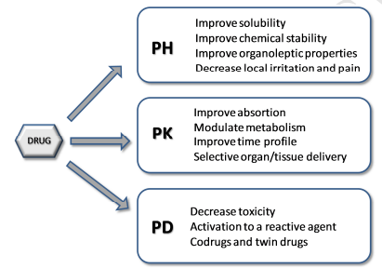
Fig. 1. A schematic classification of some objectives in prodrug research, classified by objectives related to pharmaceutical (PH), pharmacokinetic (PK) and pharmacodynamic (PD) phases.
Typically, certain enzymes, primarily hydrolases, catalyse the metabolic process required to change the prodrug into the drug. Ideally, this should only happen at the site of targeting to prevent negative side effects. The prodrug concept has found a lot of valuable uses in drug research and development because it enables the fulfilment of numerous biological and/or physicochemical goals, some of which are at odds with one another. It is important to keep in mind how many of these goals are connected [4]. In order to be effective, a prodrug must be able to solve the fundamental conundrum of needing to be both hydrophilic and lipophilic in order to satisfy solubility, bioavailability, and transport requirements [5,6].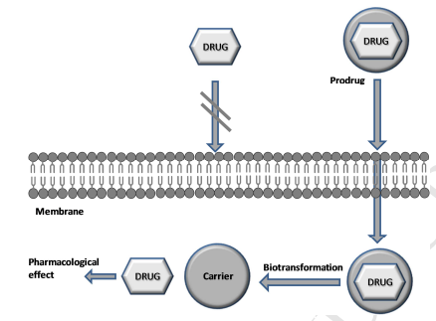
Fig. 2. Schematic representation of some prodrugs designed to by-pass a membrane

Due to insufficient absorption or sensitivity to the first-pass metabolism, which results in drug inactivation and/or the generation of hazardous metabolites, many therapeutically useful drugs have limited bioavailability following oral delivery. A formulation solution, which boosts oral bioavailability by utilising appropriate excipients that increase gastrointestinal membrane permeability, is one potential method for enhancing oral absorption. Surfactants, fatty acids, glycerides, steroidal detergents, and derivatives of amino acids are a few examples of these permeation enhancers. These excipients can, however, occasionally seriously harm the intestinal epithelium [7]. A chemical remedy utilising a prodrug strategy is a tempting substitute. By modifying physico-chemical factors that affect absorption or by focusing on certain enzymes or membrane transporters, the prodrug method has also been frequently employed to enhance drug delivery to its site of action [8]. In order to fix a flaw in a drug candidate, a prodrug design is a lead modification approach. It can be helpful in avoiding issues with formulation and solubility, absorption and distribution, instabilities, site specificity of liberation, extended release, and toxicity, among other effects [9].

- Objectives of the prodrug approach:
The principal objectives of the prodrug approach can be summarized as follows:
- Improving drug water-solubility.
- Improving absorption and membrane permeability.
- Targeted release.
- Reducing metabolism and side effects, bearing in mind that in some cases two or more objectives are interrelated.

- Types of prodrugs
The two primary categories of prodrugs are bioprecursor prodrugs and classic prodrugs (carrier-linked prodrugs). In carrier-linked prodrugs, the drug is temporarily covalently bonded to a carrier moiety. A carrier prodrug undergoes cleavage to produce at least one side product, the carrier, which could be biologically inert (such as polyethylene glycol (PEG)) or may have targeting capabilities (such as antibodies), as well as a molecular entity with increased bioactivity (the drug). The bioprecursors are stimulated by the metabolic alteration of a functional group because they lack a carrier group. Prodrugs can be further subclassified into :
- Mixed prodrugs
- Mutual prodrugs
- Targetted producgs
- Polymer and drug carriers
- Mordern selective latentiation systems

  - Classic prodrugs:
Classic prodrug (carrier-linked prodrug)“is a prodrug that contains a temporary linkage of a given active substance with a transient carrier group that produces improved physicochemical or pharmacokinetic properties and that can be easily removed in vivo, usually by hydrolytic cleavage”

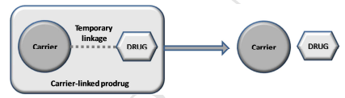
Fig. 3. Schematic representation of a carrier-linked prodrug.

A well-designed carried-prodrug may satisfy the following criteria [10]:
• Typically, a covalent bond forms the connection between the drug ingredient and the transport moiety.
• The prodrug typically has less or no activity than the parent molecule.
• In vivo dissociation of the transport moiety from the medicinal molecule is required.
• The prodrug, as well as the in vivo released transport moiety, must be nontoxic.
• To achieve efficient drug levels at the site of action and to reduce either alternative prodrug metabolism or slow drug inactivation, the synthesis of the active form must occur with quick kinetics.
Although carrier connected prodrugs have been employed for all of the aforementioned purposes, improving bioavailability has been their primary target. A drug's low bioavailability is typically caused by an unfavourable partition coefficient, and by selecting the right transporter, either the liposolubility or the hydrosolubility can be improved. Examples from the past include ampicillin ester prodrugs. Due to its strong polarity and consequent hydrosolubility, the beta-lactam antibiotic has an absorption rate of roughly 40%. Lipophilic acyloxyalkyl esters were created through the latentiation process, which enhanced the absorption to around 90% and boosted the antibiotic's bioavailability. Ampicillin, which produces the antibiotic activity, is absorbed and released within 15 minutes.
Decreased intra- or the intermolecular hydrogen bonds can also improve hydrosolubility since these interactions result in more organised structures that are less soluble in water. Increased water solubility is possible with hydroxymethyl derivatives of acidic medications, such as amides, which are also intermediary derivatives for ester pharmaceuticals with modulated partition coefficients.

  - Bioprecursor prodrugs

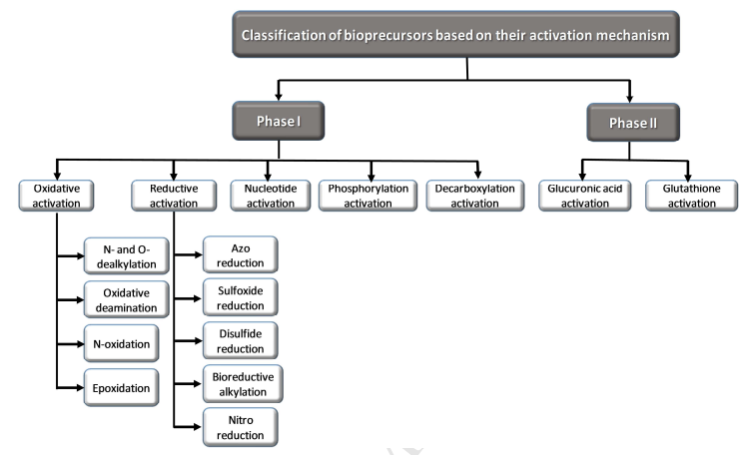
Fig. 4. Classification of bioprecursor prodrugs based on their activation mechanisms

Latent medications called bioprecursors has to be biotransformed in vivo, though typically not by hydrolytic enzyme systems.The active principle is molecularly modified to produce bioprecursor prodrugs. The metabolite, which is the anticipated active chemical, is produced as a result of the alteration and is capable of serving as a substrate for the metabolic enzymes [3,10,11]. For instance, the bioprecursor could be an alcohol that is metabolised via oxidation to the aldehyde and subsequently to the drug if the substance has a carboxylic acid group. Although phase I events (oxidation, reduction, or phosphorylation) typically create pharmacologically active metabolites, phase II conjugation processes can also result in physiologically active substances.

3.3 Mixed Prodrugs (12,13,14)
Mixed prodrugs build up bioprecursors and traditional prodrug traits, necessitating biotransformation through chemical or enzyme processes, and boosting the drug's concentration at a particular site of action. In other cases, such as the Chemical delivey System (CDS), the carrier needs to undergo biotransformation before being absorbed. This central nervous system (CNS) has been employed for prodrugs since Bodor and Abdelalim idealised it in 1985. Prior to passing the blood brain barrier in this system, the carrier—the reduced form of methylnicotinic acid—needs to undergo biotransformation through an aerobic enzyme process. The blood brain barrier is difficult for a positively charged molecule to cross back over, which causes the prodrug to concentrate in the brain. Despite the fact that this biotransformation also takes place in the periphery, the concentration in the brain.
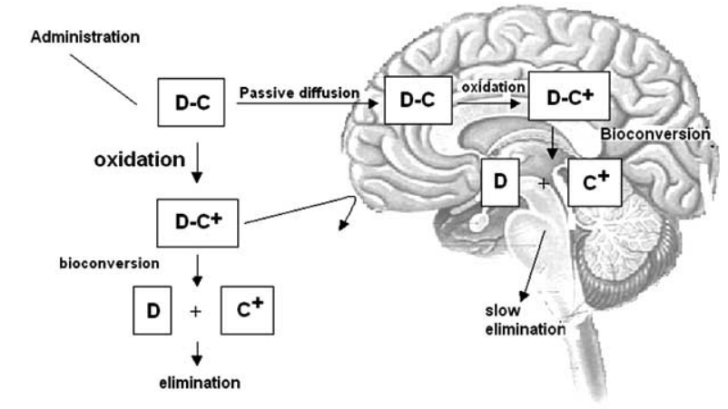
Fig no. 5 CDS(Chemical Delivery System) in SNC. D – drug; C – carrier; C+ - charged carrier.

3.4 Mutual Prodrugs (14,15)
These "latent drugs" are made up of two or more medications, where one is the carrier of the other, as opposed to typical prodrugs, where the carriers do not exhibit any biological activity. Their benefit is the ability to combine various therapeutic activities to provide a synergistic impact or increased efficacy. In 1994 [30], Singh and Sharma published a review that included numerous cases of shared prodrugs. It's interesting to note that the development of this category of prodrugs before the idea of the prodrug. For instance, sulfasalazine was first used in 1942 to treat rheumatoid arthritis and is now being used to treat ulcerative colitis. But this medication, which was once thought to be a mutual prodrug, turned out to be a classic prodrug instead, as the activity was only brought on by the anti-inflammatory effects of aminosalicyclic (Fig. 6).
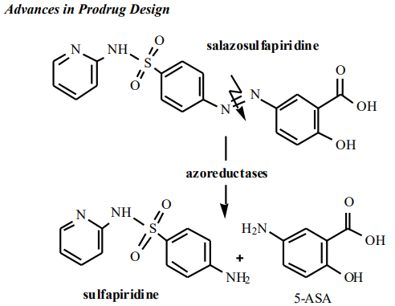
Fig 6: Salazosulfapiridine, formerly considered as mutual prodrug of sulfapyridine and aminosalycilic acid

3.5 Targeted Drugs(16,17)
Recently, the latentiation method to cell-specific medication delivery has drawn more attention. The carriers in targeted medications take on a crucial role because of the selectivity they need to engage with receptors or enzymes, which are typically found at cell membranes, reducing the negative side effects on organs or tissues unrelated to the biological action. Targeted medications can be made of polymers that act as their own distinct groups or as supports for director groups. The latter are discovered as antibodies amid certain macromolecules.
With the primary goal of achieving selective liver distribution, Nishikawa and colleagues utilised carboxymethyl and succinyldextrans as carriers in which the director groups were connected. When used with mitomycin, the transporters were shown to be advantageous for the medication.

3.6 POLYMERS AS DRUG CARRIERS (22-25)
The prolonging of action while reducing toxicity is one of the goals for using macromolecules in prodrug creation. Due to the compounds' growing significance in drug development, the polymer chemistry and biomedical research can now interact, giving rise to the "polymer therapeutics" of the twenty-first century. Many biological macromolecules, both natural and synthetic, have been used as carriers for various chemotherapeutic medicines, such as antineoplastic medications, for instance. The basis for this application is the distinction between the anatomical and physiological properties of cancer cells and those of normal cells.
The anatomical structure of tumoral vessels has an essential role in the drug distribution through the intersticial space, allowing:
- the increase in microvascular permeability related to the normal vessel, thus leading to better macromolecules penetration.
- High intersticial pressure, which can conduct to a delay in macromolecules efflux.
- Lack of a lymphatic drainage system, accumulating macromolecules into the tumor tissues to be used as carriers in the latentiation approach, polymers should have the following features:
- Biodegradability.
- Lack of either toxicity or intrinsic antigenicity.
- Incapacity of accumulating in the body.
- Functional groups for chemical bioreversible linkage
- Stability of drug linkage until the polymer prodrug reaches the site of action.

Table 1: shows some examples of most used as carriers with the purpose of prolonging action and decreasing toxicity, besides being used for director group support in targeted drugs.
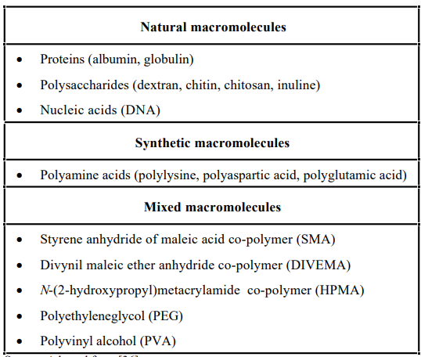

3.7 MODERN SELECTIVE LATENTIATION SYSTEMS
The development of gene-controlled transcription in mammalian cells and the discovery of membrane transporters' tridimensional structure have made it possible to develop highly targeted, highly selective medications. The following systems are recognised by these advanced latent forms.:
- CSDDS – ColonSpecific Drug Delivery System.
- ADEPT – Antibody Directed Enzyme Prodrug Therapy.
- GDEPT/VDEPT – Gene-Directed Enzyme Prodrug Therapy/Virus Directed Enzyme Prodrug Therapy.
- ODDS – Osteotropic Drug Delivery System.

- CSDDS – Colon Specific Drug Delivery System.(16)
This approach is predicated on the discovery of typical intestinal microbiota enzymes that can be utilised to facilitate colon medication delivery. The use of prodrugs with azo linkage was thought to be an alluring method of targeting drugs to the colon because it was known to have normal gastrointestinal microbiota and azoreductase presence within this medium was present.
- ADEPT – Antibody Directed Enzyme Prodrug Therapy. (25,26)
It is well knowledge that substantial drug side effects severely restrict the effectiveness of cancer chemotherapy because the drugs don't target neoplastic cells specifically. Therefore, specific antineoplastic chemotherapeutic drugs are the focus of the majority of investigations conducted in this field. However, parasites, germs, and other infectious organisms can also be treated using this strategy.

- GDEPT/VDEPT – Gene-Directed Enzyme Prodrug Therapy/Virus Directed Enzyme Prodrug Therapy.(27,28)
- This method is based on the expression of a gene that produces enzymes that can activate prodrugs. The genes may be carried by viruses (retrovirus or adenovirus), cationic lipids, or liposomes. These carriers go to both tumour and healthy cells. The method is known as VDEPT in virus-derived genes. By connecting them in the downstream transcriptional unit extremities of tumours, one can express genes. This strategy has been researched specifically for cancer therapy with the goal of developing highly selective antineoplastic medicines and has showed promise in early studies.
- ODDS – Osteotropic Drug Delivery System.(29,30)
Although numerous attempts have been made to create prodrugs that might be helpful for bone disorders, bone tissue has remained a relatively untapped target. Its biological characteristics and the absence of a circulatory system, which other body tissues have, are some of the causes of this restriction. Recently, a brand-new and promising prodrug approach was put out for the administration of medications to bone tissue. The osteotropic drug delivery system (ODDS) is made up of biphosphonate molecules connected to certain medications for bone ailments. Pirophosphate, an endogenous calcium homeostasis regulator, is a structural relative of the new class of synthetic chemicals known as biphosphonates. In several bone metabolic illnesses, including Paget's disease, malignancy hypercalcemia, bone metastases, and osteoporosis, these compounds are clinically helpful. The tissues that have calcified are the principal sites for these substances' accumulation following delivery because of their strong affinity for hydroxyapatite. The ODDS mechanism enables medication release from the bones or bone marrow based on biphosphonate tropism.

CONCLUSION AND PERSPECTIVES
Numerous viral or physiologically induced disorders have been successfully treated with the prodrug strategy. Due to the tremendous advancement in the biotechnological sector and in the identification of organic compounds, this strategy has become a significant, logical, and potential option to bring improved medications in therapy.
The current systems that have been employed for prodrug creation need more and more attention despite the use of, and also because of, generally straightforward synthetic approaches, primarily because they allow us to obtain highly selective molecules that are potentially beneficial for therapeutic applications. Due to the increasing demand for selective antineoplastic medications, studies on enhanced systems of prodrug creation have focused on the cancer field. However, it is crucial to apply these contemporary methods to infectious illnesses such as tropical endemics and tuberculosis, for example. New and better medications must be developed because these diseases primarily afflict the underprivileged in developing nations. To increase their efficacy and develop derived selective systems, we have been developing prodrug design with various antimalarial, antileishmanial, anti-Chagas disease, and tuberculostatic medicines.
Reference
- A. Albert, Chemical aspects of selective toxicity, Nature 182 (1958) 421–423. c) J. Rautio, Prodrug strategies and drug design, in Methods and principles in medicinal chemistry, Prodrugs and targeted delivery, Wiley-VCH, Weinheim, 2011, pp 3–26.
- International Union of Pure and Applied Chemistry. http://www.chem.qmul.ac.uk/iupac/medchem (accessed 7.06.2016).
- R.B. Silverman, Prodrugs and drug delivery systems, in The Organic Chemistry of drug design and drug action, J. Hayhurst (Ed.), Elsevier Academic Press: San Diego, 2004, pp 497–544.
- B. Testa, Prodrugs: bridging pharmacodynamic/pharmacokinetic gaps, Curr. Opin. Cell. Biol. 13 (2009) 338–344.
- C. Anastasi, G. Quelever, S. Burlet, C. Garino, F. Souard, J.-L. Kraus, New antiviral nucleoside prodrugs await application, Curr. Med. Chem. 10 (2003) 1825–1843.
- V.L. Campo, I. Carvalho, Prodrugs: principles, design and therapeutic application, Curr. Methods Med. Chem. Biol. Phys. 2 (2008) 187–214.
- N.N. Salama, A. Fasano, M. Thakar, N.D. Eddington, The impact of ∆G on the oral bioavailability of low bioavailable therapeutic agents, J. Pharmacol. Exp. Ther. 312 (2005) 199–205.
- H.K. Han, G.L. Amidon, Targeted prodrug design to optimize drug delivery, AAPS PharmSci 2 (2000) E6.
- J. Rautio, H. Kumpulainen, T. Heimbach, R. Oliyai, D. Oh, T. Jaervinen, J. Savolainen, Prodrugs: design and clinical applications, Nat. Rev. Drug Discov. 7 (2008) 255–270.
- C.G. Wermuth, Designing prodrugs and bioprecursors, in The Practice of Medicinal Chemistry, 3rd ed; C.G. Wermuth (Ed), Elsevier Academic Press: Amsterdam, 2008, pp 561–585.
- G.R. Kokil, P.V. Rewatkar, Bioprecursor prodrugs: molecular modification of the active principle, Mini Rev. Med. Chem. 10 (2010) 1316–1330.
- de Albuquerque Silva AT, Chung MC, Castro LF, Carvalho Guido RV, Ferreira EI. Advances in prodrug design. Mini reviews in medicinal chemistry. 2005 Oct 1;5(10):893-914.
- Bodor, N.; Abdelalim, A. M. J. Pharm. Sci., 1985, 74, 241.
- Prokai, L.; Prokai-Tatrai, K.; Bodor N. Med. Res. Rev., 2000, 20, 367.Singh, G.; Sharma, P.D. Indian J. Pharm. Sci., 1994, 56, 69.
- Vlieghe, P.; Clerc, T.; Pannecouque, C.; Witvrouw, M.; De Clercq, E.; Salles, J. P.; Kraus, J. L. J. Med. Chem., 2002, 45, 1275.
- Han, H. K.; Amidon, G. L. AAPS Pharm. Sci., 2000, 2, E6.
- Chung, M.-C.; Gonçalves, M. F.; Colli, W.; Ferreira, E. I.; Miranda, M. T. J. Pharm. Sci., 1997, 86, 1127.
- Takakura, Y.; Hashida, M. Crit. Rev. Oncol. Hematol., 1995, 18, 207.
- Chen, X.; Wu, B.; Wang, P. G. Curr. Med. Chem. Anti-Cancer Agents, 2003, 3,139.
- Hoste, K.; De Winne, K.; Schacht, E. Int. J. Pharm., 2004, 277, 119.
- Heinis, C.; Alessi, P.; Neri, D. Biochemistry, 2004, 43, 6293.
- Bouvier, E.; Thirot, S.; Schmidt, F.; Monneret, C. Org Biomol Chem., 2003, 7, 3343.
- Duncan, R. Nat. Rev. Drug Discov., 2003, 2, 347.
- Takakura, Y.; Takagi, A.; Hashida, M.; Sezaki, H. Pharm. Res., 1987, 4, 293.
- Xu, G.; Mcleod, H. L. Clin. Cancer Res., 2001, 7, 3314.
- Houba, P. H. J.; Leenders, R. G. G.; Boven, E.; Scheeren, J. W.; Pinedo, H. M.; Haisma, H. J. Biochem. Pharmacol., 1996, 52, 455.
- Grove, J. I.; Searle, P. F.; Weedon, S. J.; Green, N. K.; Mcneish, I. A.; Kerr, D. J. Anticancer Drug Des., 1999, 14, 461.
- Kerr, D. J.; Young, L. S.; Searle, P. F.; Mcneish, I. A. Adv. Drug Deliv. Rev., 1997, 26, 173.
- Castro, L. F.; Silva, A.T. A.; Ferreira, A. G.; Ferreira, E. I.; Chung, M. C. Quim. Nova, 2004, 27, 456.
- Hirabayashi, H.; Takahashi, T.; Fujisaki, J.; Masunaga, T.; Sato, S.; Hiroi, J.; Tokunaga, Y.; Kimura, S.; Hata, T. J. Controlled Release, 2001, 70, 183.

