EMERGING ERA OF MICRONEEDLE TECHNOLOGY FOR TRANSDERMAL DRUG DELIVERY SYSTEM
Akshay R Supe¹*, Abhishek Nemmaniwar², Gargi Dhaneshwar³, Riya Singh⁴, Neetu A. Khatri⁵
M. Pharm Student^{1,2,3,4}, Assistant Professor⁵
Dr. D.Y. Patil College of Pharmacy, Akurdi, Pune-411044

INTRODUCTION:
The skin is an important organ that protects the body from harmful effects including massive water damage and synthetic chemical attacks. The primary skin barrier, the stratum corneum, which is a component of the epidermis, is made up of 15-20 corneocyte layers.3-5 Transdermal medication delivery offers an important alternative to oral and hypodermic injections.
There are three layers to human skin: the hypodermis, dermis, and epidermis. It might solve the problem of drug degradation and liver or gastrointestinal absorption. It is non-invasive, painless, and self-administered.
Microarray patch technology was developed to deliver high molecular-weight drugs without the use of injections. In order to increase patient compliance, it can give delayed drug release. The surface structure of microneedles (MNs) allowed for the delivery of the medicine in the form of a bandage. MNs are composed of numerous unique micro projections that vary in size, shape, and support from a base. Their heights range from 25 to 2,000 mm. As per a 1976 patent, ALZA was the first business to create MNs. As seen in Figure 1, MNs allow for non-invasive access to the patient's dermis and allow for the direct absorption of medications into the systemic circulation. This study will concentrate on MN technologies that have lately made considerable strides towards breaking through the subcutaneous barrier and enabling enhanced transdermal medication delivery. We'll focus on the latest recent developments in MN design.
It will highlight When MN inventions go from academic research to commercial applications, challenges to effective MN encroachment and some crucial safety considerations will be taken into account. The industry has begun to see the entry of some commercial MN products that aid in the transdermal delivery of medications and vaccines. The novel coronavirus disease COVID-19 (Coronavirus disease 2019) illness has been classified as a global pandemic by the World Health Organisation (WHO). For the treatment of this condition, researchers recently produced the recombinant coronavirus vaccine (PittCoVacc).
Researchers have looked at microneedles (MNs) for transdermal medication administration and for overcoming the drawbacks of the existing methods. A micron-sized needle is used in a microneedle device. The problems with transdermal patches and hypodermic needles prompted the creation of the microneedle drug delivery system, which is seen as a hybrid of the two.
The fundamental problem with transdermal technology is that many drugs cannot exert their therapeutic effects because they cannot penetrate the skin quickly enough. The stratum corneum can be penetrated by hydrophilic, high-molecular-weight compounds thanks to the advanced method known as microneedles. More drug molecules can permeate the skin when drugs are administered using a microneedle device because the drug molecules can pass through the stratum corneum layer.
The distinguishing features of this approach include its speedier onset of action, improved patient compliance, self-administration, enhanced permeability, and efficacy. additionally, to If microneedle tips are left inside the skin, problems may arise since they are much smaller and thinner than the thickness of human hair and can shatter. These limitations are rather infrequent and can be overcome by carefully choosing the microneedle material. The main objective of this technology is to disrupt the stratum corneum by generating larger transport pathways of micron size, which are larger than molecular dimensions and smaller than holes made by hypodermic needles, allowing large molecules to pass through and increasing permeability. Traditional methods include chemical and lipid procedures, as well as electric ones like iontophoresis and electroporation.
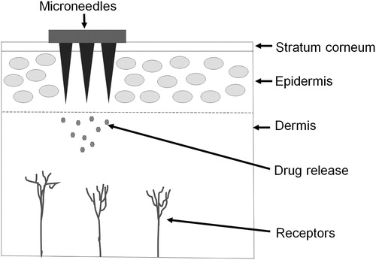
Figure 1: Microneedle
Table-I: Comparison between topical cream, transdermal patch, hypodermic needle, and microneedle drug delivery systems
 | Topical cream | Transdermal patch | Hypodermic needle | Microneedle
Description | Emulsion/ emulgel/ cream/ ointments | Adhesive patch to be placed on the skin | Fine, hollow tube having a sharp tip with small opening at the end | Micron size needles are aligned on the surface of a small patch
Onset of action | Slow | Slow | Faster | Faster
Pain | Painless | Painless | Painful | Painless
Bioavailability | Poor | Insufficient | Sufficient | Sufficient
Patient compliance | Less | Better | Less | Better
Self-administration | Possible | Possible | Not possible | Possible
Mechanism of drug delivery | Permeation through skin pores. | Drug has to cross stratum corneum barrier, thus poor diffusion of large molecules | Drug placed directly in the dermis | Bypass stratum corneum and drug placed directly into epidermis or dermis hence enhanced permeability
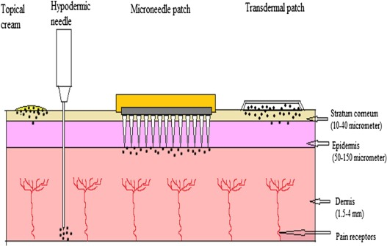
Figure 2: Comparison of topical cream, hypodermic needle, microneedle patch and transdermal patch
MECHANISM OF DELIVERY
The diffusion mechanism is used to administer the medicine via the topical route. The skin is momentarily damaged during the medication delivery process using microneedles. In order to administer enough medicine to produce the necessary therapeutic response, a microneedle device is created by arranging hundreds of microneedles in arrays on a tiny patch (similar to that of a typical transdermal patch available on the market). By cutting through the stratum corneum, it avoids the barrier layer. The medicine is immediately injected into the epidermis or upper dermis layer, where it enters the systemic circulation and, upon reaching the site of action, produces a therapeutic reaction. In Fig. No. 02 ^{[2]}, the mechanism of drug administration using microneedles is shown.

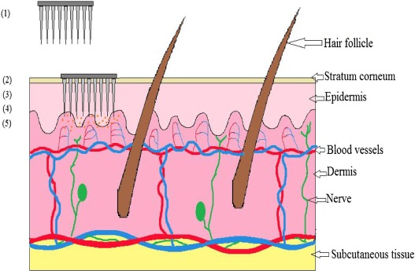
Figure 3: Mechanism of drug delivery by microneedle device: (1) Microneedle device with drug solution; (2) Device inserted into the skin; (3) Temporary mechanical
disruption of the skin; (4) Releasing the drug in the epidermis; (5) Transport of drug to the site of action
METHODOLOGY FOR TRANSDERMAL DRUG DELIVERY:
A variety of methods employed for transdermal drug delivery through hollow or solid MNs are poke and patch system in
Poke and Patch
When a patch is applied on the top of these MNs, needles form micropores into the skin upon removal of it.
Coat and Poke
The MNs perforate the skin, and afterward, the drug containing coating is released through hydration.
Dip and Scrape
The MNs or microblade are first dipped in a drug solution and then scraped over the skin leaving behind the drug within the microprojections generated by the MNs.
Poke and Flow
This approach is used for hollow MNs. The MNs are made up of polymers in which the drug is encapsulated. The incorporated drug is released for a more extended period^{[1]}
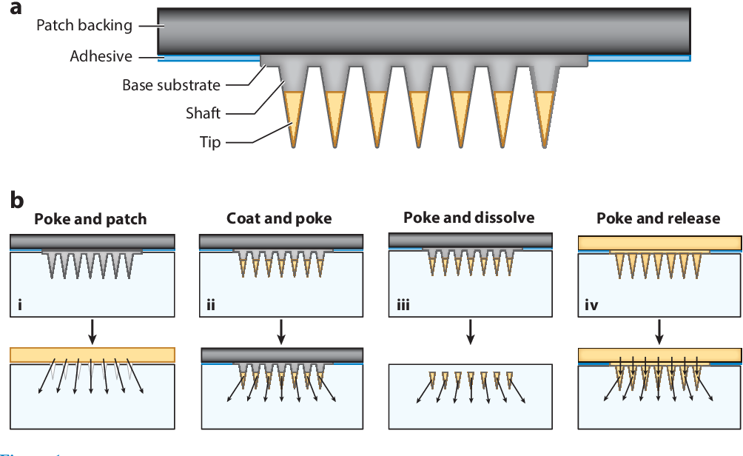
Figure 4: Microneedle patch (MNP) designs and operations. (a) Microneedles comprise a shaft and tip that often encapsulates or is coated with drug. The microneedle array is mounted on a base substrate that is attached to a patch backing to facilitate handling and skin adhesion. (b) Drug delivery approaches for MNP use. MNPs can (i) be used as a pretreatment, after which a drug formulation is placed on the skin surface for slow drug release through residual pores in the skin (poke and patch); (ii) be coated with drug in a water-soluble matrix that is released in the skin (coat and poke); (iii) encapsulate drug in water-soluble microneedles that dissolve in the skin (poke and dissolve); or (iv) encapsulate drug in the patch backing and, in some cases, the microneedles that slowly release drug through the non-water-soluble microneedle matrix (poke and release).
Types of microneedles:
Most patches share a few similar characteristics, even though the microneedle design varies depending on the distribution mechanism, kind of microneedle, and action of the medications to be delivered. A typical microneedle has a tapered sharp tip and measures 150–1500 mm in length, 50–250 mm in breadth, and 1–25 mm in tip thickness. Standard materials for microneedles include metal, silicon, polymer, glass, and ceramic. The medication is often injected into or applied to the microneedle tip, which is attached to the substrate base below to create an array. For convenience, the patch backing—which includes a skin adhesive to enhance contact with the skin—is bonded to the microneedle array. There are normally four varieties of microneedles. Metal and silicon, which offer powerful mechanical qualities and don't contain any pharmaceuticals, are the main materials used to make solid microneedles. Thus, it is vital to continue applying the medication to the area after putting the microneedles. In contrast, the medicine is administered concurrently with the application when coated microneedles are used on the skin's surface. The medicine may be included into the biodegradable matrix when dissolving microneedles, in which case there will not be any sharp debris left over following microneedle application. Because the medication is contained in all locations, including the microneedle's tip and the backing of the patch, hydrogel microneedles provide gradual drug delivery. Since the properties of microneedles vary depending on the kind, a design that is appropriate for the microneedles should be chosen based on the medication dose, time until the drug starts to take effect, length of time it takes to deliver, efficiency of distribution, packing, and sharp waste.
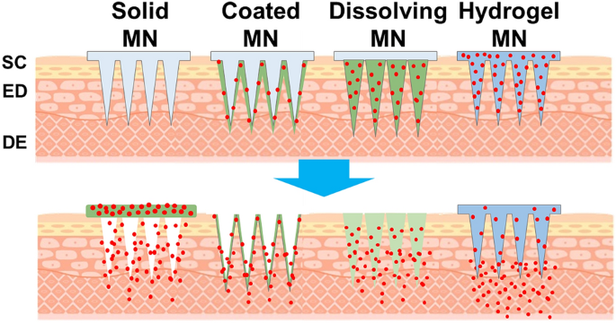

Figure 5: Schematic illustration of the types of microneedles and their drug delivery methods.
SOLID MICRONEEDLE
Hydrogel microneedles administer drugs gradually because the drug is present everywhere, including the tip of the microneedle and the backing of the patch. A design that is suitable for the microneedles should be chosen based on the medication dose, time until the drug begins to take effect, length of time it takes to deliver, efficiency of distribution, packing, and sharp waste since the qualities of microneedles vary depending on the type. Drugs can be delivered over and extended time by including reagents that keep the pores open for a longer duration.^{[4]}
COATED MICRONEEDLES
It takes less time for the drug to reach the skin after a solid microneedle has been inserted when it is coated with a water-soluble matrix (Fig. 4b). The coating must form a layer on the microneedle's surface for it to stay attached during storage and skin insertion. This requires sufficient viscosity in the coating mix. It's important to think about where you'll apply your coating. The tip of the microneedle, which actually pierces the skin, is where it is usually more cost-effective to administer the medications. By adjusting the depth at which the microneedle is dipped into the coating formulation, it is possible to control the drug-coated region while dip coating. The quantity of medication coated be subject to on how far the microneedle spreads, which can be controlled by adjusting the surface tension of the coating formulation. Rapid skin breakdown of the drug in coated microneedles results in a rapid onset of the drug's pharmacological effect. The formulation coating operation can be repeated to create a thicker coating, however due to dose restrictions, this method is not suited for administering drugs.
DISSOLVING MIRCONEEDLES
The definite microneedles can be produced using materials that are decomposable or water-soluble, contain the drugs, and have the necessary mechanical strength to puncture. A dissolving microneedle can be inserted into the skin without producing sharps waste since it dissolves or disintegrates instantly upon contact with skin fluid. The most common method for making dissolving microneedles is solvent casting with a water-soluble biodegradable polymer. Methyl cellulose and carboxymethyl cellulose (CMC) are two well-liked cellulose-based biodegradable polymers.In addition, saccharides like trehalose and sucrose are included in the microneedles to help the formulation dissolve and stabilise biomolecules.
The drug-containing tip's formulation must be appropriate for the treatment, possess mechanical strength, and have a viscosity low enough to entirely and bubble-free fill the microscale mould space. The base substrate without drugs may be more viscous than the tip with drugs, have lower mechanical properties, or be made of non-water soluble compounds. Recent studies have investigated methods to rapidly separate the tips from the base substrate without requiring the tips to fully dissolve in the skin, hence minimising the time that microneedle patches must be worn. Due to the rapid mechanical separation of the microneedle's tip and base, a small single wall was built into the device's side. Research is being done to increase the amount of medication that can be contained in these microneedles because this technology, unlike dissolving and coated microneedles, is not ideal for administering high doses.
HYDROGEL MICRONEEDLES
The drug is contained in all areas of the hydrogel microneedle tip, base substrate, and patch backing while the patch is worn against the skin (Fig. 4d). The bulk of the microneedle patches are made of hydrogel, which keeps them from disintegrating in contact with skin secretions. A significant part of the hydrogel's medication can reach the skin by diffusion. This approach can provide huge amounts of medication since the drug can be applied throughout the entire microneedle patch; nevertheless, the patch-wearing period is extended due to the slow drug delivery rate.
MICRONEEDLE FABRICATION MATERIAL AND ITS PROPERTIES
Silicon
In the 1990s, silicon was used to create the first microneedle. An anisotropic substance having a crystalline structure is silicon. Its characteristics are governed by the crystal lattice, which exhibits a range of elastic moduli (50 to 180 GPa). Due to their adaptability, needles can be produced in a variety of sizes and forms. It is a versatile substance with appealing physical characteristics. Silicon substrates can be precisely and batch-produced. Silicon cannot be employed in microneedles due to its high cost and labor-intensive, complex manufacturing process. Furthermore, silicon is brittle, so some bits may break and become stuck in the skin, causing some biocompatibility issues.
Metal
The two main metals used are titanium and stainless steel. Palladium, nickel, and palladium-cobalt alloys are also used. They have strong mechanical properties and are biocompatible. Because they are strong enough to prevent fracturing, metals are a better material than silicon for creating microneedles. The first metal used in the production of microneedles was stainless steel. Titanium is a fantastic alternative to stainless steel.
Silica glass
Glass can be used to make a variety of forms on a very small scale. Despite being biologically inert, silica glass is naturally fragile. Glass made of silica and boron trioxide is called borosilicate, and it is more elastic. Because they are often created manually, they are less time-efficient. Glass MNs are currently only used for research purposes; they have no practical use in industry.
Carbohydrate
Maltose is one of the most often utilised sugars. In addition to other sugars, you can also use polysaccharides such galactose, mannitol, trehalose, sucrose, and xylitol. Carbohydrate slurries are moulded using silicon or metal moulds. The drug-loaded carbohydrate mixture is cast into the moulds to produce the microneedles. The time-dependent breakdown of carbohydrates regulates the medication release into the skin. Carbohydrates are cheap and healthy for human health, but they are difficult to produce since they break down at high temperatures.
Polymer
A widespread variation of polymers comprising polylactic acid (PLA), poly (lactic-co-glycolic acid) (PLGA), poly (methyl methacrylate) (PMMA), poly (carbonate), cyclic-olefin copolymer, poly (vinylpyrrolidone) (PVP), polyglycolic acid (PGA), poly (vinyl alcohol) (PVA), polystyrene (PS), poly (methyl vinyl ether-co-maleic anhydride), SU-8 photoresist are reported for microneedles preparation. These polymers are typically used to create microneedle arrays, which degrade or dissolve and yield hydrogels. These polymers can be utilised to create microneedles that are more durable than glass and ceramics but not as robust as other materials.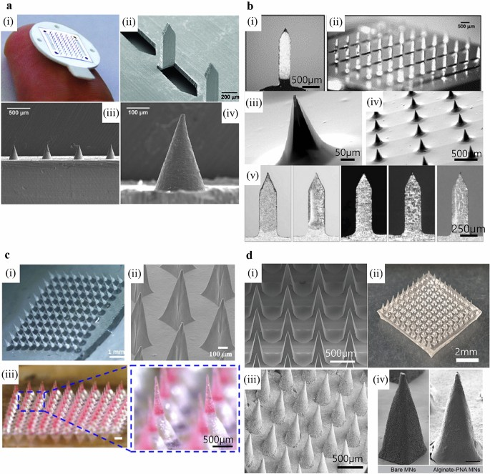
Figure 6: a. Solid microneedles made of stainless steel (i and ii) and titanium (iii and iv). b. Coated microneedles made of stainless steel (i and ii) , silicon (iii and iv), and titanium (v). c Dissolving microneedles made of CMC (i), HPMC (ii), and PLGA (iii) .d Hydrogel microneedles made from HA (i and ii) , PVA (iii) , and alginate (iv).
Fabrication Methods:
Different materials are employed to produce MNs. The method of the fabrication depends upon the types of material used.
Etching
It is one of the methods employed to produce MNs. There is an interaction between the substrate and etchant. This process falls under the categories of dry etching or wet etching, depending on the etchant used. In wet etching, the substrate is etched to the desired shape using a liquid etchant. Wet etching is still frequently employed in fabrication, despite its low selectivity and the abundance of available materials. Dry etching, on the other hand, employs gas as an etchant. Although expensive and time-consuming, dry etching produces images with great resolution and a deeper etching depth. In this approach, silicon and metal were the MNs used most frequently. 28,73 For transdermal hemodynamic dysfunction therapy, silicon hollow MNs were created using the reactive
Laser cutting
It is a good technique for generating reliable MNs. MNs are made with cutting devices. Due to the low accuracy of the cutting machine, this procedure only works on materials that are a specified degree of toughness or hardness. This technique is used by the majority of silicon and metal MNs. Using moulds and laser cutters, polydimethylsiloxane (PDMS) MNs were produced. 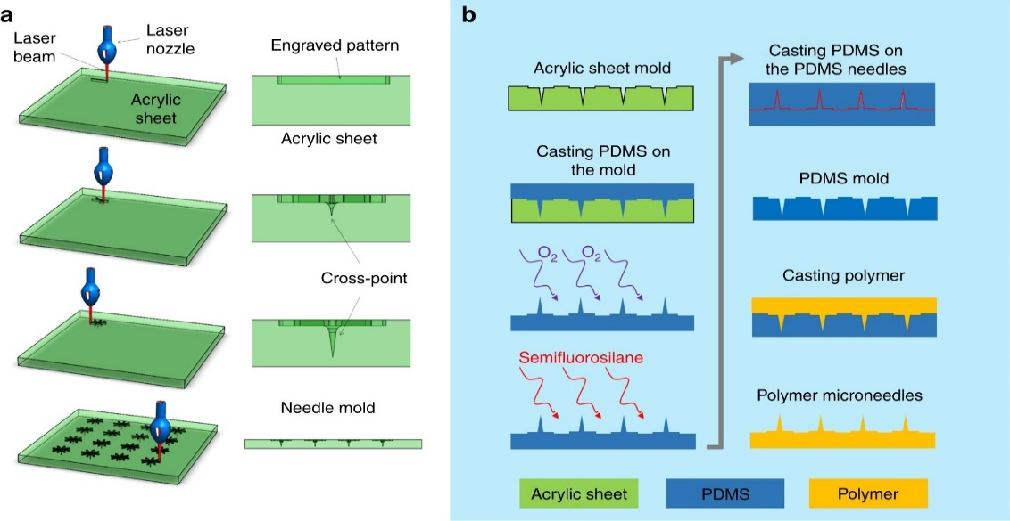
Fabrication of microneedle mold. (a) CO2 laser cutter was used to make microneedle acrylic mold using the planned cross-over lines (COL) method, (b) the acrylic mold was cast-off to construct polydimethylsiloxane (PDMS) microneedles mold, This can be used to create a variety of microneedles made of polymers.
Photolithography
A design pattern is transferred from a photomask to a substrate covered with photosensitive material using X-ray or visible ultraviolet (UV) light energy. The substrate then acquires a three-dimensional structure. The UV intensity is changed, as well as using a free or switchable laser source, to create the 3D structure. This process can be used to create polymeric hollow MNs using photolithography techniques. Micromolding. This approach uses micro- or nanoscale moulds to create MNs. The ingredients are melted or liquidised to form the forms. The MNs are removed from the shells after solidification. It is a straightforward method for mass production that saves time and is more affordable than alternatives. With sugar and polymeric MNs, this tactic makes more sense. The polymeric MN array was micromolded by the researchers. explains the typical materials and fabrication processes.
Table 2: Materials and methods used for Microneedle fabrication
Material | Technique
Silicon | Wet etching, dry etching, 3D Laser Cutting
Metal | Laser Cutting, Laser ablation, micromolding, metal electropolating
Ceramic | Ceramic micromolding and sintering lithography
Polymers | Micromolding, Drawing Lithography, Photolithography
Carbohydrates | Micromolding

EVALUATION OF MNS:
Mechanical Properties
The mechanical strength, toughness, and hardness of MNs must be sufficient to pierce skin without breaking it. Electrical measurements, force/displacement tests, dye marks, and other mechanical testing are used to measure insertion forces. Numerous methods, such as histological staining, cryosectioning, optical microscopy, and confocal microscopy, are employed to establish insertion depth. 80 The Franz diffusion cell equipment is used in in vitro permeation studies to measure how rapidly drugs permeate the skin. Usually, the test uses pig ear skin positioned between the donor and receptor compartments.
In Vivo Studies
Numerous reconstructed skin models are used for in vivo tests based on hairless rat animal models. Trans epidermal water loss is one of the properties that the Delfin VapoMeter measures.
In Vitro/In Vivo Correlation Studies
For the in vitro in vivo correlation study, hairless pig skin was put on a Franz diffusion cell. The pH and temperature of the dissolving fluid were kept at a level that replicated in vivo conditions while the drug penetration profile was investigated in the in vitro experiment. Therefore, all in vitro settings and study variables were connected to those in vivo.
Skin Irritation Studies
At the application location, transdermal administration may cause mild to severe erythema. The degree of cutaneous irritability was assessed using the Draize method. The dermatological alterations were present both before and following the application of the patch to the site of action.
RECENT ADVANCEMENTS OF MN-BASED TECHNIQUES FOR DRUG AND VACCINE DELIVERY
The applications of MNs, in conjunction with physical methods, were studied to improve drug distribution and better regulate drug delivery through the skin.
Sonophoresis in Combination with MNs -

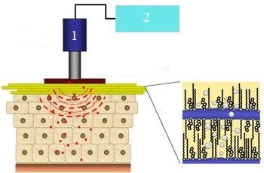
- Ultrasonic Transducer
- Power Supply

Figure 7: Sonophoresis
Sonophoresis is the technique of applying ultrasound to the skin to deliver medications. This technique uses ultrasound (3 W/cm2; 20 kHz to 10 MHz; 20 kHz to 10 MHz) to modify the lipid composition of the top layer of skin and induce cavitation, which improves medication permeability (formation and oscillation of gas bubbles). The degree to which drugs enter the skin can be altered by changing the ultrasonic frequency. Transcutaneous immunisation and gene delivery exploit this physical enhancer. The high-molecular-weight protein known as bovine serum albumin is delivered by 85 MNs and ultrasound, respectively. Combining a 1.5 mm MN patch with a 15 W ultrasonic frequency raised the permeability to 1 mm/s. This is more than ten times the permeability that passive diffusion would have expected.
Iontophoresis in Combination with MNs -
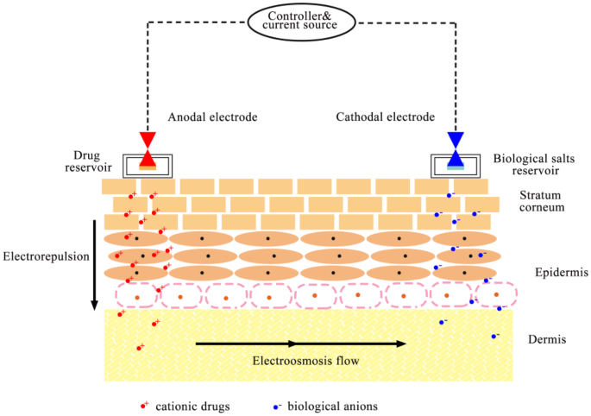
Figure 8: Iontophoresis
It is possible to increase skin penetration and rate of release of a variety of medications with low absorption capacity by promoting the flow of ions through a membrane when an externally supplied modest electrical potential difference is supplied (0.5 mA/cm2 or less). Together, iontophoresis and MN are effective because they regulate medication distribution by regulating current. Electronic methods can assist patients adhere to treatment regimens more regularly by enabling users to modify their dose as needed. D2O and fluorescein isothiocyanate (FITC)-dextrans, two high molecular weight molecules, were delivered in a research using MN and iontophoresis. The outcomes demonstrated that this boosted the molecules' skin permeability.
Electroporation in Combination with MNs -

Figure 9: Electroporation
By temporarily generating small water pores in the lipid bilayer of the skin, electroporation causes localised disruption. Drugs with a range of lipophilicity and molecular weights, including those with a molecular weight greater than 7 kDa, can have their molecular permeability increased using this method. When used in conjunction with chemotherapy, the electroporation technique can be used to treat malignancies more successfully. An MN electrode array was used to give the macromolecular medication FITC/dextran. It was discovered that electroporation and MNs improved the dispersion of macromolecular medicines.
Micropumps in Combination with MNs-

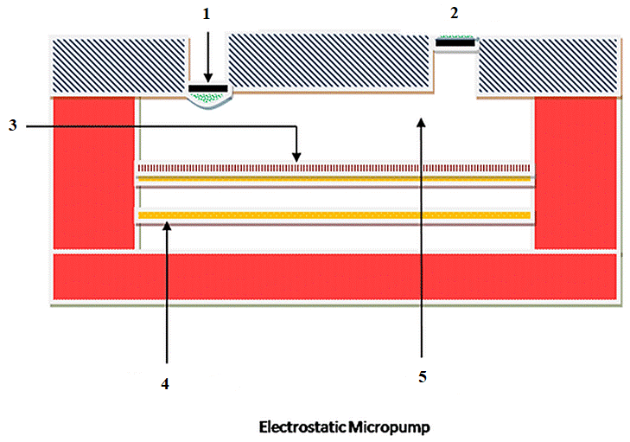
- Inlet Liquid
- Outlet Liquid
- SeparatingMembrane
- Working Electrode
- Pumping Compartment
Figure10: Micropumps
When MNs are used with micropumps, medication administration is successful. Pumps keep track of the drug solution flow rate to ensure that it complies with delivery standards. These pumps have the ability to regulate fluid outflow based on the amount of metabolites. For continuous fluid distribution, researchers demonstrated MN integration with an on-chip microelectromechanical system displacement micropump. Longer-term continuous pumping has been made possible.
Pocketed and Grooved MNs-

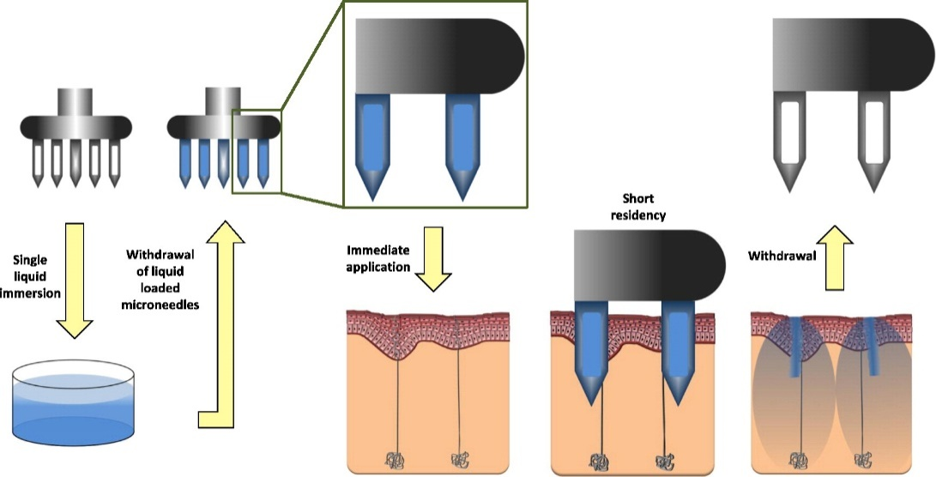

Figure11: Graphical Abstract of Pocketed and Grooved Microneedles
While switching surfaces, MNs can submerge to a certain depth and assemble greater drug loads. We build polymeric MNs with a broad base, sharp tips, and embedded shafts with grooves to assess their ability to transport drugs. Comparing smooth MNs to MNs with a higher antigen-loading capacity, it was shown that the latter had a far bigger antibody response. 91 To distribute ovalbumin through skin, the researcher created a modified MN array with a groove implanted in it. Due to the loading of more antigens in the grooves, MNs with more and deeper grooves induced a stronger antibody response.So MNs with grooves offer a better intradermal immunisation technique.
Applications of microneedle drug delivery:
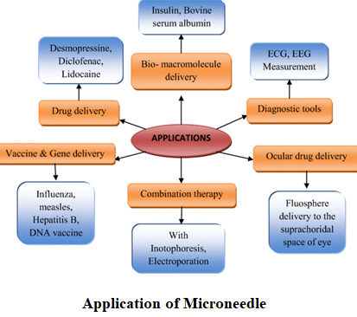
Figure12: Microneedle Applications
Advantages of MNs
- The administration of large molecules is possible.
- application that is painless and non-invasive.
- Steer clear of first-pass metabolism.
- Reduced dosage derives from improved medication efficacy.
- administration simplicity.
- controlled medication administration.
- The injection site heals more quickly.
- acceptable without being irritating.
- Reduced production and delivery costs.
- target medication delivery achieved at a specific area of skin.
Disadvantages of MNs
- It is feasible to provide just a modest amount of a medication.
- The potential for skin discomfort.
- The needle may break and 4. stay in the skin after the patch is removed.
- The external environment may have an impact on delivery, for instance, Skin moisture.
- Hollow MNs may be blocked by compressed dermal tissues.
REFERENCE:
- Gupta, Jitendra, Reena Gupta, and Vanshita. "Microneedle technology: an insight into recent advancements and future trends in drug and vaccine delivery." Assay and drug development technologies 19, no. 2 (2021): 97-114.
- Waghule, Tejashree, Gautam Singhvi, Sunil Kumar Dubey, Murali Monohar Pandey, Gaurav Gupta, Mahaveer Singh, and Kamal Dua. "Microneedles: A smart approach and increasing potential for transdermal drug delivery system." Biomedicine & pharmacotherapy 109 (2019): 1249-1258.
- Nagarkar, Rigved, Mahima Singh, Hiep X. Nguyen, and SriramakamalJonnalagadda. "A review of recent advances in microneedle technology for transdermal drug delivery." Journal of Drug Delivery Science and Technology 59 (2020): 101923.

Jung, Jae Hwan, and Sung GiuJin. "Microneedle for transdermal drug delivery: current trends and fabrication." Journal of pharmaceutical investigation (2021): 1-15.
- Chen, Bo Zhi, Ze Qiang Zhao, Mohammad-Ali Shahbazi, and Xin Dong Guo. "Microneedle-based technology for cell therapy: current status and future directions." Nanoscale Horizons 7, no. 7 (2022): 715-728.
- Prausnitz MR. Engineering Microneedle Patches for Vaccination and Drug Delivery to Skin. Annu Rev Chem Biomol Eng. 2017 Jun 7;8: 177-200.
- Nejad, H., Sadeqi, A., Kiaee, G. et al. Low-cost and cleanroom-free fabrication of microneedles. Microsyst Nanoeng 4, 17073 (2018)
- Ji Y.J., Kim K.S., Kim K.H., Byun J.Y., Yeom G.Y. A Brief Review of Plasma Enhanced Atomic Layer Deposition of Si3N4. Appl. Sci. Converg. Technol. 2019;28:142–147. doi: 10.5757/ASCT.2019.28.5.142
- Madou M.J. Fundamentals of Microfabrication: The Science of Miniaturization. 2nd ed. CRC Press; Boca Raton, FL, USA: 2017
- Virji M., Stefaniak A. Comprehensive Materials Processing. Volume 8. Elsevier; Amsterdam, The Netherlands: 2014. A Review of Engineered Nanomaterial Manufacturing Processes and Associated Exposure; pp. 103–125.
- Kim J.H., Chang W.S., Kim D., Yang J.R., Han J.T., Lee G.W., Kim J.T., Seol S.K. 3D Printing of Reduced Graphene Oxide Nanowires. Adv. Mater. 2015;27:157–161. doi: 10.1002/adma.201404380.
- Falo L.D., Jr., Erdos G., Ozdoganlar O.B. Microneedle Arrays for Cancer Therapy Applications. 14/934,927. Patent. 2016 May 19.
- Pal P., Swarnalatha V., Rao A.V.N., Pandey A.K., Tanaka H., Sato K. High Speed Silicon Wet Anisotropic Etching for Applications in Bulk Micromachining: A Review. Micro Nano Syst. Lett. 2021;9:4.
- Prausnitz MR. Microneedles for transdermal drug delivery. Adv Drug Del Rev. 2004; 56:581–587.
- Sivamani RK, Liepmann D, Malbach HI. Microneedles and transdermal applications. Expert Opin Drug Deliv. 2007;4:19–25.
- Vandervoort J, Ludwig A. Microneedles for transdermal drug delivery: a minireview. Front Biosci. 2008;13:1711–1715.
- Chen YT, Hsu CC, Tsai CH, Kang SW. Fabrication of microneedles. J Mar Sci Technol. 2010;18:243–248.
- Davis SP, Martanto W, Allen MG, Prausnitz MR. Hollow metal microneedles for insulin delivery to diabetic rats. IEEE Trans Biomed Eng. 2005;52:909–915.

