A REVIEW OF COGNITIVE WIRELESS NETWORK TECHNOLOGY

W. Minah–Eeba, P. Elechi, U. Ekwueme, T.S. Ibanibo and M. Okudu
Department of Electrical and Electronic Engineering, Rivers State University, Nigeria
elechi.promise@ust.edu.ng

Abstract
The electromagnetic radio spectrum is limited and is a precious resource in wireless communication systems. In the last decades, the development of many novel wireless systems and the associated growing demand for bandwidth has caused the frequency spectrum to become exhausted. Remarkably, many measurement campaigns have shown that virtually the entire allocated spectrum is being used ineﬃciently most of the time. As such, the spectrum inadequacy is not only caused by inﬂexible spectrum management but also owing to ineﬃcient usage. In eﬀorts to increase bandwidth utilization, this paper is reviewing the concept of cognitive radio networks (CRNs), its topology, Spectrum sensing techniques, applications, formulation Problem, benefits, challenges, and numerous features that may play a vital role in the field of next-generation cognitive wireless networks (CWN) communication system. This will give the secondary users (SU) an opportunity to access the momentarily vacant licensed bands of primary users which are known as white spaces or spectrum holes, by altering their transmitting parameters so that the interference is minimal to the primary user (PU).

Keywords: CR, CRN, SDR, CR Challenges, Spectrum Sensing, PU, SU
1.0 Introduction
It will be challenging to imagine life without wireless communication in this modern era. There are large numbers of users of wireless communication, but the available spectrum is limited. Thus spectrum scarcity becomes an issue. To mitigate this difficulty, CR was developed and designed such that it can communicate effectively and efficiently by sensing the wireless environment. Currently, several researches have been done on the use of these spectrum bands which are either empty or not in use at full capacity. CR technology was first recommended by Dr. Joseph Mitola in 1999. CR is a software-based technology that senses the electromagnetic environment in which it functions, detects inactive frequency bands, and uses the radio working parameters to broadcast in these bands [1].
The reason for CRNs is to eﬃciently utilise the temporary inactive licensed spectrum at a particular time or a particular geographic area for communications. Users in a CRN are classiﬁed into primary users (PUs) and secondary users (SUs). A PU, also known as a licensed user, has the most priority to access the spectrum and must not be subject to harmful interference from other users. A SU or cognitive user deploys innovative radio access methods along with dynamic spectrum allocation policies to coexist with the PU on condition that the interference caused by the SU does not degrade the PU performance [2]. With this approach, a CRN can overcome the shortage of radio spectrum.
The aim of this review is to briefly summarize the current state-of-the-art research in Cognitive radio systems and future research developments. The rest of the review is structured as follows: After reviewing the fundamental concepts of CR we describe the building blocks of a CRN and summarise the major research problems in perspective. Then, we summarize the current state-of-the-art spectrum sensing and spectrum-sharing techniques for CR systems. This is followed by a brief review of the work on security in CRNs and on the economics of CRNs. The current and future trends in CR including the applications (e.g., smart grid [3,4], machine-to-machine (M2M) communications [5], and cloud computing [6]) are reviewed, and the open research issues outlined. Finally, the standardization activities on CR are summarized.
CR technology is an important technology that allows a network to utilize the spectrum in a dynamic manner. A spectrum is the range of electromagnetic radiation that enables wireless communication and is controlled by governments. A Cognitive Radio is a radio that can change its transmitter parameters based on interaction with the environment in which it operates [7]. Recently, CR became apparent technology which is used to avoid congestion in wireless communication by utilizing unused radio spectrum [8].
In terms of transmission and reception parameters, CR is categorized as Full Cognitive Radio and Spectrum-Sensing Cognitive Radio. In Full CR every single parameter is monitored by a wireless node while in Spectrum-Sensing CR the radiofrequency (RF) spectrum is monitored. In terms of spectrum availability, it is classified as Licensed-Band Cognitive Radio and Unlicensed-Band Cognitive Radio. Licensed-Band CR is able to utilize bands which are allocated to licensed users. A standard was developed for wireless regional area network (WRAN) by IEEE 802.22 to operate on TV white spaces (unused television channels). Utilization of unlicensed parts of the radio frequency spectrum occurs in Unlicensed Band Cognitive Radio [9, 10]. It explained the manner in which intelligent radio devices and connected networks communicate and are able to modify their operating parameters to match the needs of the user/network. It does this by adjusting the transmission parameters (e.g., transmission power, modulation mode, and frequency band) in a real-time and online manner [10]. Communications among CR users/nodes can be established using CRN. Communication parameters are adjusted to respond to changes in the topology, radio environment, user requirements or operating conditions. Cognitive radio does not have primary rights to pre-assigned frequency bands because it operates as a secondary user; this makes it necessary for it to detect the presence of primary users [8].
The CR network topology in Figure 1 can be categorized into two groups, the primary network, and the cognitive network (CN). The primary network (PN) is the legacy network that has an exclusive right to a certain spectrum band. While CN does not have a license to function in the desired band. A PN consists of a set of primary users and one or more primary base stations. Primary users are permitted to use certain licensed spectrum bands under the coordination of primary base stations. Their transmission should not be hindered by secondary networks (SN). Primary users and primary base stations are in general not furnished with CR functions. Thus, if an SN shares a licensed spectrum band with a PN, besides detecting the spectrum white space and utilizing the best spectrum band, the secondary network is required to immediately detect the presence of a primary user and direct the secondary transmission to another accessible band to circumvent interfering with the primary transmission. An SN is a network composed of a set of secondary users (SU) with/without a secondary base station. Secondary users can only access the licensed spectrum when it is not occupied by a primary user. The opportunistic spectrum access of secondary users is mostly organized by a secondary base station, which is a fixed infrastructure component serving as a hub of the secondary network. Both SU and secondary base stations are equipped with CR functions [11].
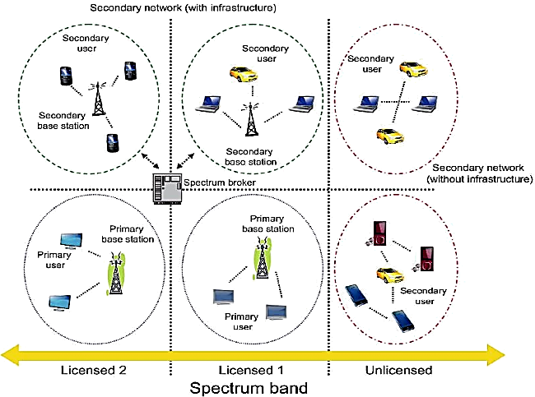
Figure 1: Cognitive radio network topology [11]
2.0 Review of Related Literature
Junhui and Tao present the power control of CR under the constraints of transmitter power and interference temperature. They anticipated interference limitations, which ensured that the quality of service and non-cooperative power control models of the PUs were considered [12]. Lu Yang investigated the multiuser diversity of uplink MIMO cognitive radio networks and recommends a two-stage opportunistic user scheduling scheme [13]. Wenhao Xiong studied user selection approaches for the downlink of multiple input and multiple output (MIMO) cognitive radio (CR) networks. Underlay CR secondary users were chosen by CBS to share sub-channel with PUs [14]. Duoying Zhang posited that the spectrum sharing multiple-input multiple-output cognitive interference channel, in which multiple PUs coexist with multiple SUs. An interference alignment (IA) approach was introduced that guarantees that secondary users access the licensed spectrum without causing harmful interference to the PUs. Numerical results indicated that the suggested designs increase the achievable degree of freedom (DoF) of the primary links and offer a considerable sum rate for both secondary and primary transmissions under the rank limitations [15]. Junhui and Qiping projected an optimization algorithm that combines diverse spectrum shared bandwidth and power allocation in CR. The state of the CU can be switched between the Underlay spectrum sharing model and the Overlay spectrum sharing model [16]. Cui & Gao considered supportive spectrum sensing, which is a vital issue in CR. The performance of the spectrum sensing algorithm suggested in the paper was significantly better than the current algorithms. In addition, multiple PUs was considered simultaneously [17]. Sidhu and Gao investigated the resource allocation problem in relay-assisted OFDM CRNs. Via combined subcarrier pairing and power allocation, the throughput of the Secondary user was maximized. Simultaneously, the interference from the secondary source and SRN to the primary receiver is kept within acceptable limits. The authors also developed a sub-optimal resource allocation algorithm to decrease computational complexity. When compared with ordinary resource allocation algorithms, the simulation results showed enhanced performance [18]. Lu and Wang suggested an FD opportunity spectrum-sharing protocol that act when the main system encounters weak channel conditions. The authors researched on the joint optimization of subcarriers and power allocation in order to take full advantage of the transmission rate of the secondary system while ensuring that the primary system reached its target rate. The simulation results support that secondary spectrum access schemes can benefit both primary and secondary systems [19].
Summarily, Table 1 surveys the limitations of some of the existing works and my contributions in this paper to ﬁll the knowledge gap. I believe this paper will give readers a broad view of what CR is, clearly stating it topology, Spectrum sensing techniques, applications, formulation Problem, benefits, challenges and other features play a vital role in the field of cognitive wireless networks (CWN) communication system. In conclusion, this paper delivers a future viewpoint of what needs to be done to expedite this desirable generation of wireless communication.

Table 1. Limitations of some added related works and contributions.

Ref. | Focus and Coverage | Limitations | This Paper’s Contributions
20  21  22  23  24  25  26  27 | Presented the fundamental concept about CR technology and CR capability functions.  Challenges and security issues of CR networks were discussed.  To explore application of using CR technology in machine to machine communication.  The study present basic theory and Key Technologies in CWN.  Issues from network architecture to multi-dimension sensing technologies and radio resource management.  Introduce the fundamental of CRN.  Architecture of a CRN and applications.  Provide a study on the recent advances and applications of  CR in various domains, such as military emergency response, communication, and commercial  communication.  The authors provides a brief overview on operation, principles, architecture and  security of CR.  Methods and practices in CRN to improve the performance of the CRN. Various models and schemes in Cross Layer and Design Network environment.  Reviewed CR technology and its numerous  Features.  Roles in the field of next generation wireless communication networks. | Challenges with enabling technology were not properly stated .  Applications were not clearly outlined.  Related literature not emphasized.  Limited practical applications of CR were presented.  Future focus not presented.  Problem of selecting a suitable frequency band as the working spectrum channel of the testbed.  Future Research Directions not clearly outlined.  Applications not clearly itemized.  Challenges with supporting  technologies are not  clearly defined.  Methods not presented.  Applications not clearly outlined.  Future Research guidelines not outlined.  No clear application presented.  Challenge with each supporting technology not well presented.  Importance of concept not stated.  No connecting related works outlined.  Challenges with methods and model if any not stated.  No cohesion between the abstract and the conclusion.  Enabling technologies were discussed, but no clearly outlined challenges.  Future focus directions not presented. | Clear understanding of CR technology.  Its role in national development.  Future focused - Security issues and efficient spectrum management challenges.  Present detail survey on machine to machine communication.  Analyze the diﬀerence between conventional and CR Machine to Machine wireless communication system.  Purpose of the research well presented.  Discussion on Flexible network architecture, cognition of multi-dimension environment, and discretionary resource management were presented as key technologies to make CWN a reality.  Challenge with each supporting  technology presented.  Architecture of a CRN discussed.  Security challenges extensively  discussed.  Enabling technologies clearly outlined.  Clearly outlined key principles of CR.  Applications were presented.  Architecture of a CRN well discussed.  Overview on security threats, including physical, link, network  and transport layer attacks is presented Future research focus clearly outlined.  Performances in Cross Layer networks and solution well outlined.  Needed resources clearly outlined.  Problems and solution clearly stated.  Future focus stated.  Spectrum sensing techniques in CR were mentioned.  Cyclostationary detection is the best  spectrum sensing technique, it senses a spectrum even in low SNR

3.0 Three Major Tasks of the CR

(i) Radio-scene analysis,
(ii) Channel identification, and
(iii) Dynamic spectrum management and transmit-power control. [28]:

Radio-scene analysis implemented in the receiver consist of the estimation of interference temperature of the surrounding radio environment of the receiver, predictive modeling of the environment and detection of spectrum holes. The Channel identification implemented in the receiver is required for coherent detection of message signal vis-a-vis for improving the spectrum utilization. Lastly, dynamic spectrum management and transmit-power control implemented in the transmitter make decision on the transmission parameters from the information made available by the radio-scene analysis and channel identification.

4.0 Fundamental Cognitive Radio Cycle (CRC)
The basic functions of CR are Spectrum Sensing, Spectrum mobility, Spectrum management and Spectrum Sharing. The CR technology has some basic functions and these functions help users in the following ways:
(i) Spectrum sensing - to detect the part of the spectrum that is free and detect the presence of licensed users when a user is active in a licensed band. It is the first and fundamental function of a cognitive radio; unused portions of spectrum are used opportunistically upon detection.
(ii) Spectrum management - to select the best available channel. When spectrum holes are detected, the CR must have the capability to select the channel that matches its communication requirements.
(iii) Spectrum sharing - to organize access to this channel with other users. In a CR network, there must an algorithm scheduled to ensure that all the cognitive radios get an impartial chance to use the spectrum.
(iv) Spectrum mobility - to free the channel when a licensed user is detected. Since the CR is given a lower importance, they should be able to interrupt their communication when a licensed user comes back and seamlessly move onto another free channel [1]. Figure 2 shows a Cognitive radio cycle. [23]
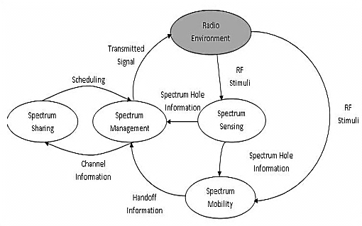
Figure 2 Cognitive Radio Cycle
The CR can also be consider as a continuous process consist of the following steps
(i) Sensing,
(ii) Understanding,
(iii) Deciding
(iv) Adapting
As shown in Figure 3. CR exploits this cycle in a way that the spectrum is the main figure to be sensed, and all the subsequent process focuses also on how to handle the spectrum based on the observations. [28]
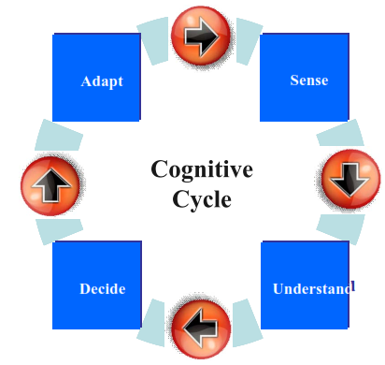
Figure 3. Generic CRC.
The CC containing the cognitive tasks is shown in Figure 4. The feedback channel between the receiver and the transmitter is the facilitator for intelligence in the CR. The feedback channel is required to transmit the following information [29]:
(i) The centre frequencies and bandwidths of the spectrum holes,
(ii) The combined variance of interference plus thermal noise in each spectrum hole,
(iii) The estimate of SNR for adaptive transmission.
Figure 4 shows a CC link where the transmitter and receiver are positioned in different CR devices. The CR devices are transceivers, the transmitter side includes a unit for radio scene analysis to sense the spectrum in the vicinity of the transmitter. Though, this sensing unit belongs to a different link and thus not shown in the figure.
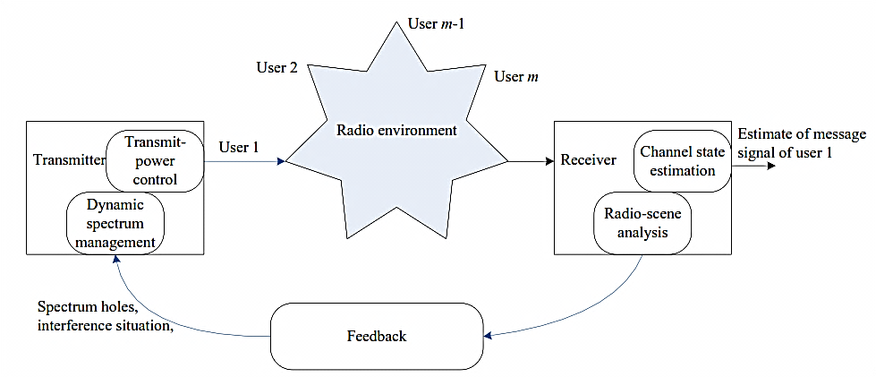
Figure 4. CC for cognitive radio link. [29]

If several SNs share one common spectrum band, their spectrum usage may be organized by a central network, called spectrum broker [30].
5.0 Spectrum Sensing Methods
CR is a key technology that allows the limited and inadequately used frequency bands to be used efficiently with an opportunistic method. Communication performance and stability in CR networks are highly dependent on whether the spectrum sensing function is performed correctly or not.
Spectrum sensing is a serious issue of CR technology because of the fading, time-varying nature of wireless channels and shadowing. To sense unused or limited frequency bands, several approaches for spectrum sensing have been suggested in the literature review. Examples are, cyclostationary-based sensing [31, 32], waveform based sensing [32], matched filtering [34, 35], eigenvalue-based sensing [36, 37], energy detection sensing [38–39] and wavelet-based sensing [40].
(i) Cyclostationary detection. Is a technique for detecting PU transmissions by taking advantage of the cyclostationary features of the received signals [41]. It uses the periodicity in the received primary signal to recognize the presence of PUs. By this, the detector can distinguish PU signals, SU signals or interference. Though, the performance of this detection technique rest on adequate number of samples, which increases the computational complexity. Performs well when compared to other detection schemes, because it has the ability of rejection of noise but has nonlinearity, spectral leakage of high amplitude signals and also high costs [42].
(ii) Waveform-based sensing. Used in systems with identified signal patterns. Such patterns comprise of preambles, midambles, regularly transmitted pilot patterns, and spreading sequences [43]. A preamble is an identified sequence transmitted before each burst and a midamble is transmitted in the middle of a burst or slot. In the case of a recognized model, the spectrum detection function is done by relating the received signal with a copy of itself.
(iii) Matched filtering detection. Matched filtering detection techniques with shorter detection periods are chosen if certain signal information, such as bandwidth, modulation type and grade, operating frequency, frame structure of the PU and pulse shape, are known [44, 45]. The detection performance of this technique basically rest on the channel reaction. To overcome this, it requires impeccable timing and synchronization in both physical and medium access control layers. However, if the PU information is delivered incorrectly to the matched ﬁlter detector, the sensing performance degrades rapidly. [46, 47]
(iv) Eigenvalue-based spectrum sensing. This does not require ample prior knowledge about the PU signals and noise power [48]. The concept of this detection technique was presented in 2007 [49]. In the eigen value-based spectrum detecting techniques, the decision threshold was obtained based on random matrix theory to make hypothesis testing. In order to know the presence or absence of the PU signal, the decision threshold is likened with the test statistic formed using the ratio of the maximum or average eigenvalue to the minimum eigenvalue. Nonetheless, having a high functioning complexity is a drawback of this technique [50, 51].
(v) Energy detection. Is a spectrum sensing technique based on measuring the received signal energy and deciding on the existence or absence of the PU by relating the received energy level with a threshold. The threshold function calculation depends on noise power [4652]. The threshold can be able to change or constant depending on the conditions of the channel. Though, this technique is inaccurate [53]
(vi) Wavelet transform. Is a great technique for analyzing singularities and edges. The frequency bands of interest are usually decomposed as a train of consecutive frequency sub-bands in the wavelet-based spectrum sensing technique [54]. Using wavelet transform, abnormalities in these bands are sensed and the spectrum decides whether it is full or empty.
In recent times, hybrid models in which two or more detection schemes are used collectively have been designed to improve spectrum sensing capability in a CRN. Artificial intelligence (AI) and machine learning algorithms (MLA) are widely used in hybrid models [55].
5.1 The Best Standard Spectrum Detection Techniques are:
(i) Cyclostationary feature detection
(ii) Energy detection
(iii) Matched filter detection

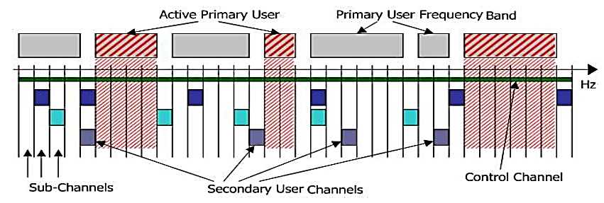
Figure 5: Spectrum pooling idea [56]
6.0 Features of the Cognitive Radio:
(i) Cognitive capability (CC) - The ability of the radio technology to sense the information from its radio surroundings. Via this, the parts of the spectrum that are inactive at a particular moment or place can be recognized, from which the best spectrum and suitable operating parameters can be selected.
(ii) Re-configurability (RC) - While the CC provides spectrum awareness, re-configurability helps the radio to be dynamically programmed in accordance with the radio environment. More precisely, CRs can be programmed to transmit and receive a broad range of frequencies and to utilize different transmission access technologies supported by their hardware, Figure 6. [9]
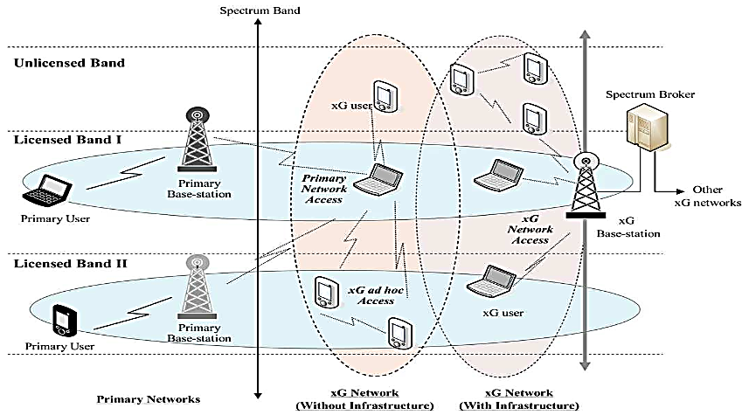
Figure 6: Cognitive radio network system [56].
6.1 Cognitive Radio (CR) and Software Defined Radio (SDR)
SDR is a type of radio having software defined physical layer functions. This is in dissimilarity to hardware radio, in which alterations in communications scheme may be realized via alterations to the hardware, otherwise by software that is programmed once in the factory and cannot be altered due to radio topological inflexibility. Cognitive radio enables adaptation and reconfiguration and is seen as the next phase in reconfiguration flexibility, after SDR. It will not be out of place to say that a cognitive radio is a software defined radio, where the software ensures the cognitive functioning of the radio. SDR is not necessarily a CR if it lacks cognition [57].
6.2 Spectrum Hole or White Space
Spectrum Hole or white space is nothing but the available free spectrum of primary user. It is shown in bellows Figure 7. The main challenge for cognitive radio systems is to sense spectrum when it lies within such a spectrum hole [58]. High Utilization of lower frequency band and lower utilization of higher frequency spectrum. This lower spectrum utilization is known as spectrum hole. CR searches the free frequency and allocate this frequency to spectrum utilization is termed as spectrum hole [16]
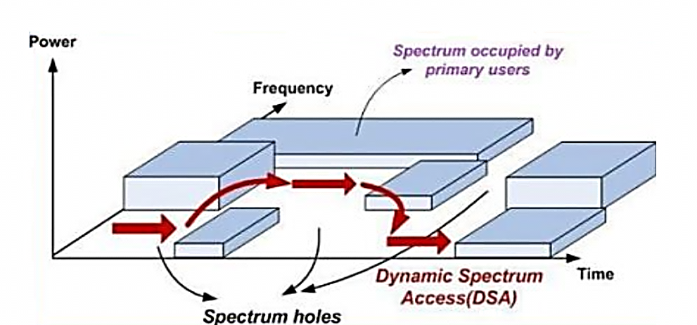
Figure 7: Spectrum hole (white space concept)
In another view a spectrum hole is deﬁned as a band of frequencies which are readily allocated to a PU, though; it may not be used always by the PU at a particular time or in a geographic area (see Figure 8), [28].
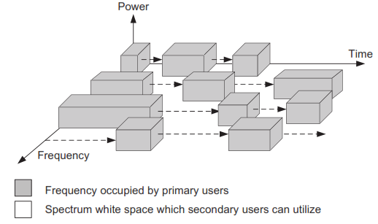
Figure 8: Example of a Spectrum Distribution Graph.
Subject to the communication environment, the spectrum holes can be identify via the following frequency and time or space as [59, 60]:
(i) Temporal spectrum hole. This is a frequency band that is not engaged by a PU for a period of time. Using cutting-edge spectrum sensing methods, an SU can sense spectrum holes and opportunistically access it without degrading the quality of service of the PU.
(ii) Frequency spectrum hole. The activities of the SU do not cause any destructive interference to the PUs.
(iii) Spatial spectrum hole. This is a speciﬁc geographic area where the PU transmission is being occupied. The SU can apply this band if it is outside this area (see Figure 9).
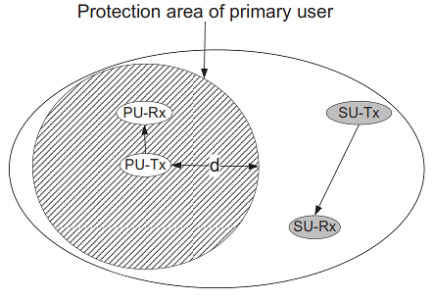
Figure 9: Spatial spectrum hole where SU is not allowed to function in the PU protection area.
In addition, spectrum holes can also be categories into so called spaces as follows [28]:
(i) Black spaces. This is where high power interferers control for some period of time.
(ii) Gray spaces. Low power interferers moderately control.
(iii) White spaces. Interferers don’t exist but natural noises such as broadband thermal noise and impulsive noise are present.
7.0 CR Characteristics
Cognitive abilities are the greatest diﬀerent characteristics of a CRN from wireless communication networks. These abilities permit a SU to detect the surrounding radio environment such as accessible frequency, noise power, interference temperature, distance, and so on. Subject to the collected information, the SU will take decisions on the selected frequency, transmit power level or modulation scheme, to get the best performance. CRN in practice should have the following characteristics during implementation [59]:
(i) The SU should take advantage of eﬃcient spectrum sensing and analysis methods so that the SU can sustain continuous spectrum and retain a reliable communication.
(ii) SU should share the spectrum information with other users and coordinate communication to cause negligible interference or no collisions to the PUs using the same frequency bands.
(iii) SU has to be equipped with uniﬁed cross-layer architecture in order to meet diﬀerent Quality of service demands.
(iv) SU should apply dynamic spectrum access methods which can adapt to the ﬂuctuating nature of the CRN.

7.1 Cooperative Spectrum Sensing (CSS)
Multi-path fading, shadowing and noise are natural features of wireless communications that aﬀect the received signal strength. For instance, if a PU is far-off from the SU, or the PU signal is obstructed by a big obstacle, the received signal may be low at the SU. Consequently, it is diﬃcult to accurately sense the presence of a PU. Figure 10 illustrates a situation in which the PU Tx is hidden by an obstacle such that the secondary transmitter (SU Tx) can’t sense the PU Tx signal. Thus, the SU Tx may cause destructive interference to the PU Rx, as it starts using the licensed spectrum to connect with the secondary receiver (SU Rx).
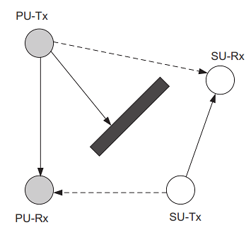
Figure 10: Example of a hidden PU where SU Tx can’t sense the presence of the PU Tx due to obstacle.
To avoid such glitches, CSS has been suggested [61, 62]. It has been revealed that the merits of spatial diversity and independent fading channels of multiple users in cooperative networks can be used to improve the detection probability and reduce the sensing time [63]. An example situation for CSS is shown in Figure 11. The SU Tx can sense the PU Tx via the help of two secondary relays (SRs), SR1 and SR2
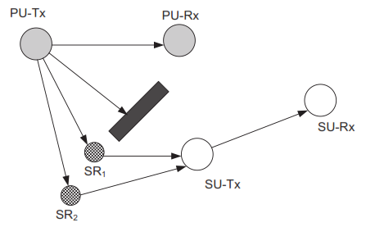
Figure 11: Two SRs support the SU Tx in detecting a hidden PU Tx.
7.2 Current State-of-the-Art Review on Spectrum Sharing in CRNs
We provide a review of the evolution of CR research covering different aspects of spectrum sharing, that is, spectrum sensing [64–77]; measurements and statistical modelling of spectrum usage [78–84]; PHY aspects such as waveform and modulation design [85–95]; multiple access, resource allocation and power control, and spectrum mobility [96–105]; cognitive learning, adaptation, and self-conﬁguration [106–117]; and multihop transmission and routing [118–123].
7.2.1 Spectrum sensing, interference modelling, measurements, and statistical modelling of spectrum usage:
Spectrum statistics are vital information for SUs to opportunistically access the spectrum of PUs. Thus, there is a need to study and comprehend the features and nature of spectrum usage by the PUs. To gain such information, the following matters are considered in the literature.
(i) Spectrum sensing: this is a primitive action for SUs to sense the status of spectrum access by PUs. Deprived of this information, the SUs may not access idle spectrum and therefore reduce the spectrum utilization or may cause interference to the PUs occupying the spectrum.
(ii) Interference modelling: SUs may observe interference on spectrum for two reasons.
(a) The SUs must certify that their transmission will not interfere and interrupt ongoing transmission of PUs.
(b) Given an interference condition, the SUs must access the spectrum such that their transmission requirements are satisﬁed. Interference modeling provides the SUs with the ability to achieve these goals. 64–77
(iii) Measurements and statistical modeling of spectrum usage: While spectrum sensing is a short-term action to observe the instantaneous status of the spectrum, spectrum measurement is done on a long-term basis (over a few months) to have knowledge and statistical data of PUs. This information is valuable for the SUs to determine their spectrum access scheme (access in a particular time of the day to minimize interference to the PUs) [78–84].
7.2.2 Waveform and modulation design for cognitive radios
In other to reduce interference to PUs, the design of waveform and modulation of signal from SUs can be optimized. Example, in an underlay spectrum access arrangement, the SU can use ultra-wideband transmission and regulate the pulse position and/or width to avoid interference to the narrowband transmission of the PUs. Likewise, in an overlay spectrum access arrangement, the SU adapts the multicarrier modulation for an orthogonal frequency division multiplexing (OFDM) based system to reduce interference. [124–126]
7.2.3 Multiple Access, Resource Allocation, Power Control and Spectrum Mobility
In a spectrum underlay scenario, the challenges of optimal spectrum sharing among SUs can be expressed as an optimization problem with an appropriate objective function and a set of constraints that capture user fairness, quality of service (QoS) of SUs, and interference constraints for PUs.
Note that the optimization problem may not be possible when its constraints are too stringent and/or the network load is too high. If this arises, an admission control mechanism needs to be used to limit the number of admitted SUs. At that point, the power allocation for the set of admitted SUs can be done. Using this background, in [99], a solution approach was suggested for the joint admission control and power allocation problem for SUs to achieve fairness among them, if CDMA technology at the PHY. To acquire the power allocation solutions, the instantaneous channel gains among SUs and interference from secondary transmitters (STs) to primary receivers (PRs) need to be estimated. In a practical scenario where only estimates of the average channel gains are available, the power allocations for the STs need to be done in a conservative manner to fulfill the target interference constraint violation probability for PRs [101]. The challenge of sum-rate maximization for STs under joint beam forming and power allocation in a CRN with multiple STs and PRs (each with one antenna) was investigated in [102]. A review on dynamic resource allocation arrangements for CR systems with the interference temperature based spectrum sharing model is found in [103]. To maximize the secondary network output, the transmission power, bit rate, bandwidth, and antenna beam can be dynamically allocated in accordance with the available CSI of the primary and secondary networks. Several new and challenging issues regarding the design of CR systems were formulated, and some of the corresponding solutions were shown to be accessible by restructuring some classic results known for traditional (non-CR) wireless networks.
8.0 Economics of Cognitive Radio Networks
In the CR system, pricing is a vital issue, which inspires the primary and secondary users to share the vacant spectrum through a process often called spectrum trading [127]. Spectrum trading is the mechanism for the entities in the CR system (e.g., primary and secondary users, spectrum owners and users, service providers and subscribers) to exchange radio resources. The exchange could be done via money or via different forms of resources (bartering). In spectrum trading, the primary users or service providers attempt to sell vacant spectrum resources to secondary users for monetary gains, and the secondary users attempt to buy these resources to achieve their desired communication goals. Two major approaches for spectrum trading are based on auction and open market.
8.1 Price Competition in the Open Market
Just like an auction, which requires an auctioneer to regulate the trading, in an open market model, the primary users and secondary users are allowed to sell and buy radio resources. Because there is no regulator, the pricing strategy of primary users plays a vital role, which determines the revenue made by the primary users. Moreover, pricing inﬂuences the choices of the secondary users to buy the radio resource. A competitive pricing scheme based on a noncooperative game among multiple primary networks was proposed in [128]. In most general situations, spectrum trading in a CR system may include multiple spectrum sellers and buyers. In [129], the writers developed a spectrum trading structure for this general spectrum trading situation (Figure 12).
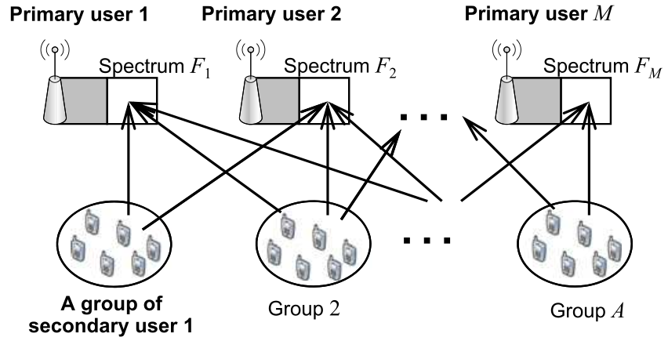
Figure 12. Spectrum trading in CR with multiple spectrum sellers and buyers [129].
9.0 Problem Formulation
The following problems were identified in the review. First, the problem of optimization that occurred during the transmission of data, the complexity problem on multiple cognitive base station (CBS) and PU. Others are the interference channel scenario with multiple CBSs and PUs; primary and secondary cognitive base station and User problem, and the transmission rank problem on many users [130].
9.1 Implementation Challenges
Implementation of a CR is a thought-provoking task. CR should familiarize transmission and reception to avoid interference with PUs. There are many techniques that can be deployed to avoid interferences and combine frequency tuning [131], they are:
(i) Adaptive frequency hopping
(ii) Dynamic frequency selection
(iii) RF band switching
Other challenges of CRN are to monitor the surroundings and then attain the resources logically based on practices. There are three important challenges in implementing a Cognitive Radio, [132] they are:
(i) RF front end-transceiver challenges
(ii) ADC and DAC challenges
(iii) Baseband challenges
Cognitive radio has to face very challenging issues to perform sustainable communication.
9.2 The Technical Challenges Are:
According to [133], CR has to face very challenging issues to carry out viable communication. The challenges are designing the RF- front end, ADC/DAC performance and flexible, and to make it able to support flexible wideband multiband communication. Spectrum sensing, channel estimation, modulation and coding, spectrum shaping, transmit power control, interference avoidance and the ability to sense, discover, negotiate, and transfer
9.3 Security Challenges in CRNs
Security and privacy are essential problems right from the inception of the information era. There is a precise security system, consisting of security mechanisms, security attacks, and security requirements /services, to define, study, and evaluate security challenges in a systematic way.
In any wireless communication security is an essential aspect. In a traditional wireless network, security attacks are the greatest problematic one. There are two main types of security issues in CRN [134], they are:
(i) Traditional security threats
(ii) CRN- Specific threats
The categorizations of security attacks in CRN are Infrastructure based and Infrastructure less CRN specific attacks.
9.3.1 Infrastructure Based CRN Attack. It is time consuming and costly. The CRNs will practically be adjusted towards frequency bands with second importance spectrum stability. There are several attackers in the infrastructure based CRN, they are:
(i) IE (Incumbent Emulation)
(ii) Control channel jamming
(iii) SSDF (Spectrum Sensing Data Falsification)
9.3.2 Infrastructure–Less CRN Specific Attacks. Consist of three major attackers, they are:
(i) Intruding Attacker
(ii) Exogenous Attacker
(iii) Jamming
(i) Intruding Attackers
Ad-hoc CRNs are susceptible to intruding challenger nodes attack which can access the system and pushing as authorized nodes. This unpleasant node can influence the overall spectrum sensing decision of CRN. This type of CRN security issue is called SSDF.
SSDF stands for Spectrum Sensing Data Falsification. This attack causes perpetual reporting of a busy channel. To identifying this attack is very difficult.
(ii) Exogenous Attacker. It is not a portion of the CRN and thus not part of the CRN’s spectrum detecting resolution. This attacker can interrupt the process of the ad-hoc CRN.
(iii) Jamming. It is the most used attack on wireless transmissions. It decreases the received SNR below the desired threshold by transmitting noise over the receiving channel [135].
9.3.3 Other security challenges are:
(i) Confidentiality: Unauthorized disclosure of transmitted information from passive attacks, such as eavesdropping is prevented. Prevention is realized by deploying ciphers and encrypting the data to be transmitted with a secret key which is shared only with the recipients.
(ii) Integrity: Illegally modified of transmitted information is prevented. Modification includes changing, creating, deleting, replaying transmitted messages or delaying.
(iii) Authentication: Authentication prevents unapproved users from gaining access to protected systems. It is a necessary procedure for verifying both identity and authority.
(iv) Non-repudiation: It ensures that neither the sender nor the receiver of a message is able to refute the transmission. In CRN configuration, when malicious CRUs violating the protocol are recognized, non-repudiation techniques can be used to prove the misbehavior and ban the malicious users from the SN.
(v) Availability: The network services should be available to devices and applications through communication links. In CRNs, availability denotes the ability of PUs and CRUs to access the spectrum. For PUs, availability denotes being able to transmit in the licensed band without harmful interference from the CRUs. [135]
10.0 Benefits of Cognitive Radio
The following are some of the benefit of CWN
(i) Implementation cost is low
(ii) It increases link reliability
(iii) Less in complexity.
(iv) Overcome radio spectrum scarcity
(v) It has easy network topology.
(vi) It offers better spectrum utilization and efficiency.
(vii) Uses modern network topology.
(viii) Configuration and upgrade are easy.

11.0 Areas for Future Consideration
CR technology has many areas for future investigations which can be consider to better understand the behaviour of the user detection. Under listed are some of these areas:
(i) Cooperative approach for detecting and isolating intruders.
(ii) Assessment of denial-of-service (DoS) attack scenarios and methods for defense.
(iii) Implementation of hybrid sensing approach.
(iv) Consideration of multiple attackers’ defense mechanism.
(v) Investigations to introduce capable preventive techniques to mitigate threats and attacks that CR networks face.
(vi) Using Cyclostationary detectors which employ second-order signal structure.

12.0 CR STANDARDIZATION
The IEEE 802.22 and SCC 41 are known as the primary CR standards today. They are also the finished standards of interest for Cognitive Radio [136]. Though, there are also several other standards being established. IEEE created the 802.22 Working Group (WG) for WRANs in November, 2004. WG was assigned to improve an air interface (i.e., PHY and MAC) based on CRs for unlicensed operation in the TV broadcast bands. The focus of 802.22 is on rural broadband wireless access and its coverage distance is substantially larger than that of the IEEE 802.16 [137]. A brief survey of the different standardization efforts is provided in the following.
12.1. IEEE 802.22
A summary of the 802.22 architecture (e.g., entities, connections and topology), its requirements (e.g., service coverage, MAC layer details and service capacity,), applications, and coexistence problems (e.g., TV, antenna, and wireless microphone protection and sensing) was provided in [138,139]. In North America, frequency band of operation of the IEEE 802.22 networks is 54–862 MHz. The standard shall accommodate numerous international TV channel bandwidths of 6, 7, and 8 MHz. The IEEE 802.22 systems have a ﬁxed point to multipoint air interface. The base station regulates the consumer premise equipments (CPEs).
12.2. IEEE 1900–SCC41-DYSPAN
IEEE Standard Coordinating Committee 41 (SCC41), previously known as the IEEE 1900 task force [140], was created by the IEEE to work in the area of dynamic spectrum access (DSA) networks for CR standardization. The IEEE SCC41 is divided into four WGs termed as 1900.x, “x” being the WG. In 2010, the SCC41 was consulted by the IEEE Communications Society Standards Board (CSSB) and was retitled as IEEE DYSPAN-SC.
IEEE P1900.1 (Terminology and Concepts for Next Generation Radio Systems and Spectrum Management): This standard was developed to create a glossary of vital CR terms and ideas related to policy-deﬁned radio, spectrum management, SDR, adaptive radio, and interconnected technology and also compare different technologies and their capabilities [141].
IEEE P1900.2 (Recommended Practice for Interference and Coexistence Analysis): The 1900.2 WG endorses interference analysis criteria and develops a system for measuring and analyzing the interference. This standard delivers an organized way of analyzing interference and coexistence.
IEEE P1900.3 (Dependability and Evaluation of Regulatory Compliance for Radio Systems with DSA): At the software side, the 1900.3 WG is developing test techniques for appraising SDR devices. The main goal is to attest the coexistence and compliance of the software modules for CR devices before certifying ﬁnal devices.
IEEE P1900.4 (Architectural Building Blocks Enabling Network-Device Distributed Decision Making for Optimized Radio Resource Usage in Heterogeneous Wireless Access Networks): This standard is for radio schemes with multiple RATs [142, 143]. The end terminal users are considered to be supporting multiple RATs and with some Cognitive Radio abilities such as ﬂexible operations in different frequency bands. The IEEE 1900.4 deﬁnes reconﬁguration management entities, which help in choice making at the terminal and network sides.
12.3 International Telecommunication Union standardization
The International Telecommunication Union (ITU) Radio communication sector (ITU-R) study Group 8 (Radio Determination, Mobile, Related Satellite Services and Amateur) deals with standardization of CRNs. The ITU-R study Group 8 published two reports on SDR [144, 145]. The reports focused on the uses of SDR in International Mobile Telecommunications-2000 (IMT-2000) technology. IMT-2000 systems are the third generation mobile systems, which give access to a wide range of telecommunication services, sustained by the ﬁxed telecommunication networks (e.g., PSTN/ISDN/IP), and to other services, which are particular to mobile users. The Software Defined Radio technology is used in the base station and the controllers of a mobile radio access network to raise the ﬂexibility of radio access networks.

Conclusion
CR signifies a new model for designing intelligent wireless networks to alleviate the spectrum scarcity problem and make available signiﬁcant gain in spectrum efﬁciency. We have delivered a comprehensive review of the research activities in Cognitive radio. The major problems in the design of Cognitive radio communication networks have been discussed (e.g., spectrum sensing, dynamic spectrum access (DSA), applications, and standardization), and the related work in the literature reviewed. First, the history of the CR was provided as a motivation for the dynamic and efﬁcient next generation wireless systems. The various methods of spectrum sharing in CR were reviewed. The security and economic problems also discussed. The future research focuses have been discussed and open research issues have been outlined. Also, some of the standardization activities associated with CR were summarized.
References
[1] Mitola, J. (2000). Cognitive Radio: An integrated agent architecture for software-defined radio. PhD dissertation, KTH Royal Institute of Technology, (Sweden, 2000)
[2] Hung, T. (2013). Performance Analysis of Cognitive Radio Networks with Interference Constraints. School of Computing. Publisher: Blekinge Institute of Technology, SE-371 79 Karlskrona, Sweden. Printed by Printfabriken, Karlskrona, Sweden 2013
[3] Deng, R, Chen J, Cao, X, Zhang, Y., Mahajan, S. and Gjessing S. Sensing-performance tradeoff in cognitive radio enabled smart grid. IEEE Transactions on Smart Grid 2013; 4(1): 302–310.
[4] Huang J, Wang H, Qian Y, Wang C. Priority-based trafﬁc scheduling and utility optimization for cognitive radio communication infrastructure-based smart grid. IEEE Transactions on Smart Grid 2013; 4(1):78–86.
[5] Zhang Y, Yu R, Nekovee M, Liu Y, Xie S, Gjessing S. Cognitive machine-to-machine communications: visions and potentials for the smart grid. IEEE Network 2012; 26(3): 6–13.
[6] Wu SH, Chao HL, Ko CH, Mo SR, Jiang CT, Li TL, Cheng CC, Liang CF. A cloud model and concept prototype for cognitive radio networks. IEEE Wireless Communications 2012; 19(4): 49–58.
[7] Abu, B., Soumik, G., Ashok, K., & Magdy, B. (2007). A Cognitive Radio Perspective for Next Generation (XG Communication, IEEE CIRCUITS AND SYSTEMS MAGAZINE, 2007.
[8] LIU, X., & ZHONG, W. (2015). Optimization and Performance Analysis for Bandwidth Spectrum Sensing in Cognitive Radio. Journal of Southwest Jiaotong University, 50 (1). Available from http://jsju.org/index.php/journal/article/view/191
[9] PREET, A., & KAUR, A. (2014). Cognitive Radio Networking and Communications. International Journal of Computer Science and Information Technologies, 5 (4), pp. 5508-5511.
[10] Bakare, B.I., & Okolie, E.E. (2022). A Review of Cognitive Radio (CR) Technology Application, Prospect and Challenges. European Journal of Advances in Engineering and Technology, 2022, 9(1):1-5
[11] [50] Popoola, J., & Van, R. (2011). Application of neural network for sensing primary radio signals in a cognitive radio environment, in IEEE Africon ’11, Livingstone, 13–15 September 2011. https://doi.org/10.1109/AFRCO N.2011.6072009
[12] Junhui Z., Tao, Y., & Yi, G. (2013). Power Control Algorithm of Cognitive Radio Based on Non-Cooperative Game Theory [J]. China Communications, vol. 10, no. 11, pp. 143-154, 2013.
[13] Lu, Y. (2014). “Opportunistic User Scheduling In Mimo Cognitive Radio Networks” IEEE International Conference on Acoustic, Speech and Signal Processing (ICASSP)- 2014.
[14] Wenhao, X. (2016). “MIMO Cognitive Radio User Selection with and without Primary Channel State Information” IEEE-2016.
[15] Duoying, Z. (2016). “Rank-Constrained Beamforming for MIMO Cognitive Interference Channel” Hindawi Publishing Corporation Mobile Information Systems Volume 2016
[16] Junhui, Z., Qiping, L., & Yi, G. (2018). Joint Bandwidth and Power Allocation of Hybrid Spectrum Sharing in Cognitive Radio[C]// IEEE 87th Vehicular Technology Conference (VTC Spring), 2018.
[17] Cui, T., Gao, F., & Nallanathan, A. (2011). Optimization of Cooperative Spectrum Sensing in Cognitive Radio[J]. IEEE Transactions on Vehicular Technology, vol. 60, no. 4, pp. 1578-1589, 2011.
[18] Sidhu, G. A. S., Gao, F., & Wang, W. (2013). Resource Allocation in Relay-Aided OFDM Cognitive Radio Networks[J]. IEEE Transactions on Vehicular Technology, vol. 62, no. 8, pp. 3700-3710, 2013.
[19] Lu, W., & Wang, J. (2014). Opportunistic Spectrum Sharing Based on Full-Duplex Cooperative OFDM Relaying. IEEE communications letters, vol. 18, no. 2, pp. 241-244, 2014.
[20] Oladele, R. O., & Damilola, N. A. (2019). Contemporary Issues in Cognitive Radio Network Anale. Seria Informatica. Vol. XV fasc. 2 – 2017 Annals. Computer Science Series. 15th Tome 2nd Fasc. – 2017
[21] Negasa, B. T., & Habib, M. H. (2018). Review on Cognitive Radio Technology for Machine to Machine Communication. ICST Institute for Computer Sciences, Social Informatics and Telecommunications Engineering 2018 F. Mekuria et al. (Eds.): ICT4DA 2017, LNICST 244, pp. 347–355, 2018. https://doi.org/10.1007/978-3-319-95153-9_31
[22] Ying, X., Zhiyong, Feng., & Ping, Z. (2012). Research on Cognitive Wireless Networks : Theory, Key Technologies and Testbed. CROWNCOM 2011, June 01-03, Osaka, Japan Copyright © 2012 ICST https://doi.org/10.4108/icst.crowncom.2011.245826
[23] Pooja, A., Nidhi, J., & Mahima, K. (2014). Cognitive Radio: A Review. International Journal of Engineering Research & Technology (IJERT) NCETECE`14 Conference Proceedings ISSN: 2278-0181
[24] Ayushi, & Priyanka, J. (2023). Methods for Detecting Energy and Signals in Cognitive Radio: A Review. International Research Journal of Engineering and Technology (IRJET). Volume: 10 Issue: 04 | Apr 2023.
[25] Nikita, T., Archana, I., Karishma, R., & Madhura, T. (2015). Cognitive Radio Network – A New Paradigm in Wireless Communication. International Journal of Computer Applications (0975 – 8887) National Conference on Role of Engineers in Nation Building (NCRENB-15)
[26] Rushabh, M. (2016). Cognitive Radio Networks Issues and Solutions. https://www.researchgate.net/publication/311949773.
[27] Nandhakumar, P., & Arun, K. (2017). A Review on Cognitive Radio for Next Generation Cellular Network and its Challenges. American Journal of Engineering and Applied Sciences 2017, 10 (2): 334.347 https://doi.org/10.3844/ajeassp.2017.334.347.
[28] Haykin, S. (2005). “Cognitive radio: Brain-empowered wireless communications,” IEEE Journal on Selected Areas in Communications, vol. 25, pp. 201–220, February 2005.
[29] S. M. Haykin, Cognitive radio and radio networks. INFWEST seminar in Helsinki, 27-28 June 2007.
[30] Raman, C., Yates, R. D., & Mandayam, N. B. (2005). “Scheduling variable rate links via a spectrum server,” in Proc. IEEE Symp. New Frontiers in Dynamic Spectrum Access Networks (DySPAN), Baltimore, MD, Nov. 2005, pp. 110–118.
[31] Urriza, P., Rebeiz, E., & Cabric, D. (2013). Multiple antenna cyclostationary spectrum sensing based on the cyclic correlation signiicance test. IEEE J. Sel. Areas Commun. 31(11), 2185–2195 (2013). https://doi.org/10.1109/JSAC.2013.131118.
[32] Li, Y., & Jayaweera, S. (2013). Dynamic spectrum tracking using energy and cyclo stationarity-based multi-variate non-parametric quickest detection for cognitive radios. IEEE Trans. Wirel. Commun. 12(7), 3522–3532 (2013). https://doi.org/10.1109/TW.2013.060413.121814
[33] Iqbal, M., & Ghafoor, A. (2012). Analysis of multiband joint detection framework for waveform-based sensing in cognitive radios, in 2012 IEEE Vehicular Technology Conference (VTC Fall) (3–6 September 2012), pp. 1–5. https://doi.org/10.1109/VTCFa ll.2012.6399372
[34] Proakis, J., & Salehi, M. (2007). Digital Communications, 5th edn. (McGraw-Hill, Boston, 2007).
[35] Tandra, R., & Sahai, A. (2005). Fundamental limits on detection in low SNR under noise uncertainty, in 2005 International Conference on Wireless Networks, Communications and Mobile Computing (13–16 June 2005), pp. 464–469. https://doi.org/10.1109/WIRLE S.2005.1549453
[36] Zeng, Y., Koh, C., & Liang, Y. C. (2008). Maximum eigenvalue detection: theory and application, in IEEE International Conference on Communications, ICC ’08 (19–23 May 2008), pp.4160–4164. https://doi.org/10.1109/ICC.2008.781
[37] Pillay, N., & Xu, N. (2012). Blind eigenvalue-based spectrum sensing for cognitive radio networks. IET Commun. 6(11), 1388–1396 (2012). https://doi.org/10.1049/iet-com.2011.0506
[38] Ruttik, K., Koufos, K., & Jantti, R. (2009). Detection of unknown signals in a fading environment. IEEE Commun. Lett. 13(7), 498–500 (2009). https://doi.org/10.1109/LCOMM.2009.090169
[39] Herath, S., Rajatheva, N., Tellambura, C. (2011). Energy detection of unknown signals in fading and diversity reception. IEEE Trans. Commun. 59(9), 2443–2453 (2011). https://doi.org/10.1109/TCOMM.2011.071111.090349
[40] Lu, L., Zhou, X., Onunkwo, U., & Li, G. (2012). Ten years of research in spectrum sensing and sharing in cognitive radio. EURASIP J. Wirel. Commun. Netw. 1–16, 28 (2012). https://doi.org/10.1186/1687-1499-2012-28
[41] Rao, S.V.R.K., & Singh, G. (2012). Wavelet-based spectrum sensing techniques in cognitive radio. Procedia Eng. (2012). https://doi.org/10.1016/j.proeng.2012.06.111
[42] Mohapatra, S., Mohapatra, A.G., & Lenka, S.K. (2013). Performance evaluation of cyclostationary based spectrum sensing in cognitive radio network proceedings of the International Multi-Conference on Automation, Computing, Communication, Control and Compressed Sensing, Mar. 22-23, IEEE Xplore Press, pp: 90-97. https://doi.org/10.1109/iMac4s.2013.6526389
[43] Gardner, W.A. (1999). Exploitation of spectral redundancy in cyclostationary signals. IEEE Signal Process. Mag. 8(2),14–36 (1991). https://doi.org/10.1109/79.81007
[44] Yucek, Y., & Arslan, H. (2009). A survey of spectrum sensing algorithms for cognitive radio applications. IEEE Commun. Surv. Tutor. 11(1), 116–130 (2009)
[45] Ma, L., Li, Y., & Demir, A. (2012). Matched filtering assisted energy detection for sensing weak primary user signals, in IEEE International Conference on Acoustics, Speech, and Signal Processing (ICASSP), 25–30 March 2012, pp. 3149–3152. https://doi.org/10.1109/ICASSP.2012.6288583
[46] Zeng, Y., & Liang, Y.-C. (2009). “Spectrum-sensing algorithms for cognitive radio based on statistical covariances,” IEEE Trans. Veh. Technol., vol. 58, no. 4, pp. 1804–1815, May 2009.
[47] Zeng, Y., & Liang, Y.-C. (2007). “Covariance based signal detections for cognitive radio,” in Proc. IEEE International Symposium on New Frontiers in Dynamic Spectrum Access Networks, Dublin, Ireland, Apr. 2007, pp. 202–207.
[48] Zhang, X., Chai, R., & Gao, F. (2014). Matched filter based spectrum sensing and power level detection for cognitive radio network, in IEEE Global Conference on Signal and Information Processing (Global SIP), Atlanta, 3–5 December 2014, pp. 1267–1270. https://doi.org/10.1109/GlobalSIP.2014.7032326
[49] Tsinos, C.G., & Berberidis, K. (2015). Decentralized adaptive eigenvalue-based spectrum sensing for multiantenna cognitive radio systems. IEEE Trans. Wirel. Commun. 14(3), 1703–1715 (2015). https://doi.org/10.1109/TWC.2014.2372756
[50] Zeng, Y., Koh, C. L., & Liang, Y. C. (2008). Maximum eigenvalue detection: Theory and application, in 2008 IEEE International Conference on Communications (ICC ’08), 19–23 May 2008, pp. 4160–4164. https://doi.org/10.1109/TCOMM.2009.06.070402
[51] Atapattu, S. (2011). Energy Detection based cooperative spectrum sensing in cognitive radio networks. IEEE Trans. Wirel. Commun. 10(4), 1232–1241 (2011). https://doi.org/10.1109/TWC.2011.01241 1.100611
[52] Digham, F. F., Alouini, M. S. & Simon, M. k. (2007). On the energy detection of unknown signals over fading channels. IEEE Trans. Commun. 55(1), 21–24 (2007). https://doi.org/10.1109/TCOMM .2006.887483
[53] Sansoy, M., & Buttar, A. (2015). Spectrum sensing algorithms in cognitive radio: A survey. Proceedings of the IEEE International Conference on Electrical, Computer and Communication Technologies, Mar. 5-7, IEEE Xplore Press, pp: 1-5. https://doi.org/10.1109/ICECCT.2015.7226181
[54] Gorcin, A., Qaraqe, K.A., Celebi, H., & Arslan, H. (2010). An adaptive threshold method for spectrum sensing in multi-channel cognitive radio networks, in 17th International Conference on Telecommunications (ICT’10), Doha, 4–7 April 2010, pp. 425–429. https://doi.org/10.1109/ICTEL .2010.54787 83
[55] Zhi, T., Giannakis, G. (2006). A wavelet approach to wideband spectrum sensing for cognitive radios, in 2006 1st International Conference on Cognitive Radio Oriented Wireless Networks and Communications, 8–10 June 2006, pp. 1–5. https://doi.org/10.1109/CROWN COM.2006.36345 9
[56] Mahamuni, S.M., Vivekanand, M., Wadhai, V.M. (2010). Cognitive Networks: Smart Network. Journal of Engineering Research and Studies. JERS/Vol.I/ Issue II/Oct.-Dec.,2010/121-134
[57] Brown, T. X. (2005). “An analysis of unlicensed device operation in licensed broadcast service bands,” in Proc. IEEE DySPAN 2005, pp. 11–29, Nov. 2005.
[58] Wassim, E., Haidar, S., & Mohsen, G. (2011), Survey of Security Issues in Cognitive Radio Networks, Journal of Internet Technology Volume 12 (2011) No.2
[59] Ma, J., Li, G., & Juang, B. H. (2009). “Signal processing in cognitive radio,” Proc. IEEE, vol. 97, no. 5, pp. 805–823, May 2009.
[60] Tandra, R., Sahai, A., & Mishra, S. (2009). “What is a spectrum hole and what does it take to recognize one?” Proc. IEEE, vol. 97, no. 5, pp. 824–848, May 2009.
[61] Letaief, K. B., & Zhang, W. (2009). “Cooperative communications for cognitive radio networks,” Proc. IEEE, vol. 97, no. 5, pp. 878–893, May 2009.
[62] Ghasemi, A., & Sousa, E. (2005). “Collaborative spectrum sensing for opportunistic access in fading environments,” in Proc. IEEE International Symposium on New Frontiers in Dynamic Spectrum Access Networks, Baltimore, U.S.A., Nov. 2005, pp. 131–136.
[63] Ganesan, G., & Li, Y. (2007). “Cooperative spectrum sensing in cognitive radio, part I: Two user networks,” IEEE Trans. Wireless Commun., vol. 6, no. 6, pp. 2204–2212, Nov. 2007
[64] Yucek T, Arslan H. A survey of spectrum sensing algorithms for cognitive radio applications. IEEE Communications Surveys and Tutorials 2009; 11(1): 116–130.
[65] Zeng Y, Liang YC, Hoang AT, Zhang R. A review on spectrum sensing for cognitive radio: Challenges and solutions. EURASIP Journal on Advances in Signal Processing 2010; 2010. Article ID 381465.
[66] Sutton PD, Nolan KE, Doyle LE. Cyclostationary signatures in practical cognitive radio applications. IEEE Journal on Selected Areas in Communications 2008; 26(1): 13–24.
[67] Molisch AF, Shaﬁ M, Greenstein LJ. Propagation issues for cognitive radio. Proceedings of the IEEE, Special Issue on Cognitive Radio 2009; 97: 787–804.
[68] Ghasemi A, Sousa ES. Fundamental limits of spectrum-sharing in fading environments. IEEE Transactions on Wireless Communications 2007; 6(2): 649–658.
[69] Zeng Y, Liang YC. Eigenvalue based spectrum sensing algorithms for cognitive radio. IEEE Transactions Communications 2009; 57(6): 1784–1793.
[70] Mariani A, Giorgetti A, Chiani M. Effects of noise power estimation on energy detection for cognitive radio applications. IEEE Transactions on Communications 2011; 59(12): 3410–3420.
[71] Tandra R, Sahai A. SNR walls for signal detection. IEEE Journal of Selected Topics in Signal Processing 2008; 2(1): 4–17.
[72] Haykin S, Thomson D, Reed J. Spectrum sensing for cognitive radio. Proceedings of the IEEE, Special Issue on Cognitive Radio May 2009; 97(5): 849–877.
[73] Liang YC, Zeng Y, Peh ECY, Hoang AT. Sensing– throughput tradeoff for cognitive radio networks. IEEE Transactions on Wireless Communications 2008; 7(4): 1326–1337.
[74] Letaief KB, Zhang W. Cooperative communications for cognitive radio networks. Proceedings of the IEEE 2009; 97(5): 878–893.
[75] Ganesan G, Li Y. Cooperative spectrum sensing in cognitive radio, part I: two user networks. IEEE Transactions on Wireless Communications 2007; 6(6): 2204–2213.
[76] Ganesan G, Li Y. Cooperative spectrum sensing in cognitive radio, part II: multiuser networks. IEEE Transactions on Wireless Communications 2007; 6(6): 2214–2222.
[77] Unnikrishnan J, Veeravalli VV. Cooperative sensing for primary detection in cognitive radio. IEEE Journal of Selected Topics in Signal Processing 2008; 2(1): 18–27.
[78] Stuber GL, Almalfouh SM, Sale D. Interference analysis of TV-band white space. Proceedings of the IEEE 2009; 97(4): 741–754.
[79] Rabbachin A, Quek TQS, Shin H, Win MZ. Cognitive network interference. IEEE Journal on Selected Areas in Communications 2011; 29(2): 480–493.
[80] Roberson DA, Hood CS, LoCicero JL, MacDonald JT. Spectral occupancy and interference studies in support of cognitive radio technology deployment, In Proc. of First IEEE Workshop on Networking Technologies for Software Deﬁned Radio Networks, September 2006; 26–35.
[81] Datla D, Wyglinski AM, Minden GJ. A spectrum surveying framework for dynamic spectrum access networks. IEEE Transactions on Vehicular Technology 2009; 58(8): 4158–4158.
[82] Ghosh C, Pagadarai S, Agrawal D, Wyglinski AM. A framework for statistical wireless spectrum occupancy modeling. IEEE Transactions on Wireless Communications 2010; 9(1): 38–44.
[83] Wellens M, Mähönen P. Lessons learned from an extensive spectrum occupancy measurement campaign and a stochastic duty cycle model. Mobile Networks and Applications June 2010 2010; 15(3): 461–474.
[84] Canberk B, Akyildiz IF, Oktug S. Primary user activity modeling using ﬁrst-difference ﬁlter clustering and correlation in cognitive radio networks. IEEE/ACM Transactions on Networking 2011; 19(1): 170–183.
[85] Wei F, Xia P, Yang Z, Tian F. Decentralized waveform design for MIMO cognitive radio under interference temperature constraint, In Proc. of 2011 Second International Conference on Networking and Distributed Computing (ICNDC), September 2011; 159–162.
[86] Zhou LL, Zhu HB, Zhang NT. Iterative solution to the notched waveform design in cognitive ultra-wideband radio system. Progress In Electromagnetic Research 2007; 75: 271–284.
[87] Tian Z, Leus G, Lottici V. Joint dynamic resource allocation and waveform adaptation in cognitive radio networks, In Proc. of IEEE International Conference on Acoustics, Speech and Signal Processing (ICASSP 2008), April 4 2008-March 31 2008; 5368–5371.
[88] Chakravarthy V, Li X, Wu Z, Temple M, Garber F, Kannan R, Vasilakos A. Novel overlay/underlay cognitive radio waveforms using SD-SMSE framework to enhance spectrum efﬁciency—part i: theoretical framework and analysis in AWGN channel. IEEE Transactions on Communications 2009; 57(12): 3794–3804.
[89] Pagadarai S, Kliks A, Bogucka H, Wyglinski AM. On non-contiguous multicarrier waveforms for spectrally opportunistic cognitive radio systems, In Proc. of 2010 International Waveform Diversity and Design Conference (WDD), 8–13 August 2010; 177–181.
[90] Hu Z, Guo N, Qiu R. Wideband waveform design for relay cognitive network, In Proc. of IEEE Military Communications Conference (Milcom 2010), November 3-October 31 2010; 749–754.
[91] Hu Z, Guo N, Qiu R. Wideband waveform optimization for multiple input single output cognitive radio with practical considerations, In Proc. of IEEE Military Communications Conference (Milcom 2010), November 3-October 31 2010; 1227–1232.
[92] Kollar Z, Horvath P. Physical layer considerations for cognitive radio: Modulation techniques, In Proc. of 2011 IEEE 73rd Vehicular Technology Conference (VTC Spring), 15–18 August 2011; 1–5.
[93] Chen Y, Alouini MS, Tang L. Performance analysis of adaptive modulation for cognitive radios with opportunistic access, In Proc. of 2011 IEEE International Conference on Communications (ICC), 5–9 June 2011; 1–5.
[94] Zamanian M, Tadaion AA, Sadeghi MT. Modulation classiﬁcation of linearly modulated signals in a cognitive radio network using constellation shape, In Proc. of 2011 7th International Workshop on Systems, Signal Processing and their Applications (WOSSPA), 9–11 May 2011; 13–16.
[95] Khanzadi MR, Haghighi K, Panahi A, Eriksson T. A novel cognitive modulation method considering the performance of primary user, In Proc. of 2010 6th Conference on Wireless Advanced (WiAD), 27–29 June 2010; 1–6.
[96] Khoshkholgh MG, Navaie K, Yanikomeroglu H. Access strategies for spectrum sharing in fading environment: overlay, underlay and mixed. IEEE Transactions on Mobile Computing 2010; 9(12): 1780–1793.
[97] Tannious RA, Nosratinia A. Cognitive radio protocols based on exploiting hybrid ARQ retransmissions. IEEE Transactions on Wireless Communications 2010; 9(9): 2833–2841.
[98] Xing Y, Chandramouli R, Mangold S, Sankar N, S. Dynamic spectrum access in open spectrum wireless networks. IEEE Journal on Selected Areas in Communications 2006; 24(3): 626–637.
[99] Le LB, Hossain E. Resource allocation for spectrum underlay in cognitive wireless networks. IEEE Transactions on Wireless Communications 2008; 7(12): 5306–5315.
[100] Liang YC, Zeng Y, Peh ECY, Hoang AT. Sensing– throughput tradeoff for cognitive radio networks. IEEE Transactions on Wireless Communications 2008; 7(4): 1326–1337.
[101] Kim DI, Le LB, Hossain E. Joint rate and power allocation for cognitive radios in dynamic spectrum access environment. IEEE Transactions on Wireless Communications 2008; 7(12- part 2): 5517–5527.
[102] Zhang R, Liang Y-C. Exploiting multi-antennas for opportunistic spectrum sharing in cognitive radio networks. IEEE Journal of Selected Topics in Signal Processing 2008; 2(1): 88–102.
[103] Zhang L, Liang Y-C, Xin Y. Joint beamforming and power allocation for multiple access channels in cognitive radio networks. IEEE Journal on Selected Areas in Communications 2008; 26(1): 38–51.
[104] Zhang R, Liang Y-C, Cui S. Dynamic resource allocation in cognitive radio networks. IEEE Signal Processing Magazine 2010; 27(3): 102–114.
[105] Hossain E, Le L, Devroye N, Vu M. Cognitive radio: from theory to practical network engineering. In invited chapter in Advances in Wireless Communications, Tarokh V (ed.). Springer, 2009.
[106] Nie N, Comaniciu C. Adaptive channel allocation spectrum etiquette for cognitive radio networks, In Proc. of First IEEE International Symposium on Dynamic Spectrum Access Networks (DySPAN05) November 2005; 269–278.
[107] Pang J-S, Scutari G. Joint sensing and power allocation in nonconvex cognitive radio games: quasi-Nash equilibria. IEEE Transactions on Signal Processing 2013; 61(9): 2366–2382.
[108] He A, Bae KK, Newman T, Gaeddert J, Kim KMenon R, Morales-Tirado L, Neel J, Zhao Y, Reed J, Tranter W. A survey of artiﬁcial intelligence for cognitive radios. IEEE Transactions on Vehicular Technology 2010; 59(4): 1578–1592.
[109] Xing Y, Chandramouli R. Human behaviour inspired cognitive radio network design. IEEE Communications Magazine 2008; 46(12): 122–127.
[110] Clancy C, Hecker J, Stuntebeck E, OShea T. Applications of machine learning to cognitive radio networks. Wireless Communications August 2004; 14(4): 47–52.
[111] Serrano AG, Giupponi L. Distributed Q-learning for aggregated interference control in cognitive radio networks. IEEE Transactions on Vehicular Technology 2010; 59(4): 1823–1834.
[112] Han Z, Zheng R, Poor H. Repeated auctions with Bayesian nonparametric learning for spectrum access in cognitive radio networks. IEEE Transactions on Wireless Communications 2011; 10(3): 890–900.
[113] Clancy T, Khawar A, Newman T. Robust signal classiﬁcation using unsupervised learning. IEEE Transactions on Wireless Communications 2011; 10(4): 1289–1299.
[114] Maskery M, Krishnamurthy V, Zhao Q. Decentralized dynamic spectrum access for cognitive radios: cooperative design of a non-cooperative game. IEEE Transactions on Communications 2009; 57(2): 459–469.
[115] Van der Schaar M, Fu F. Spectrum access games and strategic learning in cognitive radio networks for delay-critical applications. Proceedings of the IEEE 2009; 97(4): 720–740.
[116] Baldo N, Tamma B, Manojt B, Rao R, Zorzi MA neural network based cognitive controller for dynamic channel selection, In Proc. of IEEE International Conference on Communications (ICC09), June 2009; 1–5.
[117] Tumuluru V, Wang P, Niyato D. A neural network based spectrum prediction scheme for cognitive radio, In Proc. of IEEE International Conference on Communications (ICC’10), May 2010; 1–5.
[118] Akyildiz IF, Lee WY, Chowdhury KR. CRAHNs: cognitive radio ad hoc networks. Ad Hoc Networks (Elsevier) 2009; 7(5): 810–836.
[119] Yang Z, Cheng G, Liu W, Yuan W, Cheng W. Local coordination based routing and spectrum assignment in multi-hop cognitive radio networks. ACM MONET 2008; 13: 67–81.
[120] Hou YT, Shi Y, Sherali HD. Spectrum sharing for multi-hop networking with cognitive radios. IEEE Journal on Selected Areas in Communications 2008; 26(1): 146–155.
[121] Urgaonkar R, Neely MJ. Opportunistic scheduling with reliability guarantees in cognitive radio networks. IEEE Transactions on Mobile Computing 2009; 8(6): 766–777.
[122] Xue D, Ekici E. Cross-layer scheduling for cooperative multi-hop cognitive radio networks. IEEE Journal on Selected Areas in Communications 2013; 31(3): 534–543.
[123] Song SH, Hasna MO, Letaief KB. Prior zero-forcing for cognitive relaying. IEEE Transactions on Wireless Communications 2013; 12(2): 938–947.
[124] Wei F, Xia P, Yang Z, Tian F. Decentralized waveform design for MIMO cognitive radio under interference temperature constraint, In Proc. of 2011 Second International Conference on Networking and Distributed Computing (ICNDC), September 2011; 159–162.
[125] Zhou LL, Zhu HB, Zhang NT. An iterative solution to the notched waveform design in cognitive ultra-wideband radio system. Progress In Electromagnetic Research 2007; 75: 271–284.
[126] Tian Z, Leus G, Lottici V. Joint dynamic resource allocation and waveform adaptation in cognitive radio networks, In Proc. of IEEE International Conference on Acoustics, Speech and Signal Processing (ICASSP 2008), April 4 2008-March 31 2008; 5368–5371.
[127] Niyato D, Hossain E. Spectrum trading in cognitive radio networks: a market-equilibrium-based approach. IEEE Wireless Communications Magazine 2008; 15(6): 71–80.

[128] Niyato D, Hossain E, Han Z. Dynamics of multiple sellers and multiple-buyer spectrum trading in cognitive radio networks: a game theoretic modelling approach. IEEE Transactions on Mobile Computing 2009; 8(8): 1009–1022.

[129] Niyato D, Hossain E. Competitive pricing for spectrum sharing in cognitive radio networks: Dynamic game, inefﬁciency of Nash equilibrium, and collusion. IEEE Journal on Selected Areas in Communications 2008; 26(1): 192–202.

[130] Hyunsung, K. (2013). Privacy-Preserving Security Framework For Cognitive Radio Networks, IETE Technical Review,Vol 30, Issue 2, Mar-Apr 2013

[131] Samar, K. T. (2020). Cognitive Radio, Journal of Southwest Jiaotong University. Vol. 55 No. 1 Feb. 2020
[132] Nguyen, V., Villain, F., & Guillou, Y. L. (2011). Cognitive radio systems: Overview and challenges. Proceedings of the 3rd International Conference on Awareness Science and Technology, Sept. 27-30, IEEE Xplore Press, pp: 497-502. https://doi.org/10.1109/ICAwST.2011.6163179
[133] Brodersen, R.W., Wolisz, D., Cabric, S.M., & Mishra, D. (2004). “Corvus: a cognitive radio approach for usage of virtual unlicensed spectrum,” Berkeley Wireless Research Center (BWRC) White paper, 2004.
[134] Attar, A., Tang, H., Vasilakos, A.V., Yu, F.R., & Leung, V. (2012). A survey of security challenges in cognitive radio networks: Solutions and future research directions. Proc. IEEE, 100: 3172-3186. https://doi.org/10.1109/JPROC.2012.2208211
[135] Yang, Y. (2015). “Underlay MIMO Cognitive Radio Downlink Scheduling with Multiple Primary Users and no CSI” .semanticscholar.org-2015.
[136] Granelli F, Pawelczak P, Venkatesha Prasad R, Subbalakshmi KP, Chandramouli R, Hoffmeyer JA, Berger S. Standardization and research in cognitive and dynamic spectrum access networks: IEEE SCC 41 efforts and open issues. IEEE Communications Magazine 2010; 48(1): 71–79.
[137] Overview of the IEEE 802.22 Standard on Wireless Regional Area Networks (WRAN) and Core Technologies. IEEE 802.22 Working Group Website, (Available from: http://ieee802.org/22/). [accessed on June 2023].
[138] Cordeiro C, Challapali K, Birru D, Shankar NS. IEEE 802.22: the ﬁrst worldwide wireless standard based on cognitive radios, In Proc. of First IEEE International Symposium on Dynamic Spectrum Access Networks (DySPAN05), 8–11 November 2005; 328–337.
[139] Stevenson C, Chouinard G, Lei Z, Hu W, Shellhammer S, Caldwell W. IEEE 802.22: the ﬁrst cognitive radio wireless regional area network standard. IEEE Communications Magazine 2009; 47(1): 130–138.
[140] Murroni M, et al. IEEE 1900.6 Spectrum sensing interfaces and data structures for dynamic spectrum access and other advanced radio communication systems standard: technical aspects and future outlook. IEEE Communications Magazine 2011; 49(12): 118–127.
[141] IEEE, Standard Deﬁnitions and concepts for Spectrum Management and Advanced Radio Technologies, June 2007. P1900.1 drafts std, v.031.
[142] Holland O, et al. Development of a radio enabler for reconﬁguration management within the IEEE P1900.4 Working Group, In Proc. of IEEE DySPAN 2007, Dublin, Ireland, April 2007.
[143] Buljore S, Merat V, Harada H, Filin S, Houze P. IEEE P1900.4 system overview on architecture and enablers for optimised radio and spectrum resource usage, In Proc. of IEEE symposium on New Frontiers in Dynamic Spectrum Access Networks (DySPAN’08), October 2008.
[144] ITU-R Report 2063. The impact of software deﬁned radio on IMT-2000, the future development of IMT2000 and systems beyond IMT-2000.
[145] ITU-R Report M.2064. Software-deﬁned radio in the land mobile service.

