Research Article

**Analytical QbD approach to HPLC method development and validation for Pregabalin**

**Shah Chandra K, *Dedania Zarna, Dedania Ronak, Jain Vineet C**

Quality Assurance Department, Bhagwan Mahavir College of Pharmacy, Bhagwan Mahavir University, Surat-395017

*Corresponding Author:

Quality Assurance Department, Bhagwan Mahavir College of Pharmacy, BMU

**Email address:** [**zaroo229@gmial.com**](mailto:zaroo229@gmial.com)

**Mob No:** 9427239022

**ABSTRACT**

Analytical QbD helps to provide analytical life cycle management by systemic method development and maintenance. An efficient CCD - Central Composite Design was developed at 23 factorial designs; mobile phase composition and pH kept as two different factors at law(-1), medium(0) and high(+1) at three levels for RP-HPLC method. The response to be evaluated being retention time, peak asymmetry and theoretical plates. The chromatographic separation conditions were optimized with the Design Expert Software version10.0.1.0, i.e. Inertsil ODS column C18 (250×4.6mm, 5.0µm), mobile phase used were phosphate buffer: methanol: acetonitrile (92:5:3, v/v/v) adjusted to pH 5. The flow rate was set 1.2 ml/min and 210 nm was set as detection wavelength with PDA detector. The above chromatographic condition for elution, Pregabalin was found to be eluted at 6.083 min of retention time. The linearity of developed RP-HPLC method was from 200-1000 µg/ml with r2 = 0.9992. The system suitability parameters were; 0.916 as value of tailing factor and 4238 as value of theoretical plates. The % RSD for inter day and intraday precision with 0.0112-0.0225 and 0.0058- 0.0182 respectively. The %RSD for precision and robustness values were observed less than 2% indicate the preciseness of developed method. The assay results from pharmaceutical dosage form with 100.01 ± 0.72 %w/w. The chromatographic peak purity indicate only pregabalin peak at observed retention time and any other peaks were absent. The results of all the validation parameters were as per ICH guidelines within the acceptance criteria. This experiment provides a better knowledge of the parameters that improve chromatographic separation with more dependence on the capabilities of the created HPLC technique to meet their intended demand. It gives practical information understanding that aids in the construction of chromatographic optimization for future application. The QbD technique of method development has aided in the understanding of method variables, lowering the probability of failure during method validation and transfer.

**KEY WORDS:** Analytical QbD, HPLC, Pregabalin, Design approach, CCD

**INTRODUCTION:**

Pregabalin is an antiepileptic agent which has structural similarity to gabapentin, its mechanism of action is by binding with calcium channels.[1]. Pregabalin was found to be stable at room temperature for about 26hrs. According to literature survey, few reports on determining pregabalin in pharmaceutical dosage form like spectrophotometric analytical method[2], estimation of Pregabalin either individual or combination with other drugs by HPLC and Stability indicating HPLC method[3-6] and UPLC[7]. No method has been reported on QbD approach for RP-HPLC method. This proposed experiment is to develop an optimize HPLC method for pregabalin by AQbD approach.

The QbD method suggests investigating the analytical process's quality throughout the development stage. It states that rather than assessing the outputs for the analytical process, well defined quality parameters should be embedded into the process design. A QbD is a structured approach to method development starts with clear objectives, focusing on understanding products and processes through solid science and quality risk management. Process control remains integral throughout. The QbD technique was founded on an awareness of and adherence to the ICH Q8, ICH Q9 and ICH Q10 principles. Many times, the difficulties in reaching the needed "six-sigma" performance are attributable to inadequate analytical technique robustness and dependability rather than manufacturing constraints. One of the methods is analytical testing. [8-10]

The aim of AQbD incorporates the different steps in method development and implementation of QbD in analytical validation. HPLC is one of the most widely used analytical technique in the pharmaceutical sector. In a QbD setting, the quality of RP-HPLC procedures has become more crucial. The analytical chemist's main task is to build a strong and durable analytical technique with optimal separation and lower run time. The conventional way for developing analytical methods is based on 'trial and error.' In this strategy, the analytical chemist optimizes one factor at a time utilizing past information. This strategy may produce in stable method circumstances, although they may not be optimum. Methods built using a conventional methodology may have robustness concerns. [11-15]. By statistical design of experiments, DoE develop multidimensional region of experimental space in which the effect of key factors are understand and documented. There is a high degree of confidence that the approach will work reliably, and this region can be characterized as the operating region. By doing earlier testing of robustness and ruggedness at the HPLC method's development stage using the QbD approach, enhancing method efficiency over the method validation is a key goal. However, AQbD decreases the amount of time and effort needed to redesign and revalidate analytical procedures [16-18].

Regulatory authorities have not yet defined a precise procedure for AQbD. Analytical QbD (AQbD) produces results that are well understood and suitable for purpose throughout the life cycle, like process QbD. The Analytical Target Profile (ATP) for HPLC methods encompasses HPLC system suitability test parameters. The Critical Method Attributes (CMAs) includes the different chromatographic parameters need to be optimized. With given set of ATP and CMA, the method operable design region MODR was developed for Analytical QbD method. [19,20]

Required steps in developing analytical method with QbD approach includes Selection of API and formulation; Risk Assessment by literature; Selection of ATP and CMA; HPLC Method optimization with DoE; MODR; AQbD method validation and Continuous monitoring.

With all of these processes, the goal of the study was to go through the essential procedures, such as developing an HPLC technique for the quantitative detection of pregabalin and optimizing it according to the QbD principle. The technique was then validated in accordance with ICH Q2(R1) [21] requirements, and the improved and validated HPLC method was used to quantify Pregabalin in pharmaceutical dose form.

**MATERIALS AND METHODS:**

**Instrument**

The Agilent HPLC 1260 infinity (binary pump) with Detector–PDA absorbance detector, Inertsil ODS C18 column (250×4.6 mm, 5.0 µm) was used.

**Materials**

Pregabalin Active Pharmaceutical Ingredient (API) was obtained as sample from Intas Pharmaceutical Pvt. Ltd., Ahmedabad, Gujarat. All reagent and chemical used were HPLC and Analytical grade solvents were used. The marketed formulation 75 mg Neurica by micro labs was used for assay.

**Preparation of standard solution**

A 1000 µg/ml Pregabalin solution was prepared by dissolving 10 mg of Pregabalin API to 10 ml volumetric flask with methanol as solvent. The resulting solution was further diluted to 100 µg/ml with methanol as solvent as sub-stock solution. The 10 µg/ml of working standard solution was prepared by diluting 1 ml form sub-stock solution of 100µg/ml and dilute upto 10 ml with methanol.

**Selection of detection wavelength**

10g/ml of pregabalin was scanned in the 200-400nm range, and the of 210 nm wavelength maxima was chosen as the detection wavelength.

**HPLC method development and optimization by QbD approach**

**Analytical Target Profile Selection**

For the suggested HPLC technique, the retention duration, theoretical plates, and peak asymmetry were recognized as ATP plays crucial role for the same.

**Critical Material Attributes Determination**

The mobile phase composition and pH were two CMAs essential factors to be regulated for maintenance of an appropriate ATP responses.

**Optimization of chromatographic condition**

The Inertsil ODS C18 column (250mm × 4.6mm, 5 µm) as stationary phase and phosphate buffer: methanol: acetonitrile (pH 5) to (92:5:3 v/v/v) as a mobile phase. at. The PDA detector was used and 210nm was selected as detection wavelength and 1.2 ml/min flow rate. With these optimized chromatographic parameters, the drug acquired a decent separation and peak asymmetry. Using a central composite design, the HPLC technique for pregabalin was adjusted for design response.

**Factorial design**

In AQbD, ATP and CMAs established, Design Expert v10.0.1 employed for optimizing mobile phase ratio and pH via CCD with (-1, 0, +1) levels. CCD enhances resolution [22-29]. Mobile phase composition and pH are key independent variables. Central point (0, 0) and low (-1), medium (0), high (+1) values with triplicate tests used for 11 experiments. Design Expert* v10.0.1 employed for second-order polynomial response surface analysis, studying interactions and quadratic effects of mobile phase composition and pH on three responses a) retention time b) theoretical plates and c) peak asymmetry [30].

Y=ß0 + ß1X1 + ß2X2 + ß12X1X2+ ß11X12 + ß22 X22 (1)

ß0 is an intercept, ß1, ß2, ß12, ß11, ß22, are regression coefficients and X1 ismobile phase composition and X2 is pH of buffer solution as independent variables coded for levels. Interaction and quadratic terms respectively is represented by X1X2, X12, and X22.

ANOVA is used to decide for inclusion or omission the X1, X2 - coefficients of linear terms, X1X2 - interaction terms and X12, X22 quadratic terms. When the p-value of a coefficient regression term is less than 0.05, it should usually be included in the regression model. In other words, when the regression coefficient term (p-value > 0.05) shows that modifying the input factor levels has no effect on the output response.

Variable and process parameter multivariable interactions have been investigated. These procedure conditions were being selected by evaluating experimental results utilizing the CCD methodology. The all three responses were investigated first. The chromatographic condition for pregabalin was distinct. The demonstrated acceptable ranges are derived from resilient zones where purposeful modification in procedure parameters has no effect on quality. This ensures the method's success during validation testing. If the modeling trials fall short, variables must be adjusted across levels until achieving results within the acceptable range. Table 1 shows the most appropriate chromatographic condition, which will be tuned using Design Expert Tools.

**Table 1 23 factorial design experiments**

|  |  |  |  |
| --- | --- | --- | --- |
| **Analytical Factors** | **Different Levels** | | |
|  | Law(-1) | Medium(0) | High(+1) |
| X1 Phosphate buffer: Methanol: Acetonitrile | 87:8:5 | 92:5:3 | 97:2:1 |
| X2 pH of buffer | 4 | 5 | 6 |

**Risk Assessment and Control Strategy**

Control Strategy is done by active control to process that to minimize the variation in responses. It should be monitored throughout the analytical life cycle will result in continuous improvement by risk assessment monitoring. [28].

**Analytical method validation**

The developed CCD method was validated in accordance with ICH Q2 (R1) requirements.

**System Suitability Test Parameters**

Retention time(Rt), peak asymmetry(As) and theoretical plates(N) of chromatographic peak were computed for the six standard solutions of Pregabalin.

**Linearity**

Pregabalin's linearity was determined from conc. ranges of 200-1000 µg/ml. The calibration curve was plotted for regression line equation and correlation coefficient.

**Precision**

The repeatability was determined by analyzing 1000 µg/ml (n=6) pregabalin. The intraday and interday precision were assessed by 400, 600, and 800 µg/ml (n=3) pregabalin on the same day at a 2hr interval and on different days respectively. The less than 2% RSD was acceptability limit.

**Accuracy**

The method's accuracy was analyzed by spiking or standard addition of API method at 80%, 100%, and 120% level to pharmaceutical formulation. The acceptability limit for % recovery was 98-102%.

**LOD and LOQ**

The LOD and LOQ was measured by ten replicates at lowest level conc.

**Robustness and ruggedness**

Robustness is measured by subjecting the technique to slight changes in its condition, intrinsic parameters like flow rate and mobile phase pH. Ruggedness is measured by change in instrument and analyst as extrinsic influencing parameters. The less than 2% RSD of peak area was conceded as acceptance criteria.

**Assay**

The powder equivalent to 75 mg of pregabalin tablet powder from 20 tablets powder was transferred to 100 ml volumetric flask, 25 ml of methanol was added and sonicate for 15 minutes, or until the powder dissolves, before making up the volume with the mobile phase. Using 0.42 Whatman filter paper, filter the solution. Dilute 6 ml of the filtrate upto 10 ml with mobile phase to get a concentration of 450µg/ml. Calculation was based on the mean of three separate experiments.

**RESULTS AND DISCUSSION:**

The mobile phase (Phosphate buffer: Methanol: Acetonitrile 92:5:3,v/v/v adjusted to pH 5) showed the results as per acceptance criteria of system suitability test parameters. So, this mobile phase composition and pH is chosen as further introduced to Design Expert Software. QbD approach using CCD by studying the interrelationships of two factors X1 (mobile phase composition) and X2 (pH) at three levels (-1,0,+1) were shown in Table 2. The 3D response surface plot for (R1) retention time (R2) peak asymmetry (R3) theoretical plates, showing effect of mobile phase ratio and pH were shown in Figure 1.

**Table 2 CCD Responses Summary**

|  |  |  |  |  |  |
| --- | --- | --- | --- | --- | --- |
| **Experiment No** | **X1**  **Phosphate buffer: Methanol: Acetonitrile** | **X2**  **pH** | **R1**  **Retention time(Rt)** | **R2**  **Peak asymmetry(As)** | **R3**  **Theoretical plate(N)** |
| 1 | 92:5:3 | 5 | 4.310 | 0.916 | 1440 |
| 2 | 92:5:3 | 6 | 9.973 | 0.793 | 4073 |
| 3 | 97:2:1 | 4 | 13.127 | 1.917 | 3230 |
| 4 | 97:2:1 | 6 | 18.037 | 0.844 | 3952 |
| 5 | 87:8:5 | 5 | 7.607 | 0.810 | 1469 |
| 6 | 87:8:5 | 4 | 7.937 | 1.555 | 3502 |
| 7 | 97:2:1 | 5 | 15.467 | 0.704 | 2846 |
| 8 | 92:5:3 | 5 | 4.310 | 0.916 | 1440 |
| 9 | 92:5:3 | 4 | 12.217 | 2.062 | 3816 |
| 10 | 87:8:5 | 6 | 6.083 | 0.885 | 4238 |
| 11 | 92:5:3 | 5 | 4.310 | 0.916 | 1440 |

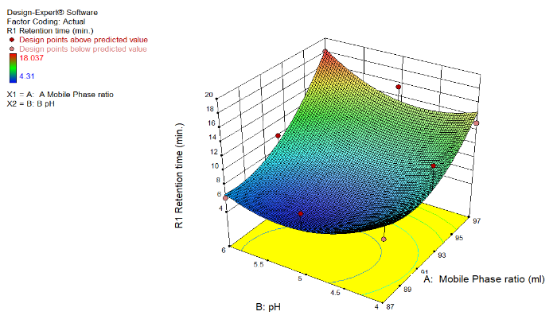 (a)

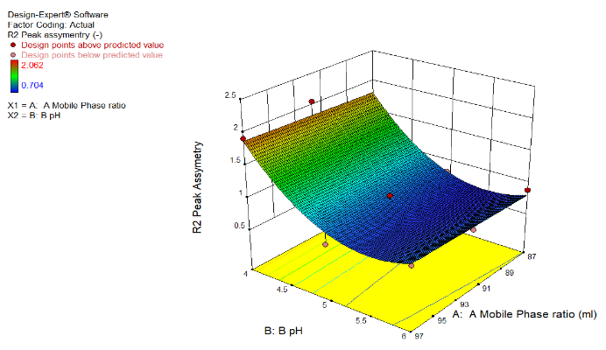 (b)

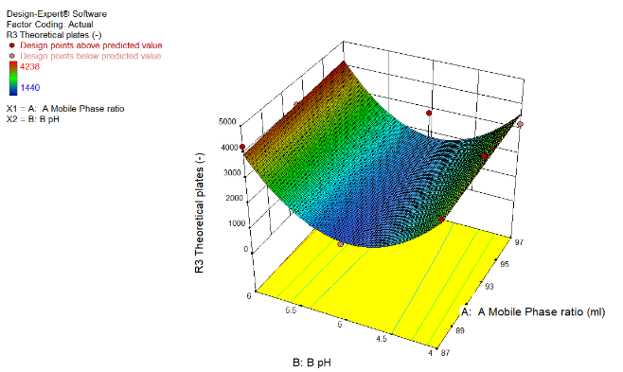

(c)

**Figure 1: 3D response surface plot for R1, R2 and R3**

R1 Retention Time = 1355.99 -26.83*A -61.85*B +0.3382*AB + 0.1411*A2 +3.087B2,

R2 Peak Asymmetry = 3473.55-1641.66*A.-19792.13*B- 0.700*AB + 9.089 *A2 + 2014.23*B2,

R3 Theoretical Plates = 44.26 + 1.155*A – 3.93*B - 0.02*AB- 5.611E-003*A 2+ 0.52*B2,

A positive value indicates the favour and negative value indicate inverse relationship between factor and respective responses.

The optimized solution showed the phosphate buffer: methanol: acetonitrile in a ratio of 87:8:5 (v/v/v) and buffer pH were 6 for which the observed desirability was 0.906 which is very close to 1 as shown in Table 3 and Figure 2.

**Table 3 Suggested optimized chromatographic conditions**

|  |  |  |  |  |  |
| --- | --- | --- | --- | --- | --- |
| **Phosphate buffer: methanol: Acetonitrile** | **pH** | **R1** | **R2** | **R3** | **Desirability** |
| 87:8:5 | 6 | 6.682 | 0.805 | 4030 | 0.906 |

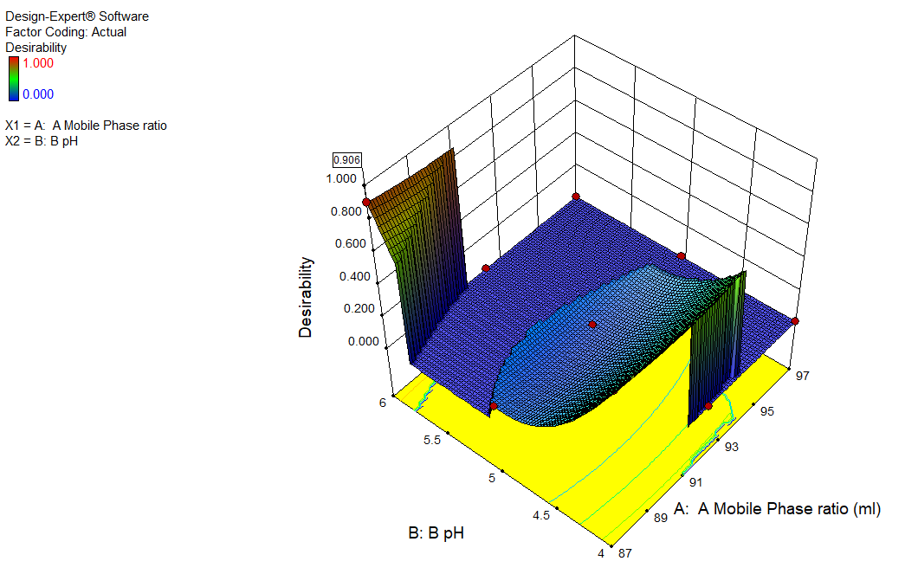

**Figure 2: Desirability for optimized chromatographic conditions**

**HPLC method development by QbD approach**

**Analytical target product profile (ATP)**

The ATPs used for optimization of HPLC chromatographic conditions were R1 retention time, R2 peak asymmetry, and R3 theoretical plates.

**Critical Material Attributes (CMAs)**

The mobile phase was identified as phosphate buffer: methanol: acetonitrile 92:5:3 (v/v/v), pH adjusted to 5.

**Factorial design**

For the suggested HPLC technique development, the CCD central composite design was chosen. Table 2 depicts the optimization of several parameters.

**Design space**

With 11 runs, It was achieved by analyzing all answers conditions by DoE and anticipated responses were determined in Figure 3.



**Figure 3** Design space plot for pregabalin.

**Method validation**

**System suitability**

The results were 6.236min retention time, 4038 as theoretical plates, 0.914 as peak asymmetry, 0.0045 of % RSD.

**Linearity**

The calibration curve for pregabalin was plotted across the concentration range 200-1000µg/ml. The regression equation was y = 780.3x - 58085 with a 0.9992 correlation coefficient, as shown in Table 3.

**Table 3** Linearity of Pregabalin

|  |  |  |
| --- | --- | --- |
| **Sr. no.** | **Concentration**  **(µg/ml)** | **Peak area**  **(Mean ± SD) (n=5)** |
| 1 | 200 | 91274 ± 19.40 |
| 2 | 400 | 255735 ± 23.57 |
| 3 | 600 | 419160 ± 22.94 |
| 4 | 800 | 569721 ± 11.69 |
| 5 | 1000 | 714579 ± 12.72 |

**Precision**

The % RSD for repeatability for pregabalin was determined to be 0.0045. The less than 2 % RSD of intraday and interday precision were shown in Table 5 indicate the preciseness of method.

**Table 5 Intraday and Interday Precision Study for pregabalin**

|  |  |  |  |
| --- | --- | --- | --- |
| **Precision** | **Concentration**  **(µg/ml)** | **(Mean ± SD)**  **(n= 3)** | **%RSD** |
| Intraday precision | 400 | 255641 ± 20.01 | 0.0078 |
|  | 600 | 419067 ± 76.64 | 0.0182 |
|  | 800 | 568854 ± 33.02 | 0.0058 |
| Interday precision | 400 | 255651 ± 57.56 | 0.0225 |
|  | 600 | 419018 ± 87.09 | 0.0208 |
|  | 800 | 569306 ± 68.13 | 0.0112 |

**Accuracy**

The accuracy was determined using a recovery study by spiking at three levels: 80%, 100%, and 120%. The results in Table 6 demonstrate that the percentage recovery ranges between 98 and 102%.

**Table 6 Recovery of Pregabalin**

|  |  |  |  |  |  |
| --- | --- | --- | --- | --- | --- |
| **Level** | **Tablet Powder Equivalent Amount (mg)** | **Spiked Amount**  **(mg)** | **Total amount (mg)** | **Recovered amount**  **(mg ± SD) (n=3)** | **% Recovery ± SD**  **(n=3)** |
| Blank | 450 | 00 | 450 | 450.59 ± 0.88 | 101.19 ± 1.42 |
| 80% | 450 | 360 | 810 | 803.23 ± 8.08 | 99.18 ± 1.08 |
| 100% | 450 | 450 | 900 | 899.34 ± 8.73 | 99.93 ± 1.78 |
| 120% | 450 | 540 | 990 | 991.24 ± 7.67 | 100.13 ± 1.76 |

**Robustness and ruggedness studies**

The roughness was investigated as an external influencing element by a change in analyst. By changing the pH of the mobile phase, the flow rate, and the analyst, the % RSD for the peak was determined to be less than 2.

**LOD and LOQ**

The LOD and LOQ for pregabalin were found to be 36.30µg/ml and 110.02µg/ml respectively.

**Assay**

When the analysis was done from tablets, the optimized chromatogram for pregabalin indicated a well resolved peak at 6.083 min retention time(Rt). The 100.01 ± 0.72 %w/w of drug content for pregabalin found it to be for the label claim.

**CONCLUSION:**

AQbD approach to for pregabalin for HPLC analysis of the Quality Target Product Profile(QTPP) reveals the method's precise objectives. The analytical QbD strategy simplifies the development of the Pregabalin HPLC procedure, identifies the higher performing system, and selects the optimized design space. Using a central composite design, a multivariate investigation of numerous process parameters such as mobile phase composition(X1) and buffer solution pH(X2) was undertaken at three distinct levels. Chromatographic optimization gives the idea about the factors influencing chromatographic separation in the ability to meet the acceptance criteria for system suitability test parameters. Then method validation is done. Method validation gives the idea about all the parameters were in acceptable range. The method was found to be robust, accurate, precise, linear, specific, and rugged for determination of pregabalin.

In comparison to manual QbD, the Design Expert Software 10.0.1 automates the process, which takes less time and uses less solvent and less failure chances in accordance to relationship between independent factors or variables and dependent factors or responses is shown through statistical analysis of the data. It conveys the sense of robust, accurate selection, and reproducibility. Future analyses of quality control in the pharmaceutical business will follow this methodology.

**REFERENCES**

1. Blommel ML, Blommel AL. Pregabalin an antiepileptic agent useful for neuropathic pain. Am J Health Syst Pharm. 2007 Jul 15; 64(14):1475-82. https://doi.org/10.2146/ajhp060371.
2. Santosh S. Chhajed a, Sandeep S. Sonawane, Akshada P. Pingle, Neelam Dashputre, Sakshi, Sanjay J. Kshirsagara. Development and Validation of UV Spectrophotometric Method for Estimation of Pregabalin. Asian J. Pharm. Ana. 2019; 9(1):15-18.
3. Janmajoy Banerjee, H. Padmalatha, Rahul, Ranabir Chanda. Method Development and Validation for the Simultaneous Estimation of Eplarestat and Pragabalin in Bulk and Pharmaceutical Formulation by using RP-HPLC. Asian J. Pharm. Ana. 2018; 8(3): 174-180.
4. Prashant Pingale, Tanmay Singasane. Development and validation of HPLC method for the determination of pregabalin in bulk and in pharmaceutical formulations. Research J. Pharm. and Tech. 5(6): June 2012; Page 829-833.
5. S. Ashutosh Kumar, Manidipa Debnath, J.V.L.N. Seshagiri Rao, D. Gowri Sankar. Stability Indicating Analytical Method Development and Validation for Simultaneous Estimation of Pregabalin, Mecobalamin and Alpha Lipoic Acid in Bulk as well as in Pharmaceutical Dosage Form by using RP-HPLC. Research J. Pharm. and Tech. 7(9): Sept. 2014 Page 1004-1013.
6. Sreekanth.D, P. Ramya, Vishwanadham.Y, Vanitha. R. Development and Method Validation of RP-HPLC For Simultaneous Determination of Pregabalin and Methylcobalamin in Pure and Pharmaceutical Dosage Form. Asian J. Research Chem. 2017; 10(4):557-565.
7. Parthasarathi Thoddi, Girendra Kumar Gautam CH, Narasimha Raju BH. A Stability-Indicating UPLC Method for Simultaneous Quantification of Epalrestat and Pregabalin in Bulk and Marketed Formulations. Research Journal of Pharmacy and Technology. 2022; 15(1):206-2.
8. The international Conference on Harmonisation ICH Technical Requirements for Registration of Pharmaceuticals for Human Use on Pharmaceutical Development Q8 (R2). 2009; https://database.ich.org/sites/default/files/ Q8_R2_Guideline.pdf
9. The international Conference on Harmonisation ICH Technical Requirements for Registration of Pharmaceuticals for Human Use on Quality Risk Management Q9. 2005; https://database.ich.org/sites/default/files/ Q9_Guideline.pdf
10. The international Conference on Harmonisation ICH Technical Requirements for Registration of Pharmaceuticals for Human Use on Pharmaceutical Quality System Q10. 2008; https://database.ich.org/sites/default/files/Q10_Presentation.pdf
11. Dhand V, Dedania Z, Dedania R, Nakrani K. QbD approach to HPLC method development and validation of orciprenaline sulphate. J Global Trends Pharm Sci. 2020; 11: 8634-8640.
12. Rajkotwala A, Shaikh S, Dedania Z, Dedania R, Vijyendraswamy S (2016) QbD Approach To Analytical Method Development and Validation of Piracetam By HPLC. World J Pharmacy Pharmaceutical Sci 5:1771-1784.
13. Singh P, Maurya J, Dedania Z, Dedania R (2017) QbD Approach for Stability Indicating HPLC Method For Determination of Artemether And Lumefantrine In Combined Dosage Form. Int J Drug Reg Affairs 5:44-59.
14. Prajapati R, Dedania Z, Jain V, Sutariya V, Dedania R, Chisti Z (2019) QbD Approach to HPLC Method Development and Validation for Estimation of Fluoxetine Hydrochloride and Olanzapine In Pharmaceutical Dosage Form. J Emerging Tech Innovative Res 6:179-195.
15. Babar S, Sudhakar L, Padwal. QbD approach to HPLC method development and validation for estimation of lenvatinib in bulk and pharmaceutical formulation. Int J App Pharm. 2021;13(5): 183-188.
16. Bhutani H, Kurmi M, Singh S, Beg S, Singh B. Quality by Design (QbD) in analytical science: an overview. Pharma Times. 2014; 46(8): 71-75.
17. Noel Baker, Walkiria S, Mark G. Quality Risk Management https://onlinelibrary.wiley.com/doi/10.1002/9781118895238.ch2
18. Patel, K.Y., Dedania, Z.R., Dedania, R.R. et al. QbD approach to HPLC method development and validation of ceftriaxone sodium. Futur J Pharm Sci 7, 141 (2021). <https://doi.org/10.1186/s43094-021-00286-4>
19. Desai Devanshi, Dedania Zarna, Jain Vineet. Analytical Qbd Approach to HPLC Method Development and Validation for Tolfenamic Acid. International Journal of Research and Analytical Reviews. 2022;9(3):498-507
20. Kalleshvar P. Jatte, R. D. Chakole, M. S. Charde. Degradation Profiling of Lisinopril and Hydrochlorothiazide by RP- HPLC method with QbD Approach. Asian Journal of Pharmaceutical Analysis. 2021; 11(4):270-4.
21. The international Conference on Harmonisation ICH Technical Requirements for Registration of Pharmaceuticals for Human Use on Validation of Analytical Procedure Text and Methodology Q2(R1). 2005; https://database.ich.org/sites/default/files/Q2%28R1%29%20Guideline.pdf
22. D. D. Masne, R. D. Chakole, M. S. Charde. QbD Approached in Method Development, Validation and Degradation Profiling of Aripiprazole a Antidepressent Agent. Asian Journal of Pharmaceutical Analysis. 2022; 12(1):29-4.
23. Patil Karishma Ashok, Firke Sandip Dinkar. Determination and Development of UV-Spectrophotometric method for the Amodiquine Hydrochloride by using quality by design (QBD) approach. Asian J. Pharm. Ana. 2019; 9(3):113-117.
24. G. K. Dyade, Bhushankumar Arve, Chaitanya Nimbalkar. Implementation of QBD Approach in Analytical Method Development of Fluvastatin by UV-VIS Spectrophotometry. Asian Journal of Pharmaceutical Analysis. 2022; 12(2):87-3.
25. Kumar N, Sangeetha D, Analytical method development by using QbD An emerging approach for robust analytical method development. J. Pharm. Sci. Res. 2020; 12, 1298–1305.
26. Fukiuda IM, Pinto CF, Moreira CS, Saviano Am, Lourenco FR. Design of experiment applied to pharmaceutical and analytical QbD. Braz. J. Pharma. Sci.2018; 54: https://doi.org/10.1590/s2175-97902018000001006
27. Ramalingam P, Kalva B, Reddy Y. Analytical quality by design; a tool for regulatory flexibility and robust analytics, Int J ana Chem. 2015; https://doi.org/10.1155/2015/888727
28. Bhattacharya S. Central Composite Design for Response Surface Methodology and Its Application in Pharmacy. In Response Surface Methodology in Engineering Science; Kayaroganam P. Ed.; Intech Open: London, UK, 2021; p. 270.
29. Jaybhave AR, Shindhe M, Mogal R, Narkhede S, Jadhav A. QbD Approach to Analytical RP-HPLC Method Development and Validation of Tenofovir Disoproxil Fumarate in Dosage Form. J of Pharm Sci. and Research. 2021; 13(7), 381-386.
30. Sandhu, PS, Beg S, Katare OP, Singh B, QbD-Driven Development and Validation of a HPLC Method for Estimation of Tamoxifen Citrate with Improved Performance. J. Chromatogr. Sci. 2016; 54: 1373–1384. Petitti DB, Crooks VC, Buckwalter JG, Chiu V. Blood pressure levels before dementia. Arch Neurol. 2005 Jan;62(1):112-6.