Fume Recognition using Intelligent Chamber Analyzation System

Dr. Ayesha Butalia * Rohit Oturkar* Komal Narke* Mousam Thakur*
Project Guide & IT Professor Student SY-IT Student SY-IT Student SY-IT
Contact no. 919673102198 Contact no. 919860053468 Contact no. 917498130422 Contact no. 919730127364
Information Technology MIT Information Technology MIT Information Technology MIT Information Technology MIT
ADT University Loni , pune ADT University Loni ,pune ADT University Loni ,pune ADT University Loni ,pune
ayesha.butalia@mituniversity.edu.in rohit.oturkar2003@gmail.com narkekomal5@gmail.com thakurmousam13@gmail.com

Abstract—
Concept of our Smart manhole detection system works on analysis, monitoring, detecting and the critical situation related to sewage chambers, drainage, or any situation. Our system name ‘Fume recognition using intelligent chamber Analyzation System’ can also be addressed as FRICAS. It will also help workers they feel safe while working inside the chambers. This includes capturing data like water capacity or amount of toxic gases or any harmful gases, fluctuation of temperature and to check humidity for optimal uses with the help of several sensors.
So our project is a need of modern society as we know due to increasing population, amount of waste and Drainage monitoring teams aren’t present in every region, which checks drainage status on a regular basis. This system is having gap in fulfilling the real time data monitoring, remote access to information, and need of humans for physically present monitoring, To overcame this issues our system with hardware abilities uses few sensors like humidity sensors, floating sensors, gas sensor by using Arduino Uno board. It will help to reduce miss-happening causes due to human inaccuracy and then it alerts to reduce blockage of water, harmful gases and from other situation. Then data sent to administrator on real-time basis using internet to alert and essential treatment. As we are modifying our project for easiest and Smart purpose for the appropriate safety of people by adding floating sensors ,as the floating sensors is going to alert the administration whenever the water level increases before it reach to the chambers. We will also be applying machine learning algorithm in future so that we can distinguish the outputs and do the analysis. The ml model will predict the water level and give the alerts beforehand so the action can be taken intime. This will be done by integrating the project with IoT ,Arduino and other required sensors. Also we will be creating database of the recorded data which will be used in our website where one can see the status of work done by municipal and can give their review regarding their respective areas. Bringing all this methods in one frame we will be able to accelerate our cities cleanliness and to adapt the modern architecture for human benifits Applying this above methods will enrich our project in a certain way which will help to meet the ease ness of daily life for humans in an appropriate way. This will definitely help to reduce accidents, health issues and viral infections which will allow the citizens to live an prosperous life and thus it will not only make the city smarter but also the country smarter.

Keywords— Fume, harmful gases, mankind, cost effective, manhole, fume, gas sensor, humidity sensor, temperature sensor, water sensor, ultrasonic sensor.
- Introduction
For a clean and healthy environment, many Indian cities have an underground drainage system that is controlled by the Municipal Corporation[1].The water in the drainage system is occasionally mixed with pure water due to chemical fluids many other unhygienic components infections and diseases can be spread through the drainage system. Because of climate change, drainage is affected throughout the year, and the environment is dynamic, people's daily lives are disrupted[2].To fix all drainage system concerns and to send Blynk notifications to the municipal corporation informing them of the state of the drainage system so that officials can take the necessary steps to restore the drainage system.
Our system ‘Fume recognition using intelligent chamber Analyzation System’ FRICAS will help to resolve the issue. When the sewage system is obstructed, water overflows, or the drainage lid is removed, sensors monitor the drainage and send the data to a nearby municipal corporation official via integrated Wi-Fi and Bluetooth where the water overflow and gas value are presented live in the cloud for later examination. sensors detect the water level, and if the difference between the two levels exceeds the threshold value, an alert message is delivered to the person in charge. The Arduino micro controller is connected to the sensors' output. It looks at the previously set threshold level and sends a GSM alarm message to the person in control, which is tracked via IoT.
- literature survey
Existing System 1:
Reference[3] shows:
NAME:IOT based drainage and waste management monitoring and alert system for city.
Problem Statement: In our system the operators will be the worker themselves as they will get alert values on their phone.
Drawback: Operators are also unaware of the state of this manhole, which can result in an accident.
Our Outline:In our system the operators will be the worker themselves as they will get alert values on their phone
Reference link: [a]

Existing system 2:
Reference[4] shows:
NAME :Development of alerting and monitoring system for manhole management.
Problem Statement: Nowadays the major issue in cities is manhole management. The probability of rate of accidents on roads is increasing gradually due to improper and damaged manholes.
Drawback: The control and implementation of system is not properly handled.
Our Outline: Sensors of our system give useful precision
And are adequately handled.
Reference link: [b]

Existing System 3:
Reference[5] shows:
NAME:Smart managing and monitoring system using IOT
Problem Statement: Aging public buildings and facilities have caused increased needs for systems that support the maintenance and management of social infrastructure.
Drawback: Their system includes wi-fi modules which may face connection issues due to poor network.
Our Outline : Our system will use Bluetooth module which does not internet to send the data thus making it more reliable.
Reference link: [c]

- proposed system FOR FRICAS
Smart manhole monitoring system works by taking crucial input from the drainage itself with help of various sensors together integrated after researching factors affecting humans inside the chambers Manhole management is need of modern society as due to increasing population amount of waste is increasing rapidly, system present currently are having gap in fulfilling the real-time data monitoring, remote access to information, need of humans physically present for monitoring. with hardware abilities uses sensors, and IOT for efficiently handling the management, it helps reducing miss-happenings causes due to human inaccuracy, timely alerts to reduce blockage of water harmful gasses and any other harmful factors, this data is sent to administrator on real-time basis using internet for essential treatments.

The gases let alone aren't the only threat to the humans, open chambers, drainage are a death trap, people can fall and can meet death for certain, creating system which also alerts when the lid / cap of chamber is moved or removed or not present helping people to avoid it. Our aim is to provide a permanent efficient solution on management issues of manhole. This system can also be efficiently used for year as the main monitoring unit would be sealed, reducing the need of human for monitoring physically reducing manpower helping saving money and life at same time.

So our system basically tries to overcomes the draw back of the existing system which we already discussed in above section that is literature survey. Our system provides facilitates the user by providing accurate data in digital form. We are proposing this system so as to make our country manufacturing smarter and digital , which would make easier for the government to handle the drainage managing system. Also to ensure the safety and to maintain hygienic environment for the citizens, as it will give us alerts when any miss happening in drainage such as lid being not present on the chamber by using ultrasonic sensor , giving water level before the chamber is going to clogged especially in rainy seasons by using digital temperature and humidity sensor.
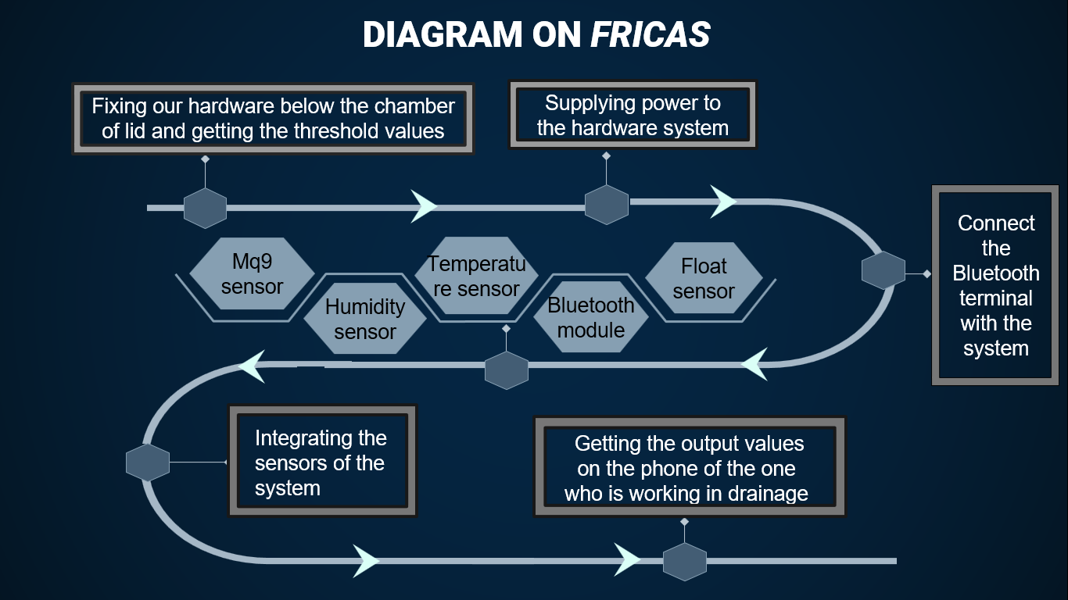
Fig.1 Diagram on working of FRICAS

- METHODOLOGY FOR FRICAS
To gain more knowledge about our hardware in order to achieve valid output, we did a research in certain fields related to our project. Foremost thing we did was that we collected the data which was in BI-VARIATE table containing categorical and numerical data about the harmful gases. We then also studied about the various types of sensors we will be using.[6]
We also acknowledged about the differences in the existing system, drawbacks of their, and also what was their problem statement and how they carried out their work.[6][7]
To record the threshold values inside the chambers we have used various sensors such as Temperature sensor, humidity sensor, MQ9 sensor, GPS module and water sensor. Now this
sensors measures the value of their respective conditions and gives alert on the basis of readings. Sensors are been set up with some max value according to the impact of harmful[7][8]

Software:
Coding part mostly done for our project is done using arduino IDE where codes are saves in into format.
Calibration of every sensor is done using suitable conditions and importing libraries if required
1.softwareserial.h:to establish connection with pins
2..inyGPSplus.h:to use gps sensor[8],[9]

Hardware:
1. Arduino UNO:

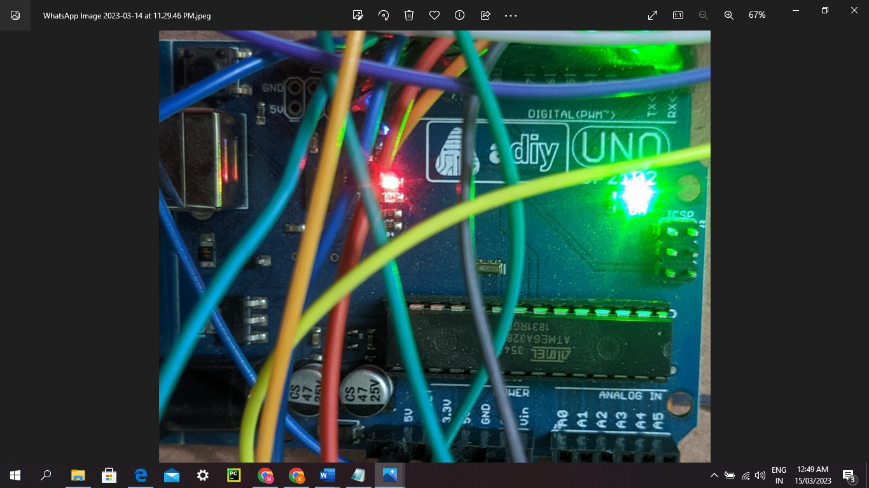
Image 1.1 Arduino UNO used for FRICAS

Arduino UNO is a very useful electronic component as it is a very low-cost, flexible, and easy-to use programmable open-supply microcontroller board that may be incorporated into a lot of digital initiatives. Thus we are implementing this in our system. Digital I/O Pins: there are 14 virtual (0-13) I/O pins to be had at the board that may be linked with outside digital additives. This board may be interfaced with different Arduino forums, Arduino shields, Raspberry Pi forums and might manage relays, LEDs, servos, and cars as an output. Arduino UNO capabilities are AVR microcontroller Atmega328, 6 analogue enter pins, and 14 virtual I/O pins out of which 6 are used as PWM output. This board includes a USB interface i.e. USB cable is used to attach the board with the laptop and Arduino IDE (Integrated Development Environment) software program is used to application the board. The unit comes with 32 KB flash reminiscence, this is used to keep the variety of commands, whilst the SRAM is 2 KB and EEPROM is 1 KB. The working voltage of the unit is 5V which initiatives the microcontroller at the board and its related circuitry operates at 5V whilst the entered voltage levels among 6V to 20V and the advocated enter voltage levels from 7V to 12V Arduino UNO Components[1].
2. Fume/ Gas Sensor:

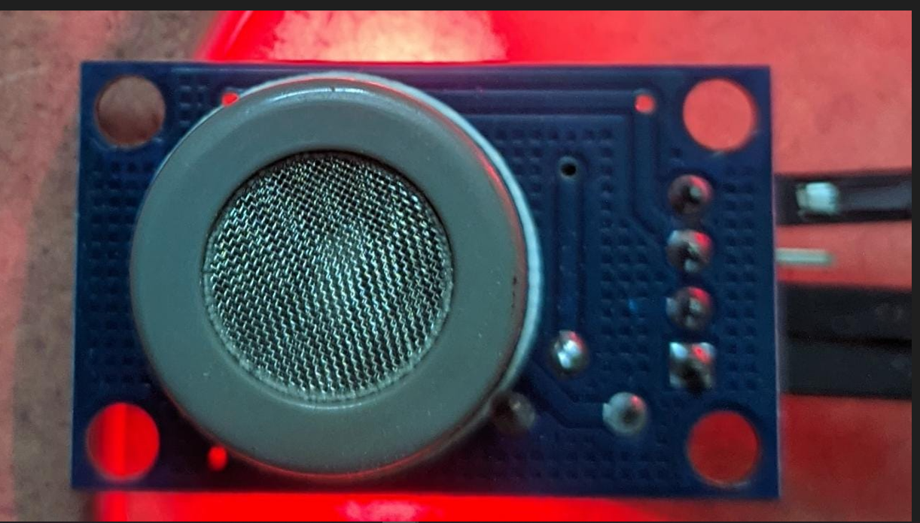
Image 1.2 Fume/Gas sensor used in FRICAS

Fume or gas sensor are applicable for detecting the fumes or harmful gases present in the surrounding atmosphere. There are various types of gas sensors, in which most commonly used is MQ9 sensor. It detects the alcohol, smoke, methane, LPG, hydrogen, NH3, Benzene, Propane[1].

3. Temperature and Humidity Sensor:

The DHT-11 Digital Temperature And Humidity Sensor is a basic, ultra low-cost digital temperature and humidity sensor. It uses a capacitive humidity sensor and a thermistor to measure the surrounding air and spits out a digital signal on the data pin (no analogue input pins needed). This sensors will play an important role for getting the update that whether the chamber is going to get clogged or not. This sensor provides us faster response as it is stable for longer period of time and also power supply needed is less.
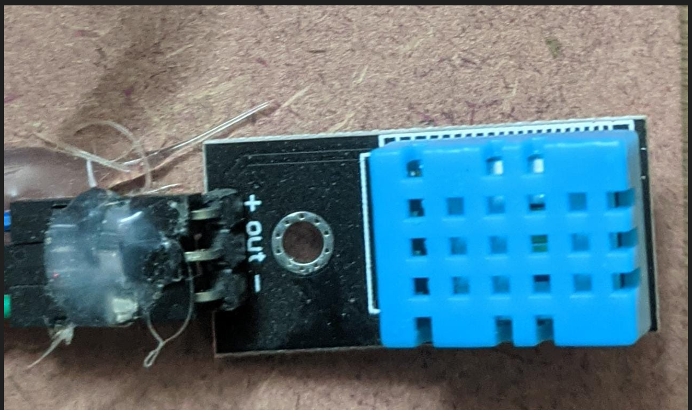
Image 1.3 DHT11 used in FRICAS

The temperature and humidity sensor are used to provide the measuring of the amount of heat, moist or coldness present in the air. As it also senses the moist in air it can easily give us the amount of humidity present in surroundings. There are various temperature and humidity sensor available in market. The one which we have used is DHT11. DHT11 has a dedicated NTC to carryout their main objective of measurement and also an 8-bit microcontroller to output the values of temperature and humidity as serial data[1].

Table 1.1 For DHT11 Sensor
SR NO. | Pin Name | Description
1. | Vcc | Power supply 3.5V to 5.5V
2. | Data | Outputs both Temperature and Humidity through serial Data
3. | NC | No Connection and hence not used
4. | Ground | Connected to the ground of the circuit

DHT11 Specifications
- Operating Voltage: 3.5V to 5.5V
- Operating current: 0.3mA (measuring) 60uA
- Output: Serial data
- Temperature Range: 0°C to 50°C
- Humidity Range: 20% to 90%
- Resolution: Temperature & Humidity both are 16-bit
4. GPS Module:

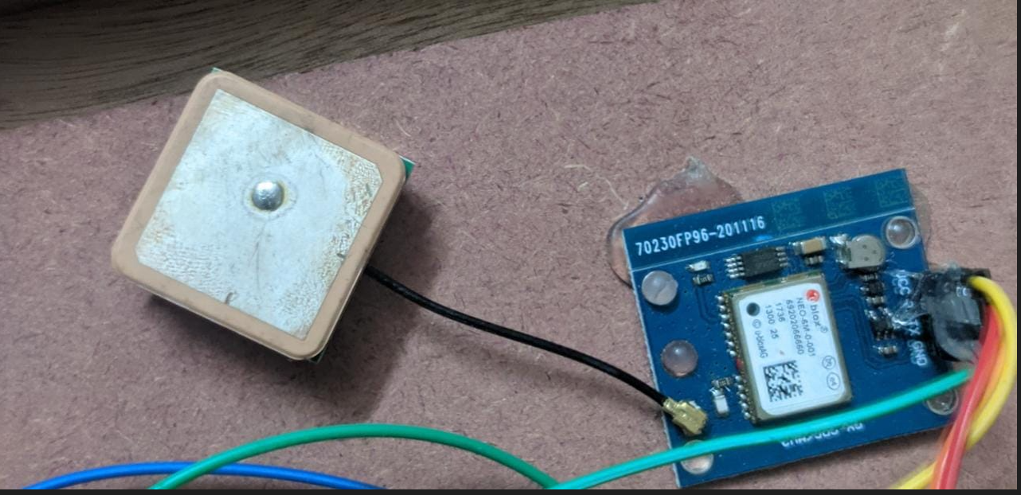
Image 1.3 GPS Module used in FRICAS

The Global Positioning System (GPS) is a space-based navigation system that provides location and time information in all weather conditions, anywhere on or near the Earth where there is an unobstructed line of sight to four or more GPS satellites. The system provides critical capabilities to military, civil, and commercial users around the world. The United States government created the system, maintains it, and makes it freely accessible to anyone with a GPS receiver[1].

5. Ultrasonic Senor:

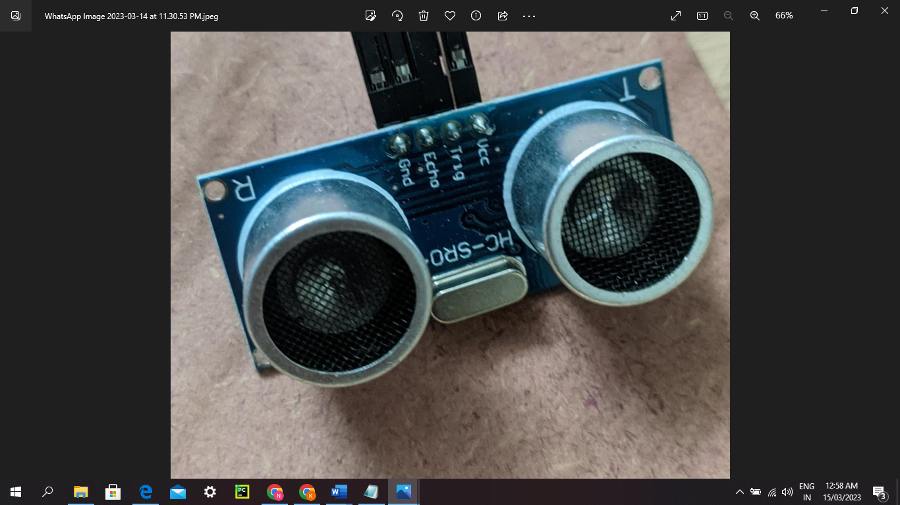
Image 1.5 Ultrasonic Module used in FRICAS

Ultrasonic sensor is an equipment which is mostly used to generate ultrasonic waves which are then converted into reflected sound into an electrical signal. It is a hardware which can be very useful in our project to emit whether the drainage lid is open or closed, when someone tries to change the position of lid it will transform the ultrasonic waves into sound waves which will alert surrounding people. Ultrasonic sensors are also used as level sensors to detect, monitor, and regulate liquid levels in closed containers

6. Bluetooth Terminal:
Designed to replace cable connections HC-05 uses serial communication to communicate with the electronics Usually, it is used to connect small devices like mobile phones using a short-range wireless connection to exchange files. It uses the 2.45GHz frequency band. The transfer rate of the data can vary up to 1Mbps and is in range of 10 meters. Bluetooth module hc-10… Bluetooth terminal which will be connected to the mobile. its is use for detect the value This pin is used to toggle between Data Mode (set low) and AT command mode (set high). By default it is in Data mode. TX – Transmitter: Transmits Serial Data. Everything received via Bluetooth will be given out by this pin as serial data. RX – Receiver: Receive Serial Data. Every serial data given to this pin will be broadcasted via Bluetooth.
V. EXPERIMENTATION OF FRICAS
We experimented in the drainage system of a society to get a rough idea about the working of our systems inside the walls of sewage. The main moto of doing the real time experimentation on the hardware system was to get a clear idea and verification of the test model of our system. This real time testing helps us in improving the system and to make it work in more efficient way.

Experimentation was carried out by our team members in such way that we could tally our outcomes. We found a convenient way of taking our hardware system into the sewage in such a way that no harm was caused in the drainage to the components of the hardware due to the waste or water flow in the drainage. Before taking our System inside the drainage what we did was, we gave a temporary continuous power supply to the system by attaching power bank in the hardware and then we firstly observed the readings of threshold values outside the lid of drainage that is in normal surroundings or conditions. Further we took our system inside the drainage, the first thing which we tested was that were the components working properly inside the sewage conditions too. Then we observed the changes occurring in the threshold values. According to which will make it more efficient .

Table 1.2 Range of harmful fumes/gas
Sr.  no | Amount of gases harmful for the workers
 | Hydrogen sulphide | Carbon monoxide | methane
normal | 10ppm | 50ppm | 2.2ppm
hazard | 100ppm | 200ppm | 9ppm

We did a comparison between the first reading values we took with the one which we recorded after taking the system in the drainage. We acknowledged that the temperature decreases due to the presence of water and humidity was increased due to the presence of moist in surrounding air. Another major factor what we noticed was that we will be needing a floating sensor as our system will be placed beneath the lid of drainage so we need to use float sensor. As the name suggests it will float in the water and give the values as the water level will increase.

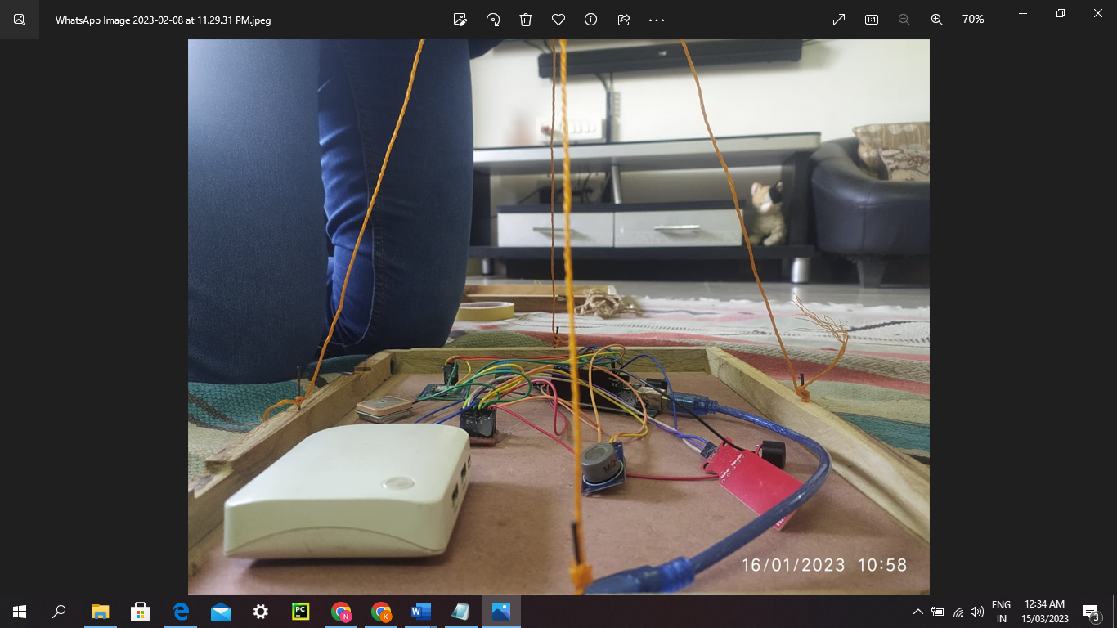
Image 1.6 Picture before experimentation

Image 1.7 Picture while experimentation

VI. Conclusions
The proposed system ensures the security of the humans by avoiding the accidents, Improper management of manhole lead to spreading infections and diseases because of miss happning. If this system implemented properly, it can bring progressive changes in the environment, in our society. We did real time based model testing with the help of bluetooth GPS moduling for output of the sensors which helps authority to take necessary actions before any critical situation. It provides the data accuracy about temperature and humidity, presence of any harmful gases , water capacity inside the manhole. This system too came with some drawbacks that we need to overcome the changes and additional future.
So in future we need to implement and add flame sensor which will help in detecting as well as responding to the occurrence of a fire or flame. ultrasonic sensor will help to recognise absence of lid on manhole also we can make this system more efficient by implementing water float sensor instead of water sensor for better implementation and we also thinking about our own app implement for the alert message. Also our model will be implementing machine learning model which will increase the efficiency of the system. We also provide website which will receive feedbacks o know the status about work and also store the data of readings which can be further utilized for the studying and predicting the values. Thus it well help us to take preventions from clogging or overflowing the chambers before the rainy seasons start which is the period when chambers are affected the most and making our cities more cleaner and organised.

VII. ACKNOWLEGEMENT

We would like to give our special thanks to our HOD of the IT department Prof. Dr. Rekha Sugandhai for assistance us regarding the project. We also like to show our gratitude towards our Director of SOC Department -Prof. Dr. Rajneesh Kaur Sachdeo. A heart warming thanks to our families who always there to encourage us and for enthusiastically supporting us. Lastly we would like to thank MIT ADT University for all the support and help that made our project more advance and enhanced.

References
- Komal Mahalunge , Usha Mittal Institute of Technology SNDT Women’s University Mumbai, Maharashtra. ”An IoT based Manhole Monitoring System”. Reference Article Issue date 01/07/2020.
- 1 Sowndharya VadiveluA. 2 Prakashraja Karnik, 3 Sahana Raga Saini. “Smart Manhole Coverage System Using IoT“. Reference link http://ijaet-e.com/files/100-103.pdf
- S. Zhang, C. Zhu, J. K. O. Sin, and P. K. T. Mok, “A novel ultrathin elevated channel low-temperature poly-Si TFT,” IEEE Electron Device Lett., vol. 20, pp. 569–571, Nov. 1999.
- Amutha M1 , Kamali S2 , and Sherli T3 {amutha@soantech.ac.in1 , kamali.18ece@sonatech.ac.in2 , sherli.18ece@sonatech.ac.in3} Sona College of Technology, Tamil Nadu. “Smart Manhole Mangaing and Monitoring System using IoT”.Available reference link https://eudl.eu/pdf/10.4108/eai.16-4-2022.2318149.
- Snehal K. Jagtap*,Shradha S.Khalate**, Pratiksha Y. Madane***, Kshitija k. Shirke**** “Smart Manhole System “ .Reference article issued on 5th September 2020.
- Mr.ManeHarshavardhan Vijay1 ,Mr.Nimbaler Swapnil Sanjay2 , ChougulePushpraj Babaso3 , Mr.Ghatage Abhishek Dundappa4 , Ms.Saundatte M .G 5. “Man Hole Detection and Monitoring System using IoT”. IJRPR issued on September 2021.
- Ruheena M. A & Rukhayia Sheereen dept. Electronics & Communication GSSSIETW Mysore, India Sheeba Kulsum & T. Komala Dept. Electronics & Communication GSSSIETW Mysore, India ‘Manhole detection and monitoring system. IEEE Std 2021
- G Chandhini, B Chithra, P Kiruthikadevi, Bhagya Sasi, V. Kamal Kumar “IOT based underground drainage monitoring system”. IEEE Std issued on 3rd September 2020.
- Memane Abhishek Ganpat, Aher Omkar Ganpat Bansoe, Sumit Shivaji. ”Smart Manhole Detection”. IEEE Std March 2022(2002)
Reference links:
[a] https://www.annalsofrscb.ro/index.php/journal/article/view/2179
[b] http://sersc.org/journals/index.php/IJAST/article/view/9617
[c] https://eudl.eu/doi/10.4108/eai.16-4-2022.2318149

