IoT Based Solar Panel Monitoring System
Mahitha Mohan^{1,a)}Thangavel K^{1, b)}, Balaprakash V^{1, c)}
1 Department of Electronics
Hindusthan College of Arts & Science
Coimbatore, Tamilnadu, India,641028
Abstract
IoT provides businesses with a real-time look into how their systems really work, delivering insights into everything from the performance of machines to supply chain and logistics operations. IoT enables companies to automate processes and reduce labor costs. It also cuts down on waste and improves service delivery, making it less expensive to manufacture and deliver goods, as well as offering transparency into customer transactions. As such, IoT is one of the most important technologies of everyday life, and it will continue to pick up steam as more businesses realize the potential of connected devices to keep them competitive. The proposed solar panel monitoring system using IoT, LCD display, variable part, voltage sensor, current sensor, battery, and solar panel can provide valuable insights into energy production, consumption, and storage. By implementing this system, users can remotely monitor the performance of their solar panel systems, including voltage and current output, and the state of charge of the battery. This information can be used to optimize energy usage and reduce costs. The internet of things helps people live and work smarter, as well as gain complete control over their lives. In addition to offering smart devices to automate homes, IoT is essential to business.
1. INTRODUCTION
Solar energy is rapidly becoming one of the most popular and cost-effective sources of renewable energy worldwide. Solar panel systems have been widely adopted due to their efficiency, environmental friendliness, and long-term cost savings. However, it is crucial to monitor the performance of these solar panel systems to ensure they are functioning optimally and providing maximum energy output. Monitoring solar panel systems can be done using various methods, including the use of Internet of Things (IoT) technology. IoT technology allows for remote monitoring and control of solar panel systems, providing valuable insights into energy production and consumption. In this proposed system, we use an ESP8266 module that connects the solar panel system to the internet, allowing for remote monitoring and control. The system includes voltage and current sensors that measure the voltage and current output of the solar panel, respectively. This data is then sent to an IoT platform where it can be analyzed and visualized using an LCD display. The proposed system also includes a variable part, such as a battery, that stores excess energy generated by the solar panel system. The battery's state of charge can also be monitored and displayed on the LCD display, providing valuable insights into the system's energy storage capabilities. The proposed solar panel monitoring system using IoT, LCD display, variable part, voltage sensor, current sensor, battery, and solar panel is essential in ensuring the efficiency and optimal performance of solar panel systems. It can also provide valuable insights into energy consumption and storage, allowing for better decision-making regarding energy usage and cost savings.
1.1. BLOCK DIAGRAM

LCD DISPLAY

ARDUINO
UNO

VARIABLE POT
SOLAR PANEL

BATTERY

VOLTAGE SENSOR
IOT

CURRENT SENSOR

1.2. CIRCUIT DIAGRAM

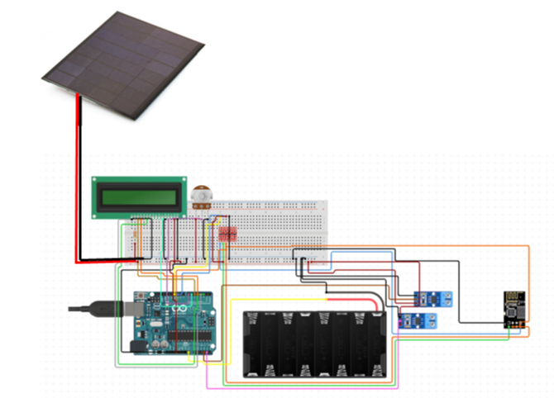
1.3. HARDWARE REQUIRED
SNO | COMPONENTS | REQUIREMENT
1 | Arduino UNO | 1
2 | ESP8266 WIFI Module | 1
3 | Voltage sensor | 1
4 | Current sensor | 1
6 | Solar panel | 1
7 | Potentiometer | 1
8 | LCD display | 1
9 | Battery(12v) | 1

2. Arduino UNO:
Arduino is an open-source electronics platform based on easy-to-use hardware and software.

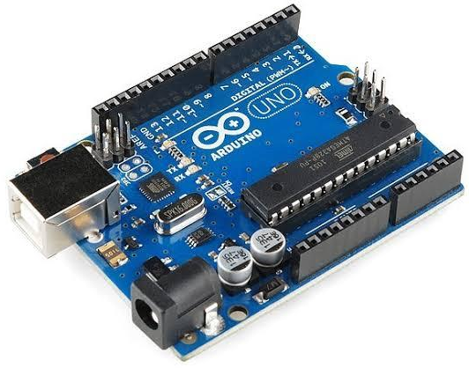

2.1 Pin Description
Pin Category | Pin Name | Details
Power | Vin, 3.3V, 5V, GND | Vin: Input voltage to Arduino when using an external power source.  5V: Regulated power supply used to power microcontroller and other components on the board.  3.3V: 3.3V supply generated by on-board voltage regulator. Maximum current draw is 50mA.  GND: ground pins.
Reset | Reset | Resets the microcontroller.
Analog Pins | A0 – A5 | Used to provide analog input in the range of 0-5V
Input/Output Pins | Digital Pins 0 - 13 | Can be used as input or output pins.
Serial | 0(Rx), 1(Tx) | Used to receive and transmit TTL serial data.
External Interrupts | 2, 3 | To trigger an interrupt.
PWM | 3, 5, 6, 9, 11 | Provides 8-bit PWM output.
SPI | 10 (SS), 11 (MOSI), 12 (MISO) and 13 (SCK) | Used for SPI communication.
Inbuilt LED | 13 | To turn on the inbuilt LED.
TWI | A4 (SDA), A5 (SCA) | Used for TWI communication.
AREF | AREF | To provide reference voltage for input voltage.
2.2 Arduino Uno Technical Specifications
Microcontroller | ATmega328P – 8 bit AVR family microcontroller
Operating Voltage | 5V
Recommended Input Voltage | 7-12V
Input Voltage Limits | 6-20V
Analog Input Pins | 6 (A0 – A5)
Digital I/O Pins | 14 (Out of which 6 provide PWM output)
DC Current on I/O Pins | 40 mA
DC Current on 3.3V Pin | 50 mA
Flash Memory | 32 KB (0.5 KB is used for Bootloader)
SRAM | 2 KB
EEPROM | 1 KB
Frequency (Clock Speed) | 16 MHz
2.3 Other Arduino Boards:
Arduino Nano, Arduino Pro Mini, Arduino Mega, Arduino Due, Arduino Leonardo.
2.4 Overview:
Arduino Uno is a microcontroller board based on an 8-bit ATmega328P microcontroller. Along with ATmega328P, it consists of other components such as crystal oscillator, serial communication, voltage regulator, etc. to support the microcontroller.
Arduino Uno has 14 digital input/output pins (out of which 6 can be used as PWM outputs), 6 analog input pins, a USB connection, A Power barrel jack, an ICSP header and a reset button.
2.5 How to use the Arduino Board:
The 14 digital input/output pins can be used as input or output pins by using pin Mode (), digital Read() and digital Write() functions in arduino programming.
Each pin operates at 5V and can provide or receive a maximum of 40mA current, and has an internal pull-up resistor of 20-50 KOhms which are disconnected by default. Out of these 14 pins, some pins have specific functions as listed below:
- Serial Pins 0 (Rx) and 1 (Tx): Rx and Tx pins are used to receive and transmit TTL serial data. They are connected with the corresponding ATmega328P USB to TTL serial chip.
- Interrupt Pins 2 and 3: These pins can be configured to trigger an interrupt on a low value, a rising or falling edge, or a change in value.
- PWM Pins 3, 5, 6, 9 and 11: These pins provide an 8-bit PWM output by using analog Write() function.
- SPI Pins 10 (SS), 11 (MOSI), 12 (MISO) and 13 (SCK): These pins are used for SPI communication.
- In-built LED Pin 13: This pin is connected with an built-in LED, when pin 13 is HIGH – LED is on and when pin 13 is LOW, it's off.
Along with 14 Digital pins, there are 6 analog input pins, each of which provide 10 bits of resolution, i.e. 1024 different values. They measure from 0 to 5 volts but this limit can be increased by using AREF pins with analog reference function.
  - Analog pin 4 (SDA) and pin 5 (SCA) are also used for TWI communication using the Wire library.
Arduino Uno has a couple of other pins as explained below:
- AREF: Used to provide reference voltage for analog inputs with analog Reference () function.
- Reset Pin: Making this pin LOW, resets the microcontroller.
2.6 Communication
Arduino can be used to communicate with a computer, another Arduino board or other microcontrollers. The ATmega328P microcontroller provides UART TTL (5V) serial communication which can be done using digital pin 0 (Rx) and digital pin 1 (Tx).
An ATmega16U2 on the board channels this serial communication over USB and appears as a virtual com port to software on the computer. The ATmega16U2 firmware uses the standard USB COM drivers, and no external driver is needed. However, on Windows, a .inf file is required.
The Arduino software includes a serial monitor which allows simple textual data to be sent to and from the Arduino board. There are two RX and TX LEDs on the arduino board which will flash when data is being transmitted via the USB-to-serial chip and USB connection to the computer (not for serial communication on pins 0 and 1).
A Software Serial library allows for serial communication on any of the Uno's digital pins. The ATmega328P also supports I2C (TWI) and SPI communication. The Arduino software includes a Wire library to simplify use of the I2C bus.
2.7 Arduino Uno to ATmega328 Pin Mapping:
When ATmega328 chip is used in place of Arduino Uno, or vice versa, the image below shows the pin mapping between the two
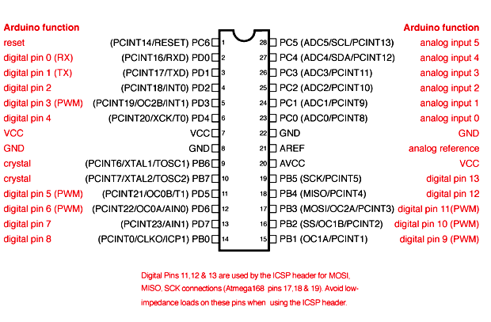
3. LCD:
LCD (Liquid Crystal Display) is a type of flat panel display which uses liquid crystals in its primary form of operation. LCD draws its definition from its name itself. It is combination of two states of matter, the solid and the liquid. LCD uses a liquid crystal to produce a visible image. LCD's technologies allow displays to be much thinner when compared to cathode ray tube (CRT) technology.
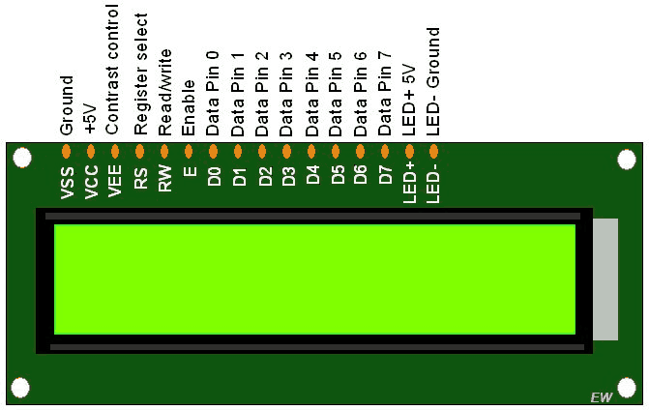
- In an LCD television, the pixels are switched on or off electronically using liquid crystals to rotate polarized light.
- LCDs are used in a wide range of applications, including LCD televisions, computer monitors, instrument panels, aircraft cockpit displays, and indoor and outdoor signage.
- LCDs (Liquid Crystal Displays) are used in embedded system applications for displaying various parameters and status of the system.
- LCD 16x2 is a 16-pin device that has 2 rows that can accommodate 16 characters each.
- LCD 16x2 can be used in 4-bit mode or 8-bit mode.
- It is also possible to create custom characters.
- It has 8 data lines and 3 control lines that can be used for control purposes.
- For more information about LCD 16x2 and how to use it, refer the topic LCD 16x2 module in the sensors and modules section.
3.1 Functions Used:
3.1.1. Liquid Crystal object name
(rs,rw,en,d0,d1,d2,d3,d4,d5,d6,d7)
Liquid Crystal object name(rs, rw,en,d4,d5,d6,d7)
This function defines an object named object name of the class Liquid Crystal.
rs, rw and en are the pin numbers of the Arduino board that are connected to rs, rw and en of the LCD.
d0, d1, d2, d3, d4, d5, d6 and d7 are the pin numbers of the Arduino board that are connected to data pins D1, D2, D3, D4, D5, D6 and D7 of the LCD.
Example, Liquid Crystal LCD (13, 12, 11, 10, 9, 8, 7, 6, 5, 4, 3). This makes use of the LCD in 8-bit mode.
Example, Liquid Crystal LCD (13, 12, 11, 6, 5, 4, 3). This makes use of the LCD in 4-bit mode.
3.1.2 LCD begin (cols,rows)
This function is used to define the number of rows and columns the LCD has and to initialize the LCD.
Needs to be called before calling other functions, once the object is defined using the function in point 1.
Example, for a 16x2 LCD we write lcd. Begin (16,2). lcd is the name of the object of the class Liquid Crystal. 16 is the number of columns and 2 is the number of rows.
3.1.3 LCD set Cursor (col, row)
This function positions the cursor of the LCD to a location specified by the row and column parameters.
col is the column number at which the cursor should be at (0 for column 1, 4 for column 5 and so on).
row is the row number at which the cursor should be at (0 for row 1, 1 for row 2).
Example, for setting the cursor at the 5th column in the 2nd row, LCD Set Cursor (4,1). lcd is the name of the object of the class Liquid Crystal.
3.1.4 LCD create Char (num, data)
This function is used to create a new custom character for use on the LCD. num is the CGRAM location (0 to 7) at which the custom character is to be stored. Data is an array of eight bytes which represent the custom character. Custom characters can be of 5x8 pixels only. Each custom character is specified by an array of eight bytes, one for each row. The five least significant bits of each byte determine the pixels in that row.
To display a custom character on the screen, a write () function needs to be used. CGRAM location number (0 to 7) of the custom character which is to be displayed on LCD is passed as an argument to the write function.

3.2 Interfacing 16×2 LCD to an Arduino uno:
LCD modules form a very important part in many Arduinos based embedded system designs. So the knowledge on interfacing LCD modules to Arduino is very essential in designing embedded systems. This section of the article is about interfacing an Arduino to 16×2 LCD. JHD162A is the LCD module used here. JHD162A is a 16×2 LCD module based on the HD44780 driver from Hitachi.
The JHD162A has 16 pins and can be operated in 4-bit mode (using only 4 data lines) or 8-bit mode (using all 8 data lines). Here we are using the LCD module in 4-bit mode. First, I will show you how to display a plain text message on the LCD module using Arduino and then I have designed a useful project using LCD and Arduino a digital thermometer. Before going into the details of the project, let’s have a look at the JHD162A LCD module.

3.3 16×2 LCD Module Pin Out Diagram:
The JHD162A lcd module has 16 pins and can be operated in 4-bit mode or 8-bit mode. Here we are using the LCD module in 4-bit mode. Before going into the details of the project, let’s have a look at the JHD162A LCD module. The schematic of a JHD162A LCD pin diagram is given below.
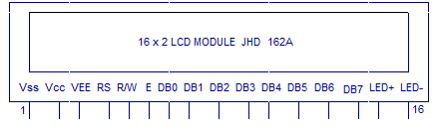
The name and functions of each pin of the 16×2 LCD module is given below.

Pin1(Vss)
Ground pin of the LCD module.
Pin2(Vcc)
Power to LCD module (+5V supply is given to this pin)
Pin3(VEE)
Contrast adjustment pin. This is done by connecting the ends of a 10K potentiometer to +5V and ground and then connecting the slider pin to the VEE pin. The voltage at the VEE pin defines the contrast. The normal setting is between 0.4 and 0.9V.
Pin4(RS)
Register select pin. The JHD162A has two registers namely command register and data register. Logic HIGH at RS pin selects data register and logic LOW at RS pin selects command register. If we make the RS pin HIGH and feed an input to the data lines (DB0 to DB7), this input will be treated as data to display on the LCD screen.
If we make the RS pin LOW and feed an input to the data lines, then this will be treated as a command ( a command to be written to the LCD controller – like positioning cursor or clear screen or scroll).
Pin5(R/W)
Read/Write modes. This pin is used for selecting between read and write modes. Logic HIGH at this pin activates read mode and logic LOW at this pin activates write mode.
Pin6(E)
This pin is meant for enabling the LCD module. A HIGH to LOW signal at this pin will enable the module.
Pin7(DB0) to Pin14(DB7)
These are data pins. The commands and data are fed to the LCD module through these pins.
Pin15(LED+)
Anode of the back light LED. When operated on 5V, a 560 ohm resistor should be connected in series to this pin. In Arduino based projects the back light LED can be powered from the 3.3V source on the Arduino board.
Pin16(LED-)
Cathode of the back light LED.
For knowing more about LCD module JHD162A and its pin functions, read this article: Interfacing 16×2 LCD and 8051 microcontroller. The circuit diagram of interfacing LCD to Arduino for displaying a text message is shown below.

3.4 Circuit diagram:

Arduino to 16×2 LCD Module:

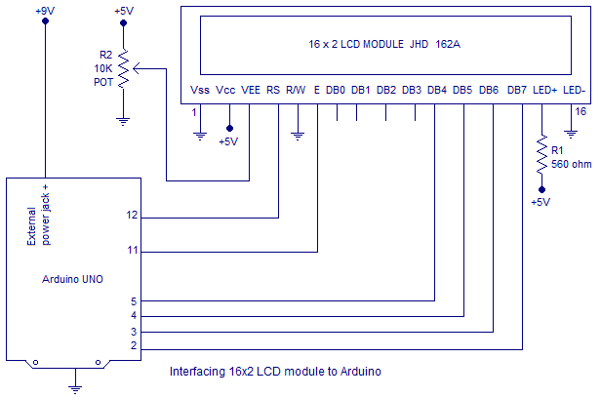

The RS pin of the LCD module is connected to digital pin 12 of the Arduino. R /W pin of the LCD is grounded. Enable pin of the LCD module is connected to digital pin 11 of the Arduino.
In this project, the LCD module and Arduino are interfaced in the 4-bit mode. This means only four of the digital input lines( DB4 to DB7) of the LCD are used. This method is very simple, requires less connections and you can almost utilize the full potential of the LCD module. Digital lines DB4, DB5, DB6 and DB7 are interfaced to digital pins 5, 4, 3 and 2 of the Arduino.
The 10K potentiometer is used for adjusting the contrast of the display. 560 ohm resistor R1 limits the current through the back light LED. The arduino can be powered through the external power jack provided on the board.
+5V required in some other parts of the circuit can be tapped from the 5V source on the arduino
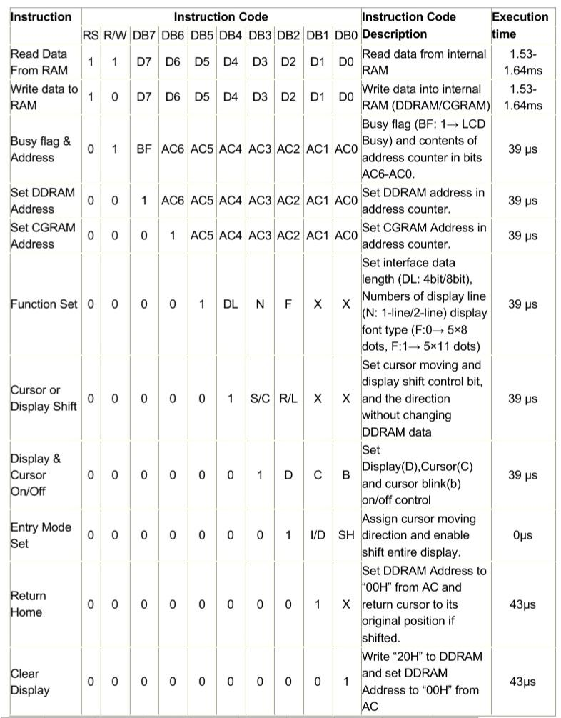
Control and display commands
AC -Address Counter
3.5 Outline
Now the instruction can be divided mainly in four kinds
1) Function set instructions
2) Address set instructions
3) Data transfer instructions with internal RAM
4) Others
3.6 Details of the Instructions
1) Read Data from RAM
RS | R/W | DB7 | DB6 | DB5 | DB4 | DB3 | DB2 | DB1 | DB0
1 | 1 | D7 | D6 | D5 | D4 | D3 | D2 | D1 | D0
Read 8 bit binary data from DDRAM/CGRAM
The selection of RAM is set by the previous address set instruction. If the address set instruction of RAM is not performed before this instruction, the data that is read first is invalid, because the direction of AC is not determined. If the RAM data is read several times without RAM address set instruction before read operation, the correct RAM data from the second, but the first data would be incorrect, as there is no time to transfer RAM data. In case of DDRAM read operation, cursor shift instruction plays the same role as DDRAM address set instruction; it also transfers RAM data to the output data registers.
After read operation, the data address counter is automatically increased or decreased by 1 according to the entry mode. After CGRAM read operation, display shift may not be executed properly.
In case of RAM write operation, AC is increased or decreased by 1 like that of the read operation. In this time AC indicates the next address position, but the previous data can only by the read instruction.
2) Write data to ram
RS | R/W | DB7 | DB6 | DB5 | DB4 | DB3 | DB2 | DB1 | DB0
1 | 0 | D7 | D6 | D5 | D4 | D3 | D2 | D1 | D0
Write binary 8bit data to DDRAM/CGRAM. The selection of CGRAM or DRAM is set by the previous address set instruction; DDRAM address set, CGRAM address set. RAM set instruction can also determine the AC direction to RAM.
After write operation, the address is automatically increased or decreased by 1 according to the entry mode.
3) Read Busy Flag and Address
RS | R/W | DB7 | DB6 | DB5 | DB4 | DB3 | DB2 | DB1 | DB0
0 | 1 | BF | AC6 | AC5 | AC4 | AC3 | AC2 | AC1 | AC0
By making this readout operation, it can be determined if the LCD is performing some internal operation or not. If Busy Flag (BF) is high, some internal operation is going inside the LCD at that particular moment. To perform further operation the data source (e.g. micro controller) must wait for the BF to go low. Here, the address counter value can also be read.
RS | R/W | DB7 | DB6 | DB5 | DB4 | DB3 | DB2 | DB1 | DB0
0 | 0 | 1 | AC6 | AC5 | AC4 | AC3 | AC2 | AC1 | AC0
4) Set DDRAM Address

Set DDRAM address to AC, this instruction makes DDRAM data available from MPU. In 1-line display mode, DDRAM address rangers from “00H” to “4FH”. In 2-line display mode, DDRAM address in the first line ranges from “00H” to “27H”, and DDRAM address in the 2nd line is from “40H” to “67H”.
5) Set CGRAM address
RS | R/W | DB7 | DB6 | DB5 | DB4 | DB3 | DB2 | DB1 | DB0
0 | 0 | 0 | 1 | AC5 | AC4 | AC3 | AC2 | AC1 | AC0
Set CGRAM address to AC. This instruction makes CGRAM data available from MPU.
6) Function Set
RS | R/W | DB7 | DB6 | DB5 | DB4 | DB3 | DB2 | DB1 | DB0
0 | 0 | 0 | 0 | 1 | DL | N | F | X | X
DL: Interface data length control bit
DL=’1’ means 8bit mode of data transfer.
DL=’0’ means 4bit mode of data transfer
When 4 bit mode is activated, the data needs to be transferred in two parts, first higher 4 bits, and then lower 4 bits.
N: display line number control bit
N=’1’ will allows to characters to display in 2-lines
N=’0’ will allows to characters to display in the first line only
F: display font control bit
F=’0’ will use 5×8 dots format display mode
F=’1’ will use 5×11 dots format display mode
7) Cursor or display Shift
RS | R/W | DB7 | DB6 | DB5 | DB4 | DB3 | DB2 | DB1 | DB0
0 | 0 | 0 | 0 | 0 | 1 | S/C | R/L | X | X
Without writing or reading the display data, shifting right/left cursor position or display.
This instruction is made to correct or search or display data. During 2-line display mode, cursor moves to the 2nd line after the 40th digit of the 1st line.
When displayed data is shifted repeatedly, each line shifts individually.
When display shift is performed, the contents of the address counter are not changed.
8) Display On/Off Control
RS | R/W | DB7 | DB6 | DB5 | DB4 | DB3 | DB2 | DB1 | DB0
0 | 0 | 0 | 0 | 0 | 0 | 1 | D | C | B
This instruction controls Display, Cursor and cursor blink.
D: Display On/Off control bit
D=’1’ means entire display is turned on
D=’0’ means the entire display is turned off. But Display data remains in DDRAM.
C: cursor On/Off control bit
C=’1’ turns on the cursor
C=’0’ turns off the cursor. But I/D register retains the data

B: Cursor blink On/Off control bit
B=’1’ makes the cursor blink periodically.
B=’0’ stops the cursor to blink and the cursor looks steady if the Cursor is turned on.
9) Entry Mode Set
RS | R/W | DB7 | DB6 | DB5 | DB4 | DB3 | DB2 | DB1 | DB0
0 | 0 | 0 | 0 | 0 | 0 | 0 | 1 | I/D | SH
This instruction sets the moving direction of the cursor and display.
When I/D= ’1’ cursor moves to the right and the DDRAM address is increased by 1.
When I/D= ’0’ cursor moves to the left and DDRAM address is decreased by 1.
CGRAM operates in the same way in this setting.
10) Return Home
RS | R/W | DB7 | DB6 | DB5 | DB4 | DB3 | DB2 | DB1 | DB0
0 | 0 | 0 | 0 | 0 | 0 | 0 | 0 | 1 | X
This instruction sets the address counter to ‘00H’, and returns the cursor to the first column of the first line. And if the display is shifted previously, this instruction shifts this too. The DDRAM contents don’t change in this instruction.
11) Clear display
RS | R/W | DB7 | DB6 | DB5 | DB4 | DB3 | DB2 | DB1 | DB0
0 | 0 | 0 | 0 | 0 | 0 | 0 | 0 | 0 | 1
Clear all the display data by writing “20H” (ASCII code of ‘space’ character) to all DDRAM addresses, AND set value DDRAM address counter (AC) to “00H”. It returns the cursor to the first column of the first line and sets the entry mode to increment mode (I/D=’1’).
3. 7 8-bit and 4-bit interfacing of LCD
Now the question is how to display data in the LCD or give commands to it. There are two modes of data transfer that are supported by LCD displays. One is 4bit mode, another is 8 bit mode. To transfer data In 8 bit mode, first put your data in the 8bit bus, then put command in the command bus and then pulse the enable signal.
To send data in 4bit mode; first put the upper 4bit in the 4 bit data bus connected to 4MSB pins of the LCD display, then put control signals in the control bus, then pulse the E pin once. Next put the lower 4 bit in the data bus and pulse the E pin again. Here is a flowchart simply describing it.
4. ESP8266 Module:
The ESP8266 is a very user friendly and low cost device to provide internet connectivity to your projects. The module can work both as a access point (can create hotspot) and as a station (can connect to Wi-Fi), hence it can easily fetch data and upload it to the internet making Internet of Things as easy as possible. It can also fetch data from the internet using API’s hence your project could access any information that is available on the internet, thus making it smarter. Another exciting feature of this module is that it can be programmed using the Arduino IDE which makes it a lot more user friendly. However this version of the module has only 2 GPIO pins (you can hack it to use upto 4) so you have to use it along with another microcontroller like Arduino, else you can look onto the more standalone ESP-12 or ESP-32 versions.
There are so many methods and IDEs available with ESP modules, but the most commonly used one is the Arduino IDE. So let us discuss only that further below.
The ESP8266 module works with 3.3V only, anything more than 3.7V would kill the module hence be cautious with your circuits. The best way to program an ESP-01 is by using the FTDI board that supports 3.3V programming. If you don’t have one it is recommended to buy one or for time being you can also use an Arduino board. One common problem that everyone faces with ESP-01 is the powering up problem. The module is a bit power hungry while programming and hence you can power it with a 3.3V pin on Arduino or just use a potential divider. So it is important to make a small voltage regulator for 3.31v that could supply a minimum of 500mA. One recommended regulator is the LM317 which could handle the job easily.

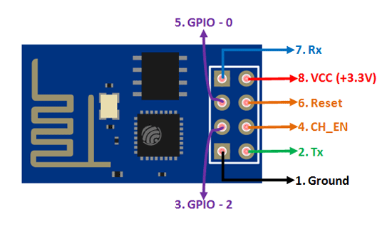
4.1 ESP8266 Pin Configuration
Pin Number | Pin Name | Alternate Name | Normally used for | Alternate purpose
1 | Ground | - | Connected to the ground of the circuit | -
2 | TX | GPIO – 1 | Connected to Rx pin of programmer/uC to upload program | Can act as a General purpose Input/output pin when not used as TX
3 | GPIO-2 | - | General purpose Input/output pin | -
4 | CH_EN | - | Chip Enable – Active high | -
5 | GPIO - 0 | Flash | General purpose Input/output pin | Takes module into serial programming when held low during start up
6 | Reset | - | Resets the module | -
7 | RX | GPIO - 3 | General purpose Input/output pin | Can act as a General purpose Input/output pin when not used as RX
8 | Vcc | - | Connect to +3.3V only
4.2 ESP8266-01 Features
- Low cost, compact and powerful Wi-Fi Module
- Power Supply: +3.3V only
- Current Consumption: 100mA
- I/O Voltage: 3.6V (max)
- I/O source current: 12mA (max)
- Built-in low power 32-bit MCU @ 80MHz
- 512kB Flash Memory
- Can be used as Station or Access Point or both combined
- Supports Deep sleep (<10uA)
- Supports serial communication hence compatible with many development platform like Arduino
- Can be programmed using Arduino IDE or AT-commands or Lua Script
5. Solar panel:
- 12 volt 10-watt polycrystalline solar panel USB charging.
- High conversion speed, high-efficiency output.
- Excellent low light effect.
- High transmittance tempered glass.
- A unique technique to prevent water frozen within the deforming framework.
The 10W 12 Volts 36-cell Solar Panel (41 x 30 cm) for DIY Projects is ready to use without requiring a frame or special modifications. We have chosen to sell these Polycrystalline solar cells because they are Laser cut to the proper size and encapsulated in the special sun and weather-resistant materials which give them unique characteristics.
The 12v 10W mini Solar Panel has Polycrystalline solar cells which are encased and protected by a durable outer poly frame. This 3v 150mA mini Solar Panel for DIY Projects is light weighted, very strong and weather-resistant substrates or injection molded trays custom-designed for the target product. These Small Epoxy Solar Panels are simple to install or add to your existing product and their construction requires no frame or special modifications.
Polycrystalline solar cells have 2 to 3 times the power of amorphous thin-film solar panels.

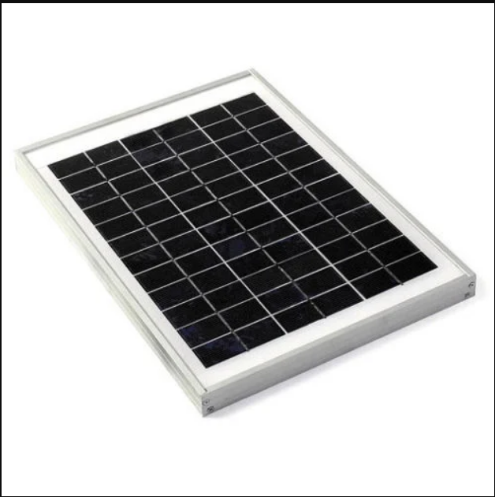
5.1 Features:
- 100% new high quality.
- 12 volt 10-watt polycrystalline solar panel USB charging
- High conversion speed, high-efficiency output.
- Excellent low light effect.
- High transmittance tempered glass.
- A unique technique to prevent water frozen within the deforming framework.
- Small Epoxy Solar Panels are simple to install or add to your existing product.
- Construction requires no frame or special modifications
- Small space required for installation.
- Has 2 to 3 times the power of amorphous thin-film solar panels
- Ready to use, they require no frame or special modifications.
- For connection, just solder or crimp to the copper tape.
5.2 Applications of Small Solar Panels:
- Small Home Projects
- Science Projects
- Electronic Applications.
- Charging Small DC Batteries.
- Build Your Own Solar-powered Models/Toys.
6. Battery:
1 x 10W 12 Volts 36-cell Solar Panel (41 x 30 cm). A twelve-volt battery has six single cells in series producing a fully charged output voltage of 12.6 volts. A battery cell consists of two lead plates a positive plate covered with a paste of lead dioxide and a negative made of sponge lead, with an insulating material (separator) in between. This is a rechargeable 12 volt 1.2AH Sealed Lead Acid Battery Our Power-Sonic or Equivalent valve regulated sealed lead acid batteries are maintenance free, easy to handle, rugged and economical. It has a characteristic of high discharge rate, wide operating temperature, long service life and deep discharge recovery. This product has Absorbent Glass Mat (AGM) technology for superior performance. This product is valve regulated and spill proof construction allows safe operation in any position and the power/ volume ratio yields unrivaled energy density. This product is approved for transport by air.

A 12-volt motorcycle battery is made up of a plastic case containing six cells. Each cell is made up of a set of positive and negative plates immersed in a dilute sulfuric acid solution known as electrolyte, and each cell has a voltage of around 2.1 volts when fully charged
Voltage | Amp Hours | Size
 | (20 hour) | Inches
12 | 1.2 | 3.82 x 1.77 x 2.09
12 | 1.9 | 7.01 x 1.34 x 2.36
12 | 2.3 | 7.01 x 1.34 x 2.36

7. CURRENT SENSOR
The current sensor is a device that detects and converts current to get an output voltage, which is directly proportional to the current in the designed path. When current is passing through the circuit, a voltage drops across the path where the current is flowing. Also, a magnetic field is generated near the current-carrying conductor. These above phenomena are used in the current sensor design technique.
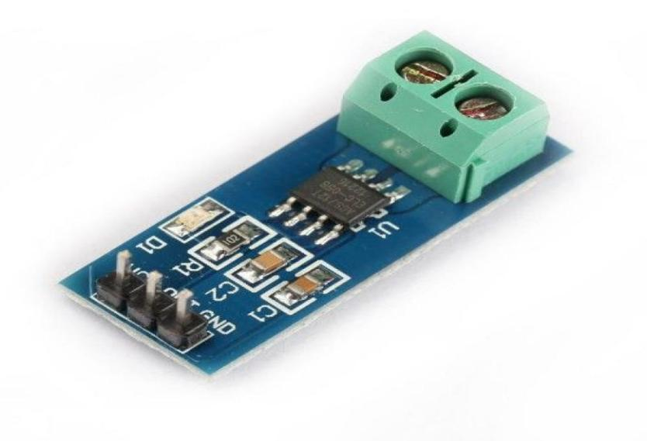
8. VOLTAGE SENSOR
A voltage sensor is a sensor used to calculate and monitor the amount of voltage in an object. Voltage sensors can determine the AC voltage or DC voltage level. The input of this sensor is the voltage, whereas the output is the switches, analog voltage signal, a current signal, or an audible signal. Sensors are devices that can sense or identify and react to certain types of electrical or optical signals. The implementation of a voltage sensor and current sensor techniques have become an excellent choice for the conventional current and voltage measurement methods. In this article, we can discuss a voltage sensor in detail. A voltage sensor can determine, monitor, and measure the supply of voltage. It can measure the AC level and/or DC voltage level. The input to the voltage sensor is the voltage itself, and the output can be analog voltage signals, switches, audible signals, analog current levels, frequency, or even frequency-modulated outputs.
We know that a capacitor comprises two conductors (or two plates); between these plates, a non-conductor is kept. That non-conducting material is termed dielectric. When an AC voltage is provided across these plates, current will start to pass due to either the electrons’ attraction or repulsion via the opposite plate’s voltage. The field among the plates will create a complete AC circuit without any hardware connection. This is how a capacitor works. Next, we can discuss the voltage division in two capacitors which are in series. Usually, in series circuits, high voltage will develop across the component with high impedance. In the case of capacitors, capacitance and impedance (capacitive reactance) are always inversely proportional. That is, some voltage sensors can provide sine or pulse trains as output, and others can produce amplitude modulation, pulse width modulation, or frequency modulation outputs. In voltage sensors, the measurement is based on a voltage divider. Two main types of voltage sensors are available: capacitive type voltage sensor and resistive type voltage sensor.
9. Internet of Things
The internet of things, or IoT, is a system of interrelated computing devices, mechanical and digital machines, objects, animals or people that are provided with unique identifiers (UIDs) and the ability to transfer data over a network without requiring human-to-human or human-to-computer interaction. A thing in the internet of things can be a person with a heart monitor implant, a farm animal with a biochip transponder, an automobile that has built-in sensors to alert the driver when tire pressure is low or any other natural or man-made object that can be assigned an Internet Protocol (IP) address and is able to transfer data over a network.
Increasingly, organizations in a variety of industries are using IoT to operate more efficiently, better understand customers to deliver enhanced customer service, improve decision-making and increase the value of the business.
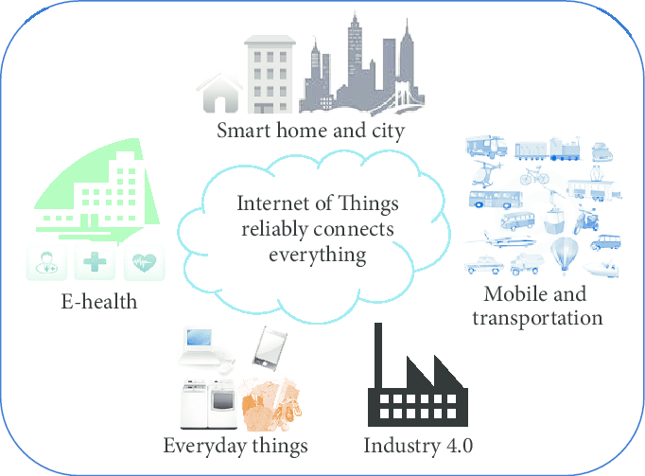
9.1 How IoT works?
An IoT ecosystem consists of web-enabled smart devices that use embedded systems, such as processors, sensors and communication hardware, to collect, send and act on data they acquire from their environments. IoT devices share the sensor data they collect by connecting to an IoT gateway or other edge device where data is either sent to the cloud to be analyzed or analyzed locally. Sometimes, these devices communicate with other related devices and act on the information they get from one another. The devices do most of the work without human intervention, although people can interact with the devices -- for instance, to set them up, give them instructions or access the data. The connectivity, networking and communication protocols used with these web-enabled devices largely depend on the specific IoT applications deployed. IoT can also make use of artificial intelligence (AI) and machine learning to aid in making data collecting processes easier and more dynamic.

10. CONCLUSION
In conclusion, monitoring the performance of solar panel systems is crucial to ensure they are functioning optimally and providing maximum energy output. IoT technology offers a reliable and convenient way to remotely monitor and control solar panel systems. The proposed solar panel monitoring system using IoT, LCD display, variable part, voltage sensor, current sensor, battery, and solar panel can provide valuable insights into energy production, consumption, and storage. By implementing this system, users can remotely monitor the performance of their solar panel systems, including voltage and current output, and the state of charge of the battery. This information can be used to optimize energy usage and reduce costs. Additionally, the system can detect any faults or issues with the solar panel system, allowing for prompt maintenance and repairs. the proposed solar panel monitoring system using IoT offers an efficient and effective way to monitor solar panel systems, ensuring they are functioning optimally, and providing maximum energy output.

REFERENCES
- J. Singh, "Internet of things (IoT) enabled solar panel monitoring system," 2019 IEEE 9th International Conference on Power and Energy Systems (ICPES), Chennai, India, 2019, pp. 127-132.
- Alharbi, A. Almutairi, and A. Alabdulwahhab, "Design and implementation of a solar panel monitoring system using internet of things," 2020 1st International Conference on Renewable Energy and Energy Storage (CREES), Riyadh, Saudi Arabia, 2020, pp. 1-6.
- K. Khairnar and R. Kulkarni, "Solar panel monitoring system using IoT," 2018 3rd IEEE International Conference on Recent Trends in Electronics, Information & Communication Technology (RTEICT), Bangalore, India, 2018, pp. 1251-1254.
- Darwesh, M. Elshaer, and H. El-Bakry, "Design and implementation of solar panel monitoring system based on internet of things," 2020 IEEE 13th International Conference on Compatibility, Power Electronics and Power Engineering (CPE-POWERENG), Blagoevgrad, Bulgaria, 2020, pp. 1-5.
- S. Shah, M. Khanna, and R. Kumar, "Design and implementation of a solar panel monitoring system using IoT," 2019 IEEE International Conference on Computational Intelligence and Communication Networks (CICN), Durgapur, India, 2019, pp. 354-358.
- Gupta and A. Kumar, "Solar panel monitoring system using IoT," 2019 2nd International Conference on Intelligent Computing, Instrumentation and Control Technologies (ICICICT), Kannur, India, 2019, pp. 1350-1354.
- B. A. Akram, N. N. Ismail, and M. F. Abdollah, "Smart solar panel monitoring system using IoT," 2020 International Conference on Computer and Communication Engineering (ICCCE), Penang, Malaysia, 2020, pp. 107-112.
- S. S. Srinivasan and S. Sankaranarayanan, "Solar panel monitoring system using IoT and machine learning," 2018 IEEE International Conference on Advanced Networks and Telecommunications Systems (ANTS), Indore, India, 2018, pp. 1-4.
- J. A. Oon, N. Ismail, and M. F. Abdollah, "A review on solar panel monitoring systems using Internet of Things (IoT)," 2018 International Conference on Innovative Technology, Engineering and Sciences (iCITES), Bali, Indonesia, 2018, pp. 1-5.
- P. C. P. Abraham and P. John, "IoT based smart solar panel monitoring system," 2017 IEEE International Conference on Innovations in Green Energy and Healthcare Technologies (IGEHT), Coimbatore, India, 2017, pp. 1-5.

