Blue, Green and Grey: Decoding the Colors of Water Footprint
Afreen Fatima*, Apoorva Singh Parihar, Sadanand Yadav, Deepa Srivastava
Department of Chemistry, C.M.P Degree College, University of Allahabad
211002, U.P, India
E-mail-srivastavadeepa660@gmail.com

ABSTRACT
In the twenty-first century, water scarcity and pollution have emerged as major global issues. Understanding the "water footprint" of various industries and locations has emerged as a crucial part of sustainable water management as water resources are depleted and water quality declines. This chapter explores the complicated realm of water footprints with the goal of unraveling the delicate connections between environmental effect, human activity, and water usage. The chapter emphasizes its value as a comprehensive measure of water consumption—direct and indirect—across the entire supply chain of goods and services. It covers alternative approaches for calculating water footprints, including the blue, green, and grey water components and their individual contributions to total water use, through a comprehensive review of the literature.
KEYWORDS
Sustainable practices, Virtual water, Water Footprint, Water scarcity, Awareness
INTRODUCTION TO WATER FOOTPRINT
A country, community, corporation, or individual's entire direct or indirect freshwater use for the production of products and services is referred to as their "water footprint." It is an assessment of the volume of water used, contaminated, or lost across the whole supply chain of a good or service (1). Professor Arjen Hoekstra of the University of Twente developed the idea of the water footprint in 2002 to offer a thorough understanding of water usage and its effects beyond the conventional method of focusing only on direct water consumption(2).
There are three components of Water Footprint
1. Blue Water Footprint: The entire amount of freshwater used by a person, business, or country to produce goods or services are referred to as their "blue water footprint". It specifically takes into account how much groundwater and surface water are used up or contaminated during manufacturing (3).
2. Green Water Footprint: The amount of precipitation used up by vegetation or crops is known as the "green water footprint." It has to do with the water that plants use that is kept in the soil(4).
3. Grey Water Footprint: The term "grey water footprint" describes the amount of freshwater needed to ingest the trash and pollutants produced by human activity. It calculates the amount of water required to dilute contaminants in order to achieve water quality standards (5).
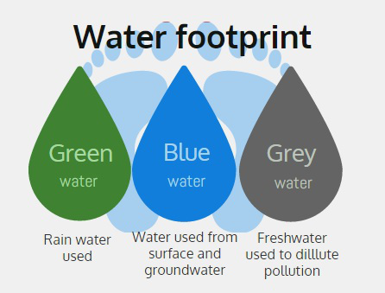
Fig 1: Source: Tinkersprogram.com(6).
SIGNIFICANCE OF WATER FOOTPRINT IN WATER RESOURCE MANAGEMENT
1. Awareness and Accountability: By estimating and comprehending the water footprint, people, organizations, and governments become more conscious of their water usage and the effects it has on regional and global water supplies. It encourages sustainable practices and encourages water consumption that is prudent (7).
2. Water Scarcity and Stress: Assessing water scarcity and stress in various places is made easier by the idea of water footprint. It enables decision-makers to pinpoint areas with scarce water resources and put policies in place to lessen the risks related to water shortage (8).
3. Water resource management: Water footprints offer useful data for efficient water resource management. It assists in identifying locations with excessive water use so that such regions can be targeted for efficiency and conservation measures.
4. Virtual Water Trade: Analyzing virtual water trade is made easier by being aware of the water footprint of products and services. Virtual water is the term used to describe the water that is incorporated into items that are sold abroad. By importing commodities that require a lot of water instead of producing them domestically in places with limited water supplies, nations may make the most use of their water resources(9).
5. Corporate social responsibility (CSR) and sustainability: Businesses can utilise the water footprint as a tool for CSR reporting and sustainability evaluations. It enables businesses to monitor and control their water usage, lessen their negative environmental effects, and encourage sustainable supply chain practices(10).
6. Policy Formulation: Governments can use water footprint information to create rules and laws for water management and conservation. This might entail establishing goals for water use effectiveness, implementing water pricing systems, and encouraging water-saving technologies.
CALCULATION AND ASSESSMENT OF WATER FOOTPRINT
1. Identify the Scope: Establish the parameters of the water footprint study. It could be a person, a group of people, a company, a thing, a whole nation. Be clear about the metrics being used.
2. Identify the Three Water Categories: Blue, Green, and Grey Water. These are the three elements that make up the water footprint. Understanding the various water sources and how they are used in the system under evaluation is necessary for this.
3. Gather Data: Compile information on water usage and consumption in the context of the selected scope. Water bills, agricultural records, industrial processes, and data from supply networks are a few examples of data sources. Since obtaining precise data might be difficult, guesses and averages may be employed(11).
4. Determine your water footprint:
- Blue Water Footprint: Determine how much freshwater was taken from surface or groundwater sources for a given activity. This covers irrigation, household water use, and commercial water use.
- Calculate the amount of precipitation used up by crops or other vegetation throughout their growth. Based on the water needs of various crops and the geographical areas where they are grown, this can be estimated.
- Grey Water Footprint: Determine the amount of freshwater needed to ingest the trash and pollutants produced by human activity. Understanding pollutant types, amounts, and water body dilution potential are necessary for this(12).
5. Add up the Parts: To calculate the overall water footprint for the given scope, add the blue, green, and grey water footprints together.
6. Normalize or Convert: By connecting the water footprint to a particular unit, such as per capita (for example, litre per person per day) or per unit of production (for example, litre per kilogram of product), the water footprint can be made more understandable. This makes comparison and analysis simpler (13).
With the aid of the CROPWAT 8.0 model, the water footprint assessment manual by Hoekstra et al. offers us two options for calculating the green and blue water footprint of crops: the crop water requirement option and the irrigation schedule option. Both of these options are thoroughly explained in the manual.
EFFECTS OF WATER SCARCITY AND WATER FOOTPRINT
1. Water Stress: Water stress occurs when a region's needs cannot be met by the water resources that are now available due to high water footprints and rising water demands. Water shortages, decreased agricultural production, and weakened ecosystems can all be caused by water stress (14).
2 .Ecological Impacts: A lack of water resources can damage ecosystems by causing wetlands, rivers, and other freshwater habitats to degrade. Reduced water flow has the potential to disturb aquatic ecosystems, have an impact on fish populations, and make species that depend on freshwater more vulnerable (15).
3. Food safety: The largest portion of water used globally is for agriculture. Especially in areas that primarily rely on irrigated agriculture, water scarcity and high water footprints in agriculture can pose a danger to food security. To secure food production in water-stressed locations, effective water management and sustainable farming practices are crucial (16).
4. Socioeconomic Consequences: A lack of water may have negative social and economic effects. As communities fight for few water supplies, it may cause poverty, inequality, and violence. Additionally, water-dependent industries like manufacturing and energy generation may experience operating difficulties and higher expenses (17).
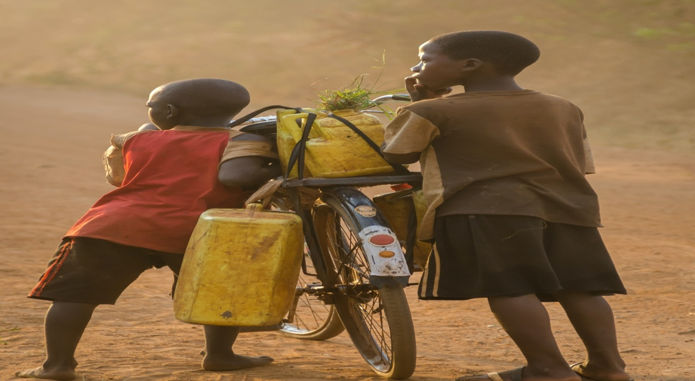
Fig2: Source:Unsplash.com, by Jeff Ackley(18)

MULTIFACETED STRATEGY TO ADDRESS GLOBAL WATER SCARCITY AND REDUCE WATER FOOTPRINT
1. Efficiency and conservation: Water resources can be released from stress by encouraging water conservation methods and enhancing water usage effectiveness in households, businesses, and agriculture.
2. Education and Awareness: Promoting responsible water usage, raising public awareness of water scarcity, and enticing people, groups, and organisations to adopt water-saving habits can all help ensure the long-term sustainability of water resources(19).
3. Governance and Policy: Governments are essential to the implementation of efficient water management plans, the promotion of water-saving technology, and the equitable distribution of water resources. To address the problems associated with transboundary water, international coordination and cooperation are also required(20).
4. Infrastructure for managing water resources: Creating and maintaining effective systems for managing water resources, such as water storage, distribution networks, and wastewater treatment facilities, can increase water availability and decrease waste.
5. Sustainable Agriculture: Using water-saving technologies, crop selection based on water availability, and precision irrigation techniques can help minimise the water footprint of agriculture while maintaining output(21).
VIRTUAL WATER TRADE
The term "virtual water trade" describes the covert transnational exchange of water incorporated into products and services. It measures the amount of water utilised in the manufacturing of goods that are traded between places with abundant and limited water supplies. A nation imports the virtual water necessary to produce things that need a lot of water. As a result of utilising water resources from exporting nations subtly, countries with a shortage of water are able to relieve strain on their local water supplies(22).
- Relation between Virtual Water ans Water Footprint
1. Virtual water as part of a product's water footprint: A product's virtual water content is essentially a component of its water footprint. In a way, importing a good with a large water footprint also entails importing the embedded virtual water needed for production(23).
2.Global Water balance: Understanding the allocation of water resources on a global scale requires knowledge of virtual water trade and water footprints. By utilising resources from water-rich locations, the trade enables regions with limited water resources to balance their water needs(24).
3. Sustainable Water Management: Countries may move towards more sustainable water management practises by taking into account the water footprint of items and promoting virtual water trade. This entails maximising water use, encouraging water-efficient technologies, and minimising wasteful water waste(25).

WATER FOOTPRINT OF FOOD AND AGRICULTURE
The entire amount of water used in the production, processing, and consumption of food and agricultural products is referred to as the "water footprint" of food and agriculture. It includes water needed for food processing, packing, and transportation as well as water used to grow crops, rear livestock, and manufacture other types of food.
The water footprint is a crucial idea because it clarifies how much water is needed to support our food systems. It sheds light on how human culinary habits and agricultural methods affect the environment, especially in areas where water is scarce(26).
Food item | Unit | Global average water footprint (litres)
Apple or pear | 1 kg | 700
Banana | 1 kg | 860
Beef | 1 kg | 15,500
Beer (from barley) | 1 glass of 250 ml | 75
Bread (from wheat) | 1 kg | 1,300
Cabbage | 1 kg | 200
Cheese | 1 kg | 5,000
Chicken | 1 kg | 3,900
Chocolate | 1 kg | 24,000
Coffee | 1 cup of 125 ml | 140
Cucumber or pumpkin | 1 kg | 240
Dates | 1 kg | 3,000
Groundnuts (in shell) | 1 kg | 3,100
Lettuce | 1 kg | 130
Maize | 1 kg | 900
Mango | 1 kg | 1,600
Milk | 1 glass of 250 ml | 250
Olives | 1 kg | 4,400
Orange | 1 kg | 460
Peach or nectarine | 1 kg | 1,200
Pork | 1kg | 4800
Potato | 1 kg | 250
Rice | 1 kg | 3,400
Sugar (from sugar cane) | 1 kg | 1,500
Tea | 1 cup of 250 ml | 30
Tomato | 1 kg | 180
Wine | 1 glass of 125 ml | 120
Table1: Food items, Units and Global Average Water Footprint(27)
The average global water footprint of different food products is shown in Table 1, and it is obvious that among the foods included, chocolate has the highest water footprint, requiring the most water during the entire production process.
CONCLUSION
Professor Arjen Hoekstra's idea of the water footprint is a crucial tool for comprehending and controlling water usage at all scales, from individuals to entire countries. The blue, green, and grey water footprints, which are the three parts of the water footprint, provide a thorough evaluation of direct and indirect water usage during the creation of goods and services.
The importance of the water footprint in managing water resources is extensive. It increases awareness, encourages accountability, and aids in locating water stress and scarcity hotspots. In order to maximise water resources internationally, rules can be developed that encourage sustainable behaviour and enable virtual water commerce.
Lastly taking into account the water footprint of food and agricultural goods is essential to comprehending how our dietary practises and agricultural practises affect the environment, particularly in areas with limited water resources. People and societies can choose more environmentally friendly consumption habits by being aware of the water footprint of various food items. We can strive towards protecting and effectively managing this priceless and limited resource by group efforts and deliberate decisions, ensuring a sustainable water future for future generations.

REFERENCES
1. Lovarelli, D., Bacenetti, J., & Fiala, M. (2016). Water Footprint of crop productions: A review. Science of The Total Environment, 548-549, 236 251. doi:10.1016/j.scitotenv.2016.01.022
2. Arjen Y. Hoekstra, The hidden water resource use behind meat and dairy Animal Frontiers, Volume 2, Issue 2, April 2012, Pages 3–8, https://doi.org/10.2527/af.2012-0038
3. Mekonnen, M. M., & Hoekstra, A. Y. (2020). Sustainability of the blue water footprint of crops. Advances in Water Resources, 103679. doi:10.1016/j.advwatres.2020.103679
4. Mekonnen, M. M. and Hoekstra, A. Y.: The green, blue and grey water footprint of crops and derived crop products, Hydrol. Earth Syst. Sci., 15, 1577–1600
.
5. Martínez-Alcalá, I., Pellicer-Martínez, F., & Fernández-López, C. (2018). Pharmaceutical grey water footprint: Accounting, influence of wastewater treatment plants and implications of the reuse. Water Research, 135, 278–287. doi:10.1016/j.watres.2018.02.033
6. Tinkersprogram.com
7. Christ, K.L. and Burritt, R.L. (2017), "Supply chain-oriented corporate water accounting: a research agenda", Sustainability Accounting, Management and Policy Journal, Vol. 8 No. 2, pp. 216-242. https://doi.org/10.1108/SAMPJ-05-2016-0029
8. Brauman, K.A., B.D. Richter, S. Postel, M. Malsy, and M. Flörke. 2016. Water depletion: An improved metric for incorporating seasonal and dry-year water scarcity into water risk assessments. Elementa Science of the Anthropocene 4: 1–12.
9. Paolo D'Odorico et al 2019 Environ. Res. Lett. 14 053001, DOI 10.1088/1748-9326/ab05f4
10. Simona Andreea Ene, Carmen Teodosiu, Brindusa Robu, Irina Volf, “Water footprint assessment in the winemaking industry: a case study for a Romanian medium size production plant”, Journal of Cleaner Production, Volume 43,2013,Pages 122-135,ISSN 0959-6526, https://doi.org/10.1016/j.jclepro.2012.11.051.
11. Hoekstra, A. Y., Chapagain, A.K.., Aldaya, M.M., and Mekonnen, M. M., 2011. The Water Footprint Assessment Manual: Setting the Global Standard. Earthscan, London.
12. M. Suhail, “Assessment of Water Footprint in Selected Crops: A State Level Appraisal”, J. Geographical Studies, 1(1), 11-25, 2017, DOI: 10.21523/gcj5.17010102

13. Winnie Gerbens-Leenes and Arjen Y. Hoekstra , “The water footprint of biofuel-based transport” Energy Environ. Sci., 2011,4, 2658-2668, https://doi.org/10.1039/C1EE01187A

14. M.M. Mekonnen, A.Y. Hoekstra, “Water footprint benchmarks for crop production: A first global assessment” / Ecological Indicators 46 (2014) 214–223,

https://doi.org/10.1016/j.ecolind.2014.06.013

15. Richter, B.D.; Mathews, R.; Harrison, D.L.; Wigington, R. Ecologically sustainable water management: Managing river flows for ecological integrity. Ecol. Appl. 2003, 13, 206–224 https://doi.org/10.1890/1051-0761(2003)013[0206:ESWMMR]2.0.CO;2

16. Munir A. Hanjra et al. Global water crisis and future food security in an era of climate changeFood Pol. (2010), https://doi.org/10.1016/j.foodpol.2010.05.006
17. Esha Shah, Janwillem Liebrand, Jeroen Vos, Gert Jan Veldwisch and Rutgerd Boelens, United Nations, World Water Development Report 2016: Water and Jobs. World Water Assessment Programme. Paris: UNESCO, 2016, Development and Change 49(2): 678–691. DOI: 10.1111/dech.12395
18. Unsplash.com, by Jeff Ackley
19. Tortajada, C., Joshi, Y.K. Water Demand Management in Singapore: Involving the Public. Water Resour Manage 27, 2729–2746 (2013). https://doi.org/10.1007/s11269-013-0312-5
20. Alejandro Jiménez et al, Unpacking Water Governance: A Framework for PractitionersWater 2020, 12(3), 827 https://doi.org/10.3390/w12030827
21. Hui Yu, Keli Liu, Yongyan Bai, Yong Luo, Tao Wang, Jia Zhong, Shaoquan Liu, Zhuoying Bai, The Agricultural Planting Structure Adjustment based on Water Footprint and Multi-objective optimisation models in China, Journal of Cleaner Production,Volume 297,2021,126646,ISSN 0959-6526,https://doi.org/10.1016/j.jclepro.2021.126646
22. Tamea, S., Laio, F. & Ridolfi, L. Global effects of local food-production crises: a virtual water perspective. Sci Rep 6, 18803 (2016). https://doi.org/10.1038/srep18803
23. Stanley T. Mubako & Christopher L. Lant (2013) Agricultural Virtual Water Trade and Water Footprint of U.S. States, Annals of the Association of American Geographers, 103:2, 385-396, DOI: 10.1080/00045608.2013.756267
24. Kuishuang Feng et al. Environ. Sci. Technol. 2014, 48, 14, 7704–7713, https://doi.org/10.1021/es500502q

25. Joana B. Aguiar, Ana M. Martins, Cristina Almeida, Helena M. Ribeiro, Joana Marto, Water sustainability: A waterless life cycle for cosmetic products, Sustainable Production and Consumption, Volume 32, 2022, Pages 35-51, ISSN 2352-5509, https://doi.org/10.1016/j.spc.2022.04.008

26. A. Ertug Ercin, Maite M. Aldaya, Arjen Y. Hoekstra,The water footprint of soy milk and soy burger and equivalent animal products,Ecological Indicators,Volume 18,2012,Pages 392-402,ISSN 1470-160X,
https://doi.org/10.1016/j.ecolind.2011.12.009
.
27. https://www.waterfootprint.org/resources/Hoekstra-2008-WaterfootprintFood.pdf

