Soil quality and Agroforestry

Varsha Pandey
Department of Soil Science
School of Agricultural Sciences, GD Goenka University, Sohna Road, Gurugram - 122103, Haryana, India
Rini Labanya
Faculty of Agriculture,
Sri Sri University, Cuttack - 754006,
Odisha, India

varshapandey.p93@gmail.com

Deepak Kumar
Department of Agronomy
School of Agriculture, Galgotias University,
Greater Noida, Uttar Pradesh- 203201

ABSTRACT

Soil represents a dynamic natural entity and serves as the foundation for both agricultural and natural plant ecosystems. It fulfills a multitude of functions, and soil quality can be defined as the "capability of the soil to perform these functions." Soil quality can be assessed from two perspectives: the inherent characteristics of the soil and its ever-changing nature influenced by factors such as climate, human activities, management practices, and land use patterns. Agroforestry is a land use approach that integrates the cultivation of woody perennial plants with agricultural crops and animal husbandry, aiming to harness multiple benefits from this symbiotic relationship. These benefits encompass economic, ecological, and biological interactions among the various components of agroforestry systems. One of the notable advantages of agroforestry is its positive impact on soil quality. Agroforestry practices have a pronounced effect on soil quality by enhancing soil aggregation and increasing the rate of water infiltration. Additionally, these practices elevate levels of soil organic carbon and augment the availability of essential nutrients in the soil. They also contribute to the enrichment of soil biodiversity. This enrichment results from the substantial input of biomass, both above and below ground, which introduces carbon and nutrients into the soil through the processes of decomposition and mineralization. Furthermore, the accumulation of organic matter in the form of litter from trees, shrubs, palms, and other vegetation in agroforestry systems acts as a protective shield for the soil surface, mitigating erosion and preventing the loss of valuable soil nutrients and fertility. Trees in these systems serve as effective windbreaks and shelter belts, providing a physical barrier that reduces wind-induced soil erosion. In summary, agroforestry-based land use systems significantly enhance soil quality, thereby improving agricultural productivity and ecological stability. This contribution to sustainable agriculture and environmental protection underscores the importance of integrating agroforestry practices into land management strategies.
窗体顶端
窗体底端

.

Keywords—soil quality, sustainability, litter, soil fertility, agroforestry.

INTRODUCTION

Soil, an integral component of the Earth's surface, is a dynamic natural entity formed through pedogenic processes arising from the weathering of rocks. It comprises mineral and organic components, possessing distinct chemical, physical, mineralogical, and biological attributes. Soil varies in depth across the Earth's surface, serving as a medium for plant growth [1]. According to the Food and Agriculture Organization (FAO), soil is a natural structure consisting of layers, known as soil horizons, comprised of weathered minerals, organic matter, air, and water, providing a natural environment for plant growth.
Soil microbiologists define soil as a 'polis,' essentially a society or community governed by soil microorganisms. The soil plays a crucial role in crop cultivation by serving as a reservoir for both water and essential nutrients, which in turn provides vital support for plant growth and development. The mineral components of soil house essential nutrients released gradually for plant uptake. Soil's organic matter and humus content vary, resulting from the decomposition of biomass, and the spaces between soil particles are filled with either air or water. In addition to serving as a physical medium for plant growth, soil is considered a living system vital for food and fiber production, as well as the provision of ecosystem services upon which life relies. Due to the interaction of physical, chemical, biological, and human-induced processes that operate at varying intensities within soil, it exhibits a high degree of variability [2], and these properties, in turn, influence its characteristics.
Soil is often referred to as the 'soul' of life due to its multifaceted functions. These functions describe what soil accomplishes and are commonly termed ecosystem services provided by soil resources. Soil constitutes a significant component of ecosystems, and its seven key functions are interconnected with one or more ecosystem services (Figure 1).

According to Seybold et al. (1998) [3], soil serves several critical functions:

- Sustaining plant and animal life, thereby promoting productivity.
- Facilitating the cycling of nutrients and carbon within the Earth's biosphere.
- Regulating and directing the flow of water and solutes.
- Acting as a filter, buffer, and detoxification agent for organic and inorganic substances, including municipal and industrial by-products, as well as atmospheric deposition.
- Providing physical stability and support for plants, socioeconomic structures, or safeguarding archaeological treasures associated with human habitation.

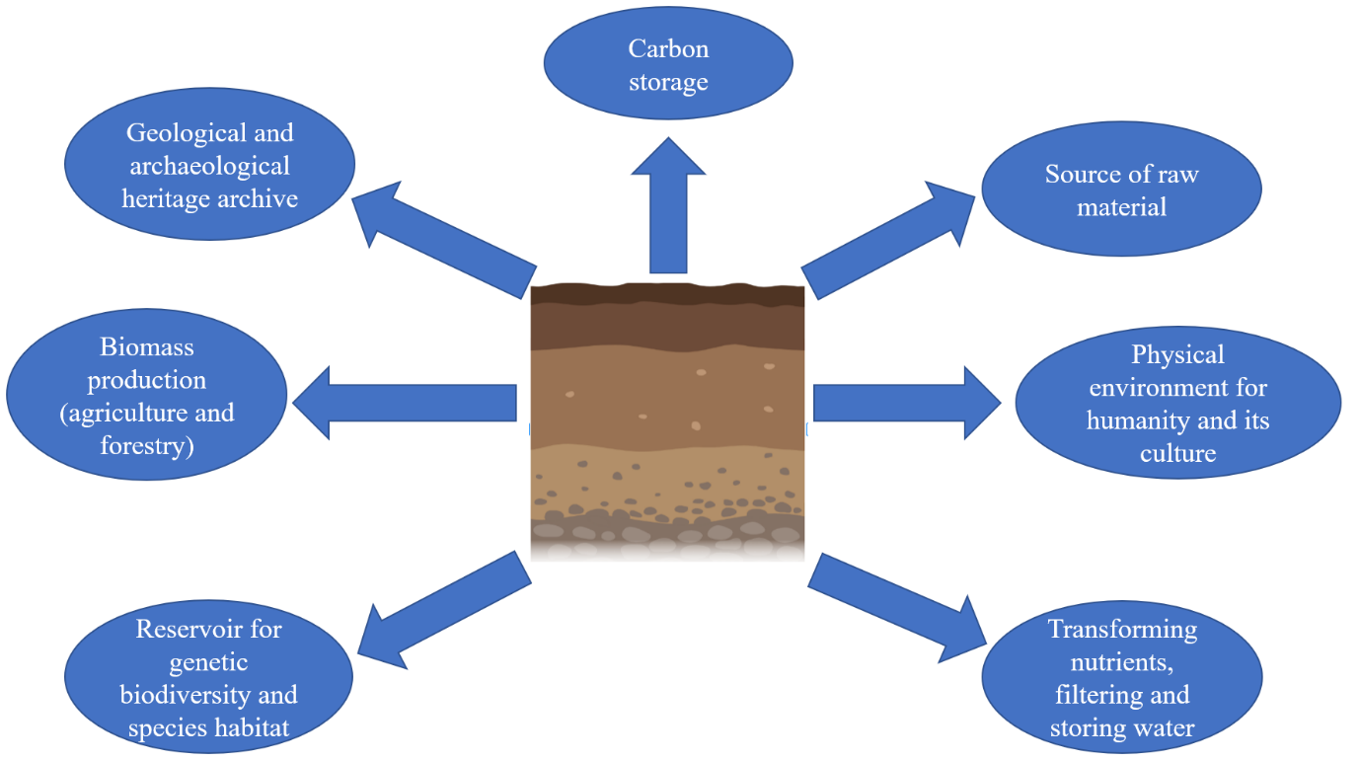
Figure 1: The 7 key functions of soil.

Soil is a fundamental natural resource, and its fertility represents the culmination of various soil properties managed to determine crop productivity and sustainability. Soil fertility is essentially the inherent capacity of soil to provide nutrients in sufficient quantities and in a balanced manner. Healthy and fertile soil not only leads to increased crop yields but also plays a vital role in maintaining environmental quality, which in turn influences the well-being of plants, animals, and humans. Unfortunately, due to the advancement of agriculture, soil degradation is occurring at an alarming rate. Factors such as water and wind erosion, desertification, and salinization are contributing to this degradation, primarily due to improper farming practices and misuse of the land. The decline in soil fertility is further exacerbated by the continuous cultivation of crops without adequate consideration for their specific nutrient requirements. Therefore, it is imperative to establish criteria for assessing soil fertility and implementing corrective measures to enhance it. The ultimate goal of evaluating soil fertility extends beyond achieving high levels of biological activity, aggregate stability, or other soil properties. It also encompasses the protection and improvement of long-term agricultural productivity, water quality, and the overall habitat for all living organisms, including humans [4].

SOIL QUALITY

- What is soil quality?

The notion of soil quality was initially introduced by Warkentin and Fletcher in 1977 [5] with the aim of enhancing resource distribution to boost food and fiber production. Since the early 1990s, numerous researchers have proposed various definitions for soil quality. According to Karlen, Gardner, and Rosek in 1998 [6], soil quality is described as the "capacity of a specific type of soil to function within its natural ecosystem boundaries, supporting plant and animal productivity, maintaining or improving water and air quality, and contributing to human health and habitation." Several scientists have also referred to soil quality as "fitness for use" or the "ability of the soil to function." Regardless of the specific definition, the common focus in literature remains on the soil's functions.
The perception of soil functions varies depending on the perspective of the observer. For land managers, soil quality is synonymous with the ability to enhance soil productivity and ensure sustainable crop yields. Farmers often equate soil quality with soil health, emphasizing the well-being of the soil. Conservationists prioritize the sustainability of soil resources while also safeguarding the environment. Consumers associate soil quality with the production of healthy and affordable food products. Environmentalists, on the other hand, emphasize the soil's role in maintaining biodiversity, water quality, and nutrient cycling [7]. With reference to national context, soil quality forms the basis for environmental policies aimed at protecting our ecosystems.
In scientific literature, "soil quality" and "soil health" are frequently used interchangeably, although scientists tend to favor the term "soil quality," while producers prefer "soil health" [8]. The United States Department of Agriculture (USDA) defines soil health as the "ongoing ability of soil to function as a vital, living ecosystem that supports plants, animals, and humans." Soil health is a dynamic property that can change in the short term and represents the condition of the soil at a specific moment. In contrast, soil quality is considered an intrinsic or static soil property, reflecting its suitability for a particular purpose over the long term [9]. These concepts of soil quality and soil health are subjects of debate within the soil science community. Soil quality primarily pertains to soil functions, while soil health characterizes soil as a finite, non-renewable, and dynamic living resource. Soil quality encompasses attributes of soil that may be influenced by management practices and have the potential to enhance or diminish soil health.

B. Inherent and dynamic soil quality

Soil quality can be understood in two distinct ways: as inherent properties of a soil and as the dynamic characteristics of soils influenced by climate, human activities, and management practices [10]. Inherent properties of soil are determined by the factors of soil formation, including climate, topography, vegetation, parent material, and time [11]. Each soil type possesses innate characteristics that define its capacity to function. In the context of the National Cooperative Soil Survey Program, soil qualities are defined as the inherent attributes of soil, such as texture, slope, structure, and soil color [12]. The second perspective on soil quality concerns the dynamic nature of soils, shaped by human use and management practices. Examples of this include the levels of organic matter and nutrient content in the soil. This interpretation of soil quality necessitates a reference condition specific to each soil type, against which changes in soil condition can be assessed. Currently, this dynamic aspect is the primary focus of the term "soil quality" (Figure 2).
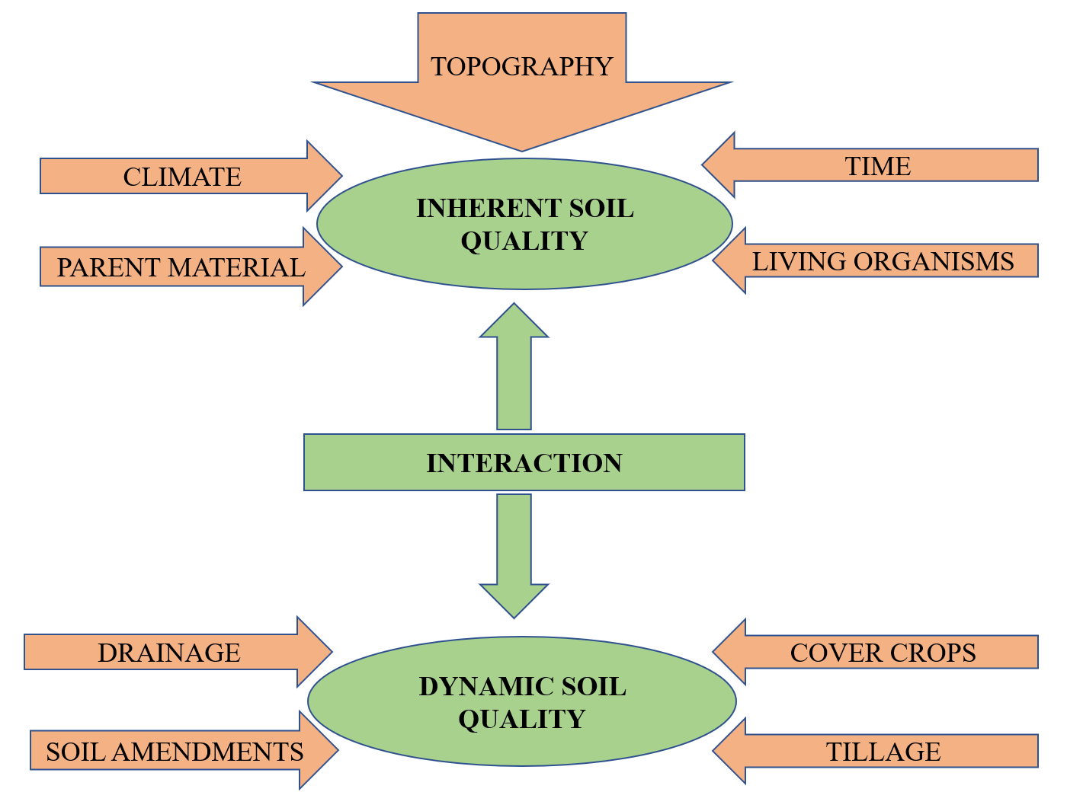
Figure 2: Inherent and dynamic features of soil quality.

C. Assessment of soil quality

Soil quality assessment relies on indirect measures due to the complex and imprecise nature of soil functions, which cannot be directly quantified. Instead, soil quality is evaluated through a set of versatile and broad indicators [13]. These indicators encompass various aspects of soil, including its chemical, physical, and biological properties. The objective is to establish a valid soil quality index that amalgamates data from diverse soil properties, thereby indicating whether specific land use or management practices are achieving desired outcomes in terms of productivity, environmental protection, and overall soil health [14].
To gauge a soil's capacity to function effectively, we rely on soil quality indicators (SQIs), which encompass its physical, chemical, and biological attributes [15]. These indicators must fulfill several criteria:

- Integration of Attributes: SQIs should encompass a blend of physical, chemical, and biological properties of the soil.
- Applicability in Diverse Conditions: They should be adaptable to various field conditions.
- Compatibility with Existing Data: SQIs should either complement existing databases or be easily measurable.
- Sensitivity to Environmental and Management Factors: They should be responsive to changes in land use, management practices, climatic variations, and human activities [15].
Selecting the right indicators is the cornerstone of soil health assessment (Table 1). These chosen indicators must strike a balance between ease of measurement and their ability to reveal underlying soil issues. Since soil quality cannot be directly measured in the field or laboratory due to its multifaceted nature, it is estimated using soil parameters or indicators. A mathematical or statistical framework emerged in the early 1990s to derive a soil quality index (SQI). This index reflects the state of soil and its quality by amalgamating various soil quality indicators into a single value, based on a combination of several soil properties [16]. Conceptual connections between soil quality indicators and crucial soil functions serve as the basis for computing these soil quality indices [18].

Table 1: Some of the commonly used soil quality indicators
Physical attributes | Chemical attributes | Biological attributes
- Soil texture  - Bulk density  - Porosity  - Water holding capacity  - Soil structure (aggregate stability)  - Water holding capacity  - Soil depth  - Hydraulic conductivity  - Infilteration  - Penetration depth  - Penetration resistance | - Soil pH  - EC  - Organic carbon  - Available macronutrients and micronutrients  - CEC  - Labile C and N  - Total and available N  - Available P and K  - Sodicity and salinity  - Heavy metals | - Microbial biomass C and N  - Soil enzymatic activities  - Soil respiration  - Earthworms  - N– mineralisation
Source: Vasu et al. (2020) [17]

Three common methods for computing the Soil Quality Index (SQI) [19]:

- Simple Additive SQI
This method, as outlined by Amacher, Neil, and Perry in 2007 [16], involves setting threshold values for various soil parameters based on literature review. Individual index values are assigned to each parameter, and these values are then summed up to calculate the total SQI. The SQI percentage is derived by dividing the total SQI by the maximum possible total SQI for the measured properties and multiplying by 100 [20].
$$\sum{ S}QI=\sum{Indiviual soil parameter index values}$$
SQI (%) = (total SQI / Maximum possible total SQI for properties measured) x 100

2. Weighted additive SQI
In this approach, soil parameters are first assigned unitless scores ranging from 0 to 1 using linear scoring functions [21]. The parameters are categorized based on mathematical algorithms:

- "More is better" (upper asymptotic sigmoid curve)
- "Less is better" (lower asymptotic sigmoid curve)
- "Optimum" (Gaussian function) [22]

Soil indicators are arranged based on whether higher or lower values are desirable for soil function. For example, for "higher is better" parameters like organic carbon, each observation is divided by the highest value to score it as 1. Conversely, for "less is better" parameters like bulk density, each data value is divided by the lowest value to score it as 1. "Optimum" parameters, like pH, are scored as "higher is better" up to a threshold value and as "lower is better" above that threshold [23]. These scores are then multiplied by weights assigned to each parameter based on their importance in soil quality [24-25].
Weighted soil quality index (WSQI) -
$$WSQI=\frac{1}{n} \sum_{i=1}^{n}{Wi∗Si}$$

Where,
Wi = weight assigned to the i ^{th} indicator
Si = linear or non-linear score of the i ^{th} indicator
n = number of indicators included in the index [26].

3. Statistically modeled SQI
This method utilizes principal component analysis (PCA) to create a statistics-based model for SQI. PCA reduces indicator load while retaining important information, and a minimum data set (MDS) is selected to reduce data dimensionality [27]. The choice of MDS can be initially based on expert opinion and then refined through statistical data reduction using techniques like PCA. Transformed scores are multiplied by weightage factors and summed to derive the SQI [28]. The schematic diagram for the computation of SQI using PCA is given in Figure 3.

The transformed scores are then multiplied by the weightage factors and then finally added to derive SQI.
SQI (PCA) = Ʃ Weight × individual soil parameter score

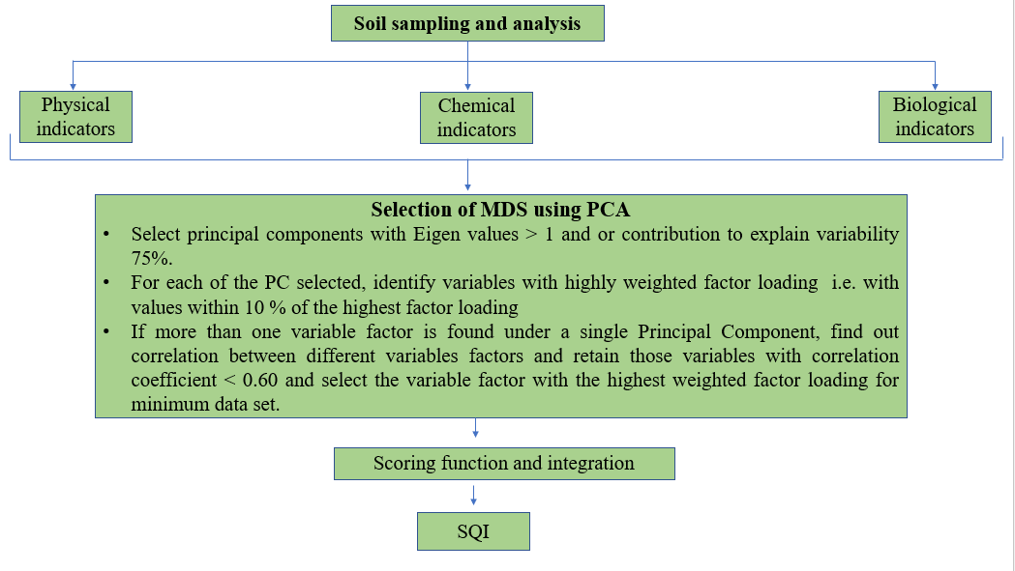
Fig. 3: Schematic diagram for calculation of Soil Quality Index using PCA.

Agroforestry

A. What is agroforestry?

Agroforestry is a dynamic and ecologically-driven method for natural resource management that involves the intentional integration of trees, shrubs, or palms into agricultural landscapes. This integration can occur through spatial arrangement or temporal sequencing, creating a diverse land use system. The primary objective is to enhance production while delivering a wide range of benefits, including social, economic, and environmental advantages to land users at various levels [29]. Agroforestry systems facilitate both ecological and economic interactions among these components, yielding various benefits in terms of economics, sociocultural aspects, and the environment. This approach is particularly important for rural communities and smallholder farmers, as it can have a positive impact on food availability, income generation, and public health. Agroforestry-based land use systems contribute to soil ecosystem functions in several ways [30]:
- Preservation of soil organic matter levels and the promotion of biological activity in the soil.
- Enhancement of nutrient cycling and efficiency in nutrient utilization.
- Improved water utilization efficiency in the soil.
- Restoration of degraded and eroded lands.
- Mitigation of climate change through carbon sequestration.
- Enhancement of air and water quality.
- Utilization of marginal lands.
Agroforestry is a holistic approach to land management that incorporates trees into agricultural settings, offering a wide array of benefits for both the environment and the people who depend on the land. It plays a critical role in enhancing soil health and sustainability while contributing to various socioeconomic aspects.

窗体顶端

窗体底端
B. Role of agroforestry system in influencing soil quality

Forests play a crucial role in the formation of soil through a combination of physical, chemical, and biological processes that weather parent rock and incorporate leaf litter, subsequently decomposing it. These processes significantly contribute to enhancing soil fertility. The ways in which trees can positively impact soil quality can be broadly categorized into four key areas (Table 3):

- Increased Input: Trees contribute by adding organic matter in the form of leaf litter and living biomass, both above and below ground, which enriches the soil with essential nutrients.
- Reduction of Losses: They help in reducing soil erosion and nutrient leaching, thus preserving soil resources and preventing valuable nutrients from being lost.
- Enhancement of chemical and physical properties of soil: Trees can enhance soil structure and composition, making it more conducive to plant growth. They also play a role in modifying soil pH and nutrient availability.
- Improvement in Biological Properties of Soil: Trees promote soil biodiversity by providing habitat and food sources for various microorganisms. This, in turn, enhances soil biological functions crucial for nutrient cycling and overall soil health.

The inclusion of trees in different land use systems leads to an increase in soil organic matter content due to the continuous addition of litter and living biomass, both above and below the surface. This organic matter serves as a source of carbon and energy for soil microbes, influencing soil biodiversity and associated biological functions [31]. In a soil-plant system, nutrients are in a constant state of dynamic transfer. Nutrients present in the soil are taken up by plants for various metabolic activities, and they are later returned to the soil through natural litterfall, pruning, or root senescence. Microbial activity decomposes these plant materials, releasing nutrients back into the soil, making them available for plant uptake. This continuous movement of nutrients within the soil-plant system is referred to as nutrient cycling. Nutrient cycling involves various processes, including rock weathering, nutrient release, soil biota activity, and transformations within the soil-plant-atmosphere continuum. Agroforestry-based systems occupy a middle ground in the spectrum of nutrient cycling systems. They are neither fully "closed" systems with minimal nutrient loss or gain, such as natural forest ecosystems, nor entirely "open" systems with high nutrient losses, like conventional agricultural systems [32]. As a result, agroforestry-based land use systems play a significant role in influencing soil fertility and overall soil quality. They strike a balance between nutrient conservation and productive land use, making them valuable tools for sustainable agriculture and environmental stewardship.

Table 2: Processes by which agroforestry-based systems improve soil quality.
Increased input  - Carbon fixation via photosynthesis  - Adding to soil N by nitrogen fixation  - Nutrient uptake from deeper layers of soil  - Exudation of certain growth promoting substances by the root rhizosphere | Reduction of losses  - Protection of soil from erosion  - Recycling nutrients which would otherwise be lost by leaching.  - Reduction of rate of organic matter decomposition by shading effect.
Enhancement of soil chemical and physical properties  - Improvement in soil moisture retention capacity, soil structure, soil porosity, permeability, infiltration rate  - Roots break down compact layers of soil  - Litter cover by tree canopy provides shading effect and regulates extremes of soil temperature.  - Enhance organic matter content of soil, ultimately increasing available nutrients for plants.  - Extensive lateral root system of trees scavenges soil nutrients and redistribute them.  - Reduction of soil acidity, basicity or sodicity. | Improvement in biological properties  of soil  - Higher microbial enzymatic activity due above and below ground litter cover and root exudates.  - Higher amount of soil microbial biomass C, N and P due to addition of varying quantity of organic matter input through litter fall.  - Availability of carbonaceous materials and substrates by decomposing litter fall of trees such as amino acids, sugar or organic acids supply carbon and energy to soil microbes.  - Positive effect on soil fauna.

During the lifecycle of a tree, branches, leaves, and twigs fall as litter contributing to soil organic matter after its decomposition. Also, the tree biomass can be used as a mulch. This reduces the erosive effect of the rainfall on soil surface. Root system of trees also stabilize the soil surface, reducing impact of rain drop and decreasing the intensity of erosion. Litter cover also have an added advantage of suppressing the weed growth. Many trees of the genera Acacia, Calliandra, Mimosa, Dalbergia, Erythrina can fix atmospheric nitrogen through symbiotic relationship with bacteria and fungus [33]. These nitrogen fixing trees are the key constituents in many natural ecosystems in the world. Besides N-fixation, the litter from these trees adds nitrogen to the soil after decomposition of litter.
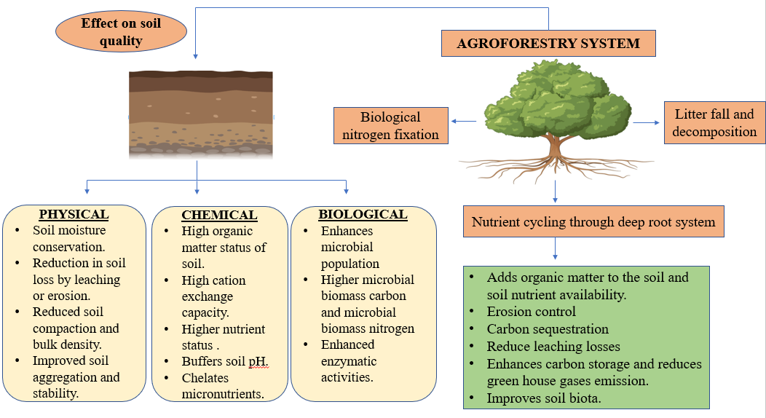
Fig. 4: Effect of Agroforestry based systems on soil quality.

Agroforestry-based land use systems offer a promising solution to mitigate land degradation and soil erosion, enabling the sustainable production of crops and livestock. Unfortunately, due to inadequate natural resource management, these resources face sustainability challenges. Trees play a pivotal role in conserving these resources. The extensive root systems of tree species effectively anchor the soil, reducing erosion caused by wind and water. Additionally, the vegetation acts as a protective shield against soil erosion processes, while also enhancing soil moisture retention through the capture of rainfall within the field [34].

IV. Case study: Assessing soil quality under agroforestry-based land use systems.

Land use refers to the arrangements, activities, and interventions carried out by individuals within a specific type of land cover to either produce, alter, or sustain it. The transition from forests to rangelands and agricultural lands has raised significant concerns regarding environmental degradation and global climate change. These land use systems have substantial impacts on soil properties, contingent upon factors like crop rotation, nutrient enhancements, and tillage methods employed. Over time, these practices can either enhance soil quality, degrade it, or maintain it at its current level. Alterations in land use systems and various management approaches can influence soil structure, soil organic carbon content, and nutrient reserves, ultimately affecting overall soil quality. To ensure sustained agricultural productivity, it is imperative to focus on the preservation and enhancement of soil quality.
An experiment conducted by Sharma in 2011 [36] aimed to investigate the effects of ten-year-old land use systems on soil quality. The study encompassed various systems, including agri-horticultural, agroforestry, pastoral, and arable land. The chemical soil quality index was utilized to assess the impact of physico-chemical soil properties on its overall quality. Weighted mean values of different parameters were standardized using a linear scoring method. The study findings revealed that the agroforestry system exhibited superior soil quality maintenance compared to other land use systems. Arable land, which remains under continuous agriculture, exhibited the lowest soil quality. This discrepancy could be attributed to the organic matter contribution from tree litter falls (such as Acacia auriculiformis), which comprised dead leaves, twigs, and branches. Additionally, biological nitrogen fixation by tree legumes and efficient nutrient cycling and mining from the sub-surface layer, along with nutrient solubilization through root exudate secretion, contributed to improved soil fertility. The root system of the trees also helped reduce nutrient losses through runoff and sedimentation.
In another study conducted by Pandey in 2018 [37], soil health was assessed under various land use systems in a Mollisol. Soil samples were collected from field crops, horticultural crops, agroforestry crops, and fallow land. These samples were subjected to analysis for diverse physico-chemical and biological properties, culminating in the evaluation of a soil health index using a simple additive method. The soil health index ranged from 69 to 83 percent across different land use systems (Figure 5). The highest soil health index was recorded in the eucalyptus + turmeric system, followed by the poplar + turmeric system, while the lowest was observed in the fallow (uncultivated land) system. The success of agroforestry-based land use systems can be attributed to their dense canopies, which facilitate increased nutrient accumulation and minimize nutrient loss through leaching.
These studies underscore the critical importance of land use systems in shaping soil quality and, consequently, agricultural productivity. Agroforestry systems, with their diverse benefits, emerge as a promising approach to maintain and enhance soil quality, offering valuable insights for sustainable land management practices. It also provided congenial conditions for microbial growth. Forest based system was also found to have more organic carbon status due to more litter falling from the trees [38-44].

Source: Pandey (2018) [37]

Fig.5: Soil health index (%) under different land use system in a Mollisol

V. Hierarchical relationship of soil quality to agricultural sustainability

Soil possesses various physical, chemical, and biological characteristics, and soil quality reflects the combined impact of these dynamic attributes. It is closely intertwined with environmental quality, a broader concept encompassing the quality of air, water, and soil. High-quality soils are effective in carrying out essential functions necessary for optimal plant growth. Each of these soil functions directly influences environmental quality. As a result, the condition of soil resources also has a consequential effect on air and water quality, thereby further influencing overall environmental quality (as depicted in Figure 6) [23;45].
The National Research Council (NRC), in their publication on soil and water quality [46], emphasized the significance of safeguarding soil quality as a core objective of national policy, akin to the protection of air and water quality. They drew a connection between soil quality and water quality, asserting that improving soil quality should be the primary step toward enhancing water quality.
Agricultural sustainability is defined as the "capability of crop production systems to consistently generate food without causing harm to the environment" [47]. A sustainable agricultural system typically contributes to the enhancement of soil quality. In 1977, Warkentin and Fletcher introduced the notion of soil quality as a metric for measuring agricultural sustainability [5]. Soil quality is also employed as an indicator of both environmental quality and agricultural sustainability [48-49]. The choice of soil quality indicators depends on the objectives of ecosystem management. If achieving sustainability is the primary goal of agroecosystem management, then soil quality becomes a vital component within a hierarchical framework for agroecosystem sustainability.

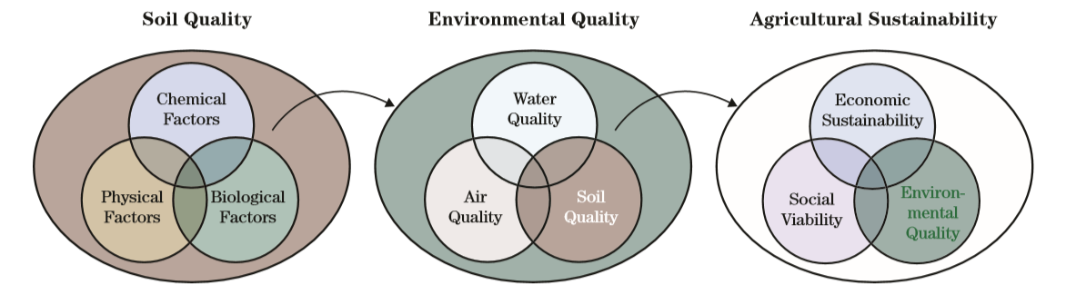Source: Andrews et al. (2002) [50]

Fig.6. Hierarchical relationship of soil quality to agricultural sustainability

VI. Methods for improving soil quality.

- Enhancement of Organic Matter: One of the most crucial methods for preserving or enhancing soil quality involves the annual incorporation of fresh organic matter. The addition of organic materials serves to enhance soil structure and aggregation, boost water and nutrient retention capacity, shield against erosion and compaction, and support microbial communities by supplying a carbon source. Regularly adding organic matter to the soil can be achieved through practices such as applying manure and compost, leaving crop residues in the field, cultivating cover crops, optimizing nutrient and water management, implementing reduced tillage systems, using mulching, and practicing crop rotation with high root biomass plants.
- Reduction in Tillage Intensity: Tillage refers to the mechanical manipulation of soil to loosen the surface, control weeds and pests, and create favorable conditions for crop growth. However, excessive tillage can disrupt soil structure, accelerate the decomposition of organic matter, induce compaction, and increase the risk of erosion.
- Maintenance of Ground Cover: Maintaining adequate ground cover safeguards the soil from erosion, provides habitat for soil organisms, enhances moisture retention, reduces evaporation losses, and, when using crop residues as ground cover, contributes additional organic matter to the soil while serving as a food source for soil organisms.
- Diversification of Cropping Systems: Crop diversification is a strategy that involves cultivating different plant species with varying root patterns. This approach can effectively reduce weed pressure, lower the incidence of diseases, and aid in pest management.
- Efficient management of pests and nutrients: excessive use of pesticides and chemical fertilizers can lead to soil quality degradation and environmental pollution over a period. Therefore, efficient management of pests and nutrients should be done by applying nutrient sources in the right dose and right place. Soil testing should be necessary part of nutrient management strategy as it will prevent excess or under usage of chemicals which will adversely affect soil quality. The usage of chemicals should be kept minimum by integrating its use with organic sources.
- Prevention of soil compaction: soil compaction leads to reduction of soil porosity, hinder root growth and impact soil organisms. Try to minimize soil compaction caused by heavy machinery, equipment or repeated traffic. [51;17].

窗体底端

Fig. 7. Principles of conservation agriculture

VII. Conclusion

The impact of agroforestry-based land use systems on soil quality is dependent upon factors such as soil type, climate, management techniques, and the specific crop cultivated. In a broad context, it is evident that agroforestry practices contribute to the enhancement of soil quality by augmenting its organic matter content, both through surface litter and soil carbon. The litter generated by trees additionally fosters the preservation of soil biodiversity, which positively influences soil fertility. Furthermore, agroforestry systems play a pivotal role in carbon sequestration, thereby mitigating greenhouse gas emissions and supporting the global effort to combat climate change, ultimately aligning with sustainable development goals.

REFERENCES

[1] Velayutham, M. and Bhattacharyya, T. 2000. Soil resource management. Natural Resource Management for Agricultural Production in India. Ed. Yadav, J.S.P. and G.B. Singh, International Conference on Managing Natural Resources for Sustainables Agricultural Production in the 21st Century.
[2] Goovaerts, P. 1998. Geostatistical tools for characterizing the spatial variability of microbiological and physico-chemical soil properties. Biol. Fertil. Soil. 27, 315–334.
[3] Seybold, C.A., Mausbach, M. J. Karlen, D.L. and Rogers, H.H. 1998. Quantification of soil quality. In Soil Processes and the Carbon Cycle.
[4] USDA, 2006. Soil quality institute. Natural resources conservation service. http://soils.usda.gov/sqi/.
[5] Warkentin, B. P. and Fletcher, H. F. 1977. Soil quality for intensive agriculture. In: Proceedings of international seminar on soil environ and fertilizer management in intensive agriculture, Society for Science of Soil and Manure – National Institute of Agricultural Science, Tokyo, 594–598.
[6] Karlen, D.L., Gardner, J.C. and Rosek, M.J. 1998. A soil quality framework for evaluating the impact of CRP. Journal of Production Agriculture 11: 56-60.
[7] Shukla, M. K., Lal, R. and Ebinger, M. 2006. Determining soil quality indicators by factor analysis. Soil & Tillage Research 87: 194–204.
[8] Harris, R.F. and Bezdicek, D. F. 1994. Descriptive aspects of soil quality/health. In: Defining Soil quality for a Sustainable Environment (J.W.Doran, D.C. Coleman, D.F. Bezdicek and B.A. Stewart, Eds). Soil Science Society of America, Special Publication. No. 35, Madison, Wisconsin. pp 23-35.
[9] Goswami, N.N. 2006. Soil and its quality vis-à-vis sustainability and society: some random thoughts. In Proceedings of International Conference on Soil, Water and Environmental Quality – Issues and Strategies, held during January 28 to February 1, 2005, at New Delhi, organized by Indian Society of Soil Science.
[10] Pierce, F.J. and Larson, W.E. 1993. Developing criteria to evaluate sustainable land management. In Proceedings of the 8th International Soil Management Workshop: Utilization of Soil Survey Information for Sustainable Land Use. J.M. Kimble, ed. USDA SCS, National Soil Survey Center, Lincoln, NE.
[11] Jenny, H. 1941. Factors of Soil Formation. McGraw-Hill, New York, 281 pp.
[12] Soil Survey Division Staff, 1993. Soil Survey Manual. U.S. Dept. Agric. Handbk No. 18, U.S. Govt. Print. Office, Washington, D.C. 437 pp.
[13] Andrews, S.S., Karlen, D.L. and Cambardella, C.A. 2004. The soil management assessment framework: a quantitative soil quality evaluation method. Soil Science Society of America Journal 68: 1945–1962.
[14] Chaudhary, J., Mandal, U. K. and Sharma, K. L. 2005. Assessing Soil Quality Under Long Term Rice-Based Cropping System. Communications in Soil Science and Plant Analysis 36: 1141–1161.
[15] Doran, J.W. and Parkin, T.B. 1994. Defining and assessing soil quality. In: Doran, J.W., Coleman, D.C., Bezdicek, D.F., Stewart, B.A. (Eds.), Defining Soil Quality for a Sustainable Environment. SSSA, Madison, WI, 3–21.
[16] Amacher, M. C., O’Neil, K. P. and Perry, C. H. 2007. Soil vital signs: a new soil quality index (SQI) for assessing forest soil health. Research Paper. RMRS-RP-65 www.Fort Collins, CO: U.S. Department of Agriculture, Forest Service, Rocky Mountain Research Station.
[17] Vasu, D., Tiwary, P. Chandran, P. and Singh, S. K. 2020. Soil Quality for Sustainable Agriculture Nutrient Dynamics for Sustainable Crop Production In book: Nutrient Dynamics for Sustainable Crop Production, 41-66. Doi 10.1007/978-981-13-8660-2_2.
[18] Karlen, D.L., Andrews, S. S. and Doran, J.W. 2001. Soil Quality: Current Concepts and Applications. Advances in Agronomy 74.
[19] Mukherjee, A. and Lal, R. 2014. Comparison of Soil Quality Index Using Three Methods. PLOS ONE 9(8).
[20] Michael, A. C., O’Neil, Katherine P Perry and Charles, H. 2007. Soil vital signs: A new Soil Quality Index (SQI) for assessing forest soil health. Res. Pap. RMRS-RP65WWW. Fort Collins, CO: U.S. Department of Agriculture, Forest Service, Rocky Mountain Research Station. 12 p.
[21] Triantafyllidis, V., Kosma, A. K. C. and Patakas, A. 2018. An Assessment of the Soil Quality Index in a Mediterranean Agro Ecosystem. Emirates Journal of Food and Agriculture 30(12): 1042-1050.
[22] Karlen, D. L. and Stott, D. E. 1994. A framework for evaluating physical and chemical indicators of soil quality. In: Doran JW, Coleman DC, Bezdicek DF, Stewart BA, editors. Defining soil quality for a sustainable environment. Madison, WI: Soil Science Society of America. 53–72.
[23] Andrews, S.S., Karlen, D.L. and Mitchell, J.P. 2002. A comparison of soil quality indexing methods for vegetable production systems in Northern California. Agriculture, Ecosystems & Environment 90:25-45.
[24] Bhaduri, D., Purakayastha, T. J. Patra, A. K. and Chakraborty, D. 2014. Evaluating soil quality under a long-term integrated tillage– water–nutrient experiment with intensive rice–wheat rotation in a semi-arid Inceptisol. Environmental Monitoring and Assessment 186:2535–2547.
[25] Liebig, M. A., Varvel, G. and Doran, J. 2001. A simple performance-based index for assessing multiple agroecosystem functions. Agronomy Journal 93: 313–318.
[26] Sinha, N. K., Chopra, U. K. and Singh, A. K. 2014. Cropping System Effects on Soil Quality For Three Agro-Ecosystems In India. Experimental Agriculture 50 (3): 321–342.
[27] Armenise, E., Redmile-Gorden, M. A. Stellacci, A. M. Ciccarese, A. and Rubino, P. 2013. Developing a soil quality index to compare soil fitness for agricultural use under different managements in the Mediterranean environment. Soil and Tillage Research 130:91–98.
[28] Lima, A.C.R., Brussaard, L. Totola, M. R. Hoogmoed, W.B. and de Goede, R.G.M. 2013. A functional evaluation of three indicator sets for assessing soil quality. Applied Soil Ecology 64, 194–200.
[29] Mead, D.J. 2004. Agroforestry. Forests and Forest Plants Vol 1. EOLSS Publishers, Oxford UK, pp. 324–355 Encyclopedia of life science systems.
[30] Young, A. 2003. Agroforestry for Soil Management (2nd ed.). CAB International, Wallingford, UK.
[31] Buresh, R.J. and Tian, G. 1997. Soil improvement by trees in sub-Saharan Africa. Agrofor. Syst. 38, 51–76.
[32] Nair, P.K.R., Kang, B.T. and Kass, D.B.L. 1995 Nutrient cycling and soil erosion control in agroforestry system. In Agriculture and Environment: Bridging Food production in Developing Countries. American Society of Agronomy. Madison, USA, pp. 117-138.
[33] Sarvade, S., Gautam, D.S., Upadhyay, V.V., Sahu, R. K., Shrivastava, A. K., Kaushal, R., Singh, R. and Yewale, A.G. 2019. Agroforestry and Soil Health: An Overview. In book: Agroforestry for Climate Resilience and Rural Livelihood (pp.275-297) Publisher: Scientific Publisher.
[34] Bundela, D. S. 2007 Water Management in Northeast India - Some Case Studies. Kaledhonkar et al (Eds). CSSRI, Karnal, India. pp. 40-46.
[35] Di Gregorio, A. and Jansen, L.J.M. 1998. Land Cover Classification System (LCCS): Classification Concepts and User Manual. For software version 1.0. GCP/RAF/287/ITA Africover – East Africa Project in cooperation with AGLS and SDRN. Nairobi, Rome.
[36] Sharma, K.L. 2011. Effect of Agroforestry Systems on Soil Quality-Monitoring Assesment.122-132. http://www.crida.in/DRM1-Winter%20School/KLS.pdf.
[37] Pandey, V. 2018. Assessment of soil health under different land use systems in a Mollisol. PhD diss. G. B. Pant University of Agriculture and Technology.
[38] Yadav, R. S., Yadav, B. L., Chhipa, B. R., Dhyani, S. K. and Ram, M. 2011. Soil biological properties under different tree based traditional agroforestry systems in a semi-arid region of Rajasthan, India. Agroforestry Systems 81:195–202.
[39] Ramos, Helen & Vasconcelos, Steel & Kato, Osvaldo & Castellani, Debora. 2018. Above- and belowground carbon stocks of two organic, agroforestry-based oil palm production systems in eastern Amazonia. Agroforestry Systems 92(2): 1-17.
[40] Hoosbeek, M.R., Remme, R.P. and Rusch, G.M. 2018. Trees enhance soil carbon sequestration and nutrient cycling in a silvopastoral system in south-western Nicaragua. Agrofor Syst. https://doi.org/10.1007/s10457-016-0049-2.
[41] Dhaliwal, J., Kukal, S.S. and Sharma, S. 2018. Soil organic carbon stock in relation to aggregate size and stability under tree-based cropping systems in Typic Ustochrepts. Agrofor Syst. https://doi.org/10.1007/s10457-017-0103-8.
[42] Yengwe, J., Amalia, O., Lungu, O. I. and Neve, S. D. 2018. Quantifying nutrient deposition and yield levels of maize (Zea mays) under Faidherbia albida agroforestry system in Zambia. European Journal of Agronomy 99:148-155.
[43] Prakash, D., Benbi, D.K. and Saroa, G.S. 2018. Land-use effects on phosphorus fractions in Indo-Gangetic alluvial soils. Agroforestry Systems 92: 437-448.
[44] De, P., Deb, S., Deb, D., Chakraborty, S., Santra, P. and Dutta P. et al. 2022. Soil quality under different land uses in eastern India: Evaluation by using soil indicators and quality index. PLoS ONE 17(9): e0275062. https://doi.org/10.1371/journal. pone.0275062.
[45] Soil Quality Technical Note No. 10. 2008. Soil Quality Physical Indicators: Selecting Dynamic Soil Properties to Assess Soil Function.
[46] National Research Council, 1993. Soil and Water Quality: An Agenda for Agriculture. Nationai Academy Press, Washington, D.C., 516 pp.
[47] Sharma, K. L. and Mandal, B. 2009. Soil quality and its relevance for sustainable agriculture. Journal of Indian Society of Soil Science 57:572–586.
[48] Bünemann, E. K., Bongiorno, G. Bai, Z. Creamer, R. E. Deyn, G. N. Goede, R. D. Fleskens, L. Geissen, V. Kuyper, T. W. Mädera, P. et al. 2018. Soil quality – a critical review. Soil Biology and Biochemistry 120:105–125.
[49] Herrick, J. E. 2000. Soil quality: an indicator of sustainable land management. Applied Soil Ecology 15:75–83.
[50] Andrews, S. S., Mitchell, J. P. Mancinelli, R. Karlen, D. L. and Hartz, T. K. 2002. On Farm Assessment of Soil Quality in California’s Central Valley. Agronomy Journal 94: 12–23.
[51] Chauhan, A. and Mittu, B. 2015. Soil Health - An Issue of Concern for Environment and Agriculture. Journal of Bioremediation and Biodegradation 6:286. doi:10.4172/2155-6199.1000286.

