AI-Powered Solutions for mitigating Climate Change and Enhancing
Public Health: Advancements in Addressing
Skin Disease Concerns

Shruti Awasthi¹, Archana Nalinan¹, Lahar Khandelwal¹,
Disha Maheshwari¹, Chethana V Chalapathy²*
Garden City University, Bangalore
shruti.awasthi@gardencity.university,archnanalinan@gmail.com, laharkhandelwal@gmail.com , maheshwaridisha8@gmail.com ,.
* Corresponding author. Tel: +91 78998 49374, chethana.v@gardencity.university

- Introduction

Climate change poses a significant challenge to environmental stability and human health, especially in vulnerable regions with diverse ecosystems. Extreme weather events, such as heatwaves, floods, and droughts, disrupt the delicate balance of the ecosystem, posing direct and indirect threats to human health. The region's reliance on agriculture and natural resources increases susceptibility to climate-related disruptions, potentially leading to food insecurity and adverse health consequences. One major health concern in this region is the increasing prevalence of skin diseases and related conditions. The changing climate creates a conducive environment for the proliferation of certain skin ailments, such as heat rashes, sunburns, and fungal infections. Additionally, changes in vector and pest distribution contribute to the spread of vector-borne skin diseases like leishmaniasis, dengue fever, and Lyme disease, which cause discomfort and pain but pose significant health risks if left untreated. AI technologies have emerged as invaluable tools to address the intertwined challenges of climate change and its health impacts. Machine learning algorithms can analyse vast datasets encompassing climate variables, environmental parameters, and health records, enabling researchers and policymakers to gain valuable insights into the intricate relationship between climate change and the health of the population in the region (Kim et al., 2022).

In this chapter, we will explore how AI-driven models are being employed to predict climate change patterns and assess potential health risks. Additionally, we will examine case studies and innovative applications where AI is leveraged to diagnose and manage skin diseases effectively. By understanding the nexus between climate change and health and harnessing AI's capabilities, we can take proactive measures to mitigate the adverse effects of climate change on vulnerable communities and improve overall health outcomes.

  - Climate Change and Skin Diseases

The increasing frequency of extreme weather events, rising temperatures, and shifts in precipitation patterns have contributed to changes in the distribution and prevalence of various skin conditions. Heat-related illnesses, allergic reactions, infectious diseases, and exacerbations of chronic skin conditions are among the health issues exacerbated by climate change. We concentrate on a specific area with a high incidence of skin diseases linked to climate change, such as a coastal region experiencing increased humidity, frequent storms, and rising temperatures. In this coastal region, the combination of increased humidity and rising temperatures has created a favorable environment for the growth of mold and fungi, leading to an increase in cases of fungal skin infections. Additionally, the frequent storms and heavy rainfall have resulted in more instances of dermatitis and other inflammatory skin conditions due to prolonged exposure to moisture (Balato et al., 2014).

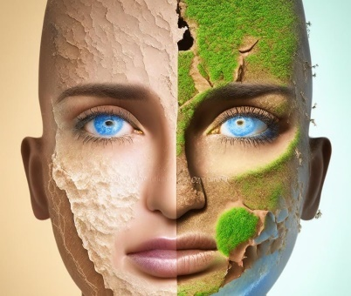
Figure 1 Climate Change and Skin Diseases

  - The Role of AI in Combating Climate Change and Health Impacts

Environmental monitoring parameters related to the climate are greatly aided by AI technologies such as machine learning algorithms and satellite imagery. This entails monitoring modifications in the vegetation cover, identifying regions susceptible to severe weather, and assessing pollution levels. Such data can help public health authorities better understand the local environmental factors that affect skin diseases. Statistical Models To predict the likelihood of skin disease outbreaks in the targeted area, AI-powered predictive models can analyse historical climate and health data. These models can provide advanced warning systems by taking into account variables like temperature, humidity, and pollution levels, allowing medical facilities to better plan and allocate resources. For example, in a coastal city with high pollution levels and humid weather, an AI-powered predictive model can analyse historical data to identify patterns of increased skin disease outbreaks during certain times of the year. This information can then be used by public health authorities to issue advisories and allocate resources such as additional dermatologists and medication supplies in advance, resulting in better preparedness and improved healthcare outcomes for the local population (Cowls et al., 2021).

  - AI Applications in Skin Disease Diagnosis and Treatment

AI-driven image recognition technology, specifically deep learning neural networks, can assist dermatologists in accurately diagnosing skin conditions like rashes, lesions, and infections. With access to a vast database of annotated images, AI algorithms can identify diseases with precision comparable to that of expert dermatologists. Personalized treatment plans can be recommended by integrating patient data and historical treatment outcomes and tailoring them to a patient's specific condition, medical history, and environmental factors, maximizing treatment chances. For example, a dermatologist can use a neural network to analyse images of a patient's skin rash and compare it to a database of annotated images to accurately diagnose the condition. The AI algorithm can then recommend a personalized treatment plan based on the patient's medical history, environmental factors, and previous treatment outcomes, increasing the likelihood of successful treatment (Li et al., 2020).

2 Climate Change and Skin Health: The Rising Concerns of Temperature, UV Radiation, and Their Impact on Skin Diseases

Climate change, caused by human activities like industrialization and deforestation, is a global concern with significant threats to human health, including skin health. Factors like rising temperatures, weather patterns, and UV radiation impact our skin. This chapter examines the effects of climate change on skin health, disease development, and the role of temperature, UV radiation, and other environmental factors in these processes.

2.1 Heatwaves and Skin: Unravelling the Impact of Rising Temperatures on Skin Health

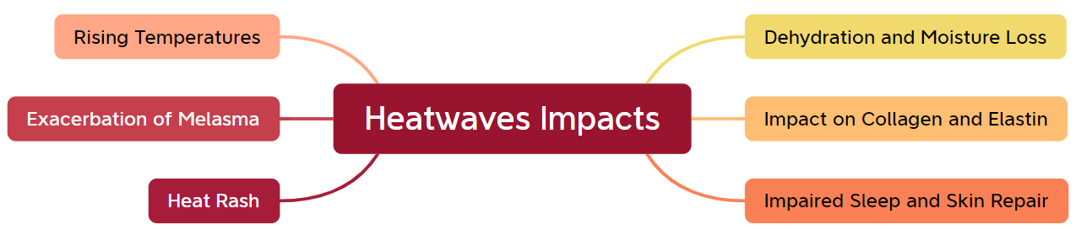
Figure 2 Impacts of heatwaves

Rising temperatures due to climate change cause prolonged periods of heat exposure, resulting in increased sweating and water loss from the skin. This can lead to dehydration, dryness, and exacerbation of skin conditions like eczema and psoriasis. Additionally, higher temperatures can cause skin inflammation and heat-related conditions like heat rash and heat stroke. These effects can be felt in various ways, including dehydration, moisture loss, heat rash, melasma exacerbated by sun exposure, impact on collagen and elastin production, and impaired sleep and skin repair. To mitigate these adverse effects, individuals must be proactive in protecting their skin from excessive heat and UV radiation by using sunscreen, seeking shade, and wearing protective clothing. Addressing climate change on a global scale is crucial to mitigate these adverse effects on skin health and overall well-being (Pliquett et al., 2008).

2.2 Solar Influence on Skin: Understanding the Effects of UV Radiation.
Climate change increases UV radiation levels, causing premature aging, wrinkles, and increased skin cancer risk. High UV index regions are at higher risk. Sunburn and UV-induced damage increase with higher temperatures, leading to long-term issues like premature aging, pigmentation changes, and skin cancer. Additionally, increased temperatures and UV exposure can trigger skin inflammation, worsening conditions like acne, rosacea, and psoriasis. A significant factor in how climate change affects skin health is UV radiation. It is a type of electromagnetic radiation that the sun emits and that reaches the surface of the Earth, where it can affect the skin in both good and bad ways. Based on wavelength, UV radiation is divided into three types: UVA, UVB, and UVC.

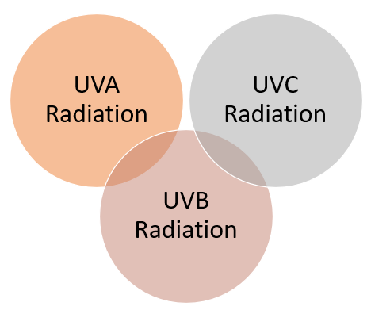

Figure 3 Three types of UV radiation

UV radiation, particularly UVB and UVA rays, significantly impact skin health, including sunburn, skin cancer, premature aging, immune system suppression, and eye damage. Exposure to UV radiation can cause redness, pain, and inflammation, leading to DNA damage and an increased risk of skin cancer. To protect the skin, it is essential to use a broad-spectrum sunscreen with an SPF of 30 or higher, seek shade, wear protective clothing, use UV-blocking sunglasses, and avoid tanning beds. Adopting preventive measures and recognizing the risks associated with UV radiation can help safeguard skin health and reduce the prevalence of skin diseases caused by exposure to harmful rays (Rigel et al., 2012).

UVA radiation | UVB radiation | UVC radiation
It has longer wavelengths and is less energetic than UVB and UVC rays, causing skin aging and wrinkling. | It’s has medium-wavelengths and more energy, primarily affects the outer layer of the skin, causing sunburns and skin cancer. | The most energetic and shortest wavelength is absorbed by Earth's atmosphere, it not a significant concern for skin health.
It damages collagen and elastin fibres, causing wrinkles, fine lines, and age spots. | Melanin, provides some protection against UVB rays, making darker skin less susceptible to sunburns | Excessive UVC radiation exposure can cause skin-related issues like sunburn, skin aging, skin cancer risk, and eye irritation.

Table 1: Types of UV radiation

2.3 Climate Woes: The Drying Effect of Droughts on Skin Health

Due to the arid temperatures that arise from climate change and extended droughts in some areas, people in those areas experience dry, cracked skin. As a result, xerosis (dry skin) and atopic dermatitis (eczema) may develop. As a result of dehydration, xerosis (dry skin), eczema (atopic dermatitis), pruritus (itching), slowed wound healing, and weakened barrier function, dryness, and droughts have a substantial negative influence on the health of the skin. Moreover, these disorders can speed up the aging process and emphasize wrinkles, fine lines, and sagging skin. People should apply moisturizers and emollients, stay out of the sun for short periods of time, and develop good skincare routines to keep their skin hydrated and safeguard its barrier function. It is essential to combat climate change via sustainable practices and water conservation initiatives to reduce the negative consequences of dryness on both the ecosystem and human health (Kiem et al., 2013).

2.4 Weathering the Storm: The Impact of Extreme Weather Events on Skin Diseases

Extreme weather events, such as hurricanes, cyclones, and wildfires, significantly impact skin health, causing burns, abrasions, and skin injuries. These events can lead to infections and scarring, as well as increased humidity and sunburn. Water-related skin conditions, such as contaminated water, can exacerbate existing conditions like eczema, acne, and fungal infections. Increased humidity can exacerbate existing skin conditions, and sunburns can occur due to increased UV radiation. Emotional stress, lack of access to skincare, and vector-borne diseases can also contribute to skin issues. Prioritizing safety and taking necessary precautions during and after these events is crucial to protecting skin health. Prompt medical attention and proper hygiene practices can help mitigate the risks associated with extreme weather conditions. Communities and healthcare systems should be prepared to provide support and resources to address the potential impact on skin health and overall well-being after these events (Ouyang et al., 2015).

2.5 Polluted Air, Unhealthy Skin: The Link Between Air Pollution and Dermatological Effects

Air pollution and Skin Health: One of the major effects of climate change is air pollution, which is brought on by numerous human activities including industrial operations, transportation, and the combustion of fossil fuels. These contaminants can harm the skin, aggravating pre-existing problems while also promoting the emergence of new ones.

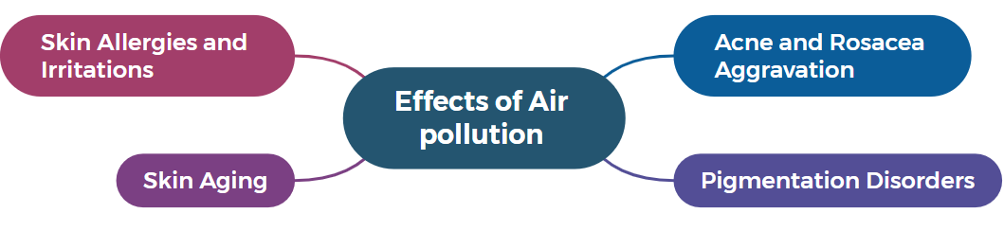
Figure 4 Some particular effects of air pollution on the health of the skin

Air pollution, including particulate matter (PM), can cause skin aging, acne, and rosacea aggravation. PM can penetrate the skin, causing oxidative stress and the breakdown of collagen and elastin, which are essential proteins for skin elasticity. Long-term exposure to air pollution can lead to wrinkles, fine lines, and a dull complexion. Additionally, air pollution can clog pores, increase dirt and bacteria accumulation, and worsen acne breakouts. The inflammatory nature of air pollutants can exacerbate conditions like rosacea, causing redness, flushing, and increased sensitivity. Air pollutants can also cause skin allergies and irritations, leading to contact dermatitis and other skin conditions. Additionally, certain air pollutants, like polycyclic aromatic hydrocarbons (PAHs), can disrupt melanin production, causing hyperpigmentation or dark spots, particularly in areas exposed to the sun (Koohgoli et al., 2017).

2.6 Other Environmental Factors in Skin Disease: Occupational Exposures, Climate, and Geographic Distribution

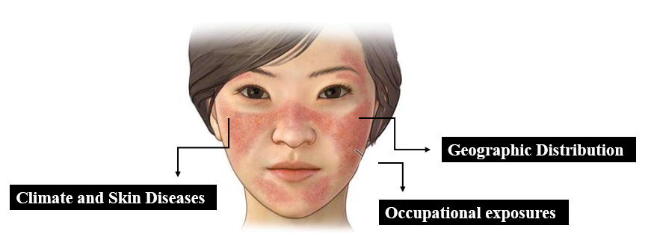
Figure 6 Other Environmental Factors in Skin Disease

Occupational exposures: refer to the contact with various agents and substances in the workplace that can affect the skin. Certain occupations, such as agriculture or construction, increase the risk of developing work-related skin diseases. Common occupational skin conditions include contact dermatitis, which can lead to redness, itching, and skin lesions. Occupational acne can result from exposure to oils, greases, or cutting fluids, clogging pores and causing breakouts. Outdoor professions, like construction or agriculture, may expose workers to higher levels of UV radiation, increasing the risk of skin cancer, including basal cell carcinoma and squamous cell carcinoma.
Climate and Skin Diseases: Climate and weather can impact the severity and prevalence of certain skin diseases, such as psoriasis, eczema, and eczema. Dry and cold climates can worsen symptoms, while warmer and more humid climates may lead to improvements. Warm and humid environments promote the growth of fungi and bacteria, increasing the risk of infections like athlete's foot, ringworm, and candidiasis. Additionally, intense sunlight in regions with high UV radiation levels can trigger photodermatoses, which are skin disorders worsened upon exposure to sunlight (Cecchi et al., 2018).
Geographic Distribution of Skin Diseases: Skin diseases can vary based on geographic locations due to environmental factors. For example, tropical regions may have more prevalent skin infections due to temperature and humidity differences. Cold climates may have more common conditions like cold urticaria and frostbite, while altitude may increase UV radiation levels, potentially increasing skin cancer and photodermatoses incidence. These variations in skin diseases can be influenced by factors such as vector insects, cold climates, and altitude.

3.AI in climate data analysis and identify disease

AI has significantly impacted climate data analysis and disease identification, offering valuable insights into climate patterns, trends, and potential correlations with diseases. AI-driven climate models improve prediction accuracy by incorporating historical data, satellite observations, and atmospheric parameters. Deep learning and neural networks help recognize intricate patterns, leading to more precise predictions of climate events like hurricanes, droughts, and heat waves. AI also aids in real-time weather event detection, detecting and monitoring extreme weather events, and assessing climate change impacts on regions and ecosystems. These insights help policymakers and scientists understand the potential consequences of climate change on agriculture, biodiversity, and human settlements (Subramanian et al., 2020).

3.1 AI-Driven Climate Modelling: Accurate Predictions for Climate Projections

AI-driven climate models improve future climate patterns with higher accuracy by incorporating historical data, satellite observations, and atmospheric parameters. Deep learning and neural networks recognize intricate patterns, enabling more precise predictions of climate events like hurricanes, droughts, and heatwaves. These complex models simulate interactions between Earth's climate system components, run on supercomputers, and generate simulations under various scenarios, including historical conditions, greenhouse gas emissions, and natural variability. Climate prediction deals with long-term trends and averages over extended periods, while weather forecasting focuses on short-term conditions. Climate models aid in attribution studies, policy implications, and aiding in adaptation and mitigation strategies (Singh et al., 2023).

AI-driven climate models
Global Climate Models (GCMs) | Regional Climate Models (RCMs)
GCMs analyse Earth's climate system interactions, providing insights into global phenomena like temperature rise, sea level changes, and precipitation patterns. | RCMs offer higher-resolution climate projections by simulating Earth's atmosphere, land, and oceans, downscaling from larger GCMs.
GCMs create a three-dimensional grid system representing Earth's atmosphere, oceans, land, and ice, with associated variables. | RCMs utilize a three-dimensional grid system for accurate climate patterns representation of smaller-scale features.
GCMs solve Earth's climate system equations using numerical methods, considering fluid dynamics, thermodynamics, and radiative transfer interactions. | RCM simulations use initial conditions, boundary conditions, and physical parameterizations for regional domains.
GCMs use time-stepping techniques to simulate climate over time, calculating variables' changes based on physical equations and grid cell values. | RCMs solve climate system equations, simulate short-term processes, and update grid cells based on physical interactions.
GCM simulates Earth's atmosphere, predicting weather patterns and long-term climate trends through processes like convection, radiation, and circulation. | RCMs simulate regional climate responses accurately, involving feedback mechanisms and validation processes for replication.
GCM simulations require supercomputers for complex calculations and vast data, accurately modelling Earth's climate system. | RCMs assess climate change impacts on water resources, agriculture, ecosystems, and extreme weather, aiding local adaptation.

Figure 7 AI-Driven Climate Models

3.2 Harnessing AI for Early Detection of Extreme Weather Events

Extreme weather events, such as hurricanes, tornadoes, heatwaves, and intense rainfall, can have severe impacts on communities, economies, and ecosystems. AI plays a vital role in detecting and monitoring these events in real-time, allowing for timely responses and disaster preparedness.
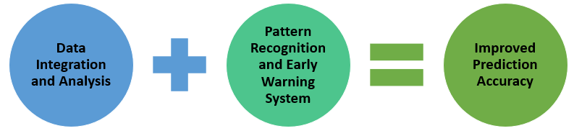
Figure 8 AI contributes to extreme weather event detection

Data Integration and Analysis

Data from different sources, such as weather satellites, ground-based sensors, weather stations, and social media platforms, is processed by AI algorithms. AI can quickly find patterns and anomalies connected to extreme weather events by integrating multiple datasets. As a result, the public can receive timely warnings and advisories from meteorologists and emergency personnel, preventing potential losses and saving lives

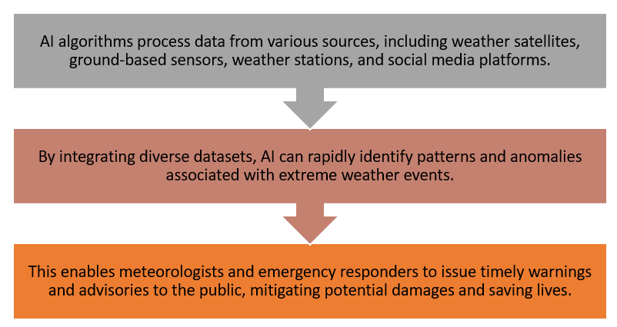
Figure 9 Data Integration and Analysis

Pattern Recognition and Early Warning Systems

AI-driven pattern recognition algorithms can identify specific weather patterns and precursors to extreme events. For instance, machine learning models can detect atmospheric conditions that precede a hurricane's formation or signs of an impending heatwave. Early warning systems powered by AI allow authorities to take preventive measures and evacuate vulnerable areas well in advance.
Pattern Recognition in dermatology uses AI algorithms to analyse skin images, identifying and categorizing conditions. Early Warning Systems can improve patient outcomes and reduce healthcare costs by facilitating early diagnosis of skin diseases. These systems offer advantages like timely detection, accessibility, efficiency, and enhanced accuracy. However, clinical expertise and human touch are crucial for comprehensive patient care (Tshipa et al., 2023).

Improved Prediction Accuracy

AI enhances short-term weather forecast accuracy by assimilating real-time data and machine learning algorithms. This allows for faster updates and more accurate predictions, particularly in rapidly changing weather conditions, where timely information is crucial. AI revolutionized healthcare by enhancing early detection of extreme weather events and their impact on public health. AI algorithms, like machine learning and deep learning, analyse weather data, predict skin disease outbreaks, and improve accuracy. AI systems enable data integration, pattern recognition, real-time monitoring, and geospatial analysis, enabling targeted public health interventions.
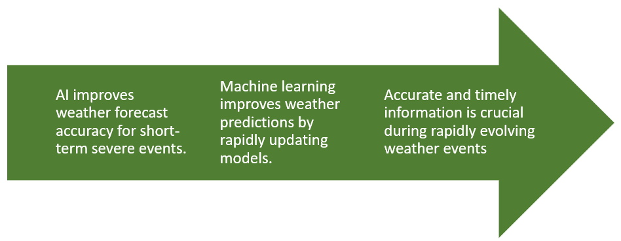

Figure 10 Features of Improved Prediction Accuracy

3.3 Assessing Climate Change Vulnerabilities

The environment, society, and economy are all significantly impacted by climate change. By examining extensive climatic data and identifying patterns, vulnerabilities, and possible dangers related to climate change, AI assists in evaluating these implications.
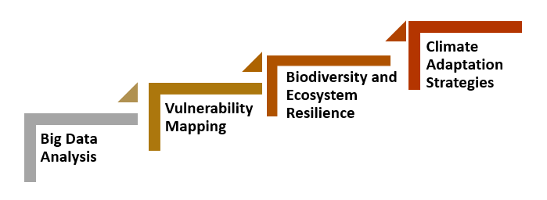
Figure 11 How AI benefits the evaluation of the effects of climate change

AI excels in processing large volumes of climate data, identifying patterns and detecting subtle changes in climate variables. This enables scientists and policymakers to assess the long-term effects of climate change on temperature, precipitation, sea level rise, and other crucial indicators. AI algorithms can create vulnerability maps highlighting regions most susceptible to climate change impacts, considering factors like population density, infrastructure, ecosystem health, and exposure to extreme weather events. AI supports the assessment of climate change impacts on biodiversity and ecosystems, projecting shifts in species distributions, habitat loss, and potential ecological disruptions. This information aids conservation efforts and the development of strategies to enhance ecosystem resilience in the face of climate change. AI-driven models can help develop climate adaptation strategies, such as building resilient infrastructure, implementing water management strategies, and formulating climate-aware agricultural practices (Jain et al., 2023).

3.4 Early Detection and Surveillance: AI-Driven Disease Identification

AI integration in disease identification revolutionizes healthcare by enabling healthcare professionals to analyse vast amounts of medical data with unparalleled accuracy and efficiency. This chapter explores the transformative impact of AI on disease identification, from early detection to personalized treatments, aiming for improved patient outcomes and a healthier future.

3.4.1 AI in Vector-Borne Disease Identification: Harnessing Climate Data for Public Health

AI in vector-borne disease identification uses advanced algorithms to analyse climate data and disease occurrence information for effective public health management. This approach helps identify patterns and correlations between climate variables and disease outbreaks, enabling early detection and prediction of potential disease hotspots. By leveraging AI, health authorities can allocate resources, implement control measures, and deploy interventions to mitigate the impact of vector-borne diseases in a changing climate (Eisen et al., 2011).

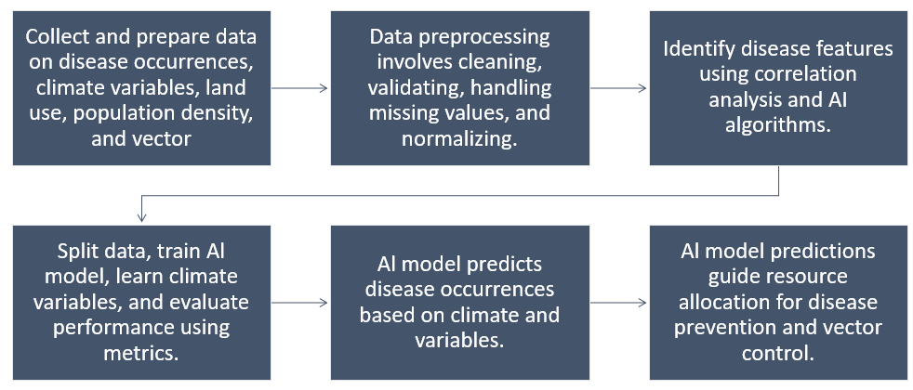

Figure 12 Steps involved in AI in Vector-Borne Disease Identification

3.4.2 AI-Driven Dermatology: Advancing Disease Identification in Skin Health

The first step in building an AI model for skin disease identification is data collection and preprocessing. A diverse dataset of skin images, including various skin conditions, is collected from medical databases, research institutions, or dermatology clinics. The model is trained using convolutional neural networks (CNNs), which learn from labelled images and adjust internal parameters to identify patterns and features indicative of specific skin diseases. Feature extraction is performed during training, allowing the model to detect subtle differences in skin lesions for accurate diagnosis. Validation and testing are crucial to ensure the model generalizes well and accurately identifies skin diseases beyond the training dataset (Barbieri et al., 2022).

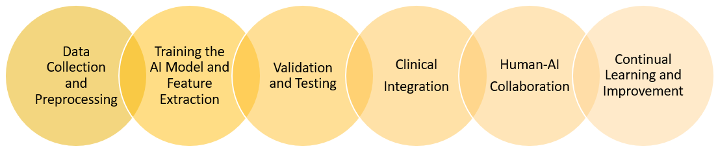

Figure 13 Unravelling the Steps in AI-Driven Skin Health

4 Harnessing AI to Predict Disease Hotspots based on Environmental Factors

The emergence and spread of infectious diseases have long posed significant challenges to global health. As human populations grow and interact with their surroundings, environmental factors impact disease transmission. AI advances enable innovative disease surveillance and prediction, accurately predicting disease hotspots based on vast datasets and complex interactions. This article explores the potential implications of AI in predicting disease hotspots based on environmental factors for public health (Arfanuzzaman et al., 2021).

4.1 The Integration of AI in Disease Surveillance

Disease surveillance is essential for public health, enabling early detection, monitoring, and response to infectious diseases. AI integration has revolutionized the field, offering advanced capabilities. AI-driven surveillance systems use machine learning algorithms to process vast amounts of data in real-time, resulting in more accurate predictions, targeted interventions, and lifesaving benefits. This enables targeted interventions and improved health outcomes (Wong et al., 2019).
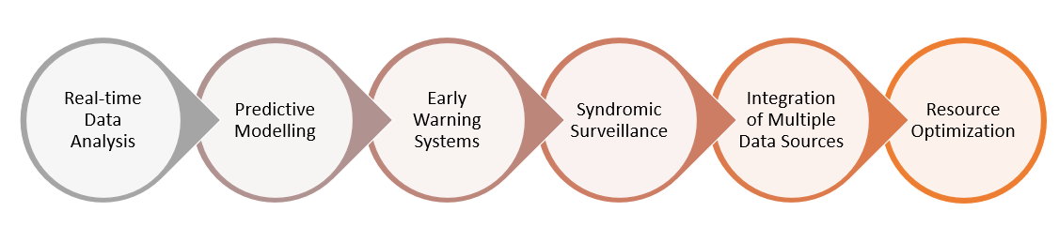

Figure 14 A Paradigm Shift in Public Health Monitoring and Intervention

AI algorithms enable real-time data analysis, enabling public health officials to stay updated on disease trends, track outbreaks, and respond quickly to emerging threats. Early detection is crucial in preventing the rapid spread of infectious diseases, and AI-powered surveillance systems excel at identifying unusual patterns or spikes in reported cases. Predictive modelling is another significant advantage of AI in disease surveillance, helping forecast the potential trajectory of an outbreak and aiding in resource allocation. AI-driven early warning systems bridge the gap between local and global health authorities, facilitating timely information sharing and collaborative efforts to control diseases at their source. Syndromic surveillance is enhanced by AI algorithms, which can analyse social media posts or search engine queries related to specific symptoms to detect clusters of illnesses in real time. AI-powered disease surveillance platforms integrate and analyse data from multiple sources, enabling more targeted and precise interventions. Resource optimization is crucial during large-scale outbreaks, where resources may be limited. By accurately predicting disease hotspots and transmission patterns, AI-driven surveillance systems enable more efficient allocation of resources, allowing health authorities to focus on areas with the highest risk, and ensuring medical supplies, vaccines, and healthcare professionals are deployed where they are most needed.

4.2 Machine Learning for Disease Hotspot Prediction

The ability to predict disease hotspots using machine learning (ML) has revolutionized how public health authorities monitor and address infectious diseases. By analysing enormous amounts of data from numerous sources, ML techniques make it possible to spot patterns, trends, and potential risk factors for the spread of disease (Ovek et al., 2022).

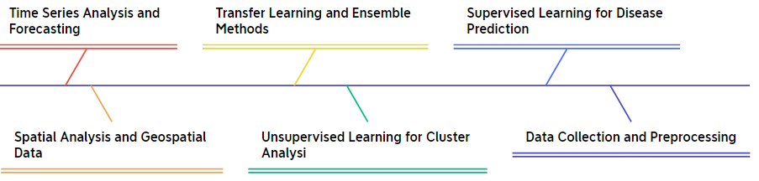

Figure 15 Several important features of machine learning for disease hotspot prediction

4.2.1 Data Collection and Pre-processing:

The success of ML models depends on quality and quantity of data available for analysis Relevant information in the context of disease hotspot prediction includes environmental factors (such as temperature, humidity, rainfall, land use, and vegetation), demographic data (such as population density, and age distribution), disease incidence data (such as reported cases, hospital admissions), and other factors that may affect disease transmission. Data preprocessing is crucial for maintaining consistency and removing biases in data. It involves cleaning, transforming, and normalizing the data, and imputes missing data using techniques to maintain dataset integrity.

4.2.2 Supervised Learning for Disease Prediction

Supervised learning is a widely used method for disease hotspot prediction, particularly when historical data on disease incidence and environmental factors is available. The ML model is trained on labelled data, identifying patterns and relationships between environmental factors and disease transmission.
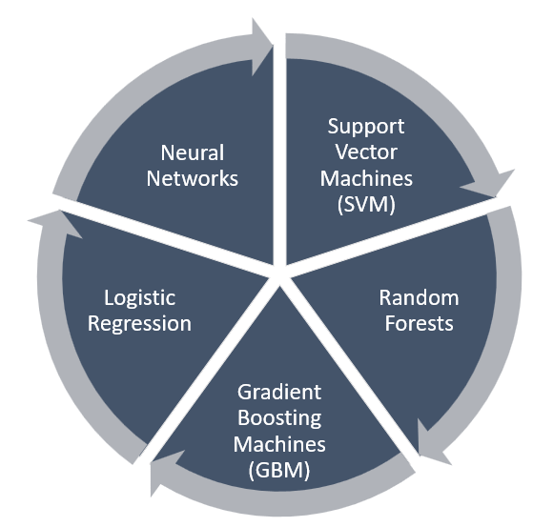

Figure 16 Popular supervised learning algorithms

4.2.3 Unsupervised Learning for Cluster Analysis

Unsupervised learning is employed when the dataset lacks labelled information, and the goal is to identify inherent patterns or clusters within the data. Clustering techniques are particularly useful for grouping regions or areas with similar characteristics, allowing the identification of potential disease hotspots. K-means clustering and hierarchical clustering are two common unsupervised learning techniques used in disease hotspot prediction. By analysing environmental variables and disease incidence, these algorithms can group areas that share similar characteristics and may be prone to similar disease patterns (Huang et al., 2020).

These clustering techniques can provide valuable insights into the spatial distribution of diseases and help public health officials allocate resources effectively. K-means clustering assigns each data point to the nearest centroid, while hierarchical clustering creates a hierarchy of nested clusters. Both methods can help identify clusters of high disease prevalence, aiding in targeted interventions and prevention strategies. By utilizing these unsupervised learning techniques, public health organizations can take proactive measures in controlling and preventing the spread of diseases.

4.2.4 Time Series Analysis and Forecasting

To comprehend how diseases change over time and how environmental factors affect them, time series analysis is essential. Based on historical data, time series forecasting techniques such as Autoregressive Integrated Moving Average (ARIMA) and Long Short-Term Memory (LSTM) networks are used to forecast disease trends and potential outbreaks.

These models can offer important insights into potential disease occurrences by examining historical disease patterns along with environmental factors and seasonal trends. For example, by analysing historical data on the mosquito population, temperature, and rainfall patterns, a time series analysis using ARIMA can identify periods of high mosquito activity and predict the likelihood of a dengue fever outbreak in a particular region. Additionally, LSTM networks can be utilized to forecast the spread of infectious diseases like COVID-19 by considering past transmission rates, population density, and social distancing measures (Kazemi et al., 2023).

4.2.5 Spatial Analysis and Geospatial Data

GIS is essential for disease hotspot prediction by integrating spatial data with machine learning algorithms. This enables the creation of disease risk maps, visualizations, and cluster identifications of diseases. By combining geographic data with environmental factors and disease incidence, public health authorities can pinpoint high-risk areas, prioritize resource allocation, and design targeted interventions. GIS-based approaches are effective in predicting disease outbreaks and preventing the spread of infectious diseases. Researchers can analyse patterns and trends in disease data to identify potential hotspots and take proactive measures. Real-time monitoring and tracking of disease transmission enable authorities to respond quickly to emerging outbreaks and implement timely interventions. The integration of GIS with ML algorithms further enhances the accuracy and efficiency of disease hotspot prediction, as machine learning algorithms can analyse large volumes of data and identify complex spatial patterns.

4.2.6 Geospatial Analysis and GIS Integration

GIS platforms, powered by AI, help map disease data and environmental variables. By combining spatial data with machine learning algorithms, they identify disease hotspots and risk areas. This enables public health authorities to allocate resources efficiently and implement targeted interventions. For instance, an AI-driven GIS platform can analyse malaria cases and environmental variables, creating predictive models to identify high-risk areas. This information can be used to prioritize mosquito control, distribute bed nets, and allocate funding for healthcare facilities in identified disease hotspots.

4.2.7 Transfer Learning and Ensemble Methods

Transfer learning is a method where pre-trained ML models are adjusted to a particular disease prediction task. These models are frequently trained on large and diverse datasets. Transfer learning can improve disease hotspot prediction models' performance even with sparse data by drawing on knowledge from previously learned patterns. Multiple ML models are combined using ensemble methods to increase prediction accuracy and decrease overfitting. Ensemble techniques produce predictions for disease hotspots that are more dependable and robust by combining the results of multiple models (Ahasan et al., 2020).
This is especially helpful when dealing with complex and dynamic diseases that require accurate and timely predictions. Ensemble methods also allow for the exploration of different learning algorithms and parameters, providing a comprehensive analysis of the disease hotspot prediction task. In practice, combining the strengths of transfer learning and ensemble methods can lead to highly accurate and generalizable disease hotspot predictions, aiding in the effective allocation of resources and targeted interventions.

4.2.8 Benefits and Challenges

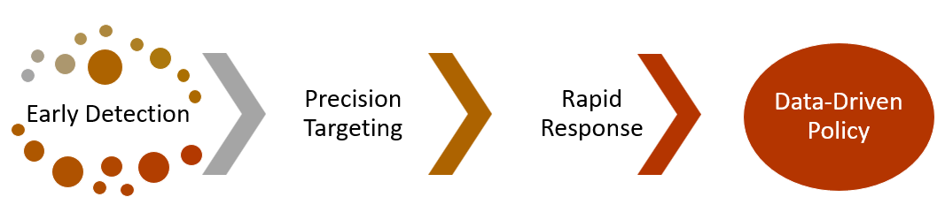

Figure 17 Several advantages to integrating AI in disease hotspot prediction based on environmental factors

AI algorithms enable early detection of outbreaks, containment, and containment, optimizing public health interventions' impact in high-risk areas. Real-time analysis minimizes disease spread and informs data-driven policies. AI-powered disease hotspot prediction revolutionizes public health and disease prevention efforts by enabling early warning, improved resource allocation, targeted interventions, enhanced surveillance, cost-effective solutions, identification of causative factors, global health impact, continuous improvement, and cross-disciplinary collaboration. AI models can identify disease-prone regions and high-risk areas, contributing to international efforts to control and prevent disease spread.

Data quality and availability are crucial for accurate predictions in the healthcare industry. Obtaining high-quality environmental data, such as air, water, temperature, humidity, and pollution levels, is essential for accurate predictions. Data integration is crucial for harmonizing diverse datasets from various sources. Researchers must carefully select and validate relevant environmental factors to ensure accurate predictions. Complex interactions between environmental factors and disease patterns require AI models to account for these interactions. Limited historical data for rare or emerging diseases can make it challenging to build accurate predictive models. Temporal and spatial variability is crucial for the effectiveness of predictive models. Disease surveillance and reporting inaccuracies can impact the data quality, potentially leading to biased or incomplete results. Ethical and privacy concerns arise when working with sensitive health and environmental data, and ensuring data security and consent is essential. Model interpretability is crucial for gaining trust from healthcare professionals and policymakers (Yang et al., 2017).

5 AI-enabled disease surveillance and early warning system

AI has revolutionized disease surveillance and early warning systems, especially in response to global pandemics and infectious diseases. AI-powered algorithms analyse vast amounts of data from social media, news reports, and health records, enabling faster detection of patterns and trends. This helps public health officials identify high-risk areas, monitor disease spread, and allocate resources accordingly. Machine learning models can predict future outbreak likelihood, aiding in proactive measures to prevent and mitigate the impact of pandemics. Skin diseases are a significant global health burden, affecting millions of people. Traditional disease surveillance methods have limitations in speed and accuracy, leading to delays in identifying outbreaks. AI presents an opportunity to revolutionize disease surveillance and create early warning systems for more effective skin disease detection and management (Zeng et al., 2021).

5.1 Data Sources and Integration

AI algorithms monitor social media, health records, and other online sources to detect skin disease outbreaks and unusual occurrences. This real-time data enables public health authorities to respond promptly and efficiently allocate resources. An effective AI-driven surveillance system relies on diverse data sources to gather comprehensive information. These sources include:

- Clinical Data: Electronic health records, laboratory results, and patient data from healthcare facilities contribute to a patient-centric perspective.
- Environmental Data: Information on weather patterns, climate changes, and ecological factors can help predict disease transmission and outbreaks.
- Social Media and Web Data: AI algorithms can analyse social media posts, news articles, and online discussions to detect early signals of potential outbreaks or public health concerns.
- Global Data Sharing: International collaboration and data sharing are vital in a globally connected world, as diseases can spread rapidly across borders.

5.2 AI-Powered Skin Disease Detection

AI technologies, particularly deep learning algorithms, have shown promise in image recognition tasks, including skin disease diagnosis. By training models on large datasets of skin images, these systems can accurately identify various skin conditions like dermatitis, psoriasis, eczema, and skin cancer. Integrating AI-powered skin disease detection systems into mobile apps allows users to take pictures of lesions and receive instant feedback on potential diagnoses, empowering individuals to monitor their skin health and contributing valuable data to a larger disease surveillance network.

5.3 Early Warning and Predictive Analysis

AI-driven early warning systems can detect skin disease prevalence changes at local, regional, and global levels. By analysing data from weather patterns, environmental conditions, and population mobility, these systems identify factors contributing to skin disease spread. This information enables health authorities to implement targeted interventions, raise public awareness, and provide medical assistance. AI algorithms excel in predictive analysis, learning from historical data to identify potential outbreaks before they escalate. They issue early warnings and analyse large-scale data in real-time, enabling early detection of disease outbreaks before widespread spread. Monitoring multiple data sources helps identify unusual patterns or clusters of symptoms, enabling swift response and containment measures to prevent further spread.
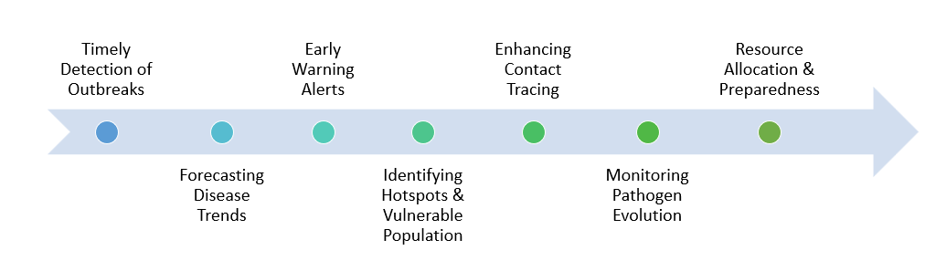

Figure 18 Early Warning and Predictive Analysis

5.2.1 Timely Detection of Outbreaks
Large-scale data can be analysed in real-time by AI algorithms, allowing for the early detection of disease outbreaks before they spread widely. AI can detect unusual patterns or clusters of symptoms that may point to the emergence of a new disease or the re-emergence of a known pathogen by simultaneously monitoring multiple data sources, such as clinical records, environmental data, and social media trends. Public health authorities can respond quickly and put containment measures in place to stop further spread thanks to this timely detection. This early detection can be crucial in preventing a small outbreak from turning into a full-blown epidemic. Additionally, AI algorithms can also analyse large amounts of data to identify the most effective and targeted containment measures. This not only saves valuable time and resources but also minimizes the impact on the affected population. Overall, the integration of AI in disease surveillance has revolutionized public health practices and has the potential to save countless lives (Borda et al., 2022).

5.2.2 Forecasting Disease Trends

AI-powered predictive models can forecast disease trends based on historical data and current variables. To predict the possible course of a disease epidemic, these models take into account variables including population migration, weather patterns, vaccination rates, and demographic data. Decision-makers may more efficiently allocate resources, schedule healthcare services, and get communities ready for possible health hazards by giving accurate forecasts. By analysing population migration patterns, AI-powered predictive models can estimate the potential spread of diseases across different regions. Additionally, considering weather patterns helps in understanding how climatic conditions may influence the transmission and severity of an epidemic. Furthermore, factoring in vaccination rates and demographic data allows decision-makers to identify vulnerable populations and prioritize preventive measures or allocate resources accordingly. Ultimately, the use of accurate forecasts enables healthcare providers to proactively prepare and respond to potential health hazards, ultimately saving lives and minimizing the impact of epidemics.

5.2.3 Early Warning Alerts

AI-driven surveillance systems can automatically produce early warning notifications for the public, healthcare professionals, and other relevant stakeholders. These warnings could contain details on the type of epidemic, the affected regions, and suggested preventive actions. The timely distribution of such information is essential for starting a quick reaction, stopping further transmission, and making sure that the right medical measures are carried out as soon as possible. By analysing patterns in data and monitoring real-time trends, AI-driven surveillance systems can provide accurate and up-to-date information on the spread of diseases. This enables public health authorities to quickly mobilize resources, allocate medical supplies, and implement targeted interventions in the affected regions. Additionally, the suggested preventive actions can help raise public awareness and educate individuals on how to protect themselves, ultimately curbing the transmission of the epidemic more effectively. Overall, these AI-powered early warning systems play a crucial role in mitigating the impact of outbreaks and safeguarding public health (Borda et al., 2022).

5.2.4 Identifying Hotspots and Vulnerable Populations

Geographical hotspots where disease transmission is more likely to happen can be found using AI algorithms. AI can identify regions that may be more at risk by fusing geographic data with other data points, such as population density, migration patterns, and socioeconomic variables. To effectively stop the spread of the disease, public health authorities can use this information to execute targeted interventions and allocate resources (Sarker et al., 2021).
By pinpointing these geographical hotspots, AI algorithms provide invaluable insights that enable public health authorities to take proactive measures in preventing the spread of diseases. With the integration of geographic data, population density, migration patterns, and socioeconomic variables, AI can generate a comprehensive understanding of the area’s most vulnerable to disease transmission. Armed with this knowledge, authorities can strategically plan and implement targeted interventions, ensuring that resources are efficiently allocated to the regions that need them the most. This data-driven approach not only increases the effectiveness of disease control measures but also minimizes the burden on healthcare systems and saves lives.

5.2.5 Enhancing Contact Tracing
A crucial component of controlling infectious ailments is contact tracing. By immediately detecting and alerting anyone who may have had contact with an infected person, AI-powered contact tracing systems can speed the procedure. AI can discover prospective contacts by analysing data from mobile devices, security cameras, and public transit systems. This cuts down on the time and effort needed for manual contact tracking and containment activities. AI-powered contact tracing systems have proven to be efficient and accurate in identifying potential contacts, even in densely populated areas. The ability of AI to quickly analyse vast amounts of data significantly reduces the time needed to identify and notify individuals who may be at risk. Furthermore, these systems can also provide valuable insights to public health authorities, helping them make informed decisions regarding quarantine measures and resource allocation. Overall, AI-powered contact tracing plays a pivotal role in rapidly controlling the spread of infectious diseases and safeguarding public health.

5.2.6 Monitoring Pathogen Evolution

By examining the genomic information obtained from affected people, AI can monitor the genetic development of diseases. This enables scientists to comprehend how the disease is altering over time, maybe growing more virulent or gaining resistance to current medications. The development of tailored medicines and vaccines can be guided by early identification of genetic alterations. By analyzing genomic information, AI can detect patterns and mutations in the DNA that may indicate the progression of diseases. This allows scientists to predict and understand how the disease may evolve in the future, aiding in the development of more effective treatments. Additionally, early identification of genetic alterations can help researchers create personalized medicines and vaccines that target specific genetic variations, leading to more targeted and efficient healthcare interventions (Gabaldon et al., 2021).

6. Future directions

Several key directions can improve the impact of AI applications in addressing climate change and health impacts, particularly in the context of skin diseases:

- Data Integration and Standardization: To improve the accuracy and robustness of AI models, efforts should be directed towards integrating diverse datasets from various sources, including climate data, environmental parameters, and health records.

- AI-Driven Drug Discovery and Treatment: AI can play a pivotal role in accelerating drug discovery and treatment development for skin diseases associated with climate change.

- Ethical Considerations and Equity: As AI technologies are integrated into climate change and health-related initiatives, it is essential to address ethical concerns, data privacy, and potential biases in algorithms.

The convergence of AI and climate change research offers an unprecedented opportunity to address the health impacts of climate change, with a specific focus on skin diseases in a particular area. By harnessing the potential of AI and embracing collaborative efforts, we can pave the way for a more resilient and healthier future for communities affected by the interplay of climate change and skin health (Kumar et al., 2022).

7. Conclusion

AI has shown significant potential in addressing climate change and its health impacts, particularly skin diseases. By integrating AI technologies, we can gain insights into the complex interactions between climate change and skin health, enabling the development of targeted interventions and public health strategies.

AI-driven predictive models have improved our ability to anticipate skin disease outbreaks and develop proactive measures to mitigate their impact on affected communities. This knowledge has contributed to the development of targeted interventions and public health strategies, enabling more efficient allocation of resources to prevent, control, and manage skin diseases in the face of changing climatic conditions.

AI's real-time and predictive capabilities have empowered healthcare professionals and policymakers to proactively respond to emerging health threats linked to climate change. Timely identification of potential disease outbreaks allows for swift deployment of resources and medical assistance, ultimately reducing the burden on healthcare systems and saving lives.

As AI technologies continue to evolve, their integration with cutting-edge technologies like IoT and remote sensing can further enhance their effectiveness. Collaborative efforts in developing AI-driven sensor networks can provide real-time environmental data, enabling precise monitoring of climate-related parameters and their potential health consequences.

However, there are challenges and limitations in the application of AI in this context. Data availability and quality, particularly in remote or underprivileged areas, can pose obstacles to training accurate AI models. Prioritizing data disparities and inclusivity in data collection is crucial to avoid biased representations and achieve more equitable healthcare outcomes.

Ethical considerations surrounding data privacy, transparency, and responsible AI deployment must also be at the forefront of these endeavors. Striking a balance between harnessing AI's potential while safeguarding individual rights and security is crucial for gaining public trust and acceptance of AI-based solutions (Neuerburg et al., 2022).

References

Abdur Rehman, Nabeel, Umar Saif, and Rumi Chunara. "Deep landscape features for improving vector-borne disease prediction." Proceedings of the IEEE/CVF Conference on Computer Vision and Pattern Recognition Workshops. 2019.
Ahasan, Rakibul, et al. "Applications of GIS and geospatial analyses in COVID-19 research: A systematic review." F1000Research 9 (2020).
Arfanuzzaman, Md. "Harnessing artificial intelligence and big data for SDGs and prosperous urban future in South Asia." Environmental and sustainability indicators 11 (2021): 100127.
Arfanuzzaman, Md. "Harnessing artificial intelligence and big data for SDGs and prosperous urban future in South Asia." Environmental and sustainability indicators 11 (2021): 100127.
Balato, Nicola, et al. "Effects of climate changes on skin diseases." Expert review of anti-infective therapy 12.2 (2014): 171-181.
Barazzetti, L., and F. Banfi. "BIM and GIS: When parametric modeling meets geospatial data." ISPRS Annals of the Photogrammetry, Remote Sensing and Spatial Information Sciences 4 (2017): 1-8.
Barbieri, Raquel R., et al. "Reimagining leprosy elimination with AI analysis of a combination of skin lesion images with demographic and clinical data." The Lancet Regional Health–Americas 9 (2022).
Borda, Ann, et al. "Ethical Issues in AI-Enabled Disease Surveillance: Perspectives from Global Health." Applied Sciences 12.8 (2022): 3890.
Brantov, A. V., et al. "Nonlocal heat wave propagation due to skin layer plasma heating by short laser pulses." Computer Physics communications 164.1-3 (2004): 67-72.
Cecchi, Lorenzo, Gennaro D'Amato, and Isabella Annesi-Maesano. "External exposome and allergic respiratory and skin diseases." Journal of Allergy and Clinical Immunology 141.3 (2018): 846-857.
Cowls, Josh, et al. "The AI gambit: leveraging artificial intelligence to combat climate change—opportunities, challenges, and recommendations." Ai & Society (2021): 1-25.
Das, Kinnor, et al. "Machine learning and its application in skin cancer." International Journal of Environmental Research and Public Health 18.24 (2021): 13409.
Eisen, Lars, and Rebecca J. Eisen. "Using geographic information systems and decision support systems for the prediction, prevention, and control of vector-borne diseases." Annual review of entomology 56 (2011): 41-61.
Findley, Keisha, and Elizabeth A. Grice. "The skin microbiome: a focus on pathogens and their association with skin disease." Plos pathogens 10.11 (2014): e1004436.
Fredman, Gabriella, et al. "Towards precision dermatology: emerging role of proteomic analysis of the skin." Dermatology 238.2 (2022): 185-194.
Gabaldon-Figueira, Juan Carlos, et al. "Digital acoustic surveillance for early detection of respiratory disease outbreaks in Spain: a protocol for an observational study." BMJ open 11.7 (2021): e051278.
Gatto, Maria Pia, Renato Cabella, and Monica Gherardi. "Climate change: the potential impact on occupational exposure to pesticides." Annali dell'Istituto superiore di sanita 52.3 (2016): 374-385.
Horton, Graeme, Liz Hanna, and Brian Kelly. "Drought, drying and climate change: Emerging health issues for ageing Australians in rural areas." Australasian journal on ageing 29.1 (2010): 2-7.
Huang, Jui-Chan, et al. "Application and comparison of several machine learning algorithms and their integration models in regression problems." Neural Computing and Applications 32 (2020): 5461-5469.
Jain, Harshita, et al. "AI-enabled strategies for climate change adaptation: protecting communities, infrastructure, and businesses from the impacts of climate change." Computational Urban Science 3.1 (2023): 25.
Jakhar, Rakshit, et al. "Different Applications of Artificial Intelligence to Combat Climate Change Issues." International Journal 11.2 (2022).
Kazemi Garajeh, Mohammad, et al. "An integrated approach of remote sensing and geospatial analysis for modeling and predicting the impacts of climate change on food security." Scientific Reports 13.1 (2023): 1057.
Kiem, Anthony S., and Emma K. Austin. "Drought and the future of rural communities: Opportunities and challenges for climate change adaptation in regional Victoria, Australia." Global Environmental Change 23.5 (2013): 1307-1316.
Kim, Hyun, et al. "Health risks of climate change in the 21 Pacific Island states and noted gaps in scientific evidence: a scoping review." The Journal of Climate Change and Health (2022): 100166.
Koohgoli, Roxanna, et al. "Bad air gets under your skin." Experimental dermatology 26.5 (2017): 384-387.
Kumar, Ritik, et al. "AI-powered blockchain technology for public health: A contemporary review, open challenges, and future research directions." Healthcare. Vol. 11. No. 1. MDPI, 2022.
Kundzewicz, Zbigniew W., and Eugene Z. Stakhiv. "Are climate models “ready for prime time” in water resources management applications, or is more research needed?." Hydrological Sciences Journal–Journal des Sciences Hydrologiques 55.7 (2010): 1085-1089.
Li, Ling-Fang, et al. "Deep learning in skin disease image recognition: A review." Ieee Access 8 (2020): 208264-208280.
Maddodi, Nityanand, Ashika Jayanthy, and Vijayasaradhi Setaluri. "Shining light on skin pigmentation: the darker and the brighter side of effects of UV radiation." Photochemistry and photobiology 88.5 (2012): 1075-1082.
Mremi, Irene R., et al. "Twenty years of integrated disease surveillance and response in Sub-Saharan Africa: challenges and opportunities for effective management of infectious disease epidemics." One Health Outlook 3.1 (2021): 1-15.
Narayanan, Deevya L., Rao N. Saladi, and Joshua L. Fox. "Ultraviolet radiation and skin cancer." International journal of dermatology 49.9 (2010): 978-986.
Neuerburg, Kent. "Applications of Artificial Intelligence in Achieving Development Goals." International Journal of Technology, Knowledge and Society 18.1 (2022): 35.
Ouyang, J. Q., et al. "Weathering the storm: parental effort and experimental manipulation of stress hormones predict brood survival." BMC Evolutionary Biology 15 (2015): 1-8.
Ovek, Damla, et al. "Artificial intelligence based methods for hot spot prediction." Current Opinion in Structural Biology 72 (2022): 209-218.
Pliquett, Uwe, Ch Gusbeth, and Richard Nuccitelli. "A propagating heat wave model of skin electroporation." Journal of theoretical biology 251.2 (2008): 195-201.
Pollett, Simon, et al. "Internet-based biosurveillance methods for vector-borne diseases: Are they novel public health tools or just novelties?." PLoS neglected tropical diseases 11.11 (2017): e0005871.
Rigel, Darrell S. "Cutaneous ultraviolet exposure and its relationship to the development of skin cancer." Journal of the American Academy of Dermatology 58.5 (2008): S129-S132.
Rodríguez-González, Alejandro, Massimiliano Zanin, and Ernestina Menasalvas-Ruiz. "Public health and epidemiology informatics: can artificial intelligence help future global challenges? An overview of antimicrobial resistance and impact of climate change in disease epidemiology." Yearbook of Medical Informatics 28.01 (2019): 224-231.
Rolnick, David, et al. "Tackling climate change with machine learning." ACM Computing Surveys (CSUR) 55.2 (2022): 1-96.
Sarker, Sujan, et al. "Robotics and artificial intelligence in healthcare during COVID-19 pandemic: A systematic review." Robotics and autonomous systems 146 (2021): 103902.
Saxena, Deepika, et al. "An AI-Driven VM Threat Prediction Model for Multi-Risks Analysis-Based Cloud Cybersecurity." IEEE Transactions on Systems, Man, and Cybernetics: Systems (2023).
Singh, Shivam, and Manish Kumar Goyal. "Enhancing climate resilience in businesses: The role of artificial intelligence." Journal of Cleaner Production (2023): 138228.
Subramanian, Murugan, et al. "Precision medicine in the era of artificial intelligence: implications in chronic disease management." Journal of translational medicine 18.1 (2020): 1-12.
Subramanian, Murugan, et al. "Precision medicine in the era of artificial intelligence: implications in chronic disease management." Journal of translational medicine 18.1 (2020): 1-12.
Tao, Sile, et al. "Harnessing Artificial Intelligence to assess the impact of nonpharmaceutical interventions on the second wave of the Coronavirus Disease 2019 pandemic across the world." Scientific Reports 12.1 (2022): 944.
Tshipa, Sharon. "Climate diplomacy: Harnessing AI for damage mitigation in Africa." New Agenda: South African Journal of Social and Economic Policy 2023.88 (2023): 33-37.
Wong, Zoie SY, Jiaqi Zhou, and Qingpeng Zhang. "Artificial intelligence for infectious disease big data analytics." Infection, disease & health 24.1 (2019): 44-48.
Yang, Haoyu, et al. "Imbalance aware lithography hotspot detection: a deep learning approach." Journal of Micro/Nanolithography, MEMS, and MOEMS 16.3 (2017): 033504-033504.
Zeng, Daniel, Zhidong Cao, and Daniel B. Neill. "Artificial intelligence–enabled public health surveillance—from local detection to global epidemic monitoring and control." Artificial intelligence in medicine. Academic Press, 2021. 437-453.

