POLLUTION DETECTION TECHNIQUE USING IOT WITH PREVENTION
Vanitha V¹, Mohana Priya R², Karthikeyan R³, Md Danish Raza⁴
¹²³⁴Department of ECE, Aarupadai Veedu Institute of Technology, Vinayaka Mission’s Research Foundation (Deemed to be University), Chennai, Tamil Nadu, India
¹vanitha.vlsi@gmail.com
ABSTRACT
Our quality of life is directly impacted by environmental air characteristics, which change from day to day or maybe hour to hour. With recent decades of rapid industrial development, there is a sharply rising desire for every individual to check and monitor the quality of air in order to understand their livelihood and about the quality air which has been breathed by them. In the article, we plan to implement an air monitoring system that is supported by the Embedded – Arduino(UNO) platform. This environmental-air monitoring system aims to provide an affordable, simple, and reliable solution to continuously and consistently monitor the quality of air. Thus, a transportable system that combines several sensors into a one complete device and may be installed anywhere. Thereby, results of the noninheritable tests are shown on a screen and may even be saved on a number of computers for further examination.
INTRODUCTION
The atmosphere is a potentially chaotic system, and the air quality is subject to fast changes depending on a variety of circumstances. Air quality and condition have a direct impact on people's daily life, including their travel to work and, consequently, the safety of outdoor activities. There is a rising need for several affordable ways to observe, record, and gather data on air quality as a result of the growing attention to and severity of pollution in many countries. Usually, folks can acquire atmospherically conditions from weather forecasts, however these will solely offer restricted data in any given location, and aren't terribly correct. though there are some advanced systems which may be ready to monitor a lot of atmospherically parameters, these systems occasionally extrapolate their measurements to a very large area, for instance, using a few observation stations to measure the real-time parameters for a city or a large suburb. In addition, when reviewing several articles, presently there's no device out there on the market that might mechanically monitor multiple forms of air quality parameters at a similar time, specifically the mix the mix matter that includes a diameter of two.5um or less, CO2 (Carbon Dioxide), rain, temperature and humidness. This makes obtaining the total image in terms of harmful particles, gases, temperature and humidness terribly troublesome so, it's helpful to develop one mobile device that's absolutely automatic mobile device that may capture measurements at any location for short and long analysis. This planned environmental observance system will provide real time measurements of half dozen air parameters and record the results on a number laptop for future studies. The system integrates O2, GP2Y1010AU0F, CO2, rain, temperature Associate in Nursing humidness sensors into one single unit and utilizes an Arduino Mega 2560 because the controller part. The devised system provides a compatible, economical, and moveable resolution to observe multiple environmental air parameters.
PROBLEM STATEMENT
The number of hazardously polluting industries, open burning of trash and leaves, massive amounts of construction waste, significant forest loss, and the number of vehicles (particularly diesel-powered cars) on the road have all increased significantly as a result of civilization and urbanization. Therefore, it's crucial to constantly assess and document the harmful impacts of pollution. A new system is being developed to monitor environmental characteristics across the United States of America, such as carbon dioxide, CO, the presence of smoke, alcohol, LPG, temperature, and wetness, using liquid crystal displays or LCDs and GSM.
OVERVIEW OF PROJECT
This project offers a combination of techniques for detecting multiple gas concentrations in the air and also to the nearby humidity and temperature, thereby detecting the air quality.
An extremely large liquid crystal display board that continuously displays the $64,000 time output data of the gas sensors, temperature, and moisture detector displays the amount of the gases and therefore the temperature.

OBJECTIVE

The purpose of displaying the local temperature and level of humidity. To combine cutting-edge detection technologies to create an air quality monitoring system with cutting-edge capabilities to create affordable, thorough observation. A liquid crystal display board to present the observed information in a user-friendly fashion.
LITERTURE SURVEY
[1]. Narinder Kaur, Rita Mahajan, Deepak Bagian: Air Quality Observance System supported Arduino Microcontroller: This study illustrates a method to track several victimization characteristics in the environment. The use of WSN, GSM, and the Arduino microcontroller is expected to improve air quality. The way of observing several environmental factors, such as air quality, is improved by the maximum use of the technologies which are GSM and WSN, a problem that is projected in this study. A dangerous gas detection and observation are taken very seriously, and related safety measures are noticed and shared in the form of an alert message followed by a buzzer for the appropriate action to be performed. Given that this method may be a centralized system for the entire observation process, it is conceivable that it could have a good commercial adoption. This air quality monitoring system is planned to integrate a variety of technologies, including virtual instrument technology and frequency hopping communication technology, to enable wireless information transmission. Utilizing a spectrum hole detection sample and full spectrum operation, the carrier frequency is modified in accordance with the results. By using the wireless transmission of knowledge is carried out by not interrupting with the model, allowing a system to effectively receive real-time information. Because the material is easy to explore and presented properly, this method is also advantageous for non-professional personnel.
[2]. Anand Kante, Jagadish P M, academic Soumya: pollution observance SYSTEM victimization ARDUINO WITH MQ135 SENSOR: This paper describes the methodology for analyzing the air quality of the neighbouring environment. Arduino UNO microcontroller and IoT Technology are anticipated to improving quality of air. This paper proposes that the use of IoT technology improves the strategy for observing numerous environmental features, like air - quality observance. Here, numerous dangerous chemicals are detected using the MQ135 gas detector, and Arduino is at the center of this project. Using the MQ135 detector, we implemented our system on the Arduino system monitor and the 16x2 LCD liquid crystal show display. The system displays the prices that it received from the MQ135 detector and can display the appropriate air quality rating based on the PPM value. Air contamination is the presence of tiny particles that interfere with routine operations and are harmful to human health. Alternately, contamination will affect the characteristic regularity and will also aggravate human wellbeing. As modernization and automation become pervasive in all spheres, pollution is also spreading globally.
[3]. Mahsh V. Falange, Prof. Yerger V.V: Arduino and detector based mostly pollution observance System victimization IOT: The paper outlines a framework for using an Arduino microcontroller to track environmental behaviour; IOT technology is expected to enhance air quality. This project's fundamental component, Arduino, manages every step, and Internet of Things technology enhances how different environmental factors are examined. For instance, an air quality observant problems projected immediately detector can detect a variety of hazardous gases. The Wi-Fi module connects the entire procedure to the internet. Pollution implies the presence of high concentrations of toxic substances, such as mud and smoke. Inhaling these gases will increase the likelihood of becoming unwell. Once inhaled, silt causes respiratory issues, damages respiratory organ tissue, and exacerbates the existing health problems. Green-house gases trap heat and cause global warming. Human activities are responsible for the vast majority of the increase in greenhouse gases. Therefore, each nation has stringent laws requiring intervention and emission reduction.
[4]. Poonam Pal, Ritika Gupta, Sanjana Tiwari, Ashutosh Sharma: IOT based mostly pollution observance system victimization Arduino: The mechanism for tracking the quality of the nearby air is described in this study. IOT technology and the Arduino microcontroller are expected to enhance air quality. The application of IOT technology, according to this article, enhances the process of monitoring a variety of environmental factors, such as air quality. The MQ135 gas detector is utilized in this project to detect a variety of dangerous chemicals, and Arduino serves as the project's central processing unit, in charge of the entire system.
[5]. S. Kalamarakia, Shubham Gautam, Anshuman Behera, Mansi Mewari: Arduino Based Temperature and Humidity Sensor: The DHT11 and DHT22 sensors, made by the Swiss company Sensation, are used in this study to introduce a temperature and humidity monitoring and transmission system based on digital and computer technologies. The system provides more accurate temperature and humidity measurements by overcoming the drawbacks of the conventional method's weak linearity, low accuracy transmission, and complicated use of the analogue humidity sensor. The Temperature and Humidity Sensor Project may be produced inexpensively using readily accessible, low-cost components and used to monitor and control the temperature and humidity in a data center, according to the project's findings. Additionally, the necessary parts are so small and few that they can all fit inside a little container. The designed project has gone through a number of tests and been approved as fulfilling the project's goals. The esp8266 or other sensors might also be used to complete this temperature and humidity sensor project. As a result, this system is flexible and scalable. The LCR sensor's design and use for measuring temperature at interference fasteners are presented. With a linear and reliable temperature output and no discernible measurement drift, the LCR sensor was demonstrated to be temperature-stable. Although the sensor's orientation and position with respect to the detecting coil have an impact on how well it performs, this study shows that the sensor can still produce reliable data as long as it is within 20 mm of the coil and their angles are not more than 40 degrees off. Results from the experiments also show that by increasing the inductor's wire diameter and turn count, the sensor's signal can be improved.
METHODOLOGY
This system operates by combining knowledge of specific environmental parameters, such as gas concentrations and airborne particles. The system includes five fixed sensing components and an additional connection port for an additional gas sensor. The five attached sensors monitor various air parameters, including humidity, temperature, CO2, O2, and particulate. Based on the diagram, this environmental air observation system consists of two primary components. The dashed lines represent mechanisms for acquiring knowledge. The precise portion represents the data processing and display components. The left portion is designed to collect air parameters, including circuits for measuring carbon dioxide, GP2Y1010AU0F, temperature, and humidity, O2. The analogue data collected from O2, CO2, and possibly additional gas sensors is converted to digital format using the same AD converter. The precise portion contains the ability offer module, clock circuit, and display circuit. The Arduino microcontroller is the primary component that is centrally connected to the other components. The clock circuit provides timekeeping functionality and synchronizes the various components of the circuit. A microcontroller connected to the power supply and it is further connected to the liquid crystal display, and a fan is used for exhaustion if the excessive gas release makes it more likely to fail. Exhaust fans are sometimes able to extract hot or moist air from a small, localized area in order to interchange it with clean air from another location (such as a door or ventilation system). The heated air extracted by an electrical fan is propelled through a device and expelled outside, and the owner is notified. To send a message to a registered number, GSM electronic apparatus is required because it facilitates signal transmission to the number.

WORKING PRINCIPLE
In general, once sensing element modules observe the air environmental variables, they generate either analog knowledge or digital knowledge counting on the sensing element sort for more process. To turn analogue information into a digital signal, an analogue to digital converter is used. The liquid crystal display (liquid crystal display) screen shows the final results after the Arduino microcontroller processes all the noninheritable digital signals. These extracted knowledge may be show on liquid crystal display, if temperature, wetness and dirt sensors ascertained high pollution the worth hold on within the controller comparison the pre-defined values thus if its reaches threshold values buzzer processing mechanically at the same time exhaust fans can on like if anybody like worker, wetness and dirt is high suggests that fan is on the heated air extracted by an electrical fans is pushed via a device and driven out outside the notification are sent to the owner. To send the message to registered variety, the GSM electronic equipment is needed as a result of it'll facilitate to send the signal to the amount.
FLOWCHART
Start

Interface with Arduino

Display on LCD
Collect the data from Air quality sensor

Collect the data from temp and humidity sensor
Display on LCD

Display on LCD
Collet the data from sensor

Sensor value reaches threshold value
no no
Stop

yes
Exhaust fan automatically on

Send message to authorized parson

RESULTS AND DISCUSSION
This paper is to help in reducing the respiratory and breathing related problems related to industrial activities and to monitor the levels of pollution. Our main objective is to find related and easy solutions from all the harmful gases which accounts from the industrial waste and its practices across the country. In this work several industrial sensors are used to detect different harmful and poisonous gases, wastes at different levels in the air of nearby residential areas and societies located near to different industries. The above sensor continuously monitors and records the data regarding the polluted air and analyses by IoT.

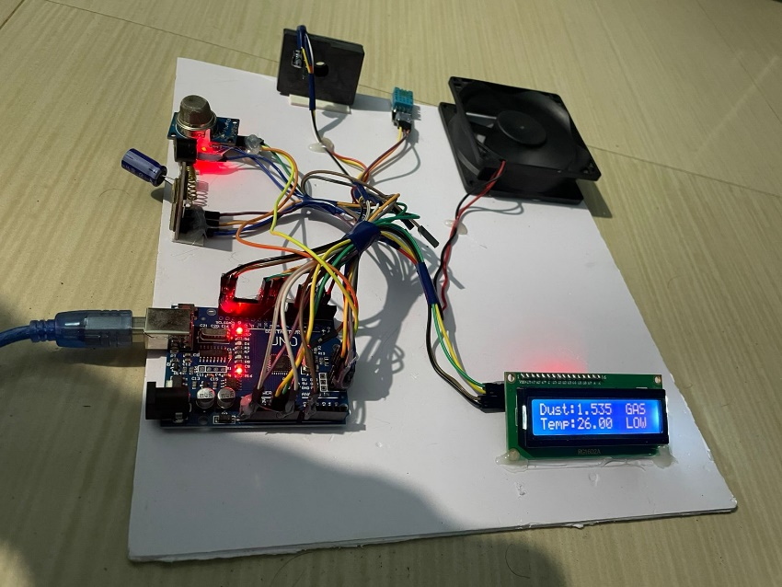
Fig 1: - Readings for ideal environment

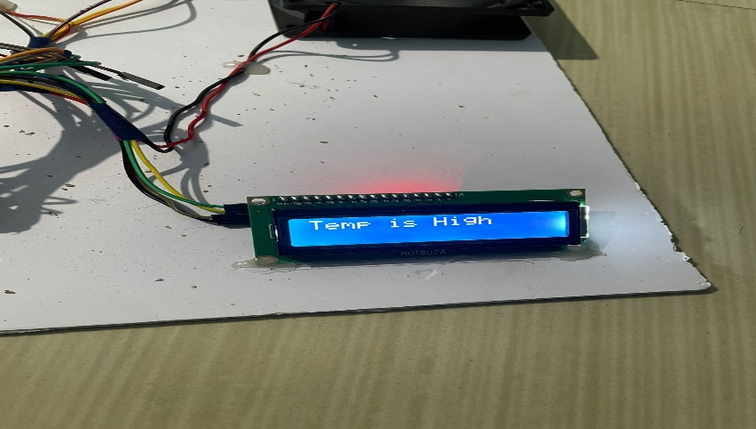
Fig 2: - Indication for high temperature

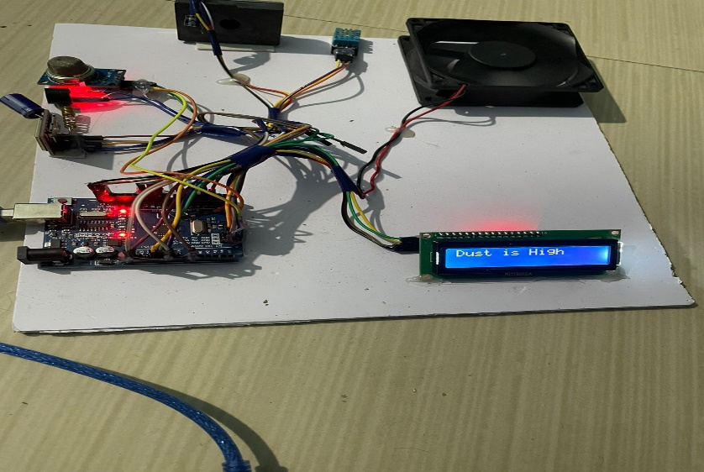
Fig 3: - Indication for high dust
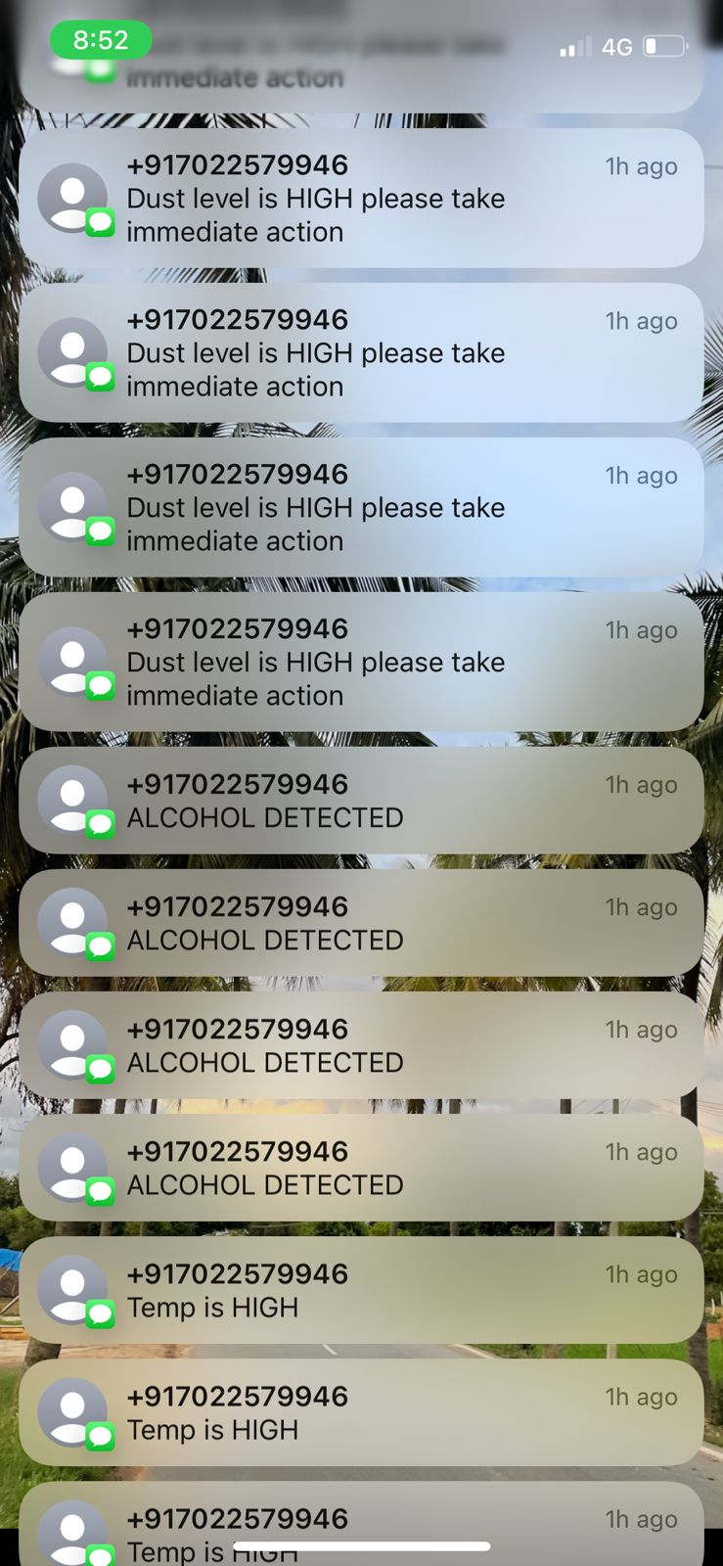
Fig 4: - GSM notification for irregular readings
CONCLUSION
The system to monitor several environmental abuse parameters GSM technology with the Arduino microcontroller are expected to improve air quality. The way of observing several environmental factors, such as air quality, is improved by the use of technologies like GSM, a problem that is projected in this study. An extremely serious approach is taken to the detection and observation of hazardous gases, and related measures are considered here in the form of a warning message and fan so that the necessary action can be done. Given that this method might serve as a centralized system for an entire observation process, it is foreseeable that it will have a high level of market adoption.
REFERENCES
[1] Tudose, D. Ş., Pătraşcu, N., Voinescu, A., Tataroiu, R., and Ţăpuş, N. , “Mobile Sensors in Air Pollution Measurement.”, in Positioning Navigation and Communication (WPNC), IEEE , pp. 166-170, 7 Apr 2011.
[2] TERI. 2015. Air Pollution and Health. Discussion Paper by The Energy and Resources Institute: New Delhi by Rinki Jain (Associate Fellow, TERI), KarnikaPalwa (Research Associate, TERI)
[3] João Ramos Maria, João Dias, “Analyses of Indoor Environmental Quality and Ventilation in a Building of a School of Higher Education in Portugal”, in the 4th Advanced Research in Scientific Areas conference, pp. 273-278, 1 Nov 2015.
[4] Dias, M. J. et al., (2010). “Indoor Air Quality Evaluation in School Buildings Ventilated by Natural and Mechanical Systems”. Clima pp. R6- TS62-0P02, Turkey: REHVA. ISBN Code of the CD 978-975-6907-14-6, 2010.
[5] Olesen, B. W., &Brager, G. S., “A Better Way to Predict Comfort: The New ASHRAE Standard 55-2004”, ASHRAE Journal, pp. 20-26, 8 Aug 2007.
[6] Al-Haija, Q. A., Al-Qadeeb, H., & Al-Lwaimi, A.,“Case study: Monitoring of air quality in king Faisal University using a microcontroller and WSN”, Procedia Computer Science, volume 21, pp. 517–521, 31 Dec 2013.
[7] Sricharan, K. S., Shrivasan, M. A., & Kumar, S. S., “An Intelligent Automated Emission Quality Monitoring System Designed to Test the Vehicles in the Signal”, in Green Computing, Communication and Conservation of Energy (ICGCE), International Conference on IEEE , pp. 590-593, 12 Dec 2013.
[8] Zhang, S., & Zhang, H., “A Review of Wireless Sensor Networks and its Applications”, in Automation and Logistics (ICAL), IEEE International Conference on pp. 386-389, 15 Aug 2012.
[9] Mahmoudzadeh, B., &Faez, K., “HCTT&R: A Complete Scheme for Object Tracking and Recovery of Lost Objects in Cluster-Based Wireless Sensor Networks”, in Telecommunications (IST), Sixth International Symposium IEEE conference, pp. 691-696, 6 Nov 2012.
[10] Qasem Abu Al-Haija, “Toward Secure Non-Deterministic Distributed Wireless Sensor Network Using Probabilistic Key Management Approaches”, Journal of Information Assurance and Security, Vol-6, issue-1, pp. 10-18, 2010.

