Basics of Ionic liquids and its application
Rashmita Khuntia, Manoj Kumar Banjare* and Prashant Mundeja
Department of Chemistry (MSS), MATS University, Pandri Campus, Raipur-492010 Chhattisgarh India
Email: rashmita71s@gmail.com; manojbanjare7@gmail.com

Abstract:
Ionic liquids (ILs) can be treated in chemical synthesis, biocatalytic transformations, electrochemical, and analytical device designs, biosensors constructions, and food-related separation processes. Imidazole-based ILs are generally used as extraction solvents and in food analysis. Based on this context, this book chapter focuses on the characteristics, synthesis, generations, and main applications of ILs in different areas such as Metallurgy, separations, biochemistry, the food industry, and drug delivery systems. This chapter also includes physicochemical, and toxicological, and also discusses ILs composed of ions based on natural products. Future outlooks on the subject and the major technological challenges and advantages of using these attractive liquids are also discussed. As we know in our day-to-day lives the demand for drugs in society is being to increases. With these new trends getting new challenges to design new drugs. To meet this requirement in society many pharmaceutical companies are introducing new drugs with poor solubility which shows no proper diagnosis and indicates the birth of another health issue in the human body our research groups are trying to solve the problem by introducing and adding ionic liquids in the drugs to the enhance of proper solubility of drugs in the human body. Here we have discussed the preparation and advanced types of biodegradable Ionic liquids (BDILs), Task-special Ionic liquids(TSILs), and Room-Temperature Ionic liquids(RTILs) which are very useful in society. This molten solution can be categorized as sustainable, durable, active substance in the pharmaceutical field, and reliable. It can be treated as a good catalyst and, a better quality enhancer in the medical field.

Keywords:
Ionic liquids, smelted or liquified salt, Task special ionic liquids, Biodegradable Ionic liquids, agro-food industry, pharmakon industry, Room temperature ionic liquids, Sustainable liquids, Active Pharmaceutical Ingredients.
- Introduction
The ionic liquid functions as a salt in the liquid phase having a low M.P. with a specific temperature, considered as 100 °C (212 °F). Various ionic liquids are made of a combination of salts and ions named ionic glasses, ionic fluids, liquid electrolytes ionic melts, fused and liquid salts sequentially. When a salt gets Melt with no degradation or vaporizing will produce an ionic liquid. Similarly the melting point of NaCl (Sodium chloride) at 801 °C (1,474 °F) can consist of chloride anions (Cl−) and sodium cations (Na+) Conversely, these positive and negative charges balance with each other, creating the overall compound that behaves as neutral in charge. Generally, these salts such as NaCl or KCl, are considered solid state at room temperature while it gets melt at oppressive heat of 770 °C( KCl)^{[1,2]} and 800.7 °C (NaCl) and are called "smelted or liquified salts."

In short, we can understand what is ionic liquid in the following reaction:
only ion solution not a ionic liquid
Water
Salt
At room temperatute

Self assembled
Liquid consider as a Ionic liquid.
No need other solvent
Salt

At moderate temperature
Salt

Figure: 1 when we say this is ionic liquid
Ionic liquids (ILs) are composed of oddly shaped ions, such as large, misshapen cations, and small to large anion types like bis triflates. The formation of a lattice structure is challenging due to the presence of large and irregular ions, making them liquid. The less optimal packing method allows for less heat energy to be added to facilitate IL flow. Some ionic liquids hover liquid even below the freezing point of water, demonstrating the complexity of ILs in various applications.
Conspicuously solvents marked as ionic liquids have come into the view of such an encouragement. Ionic liquids, also known as ionic fluids, inventor or architect solvents, neoteric solvents, and smelted salts, are serene of inorganic anions and organic cations. The ionic liquid is a salt with a melting point below the boiling point of water. They have a polarity and hydrophobicity/hydrophilicity that can be adjusted by a suitable combination of anion and cation, giving them the title ‘‘inventor or architect solvents’’ Salts have strong ionic bonds, leading to melting points and high lattice energies, while some, especially those with organic cations, making them liquid at or below room temperature, have low lattice energies.

Earlier Work done in this field
R. Rajni et all discussed that designer solvent leads The reaction condition can be adjusted to suit the modulation because of this specific quality called a specific ionic liquid. Singh S.K. engaged in this research about the application of ionic liquid in both academic and industrial applications. Ameta G. et all explained that the sonochemical synthesis and characterization of imidazolium has ILs which can give information about the green pathway of modification. Sarac B. et al The study explores the impact of adjusting the counter ions length and side alkyl chain on the thermodynamics of the micellization process at imidazolium-baseman SAILs in aqueous media. Yanvin J. et al. illustrate the self-assembly of the environmentally friendly (ECO-Friendly) alkyl sulphonate-based SAILs.

- History
The first ionic liquid was discovered on the date and by the discoverer of ethanololammonium nitrate, in an altercation with S. Gabriel and J. Weiner reporting it in 1888. Paul Walden reported the first room-temperature ionic liquid, (C2H5)NH+3•NO−3 methylammonium nitrate in 1914. In 1914, an alkylammonium nitrate salt was created with a melting temperature of 12°C. In the 1960s, Dr. J. Yoke discovered a liquid formed by mixing copper chloride with alkylammonium chlorides. In the 1970s and 1980s, ionic liquids with pyridinium cations and alkyl-substituted imidazolium and tetrahalogenoaluminate anions or halide emerged as potential power unit electrolytes. Ionic liquids (ILs) have a history of this topic that can be traced back to the 19th century, with the first "red oil" described in a Friedel-Crafts reaction. In the 1970s, Dr. Jerry Atwood created "liquid clathrates" by adding aluminum alkyls with salts. ILs were initially used as a supplement for LiCl-KCl smelted salt electrolytes for thermal power units.

Characteristics

Ionic liquids are distinct from traditional salts due to their actuality in the liquid phase. we would come into contact with in a typical chemistry laboratory. Ionic Liquids are naturally colorless gelatinous liquids. These materials are publicly adequate to non-ionizing, being heat resistance, nonconductors, and disclose low vapor pressure, often having low combustibility.^{[13]}

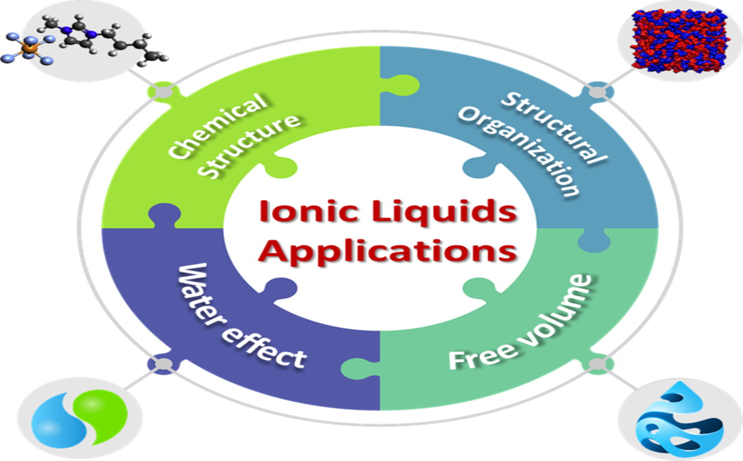

Figure:2 Relative characteristics of ionic liquids.
ILs' diverse solubility properties, including varying solubility of saturated aliphatic compounds, alkenes, and aldehydes, can be utilized in biphasic catalysis processes for easy product and substrate separation^{[17].} The solubility of gases, particularly CO2 gas, is generally favorable in many ionic liquids.
CO and hydrogen are, their solubility varies with the choice of anion and side chain lengths on the cation, less soluble in ionic liquids than in organic solvents. The capability to mix ionic liquids with organic solvents or water varies because of different chemical reactions ^{[8].} These salts can be put into operation to function as ligands, bases, or acids, and serve as precursors for preparing stable carbenes.
Ionic liquids (ILs) can be distilled under vacuum conditions at temperatures near 300°C, consisting of ion pairs. The glass transition temperature was detected below -100°C in the case of N-methyl-N-alkylpyrrolidinium cations fluorosulfonyl-trifluoromethanesulfonylimide (FTFSI). They have a wide range and can freeze down to extremely low temperatures. such as -150°C. Low-temperature ILs are recommended as the fluid base for a spinning liquid-mirror telescope ^{[10].}
Water, a common impurity in ionic liquids, can significantly influence the delivery resources of RTILs, even at low concentrations, due to its absorption from the atmosphere. ^{[16]}

- Properties of ionic liquids
Ionic liquids, with their diverse assets, can be customized for various applications, including biological, electrochemical, and catalytic research. They have low melting temperatures, and those remaining liquids below or at room temperature are known as room-temperature ionic liquids (RTILs). The majority of ionic liquid is non-volatile, meaning that it does not diffuse volatile organic compounds (VOCs) into the atmosphere.
- The substance is non-flammable, making it easier to handle and store due to very low vapor pressures, which is unlikely to evaporate.
- Ionic liquid shows very The product is changeless at high temperatures, up to 392°F or 400°C /752°F/200°C, relenting on the specific product.
- It behaves as a good conductor.
- It is Hydrophobic or Hydrophilic in nature.
- It has a broad electrochemical range.
- The ionic liquid is very stable with water and oxygen which can be used as active ingredients in the drugs.
- It has the capability to vanish both inorganic and organic compounds.
- Ionic liquids can simplify and reduce waste in the separation process, but this topic is for another blog post.

- Classification
ILs are classified based on proton transfer potential and historical generations, typically categorized into two echelons :-
- Protic ionic liquids (PILs)
- Aprotic ionic liquids (APILs)

aprotic ionic liquids and Protic ionic liquids and are formed by proton transfer from Brønsted acid to base, respectively, through neutralization and quaternization reactions.
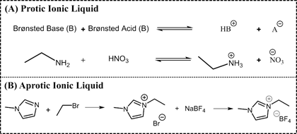
Figure:3 The synthetic route : A) 1-ethyl-3-methylimidazolium tetrafluoroborate and B) ethylammonium nitrate

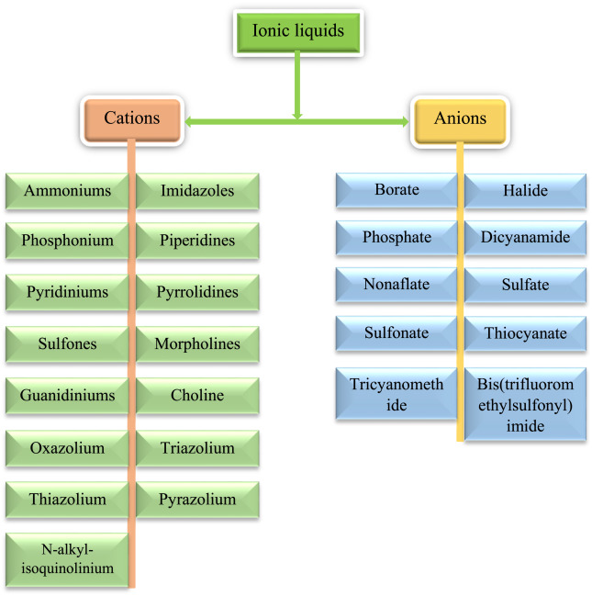
Figure:4 Classification of ionic liquids.

- Generation of ILs
Here we have discussed the basic three generations of ionic liquid which are as follows-
- First Generation
- Second Generation
- Third Generation

  - First Generation
The first generation of ionic liquids, a controversial topic, is believed to have begun with Paul Walden's discovery of ethylammonium nitrate in 1914, but some biographers attribute it to Gabriel and Weiner in 1888. The confusion arises from the reported melting point differences, indicating the beginning of the First Generation of ILs. ^{[27]}.

  - Second Generation
The 2nd Generation of Inhibitory Organic Compounds (ILs) was introduced in 1992 by Wilkes and Zaworotko, based on the alternative anions and 1-ethyl-3-methylimidazolium cation. Over the past 25 years, these ILs have become a significant scientific topic due to their ease of handling.

  - Third Generation
The third generation of ionic liquids may include various commercial pesticides, with extensive research on their properties and toxicity. An EU review led to the withdrawal of effective measures, and the potential for ionic liquid replacements remains uncertain ^{[27]}. The 3rd Generation of ILs has adjustable physical and chemical properties, allowing for rationally selected biological action, as seen in Hough's review of IL candidates as Active Pharmaceutical Ingredients or precursors.

The study presents novel ILs with 1,4-diazabicyclo[2.2.2]octane as a cation and pelargonic acid as an anion, combining herbicidal and deterrent functions..
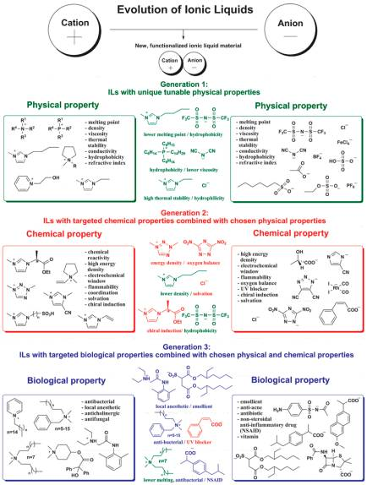
Figure :5 Generations of ILs through time.

- Example of Ionic Liquids
ILs are salts of symmetrical weakly coordinating anions and organic cations, unsymmetrical flexible with a wide variety of cationic and anionic components.
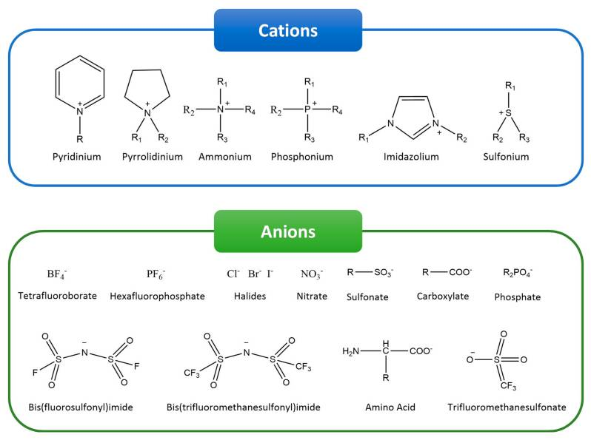
Figure: 6 Typical ions in ionic liquids (ILs).

Cations
Room-temperature ionic liquids (RTILs) are primarily composed of salts that emanate from 1-methylimidazole, such as 1,3-di(N, N-dimethylaminoethyl)-2-methylimidazolium (DAMI). 1-butyl-3-methyl- (BMIM), 1-ethyl-3-methyl- (EMIM), 1-decyl-3-methyl- (DMIM), 1-dodecyl-3-methyl- docecylMIM, 1-octyl-3 methyl (OMIM), 1-butyl-2,3-dimethylimidazolium (BMMIM).
e.g. tetrabutylammonium and tetraethylammonium^{[24]}.

Anions
Magnetic ionic liquids can be created by incorporating paramagnetic anions, as exemplified by 1-butyl-3-methylimidazolium tetrachloroferrate.^{[24]} It generally contains various types of anions, such as hexafluorophosphate (PF6), tetrafluoroborate (BF4) trifluoromethane sulfonate (OTf), dicyanamide (N(CN)2), and bis-trifluoro methanesulfonamide (NTf2), ethyl sulfate (EtOSO3) hydrogen sulfate (HSO4).
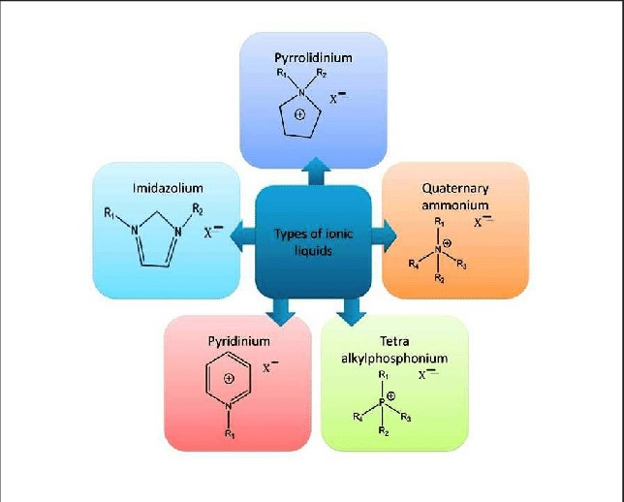
Figure :7 Structural representation of ionic liquids (ILs).
  - Polymerized ionic liquids (PILs)
PILs are a polymeric form of ionic liquids is half the ionicity of ionic liquids. due to an ion being fixed as the polymer fraction. PILs have similar applications as ionic liquids but offer better control over ionic conductivity, extending their use for smart materials and solid electrolytes.

- Synthesis of ionic liquid
The 1st room-temperature ionic liquid, [EtNH3][NO3], was stumbled on in 1914.^{[21]} Enthusiasm in ionic liquids grew after the lighting on of bipartite ionic liquids made from a combination of N-alkyl pyridinium or 1,3-dialkyl imidazolium chloride and aluminum(III) chloride. Ionic liquids are classified as simple salts and bipartite ionic liquids, with their properties and M.P. influenced by the mole fractions of these substances.^{[22,23]}The preparation of ILs can be explained in two steps:

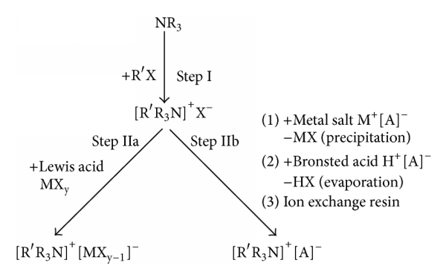
Figure:8 Preparation way of ionic liquids

Steps of synthesis of ionic liquid

Step:2
Anion reciprocity reaction involves tending halide salts with Lewis acids to create Lewis acid-based ionic liquids or by anion metathesis.

Step:1
The craved cation can be amalgamated through quaternization reactions or acid protonation with a haloalkane and heating, resulting in the emergence of carved cations.

Figure: 9 flow chart of synthetic steps of Ionic liquids.

- Application: -
Ionic liquids (ILs) are effective in solubilizing CO2 and are used as alternate solvents in various applications. They are versatile and can be used as electrolytes, with sustainable electrochemical windows, high heat resistance, and low vapor pressure. Task-special ionic liquids (TSIL) are being designed to capitalize on their potential. These substances hold significant industrial and scientific interest due to their distinctive physicochemical properties.

- Food Industry
The utilization of ILs in the food industry is a significant advancement that can be expanded by superscription the unique provocation and requirements of each process^{[20]}. With the following diagram, we can understand the importance of ionic liquids in the agri-food sector.
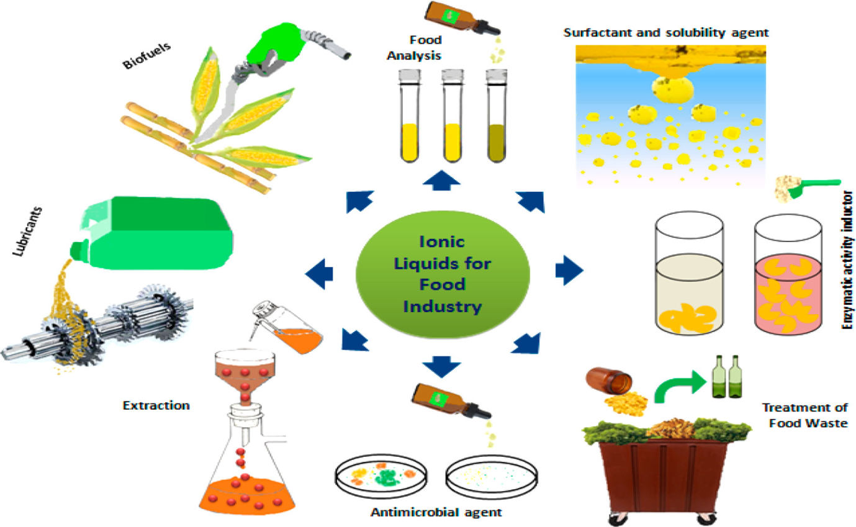
Figure:10 Application of ionic liquid in food industry
- Electrochemistry
Ionic liquids (ILs) are promising alternatives for replacing electrolyte solutions based on organic molecular solvents due to their stability, better viscosity, and ease of synthesis. They have been used in electrochemical applications such as bioanalytical sensors, electroplating of metals, power units, ultracapacitors, solar collectors, and photovoltaic cells. Imidazolium-based Ionic Liquids are the most commonly used class, with that stance of 2-4 carbon atoms in the cation chain length being preferred for electroplating processes. However, cobalt, zinc, and copper-stance setups are highly moisture sensitive, and their growth mechanisms can only be determined in wet systems. Quaternary ammonium salts are thriftycally excellent assignable to their better chemical and thermal resistance than imidazolium and pyridinium-based compounds. Novel ionic liquids are existence progressed, but their cost remains a significant limitation. The next step is to fine-tune their functionalities by amalgamating 2 or more ionic liquids. The economic impact of producing an ionic liquid that could effectively replace conventional organic solvents is significant ^{[21]}.
- Ionic Liquids as Toxicity
Ionic liquids are materials consisting of anions and cations at or below 100°C, with a theoretically possible number of 106 combinations, allowing for the creation of ILs for specific applications. ^{[11]}
- Drug Delivery
Ionic liquids (ILs) are smelted salts with enormous organic anions and cations, causing charge dispersion and making crystalline structure difficult. They are used in crystallizing active pharmaceutical ingredients (APIs), as liquid analeptics, as well as good emulgent, co-solvents, and solvents in medicine framing, and in drug-delivery-based systems attributable to their idiosyncratic characters. ^{[19]}
  - Luminescent Ln-Ionic Liquids beyond Europium
Ionic liquids (ILs) are essential in soft luminescent materials, containing lanthanides or lanthanide compounds, and are the combination of inorganic and organic ions at a M.P. below 100°C ^{[17]}.
  - Biomedical Applications
Ionic liquid gels have promising biological activity for pharmaceutical and biomedical applications. This review explores their classification, synthesis, properties, and applications, focusing on biomedical purposes like antibacterial, antitumor, drug delivery, and hemostasis ^{[24]}.

  - Protein-related Applications
Supported ionic liquids (SILs) are being explored as alternative enzyme supports in biological or organic catalysis and as brand new reinforcement in introductory liquid chromatography for purifying extravagant enzymes and proteins, by modifying their surface and properties. ^{[1]}
- Crucial aspect of Ionic Liquids for Metals
Ionic liquids (ILs), also known as molten salts, have shown promise in sustainable high-value metal recovery. solid eradication, agricultural waste-based IL, Supported Ionic Liquid Phase (SILP), and Functionalized ILs are promising solutions for efficient and environmentally friendly methods in complex systems. ^{[16]}
- Super Ionic Liquids can be applied as Chromatographic Matrices
Ionic liquids have been explored as peculiar ligands in chromatographic matrices, known as supported ionic liquids (SILs). These organic salts have a wide structural diversity and can display multi-modal behavior due to their +ve / -ve charged groups. SILs maintain ILs' valuable features but are supported, avoiding large amounts of ILs. Despite losing their liquid state when immobilized, ILs can establish numerous interactions, making them serviceable in hydrophobic, hydrophilic,multi-modal, affinity, and ion-exchange chromatography. ^{[9]}

- Liquid–Liquid Microextraction
Ionic liquids (ILs) are green chemistry-driven soft materials with unique properties like low melting points, excellent solubility, structural designability, low vapor pressures, and quality heat resistance.

- Challenges
Ionic liquids (ILs) are exciting due to their qualitative and quantitative both applications. By using techniques like Raman spectroscopy, infrared spectroscopy, SEM, potentiostats, and molecular dynamics simulations, we can explore their mysteries and explore our verdict, encouraging others to contemplate their benefits and enactment.

- Future aspects
The major objectives of Ionic liquids are low-toxicity ions used to create specific synergistic properties in ionic liquids. Ionic liquids, attributable to their adaptable characters, have potential applications as therapeutic agents for various diseases, including cancer and viral infections. The pharmakon industry is presently grappling with numerous challenges for non-sustainable drugs with poor solubility and poor aggregation behaviour with any solvents. The major aim of this proposal method is for the researcher of this field to focus on the synthesis and characterizes of sustainable drugs by using any additives such as surface active based ionic liquids which enhance their non-toxicity behaviour of drugs with more effective nature, good solubility and aggregation behaviour of drugs.
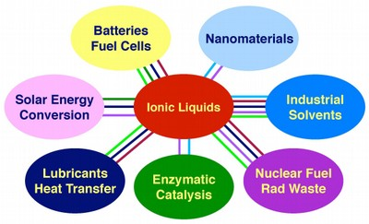
Figure:11 Future use of ionic liquid in various disciplines.
This research work will focus on some recent surface active-based ionic liquids with drug molecule formulation to enhance the diagnosis efficiency of a drug; which can prevent the toxicity level in the community and lead to sustainable methodology. This is an excellent discovery for the world of medicine.

- Conclusion
Antibiotic resistance poses new challenges to drug design and discovery, prompting the utility of ionic liquids as tenable solvents for various applications, but they are frequently too syrupy or extravagant for bulk utility. Day by day, the utility of various drugs in society may increase. To meet this demand, we need to synthesize green and less hazardous, sustainable drugs which we may characterize and synthesize with the help of surface-active ionic liquid-based drugs. Systematic investigation is ongoing of the physiochemical properties of various drugs and their interaction with surfactant/ ionic liquids. The surfactant-derived micellar solutions significantly enhanced the solubility of hydrophobic drugs in water, indicating these molecules in the hydrophobic core and protecting them from drug degradation.

Authors Contribution
The manuscript, a collaborative effort between both authors, has been finalized and all authors have given their approval.

Notes
The authors have explicitly stated that they have no involving budgetary interests.

Conflicts of undivided attention
There are no squabble to reveal.

- References
- Rao ch.j., Venkatesan K.A., Nagarajan K., Srinivasan T.G.and Rao P.R.V., Electrodeposition of metallic uranium at near ambient conditions from room temperature ionic liquid, Journal of Nuclear Materials, 408 (2011) 25–29.

- Qian W., TexterJ. and YanF., Frontiers in Poly(ionic liquid)s: Syntheses and Applications, Chemical Society Reviews, 46 (2017) 1124−1159.

- Rao ch.j., Venkatesan K.A., Nagarajan K., Srinivasan T.G.and Rao P.R.V., Electrodeposition of metallic uranium at near ambient conditions from room temperature ionic liquid, Journal of Nuclear Materials, 408 (2011) 25–29.

- Wang J., Tang X., Qi Z., Xu T., Zou T., Bie Y., Wang D., Liu Y., Ionic Liquids as Thermal Fluids for Solar Energy Storage: Computer-Aided Molecular Design and TRNSYS Simulation. ACS Sustainable Chemistry & Engineering 10 (2022), 2248-2261.

- Uto T., Yamamoto K., and Kadokawa J., Cellulose Crystal Dissolution in Imidazolium-Based Ionic Liquids: A Theoretical Study. The Journal of Physical Chemistry B 122 (2018) 258-266.

- Dr. Khan Abbul Bashar, Islamia Jamia Millia, Wani Farooq, Dohare Neeraj, Parray Mehraj, Ionic Liquid Influenced Synergistic Interaction between Amitriptyline Hydrochloride and Cetyltrimethylammonium Bromide, Journal of Chemical & Engineering Data, 2017.

- Jafari C.P., and -Ahmad B., The strong synergistic interaction between surface active ionic liquid and anionic surfactant in the mixed micelle using the spectrophotometric method, Journal of Molecular Liquids 107(2018) 2411-2502.

- Patra S., and Samanta A., Microheterogeneity of Some Imidazolium Ionic Liquids As Revealed by Fluorescence Correlation Spectroscopy, Journal Physical Chemistry, 116 (2012) 12275.
- Farooq U., Patel R. & Ali A., Interaction of a Surface-Active Ionic Liquid with an Antidepressant Drug: Micellization and Spectroscopic Studies, Journal of Solution Chemistry, 47 (2018) 568-585.

- Farooq U., Patel R. & Ali A., Interaction of a Surface-Active Ionic Liquid with an Antidepressant Drug: Micellization and Spectroscopic Studies, Journal of Solution Chemistry, 47 (2018) 568-585.

- Pal A., Yadav A., Binding interactions of the anesthetic drug with surface active ionic liquid, Journal of Molecular Liquids 222 ( 2016) 471-479.

- Shakeel M, Mehmood K.& Siddiqui M., Aggregation properties of levofloxacin in water and ethanol and its interaction with sodium dodecyl sulfate: A thermodynamic study, Journal of Chemical Sciences, 127(2015) 2073-2079.

- Pal A, Renu Punia, Effect of chain length and counter-ion on interaction study of mixed micellar system of isoquinoline -based surface active ionic liquid and cationic surfactants in aqueous medium, Colloid and Polymer Science, Colloidal and polymer science. 297 (2019) 1541-1557.

- . Moodley K.G., Roles of Ionic Liquids in Medicines for the Treatment of Cancer and Tuberculosis, Der Pharma Chemica,11 (2019).

- Pal A., Saini M., Effect of alkyl chain on micellization properties of dodecylbenzene sulfonate based surface active ionic liquids using conductance, surface tension, and spectroscopic techniques, Colloidal and Polymer Science, Journal of Dispersion Science and Technology,41 (2019) 1-10.

- Mahajan S., Sharma R., and Mahajan R.K., An Investigation of Drug Binding Ability of a Surface Active Ionic Liquid: Micellization, Electrochemical, and Spectroscopic Studies. Langmuir, 28 (2012) 17238–17246.

- P. Mastrorilli, C. F. Nobile, R. Paolillo, and G. P. Suranna, "Catalytic Pauson-Khand reaction in ionic liquids," Journal of Molecular Catalysis A: Chemical, vol. 214, no. 1, pp. 103–106, 2004.

- Zandu S.K., Chopra H., Singh I. Ionic Liquids for Therapeutic and Drug Delivery Applications, Journal of Drug Delivery Science and Technology,12 (2020) 26-41.

- Banjare M. K., Behera K., Banjare R.K., Pandey S., Ghosh K.K. and Karpichev Y., Molecular interactions between novel synthesized biodegradable ionic liquids with antidepressant drug, Chemical Thermodynamics, and Thermal Analysis, 3-4, (2021),.

- P. Pollet, E. A. Davey, E. E. Ureña-Benavides, C. A. Eckert, and C. L. Liotta, "Solvents for sustainable chemical processes," Green Chemistry, vol. 16, no. 3, pp. 1034–1055, 2014.

- T. Welton, "Room-temperature ionic liquids: solvents for synthesis and catalysis," Chemical Reviews, vol. 99, no. 8, pp. 2071–2083, 1999.

- C. E. Song, "Enantioselective chemo- and bio-catalysis in ionic liquids," Chemical Communications, no. 9, pp. 1033–1043, 2004.

- Yanxin J., Lushan W., Tao W., Peng C., Yanhui Bi., Aggregation behavior of dodecyl sulfonate-based surface active ionic liquids in water, Journal of Molecular Liquids, Vol. 212, pp. 23-29, 2015.

- Bojan Š., Žiga M., Alice C., Katharina B., Li-Jen C., Marija B.R., Thermodynamic study for micellization of imidazolium-based surface active ionic liquids in water: Effect of alkyl chain length and anions, Colloids and Surfaces A: Physicochemical and Engineering Aspects, Vol. 532, pp. 609-617,2017.

- Ameta G., Pathak A., Ameta C., Ameta R., Pinki B. Punjabi, Sonochemical synthesis and characterization of imidazolium-based ionic liquids: A green pathway, Journal of Molecular Liquids, Vol. 211, pp. 934-937, 2015.

- Sandip K. Singh, Anthony W. Savoy, Ionic liquids synthesis and applications: An overview, Journal of Molecular Liquids, Vol. 297,2020.

- Ana P.M. Tavares, Oscar Rodriguez and Eugenia A. Macedo, New Generation of ionic liquid Applied to enzymatic Biocataltsis, Open Access Publication, 2013.

