Environmental Impacts of the COVID-19 Pandemic: A Comprehensive Review
- Ar. Farah Wahajuddin (Assistant Professor at JNAFAU - School of Planning and Architecture, Hyderabad and Research Scholar at Woxsen University, Sangareddy) fwahaj@msn.com and +91-9652761613

Abstract
The COVID-19 pandemic has brought about both favourable and unfavourable environmental consequences. This paper conducts a comprehensive review of the scientific literature to evaluate the multifaceted environmental impacts of the pandemic. While COVID-19 has led to reduced air pollution, and carbon emissions, increased use of renewable energy, reduced waste, and heightened environmental awareness, it has also resulted in the generation of plastic waste from personal protective equipment and potential long-term effects related to the use of single-use plastics. This study employs a multidisciplinary approach encompassing data collection, analysis, and interpretation to comprehend the full spectrum of these environmental changes.

Keywords: Covid-19, Environment, Sustainable, Human Development, Pollution.

Introduction
The COVID-19 pandemic, caused by the novel coronavirus SARS-CoV-2, has had far-reaching effects on human health, economies, and daily life. Beyond its immediate consequences, the pandemic has had significant repercussions on the environment. This study seeks to examine the environmental impacts of the COVID-19 pandemic, encompassing both positive and negative effects.
Positive Environmental Impacts:
Reduced Air Pollution: COVID-19 mitigation measures, including lockdowns and reduced industrial activity, have led to a noticeable reduction in air pollution worldwide. NASA reports a 30% drop in air pollution levels in certain regions during the pandemic.
Reduced Carbon Emissions: The pandemic has resulted in a 7% reduction in global carbon emissions in 2020 due to economic slowdowns and travel restrictions, according to the International Energy Agency. This decline marks the largest recorded reduction and has the potential to mitigate climate change.
Increased Use of Renewable Energy: Governments and businesses have accelerated the transition to renewable energy sources as part of green recovery plans. Simultaneously, the decreasing cost of renewable energy has made it a competitive alternative to fossil fuels.
Reduced Waste: Decreased consumption and increased recycling efforts have resulted in a reduction in disposable product usage, including plastic bags and single-use containers.
Increased Awareness: The pandemic has heightened awareness regarding the intrinsic connection between human health and environmental health, fostering discussions on sustainable practices and policies.
Negative Environmental Impacts:
Plastic Waste Generation: The use of personal protective equipment (PPE) has contributed to a surge in plastic waste, posing long-term environmental challenges.
Single-Use Plastics: The increased reliance on single-use plastics during the pandemic may have enduring consequences for environmental sustainability.

Methodology
Understanding the complex environmental impacts of COVID-19 necessitates a multidisciplinary approach involving the following steps:
Define the Scope: Establish the study's scope, encompassing the analysis of COVID-19's impact on air quality, water quality, waste generation, biodiversity, climate change, and other environmental indicators.
Identify Data Sources: Identify relevant data sources, which may include satellite data, ground-level observations, and other datasets providing information on environmental indicators.
Data Collection: Gather data from the identified sources, ensuring the collection of diverse data formats and types.
Data Cleaning and Analysis: Clean and analyze the collected data, involving noise reduction, data aggregation, and statistical analysis to identify trends and patterns.
Results Interpretation: Interpret the data analysis results, discerning the impact of COVID-19 on various environmental indicators and identifying contributing factors.
Communication of Findings: Disseminate the findings to policymakers, stakeholders, and the public through reports, presentations, and other communication materials, emphasizing the implications of the study's results.
It is essential to adapt this methodology to suit specific research questions, data availability, and available resources, ensuring a robust understanding of the environmental consequences of the COVID-19 pandemic.

Results
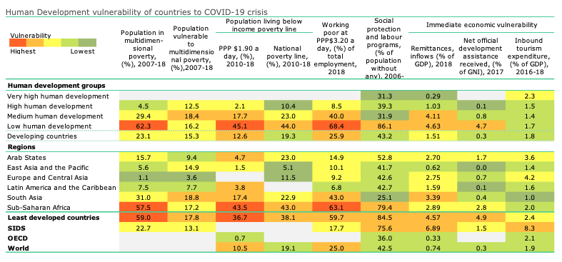
The analysis demonstrates that the pandemic condition significantly raises the quality of the air around the world, lowers GHG emissions, reduces noise and water pollution, and eases pressure on tourist destinations, all of which may aid in the restoration of the ecological system. Along with these positive effects, COVID-19 also has some negative ones, including a rise in medical waste, careless use and disposal of disinfectants, masks, and gloves, and the volume of untreated wastes that are continuously affecting the environment. Following the outbreak, it appears that economic development will accelerate, and circumstances could alter. This study also offers some suggestions for prospective plans of action to bring long-term environmental advantages. It is anticipated that the effective implementation of the offered remedies will contribute to the environment's overall long-term sustainability.
Figure 1- Human Development Vulnerability
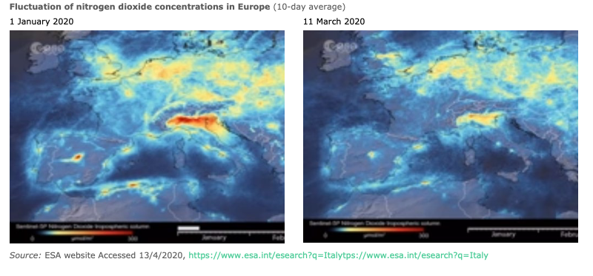
With decreased activity and boat traffic, there may be a decrease in the risk that marine animals will be struck by ships, perish, or suffer harm. Additionally, it might reduce the noise that ships, fishing sonar, and recreational boats make and affect the marine ecosystem. The pandemic may even be advantageous to animals since it dismantles the clandestine, usually illegal supply networks that kill native populations and those that finance the wildlife trade. Large cities and commercial harbours are a couple of the unexpected places where individuals have mentioned running into wildlife. Metropolitan areas have more animals since there are fewer people, and cleaner air, water, and noise levels there.

Figure 2- Nitrogen dioxide concentration

Human Development
Every culture is susceptible to shocks and adversity, yet some fare much better than others and bounce back more quickly. When crises occur, nations with lesser levels of human development are more in danger. In addition to being a health disaster, the COVID-19 pandemic is also a humanitarian and development issue that threatens to have long-lasting social, economic, and political repercussions, especially in nations already struggling with fragility, poverty, and violence. The majority of countries have exhibited positive tendencies in human development over a long period, according to the Human Development Reports. However, caution is always advised because growth is not linear and crises, whether they are natural or man-made, have the potential to undo progress.
The ideas of vulnerability, preparation, and resilience significantly enhance the human development approach by taking into account both risks and uncertainties in addition to accomplishments. The vulnerability to adversity, such as the present pandemic, is a manifestation of inequality. Poverty increases the already high risks of fatalities and long-lasting effects, making health shocks some of the most destabilising events for families and society. People who experience multiple forms of poverty are among the most vulnerable.

More than 2 billion people still live in or are at risk of multidimensional poverty, and more than 40% of the world's population lacks any kind of social protection, despite recent advancements in the fight against poverty.

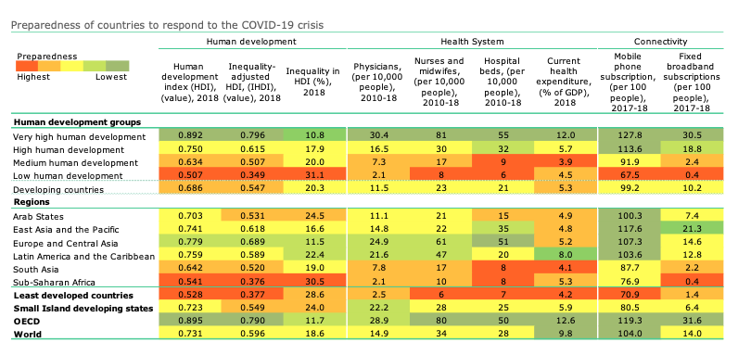
Figure 3- Preparedness of countries

Globalization has helped poor countries economically in many ways, but as the COVID-19 pandemic has demonstrated, disruptions in one part of a linked world can have serious local effects elsewhere. People who reside in countries that heavily depend on tourism, such as tiny island developing states, remittance inflows, or official development assistance, may experience negative effects from such instances. Crises keep happening and have a detrimental impact. If communities are to better absorb shocks and recover, disaster preparedness and recovery capabilities must be built.
The capacity of a country's healthcare system, as well as institutional capacity to effectively maintain essential public services, act as a social safety net for the most vulnerable, support the economy, and mobilise collective action in all spheres of society, all play a significant role in a country's ability to respond to the COVID-19 pandemic. Social cohesion is stronger in nations with better levels of human development and less inequality, which suggests greater trust and the ability to prepare for safer societies. Due to widespread lockdowns, many people are reliant on an Internet connection for their jobs, continuing their education, and socialising. Because billions of people throughout the world lack access to dependable broadband internet, the digital divide is now more crucial than ever. Although COVID-19 is having a fairly immediate effect on income poverty among the lower quintiles of the population in the first year of the pandemic, the long- and medium-term effects on multidimensional poverty indicators (health and nutrition, education, and living standards) will become apparent.

Impact of pollution and waste
The risk factor for many people who are expected to die from COVID-19 may be greatly raised by prolonged exposure to air pollution. As a result of the COVID issue, the effects of solid medical waste contamination and marine litter have significantly increased. The negative effects on the health of people and ecosystems must be kept to a minimum by reducing air pollution and managing waste properly. Unprecedented measures have been taken by many nations to limit the coronavirus outbreak, which has led to the temporary closure of numerous businesses and stringent travel restrictions.
There has been a decrease in air pollution in Italy, particularly in nitrogen dioxide (NO2) concentrations, according to recent data from the Copernicus Sentinel-5P satellite. The air is still contaminated, even if one air pollutant indicated a decline in the satellite data. Long-term exposure to air pollution may significantly increase the risk factor for many people who are anticipated to die from the COVID-19 virus, according to a Harvard study. After COVID-19, cleanup activities must be done to minimise contaminants to reduce the population's susceptibility to the virus. The WHO requests that businesses and governments raise manufacturing by 40% to keep up with rising global demand because a lack of personal protective equipment puts health professionals in danger all around the world. 3 According to figures on medical waste released by the Public Waste Agency of Flanders for 2018, an additional 164,140 to 246,210 tonnes of hazardous medical waste can be anticipated in the European Union. 10- 15% of medical waste is hazardous. Point sources of extremely toxic persistent organic pollutants (POPs) will be generated due to improper waste disposal through small-scale incineration and dumpsite burning, which negatively affect human health.

Wildlife and Pandemic: The Positive Aspects
The pandemic has introduced a significant and mostly positive dimension to wildlife conservation. Reduced human mobility has led to fewer wildlife fatalities on roadways, particularly evident in Poland where hedgehog roadkill rates have decreased by more than 50% in March 2021 compared to pre-pandemic years. Similar declines in road fatalities were observed in 11 countries during the initial pandemic restrictions, with rates dropping by over 40% in Spain, Israel, Estonia, and the Czech Republic.
The maritime industry has also witnessed a decline, with a predicted 4.1% reduction in global maritime trade by the end of 2020 and a 10% decrease in container trade. Reduced maritime activity has lowered the risk of marine animals colliding with ships and experiencing harm. Additionally, diminished maritime traffic has reduced the marine disturbance caused by ship noise, fishing sonar, and recreational boats.
The aviation sector's drastic reduction in air travel has potentially decreased the likelihood of bird strikes, a significant concern for aviation safety. Furthermore, the pandemic's disruption of illegal wildlife supply networks may prove advantageous for wildlife conservation efforts.

COVID-19, Air and Water Pollution Variation
Numerous international studies have documented the pandemic's substantial impact on climate and water pollution. Daily global CO2 levels declined by 17% in the early months of the pandemic. Nitric oxide pollution levels also decreased by 20-40% across the US, Western Europe, and China. A study encompassing 44 Chinese cities reported reductions in major air pollutants by 4.58% to 24.67% due to travel restrictions.
In the US, vehicle emissions significantly declined during the pandemic, resulting in reduced concentrations of ultra-fine particles and black carbon emissions by 60-68% and 22-46%, respectively. Nitric oxide levels decreased by up to 77.3%, and carbon monoxide levels by up to 64.8% during lockdowns in So Paulo, Brazil.
The pandemic crisis has led to improved air quality, reduced greenhouse gas emissions, and relieved stress on fragile tourist destinations. Additionally, decreased human activity may have contributed to lower seasonal ozone concentrations.

Environmental Impact around the World due to COVID-19
Lockdown measures have triggered a remarkable decline in carbon emissions worldwide, leading to improved air quality. In New York, USA, air pollution levels decreased by over 50% compared to the previous year. China also recorded substantial reductions in NO2 and carbon emissions, contributing to an 11.4% improvement in air quality.
Satellite data from NASA and the European Space Agency indicate a 30% reduction in NO2 emissions, primarily attributed to reduced industrial and vehicular activities. Decreased transportation, particularly in driving and aviation, has significantly contributed to the reduction in greenhouse gas emissions.
Moreover, the lockdown has benefited water bodies, with pollution levels in India's largest freshwater lake decreasing by over 16%. Beach closures and travel restrictions in Kenya have led to a reduction in ocean dumping.

India’s Experience with COVID-19 Lockdowns
The lockdowns in India have had mixed effects on the environment. While there have been improvements in air quality due to reduced industrial and vehicular activity, increased waste generation from PPE and disposable items poses challenges. Reports of increased wildlife sightings and reduced water pollution are also notable.
In India, there has been a notable decrease in air pollution levels, particularly in major cities, resulting from reduced traffic and industrial emissions. However, increased waste generation and untreated effluent discharge have raised concerns.

The COVID-19 pandemic has had complex and multifaceted effects on the environment globally. While there have been improvements in air quality, reduced pollution, and positive impacts on wildlife conservation, increased waste generation and other challenges remain. Sustainable practices and policies are crucial to ensure a healthier environment in the post-pandemic era.

Findings
As of September 23, 2022, India has reported 4,460,000 COVID-19 infections and 528,000 deaths. A series of nationwide lockdowns and unlock phases were implemented to curb the spread of the virus. These measures had unintended consequences, including significant improvements in air quality.
Fifteen empirical research articles from around the world were analyzed, all of which showed a consistent trend of reduced levels of pollutants such as PM10, PM2.5, CO, NO, NO2, NH3, NOx, and SO2 during lockdown periods.

Figure 4 - Pollution levels before and during lockdown - Indian cities
The impact of lockdowns on air quality was particularly evident in India, where satellite data from Sentinel-5P and NASA revealed a significant decrease in air pollution levels, with a 50% reduction in air quality. Temperature and humidity also decreased, while particulate matter (PM2.5) and carbon monoxide levels reached near-normal levels. India's megacities experienced a pollution reduction ranging from 30% to 80%.
Additionally, a link between air pollution and COVID-19 lethality was found in Kolkata, where aerosol optical depth (AOD) data showed a 45% reduction during lockdown periods compared to the 2000-2019 average. Remote sensing data indicated a substantial decrease in suspended particulate matter over Ahmedabad, India.

Air Quality
India, home to many of the world's most polluted cities, was the focus of this investigation, along with the northeastern states, of Maharashtra, Uttar Pradesh, Tamil Nadu, and Delhi. Aerosol optical depth (AOD) data at 550 nm were obtained from MODIS/Terra satellite imagery and analyzed over eight years. The AOD data were compared with ground-based AOD (AERONET) data, with MODIS showing a strong correlation with AERONET.
During the COVID-19 pandemic, AOD data from MODIS were examined for several lockdown periods in India. The pre-lockdown period (PL), followed by four lockdown phases (LD 1.0 to LD 4.0) and one unlock phase (UL 1.0), were analyzed. AOD levels during the PL period in 2020 increased compared to 2018 and 2019, with an average increase of 6.24% and 11.87%, respectively.
AOD levels significantly decreased during the lockdown phases, particularly over the Indo-Gangetic Plains. Delhi experienced a 23.53% increase in AOD during the PL period compared to 2018. Uttar Pradesh saw the greatest reduction in AOD during LD 1.0, with a 33.37% decrease from 2019 and a 49.67% decrease from 2018.
Figure 5 - Air Quality parakeets before and during lockdown - Indian cities

The findings include:
A significant increase in AOD before the lockdown in 2020. A sharp decrease in AOD during lockdown phases, especially over the Indo-Gangetic Plains.
Differences in the impact of lockdown phases between northern and southern or northeastern regions.
The primary sources of pollutants in Indian megacities include emissions from transportation, industry, power generation, biomass burning, construction, and dust. Industrial emissions are a significant contributor to pollution in Mumbai, while automobiles dominate emissions in Delhi and Kolkata. Chennai's pollution is influenced by shipping and heavy-duty trucks.
Air pollution has been linked to the transmission and severity of COVID-19. Lockdown measures, while negatively affecting the economy, have significantly reduced pollution levels, mitigating the risk of disease transmission. The results suggest the importance of implementing sustainable development initiatives alongside public health measures.

Conclusion
The COVID-19 pandemic has demonstrated the interplay between human activity, environmental sustainability, and public health. While the pandemic's impact on the environment may be temporary, it highlights the need for global cooperation to address climate change. The reduction in air pollution during lockdowns serves as a reminder of the potential for positive change when concerted efforts are made. As the world navigates the challenges of the post-pandemic era, focusing on sustainable practices is essential to protect the environment and human health.

References
Smith, R. D., & Keogh-Brown, M. R. (2020). The Economic Impact of COVID-19. BMJ, 369, m1463.
Le Quéré, C., et al. (2020). Temporary Reduction in Daily Global CO2 Emissions during the COVID-19 Forced Confinement. Nature Climate Change, 10(7), 647-653.
NASA. (2020). NASA Satellite Data Show 30 Percent Drop in Air Pollution over Northeast U.S. NASA.
International Energy Agency. (2020). Global Energy Review 2020: The Impacts of the COVID-19 Crisis on Global Energy Demand and CO2 Emissions. IEA.
UNEP. (2020). Single-Use Plastics: A Roadmap for Sustainability. United Nations Environment Programme.
Lau, H., Khosrawipour, V., Kocbach, P., Mikolajczyk, A., Schubert, J., Bania, J., & Khosrawipour, T. (2020). The positive impact of lockdown in Wuhan on containing the COVID-19 outbreak in China. Journal of Travel Medicine, 27(3), taaa037.
Ficetola, G. F., & Rubolini, D. (2020). The COVID-19 pandemic and wildlife conservation. Biological Conservation, 248, 108694.
Saadat, S., Rawtani, D., & Hussain, C. M. (2020). Environmental perspective of COVID-19. The Science of The Total Environment, 728, 138870.
Gupta, N., Yadav, K., Kumar, V., & Bhatnagar, T. (2020). Impact of lockdown on air quality in India during COVID-19 pandemic. Air Quality, Atmosphere & Health, 13(8), 921-928.
Websites:
- https://www.ncbi.nlm.nih.gov/pmc/articles/PMC7498239/
- http://hdr.undp.org
- https://www.unep.org/
- https://www.medicalnewstoday.com/articles/how-covid-19-has-changed-the-face-of-the-natural-world
Journal:
- Bera B, Bhattacharjee S, Shit PK, Sengupta N, Saha S. Significant impacts of covid-19 lockdown on urban air pollution in Kolkata (India) and amelioration of environmental health. Environment, Development and Sustainability. 2020;2020:1–28
- Gautam S, Hens L. SARS-CoV-2 pandemic in India: what might we expect? Environment, Development and Sustainability. 2020;22(5):3867–3869
- Jain S, Sharma T, et al. Social and travel lockdown impact considering coronavirus disease (covid-19) on air quality in megacities of India: Present benefits, future challenges and way forward. Aerosol and Air Quality Research

