Decision Support System for Assessment of Agricultural Activities using Physiological and Postural Ergonomics Techniques

Akash¹, Shashi Dahiya¹, Sudeep¹, Chandan Kumar Deb¹, Pratibha Joshi², Ramasubramanian V¹
¹ICAR-Indian Agricultural Statistics Research Institute, New Delhi
²Indian Agricultural Research Institute, New Delhi

- INTRODUCTION

Work-related musculoskeletal disorders (WRMSDs) are one of the most common causes of associated with high costs such as absenteeism, low productivity, and increased health care, disability, etc. Exposures in the work environment can cause or aggravate the impact of these musculoskeletal disorders and the identification of ergonomic exposures is essential in risk assessment. Injury or disease of the muscles, nerves, tendons, joints, cartilage, or spinal discs are referred to as musculoskeletal disorders (MSD).. Work-related musculoskeletal disorders (WRMSD) are conditions in which; (a) the work environment and performance of work contribute significantly to the condition; and/or (b) the condition is made worse or persists longer due to work conditions. It is important to assess all key indicators of these exposures (intensity, frequency and duration) for being able to estimate the risk level for the development of WRMSD. The agriculture activity related risks can be measured directly by using some of the scientifically proven assessment tools like Rapid Upper Limb Assessment (RULA), Rapid Entire Body Assessment (REBA), Human Physical Drudgery Index (HPDI) and Workplace Ergonomic Risk Assessment (WERA).
Farmers are vulnerable to a range of MSDs including osteoarthritis of the hip and knee, low back pain (LBP), upper limb disorders, and hand/arm vibration syndrome, as well as to the consequences of trauma such as sprains, fractures, and dislocations (Pandya et al., 2021). In their research they reported that prevalence of MSD among agricultural workers was about 87.17%. Low backache was the most common MSD. Studies on agricultural workers in California (Meyers, et al., 1998) reported rates of musculoskeletal disorder (MSD) incidence ranking among the highest risk industries and 100 times greater than rates suggested as industrial targets by NIOSH (Mason & McGinnis, 2000). merging data suggest that agriculture faces a near epidemic of musculoskeletal disorders.

  - Rapid Upper Limb Assessment (RULA)

RULA is a postural analysis technique mainly outlined to give a fast assessment of a person’s upper limb portions. Typically, the man working in the agricultural sector with undue bending, an extension of upper limbs when performing some agricultural related tasks. This technique is mainly used to find working posture problems, and it is considered an effective tool for quantifying the quality of work postures during work that involves the upper body. RULA score explains the severity of MSD experienced by operators in their upper portions of the body.

1.2 Rapid Entire Body Assessment (REBA)

In 1995, Hignett and McAtamney proposed REBA. REBA is a postural assessment approach that offers a fast and simple way to evaluate the risk of WMSDs in a range of working positions. The complete body is engaged in doing work while using the REBA method, which is utilised to assess various job-related postures in agricultural activities and risk factors for musculoskeletal disorders. It provides a scoring system for muscle activity throughout the entire body in idle, dynamic, quickly changing, or unsteady ways, as well as places where manual handling may occur. This scoring system is known as a coupling score because it is significant in the handling of loads but may not always be done with the hands. The REBA score reflects the severity of MSD that operators who operate in certain environments suffer.

1.3 Work Ergonomics Research Assessment (WERA)

Hazard analysis and postural assessment WERA tool will be used. WERA assessment signifies good working indication of musculoskeletal disorders toward pain and discomfort relevant parts of the body, particularly the musculoskeletal disorders related with workplace. WERA covers the risk of 6 physical factors including repetition, task duration, strength, vibration, posture, contact stress and. WERA also involve 5 main parts of the body (shoulder, wrist, back and leg). As a tool, WERA is a pen and paper technique without necessarily using any special equipment. This method can be implemented in every room in the workplace without disturbing the worker. It has assessment system and the act level which provide guidance about risk level and requires act to do a detail assessment. The whole technique will be online so that wherever, whenever the evaluator needs any information can interact with this system and retrieves any information related to drudgery assessment through physiological and postural assessment techniques in agriculture and allied occupation.

1.4 Human Physical Drudgery Index (HDPI)

Drudgery is often understood to refer to the physical and mental stress, boredom, and suffering that people face at work. It is laborious, time-consuming, and repetitive in nature. Farmers who labour on fields and are involved in commercialised agriculture and post-harvest activities are doomed to a life of slog. They are continually working in strenuous positions, doing repetitive tasks, and working in hot, cold, and damp environments. The Human Physical Drudgery Index (HPDI) can be calculated using a statistically linear combination method, with scores recorded from, frequency of postural change, Time spent on the specific activity, difficulty score, task performance score, type of posture adopted, load or force involved, if any, and postural discomfort related to activity. The Human Physical Drudgery Index technique may be used to determine which agricultural operations are most prone to drudgery. The farmers who are engaged in agricultural chores including harvesting, sowing, threshing, transplanting, and fertiliser application often experience a lot of drudgery. We may quickly get an understanding of the level of drudgery that farm workers and other employees endure by utilising the HPDI score.

1.5 Agriculture and Information Technology

Computers have been used in the agricultural and allied sectors for more than 40 years. The areas of usage for this system have expanded as a result of several recent agricultural research applications, including control, evaluation, and information processing, educational and training initiatives, broadcasting, and decision-support systems. Computer usage has enhanced knowledge and ability across many disciplines since it allows for data collecting and distribution. The usage of software and hardware has become considerably easier because to recent developments in computer and communication technologies, which have also sped up the flow of information. IT specialists have begun to create computer algorithms that mimic human cognition. They are known as Decision Support Systems.

1.6 Decision Support System (DSS)

DSS is referred to be a synergistic tool that offers computer-based modelling framework and expertise to assist decision-making processes, clarifies the issue, investigates potential solutions, assesses the effects, and encourages sensitivity analysis. DSS addresses organisational levels of operations, management, and planning (often mid and above), as well as assisting individuals in making choices with subjects that are subject to sudden change and are difficult to predict in advance. DSS may be entirely automated, operated by people, or a combination of both.
- DSS for Assessment of Agricultural Activities using Physiological and Postural Ergonomics Techniques
In this study a mobile based DSS "ErgoQuant" has been designed and developed which first provides physiological assessment tools such as BMI, PFI, VO2 (max), TCCW and PCW and based on fitness an option to choose ergonomic technique from RULA, REBA, HPDI and WERA for postural assessment. In this software, farmers are evaluated based on various physiological and postural measures and conclusions about their effectiveness and constraints are drawn and suggestions for correct postures are provided accordingly. In this regard, the mobile application “ErgoQuant” serves as a decision support system to eliminate the drudgery associated with the agricultural activities.
The Java programming language and Android Studio have been used to develop the application. Both users and farmers can register for the app. Selected registered farmers are subjected to various physiological and postural analyses. The database, which is developed using an SQLite database, contains the registered user data and the data produced by various analyses. After a farmer has undergone a thorough study, the findings of every parameter are displayed on the screen to allow the user or extension worker to reach at a more informed decision. It is determined whether or not there is a need to change or improve the working conditions based on the findings of the physiological and ergonomic analyses conducted using “ErgoQuant”.

Based on physiological and psychological ergonomics indicators, including Body Mass Index, the research work analysis of farmers and their farm labour has been undertaken. Total Cardiac Cost of Work (TCCW), Physiological Cost of Work (PCW), Energy Expenditure Rate (EER), Physical Fitness Index, and Total Cardiac Cost of Work (EER) (HPDI). First, the Body Mass Index (BMI) and Physical Fitness Index are used to assess the farmers' health (PFI). Only if the results of both parameters fall within a reasonable range will we move on to the study of EER, TCCW, PCW. Ergonomic analysis done with different ergonomic tecniques like Rapid Upper Limb Assessment (RULA), Rapid Entire Body Assessment (REBA), Human Physical Drudgery Index (HPDI) and Workplace Ergonomic Risk Assessment (WERA).

Body mass index is the ratio of body weight and height square of the person whether the body mass of the person say farmer or worker is well adjusted or well-maintained or justified with his or height. It can be calculated by the following formula
BMI= Weight (kg)/Height² (m)
PFI is used to assess the state of the employee's health. Evaluators help farmworkers perform the exercise on a step stool ergometer for five minutes in order to calculate the PFI. At the end of the 1 st , 2 nd, and 3 rd minutes, the heart recovery rate is noted and calculated using the formula provided below
PFI = Duration of activity *100/ (Sum of heart beats)
The maximum (max) rate of oxygen (O2) Human body can utilise during exercise is known as VO2 max. Breathing requires the use of oxygen. It can be calculated by following formulas
VO2Max (l/min) = 0.023 X Body weight(Kgs) - 0.034 X Ag(yrs.) +1.65
Following formulae were used to calculate the total cardiac cost of work (TCCW) and physiological cost of work (PCW) ( Borah 2015).
CCW = ∆ HR .tA; CCR = (AhR recovery – AhR rest) .tR; TCCW = CCW +CCR; PCW = TCCW/tA

2.1 System Architecture
The architecture of the app is divided into sections; the first section is where users get registered and log in. After logging in, the user will be able to register the farmer to whom he will apply the ergonomic settings. After login and farmer registration next section has two buttons for physiological analysis and postural analysis. Physiological section has calculation of Body mass index Physical fitness index and vo2 (max) calculations. It also analyses the cost of energy for work using physiological and total cardiac costs of work (TCCW) (PCW). The next section has postural analysis which contain Rapid upper body analysis (REBA), Rapid entire Body analysis (REBA), Work Ergonomic Research Analysis (WERA) and Human Physical Drudgery Index (HPDI). The data entered by the end user as an input to the app will be saved in the table in the background-running SQLite throughout the various stages of DSS development.
.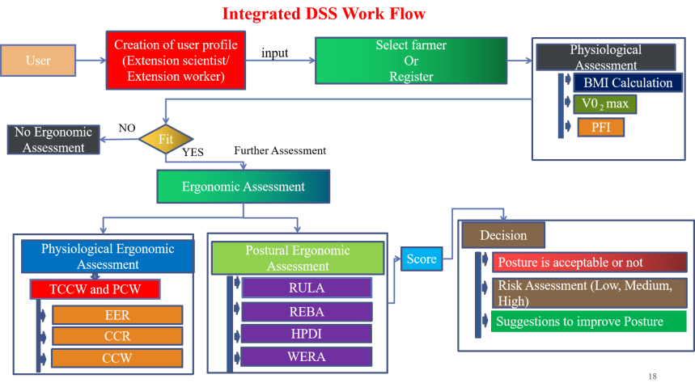
Fig 1 Work flow of Ergoquant
The user could be a researcher, extension personnel or farmer himself. Each user will be able to register as a farmer, entering their details in the process. The app aids in the analysis of agricultural activities and other ergonomic factors such as Body Mass Index (BMI), Physical Fitness Index (PFI), Physiological Cost of Work (PCW) and VO2(max) for Each of the registered farmer. BMI is useful in determining whether a worker's body mass is appropriate for his or her height. PFI assists in assessing a farmer or agricultural worker's level of fitness, which enables researchers to determine whether or not they are qualified to perform a given task. In order to understand the cost of work in terms of energy required, measured in KJ/minute, the ergonomic metric PCW is helpful. The energy expenditure rate (EER) and total cardiac cost of work (TCCW) of the farmer conducting the activity are also evaluated. If the farmer is found fit based on the values of these physiological parameters, he is undergone for postural assessment using the appl. The app provides 4 postural assessment techniques HPDI, RULA, REBA and WERA. These techniques aids in the analysis of posture for particular agricultural activity and determine whether there is a need for change in posture or not.

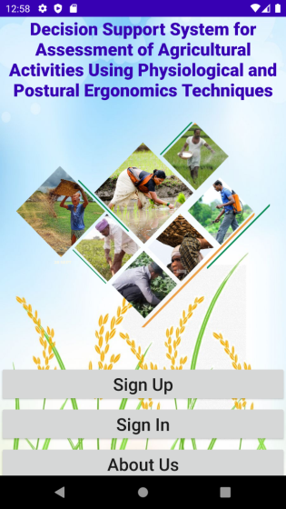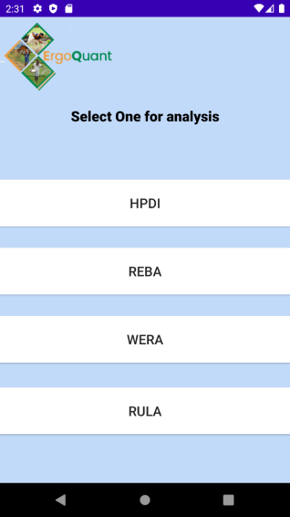
Fig .2: DSS Interface
ErgoQuant Results
The ErgoQuant user must first complete the mobile app's registration process. The opportunity to register the information for each farmer on whom we can do analysis is available after user registration. The farmer's height and weight are entered for the BMI analysis, and the farmer is assessed by contrasting the result with the range-wise category of BMI. Whether the farmer needs further evaluation will be deduced by the DSS. The database also contains the calculated BMI as well as the entered height and weight. First, we must choose the farmers we want to analyse for PFI and give them permission to complete a task for 5 minutes, or 300 seconds. Then, the three necessary inputs are needed. The maximum (max) rate of oxygen (O2) Human body can utilise during exercise is known as VO2 max. other ergonomics parameter calculated by different tools like RULA, REBA, HPDI and WERA.
Following images shows the physiological test result of BMI, PFI,Vo₂ (max) and PCW
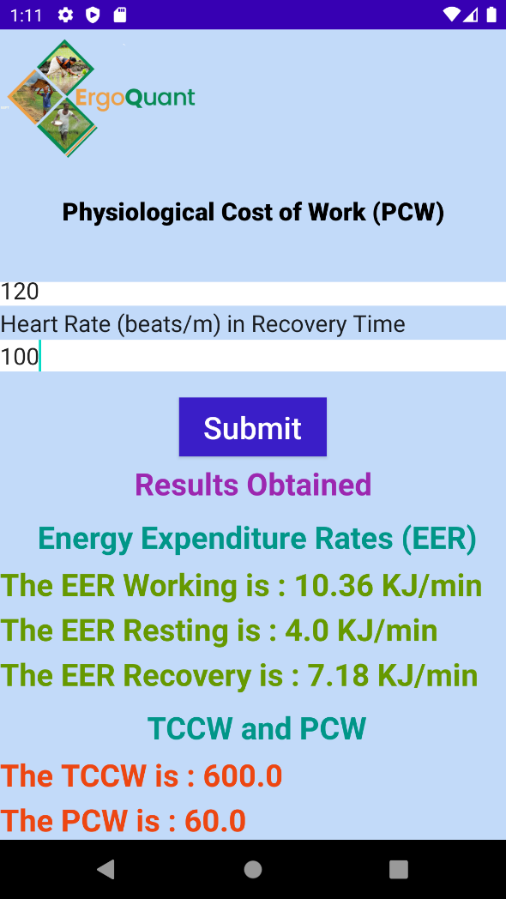
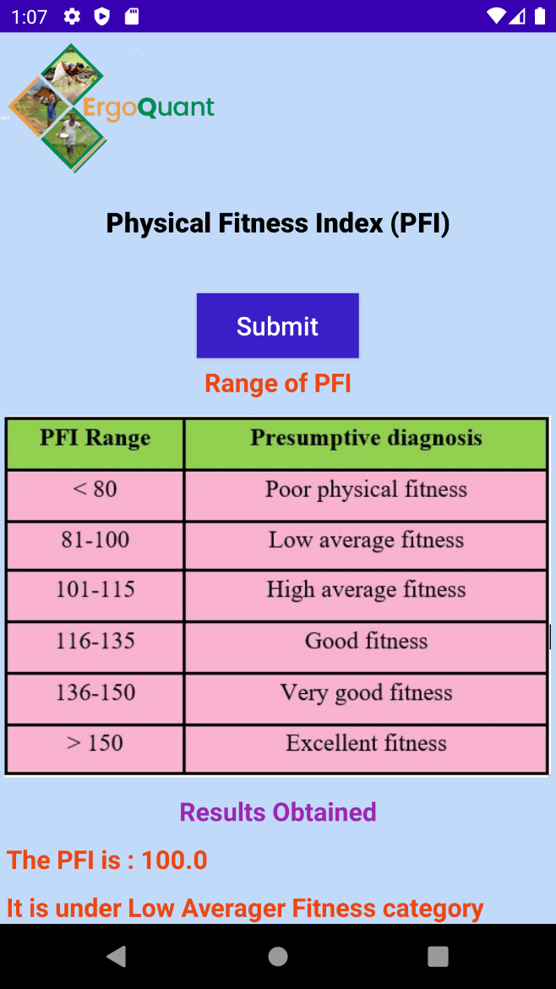
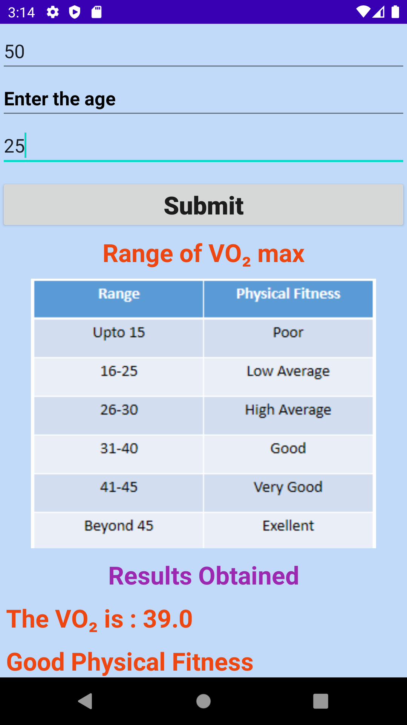
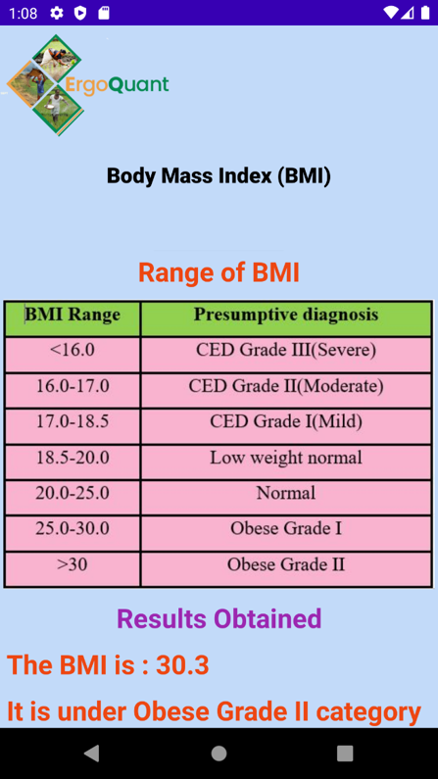

Fig .3 Physiological Analysis results of the different techniques
The WERA assessment c

consists of six physical risk factors including posture, repetition, forceful, vibration, contact stress and task duration and it involves the five main body regions (shoulder, wrist, back, neck and leg) after getting score from each body region the final sum score indicate the output decision. Similarly, RULA assessment focus on the upper body whereas REBA assessment focus on the entire region of body and HPDI focuses on biomechanical stress on body using HPDI drudgery index the following results show the assessment results of different ergonomic techniques

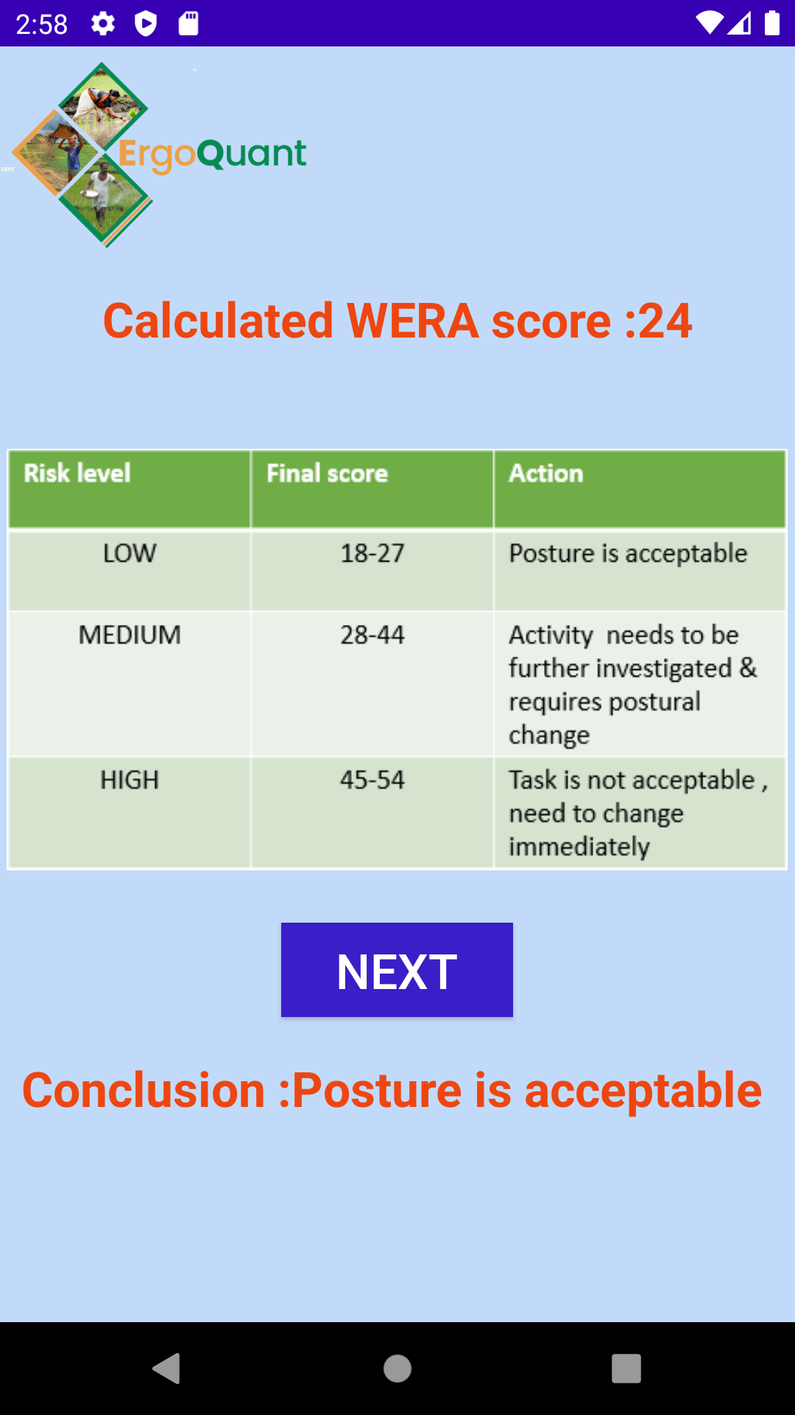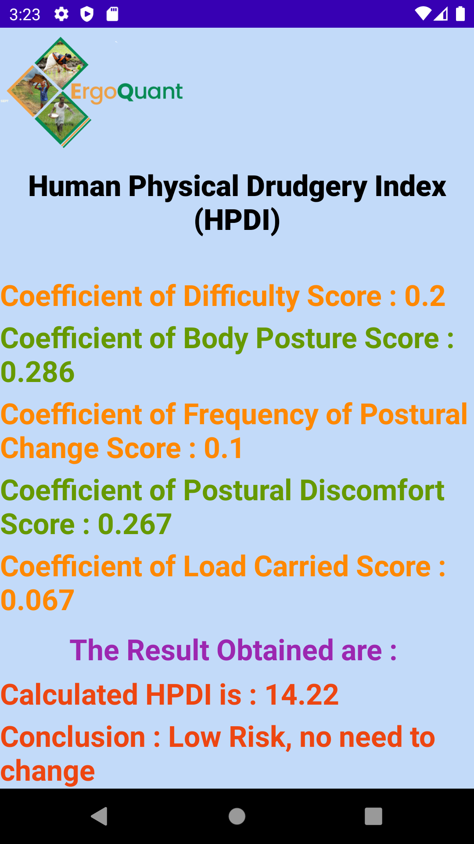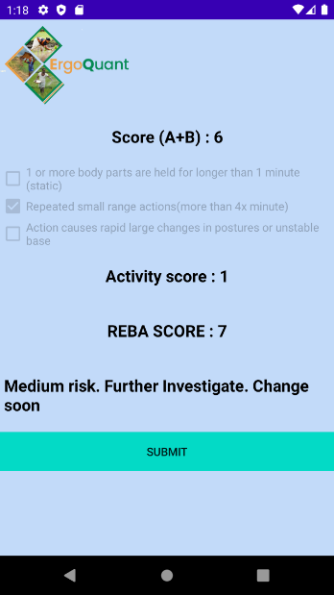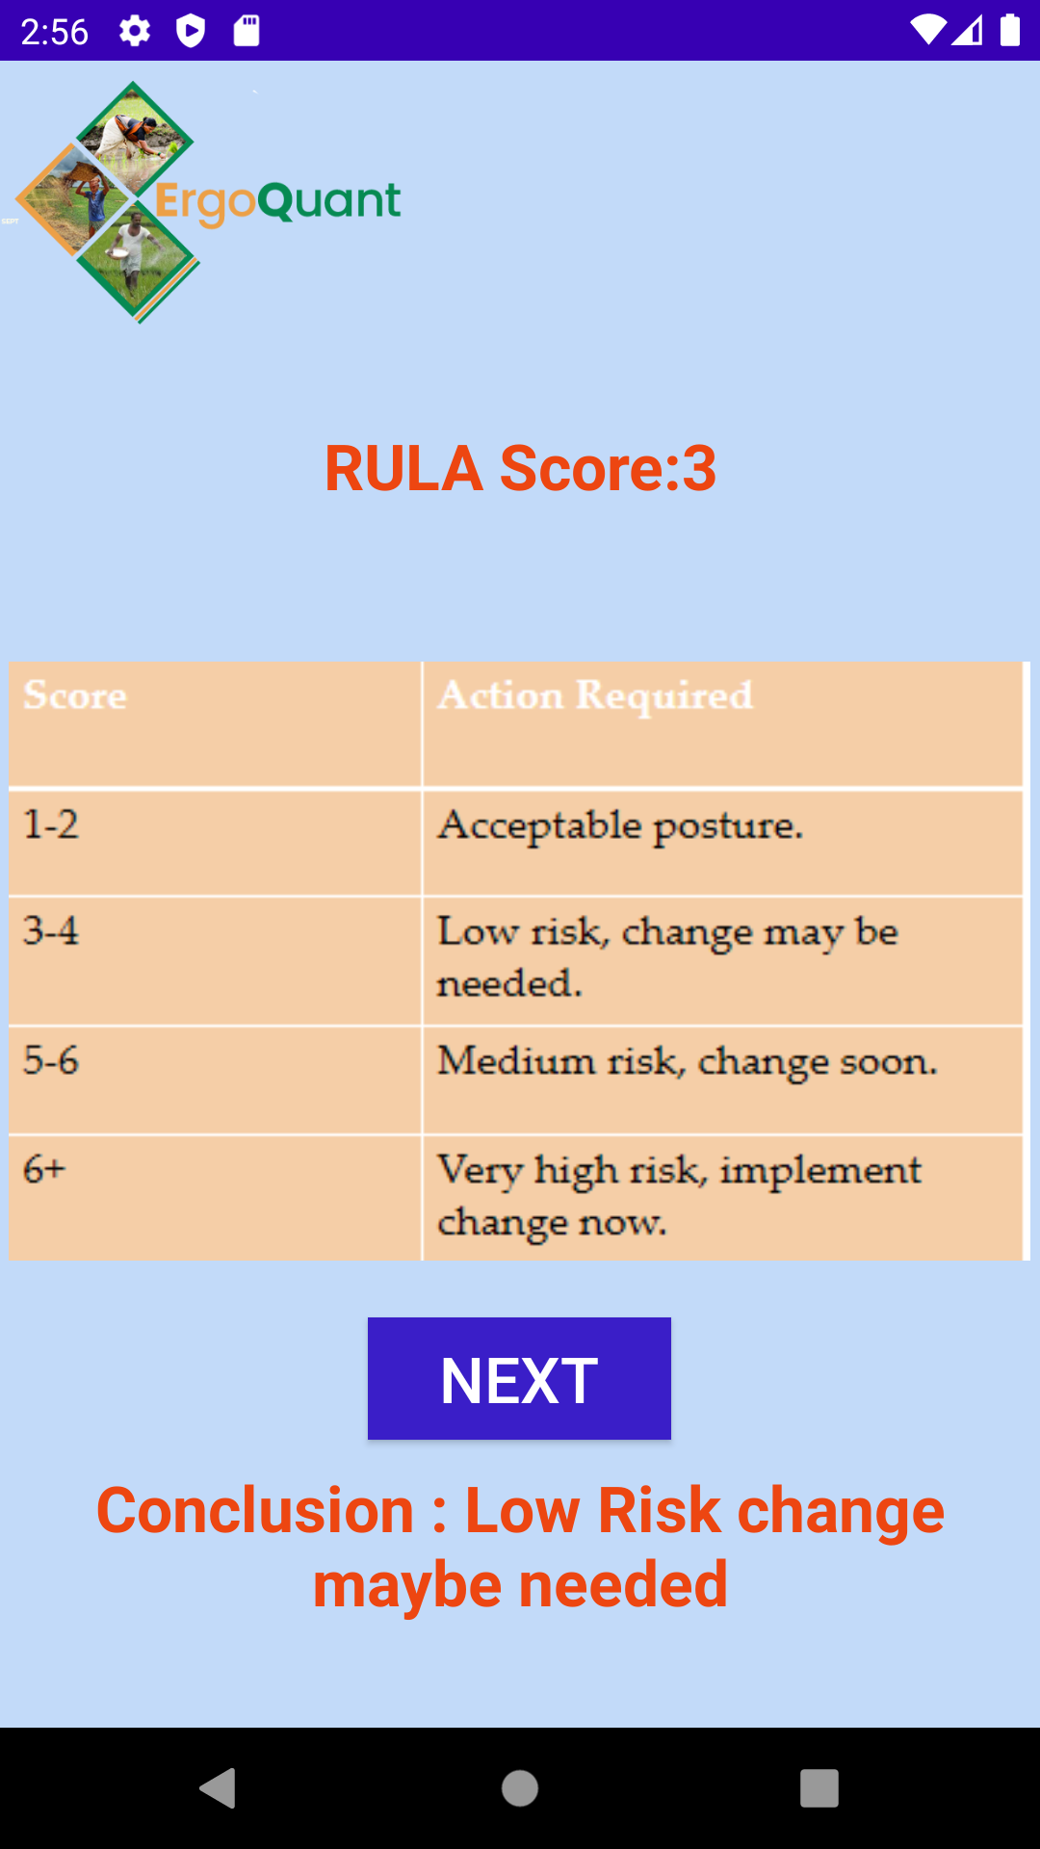
Fig.4 Ergonomic Analysis results of the different techniques

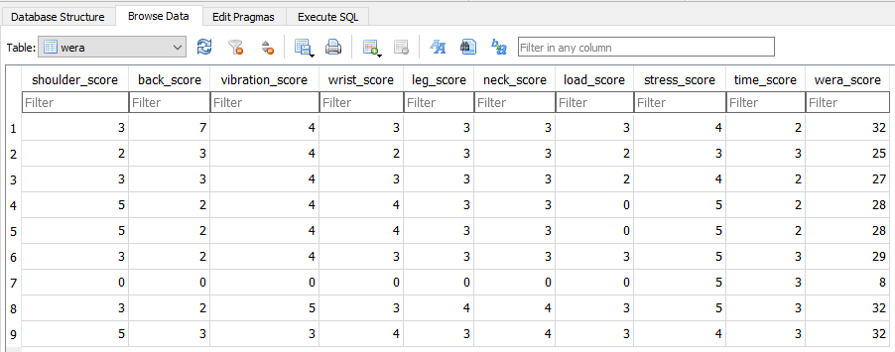
Fig 5 WERA score in database
Conclusion
India is a nation that prioritises agriculture. The backbone that keeps our economy on its feet is agriculture. About 70–72 percent of people rely exclusively on agriculture for their livelihood. However, farming is a labour-intensive occupation. The farmers or labourers who are involved in it deal with hardship on a daily basis. The lack of access to more advanced tools, better farming techniques, and an ineffective transfer of new technology to them are the main causes of this. As a result, the farmers are compelled to adopt labour patterns that are entirely dependent on physical effort and require a lot of physiological energy, which causes them to undergo drudgery and physiological stress. Farmers who deal with these issues on a daily basis in their workplace have a variety of health issues. The marginal farm workers are primarily affected by these issues. Now, in order to address this issue, it is crucial to evaluate agricultural activities using several ergonomic criteria. However, performing an evaluation manually takes time and effort. The mobile-based DSS may greatly assist the assessors in this situation by offering an interface for doing ergonomic analysis quickly and effectively. It also offers the capability of storing all records in a database in a tabular format that can be readily extended
“ErgoQuant” system helps in analysis of both physiological and postural stress. It will be useful for extension workers to assess the farmers physiological traits like Body Mass Index (BMI), Physical Fitness Index (PFI) , Physiological Cost of Work (PCW) and VO2 (max) on field and the analysis will be done very quickly and accurately. This application provides 4 different ergonomic techniques which are very useful in quick ergonomic analysis. The 4 techniques are- Rapid Upper Limb Assessment (RULA) which focuses upper limb of body, Rapid Entire Body Analysis (REBA) which focuses on entire body analysis, Work Ergonomic Risk Assessment (WERA) which has features of both REBA and RULA and it also have vibration risk assessment and contact stress assessment as an extra feature and lastly Human Physical Drudgery Index which focus on evaluation of stress on the body.
Agriculture also aids in locating the activity that is causing the drudgery, which helps to reduce it by applying new technologies or altering cultural habits that have long been used. Researchers, agricultural engineers, developers and ergonomics protocol evaluators are the intended users of mobile applications for farm implements and machinery.
REFERENCE
Abhishekh, M. P., Kumar, M., Joshi, P., Dahiya, S., Arora, A., & Pal, S. (2019) Development and validation of mobile based decision support system for postural assessment of agricultural activities using rapid upper limb assessment (RULA) technique. Progressive Research- An International Journal, Volume 14 (Special) : 335-337, Online ISSN : 2454-6003.
David, G. C. (2005). Ergonomic methods for assessing exposure to risk factors for work-related musculoskeletal disorders. Occupational medicine, 55(3): 190-199.
Drury, C. G., & Dempsey, P. G. (2021, June). EHF Audits: State of the Art and Lessons Learned. In Congress of the International Ergonomics Association (pp. 339-345). Springer, Cham.
Fabrice, M., Choubey, A. K., Kumar, M., Sharma, A., Joshi P., and Dash, S. (2018). Decision Support System for evaluating agricultural activities on ergonomics parameters. In e- Proceedings of International Conference of Asia Pacific Federation for Information Technology in Agriculture (AFITA), Mumbai, October 24-26, 2018.
Halim, I., Arep, H., Kamat, S. R., Abdullah, R., Omar, A. R., and Ismail, A. R. (2014). Development of a decision support system for analysis and solutions of prolonged standing in the workplace. Safety and health at work, 5(2): 97-105.
Joshi, P., Jethi, R., Chandra, N., Roy, M. L., Kharbikar, H. L. and Atheequlla, G.A. (2016). Ergonomics Assessment of Post Harvest Finger Millet Threshing for reducing Women Drudgery. Indian Research Journal of Extension Education, 15(1): 25-30.
Kundu, T., Kumar, M., Joshi, P., Bharadwaj, A., Marwaha, S. and Pal, S.(2021). Development and validation of mobile based decision support system for Human Physical Drudgery Index (HPDI). Indian Journal of Agricultural Sciences, 91(8) :1165-1167.

