STRAIN IMPROVEMENT BY CRISPR/Cas9 FOR ENHANCING BIOFUEL PRODUCTION
Bushra Khan¹; Shifa Ahmad^{2;} Miss Madhurima Tiwari^{Co};Dr. Deepika Delsa Dean^{Co.}
Department of Biotechnology
Isabella Thoburn college
Uttar Pradesh, Lucknow, India
bk7682372@gmail.com

ABSTRACT
The rapid progress in synthetic biology and metabolic engineering presents significant opportunities for the development of advanced biofuels. These fuels offer higher yields and efficiency while reducing carbon emissions. The clustered regularly interspaced short palindromic repeats-CRISPR-associated proteins (CRISPR-Cas9) technology is one of the significant developments in molecular biology. Compared to prior techniques like zinc finger nucleases (ZFN) and transcription activator-like effector nucleases (TALEN), it allows more precise genome editing with increased precision. Despite research on microbial genome engineering tools for biofuel production, thorough assessments of CRISPR-Cas9-based methods for improving biofuel production are lacking. Techniques are needed in particular to assure the efficacy and safety of this method and reduce off-target impacts. With an emphasis on bioethanol, biobutanol, and other hydrocarbons, this study attempts to give a thorough explanation of the CRISPR-Cas9 mechanism and its use in the generation of microbial biofuels. It also looks at other suggestions for enhancing the effectiveness of targeted gene changes. The review also discusses how targeted genome editing (TGE) may be controlled through inducible on/off genomic circuits that react to environmental variables. By using this method, the metabolic load is reduced and fermentation efficiency is increased. When using CRISPR-Cas9 technology, the analysis highlights the significance of stringent regulatory standards to reduce off-target cleavage, increase efficacy, and ensure biosafety.

Keywords: CRISPR-Cas9; Biofuels; gene-editing; biodiesel; biobutanol; bioethanol; fermentation

INTRODUCTION
The demand for fuel is increasing nowadays due to its utilization in transportation, generation of energy, and industries. As of late, the interest in petrol-based fuel has brought about various financial and natural worries, and mindful endeavors are expected to support the arising elective powers ^{[1]}. The creation of biofuels from biomass is a practical and environmentally responsible solution to combat the depletion of fossil fuels. Industry, decision-makers, and scientists have started to pay more attention to these interchangeable and inexhaustible fuel sources, such biodiesel and bioethanol, because of their considerable benefits ^{[2]}. While biodiesel is produced by transesterifying lipids taken from soybeans, canola seeds, and other crops, ethanol and butanol production is primarily dependent on the fermentation of sugar or starch feedstocks ^{[3]}. The environmentally friendly and abundant natural resources, such as lignocellulosic feedstock obtained from agricultural wastes, such as sugar stick bagasse, sugar beetroot or maize stalks, are used to produce biofuels with the added benefit of not negatively affecting food supplies ^{[4]}.
It has been demonstrated that a variety of microbial strains are capable of fermenting organic matter to create biofuels. One of the yeasts most commonly used for the large-scale commercial fermentation of monomeric carbohydrates into ethanol is Saccharomyces cerevisiae. Zymomonas mobilis, Clostridium thermosaccharolyticum, C. thermohydrosulfuricum, Thermoanaerobacter mathranii, T. brockii, and T. ethanolicus are among the bacteria employed in fermentation. The cutting-edge field of genomics known as site-specific genome editing looks to be successful in improving microbial strains for the generation of biofuels. Site-specific modifications in the genome, such as knocking down, knocking out, and knocking in genes, are routinely carried out through genetic engineering to influence a certain attribute in the native microorganisms. Contrary to conventional genetic engineering, which involves first isolating the gene to be altered, altering it in vitro, and adding it back to the host, or using genetic transformation techniques to introduce a heterologous gene to alter a specific trait of the organism ^{[5].}
The site-specific genome editing techniques RNA-guided endonuclease-mediated (REM) and modified endonuclease-mediated (MEM) have recently been used for strain enhancement. CRISPR/Cas9 (CRISPR-associated nuclease 9) is a well-known example of a REM-based genetic engineering technology and a flexible tool for genetic engineering. It is a natural bacterial defence mechanism that employs a guide RNA (gRNA) to lead Cas9 to a particular nucleotide. This simple RNA-guided genome-engineering technique has been hailed as a breakthrough in biology and offers various creative applications in producing biofuels ^{[6]}. The CRISPR/Cas9 method has been successfully utilised in industrial research to alter the genomes of several microbes, including bacteria, yeast, filamentous fungus, and algae. This technology has been changed into a versatile and trustworthy approach for genetic editing by CRISPR/developers Cas9. ^{[7,8,9]}
- AIM OF REVIEW
The potential of CRISPR/Cas to enhance biofuel production is the main topic of this review. It discusses how targeted genome editing (TGE) may be controlled by lowering the metabolic burden and boosting fermentation productivity using inducible on/off genetic circuits that react to environmental stimuli. Along with strict regulatory requirements necessary to guarantee minimal off-target cleavage with maximal effectiveness, the full biosafety of this approach is also considered.

REVIEW OF LITERATURE

Sources and generation of biofuel
Biofuels are liquid fuels produced from various biological elements including animal waste and plant waste [10] Biofuels are divided into 2 categories.
Primary biofuel-: Raw primary biofuels are frequently employed in the production of energy, heat, and cooking. Examples of primary biofuels include fuel wood, pellets, wood chips, agricultural waste, landfill gas, and fuel-wood pellets. ^{[11]}
Secondary biofuels-: Primary biofuels can be generated as gases, liquids, or solids (for example, biogas and hydrogen). These fuels include biodiesel, bioethanol, and bio-oil. Primary biofuels are transformed into secondary biofuels. Biodiesel, bioethanol, and biogas are examples of secondary biofuels that are utilised in a variety of industrial operations in addition to being used in automobiles. These are produced when biomass is digested biologically. ^{[13]}
The categorization of secondary biofuels into different generations is determined by the specific biological processes employed and the raw materials utilized in their production. The four generations of secondary biofuels can be outlined as follows:
- Biofuels of the first generation
- Biofuels of the second generation
- Biofuels of the third generation
- Biofuels of the fourth generation
Biofuels of the First-generation- First-generation biofuels, including bioethanol and butanol, are primarily produced through the fermentation of starches or sugars derived from crops like wheat, barley, corn, potatoes, sugarcane, and sugarbeet. Bioethanol, particularly notable among first-generation biofuels, is produced by S.cerevisiae enzymes fermenting high-carbohydrate crops, mainly glucose. Biodiesel, another effective first-generation biofuel, is derived from trans-esterification or breakdown of vegetable oils sourced from plants such as palm, sunflower, rapeseed, soybeans, and coconut as shown in Fig.2 [14]
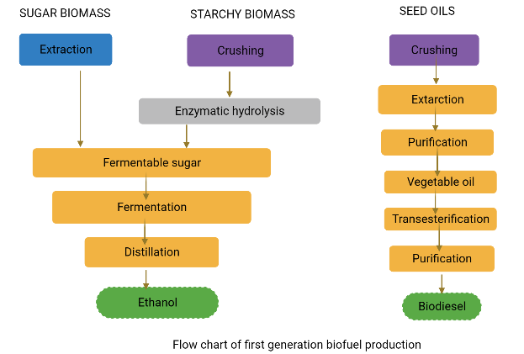
Figure 2: Flow chart for first-generation biofuel production
Biofuels of the Second-generation - Second-generation bioethanol and biodiesel are created using conventional technology from innovative sugar, starch, and fatty crops like miscanthus, jatropha or cassava. Biobutanol and Syndiesel® (produced from lignocellulosic materials including wood, grass and straw) are two other well-known second-generation biofuels ^{[12].} Second-generation biofuels have the advantage of using inedible lignocellulosic biomass (the woody part of plants), which does not compete with food, and reduced raw material costs ^{[13]}. Examples of sources of lignocellulosic material include non-edible parts of maize or sugarcane, tree-harvest debris, garbage from agriculture, and leftovers of wood processing, such as leaves, straw, or wood chips. The conversion of lignocellulosic materials into sugars, as seen in Figure 3, is an expensive process that calls for the use of specialised enzymes. This merely shows that commercial production of second-generation biofuels is not currently feasible. ^{[14]}
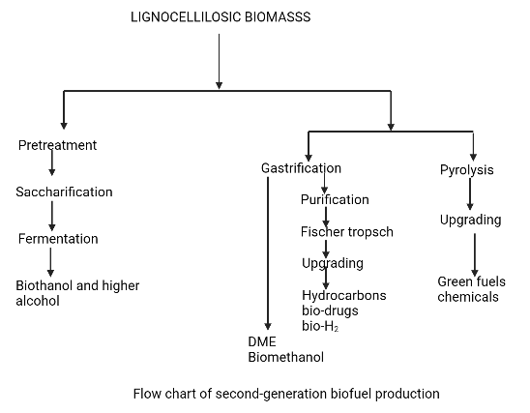
Figure 3: Flow chart for second generation biofuel production
Biofuels of the Third-generation - Third-generation biofuels are produced using microalgal biomass. Aquatic microalgae, like cyanobacteria, are autotrophic living forms ^{[15]}.When compared to conventional lignocellulosic biomass, the growth yield of microalgal biomass is quite unusual ^{[16]}. Algae is the most potential component for use as third generation biofuel due to its high oil content. Due to their high oil content (between 60 and 70%), the three species of green algae Chlorella vulgaris, Chlamydomonas reinhardtii, and Dunaliella salina are most often used to produce biofuels [17]. Despite having numerous benefits, third-generation biofuel technology is still in its infancy and has a number of drawbacks. The primary drawbacks include its high anticipated cost and extensive use of fossil fuels during manufacture, which raises environmental concerns. ^{[18]}
Biofuels of the Fourth-generation - The fourth generation of biofuels is produced using contemporary techniques such as petroleum hydro-processing, geo-synthesis, enhanced biochemistry, and low-temperature electrochemical processes. These methods allow for the capture of environmental carbon to create fourth-generation biofuels. ^{[19]}
The fourth-generation biofuels have been defined in a variety of ways by various authors. For instance, Lü et al. (2011) ^{[20]} produced fourth-generation microalgae using metabolically modified forms. This concept has been applied to the chemical production of non-renewable fourth-generation biofuels. Fourth-generation biofuel, according to Demirbas (2009), is created by applying cutting-edge technology to transform biodiesel and vegetable oil into biogas.

CONVERSION OF RAW MATERIAL INTO BIOFUELS
The bioconversion of feedstocks into biofuels involves three processes: fermentation, hydrolysis, and pre-treatment. The pre-treatment stage of turning biomass into biofuel is the most important, difficult, and expensive.
There are four types of pre-treatment processes:
- Physical treatment
- Physiochemical treatment
- Solvent treatment
- Biological treatment
The majority of the time, they are employed to dissolve cell walls so that cellulose and hemicellulose can undergo additional processing.The feedstock is hydrolyzed with acid or an enzyme following pre-treatment. ^{[21,22]}. All pre-treatment methods are often combined for maximum effectiveness The polysaccharides included in the input material are transformed into fermentable sugars by the hydrolysis process. Finally, via microbial fermentation, monomeric carbohydrates like glucose, galactose, and mannose are transformed into ethanol or other alcohol ^{[23,24]}.
Four process configurations have been created for the generation of biofuels: separate hydrolysis and fermentation (SHF), simultaneous saccharification and fermentation (SSF), simultaneous saccharification and co-fermentation (SSCF), and consolidated bioprocessing (CBP) ^{[25]}.
Separate hydrolysis and fermentation (SHF):
This process requires the hydrolysis of the substrate in two stages:
- Saccharification
- Fermentation
Enzymatic hydrolysis and fermentation are carried out separately under ideal circumstances in separate hydrolysis and fermentation (SHF). Numerous advantages of this method include the fact that each phase is completed in an ideal environment and that little or no contact exists between fermentation and saccharification [26]. Cellulose is completely broken down into monomeric sugars as a result of the SHF. 50 °C and 35 °C, respectively, are the ideal temperatures for cellulases-mediated hydrolysis and fermentation [27].
Simultaneous saccharification and fermentation (SSF):
In this method, fermentation and saccharification are carried out simultaneously in a single vessel. By instantly converting monomeric sugars produced by the enzymatic hydrolysis process into ethanol through fermentation, simultaneous saccharification and fermentation (SSF) minimize difficulties such as sugar build-up, enzyme activity retardation, and contamination [27]. In SSF, the hydrolysis of raw materials containing starch is accomplished by first treating the material with an endoenzyme (glucoamylase in this case) at 90 to 110 °C for 30 minutes. While glucoamylase transforms dextrins into glucose, amylase hydrolyses starch into dextrins. The fermentation of hexose sugars is then carried out at a lower temperature (30–32 °C) to produce biofuel. The production of bioethanol has made extensive use of this technique.

Simultaneous saccharification and co-fermentation (SSCF):
Using the simultaneous saccharification and co-fermentation (SSCF) approach, five and six-carbon sugars may be fermented concurrently. The key prerequisite for this technique is the employment of co-fermenting bacteria that are compatible and have good pH and temperature tolerance. It is difficult to identify a single bacterium that can ferment both hexose and pentose sugar. Another limitation of this approach is the dearth of suitable co-fermenting microbial strains for the generation of commercial biofuel ^{[28]}. The entire conversion of monomeric sugars (generated from feedstock hydrolysis) into biofuel has been demonstrated to be possible using the mixed-culture technique, which combines both C6-fermenting and C5-fermenting bacteria. S. cerevisiae and Candida shehatae, which are recognized for their synergistic action, have reportedly been shown to be the most effective microorganisms for the SSCF procedure.

Consolidated bioprocessing (CBP):
Consolidated bioprocessing (CBP) is another method of process architecture in which a single microbe performs both the fermentation and saccharification processes. All phases of bioconversion, including fermentation and enzymatic hydrolysis, are carried out sequentially in a single reactor. The CBP procedure is a cost-effective method because it requires little capital input [27,29]. Numerous bacterial species, including C. thermocellum, and fungi, including Fusarium oxysporum, Neurospora crassa, and Paecilomyces sp., have been observed to exhibit these behaviors [30].

- GENOME ALTERATION: THE NEW UPSET IN GENOMICS
A single organism's genome can be modified effectively to impart desired traits. This procedure precisely modifies the native genome of a microorganism to change its physiological characteristics and increase the production of a certain metabolite [31,32]. This method allows for the introduction, deletion, and up-or-down-regulation of a gene at a particular location within an organism. Unlike traditional genetic engineering methods, this approach does not entail isolating genes, conducting in vitro engineering, and then reintroducing them to the host cell in order to modify the physiological characteristics of an individual.

Genome engineering can be achieved through two distinct approaches:
- RNA-guided endonuclease-mediated (REM) genome engineering
- Modified endonuclease-mediated (MEM) genome engineering

REM utilizes the CRISPR/CRISPR-associated protein 9 (Cas9) technology [33], while MEM relies on the zinc finger nucleases (ZFNs) system and transcription activator-like effector nucleases (TALENs) system ^{[34].} The biological sciences and associated fields of study have been significantly impacted by these techniques. The CRISPR/Cas9 system has emerged as a viable alternative to ZFNs and TALENs, which have drawbacks such as ineffective delivery routes, off-target effects, toxicity, and low efficiency ^{[35]}. Table 1 summarizes the drawbacks associated with ZFNs and TALENs.
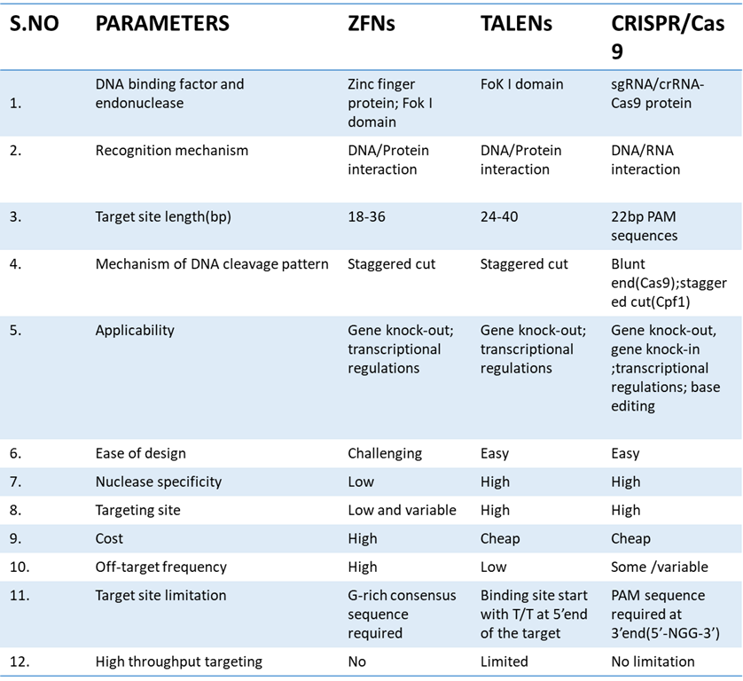
Table:1-Comparison between different types of genome editing tools[36]

CRISPR-CAS9: A PROMISING APPROACH IN GENE MODIFICATION
The biological sciences are being fundamentally changed by a succession of recent discoveries that use prokaryotes' adaptive immune systems to undertake targeted genome editing. Genetic research has grown in thousands of labs throughout the world thanks to the identification of Clustered Regularly Interspaced Short Palindromic Repeats (CRISPR) and CRISPR-associated (Cas9) proteins.
The bacterial CRISPR locus was first described by Francisco Mojica, and it was later determined that it constituted an essential part of the prokaryotic adaptive immune system. The locus consists of short palindromic repeat sequences called "spacers," which were found in between several viral or plasmid DNA pieces.The Cas9 protein was later discovered in Streptococcus thermophilus by Alexander Bolotin. Contrary to other known Cas genes, Cas9 was a large gene that encoded a single-effector protein with nuclease activity. Additionally, they found a characteristic sequence that was later given the name protospacer-adjacent motif (PAM) in the spacer-nearby region of the target DNA. To find and bind its target DNA, Cas9 has to recognise this pattern. Later studies found that spacers were transcriptionally added to the CRISPR RNAs (crRNAs), which guide the Cas proteins to the target DNA sequence. Research has revealed that a crucial part of the CRISPR system is the trans-activating CRISPR RNA (tracrRNA), which combines with the crRNA to drive Cas9 to its target DNA. [37]. The introduction of a synthetic single-guide RNA construct (sgRNA), which combines crRNA and tracrRNA (fig. 4), made this technology's potential applications simpler. [38].
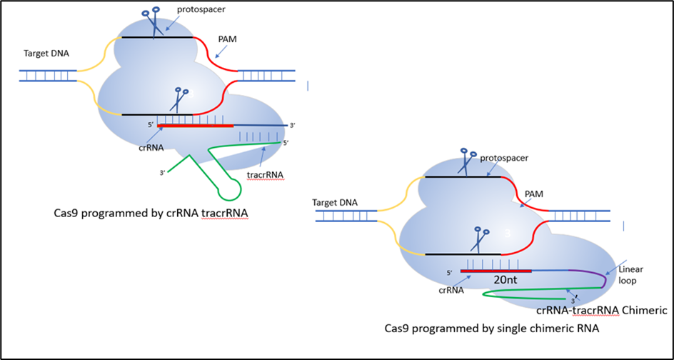
Figure 4: CRISPR/Cas9 System
The CRISPR/Cas9 method is a straightforward and precise approach for gene editing. It involves two essential components: the Cas9 protein, which contains the RuvC and HNH endonuclease domains. The RuvC domain cleaves the non-complementary DNA strand, while the HNH domain cleaves the complementary DNA strand, resulting in double-stranded breaks (DSBs) at the targeted DNA site. The second component is the single guide RNA (sgRNA), consisting of a scaffold sequence that facilitates Cas9 binding and a 20-base pair spacer sequence that is complementary to the target gene, positioned near the PAM region. The sgRNA guides the CRISPR/Cas9 system to the specific genomic region of interest. The gene editing process utilizes internal DNA repair mechanisms, as shown in Figure 5.
- Nonhomologous end-joining (NHEJ) or
- Homology-directed repair (HDR)
Most cell types experience NHEJ, which is far more frequent and includes the random insertion and deletion of base pairs, or indels, at the cut site. The frameshift mutations generated by this error-prone process are typically followed by an early stop codon and/or a non-functional polypeptide. This approach has shown to be particularly useful in functional genomic CRISPR screens and genetic knockout studies, but it can also be useful in the clinic when gene disruption presents a therapeutic opportunity. The second approach uses the error-free HDR route, which is very promising for therapeutic uses. This procedure results in error-free repair of the damaged DNA by using a homologous section of an unmodified DNA strand as a template. This approach can be used in an experiment to enable the necessary genome modification by combining an external donor template with CRISPR/Cas9 technology. ^{[39]}
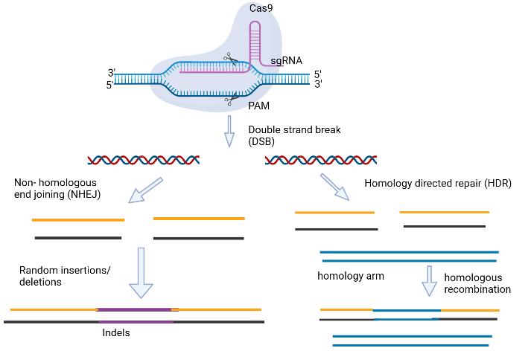
Figure 5: Gene editing carried out via CRISPR/Cas9. [99]
Site-directed mutagenesis has proven to be a valuable tool in both basic and applied research across various fields. In the realm of microbial cell genome editing for enhanced biofuel production, it serves as an advanced technology. Bacillus subtilis has been successfully modified by researchers using CRISPR/Cas9 technology, leading to the emergence of advantageous features such enhanced synthesis of b-cyclodextrin glycosyltransferase and resistance to spore formation. S. cerevisiae's genome has undergone similar changes in an effort to boost xylose utilisation and mevalonate or (R-R)-2,3-butanediol production. With the continuous publication of improved CRISPR/Cas9 protocols, we expect this approach to become increasingly integrated into routine laboratory procedures in the future. ^{[40]}

GENOME MODIFICATION OF MICROBIAL CELLS USING CRISPR/CAS9 FOR INCREASED BIOFUEL PRODUCTION
Researchers are hopeful that within the next five to ten years, cutting-edge technologies will enable them to fully use microbial cells for increased biofuel production. To achieve these objectives, site-directed mutagenesis using CRISPR/Cas9 is required to enhance the metabolic performance of the microbial cells. Recent studies on the use of CRISPR/Cas9-mediated genome engineering of microbial cells for improved biofuel production have surfaced in many publications. [41]
The systems may be modified for the production of biofuel among a variety of traditional and non-conventional bacterial hosts due to the availability of several forms of CRISPR-Cas9 machinery with various capabilities. Because specialist CRISPR expression cassettes are now readily available from well-known genetic engineering companies like Synthego and Genscript, creating a CRISPR experiment is thought to be a straightforward and quick process. The amount of CRISPR-Cas9 research being done in developing nations highlights the importance of non-profit databases like the Addgene vector database (https://www.addgene.org), where researchers from all over the world can deposit and share their plasmids for a small fee, making CRISPR technology an approachable and practical option, especially in the gene modification of microbial strains for the production of biofuels. Here, we want to draw attention to the many changes that CRISPR has brought forth.
Restricting competitive biofuel production pathways
Due to the potential for creating a sizable market, the manufacture of alcohols like bioethanol and biobutanol employing a range of industrial microbes from different renewable resources is greatly desired ^{[42]}. In a number of developed nations, bioethanol is also diluted with petrol in various ratios ^{[43]}. With the exception of bioethanol, higher alcohols (>2 carbons) are considered to be preferred substitutes for traditional petroleum-based fuels because of their high energy density, which lowers hygroscopicity and engine corrosivity ^{[44,45].} This is particularly valid for biobutanol. In the past, Clostridium species have been used to create a significant quantity of alcohol [46]. Due to their complicated genomic topologies and the lack of effective genetic methods for delivering targeted genomic modifications, this host species has fallen behind E. coli in the production of these alcohols.
Prior difficulties with CRISPR-Cas9 genome editing in Clostridium included poor recombination efficiency, Cas9 lethality upon early expression, and vector integration events. These challenges led to a decreased efficiency of transition and few or no effective conversions. However, the editing procedure was made better by employing plasmid-based editing DNA templates as replacements for linear templates. Additionally, Cas9's lethality was decreased by controlling its early expression under inducible promoters [48,49]. The subsequent developments in CRISPR use for better biobutanol and bioethanol production in Clostridium species and E. coli are further clarified, offering methods to improve genome editing for improved output.

For C. saccharoperbutylacetonicum N1-4, a non-model organism well recognised for its hyper butanol production, a very effective CRISPR-Cas9 genome engineering technology was created in order to improve the synthesis and selectivity of butanol [50]. In order to target the phosphotransacetylase (pta) and butyrate kinase (buk) genes in C. saccharoperbutylacetonicum, responsible for acetate and butyrate production, a modified CRISPR-Cas9 technique previously employed in C. beijerinckii was applied. The Cas9 open reading frame (ORF) from S. pyogenes was placed under the lactose-inducible promoter (bgaL), and the sgRNA was transcribed using the short RNA promoter (PsRNA) from C. beijerinckii. This approach resulted in the creation of single and double mutants for pta and buk. However, the effectiveness of this customized genome engineering technique was considerably lower in the non-model organism, with a mutation rate of only 18.5% compared to 100% in C. beijerinckii [49]. To identify a promoter that exhibited strong gRNA expression, several promoters including Pvegb from B. subtilis, Pvegc from C. saccharoperbutylacetonicum, and PJ23119 from E. coli were evaluated. Among them, the PJ23119 promoter stood out, showing a high transformation efficiency of 1.6 x 104 CFU/mg of DNA and a mutation rate of 75% for the pta gene. The double deletion mutant significantly reduced acetate and butyrate synthesis, leading to a biobutanol production of 19 g/L with a higher ethanol selectivity (20.8%) compared to acetone (15.6%). ^{[51]}
Table 2:-Application of the CRISPR-Cas9 system to different microorganisms for the generation of biofuels [98]
Microbial strains | Target genes | CRISPR-Cas9 machinery |  |  | Editing efficiency | Final products
 |  | gRNA promoter | Cas (Variants) | Cas promoter
Clostridium saccharoperbutylacetonicum N1-4 | Dpta, Dbuk | Pj23119 | Cas9 | Lac | 75% | Butanol (19.0 g/L)
Escherichia coli | gltA (down-regulated) | - | Cas9 | - | 75% | Butanol(1.08g/l)
Clostridium  ljungdahii DSM13528 | Dpta, DadhE1, Dctf, DpyrE | paraE | Cas9 | Pthl | 50-100% | Ethanol(0.25 g/l)
Clostridium acetobutylicum  ATCC 824 | Dupp | Pthl | Cas9 | aTC  anhydrotetracycline | 100% | Isopropanol(4.45 ± 0.34 g/L)
Clostridium tyrobutyricum | Cat1 (to replace adhE1 or adhE2) | Small RNA promoter | Casa9 | Plac lactose inducible promoter | 93.3% | Biobutanol(26.2 g/L)
Escherichia coli PA14 | Dthl, DatoDA, DctfAB, Dadc, Dadh | Pj23119 | dCas9 | Native promoter | 80% | Isopropanol(7.1 g/L)
Escherichia coli BW25113 | pta, frdA, ldhA, and adhE | Pj23119 | dCas9 | PrhaBAD | - | n-butanol1.06 g/L)
Clostridium  cellulovorans DSM743B | Dhyd, DClocel-2243 | Pj23119 | dCas9 | Pthl | 95.3% | Butanol(11.5 g/L)  Biosolvent(22.1g/l)
Escherichia coli | gabD, ybgC and tesB | Pj23119 | dCas9 | PLtetO1 | - | 1,4-butanediol(1.8 g/L)

Metabolic flux redirection for better solvent generation
The restoration of state and the diversion of carbon flux, along with the suppression of competing pathways, are thought to be additional effective methods for increasing the synthesis of biobutanol in a microbial system [61,62].
By overexpressing alcohol dehydrogenase (adhE2) from C. acetobutylicum, formate dehydrogenase (fdh1) from C. boidinii, and acetoacetyl-CoA thiolase (thl), E. coli EMJ50 strain was developed for biobutanol production from glucose. However, the oxygen sensitivity of C. acetobutylicum's aldehyde/alcohol dehydrogenase (adhE2) posed challenges under microaerobic conditions [63]. To overcome this, EMJ50 was modified by incorporating CoA-acylating propionaldehyde dehydrogenase (PduP) from S. enterica and alcohol dehydrogenase (adhA) from L. lactis, enabling butanol production of 0.82 g/L with a yield of 0.068 g/g glucose in microaerobic conditions [64]. The slight decrease in butanol yield compared to anaerobic conditions (0.082 g/g glucose) was attributed to carbon flux diversion towards citric acid production. To redirect carbon flux, CRISPR-Cas9 was utilized to downregulate the expression of citrate synthase (gltA) by modifying its 5'UTR using the UTR designer tool. The SacB gene promoter from Bacillus subtilis was employed for Cas9, crRNA, and tracrRNA expression during editing. Among the generated mutants, the gltA-deleted mutant (EMJ52, 55% cit) exhibited the highest butanol yield of 0.120 g/g glucose, demonstrating successful redirection of carbon flux from the citric acid cycle to acetoacetyl-CoA, which was positively correlated with citrate synthase activity (Table 2). [53]
Another appealing biofuel is biodiesel, which can be combined with chemically manufactured diesel in a certain ratio or used in currently operating engines. Single-cell oil (SCO) from oleaginous microorganisms is receiving more attention, and its additional characteristics, such as rapid growth, significant lipid accumulation, and absence of space constraints, all contribute to the possible creation of biofuels [65,66]. Biodiesel was created utilising oleaginous microorganisms and a range of feedstocks, such as hydrolyzed rice straw, poplar leaves, corn stalks, etc. These microorganisms were capable of producing up to 20% of their body weight in triacylglycerols (TAGs), while others had maximum butanol titers and produced more butanol by 1.3 times the amount [67,68].
Even though CRISPR-Cas9 technology is still in its infancy, it will rapidly develop due to the capacity to dramatically modify the genetic composition of oleaginous bacteria in the post-genomics era. Using a combined CRISPR-Cas9/l red recombineering strategy, genes for fatty acid (FA) metabolism, including the fatty acid regulatory transcription factor (fadR), D9 desaturase (delta9), and acetyl-CoA carboxylase (acc), were inserted into E. coli to create a fadR/delta9 and acc knock-in bacterial strain [69]. The recombinant strain's FA composition was the same as the wild-type strain's, but a 5.3% greater FA content was found. New perspectives on whether it is possible to include whole routes into appropriate microbial systems to enable the generation of biodiesel at industrial scales are opened by the ground-breaking result.
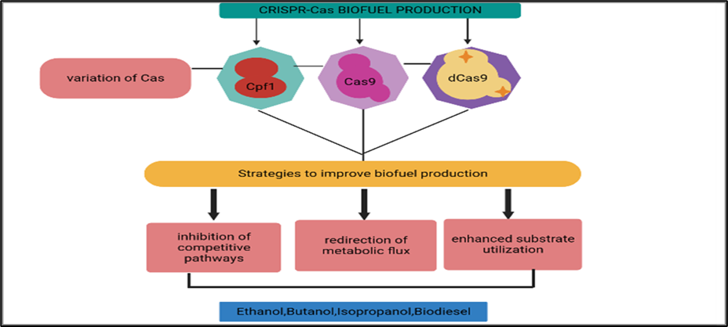
Figure 7: A summary of how the CRISPR Cas system has improved the production of different biofuels. [98]
Improvement in the ability to use substrates
A important step towards lowering production costs is the modification of commercial Clostridial strains for the use of cheap feedstock to improve alcohol fermentation [70]. The Clostridium species are unable to use other sugars due to carbon catabolite inhibition since glucose is present in the feedstock. This restriction can be lifted by altering the genes that control sugar intake [71]. Bruder et al. [72] focused on the carbon catabolite repression (CCR) of C. acetobutylicumDSM792 and C. pasteurianum ATC using SpCRISPR-dCas9. This was done by suppressing the kinase/phosphorylase (hprK) gene. This research on the suppression of carbon catabolite also shed information on the production of biobutanol using glycerol, an important by-product of the biodiesel industry. Xylose and glucose from lignocellulosic feedstock were both utilised as a result of C6013.
Huang et al. used the CRISPR-Cas9 technique created for E. coli to successfully show CRISPR-Cas9 genome editing in C. ljungdahlii in their work. An autonomous plasmid incorporating sgRNA, SpCas9, and DNA repair templates was created to prevent unwanted recombination. The original C. ljungdahlii promoters were replaced with heterologous promoters from C. acetobutylicum, and a promoter-free lacZ reporter gene region was cloned. The studied promoters with the highest activity were Pthl and ParaE. Successful deletions of the pta, adhE1, ctf, and pyrE genes were obtained using sgRNA expression cassettes, with editing efficiency ranging from >50% to 100%. The production of a mixed population of wild types and mutants was 100% effective due to antibiotic selection. The study focused on C. ljungdahlii's chromosomal alterations' effects and CRISPR's ability to address problems with Clostridium species. Additionally, in order to get around problems with single-plasmid CRISPR-Cas9 genome editing in C. acetobutylicum ATCC 824, a two-plasmid technique was created, which enhanced isopropanol synthesis. Figure 8 shows the possibility for adding novel biofuel pathways into Clostridium hosts used in biofuel production using the two-plasmid inducible CRISPR-Cas9 editing technique.
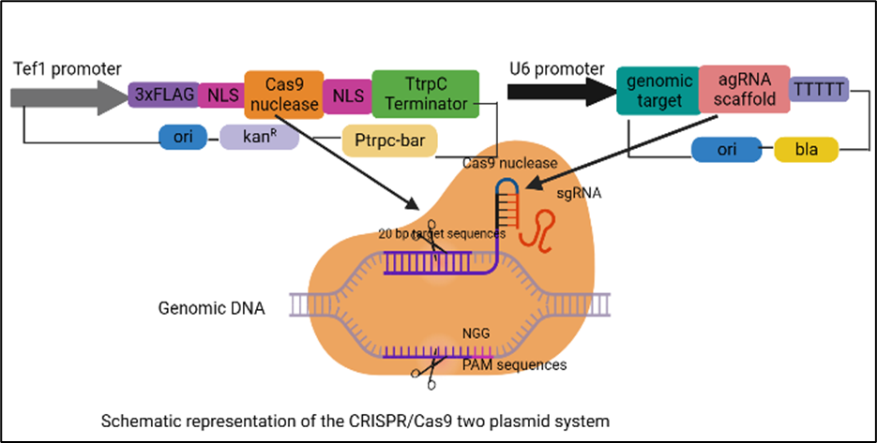
Figure 8: CRISPR/Cas9 two plasmid system (Adapted from https://www.researchgate.net/figure/Schematic-representation-of-the-CRISPR-Cas9-two-plasmid-system-in-this-study_fig1_312047270)
Expanding host-specificity in biofuel production by using endogenous CRISPR-Cas9
Numerous papers have described genome editing using CRISPR-Cas9 in different Clostridium species as well as modifications to the genes required for the synthesis of biobutanol and other alcoholic beverages. Other non-conventional species from the same genus that have distinctive metabolic traits but were previously restricted by their impenetrable genomic arrangements and a lack of useful genetic tools have also been genetically modified using CRISPR-Cas9 technology, enabling more affordable biofuel production. These unusual species are related to the common model strains C. acetobutylicum and C. beijerinckii through a common genus. A few studies that deal with preferential sugar utilisation, changing the carbon flow, and using inducible promoters are included in this review since they are all effective methods used in the generation of different alcohols by Clostridium species. However, a variety of bacteria showed low to moderate levels of toxicity when employing the Type II CRISPR-Cas9 system created from S. pyogenes [74]. Bacterial chromosomes have unique characteristics that render heterologous Cas9 expression extremely dangerous and result in lethal chromosomal breakage, rendering genome engineering useless and reducing transformation efficiency. Prokaryotic CRISPR-Cas9 machinery is so widespread (74% of Clostridium species have CRISPR-loci), thus it could be able to use it or harness it to help solve the issues caused by Cas9 toxicity and insufficient transformation efficiency [76]. Pyne et al. [77] conducted a proof-of-concept research to compare the efficiency of Type II CRISPR-Cas9 and host-encoded Type I CRISPR-Cas9 systems for genome editing in C. pasteurianum, a prospective bacterial strain capable of converting waste glycerol into butanol. The results of this work demonstrated that the naturally occurring Type I-B CRISPR-Cas9 system, which employs 37-spacer CRISPR tags rather than the Type II 3' PAM sequence, must be vulnerable to interference from host cells. Comparing the endogenous Type I-B technique to the S. pyogenes CRISPR-Cas9 machinery found 100% editing effectiveness (10/10 correct colonies) in the C. pasteurianum, demonstrating the method's applicability to additional Clostridium species including C. autoethanogenum, C. tetani, and C. thermocellum. The sole requirements for using this technology on any target organism with an active Type I CRISPR-Cas9 machinery are a functional PAM sequence positioned in 5' to the protospacers and the plasmid transformation strategy. to avoid the negative consequences of the heterologous nuclease/nickase (CRISPR-Cas9/nCas9/AsCpf1)[78]. Zhang et al. [56] altered the C. tyrobutyricum genome with the native Type-1B CRISPR-Cas9 system. To enhance butanol production, the alcohol dehydrogenase genes (adhE1/adhE2) were incorporated using endogenous CRISPR-Cas9. The cat1 gene was substituted with adhE1/adhE2, which was retained under the cat1 promoter sequences, using 103 CFU/mL transformants produced by the endogenous CRISPR-Cas9 system using the likely PAM sequence. With a butanol production titer of 26.2 g/L, the resulting mutants (Dcat1:adhE2) were discovered to generate hyper-butanol.

The multiplex automated genome engineering (MAGE) platform for the generation of biofuels
The fundamental difficulty in producing a significant number of variations with desired mutations and then separating positive transformants from a huge pool of unedited background material is that it can take a long time to achieve desired phenotypes, such as high biofuel productivity [79]. Traditional genome editing methods have limitations in terms of low transformation efficiency and targeting a single genomic location in a single round, resulting in a small number of transformants [80]. The advent of CRISPR-Cas9 genome engineering has significantly improved editing effectiveness by enabling multiple genome edits at different loci in a single mutagenesis cycle. The multiplex automated genome engineering (MAGE) technique offers a diverse range of mutants, allowing targeted mutations in specific genes while leaving others unaltered, thus bypassing the need for extensive screening and selection [80].

In one example, the DXP biosynthetic pathway was successfully optimized to enhance lycopene production in E. coli by up to five times using this approach [81]. The MAGE method has increased the genetic diversity of bacteria and may make it easier to create synthetic biofuel pathways thanks to the quick development of Cas9-based platforms. MAGE mediated by nucleases has recently been used in bacterial systems. To improve isopropanol synthesis in E. coli, Liang et al. created the CREATE (CRISPR Enabled Trackable genome Engineering) approach by combining MAGE with CRISPR-Cas9 and barcoding technology [57]. The modified strain PA06 had the maximum productivity of 0.40 g/L/h (yield of 0.62 mol/mol), thanks to codon-optimized genes (thl, atoDA, ctfAB, adc, and adh) driven by a constitutive promoter PJ23119 on a low-copy-number plasmid pACYC184-IPA-2 [82]. The strain PA14, which underwent CREATE technology and attained the maximum productivity of 0.62 g/L/h (yield of 0.75 mol/mol) by largely upregulating adc and adh genes, was created by incorporating the synthetic route into the E. coli genome. The CREATE approach, which is derived from MAGE, showed the capacity to quickly produce and analyse a large number of designed strains, making it suitable for developing high-performing strains with higher biofuel generation capabilities.
Using a single CRISPR array that encodes a variety of spacer sequences, Cpf1 has also been employed for multiplex CRISPR genome editing at various chromosomal loci in addition to the Cas9 module [83]. However, the primary limitations that led to the lower transformation rates and restricted the use of Cas9-Cpf1 in multiplex editing were still its toxicity and longer spacer arms. Zhang et al.[84,56] studied the endogenous Type I B CRISPR-Cas9 system in C. tyrobutyricum to concurrently target two genes, pyrF (encoding the orotidine 5-phosphate decarboxylase) and spoOA (encoding the sporation regulator). The endogenous CRISPR-Cas9 system-mediated multiplex genome editing, which can be further developed as genome engineering tools in other microorganisms, such as Clostridium species, demonstrated its first success in the chromosome-targeted deletion of these two genes with a 100% editing efficiency.
CRISPR toolkit optimization to increase biofuel production
- Off-target consequences in the CRISPR/Cas system
Off-target consequences can have a big impact, especially when CRISPR is used in gene therapy applications. The severe consequences of off-target impacts are far less frequently described in microbial energy biotechnology but cannot be readily ignored. As a result, this review looks at the implications of off-target effects on prokaryotic systems. The lack of a recognized eukaryotic function for Cas9 proteins, in contrast to ZFN and TALEN, raises the possibility that greater off-target effects may occur. The bacterial genome has less genetic variety simply because it is smaller, which leads to a lesser tendency for off-target mutations caused by Cas9 and, as a result, gives researchers another reason to create biofuels in prokaryotic platforms [90].

- Off-target effects are decreased by sgRNA design
TGE heavily relies on selecting a suitable target site with minimal or no closely related genetic sequences. Several algorithm-based tools, such as CHOPCHOP, E-CRISP, and CRISPR DESIGN, have been developed to aid in this process, offering varying degrees of effectiveness based on factors like sequence similarity, number and placement of mismatches, and more [90]. Additionally, studies by Ran et al. and Fu et al. established correlations between the ratio of gRNA to Cas9 and the occurrence of off-target effects [91]. Another important finding presented by Fu et al. was the relationship between gRNA length and reduced off-target effects. It was demonstrated that shorter gRNAs consisting of 17-18 nucleotides (nt) resulted in minimal off-target effects while maintaining on-target effectiveness. Furthermore, the study revealed that organisms with smaller and more complex genomes had fewer "incorrect" target sites for gRNA base pairing, contributing to improved specificity [92].

- Modifying Cas9 to reduce off-target effects
The success of a CRISPR process relies on the timing, locus-specificity, and spatial regulation of Cas9 protein expression. Continuous expression of Cas9 protein, particularly when co-expressed with gRNA on the same plasmid, can have drawbacks. Extended Cas9 production may lead to off-target effects or activate a DNA damage response, especially if the targeted genes are essential for host cell survival [93]. To mitigate Cas9 toxicity, transient expression of Cas9 and the use of inducible promoters are employed as preventive measures. Additionally, the "codon-optimized" approach can be applied to fine-tune Cas9 expression for different microbial species by considering their specific nucleotide composition [94]. Another effective strategy to minimize off-target effects involves modifying Cas9 by incorporating the Fok I nuclease domain, which is also utilized in ZFNs and TALENs. By fusing the catalytically inactive Cas9 (dCas9) with the Fok I nuclease domain, the specificity of targeted gene editing (TGE) has been observed to quadruple [95]. The enhanced specificity is attributed to the strict dimerization requirements of Fok I, which improves the effective binding of the Cas9-dCas9-Fok I complex to the target site.
High-fidelity Cas9 (SpCas9-HF1) was created by inserting precise alanine substitutions at places where Cas9-assisted hydrogen bonds connect to genomic DNA in order to increase the selectivity of Cas9. When there is even a single mismatch at the 5' end of the guide RNA (gRNA), which Cas9 employs to cleave DNA, the possibility of off-target cleavage increases. Cas9 that has been tweaked and referred to as "nickases" has been used to address this problem. Nickases, like RuvC or HNH, contain one inactive catalytic domain that aids in minimising off-target cleavage. A Cas9 nickase, in contrast to conventional Cas9, can only sever one strand of the target DNA, creating a single-strand break, or "nick" [95]. Similar to the inactive dCas9 (RuvC or HNH), a Cas9 nickase can still bind to DNA based on gRNA specificity but can only cleave one strand of the DNA. Most CRISPR plasmids are derived from S. pyogenes, and introducing a D10A mutation inactivates the RuvC domain, while an H840A mutation does the same for the HNH domain. A single-strand break is frequently quickly repaired via homology-directed repair (HDR) utilising the complementary DNA strand's intact template. The phrase "double nick" or "dual nickase" CRISPR system is frequently used when two nearby nicks on opposing DNA strands are handled by a Cas9 nickase as a double-strand break (DSB). Depending on the intended impact on the target genes, non-homologous end joining (NHEJ) or homologous DNA repair (HDR) can be used to repair a double nick-induced DSB. Slaymaker et al.'s research [96] led to the creation of eSpCas9, a better Cas9 variant with increased specificity. They discovered that Cas9's capacity to unwind and rewind DNA was what caused off-target cleavage. Based on crystallographic analyses of Cas9-gRNA and target DNA from Streptococcus species, they changed the non-target strand to address this by forming a positively charged groove.
In summary, addressing concerns related to off-target CRISPR mutagenesis can be effectively managed by combining the appropriate Cas9 variant with a well-planned gRNA design. Notably, emerging CRISPR-Cas9 nucleases like Cpf-1 have shown improved performance compared to Cas9 and eSpCas9. Cpf-1 offers advantages such as DNA cleavage using crRNA, which reduces sgRNA production costs, and the ability to create sticky ends with 4 or 5 nucleotide overhangs, enabling knock-ins through NHEJ. Additionally, Cpf-1 exhibits RNAse III activity, facilitating multiplex genome engineering and pre-crRNA processing with minimal off-target effects. Furthermore, Cpf-1 recognizes T-rich PAM regions, significantly enhancing genome editing efficiency. Furthermore, the exploration of other class II CRISPR-Cas candidates, including C2c1, C2c2, and C2c3 families, has expanded the scope of gene knockdown capabilities, broadening the possibilities for genome editing. As advanced sequencing techniques like GUIDE-Seq and Digenome-Seq become more widely available, the supremacy of the CRISPR methodology over other alternatives continues to be demonstrated.

CONCLUSION
Microorganisms play a major role in the production of biofuel but the product obtained by native strains is not economical, thus it is necessary to develop and improve these strains in order to get better and high yield. The implementation of CRISPR-Cas9 can be used to overcome these issues. With the development of CRISPR-Cas9 technology, the possibility of widespread metabolic reprogramming for the sustainable generation of diverse biofuels has advanced quickly. This technique can be used to develop and design strains of microbes with improved and enhanced ability to generate biofuel by knocking-in or knocking-out the targeted gene. Incorporating Cpf1 into the editing process offers advantages in terms of cost and efficiency by eliminating the need for a tracrRNA, thereby reducing plasmid synthesis costs and expediting the procedure. This method allows for a notable reduction in the size of the expression plasmid without the requirement of large editing templates. Furthermore, by employing a twin plasmid approach, it is possible to carry out a number of modifications at once while also drastically lowering the expenses and labour necessary for recycling the selection markerBy integrating this approach with their understanding of microbial hosts, scientists worldwide can effectively convert non-edible energy crops such as Pinnata, Pongamia, Jatropha curcas, and Ricinus communis into biofuels and other value-added products.

REFERENCES

- Gowen, C. M., & Fong, S. S. (2011). Applications of systems biology towards microbial fuel production. Trends in microbiology, 19(10), 516-524.
- Xing, M. N., Zhang, X. Z., & Huang, H. (2012). Application of metagenomic techniques in mining enzymes from microbial communities for biofuel synthesis. Biotechnology advances, 30(4), 920-929.
- Munasinghe, P. C., & Khanal, S. K. (2010). Biomass-derived syngas fermentation into biofuels: opportunities and challenges. Bioresource technology, 101(13), 5013-5022.
- Bajpai, P., & Bajpai, P. (2017). General considerations on the use of lignocellulosic residues. Single cell protein production from lignocellulosic biomass, 11-16.
- Garneau, J. E., Dupuis, M. È., Villion, M., Romero, D. A., Barrangou, R., Boyaval, P., & Moineau, S. (2010). The CRISPR/Cas bacterial immune system cleaves bacteriophage and plasmid DNA. Nature, 468(7320), 67-71.
- Wiedenheft, B., Sternberg, S. H., & Doudna, J. A. (2012). RNA-guided genetic silencing systems in bacteria and archaea. Nature, 482(7385), 331-338.
- DiCarlo, J. E., Norville, J. E., Mali, P., Rios, X., Aach, J., & Church, G. M. (2013). Genome engineering in Saccharomyces cerevisiae using CRISPR-Cas systems. Nucleic acids research, 41(7), 4336-4343.
- Javed, M. R., Noman, M., Shahid, M., Ahmed, T., Khurshid, M., Rashid, M. H., & Khan, F. (2019). Current situation of biofuel production and its enhancement by CRISPR/Cas9-mediated genome engineering of microbial cells. Microbiological research, 219, 1-11.
- Wang, Y., Zhang, Z. T., Seo, S. O., Lynn, P., Lu, T., Jin, Y. S., & Blaschek, H. P. (2016). Bacterial genome editing with CRISPR-Cas9: deletion, integration, single nucleotide modification, and desirable “clean” mutant selection in Clostridium beijerinckii as an example. ACS synthetic biology, 5(7), 721-732.
- Rodionova, M. V., Poudyal, R. S., Tiwari, I., Voloshin, R. A., Zharmukhamedov, S. K., Nam, H. G.,& Allakhverdiev, S. I. (2017). Biofuel production: challenges and opportunities. International Journal of Hydrogen Energy, 42(12), 8450-8461.
- Doshi, A., Pascoe, S., Coglan, L., & Rainey, T. J. (2016). Economic and policy issues in the production of algae-based biofuels: A review. Renewable and sustainable energy reviews, 64, 329-337.
- Naik, S. N., Goud, V. V., Rout, P. K., & Dalai, A. K. (2010). Production of first-and second generation biofuels: a comprehensive review. Renewable and sustainable energy reviews, 14(2), 578-597.
- Nigam, P. S., & Singh, A. (2011). Production of liquid biofuels from renewable resources. Progress in energy and combustion science, 37(1), 52-68.
- Havlík, P., Schneider, U. A., Schmid, E., Böttcher, H., Fritz, S., Skalský, R., & Obersteiner, M. (2011). Global land-use implications of first-and-second generation biofuel targets. Energy policy, 39(10), 5690-5702.
- Schenk, P. M., Thomas-Hall, S. R., Stephens, E., Marx, U. C., Mussgnug, J. H., Posten, C., & Hankamer, B. (2008). Second generation biofuels: high-efficiency microalgae for biodiesel production. Bioenergy research, 1, 20-43.
- Brennan, L., & Owende, P. (2010). Biofuels from microalgae—a review of technologies for production, processing, and extractions of biofuels and co-products. Renewable and sustainable energy reviews, 14(2), 557-577.
- Lee, R. A., & Lavoie, J. M. (2013). From first-to third-generation biofuels: Challenges of producing a commodity from a biomass of increasing complexity. Animal Frontiers, 3(2), 6-11
- Scott, S. A., Davey, M. P., Dennis, J. S., Horst, I., Howe, C. J., Lea-Smith, D. J., & Smith, A. G. (2010). Biodiesel from algae: challenges and prospects. Current opinion in biotechnology, 21(3), 277-286.
- Azad, A. K., Rasul, M. G., Khan, M. M. K., & Sharma, S. C. (2014, May). Review of biodiesel production from microalgae: a novel source of green energy. In Int Green Energy Conf (pp. 1-9).
- Lü, J., Sheahan, C., & Fu, P. (2011). Metabolic engineering of algae for fourth generation biofuels production. Energy & Environmental Science, 4(7), 2451-2466.
- Alvira, P., Tomás-Pejó, E., Ballesteros, M., & Negro, M. J. (2010). Pretreatment technologies for an efficient bioethanol production process based on enzymatic hydrolysis: a review. Bioresource technology, 101(13), 4851-4861.
- Mood, S. H., Golfeshan, A. H., Tabatabaei, M., Jouzani, G. S., Najafi, G. H., Gholami, M., & Ardjmand, M. (2013). Lignocellulosic biomass to bioethanol, a comprehensive review with a focus on pretreatment. Renewable and Sustainable Energy Reviews, 27, 77-93.
- Liu, K., Atiyeh, H. K., Pardo-Planas, O., Ezeji, T. C., Ujor, V., Overton, J. C., & Tanner, R. S. (2015). Butanol production from hydrothermolysis-pretreated switchgrass: quantification of inhibitors and detoxification of hydrolyzate. Bioresource technology, 189, 292-301.
- Liu, K., Atiyeh, H. K., Pardo-Planas, O., Ramachandriya, K. D., Wilkins, M. R., Ezeji, T. C., & Tanner, R. S. (2015). Process development for biological production of butanol from Eastern redcedar. Bioresource Technology, 176, 88-97.
- Devarapalli, M., & Atiyeh, H. K. (2015). A review of conversion processes for bioethanol production with a focus on syngas fermentation. Biofuel Research Journal, 2(3), 268-280.
- Saini, J. K., Saini, R., & Tewari, L. (2015). Lignocellulosic agriculture wastes as biomass feedstocks for second-generation bioethanol production: concepts and recent developments. 3 Biotech, 5, 337-353.
- Zhao, X. Q., Zi, L. H., Bai, F. W., Lin, H. L., Hao, X. M., Yue, G. J., & Ho, N. W. (2012). Bioethanol from lignocellulosic biomass. Biotechnology in China III: Biofuels and bioenergy, 25-51.
- Talebnia, F., Karakashev, D., & Angelidaki, I. (2010). Production of bioethanol from wheat straw: an overview on pretreatment, hydrolysis and fermentation. Bioresource technology, 101(13), 4744-4753.
- Kang, Q., Appels, L., Tan, T., & Dewil, R. (2014). Bioethanol from lignocellulosic biomass: current findings determine research priorities. The Scientific World Journal, 2014.
- Sethi, A., & Scharf, M. E. (2013). Biofuels: fungal, bacterial and insect degraders of lignocellulose. eLS.
- Singhania, R. R., Patel, A. K., Pandey, A., & Ganansounou, E. (2017). Genetic modification: a tool for enhancing beta-glucosidase production for biofuel application. Bioresource technology, 245, 1352-1361.
- Ulaganathan, K., Goud, S., Reddy, M., & Kayalvili, U. (2017). Genome engineering for breaking barriers in lignocellulosic bioethanol production. Renewable and Sustainable Energy Reviews, 74, 1080-1107.
- Horvath, P., & Barrangou, R. (2010). CRISPR/Cas, the immune system of bacteria and archaea. Science, 327(5962), 167-170.
- Miller, J. C., Tan, S., Qiao, G., Barlow, K. A., Wang, J., Xia, D. F., & Rebar, E. J. (2011). A TALE nuclease architecture for efficient genome editing. Nature biotechnology, 29(2), 143-148.
- Kim, S., Lee, M. J., Kim, H., Kang, M., & Kim, J. S. (2011). Preassembled zinc-finger arrays for rapid construction of ZFNs. Nature methods, 8(1), 7.
- Gaj, T., Gersbach, C. A., & Barbas, C. F. (2013). ZFN, TALEN, and CRISPR/Cas-based methods for genome engineering. Trends in biotechnology, 31(7), 397-405.
- Deltcheva, E., Chylinski, K., Sharma, C. M., Gonzales, K., Chao, Y., Pirzada, Z. A., & Charpentier, E. (2011). CRISPR RNA maturation by trans-encoded small RNA and host factor RNase III. Nature, 471(7340), 602-607.
- Jinek M, Chylinski K, Fonfara I, Hauer M, Doudna JA, Charpentier E. A. (2012). Programmable dual-RNA-guided DNA endonuclease in adaptive bacterial immunity. Science. 337:816–21.
- Ran, F. A., Hsu, P. D., Wright, J., Agarwala, V., Scott, D. A., & Zhang, F. (2013). Genome engineering using the CRISPR-Cas9 system. Nature protocols, 8(11), 2281-2308.
- Ulaganathan, K., Goud, S., Reddy, M., & Kayalvili, U. (2017). Genome engineering for breaking barriers in lignocellulosic bioethanol production. Renewable and Sustainable Energy Reviews, 74, 1080-1107.
- Nymark, M., Sharma, A. K., Sparstad, T., Bones, A. M., & Winge, P. (2016). A CRISPR/Cas9 system adapted for gene editing in marine algae. Scientific reports, 6(1), 24951.
- Voloshin, R. A., Rodionova, M. V., Zharmukhamedov, S. K., Veziroglu, T. N., & Allakhverdiev, S. I. (2019). Biofuel production from plant and algal biomass. Alternative Energy and Ecology (ISJAEE), (7-9), 12-31.
- Muruaga, M. L., Carvalho, K. G., Domínguez, J. M., de Souza Oliveira, R. P., & Perotti, N. (2016). Isolation and characterization of Saccharomyces species for bioethanol production from sugarcane molasses: Studies of scale up in bioreactor. Renewable Energy, 85, 649-656.
- Shanmugam, S., Sun, C., Zeng, X., & Wu, Y. R. (2018). High-efficient production of biobutanol by a novel Clostridium sp. strain WST with uncontrolled pH strategy. Bioresource technology, 256, 543-547.
- Nimbalkar, P. R., Khedkar, M. A., Chavan, P. V., & Bankar, S. B. (2018). Biobutanol production using pea pod waste as substrate: Impact of drying on saccharification and fermentation. Renewable Energy, 117, 520-529.
- Bankar, S. B., Jurgens, G., Survase, S. A., Ojamo, H., & Granström, T. (2015). Genetic engineering of Clostridium acetobutylicum to enhance isopropanol-butanol-ethanol production with an integrated DNA-technology approach. Renewable Energy, 83, 1076-1083.
- Xue,C., Zhao,J., Chen,L., Yang,S.-T.,Bai,F. (2017) Recent advances and state-of-the- art strategies in strain and process engineering for biobutanol production by Clostridium acetobutylicum, Biotechnol. Adv. 35 (2)
- Wang.Y., Zhang, Z.T., Seo,S.O., Choi,K., Lu,T., Jin,Y.-S., (2015) Blaschek, Markerless chromosomal gene deletion in Clostridium beijerinckii using CRISPR/ Cas9 system, J. Biotechnol. 200
- Wang, Y., Zhang, Z. T., Seo, S. O., Lynn, P., Lu, T., Jin, Y. S., & Blaschek, H. P. (2016). Bacterial genome editing with CRISPR-Cas9: deletion, integration, single nucleotide modification, and desirable “clean” mutant selection in Clostridium beijerinckii as an example. ACS synthetic biology, 5(7), 721-732.
- Wang, S., Dong, S., Wang, P., Tao, Y., & Wang, Y. (2017). Genome editing in Clostridium saccharoperbutylacetonicum N1-4 with the CRISPR-Cas9 system. Applied and environmental microbiology, 83(10), e00233-17.
- Xu, T., Li, Y., Van Nostrand, J. D., He, Z., & Zhou, J. (2014). Cas9-based tools for targeted genome editing and transcriptional control. Applied and environmental microbiology, 80(5), 1544-1552.
- Jang, Y. S., Lee, J. Y., Lee, J., Park, J. H., Im, J. A., Eom, M. H., & Lee, S. Y. (2012). Enhanced butanol production obtained by reinforcing the direct butanol-forming route in Clostridium acetobutylicum. MBio, 3(5), e00314-12.
- Heo, M. J., Jung, H. M., Um, J., Lee, S. W., & Oh, M. K. (2017). Controlling citrate synthase expression by CRISPR/Cas9 genome editing for n-butanol production in Escherichia coli. ACS synthetic biology, 6(2), 182-189.
- Huang, H., Chai, C., Li, N., Rowe, P., Minton, N. P., Yang, S., & Gu, Y. (2016). CRISPR/Cas9-based efficient genome editing in Clostridium ljungdahlii, an autotrophic gas-fermenting bacterium. ACS synthetic biology, 5(12), 1355-1361.
- Wasels, F., Jean-Marie, J., Collas, F., López-Contreras, A. M., & Ferreira, N. L. (2017). A two-plasmid inducible CRISPR/Cas9 genome editing tool for Clostridium acetobutylicum. Journal of microbiological methods, 140, 5-11.
- Zhang, J., Zong, W., Hong, W., Zhang, Z. T., & Wang, Y. (2018). Exploiting endogenous CRISPR-Cas system for multiplex genome editing in Clostridium tyrobutyricum and engineer the strain for high-level butanol production. Metabolic engineering, 47, 49-59.
- Liang, L., Liu, R., Garst, A. D., Lee, T., i Nogué, V. S., Beckham, G. T., & Gill, R. T. (2016)., CRISPR Enabled Trackable genome Engineering for isopropanol production in Escherichia coli, Metabolic Engineering.
- Kim, S. K., Seong, W., Han, G. H., Lee, D. H., & Lee, S. G. (2017). CRISPR interference-guided multiplex repression of endogenous competing pathway genes for redirecting metabolic flux in Escherichia coli. Microbial cell factories, 16, 1-15.
- Wen, Z., Minton, N. P., Zhang, Y., Li, Q., Liu, J., Jiang, Y., & Yang, S. (2017). Enhanced solvent production by metabolic engineering of a twin-clostridial consortium. Metabolic engineering, 39, 38-48.
- Wu, M. Y., Sung, L. Y., Li, H., Huang, C. H., & Hu, Y. C. (2017). Combining CRISPR and CRISPRi systems for metabolic engineering of E. coli and 1, 4-BDO biosynthesis. ACS Synthetic Biology, 6(12), 2350-2361.
- Lim, J. H., Seo, S. W., Kim, S. Y., & Jung, G. Y. (2013). Model-driven rebalancing of the intracellular redox state for optimization of a heterologous n-butanol pathway in Escherichia coli. Metabolic Engineering, 20, 56-62.
- Saini, M., Li, S. Y., Wang, Z. W., Chiang, C. J., & Chao, Y. P. (2016). Systematic engineering of the central metabolism in Escherichia coli for effective production of n-butanol. Biotechnology for biofuels, 9, 1-10.
- Fontaine, L., Meynial-Salles, I., Girbal, L., Yang, X., Croux, C., & Soucaille, P. (2002). Molecular characterization and transcriptional analysis of adhE2, the gene encoding the NADH-dependent aldehyde/alcohol dehydrogenase responsible for butanol production in alcohologenic cultures of Clostridium acetobutylicum ATCC 824. Journal of bacteriology, 184(3), 821-830.
- Bogorad,I.W.,Chen,C.T., Theisen,M.K., Schlenz,A.R., Lam,A.T., Liao, J.C. (2014) , Building carbonecarbon bonds using a biocatalytic methanol condensation cycle, Proc. Natl. Acad. Sci. U.S.A. 111 (45)
- Angerbauer, C., Siebenhofer, M., Mittelbach, M., & Guebitz, G. M. (2008). Conversion of sewage sludge into lipids by Lipomyces starkeyi for biodiesel production. Bioresource technology, 99(8), 3051-3056.
- Yellapu, S. K., Kaur, R., Kumar, L. R., Tiwari, B., Zhang, X., & Tyagi, R. D. (2018). Recent developments of downstream processing for microbial lipids and conversion to biodiesel. Bioresource technology, 256, 515-528.
- Huang, C., Zong, M. H., Wu, H., & Liu, Q. P. (2009). Microbial oil production from rice straw hydrolysate by Trichosporon fermentans. Bioresource Technology, 100(19), 4535-4538.
- Taskin, M., Ortucu, S., Aydogan, M. N., & Arslan, N. P. (2016). Lipid production from sugar beet molasses under non-aseptic culture conditions using the oleaginous yeast Rhodotorula glutinis TR29. Renewable energy, 99, 198-204.
- Xia, J., Wang, L., Zhu, J. B., Sun, C. J., Zheng, M. G., Zheng, L., & Shi, L. (2016). Expression of Shewanella frigidimarina fatty acid metabolic genes in E. coli by CRISPR/cas9-coupled lambda Red recombineering. Biotechnology letters, 38, 117-122.
- Al-Shorgani, N. K. N., Isa, M. H. M., Yusoff, W. M. W., Kalil, M. S., & Hamid, A. A. (2016). Isolation of a Clostridium acetobutylicum strain and characterization of its fermentation performance on agricultural wastes. Renewable Energy, 86, 459-465.
- Y. Gu, Y. Jiang, S. Yang, W. Jiang, Utilization of economical substrate-derived carbohydrates by solventogenic clostridia: pathway dissection, regulation and engineering, Curr. Opin. Biotechnol. 29 (2014) 124e131, https://doi.org/ 10.1016/j.copbio.2014.04.004.
- M.R. Bruder, M.E. Pyne, M. Moo-Young, D.A. Chung, C.P. Chou, Extending CRISPR-cas9 technology from genome editing to transcriptional engineering in the genus Clostridium, Appl. Environ. Microbiol. 82 (20) (2016) 6109e6119, https://doi.org/10.1128/AEM.02128-16.
- Jiang, Y., Chen, B., Duan, C., Sun, B., Yang, J., & Yang, S. (2015). Multigene editing in the Escherichia coli genome via the CRISPR-Cas9 system. Applied and environmental microbiology, 81(7), 2506-2514.
- H. Wang, H. Yang, C.S. Shivalila, M.M. Dawlaty, A.W. Cheng, F. Zhang,R. Jaenisch, One-step generation of mice carrying mutations in multiple genes by CRISPR/Cas-mediated genome engineering, Cell 153 (4) (2013) 910e918
- Charpentier, E., & Doudna, J. A. (2013). Rewriting a genome. Nature, 495(7439), 50-51.
- Jacobs, J. Z., Ciccaglione, K. M., Tournier, V., & Zaratiegui, M. (2014). Implementation of the CRISPR-Cas9 system in fission yeast. Nature communications, 5(1), 5344.
- Pyne, M. E., Bruder, M. R., Moo-Young, M., Chung, D. A., & Chou, C. P. (2016). Harnessing heterologous and endogenous CRISPR-Cas machineries for efficient markerless genome editing in Clostridium. Scientific reports, 6(1), 1-15.
- Johnson, D. T., & Taconi, K. A. (2007). The glycerin glut: Options for the value‐added conversion of crude glycerol resulting from biodiesel production. Environmental Progress, 26(4), 338-348.
- Vervoort, Y., Linares, A. G., Roncoroni, M., Liu, C., Steensels, J., & Verstrepen, K. J. (2017). High-throughput system-wide engineering and screening for microbial biotechnology. Current opinion in biotechnology, 46, 120-125.
- Carr, P.A., Church, G.M. (2016) Genome engineering, Nat. Biotechnol. 27 (12) 1151,
- Bao, Z., Cobb, R. E., & Zhao, H. (2016). Accelerated genome engineering through multiplexing. Wiley Interdisciplinary Reviews: Systems Biology and Medicine, 8(1), 5-21.
- Wang, H. H., Isaacs, F. J., Carr, P. A., Sun, Z. Z., Xu, G., Forest, C. R., & Church, G. M. (2009). Programming cells by multiplex genome engineering and accelerated evolution. Nature, 460(7257), 894-898.
- Zetsche, B., Heidenreich, M., Mohanraju, P., Fedorova, I., Kneppers, J., DeGennaro, E. M., & Zhang, F. (2017). Multiplex gene editing by CRISPR–Cpf1 using a single crRNA array. Nature biotechnology, 35(1), 31-34.
- Nielsen,J., Keasling, J.D.(2016) Engineering cellular metabolism, Cell 164 (6) 1185e1197
- Lim, H. G., Noh, M. H., Jeong, J. H., Park, S., & Jung, G. Y. (2016). Optimum rebalancing of the 3-hydroxypropionic acid production pathway from glycerol in Escherichia coli. ACS synthetic biology, 5(11), 1247-1255.
- Qi, L. S., Larson, M. H., Gilbert, L. A., Doudna, J. A., Weissman, J. S., Arkin, A. P., & Lim, W. A. (2021). Repurposing CRISPR as an RNA-guided platform for sequence-specific control of gene expression. Cell, 184(3), 844.
- Dominguez, A. A., Lim, W. A., & Qi, L. S. (2016). Beyond editing: repurposing CRISPR–Cas9 for precision genome regulation and interrogation. Nature reviews Molecular cell biology, 17(1), 5-15.
- Bikard, D., Jiang, W., Samai, P., Hochschild, A., Zhang, F., & Marraffini, L. A. (2013). Programmable repression and activation of bacterial gene expression using an engineered CRISPR-Cas system. Nucleic acids research, 41(15), 7429-7437.
- Kim, J. S. (2016). Genome editing comes of age. Nature protocols, 11(9), 1573-1578.
- Chapman, J. E., Gillum, D., & Kiani, S. (2017). Approaches to reduce CRISPR off-target effects for safer genome editing. Applied Biosafety, 22(1), 7-13.
- Ran, F. A., Hsu, P. D., Lin, C. Y., Gootenberg, J. S., Konermann, S., Trevino, A. E., & Zhang, F. (2013). Double nicking by RNA-guided CRISPR Cas9 for enhanced genome editing specificity. Cell, 154(6), 1380-1389.
- Fu,Y., Sander,J.D., Reyon,D., Cascio,V.M., Joung,J.K.(2014) Improving CRISPR-Cas nuclease specificity using truncated guide RNAs, Nat. Biotechnol. 32 (3) 279e284,
- Cho, S. W., Kim, S., Kim, Y., Kweon, J., Kim, H. S., Bae, S., & Kim, J. S. (2014). Analysis of off-target effects of CRISPR/Cas-derived RNA-guided endonucleases and nickases. Genome research, 24(1), 132-141.
- Bolukbasi, M. F., Gupta, A., Oikemus, S., Derr, A. G., Garber, M., Brodsky, M. H., & Wolfe, S. A. (2015). DNA-binding-domain fusions enhance the targeting range and precision of Cas9. Nature methods, 12(12), 1150-1156.
- Tsai, S. Q., Nguyen, N., Zheng, Z., & Joung, J. K. (2016). High-fidelity CRISPR-Cas9 variants with undetectable genome-wide off-targets. Nature, 529(7587), 490-495.
- Slaymaker, I. M., Gao, L., Zetsche, B., Scott, D. A., Yan, W. X., & Zhang, F. (2016). Rationally engineered Cas9 nucleases with improved specificity. Science, 351(6268), 84-88.
- Zhang, J., Hong, W., Zong, W., Wang, P., & Wang, Y. (2018). Markerless genome editing in Clostridium beijerinckii using the CRISPR-Cpf1 system. Journal of biotechnology, 284, 27-30.
- Shanmugam S, Ngo HH, Wu YR. Advanced CRISPR/Cas-based genome editing tools for microbial biofuels production: a review. Renewable Energy. 2020 Apr 1;149:1107-19.
- fonc-10-01387-g002.jpg (829×1165) (frontiersin.org)

