UTILIZATION OF WATER CHESTNUT AND BARLEY AS POTENTIAL INGREDIENT IN BAKERY PRODUCTS

Er. Anjali Srivastava ¹
Assistant Professor
Department of Food Technology
Bundelkhand University, Jhansi-284128 India
fetbujhansi@gmail.com

Sunil Kumar Singh ³
Bundelkhand University, Jhansi-284128 India

Siddhant Mishra ²
Department of Food Technology
Harcourt Butler Technical University, Kanpur
siddhantmishr976@gmail.com

Himanshu Singh ⁴
Bundelkhand University, Jhansi-284128 India

ABSTRACT

The one of the most common non-communicable disease, Diabetes affects a significant portion of the world's population. As bakery products have a high GI and cause blood sugar levels to rise, diabetic people are unable to consume them. Few underutilised crops, such as water chestnut and barley, for the can be used for production of low glycemic index (GI) bakery products. Water chestnut and barley flour can be used to create low GI baked items because they have low GI values (Water Chestnut GI value - 54; Barley GI value – 28). Water chestnut and barley flour Product may prove to be an effective diet for those with hyperglycemia. Jaggery and Honey, which are natural sweeteners, are used in place of table sugar in the baking process to further reduce GI and increase their commercial viability in therapeutic diets. Moreover, There are some other health benefits and essential properties which help the human body from many chronic diseases Some properties are antidiabetic properties, antiobesity, cardiovascular disease prevention, anticancer effect, antioxidation, anti-inflammation,immunomodulation, cardioprotection, hypocholesterolaemic effects etc.
Keywords: - Water Chestnut, Barley, low Glycemic Index, Bakery, Diabetes

INTRODUCTION

Bakery products like cakes and muffins are relished by present-day consumers because of their easy distribution and convenient nature. Muffins are sweet or savoury quick bread baked in small portions and resemble with cake. People favour them mostly for their flavour and soft texture. The primary ingredient in all bakery goods, wheat flour, has a medium to high GI. When additions like sugar are added, the GI of bakery goods increases even more, making them unsuitable for people with Diabetes.
With 415 million cases worldwide, Diabetes is the third most common non-communicable disease. According to the World Health Organisation, India is the "Diabetic Capital of the world," and by 2030, 134.5 million Indians are expected to be at risk (International Diabetic Federation, Atlas, 2015). In light of this, low GI bakery items may prove to be a viable meal option for persons who have hyperglycemia or are at risk for developing the condition.
The development of diabetic bakeries, or low GI bakeries, can move forward by investigating low GI food sources and changing the baking technique as well as the ingredients. A simple technique to lower the GI of bakery products is to substitute non-nutritive sweeteners for sugar (Gao, Brennan, Mason, & Brennan, 2017). According to several authors' reports, freezing baked goods both before and after baking is a successful way to lower their glycemic response (Borczak, Pisulewski, Sikora, & Krawontka, 2008; Rosin, Lajolo, & Menezes, 2002). More research must be done in this area because the production of low GI bread products is a relatively new topic in food processing. Furthermore, the worrying diabetic situation and consumer knowledge of health and diet have prompted a quest for unconventional low GI food sources as raw materials for bakery product creation. Due to its low GI, water chestnut (Trapanatans) can be investigated as a basis material for the creation of low GI baking products. However, the nut lacks certain proteins (gluten) that are required to provide baked products acceptable sensory and textural qualities. In order to create low GI bread items, water chestnut must be combined with a low GI gluten source. In addition to having a low GI, barley contains 5-8% gluten, which is sufficient for the creation of baked goods like muffins. According to several researches, barley and water chestnut flour (BARLEY FLOUR) are combined with other grains to create baked goods. Krishnaiya, Kasar, and Gupta (2016) investigated the impact of water chestnut on the chemical, sensory, and nutritive properties of muffins made with wheat. The antioxidant activity and starch digestibility of muffins made from several flours (wheat, rice, oat, corn and barley) were tested by Soong, Tan, Leong and Henry (2014). In a 2017 study, Gao, Brennan, Mason, and Brennan examined how sugar replacement affected the sensory qualities of muffins. Romjaun and Prakash (2013) created muffins with added fibre. However, there hasn't been a documented comprehensive investigation on the use of water chestnut flour (WCF) and BARLEY FLOUR blends for making muffins. The best method for creating muffins for diabetes patients appears to be blending BARLEY FLOUR and WCF, altering the prebaking and post baking methods, and replacing additives like sugar with non-nutritive sweeteners.

WATER CHESTNUT

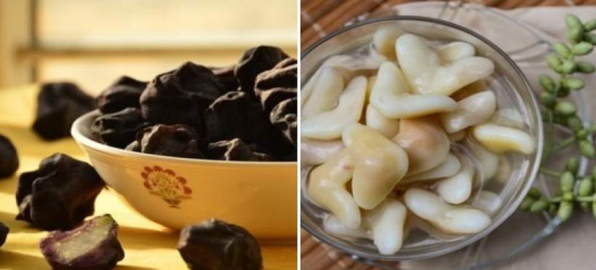
Water chestnut (Trapanatans) is an aquatic plant which is indigenous to Asia and Europe. Due to its capacity to create thick monocultures that outcompete native plants and change aquatic ecosystems, it is regarded as an invasive species in many regions of the world, including North America and Australia. Water chestnut is a floating plant that can grow as tall as 2 metres. It has triangular leaves and pink or white blooms. The plant creates a hard-shelled fruit with a solitary seed inside of it. The fruit can last up to three years before it sinks to the bottom of the body of water.

Figure 1: (a) Unpeeled Water Chestnut (b) Peeled Water Chestnut

Water chestnut is a highly adaptable plant and can grow in a wide range of water bodies, including lakes, ponds, rivers, and marshes. It can tolerate a wide range of temperatures and salinities and can grow in water that is up to 4 meter deep.
The plant is a major problem in freshwater ecosystems, as it can form dense monocultures that out compete native aquatic plants. This can lead to a decline in biodiversity and negatively impact fish and wildlife that rely on native plants for food and habitat. The plant also impairs recreational uses of water bodies, including swimming, boating and fishing.
Control of water chestnut populations is difficult due to its ability to reproduce rapidly. Mechanical and chemical methods have been used to control the plant, but they are often expensive and can have negative impacts on native species.
Biological control methods, such as introducing a plant-eating insect that feeds only on water chest (Trapa natans L.) chestnut, have shown some promise as a way to control the plant. The most promising insect species that feeds on water chestnut is the water chestnut weevil (Euhrychiopsis lecontei).

Composition
Water chestnut (Trapanatans) is a nutrient-dense food that is low in calories and high in vitamins and minerals. It is a good source of carbohydrates, dietary fibres, and protein.
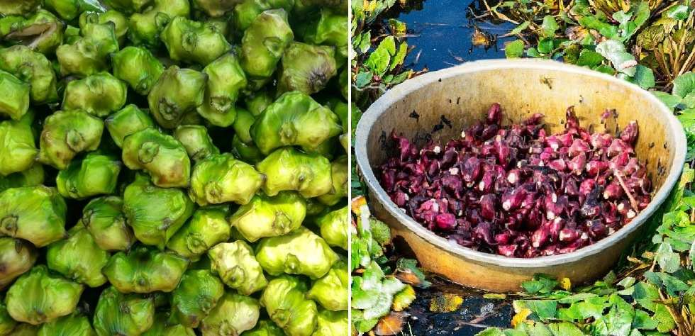
Water chestnut contains various vitamins such as Vitamin C, Vitamin B1, Vitamin B2, Vitamin B3, Vitamin B5, Vitamin B6, and Vitamin B9. It is also rich in minerals such as Calcium, Iron, Magnesium, Manganese, Phosphorus, Potassium and Zinc.

Figure 2: Harvesting of Water Chestnut (Source- Agrifarming.com)

Water chestnut also contains antioxidants, including flavonoids and polyphenols, which have anti-inflammatory and anti-cancer properties. Additionally, it contains phytosterols, which have been shown to lower cholesterol levels and improve heart health.
Water chestnut is also a good source of dietary fiber, with approximately 3.3 grams of fiber per 100 grams of fresh water chestnut. Fiber is important for maintaining healthy digestion and preventing constipation.
Water chestnut also contains a moderate amount of protein, with about 2 grams of protein per 100 grams of fresh water chestnut.
It's worth noting that the composition of water chestnut can vary depending on the stage of maturity, location and growing conditions.

Nutritional value
Here is a summary of nutritional value per 100 grams of fresh water chestnut:

Table 1: Nutritional value of Water Chestnut (Source- G.M. Barros & AG)

COMPONENTS | PROPORTIONS
Energy | 95 calories
Carbohydrates | 22.1 g
Fiber | 3.3 g
Protein | 2 g
Fat | 0.5 g
Vitamin C | 11.8 mg
Vitamin B1 | 0.13 mg
Vitamin B2 | 0.04 mg
Vitamin B3 | 0.7 mg
Vitamin B5 | 0.3 mg
Vitamin B6 | 0.04 mg
Vitamin B9 | 11 mg
Calcium | 33 mg
Iron | 0.7 mg
Magnesium | 31 mg
Manganese | 0.1 mg
Phosphorus | 44 mg
Potassium | 260 mg
Zinc | 0.2 mg

Water chestnut (Trapanatans) is a nutrient-dense food that is low in calories and high in vitamins and minerals. It's worth noting that the nutritional value of water chestnut can vary depending on the stage of maturity, location and growing conditions.

Health Benefits
Here are some of the potential health benefits of water chestnut:
- Lower blood pressure: The potassium in water chestnut can help to lower blood pressure by acting as a vasodilator and reducing the resistance in the blood vessels.
- Improve heart health: The phytosterols in water chestnut have been shown to lower cholesterol levels, which may help to improve heart health.
- Anti-inflammatory and anti-cancer properties: Water chestnut contains antioxidants, including flavonoids and polyphenols, which have anti-inflammatory and anti-cancer properties.
- Improve digestion: Water chestnut is a good source of dietary fiber, which can help to promote healthy digestion and prevent constipation.
- Aid in weight management: Water chestnut is low in calories and high in fiber, which may aid in weight management.
- Beneficial for diabetes: Water chestnut has been traditionally used in the treatment of diabetes; it contains low glycemic index which means it can help to maintain blood sugar levels.
- It's worth noting that more research is needed to confirm the health benefits of water chestnut, and that it should not replace any conventional medical treatment without consulting a doctor.

BARLEY

Barley (Hordeum vulgare L.), a major world crop ranks among the top 10 crops and is fourth among the cereals. Barley contributes significantly to the world’s food supply as human food, malt products, and livestock feed. However, the barley crop may be considered relatively under-utilized with regard to its potential use as an ingredient in processed human foods. Barley belongs to the genus Hordeum and can be considered one of the most ancient crops.

Classification
Barley is a grass belonging to the family Poaceae, the tribe Triticeae. The chief taxonomic characteristic of Hordeum is its one-flowed spikelet. There are three spikelet’s alternates on opposite sides at each node of the flat rachis of the spike or head. Thus, is formed a triplet of spikelets at each node- the central and the two laterals. Each spikelet is subtended by two glumes. When all three spikelets are fertile, the spike is described as six-rowed. When only the central spikelet is fertile, the spike is two-rowed.
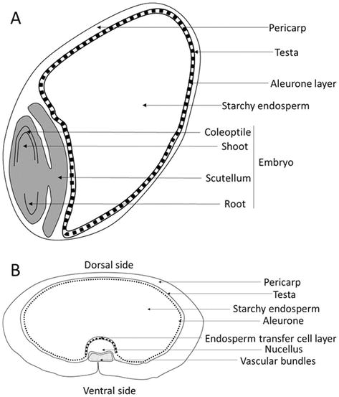
Most barley grown for commerce are husked, that is the palea and lemma of the floret adhere to the outside of the grain. Huskless barley are not suitable for malting, but they are used for human foods as their digestibility is higher than the hulled type.

Figure 3: Parts of Barley Source- www.intechopen.com

Chemical composition
Carbohydrates constitute about 80% by weight of barley grain. Starch is the most abundant single component, accounting for up to 65%, but polysaccharides of cell wall origin are also quantitatively important and may represent more than 10% of grain weight. Barley malt is produced by controlled steeping and germination schedule. The gross chemical changes observed during malting are the net result of degradation of reserve substances.

Table 2: Nutritional value of Barley (Source- Researchgate.com)

Components | Proportions (Dry weight %)
Starch | 63-65 %
Sucrose | 1-2 %
Other sugars | 1 %
Water soluble polysaccharides | 1-1.5 %
Alkali soluble polysaccharides | 8-10 %
Cellulose | 4-5 %
Lipids | 2-3 %
Protein | 10-12 %
Albumin and Globulin | 3.5 %
Hordeins | 3-4 %
Glutelin’s | 3-4 %
Nucleic acids | 0.2-0.3 %
Minerals | 2 %
Others | 5-6 %

Processing of Barley
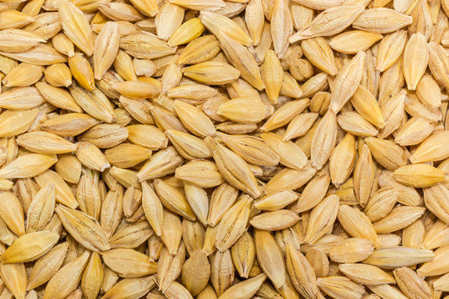
Barley is often milled to obtain blocked barley, pearled barley, barley groats, barley flakes and barley flour for human consumption. The sequence of operations in barley milling may be as follows: preliminary cleaning, conditioning or tempering, bleaching (blue aleurone barley), blocking or shelling, aspiration, size grading by sifting, groat cutting, pearling of blocked barley or large barley groats, grading and sifting and polishing. Some of the commercially available barley products are described below.

Figure 4: Barley Kernel

Pot and pearled barley are prepared by gradual removal of hull, bran and germ by abrasive action in a stone mill. Production of pot barley is the first stage of pearling, which may remove 7 - 14% of the weight of the grain. Further abrasion results in the removal of seed coat (testa and pericarp), aleurone, sub-aleurone layers and the germ leaving behind a central endosperm rich in carbohydrates and proteins.
Barley flour is made by roller milling of pearled or blocked barley. Barley flakes are made by pre-damping of barley groat, steam cooking of groats or pearled barley, flaking and hot air drying of flakes. Barley bran (excluding the hulls) consists of Testa and pericarp, germ, the tricellular aleurone and sub-aleurone layers. Barley bran is obtained as a by-product during barley milling process.

Figure 5: Processing of Barley Flour

Health Benefits of Barley
There are some Health Benefits of Barley :
- Potential use of barley for sleep:
Barley grass powder contains a high amount of gamma-aminobutyric acid (a brain chemical), calcium, potassium, and tryptophan (amino acid). It is a very good functional food and might also be a sleep promoter. Barley grass powder has a higher gamma-aminobutyric acid, calcium, and potassium concentration than polished rice. Polished rice or wheat flour and barley and their products might be effective foods for better sleep-in individuals.3 However, more research is required to prove it.

- Potential use of barley for diabetes:
Barley and its extract might scavenge oxygen free radicals and may be helpful for diabetes. Its dietary fibre might help lower fasting blood sugar and blood glucose levels. Flavonoids in barley might help people with diabetes with their post-meal blood glucose levels.
- Potential use of barley for immunity:
The polysaccharide content of young barley leaves may be helpful for immunomodulation as well as a macrophage (a type of white blood cell) stimulatory function.3 However, these effects need scientific backing. Therefore, kindly do not self-medicate.

- Potential use of barley for cancer:
The combined effects of high alkalinity, a powerful antioxidant, phytochemicals, flavonoids, and chlorophyll in barley might hinder cancer cell development. The phytochemical combinations of barley might be helpful against breast cancer.
- Potential use of barley as an antioxidant:
Barley is one of the most stress-tolerant crops producing tocopherol, glutathione, and succinate in its flag leaf. Flavonoids found in barley grass have potent antioxidant properties that might help diseases induced by oxidative stress, such as inflammation, cancer, and cardiovascular disease.

USE IN BAKERY PRODUCTS

After the text edit has been completed, the paper is ready for the template. Duplicate the template file by using the Save As command, and use the naming convention prescribed by your conference for the name of your paper. In this newly created file, highlight all of the contents and import your prepared text file. You are now ready to style your paper; use the scroll down window on the left of the MS Word Formatting toolbar.

Bread
One of the most important sources of carbs in the diet is bread. Because diabetes patients frequently require multiple meals throughout their treatment life, bread is recognised as one of the diet components that cannot be overlooked (Izydorczyk, et al., 2008). Making bread at home with specially formulated diabetes-friendly components may also help to decrease the potential negative impact that bread may have on blood sugar levels. Examples of these include Barley flaxseed meal, chia seeds, wheat bran, barley, and other ingredients (Holtekjolen, et al., 2008).
Barley is a cereal that is farmed for human use. People are becoming more and more interested in producing food products. Bread is a common component of many peoples' diets. The bread's antioxidant properties will increase if barley flour is used in place of wheat flour, provided the barley variety is stable and acceptable during baking (Gill et al., 2002). Additionally, they claimed that employing natural ingredients in the baking process enhanced the bread's sensory qualities and that the phenolic content of the barley had an impact on the sensory characteristics of bread made with barley. When barley flour is added to wheat flour in a precise ratio, beta-glucan levels rise, which also enhances the baked good's appearance and flavour.
In one slice, there are 103 calories, 20 grams of carbohydrates, 2 grams of fat, 2 grams of protein, and 1 gram of fibre. Beta-glucans and beta glucose, which reduce plasma cholesterol, enhance lipid metabolism, and lower food's glycaemic index, are the most prevalent fibre components in barley. Both soluble and insoluble dietary fibre can be found in abundance in Barley Glenn. All goods made with barley are believed to reduce the incidence of coronary heart disease, according to Wani et al. (2016).

Muffins

Muffins are tiny pieces of sweet and savoury fast bread that resemble cake. They are adored primarily for their delicate texture and mild flavour. Wheat flour is the main ingredient in all bakery goods, however because of its high glycemic index rating; it is unhealthy and can cause a variety of diseases, including diabetes (Shafi et al., 2017). As a result, it is believed to be a secure and wholesome practise to replace wheat flour with low GI grain flour, such as water chestnut (Trapanatans), while making low GI bread products. However, it lacks gluten, which is necessary for the textural characteristics of baked goods. Therefore, bakery goods need a supply of low GI gluten.

Biscuits
Low GI foods will make living a better life simpler and will be especially beneficial to diabetics. When formulating the recipe for the biscuits, the ingredient that will contribute to the glycemic index is determined. This will help us prevent any health difficulties caused by hereditary conditions, including diabetes-related disorders, and it will help create a healthy society (Brand et al., 1997).

CONCLUSION

Diabetes is the third most common non-communicable disease, affecting a significant portion of the world's population. Bakery products with high glycemic index (GI) are unsuitable for diabetic people. Water chestnut and barley can be used to create low GI baked items, as they have low GI values (54 and 28 GI). These products may prove to be an effective diet for those with hyperglycemia. Natural sweeteners like jaggery and honey can be used to further reduce GI and increase their commercial viability in therapeutic diets. Low GI bakery items may prove to be a viable meal option for those with hyperglycemia or at risk for developing the condition. Further research is needed to develop low GI bakeries and explore alternative low GI food sources.
Water chestnut, an aquatic plant native to Asia and Europe, is an invasive species that forms dense monocultures, impacting freshwater ecosystems and affecting biodiversity. It is a low-calorie, high-vitamin-dense food with a low GI content. Controlling water chestnut populations is challenging due to its rapid reproduction. Biological control methods, such as water chestnut weevils, have shown promise in controlling the plant.
Barley, a major world crop, is considered relatively underutilized in its potential use as an ingredient in processed human foods. It belongs to the genus Hordeum and is classified as a grass belonging to the tribe Triticeae. Barley grain contains carbohydrates, with starch being the most abundant component. Barley malt is produced by controlled steeping and germination schedules. Barley is often milled to obtain blocked barley, pearled barley, barley groats, barley flakes, and barley flour for human consumption.
Barley has potential health benefits, including potential use for sleep, diabetes, immunity, cancer, and antioxidant properties. Barley grass powder contains gamma-aminobutyric acid, calcium, potassium, and tryptophan, making it a good functional food and sleep promoter. Barley can also be used in baking products, such as bread, muffins, and biscuits. Bread's antioxidant properties increase if barley flour is used in place of wheat flour, provided the barley variety is stable and acceptable during baking.
Breads are a common component of many people's diets, and using barley flour in place of wheat flour can enhance the sensory qualities of baked goods. Muffins, small pieces of sweet and savoury fast bread, are a popular choice due to their delicate texture and mild flavor. However, low GI flour, such as water chestnut, is necessary for the textural characteristics of baked goods.
Low GI ingredients like Water Chestnut & Barley offers potential health benefits, including sleep, diabetes, immunity, cancer, and antioxidant properties. Its high alkalinity, antioxidant properties, and high concentration of flavonoids may help reduce blood sugar and glucose levels. Barley's potential for cancer treatment and antioxidant properties make it a promising crop for various health concerns.

REFERENCES

- AACC. (2000). Approved methods of the American society of cereal chemists. St. Paul, MN: American Association of Cereal Chemistry. Inc.
- Acosta, K., Cavender, G., & Kerr, W. L. , “Sensory and physical properties of muffins made with waxy whole wheat flour.” Journal of Food Quality, 34(5), pp. 343–351 , 2011
- Ashwini, Umashankar, K., Rajiv, J. et al. , “Development of hypoimmunogenic muffins: batter rheology, quality characteristics, microstructure and immunochemical validation.” J Food Sci Technol , vol.53 , pp. 531–540 , 2016
- Behlil, F., Saimullah, K., Muzaffar, M., Raiz, S. M., & Jan, S. A. , “Analysis of total sugars and free amino acids in wheat grains samples from five different regions of Baluchistan Lasbela. Uni. J. Sci. Tech., vol.3, pp. 10-13, 2014
- Bhatiwal, S., Jain, A., & Chaudhary, J.,“Trapanatans (water chestnut): An overview.”, International Research Journal of Pharmacy, vol.3, pp. 31–33, 2012.
- Bhise, S., & Kaur, A., “Polyols to improve quality and shelf life of baked products: A review” , International Journal of Advanced Scientific and Technical Research, 1(3), pp. 2054–2061 , 2013.
- Borczak, B., Pisulewski, P. M., Sikora, M., & Krawontka, J. "Comparison of glycemic responses to frozen and non‐ frozen wheat rolls in human volunteers—A short report.” , Polish Journal of Food and Nutrition Sciences, vol.58, pp. 377–380 , 2008 .
- Burton, P., & Lightowler, H. J. , “ The impact of freezing and toasting on the glycemic response of white bread” , European Journal of Clinical Nutrition, vol.62, pp. 1–6 , 2007 .
- Carreira, C. M., Lajolo, F. M., & Menezes, W. D. E. , “Glycemic index: Effect of food storage under low temperature” , Brazilian Archives of Biology and Technology, 47, pp. 569–574, 2004 .
- Chan, C. F., Chiang, C. M., Lai, Y. C. L., Huang, C. L., Kao, S. C., & Liao, W. C. L.,“Changes in sugar composition during baking and their effects on sensory attributes of baked sweet potatoes” , Journal of Food Science and Technology, vol.51(12), pp. 4072–4077, 2012 .
- Dewettinck, K., Van Bockstaele, F., Kühne, B., Van de Walle, D., Courtens, T. M., & Gellynck, X. , “Nutritional value of bread: Influence of processing, food interaction and consumer perception” , Journal of Cereal Science, vol. 48, pp. 243–257, 2008 .
- Gao, J., Brennan, M. A., Mason, S. L., & Brennan, C. S.,“Effects of sugar substitution with “stevianna” on the sensory characteristics of muffins” , Journal of Food Quality, 2017, pp. 1–11, 2017 .
- Gao, J., Brennan, M. A., Mason, S. L., & Brennan, C. S. , “Effect of sugar replacement with stevianna and inulin on the texture and predictive glycaemic response of muffins” , International Journal of Food Science & Technology, vol. 51(9), pp. 1979–1987. 2016 .
- Goesaert, H., Brijs, K., Veraverbeke, W. S., Courtin, C. M., Gebruers, K., & Delcour, J. A. , “Wheat flour constituents: How they impact bread quality, and how they impact their functionality” , Trends in Food Science and Technology, vol.16, pp. 12–30, 2005 .
- Goni, I., Garcia‐Alonso, A., & Saura‐Calixto, F. , “A starch hydrolysis procedure to estimate glycemic index” , Nutrition Research, vol.17, pp. 427–437, 1997.
- Gupta, M., Bawa, A. S., & Semwal, A. D. , “Effect of barley flour incorporation on the instrumental texture of sponge cake” , International Journal of Food Properties, vol.12(1), pp. 243–251 , 2009 .
- He, H., & Hoseney, R. C. , “Changes in bread firmness and moisture during longterm storage” , Cereal Chemistry, vol. 67(6), pp. 603–605 , (1990) .
- Hoebler, C., Karinthi, A., Chiron, H., Champ, M., & Barry, J. L. , “Bioavailability of starch in bread rich in amylose: Metabolic responses in healthy subjects and starch structure”, European Journal of Clinical Nutrition, vol.53, pp. 360–366 ,1999.
- Kaur, M., Singh, V., & Kaur, R. , “Effect of partial replacement of wheat flour with varying levels of flaxseed flour on physicochemical, antioxidant and sensory characteristics of cookies.” Bioactive Carbohydrates and Dietary Fibre, vpl. 9, pp.14–20 , 2016 .
- Maleki, M., & Daghir, S. , “Effect of baking on retention of thiamine, riboflavin, and niacin in Arabic bread.” Cereal Chemistry, vol. 44, pp .483–487 , 1967.
- Martin, M., Zeleznak, K. J., & Hoseney, R. C. , “A mechanism of bread firmness” , Cereal Chemistry, vol. 68(5), pp. 498–503, 1991.
- Martinez‐Villaluenga, C., Horszwald, A., Frias, J., Piskula, M., Vidal‐ Valverde, C., & Zieliński, H. , “Effect of flour extraction rate and baking process on vitamin B1 and B2 contents and antioxidant activity of ginger‐based products. European Food Research and Technology”, vol. 230(1), pp. 119–124, 2009.
- Marzougui, N., Guasmi, F., Mkaddem, M., Boubaya, A., Mrabet, A., Elfalleh, W., … Beji, M. , “Assessment of Tunisian Trigonellafoenum graecum diversity using seed vitamin B6, B1, B9 and C contents.” , Journal of Food, Agriculture and Environment, vol. 7(1), pp. 56–61 , 2009.
- McCleary, B. V., & Codd, R., “ Measurement of (1→3), (1→4)‐β‐Dglucan in barley and oats: A streamlined enzymic procedure” , Journal of the Science of Food and Agriculture, vol. 55(2), pp. 303–312 , 1991.
- Nayak, B., De Berrios, J., & Tang, J., “Impact of food processing on the glycemic index (GI) of potato products” , Food Research International, vol. 56, pp. 35–46, 2014.
- Nehir, S., “ Determination of glycemic index for some breads” , Food Chemistry, vol.67, pp. 67–69, 1999.
- Oliveira, L. C., Oliveira, M., Meneghetti, V. L., Mazzutti, S., Colla, L. M., Elias, M. C., & Gutkoski, L. C., “Effect of drying temperature on quality of β‐glucan in white oat grains” , Food Science and Technology, vol. 32(4), pp. 230–238 , 2012 .
- Ozkan, G., Simsek, B., & Kuleasan, H. , “Antioxidant activity of saturejacilicica essential oil in butter and in vitro” , Journal of Food Engineering, vol. 79, pp. 1391–1396 , 2007.
- Quiles, A., Llorca, E., Schmidt, C., Reißner, A. M., Struck, S., Rohm, H., & Hernando, I., “Use of berry pomace to replace flour, fat or sugar in cakes” , International Journal of Food Science & Technology, vol. 53(6), pp. 1579–1587 , 2018.
- Raben, A., Tagliabue, A., Christensen, N. J., Madsen, J., Holst, J. J., & Astrup, A. , “Resistant starch: The effect on postprandial glycemia, hormonal response, and satiety” , American Journal of Clinical Nutrition, vol. 60, pp. 544–551 , 1994.
- Rahman, R., Hiregoudar, S., Veeranagouda, M., Ramachandra, C. T., Nidoni, U., Roopa, R. S., … Ganjyal, G. M., “Effects of wheat grass powder incorporation on physiochemical properties of muffins” , International Journal of Food Properties, vol. 18(4), pp. 785–795 , 2015 .
- Ranhotra, G. S., & Gelroth, J. A. , “Stability of enrichment vitamins in and cookies'” , Cereal Chemistry, vol. 63(5), pp. 401–403, 1986 .
- Rogers, D. E., Zeleznak, K. J., Lai, C. S., & Hoseney, R. C., “Effect of native lipids, shortening, and bread moisture on bread firming” , Cereal Chemistry, vol. 65, pp. 398–401 , 1988 .
- Romjaun, Z. Z., & Prakash, J. , “Development and assessment of fibre‐enriched muffins” , Advances in Food Sciences, vol. 35(4), pp. 159–165 , 2013 .
- Rosin, P. M., Lajolo, F. M., & Menezes, E. W. , “Measurement and characterization of dietary starches” , Journal of Food Composition and Analysis, vol.15, pp. 367–377 , 2002.
- Shafi, M., Baba, W. N., & Masoodi, F. A. , “Composite flour blends: Influence of particle size of water cheshnut flour on nutraceutical potential and quality of Indian flat bread” , Journal of Food Measurement and Characterization, vol. 44, pp. 9486–9495 , 2017 .
- Sharma, P., Gujral, H. S., & Singh, B. , “Anti‐oxidant activity of barley as affected by extrusion cooking” , Food Chemistry, vol. 131, pp. 1406–1413 , 2012 .
- Sharma, P., Kaur, A., & Kaur, A. , “Effect of guar flour supplementation on quality and shelf life of muffins. International Journal of Engineering Research and Applications, vol. 6(3), pp. 68–73 , 2016.
- Snedecor, G. W., & Cochran, W. G. , “One way classification, analysis of variance” , Statistical methods ed.6th , pp. 381–418 , 1967.
- Somogyi, M. , “Notes on sugar determination” , Journal of Biological Chemistry, vol. 195, pp. 19–23, 1952.
- Soong, Y. Y., Tan, S. P., Leong, L. P., & Henry, J. K. , “Total antioxidant capacity and starch digestibility of muffins baked with rice, wheat, oat, corn and barley flour” , Food Chemistry, vol. 164, pp. 462–469 , 2014.
- Sudha, M. L., Baskaran, V., & Leelavathi, K., “Apple pomace as a source of dietary fiber and polyphenols and its effect on the rheological characteristics and cake making” , Food Chemistry, vol. 104, pp. 686–692 , 2007 .
- Van Hung, P., Maeda, T., Tujita, M., & Morita, N. , “Dough properties and breadmaking qualities of whole waxy wheat flour and effects of additional enzymes” , Journal of the Science of Food and Agriculture, vol. 87, pp. 2538–2543 , 2007 .
- Wani, S. A., & Kumar, P. , “Development and parameter optimization of health promising extrudate based on fenugreek, oat and pea” , Food Bioscience, vol. 23(1), pp. 18–25 , 2016 .
- Witczak, M., Ziobro, R., Juszczak, L., & Korus, J. , “Starchand starch derivatives in gluten‐free systems: A review” , Journal of Cereal Science, vol. 67, pp. 46–57 , 2016 .
- Yadav, B. S. , “Effect of frying, baking and storage conditions on resistant starch content of foods” , British Food Journal, vol. 113(6), pp. 710–719 , 2011 .
- Yaqoob, S., Baba, W. N., Masoodi, F. A., Shafi, M., & Bazaz, R. , “Effect of sprouting on cake quality from wheat–barley flour blends” , Journal of Food Measurement and Characterization, vol. 12(2), pp. 1253–1265 , 2018 .
- Ozkan, G., Simsek, B., & Kuleasan, H. , “Antioxidant activity of saturejacilicica essential oil in butter and in vitro” , Journal of Food Engineering, vol. 79, pp. 1391–1396 , 2007 .
- Quiles, A., Llorca, E., Schmidt, C., Reißner, A. M., Struck, S., Rohm, H., & Hernando, I. , “Use of berry pomace to replace flour, fat or sugar in cakes” , International Journal of Food Science & Technology, vol. 53(6), pp. 1579–1587 , 2018 .
- Raben, A., Tagliabue, A., Christensen, N. J., Madsen, J., Holst, J. J., & Astrup, A. , “Resistant starch: The effect on postprandial glycemia, hormonal response, and satiety. American” , Journal of Clinical Nutrition, vol. 60, pp. 544–551, 1994 .
- Rahman, R., Hiregoudar, S., Veeranagouda, M., Ramachandra, C. T., Nidoni, U., Roopa, R. S., … Ganjyal, G. M. , “Effects of wheat grass powder incorporation on physiochemical properties of muffins.” , International Journal of Food Properties, vol. 18:4, pp. 785-795 , (2015)
- Ranhotra, G. S., & Gelroth, J. A. , “Stability of enrichment vitamins in bread and cookies'” , Cereal Chemistry, vol. 63(5), pp. 401–403 , 1986.
- Rogers, D. E., Zeleznak, K. J., Lai, C. S., & Hoseney, R. C. , “Effect of native lipids, shortening, and bread moisture on bread firming” , Cereal Chemistry, vol. 65, pp. 398–401, 1988.
- McCleary, B. V., & Codd, R. , “Measurement of (1→3), (1→4)‐β‐Dglucan in barley and oats: A streamlined enzymic procedure.” , Journal of the Science of Food and Agriculture, vol. 55(2), pp. 303–312, 1991.
- Nayak, B., De Berrios, J., & Tang, J. , “Impact of food processing on the glycemic index (GI) of potato products” , Food Research International, vol. 56, pp. 35–46 , 2014.
- Oliveira, L. C., Oliveira, M., Meneghetti, V. L., Mazzutti, S., Colla, L. M., Elias, M. C., & Gutkoski, L. C. , “Effect of drying temperature on quality of β‐glucan in white oat grains” , Food Science and Technology, vol. 32(4), pp. 230–238 , 2012 .
- Yawen Zeng, Xiaoying Pu, Juan Du, Xiaomeng Yang, Xia Li, Md, Siddikun Nabi Mandal, Tao Yang, Jiazhen Yang, “Molecular Mechanism of Functional Ingredients in Barley to Combat Human Chronic Diseases”, Oxidative Medicine and Cellular Longevity, vol. 2020, Article ID 3836172, 26 pahes, 2020.

