Swoop® Portable MR Imaging System
Khush Jain^{1,} Mr. Raushan Kumar², Ms. Mamta Verma³ , Mr. Neeraj Kumar Sah^{4,} Mayank Pal Singh⁵
¹ M.Sc. Research fellow , Department of Radiological imaging techniques , college of Paramedical Sciences , Teerthanker Mahaveer university , Moradabad .
²Assistant Professor , Department of Radiological imaging techniques , college of Paramedical Sciences , Teerthanker Mahaveer university , Moradabad.
³Assistant Professor , Department of Radiological imaging techniques , college of Paramedical Sciences , Teerthanker Mahaveer university , Moradabad.
⁴Assistant Professor , Department of Radiological imaging techniques , college of Paramedical Sciences, Teerthanker Mahaveer university , Moradabad.
⁵ M.Sc. Research fellow , Department of Radiological imaging techniques , college of Paramedical Sciences , Teerthanker Mahaveer university , Moradabad .
The introduction of MRI in 1977 brought a significant transformation to the field of medicine, although its benefits have been limited to certain individuals. Currently, a considerable portion of the United States and other countries lacks access to magnetic resonance imaging. Only a handful of hospitals utilize MRI due to various obstacles such as infrastructure limitations, the need for specialized training, apprehension, and high expenses. Even in facilities where MRI is available, the procedure can be lengthy, isolating, and distressing for patients.
Swoop, the pioneering MRI device worldwide, enables neuroimaging to be performed directly at the point of care. This groundbreaking technology offers valuable support in the swift diagnosis and treatment of acute illnesses across a range of clinical scenarios. The Swoop system, developed by Hyperfine, was created to address the limitations of current imaging technologies and make MRI widely available in hospitals almost anywhere and at any time. To control the system, an Apple iPad® is used as a remote control, conveniently delivered to the patient's bedside. This device allows for immediate diagnosis and treatment decisions without requiring the patient to be transferred to a radiology suite. The Swoop system can be prepared for scanning in less than 3 minutes and can navigate through busy hospital environments, fitting into elevators and passing through entrances. Its compact and portable design makes it ideal for neuroimaging in intensive care units and pediatric facilities. The imaging sequences supported by the Swoop system include T2, FLAIR, T1, DWI, and ADC maps. One of the advantages of the Swoop Portable MRI System is its open design, which helps alleviate patient concerns. Additionally, the unique magnet configuration ensures the safety of family members who can stay by the patient's bedside during the procedure.
Advantages of swoop system :-
- Serial imaging: The ability to observe patients over time through multiple imaging sessions.
- Accelerated learning curve: The system's operation, navigation, and safety training are simplified, enabling a wider range of users to access and operate it.
- Portability: The Swoop system is equipped with motorized drive wheels, making it easy to move between patients.
- Location flexibility : Swoop systems operate with less than 900W when powered by a regular electrical socket.
- Cost effective ownership : Compared to a stationary conventional MRI system, the swoop system is substantially less expensive to purchase and maintain.
- Secure image upload: The Swoop system allows for the secure uploading of images to a facility's Picture Archiving and Communication System (PACS) or Hyperfine's HIPAA-compliant cloud storage.
- Improvements and updates to software
- Hardware service and maintenance: Comprehensive support for the product, including servicing and maintenance of the hardware components.
- Unlimited photo storage with the Hyperfine cloud picture viewer.
- FDA- cleared advanced image reconstruction : This enhanced procedure offers clinicians T2, FLAIR, and T1 images that have the potential to provide them with increased confidence when making immediate clinical diagnoses.
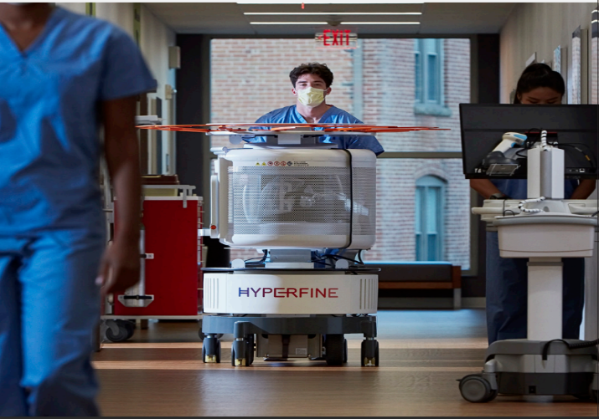
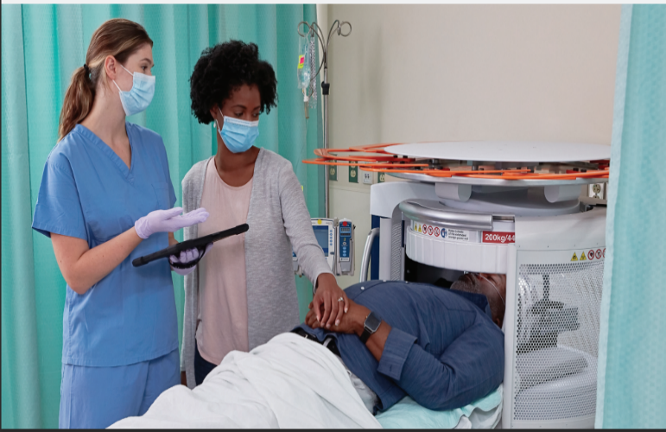
- FDA- cleared brain sight advanced AI application : Midline shift detection & automated and auto-aligned ventricular measurement.
Parts of portable MRI
1. AI-Enabled: BrainInsight™ incorporates advanced AI applications that enable automated ventricular volume measurements and midline shift detection.
2. Tablet Controller: The system includes a 12.9-inch Apple iPad® that simplifies exam setup, scan initiation, and image export.
3. Power Supply: The Swoop system can be plugged into a standard wall outlet and is ready to scan in under two minutes. Remarkably efficient, it consumes only 900 watts, which is comparable to a coffee maker's power consumption.
4. Gauss Guard: Ensuring safety, the system features a convenient 5-gauss-line guard that expands and contracts quickly.
5. Transfer Bridge: The transfer bridge unfolds effortlessly to facilitate easy loading of patients at the bedside. It can be folded back up to move the system to the next patient.
6. Shield Door and Sensors: The system operates without the need for external shielding, thanks to built-in continuous electromagnetic interference noise cancellation and the specific design of its aluminum screen.
7. Head Coil: A multi-channel removable head coil is enclosed in durable and easy-to-disinfect polycarbonate plastic, providing clear visibility.
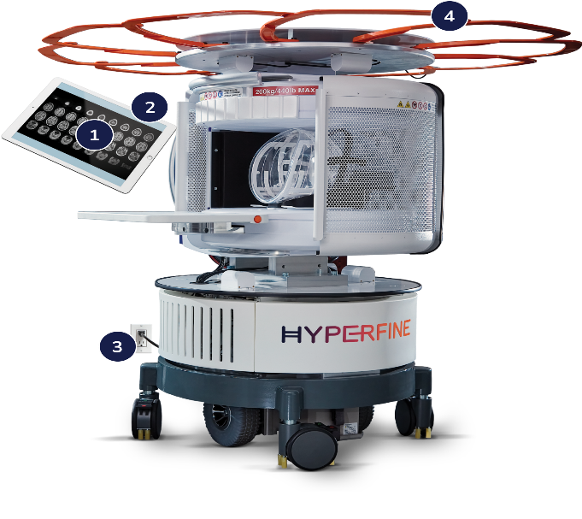
8. Casters and Joystick: The Swoop system can be easily maneuvered between patients using a joystick and powered drive wheels.
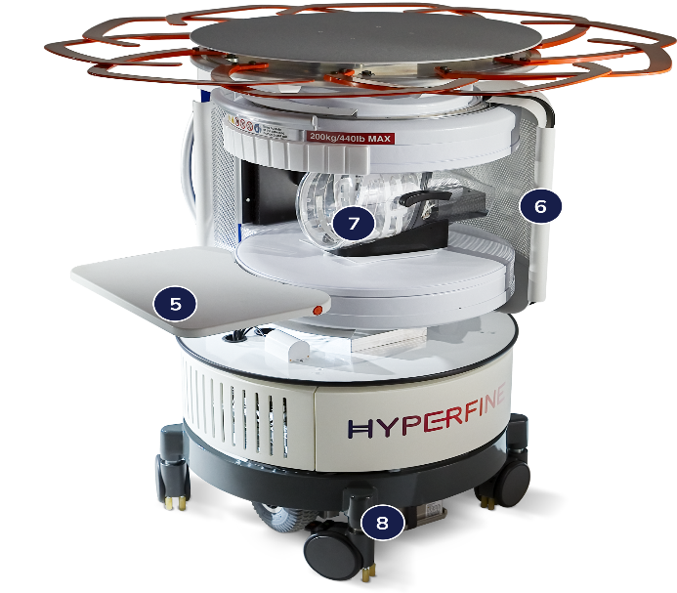
Specifications of swoop portable MRI
The Swoop Portable MRI System offers exceptional mobility within medical facilities, as it can be easily transported to various locations. Its compact and highly portable design makes it particularly suitable for neuroimaging in intensive care units and pediatric facilities. The Swoop system utilizes a 64 mT magnet and has a weight of 1,400 pounds, with dimensions of 59 inches in height and 33 inches in width. Imaging sequences such as T2, T2, FLAIR, and Diffusion weighted imaging (including the ADC map) can all be controlled through an intuitive iPad® interface.

Advanced Image Reconstruction
Before developing the image, the reconstruction pipeline of the Swoop system applies deep learning. The resulting image quality raises the portable MRI's diagnostic utility. Hyperfine utilized deep learning, a facilitating methodology that utilizes artificial neural networks (ANNs), to generate this advanced image reconstruction. ANNs are a collection of algorithms designed to identify patterns, drawing loose inspiration from the human brain. By employing this methodology, Hyperfine trained Swoop to increase the quality of T2, T1, & FLAIR images by reducing noise and blur. Through a software update, Swoop incorporates advanced gridding and denoising techniques into the linear image reconstruction process, utilizing a specially developed pipeline based on deep learning.. Prior to converting the data into an image, advanced gridding enhances the spatial frequency domain (k-space) data obtained from the Swoop scanner. In comparison to the conventional non-uniform fast Fourier transform (FFT-gridding) method, this innovative deep learning-based approach proves to be superior. Swoop's enhanced image reconstruction includes the post-processing image reconstruction step, which includes advanced denoising, the second deep learning application. Deep learning was utilized by Hyperfine to develop algorithms that apply denoising to the entire image in small patches. Through this method, the signal's noise is reduced yet crucial information for diagnosis is kept. Swoop produces sharp, clear T2, T1, & FLAIR images thanks to the addition of sophisticated image reconstruction, which has the potential to give medical professionals more confidence in making an immediate clinical diagnosis.

Automated AI tools for brain imaging, BrainInsightTM.
For patients older than 18 years old, it gives measurements of several brain regions from both T1 and T2 axial images, such as midline displacement and lateral ventricular volume. By incorporating BrainInsight into the neurocritical care process, a clinical care team can learn more about the patient's condition. It was intended for Brain Insight to integrate seamlessly with the Swoop workflow. The point-of-care Swoop system takes photos and uploads them to the Hyperfine cloud image viewer, where they are then viewed by BrainInsight, which automatically calculates and displays the measurements as colour overlays. Each colour represents a segmented area or spatial measurement of the anatomical structures. Processing of the brain's insights takes around seven minutes and includes lateral ventricle and midline shift identification & measuring. (Segmentation and volume measurement).

References
- https://hyperfine.io/products
- RE E, RF E. MRI FOR ALL.

