Assessment of Genotoxic Effect of Paris polyphylla

Kshetrimayum Guneshwor¹ and Adhikarimayum Haripyaree²
1Department of Zoology, G.P. Women’s College, ²Department of Botany, Imphal College, Imphal-795001, India. E-mail: guneshwor@hotmail.com

Abstract
The rhizome of Paris polyphylla Smith is used in number of health problems by the resident people of Manipur and connecting states. In the present study traditional chromosome aberration analysis, micronucleus assay and SC damages analysis are the three testing protocols of the cytogenetically assay to study whether aqueous extract of the plant interrelate with genetic material. Intraperitoneal injections of 3.6 ml/100g body weight (MTD) and 1.8 ml/100g body weight (less than MTD) of the aqueous extract to the animals have no significant higher frequencies. Animals received doses of distilled water equivalent to that of plant extract was recognized as negative control, while EMS at the dose of 240 mg Kg ^{–1} body weight dissolved in 1ml distilled water was recognized as the positive control. The observation of no significant higher frequencies of chromosome aberrations, SC damages and micronucleus indicating negative results of mutagenicity of the plant extract in all the test protocols.

Key words: Mutagenicity, genotoxicity, clastogenecity, cytogenetic assay, LD⁵⁰, maximum tolerated dose, less maximum tolerated dose, intraperitonial.

Introduction
The earliest recorded evidence of using herbal medicine in Indian, Chinese, Egyptian, Greek, Roman and Syrian texts dates back to about 5000 years. Medicinal plants have featured in folklore and tradition throughout the world. Herbal medicines are the synthesis of therapeutic experiences of generation of practicing physician of indigenous system of medicines. Indo-Burma biodiversity region of North- East India is a distinct part and is one of the hottest with 6th rank among the 25 mega biodiversity hotspots (MYERS, 1988; MYERS et al., 2000). Manipur which belongs to north-east India bordering Myamar has explored many species and varieties of medicinal plants. This state is a natural habitat of one of the

most useful and costly herb called Paris polyphylla Smith. The rhizome of the herb is used in number of health problems like anti-inflamatory, cancer and bleeding in other parts of world (IUCN, 2004; LEE et al., 2005; SUN et al., 2007; FU, 2007; GUANGLIA et al., 2013; MAN et al., 2017; SONGSONG et al., 2017).
According to World Health Organization (WHO) approximately 80% of world’s population in developing countries depends on traditional medicines for primary health care (WHO, 2016). Since inadequate drug laws traditional medicines escape toxicity testing before they are marketed. Drugs of plant source are not unrestricted from toxic effects were reported yet. Ingestion of herbal medicine leads to hepatic failure and even following death have been reported (DICKEN et al. 1994). Childhood blindness in Nigeria have been reported due to traditional eye medicines (HARRIES and CULLINAN 1994). A herbal medicine for impotency has been ascribed to 15 persons death in USA (JOSEFSON 1996). Mutagenic, clastogenic and carcinogenic activities were shown by several medicinal plants (NANDI et al. 1998).
In vivo mammalian tests have several advantages over in vitro tests because the metabolic activation and detoxification of the chemicals in the intact animal are closer to the human system. One of the delicate procedures to test genotoxicity of plant extract has been recognized in vivo mouse chromosome assay (CHAKRABARTI 2001) and also one of the smallest exclusive in vivo assays for genotoxic effects by the (BMM) bone marrow micronucleus test (HEDDLE 1973; SCHMID 1976). The BMM test system can only detects chromosome breaks or laggards and not steady the mature types of break. This leads to analysis of traditional chromosome aberration in conjunction with BMM test for comprehensive mutagenicity testing. Mammalian in vivo germ cell assay for determining effects of chemical overview to the gonads and assessing the hazard of genetic damage by the Synaptonemal complex (SC) analysis which holds great promise (ALLEN et al. 1988; BACKER et al. 1988).
The chemical constituents of P. polyphylla are mainly paris saponins such as diosgenins and polyphyllins (WU et al., 2004). Paris saponin VII suppressed the growth of human cervical cancer Hela cells (ZHANG et al., 2014). Paris polyphylla extract induces Apoptosis and activates Cancer Suppressor Gene (LI et al., 2012). Cytotoxicity of methanolic extract of rhizomes of P. polyphylla was determined by MTT assay on three cancer cell lines: HeLa, HepG2 and PC3 (DAWA et al., 2019). Polyphyllin D and dioscin evade drug resistance and generate Apoptosis in liver cancer HepG2, R-HepG2 cells (CHEUNG et al., 2005; DENG et al., 1999; GAO et al., 2011; LI et al., 2001). Paris saponins I exhibited effective

radiosensitivity against gefitinif resistant lung adenocarcinoma cell line (JIANG et al., 2014). Polyphyllin D is a steroidal saponin which effects in growth inhibition of human breast cancer cells and in Xenograft (LEE et al., 2005). In vivo mammalian cytogenetic assay for the genotoxicity testing of the plant extract have to be carried out since many compounds as mentioned above were contained in the extract even some of them are cytotoxic.

Materials and Methods

Collection and identification of plant defined in “A hand book of Medicinal plants” (PRAJAPATI et al. 2003). Extraction of parts of the plant was done with boiling distilled water using Soxhlet apparatus with treatment protocol Table 1. In traditional used of medicine plant parts were boiled with water and hence aqueous extract was tested (SINHA 1996) to examine whether the chemicals present in the preparation of this plant interact with genetic material. Inbred Swiss albino mice attaining the weight about 25 g and 10-12 week were sacrificed. Maximum tolerated doses, less than MTD were determined in the MTD range test. Animals received doses of distilled water equivalent to that of plant extract was recognized as negative control, while EMS at the dose of 240 mg Kg ^{–1} body weight dissolved in 1ml distilled water was recognized as the positive control. Bone marrow cells are flashed out from the animals femur bones for metaphase chromosomes study after the treatment of colchicines 24 hours, make the cells hypotonic which are spread and air dried. Spermatocytes are collected for the study of Synaptonemal complexes (SC) damages, BHAGIRATH and KUNDU (1985) and damages were counted, ALLEN et al. (1998) and BACKER et al. (1988). Bone marrow cells are flashed out for micronuclei preparation, ROMAGNA and STANIFORTH (1989) and scoring of micronuclei was done following the recommendation by two IPCS collaboration studies (ASHBY et al. 1983).

Statistical analysis
Statistical analysis of chromosome aberrations, micronuclei analysis and synaptonemal complex damages from the quantitative datas.

Results
Traditional chromosome aberration frequencies and representative types were
described in Table 2 and Figs. 1-6. Frequencies of aberration as examined from more than 5000 metaphases in five animals were 30.12% and 4.08% respectively in positive and negative control. Frequencies of aberration in animals treated with the plant extract were similar with negative control value. The treatment of aqueous extract of the plant observed no significant higher frequencies of chromosome aberrations, SC damages and micronucleus indicating negative results of mutagenicity of the plant extract in all the test protocols.
Synaptonemal complex damages types and their frequencies as suggested by ALLEN et al. (1988) and BACKER et al. (1988) were described in Figures 7-12 and Table 3. All types of the recommended synaptonemal complex damages were induced with the treatment of EMS as positive control, while only some varying types of damages were induced with the treatment of distilled water as negative control. Frequencies of synaptonemal complex damages in animals treated with the plant extract were similar with negative control value showing no significant higher frequency of SC damages with the treatment of aqueous extract of the plant.

MPCE and their frequencies were described in Figure 14 and Table 4. Red–orange coloured NCE (Fig.13) could be differentiated from bluish coloured PCE (Fig.14). There was no significant difference in the proportion of MPCE among treatments with distilled water and plant extract. The treatment of plant extract did not induce significantly higher micronucleus frequency.

Discussion
In present study, aqueous extract of the plant showed no significant higher frequencies of chromosome aberrations, SC damages and micronucleus indicating negative results of mutagenicity of the plant extract in all the test protocols. It is endorsed that a particular agent proves mutagenic when it shows the mutagenecity at least in more than one test protocols (SARKAR and MANNA 1989; BOCHKOV et al. 1976; SHARMA 1984). Additional precise and consistent mutagenicity tests need to be followed meanwhile there are cases of point

mutation, frame shift mutation which outflow recognition by methods working in the present study, even the plant extract showed negative results in all the genotoxicity testing protocols. Mutagenicity of certain medicinal plants detected in the past studies by other investigators (NANDI et al. 1998) induces the requirement of using medicinal plants with precise strategies, which have a thorough foundation and significance to the population concerned.

Table 1. The experimental protocol for the treatment of animals.

Treatment
Plant (part) | Volume in ml/100g body weight  (Concentration) |  | Treatment period | No. of animals treated
 | MTD | Half of the MTD
P. polyphylla (Rhizome) | 3.6(10%)* | 1.8 | 24 hrs | 5

* Extract concentration expressed as plant material dry weight/100 ml distilled water. Extracts of maximum treatment volume of 0.9ml/animal in MTD range tests.

 | % of dam. ± SE | *30.12±0.087 | 4.08± 0.026 | 4.16± 0.027  4.08± 0.025 | Abbreviation:Meta.=Metaphase,Centro.= Centromeric, Chrom.= Chromatid, Trans.= Tnanslocation, Attenu.= Attenuation, Frag.= Fragments,Dam.=Damage.  *P= <0.01.
 | Total Dam. | 1600 | 217 | 224  215
Table 2. Chromosomal aberrations in bone marrow cells of mice treated with EMS, distilled water and the P. polyphylla extract. | Frag. | 132 | 0 | 0  0
 | All dot Like | 61 | 0 | 0  0
 | Ring Chromo | 28 | 3 | 3  4
 | Attenu. | 160 | 13 | 14  12
 | Trans. | 15 | 0 | 0  0
 | Isochro. Break | 51 | 0 | 0  0
 | Chrom. Break | 65 | 4 | 7  5
 | Centric Fission | 541 | 123 | 124  125
 | Centric fusion | 362 | 45 | 50  49
 | Centro. Gap | 185 | 29 | 26  25
 | No. of Meta. | 5311 | 5325 | 5376  5261
 | Treatment | EMS  240mg Kg^{–1}. b. wt (positive control) | Distilled water (Negative control) | P. polyphylla  extract 0.9ml/100g. b. wt 0.45ml/100g. b. wt

Table 3. Synaptonemal complex damages in mouse spermatocytes treated with EMS, distilled water and the P. polyphylla extract. | % of dam.  ± SE |  | *27.69±0.080 | 4.01± 0.023 | 4.04± 0.021  4.02±0.019 | Abrreviation: SC= Synaptonemal complex, Frag= Fragment, MAC= Multi Axial Complex, Attn.= Attenuation, Asyn.= Asynapsis,  Auto-trans.= Autosome translocation, Elem.= Element, Sepn.= Separation, Pair.= Pairing, Dam.= Damage, *= P<0.01, SE= Standared Error.
 | Total Dam. |  | 1483 | 215 | 213  211
 | Sex Element Damage | SC  Break in Y | 13 | 0 | 0  0
 |  | SC  Break in X | 27 | 0 | 0  0
 |  | Y-  fold Back pair | 11 | 0 | 0  0
 |  | X-  fold back pair | 138 | 9 | 11  12
 |  | Y-A  Trans | 12 | 0 | 0  0
 |  | X-A  Trans | 29 | 7 | 6  5
 |  | X-Y  Sepn | 108 | 15 | 15  14
 |  | Attn. in Y Elem | 21 | 0 | 0  0
 |  | Attn. inX Elem | 26 | 0 | 0  0
 | Autosome Element Damage | Auto- Trans | 82 | 7 | 8  7
 |  | Over all Asyn | 9 | 0 | 0  0
 |  | Asyn | 13 | 0 | 0  0
 |  | Attn | 251 | 42 | 39  38
 |  | MAC | 26 | 0 | 0  0
 |  | Frag | 294 | 0 | 0  0
 |  | SC  break | 423 | 135 | 134  135
 | No. of cells scored |  | 5354 | 5343 | 5265  5244
 | Treatment |  | EMS  240mg Kg^{–1} b. wt (Positive control) | Distilled water (Negative control) | P. polyphylla  extract 0.9ml/100g. b. wt 0.45ml/100g. b. wt

Table 4. Frequency of MPCE in bone marrow cells of mice treated with EMS, distilled water and the
P. polyphylla extract.

Treatment | No. of PCE  Scored | No. of MPCE  scored | Ranges of proportion of  MPCE (MPCE/PCE)
EMS  240mgKg^{–1} b. wt (Positive control) | 5000 | 89 | *0.0178
Distilled water (Negative control) | 5000 | 9 | 0.0018
P. polyphylla  extract 0.9ml/100g. b. wt 0.45ml/100g. b. wt | 5000  5000 | 8  7 | 0.0016  0.0114

* = P<0.01

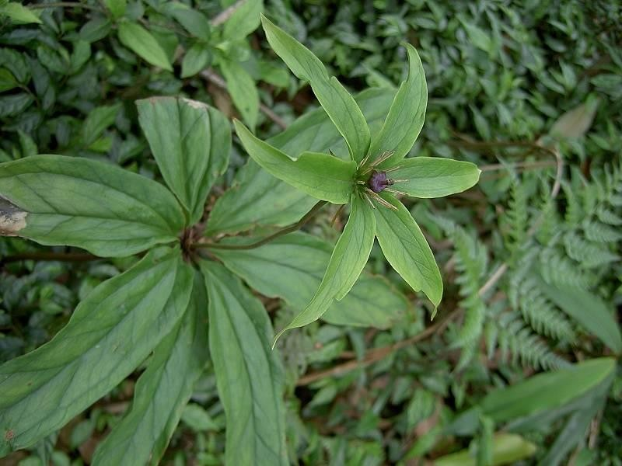

Paris polyphylla

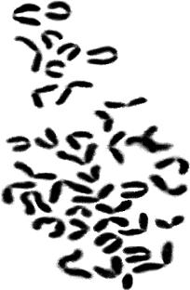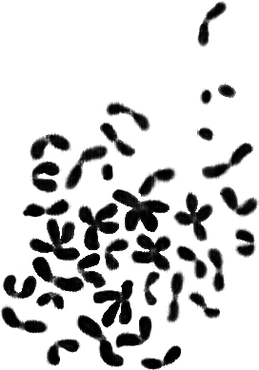
4
3
2
1
5
6

Figure 1-5. Somatic chromosome aberrations. (1) Ring chromosome (hollow arrow) and Centric fission (solid arrow); (2) Centromeric gap (hollow arrow) and Chromosome fragment (solid arrow);
(3) Centric fussion (solid arrows), Centric fission (double head arrow and hollow head); (4) All dot like; (5) Isochromatid break (solid arrow).

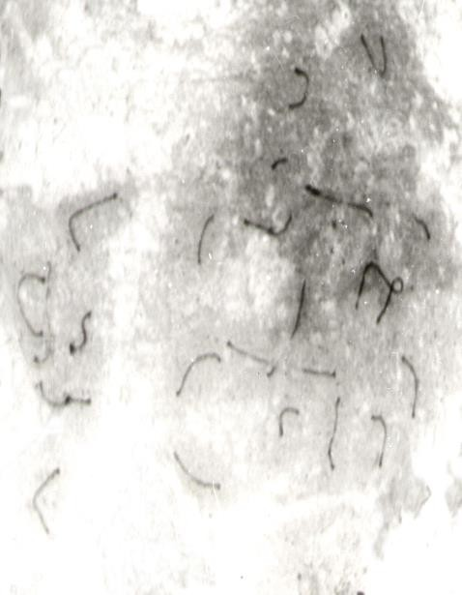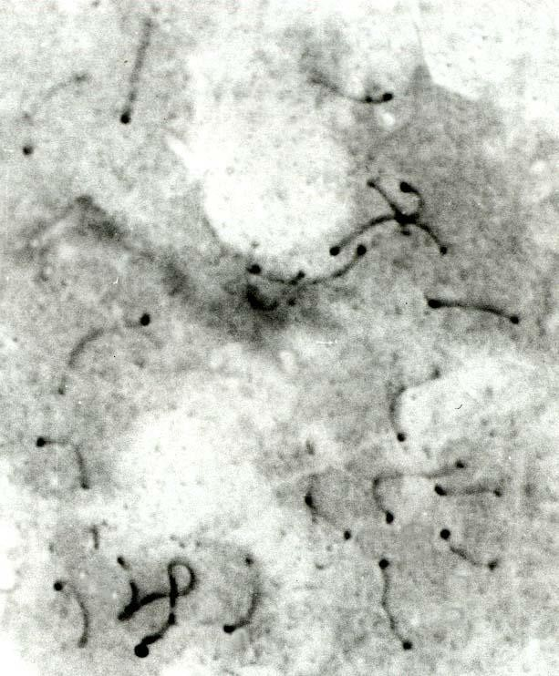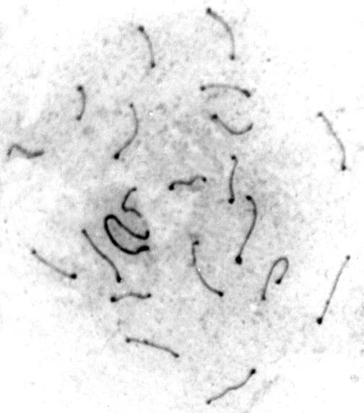

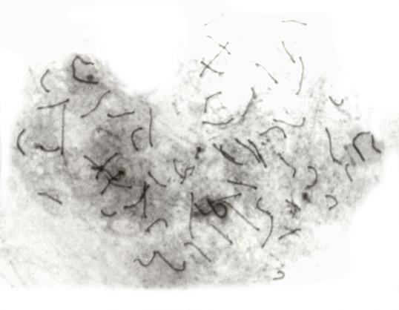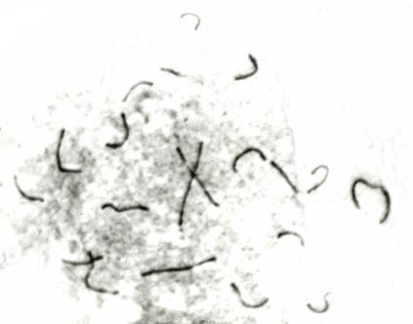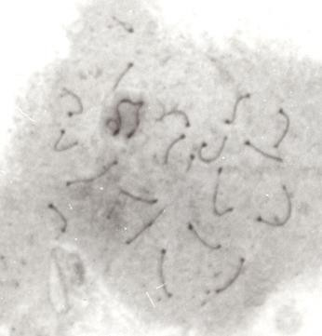
Figure 7-12. Synaptonemal complex damages. (7) Autosome fragment (Hollow arrow) and Autosome translocation (Solid arrow); (8) Y - break (solid arrow); (9) X-Y separation (Double head solid arrow) and X fold back (10) Autosome translocation (solid arrow) and Autosomal attenuation (hollow arrow) ; (11) SC breaks (Solid arrows); (12) Y-fold back (solid arrow) and X-A translocation (hollow arrow).
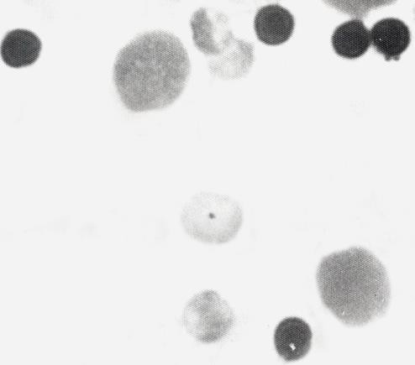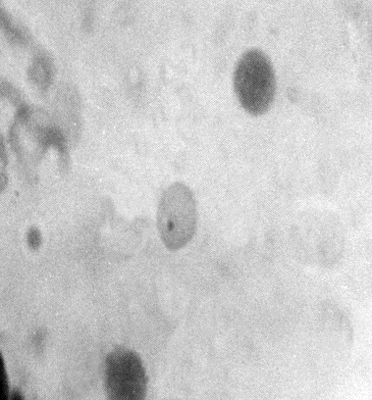

Figure 13. NCE with single micronucleus (solid arrow). Figure 14. PCE with single micronucleus (solid arrow)

References
ALAM G., WAHYUONO S., GANJAR I.G., HAKIM L., TIMMERMAN H. and VERPOORTE R., 2002 ―

Tracheospasmolytic activity of Vitoeosin A and Vitexicarpin isolated from V. trifolia. Planta Medica., 1047-1049.
ALLEN J.W., GIBSON J.B., POORMAN P.A., BACKER L.C. and MOSES M.J.,1988 ― Synaptonemal

complex damages induced by clastogenic and antimitotic chemical: implications for non- disjunction and aneuploidy. Mut. Res., 301:313-324.
ASHBY J., SERRES DE F.J., DRAPPER M.H., ISHIDATE J.K., MATTER B.I. and SHELBY M.D., 1983 ―

The two IPCS collaboration studies on short-term test system of genotoxicity and carcinogenicity. Mut. Res., 109: 123-126.
BACKER L.C., GIBSON J.B., MOSES M.J. and ALLEN J.W., 1988 ― Synaptonemal complex damage in relation to meiotic chromosome aberrations after exposure of male mice to cyclophosphamide. Mut. Res., 203: 317.
BHAGIRATH TH. and KUNDU S.C., 1985 ― Effects of male contraceptive agent gossypol on bone-marrow chromosomes of the male rat. Cytogenet. Cell Genet., 39: 228-230.
BOCHKOV N.P., SRAM R.J., KULESHOV N.P. and ZHURKOV V.S., 1976 ― System for the

evaluation of the risk from chemical mutagens: basic principles and practical recommendations. Mut. Res., 38: 191-202.
CHAKRABARTI C.S., 2001 ― Genotoxic effects of Euporatorium extract on the bone-marrow chromosomes of Rat (Rattus norvegicus). Proc. Zool. Soc. Calcutta., 54: 22-26.
DAWA LH. L., ABHIJIT CH and DHANI R. CH., 2019 ― Antioxidant and Cytotoxic Attributes of Paris polyphylla Smith from Sikkim Himalaya. Pharmacognosy journal., 11(4):705-711.
DICKENS P., TAI Y.T., BUT P.P., TOMLISON B., NG H.K. and YAN K.W., 1994 ― Toxicity of

complementary therapies: An Eastern perspective. Forensic Sci. Int., 67: 55-58.

DIGRAK M., ALMA M.H., ILCIM A. and SEN S., 1999 ― Antibacterial and antifungal effects of various commercial plant extracts. Pharmaceutical Biology., 37(3):216-220.
FU YL, ZHAO ZH, SHAN YJ, and CONG YW., 2007 ― Inducing effect of total steroid
saponins from Paris polyphylla on platelet aggregation in vitro and its potential mechanism.
Bulletin Academy Military Med Sci., 31:416-419.
GALVEZ M., MARTIN-CORDERO C., LOPEZ-LAZARO M., CORTES F. and AYURO M.J., 2003 ―
Cytotoxic effect of Plantago spp. on cancer cell lines. J. Ethnopharmacol., 88 (2-3):125-130. GHUANGLIE C., WEISHI G., GAILLING H., and JIANPING C., 2013 ― Effect of paris
Saponin on Antitumor and Immune Function in U14 Tumor- Bearing Mice. Afr J Tradit Complement Altern Med., 10:503-507.
GUIL J.L., RODRIGUEZ-GARCIA I. and TORIJA E., 1997 ― Nutritional and toxic factors in selected wild edible plant. Plant Foods for human Nutrition., 51 (2):99-107.
HARRIES A.D and CULLINAN T., 1994 ― Herbis et orbis: the dangers of traditional eye medicines. Lancet., 344: 1588.
HEDDLE J.A., 1973 ― A rapid in vivo test for chromosomal damage. Mut. Res., 18:187-190. IUCN, Nepal., 2004 ― National Register of Medicinal and Aromatic plants (Revised and updated). IUCN- The World Conservation Union, Kathmandu, Nepal.
JAGADEESWARAN R., TRIRUNAVUKHARASU C., GUNASEKARAN P., RAMAMURTY N. and SAKTHISEKARAN
D., 2000 ― In vitro studies on the selective cytotoxic effect of crocetin and quercetin. Fitoterapia., 71(4):395-399.
JIANG H., ZHAO P., FENG J., SU D and MA S., 2014 ― Effect of Paris saponin I on radiosensitivity in a gefitinib-resistant lung adenocarcinoma cell line. Oncol Lett., 7:2059- 2064.
JOSEFSON D., 1996 ― Herbal stimulant causes US deaths. Br. Med. J., 312: 1378-1379. KAMAT and SINGH. , 1994 ― Preliminary chemical in the different parts of the genus Leucas R. Br. Geobios., 21(1):31-33.
KAMBOJ V. P., 2000 ―Herbal Medicine. Curr. Sci., 78: 35-37.

KIM Y.K., YOON S.K. and RYU S.Y., 2000 ― Cytotoxic triterpenes from stem bark of Physocarpus intermedius. Planta Medica., 66(5): 485-486.

LEE, M.S., YUET-WA., J.C., KONG, S.K., YU, B., ENG-CHOON, V.O., NAI-CHING,
H.W., CHUNG-WAI, T.M. and FUNG, K.P., 2005 ― Effects of polyphyllin D, a steroidal saponin in Paris polyphylla in growth inhibition of human breast cancer cells and in xenograft. Cancer Biology and Therapy., 4:1248–1254.
LI B., YU B., HUI Y., LI M., HAN X and FU NG KP., 2001 ― An improved synthesis of the saponin, polyphyllin D. Carbohydr Res., 331:1-7.
LI FR., JIAO P., YAO ST., SANG H., QIN SC., ZHANG W., ZHANG YB and GAO LL.,
2012 ― Paris polyphylla Smith Extract Induces Apoptosis and Activates Cancer Suppressor Gene Connexin26 Expression. Asia Pac J Cancer Prev., 13:205-209.
MAN, S., CHAI, H., CUI, J., YAO, J., L., MA and GAO, W., 2017 ― Antitumor and anti-
metastatic activities of Rhizoma paridis saponins in Lewis mice. Environmental Toxicology., 33(2):149-155,
MYERS, N., 1988 ― Threatened Biotas: “Hot Spots” in the Tropical Forests. The Environmentalists., 8(3):187-208.

MYERS, N., MITTERMEIER, R.A., MITTERMEIER, C.A., DA FONSECA, G.A.B. and
KENT, J., 2000― Biodiversity hotspots for conser-vation priorities. Nature, 403:853-858. NANDI P., TALUKDAR G. and SHARMA A., 1998 ― Plants against cancer-some aspects. Nucleus., 41: 53-86.
PORTO ALEGRE R.S., 1999 ― Mutagenicity of medicinal plant extracts in Salmonella/ microsome assay. Phytotherapy Res., 13: 397-400.
PRAJAPATI N.D., PUROHIT S.S., SHARMA A.K. and KUMAR T., 2003 ― A hand book of Medicinal Plants- A Complete Source Book. 1st Edn. Agrobios, India.
RINGBOM T., SEGURA L., NOREEN Y., PERERA P. and BOHLIN L., 1998 ― Ursolic acid from

Plantago major, selective inhibitor of cyclooxygenase-2 catalyzed prostaglandin biosynthesis. J. Nat. Products., 61 (10):1212-1215.
ROMAGNA F. and STANIFORTH C.D., 1989 ― Automated bone-marrow micronucleus test. Mut. Res., 231: 91-104.

SADHU S.K., OKUYAMA E., FUJIMOTO H. and ISHIBASHI M., 2003 ― Separation of Leucas aspera, a medicinal plant of Bangladesh, guided by prostaglandin inhibitory and antioxidant activities. Chemical & Pharmaceutical Bulletin., 51 (5): 595-598.
SARKAR A.K. and MANNA G.K., 1989 ― Mutagenic potentiality of the nitrogen fixing bacterium Beijerinckia acida tested in mice. In: Perspectives in Cytology and Genetics, (G.
K. Manna and Sinha, eds)., 6: 633-639.

SCHMID W., 1976 ― Chemical Mutagens, Principle and Method for Detection. (Ed. Holaender) Plenum press New York., 4: 31.
SHARMA A., 1984 ― In: Indian Nat. Sci. Acad. Golden Jubilee publication. Perspective report., 61.
SINHA S.C., 1996 ― Medicinal Plants of Manipur. Manipur Association for Science and Society, Imphal.
SONGSONG JING., YING WANG., XIA LI., MAN S. and GAO W., 2017 ― Chemical

constituents and antitumor activity from Paris polyphylla Smith var. yunnanensis. Natural Product Research., 31(6): 660-666.
SUN J., LIU B.R., HU W.J., YU L.X. and QIAN X.P., 2007 ― In vitro anticancer activity of aqueous extracts and ethanol extracts of fifteen traditional Chinese medicines on human digestive tumor cell lines. Phytotherapy Research., 21:1102–1104.
WHO 2016 ― World Health Organization (WHO) factsheet,
WU SS., GAO WY., DUAN HQ. and WEI J., 2004 ― Advances in studies on chemical constituents and pharmacological activities of Rhizoma Paridis. Chinese Traditional and Herbal Drugs., 35:344-347.
ZHANG L., RAVIPATI AS., KOYYALAMUDI SR., JEONG SC., REDDY N., SMITH PT., BARTLETT J., SHANMUGAM K., MUNCH DG and WU MJ., 2011 ― Antioxidant and
Anti-inflammatory Activities of Selected Medicinal Plants Containing Phenolic and Flavonoid compounds. J Agr Food Chem., 59:12361-12367.

