**ENVIRONMENTAL INNOVATION AND SUSTAINABLE DEVELOPMENT THROUGH GREEN TECHNOLOGY**

Dr. Sanjay Kumar Narang,Dr. Monika Panchani1, Dr. Kiran Chauhan2 and Dr. Manoj Thakur3 Dr. Radhika Jamwal4

**INTRODUCTION**

Environmental innovation is the only way to reduce pressure on environmental quality while maintaining economic growth. The global problem of environmental degradation forces the society to reconsider the way of development and evolution of the concept of sustainable development. Various green initiatives are being undertaken to maintain and improve the quality of the environment that may grow in new future societies that consider resource efficiency and sustainability. Green technology is the development and application of products, equipment and systems that are used to protect the environment and natural resources and minimize the negative effects of human activities. The need for green technology arises due to the reduction of natural resources and the increase in pollution due to the high use of non-renewable resources. Due to its enormous impact on the built environment, green technology has become an integral part of sustainable construction projects. Green technology that promotes sustainable development means identifying green sources of growth, developing new green industries, and creating new job opportunities. Achieving green growth requires stronger investment and innovation, which are the foundations of sustainable development and open new economic pathways. Therefore, the promotion of green economy requires in-depth research on the conditions of formation, system-forming factors and the consequences of sustainable development. Parties interested in the development of the green economy include businesses (focusing on economic benefits), authorities (setting environmental goals for sustainable development) and the general public (representing the interests of the social community). Innovation is needed to achieve sustainable development goals. The understanding of green knowledge management plays a special role in sustainable development, especially in the creation, acquisition, exchange and use of knowledge, as well as in influencing green technologies, environmental innovations and socio-economic dimensions of sustainable development.

**THE NEED FOR GREEN ENERGY:**

Green energy is produced from renewable sources and has very less impact on our environment. In order to protect mother nature from pollution and ensure continuous supply of energy, we should start using green energy for both industrial and domestic purposes. To limit global warming and protect ecosystems by reducing CO2 emissions through energy efficiency and renewable energy, as temperatures rise, agricultural production will decline, damage from floods and storms will increase, diseases will become more prevalent and access to water will be a problem for more and more people. The cost to our environment is greater and the loss is irreversible. Earth's flora and fauna will suffer both directly from higher temperatures and indirectly from damage to their habitats. Ecosystems will disappear. Even a small increase in temperature will cause coral bleaching and endanger some amphibians. A temperature increases of 3° or 4°C or more will lead to mass extinctions worldwide. Green technology is the need of hour to restore earth ecosystem for sustainable livelihood. Energy like Solar, hydro and wind has the least impact on the environment because it does not contribute to the increase of carbon dioxide emissions and to global warming in any way.



Figure-1: Green Energy

**SOLAR ENERGY**

The sun is a huge source of solar energy that powers all living things on Earth. It is a renewable and clean source that produces almost 10,000 times more energy than the earth. We can use this solar energy as green energy because it is the most suitable renewable energy source. Solar energy has experienced phenomenal growth in recent years, thanks to technological improvements leading to lower costs and government policies supporting the development and use of renewable energy. India is supposed to be one of the few countries that is blessed with an abundance of solar energy. The Indian solar market has huge scope for growth. However, two factors affecting the same growth are the lack of proper knowledge about solar energy technology among consumers and the penetration of substandard products in the market. Photovoltaic cells, also called solar cells, are electronic devices that convert sunlight directly into electricity. French scientist Edmond Becquerel first discovered photovoltaic energy in 1839. The first working solar cell was successfully manufactured by Charles Fritts in 1882. It was made of thin sheets of selenium and coated with gold. The use of solar panels to generate electricity and heat appears to be a relatively new development, in fact it has been widely used to generate energy since the early 20th century. In 1954, Bell's laboratory mass produced the first crystalline silicon solar cell. Bell PV converted 4% of the sun's energy into electricity, a rate that was considered the cutting edge of energy technology. their researchers Daryl M. Chapin et al produced a silicon-based solar cell with an efficiency of about 6% reported in [8]. Solar energy has undergone an impressive technological shift. While early solar technologies consisted of small photovoltaic (PV) cells, current technologies are represented by concentrated solar power (CSP) as well as large photovoltaic systems that feed power grids. Solar energy is a type of renewable energy source that has been extensively developed and fully applied due to power transmission limitations. Solar energy usually has many advantages over fossil coal and oil as it reduces carbon emissions, cleans the air and can be regenerated during our lifetime. In the current scenario of the world, the consumption of electricity has increased. Researchers have therefore focused on developing solar energy technologies to achieve high efficiency levels with minimal investment costs and less environmental pollution.

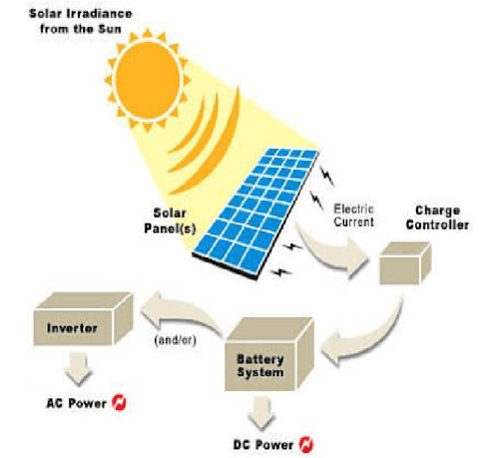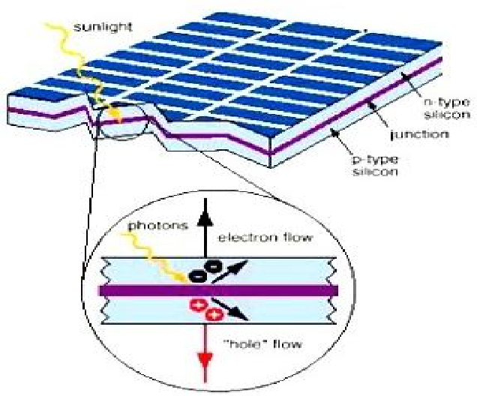

Figure-2. A: Working of solar energy B: Internal reaction of solar energy

**HYDROPOWER**

Hydropower is one of the oldest and largest sources of renewable energy, it uses the natural flow of moving water to generate electricity. Hydropower is a function of water flow, head and density. Hydroelectric power plants (HPP) are classified according to their capacity. Power plants are either "large hydro" (10 MW or more) or "small hydro" (up to 10 MW). Small scale systems are classified as "mini hydro" (up to 1 MW), "micro hydro" (up to 100 kW) and "pico hydro" (up to 5 kW). It is estimated that power plants with a capacity of less than 10 megawatts make up about 10% of the world's power plant capacity. In general, it is concluded that hydropower is one of the most efficient renewable energy sources. A hydroelectric power plant, if scaled up, costs a lot to install, but in the long run, it provides us with a lot of energy. Hydroelectric power plants can achieve an efficiency of about 90%, which is unattainable by any renewable energy generation source. Hydropower is considered renewable because solar energy powers the global water cycle. This is the power that comes from the hydrologic cycle, a continuous process in which falling water and high-velocity currents generate electricity. Hydropower is a renewable energy source that currently provides the main source of electricity and accounts for about 19% of the world's electricity. Most of the hydropower used in the world today is produced by large projects. In addition, there is more scope for the development of small-scale hydropower projects.

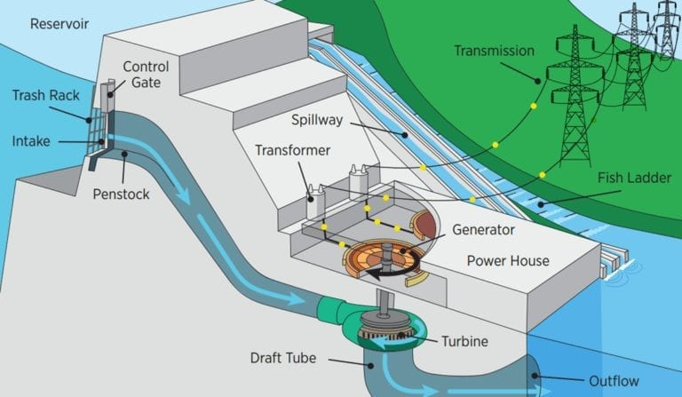 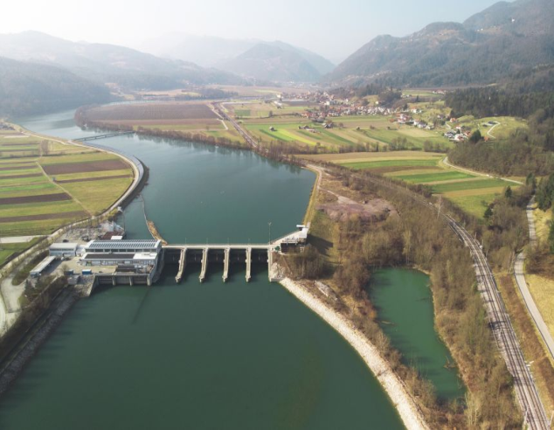

A B

Figure-3: Hydropower generation

**Green Building**

Green technology in building construction is still relatively new compared to conventional buildings, but recent studies show that over time, green buildings become more cost-effective than conventional buildings. Various technologies and materials are used in green buildings to reduce environmental impact and energy costs. Green building technologies use natural materials that include natural light from windows, solar cells installed on the roofs of buildings, rainwater harvesting systems to reduce water consumption, waste reduction through the use of recycled products. It refers to the techniques used in the built environment to ensure that the building is able to perform the function for which it is designed, comfortable and productive, while minimizing its impact on the environment. Buildings account for more than 40% of the world's energy consumption and emit more than a third of the world's greenhouse gases, so making buildings more energy efficient and reducing their impact on global warming is particularly important. As the Earth has already experienced global warming, green building technologies require not only mitigation capabilities (reducing carbon emissions), but also adaptation capabilities (allowing buildings to adapt to climate change in projects). The importance of green buildings is to ensure the sustainable development of the environment and provide a healthier environment for people. It is important to discover and promote the development of green building technology, which plays an integral role in environmental protection and ecological development.

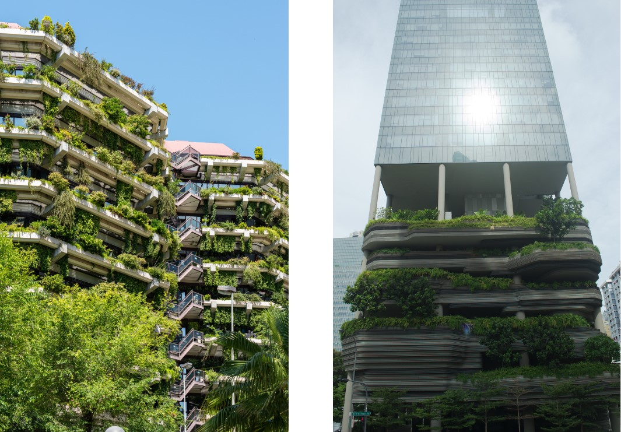

A B

Figure-4: Green Buildings

**WIND ENERGY**

Wind is an abundant source of energy that can be harnessed to generate clean electricity through wind turbines. Wind power is produced by transferring kinetic energy from the wind to rotors. The mechanical energy from the rotating turbine blades then drives an electrical generator. The power of a wind turbine depends on its size and the speed of the wind passing through the rotor blades. These blades range from 30 to 90 meters in diameter and the support towers are roughly the same size in height. The power generated by utility-scale turbines ranges from 100 kilowatts to seven megawatts. Larger turbines are grouped into wind farms that provide bulk energy to the electrical grid, which is sent through transmission and distribution lines to homes and offices. Wind energy is one of the most promising and advanced sources of sustainable energy in terms of green technology and market readiness. In fact, the growth of wind power is considered to be the fastest among other renewable energy sources

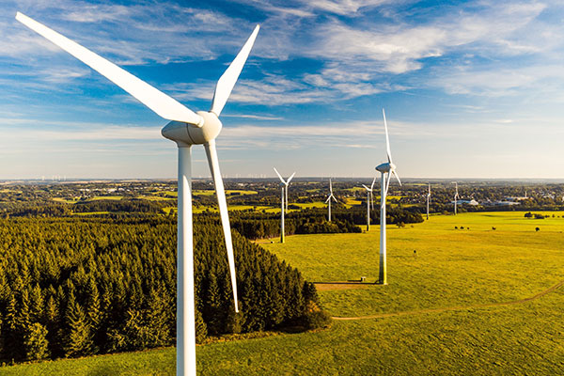 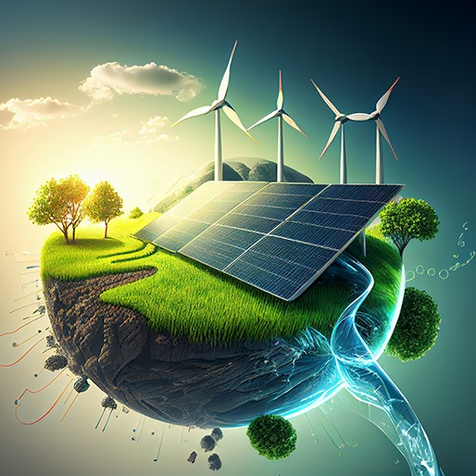

A B

Figure-5: Wind Energy

**Issues and challenges:**

**Design issues:** Correct design of a wind turbine is one of the most important challenges. The wind turbine design should be adequate in terms of blade loading (if the blades are light) and aerodynamic stability. Wind turbines are under loads such as inertia, gravity and aerodynamics.

**Location problems:** Building a wind farm requires a large area and the developer must own/secure the land. Wind power plants are usually located in rural areas where land is available and the same land can be used for other activities such as agriculture and animal husbandry. The power generated from a wind turbine mainly depends on the wind speed. Wind speed is mainly affected by obstacles such as buildings and terrain. To ensure the full use of wind energy, wind power plants should be installed at a sufficient height in the countryside.

**Environmental effects:** Wind energy can have positive and negative effects on the environment. The energy produced by wind turbines does not produce pollutants such as carbon dioxide, nitrogen oxides and sulfur dioxide.

1. Effects on wildlife: Effects on wildlife can be divided into two categories, direct and indirect. The direct effects of death from collision with wind turbines, the indirect effects include habitat destruction, etc. However, the impact of wind turbines on wildlife is negligible compared to other energy sources.

2. Noise impact: Noise pollution is one of the most important environmental issues when installing wind energy. The effects of noise pollution can lead to a decrease in property value within a certain radius of the building, and it is also (to some extent) dangerous for humans. Therefore, it is important to check the type of noise produced by the wind turbine before construction.

**Weaknesses and shortcomings of green technology**

Green technologies have been applied in many sectors, but they are not fully exploited and are still alternative energy sources in the energy sector. Initial investment and installation costs are very high, the ceiling cost of installing a 1 MW solar power plant in India is around Rs 300-350 crore (discounting government subsidies). On the other hand, the cost of installing a sub-critical coal power plant (Ultra Mega Power Plant 4000 MW) is about 184,736 crores. That is 46184000 rupees per MW. The difference is huge and quite out of reach for many developing countries. Government's heavy investment in green technology will effectively reduce the flow of cash in other important areas such as industry, Health and infrastructure. The technology is still evolving and many products are in research and development stage. So, people don't know the performance results. Solar panel disposal is still a matter of research management as solar panels contain harmful substances.

**SUMMARY**

This chapter highlights the importance of sustainable energy development through green technologies. Solar energy would help stabilize energy prices and provide a range of social, environmental and economic benefits. Based on the current state of fossil fuel resources, which are considered as depleting sources of energy, finding an innovative technique for deploying clean energy technology is essential and expected. Despite the fact that solar energy has not yet reached maturity in development. Wind energy has enormous potential and calls for greater focus, especially in large systems. The positive impacts of wind power on climate change mitigation and the opportunity to reduce energy dependency are undeniable. For developing countries like India, apart from reducing carbon emissions and energy scarcity, it also plays a key role in increasing employment opportunities. Hydropower is one of the cleanest sources of energy and is also the most reliable and cheapest. It does not contribute to global warming and climate change like fossil fuels such as oil. Hydroelectric power plants ensure a reliable supply of electricity by enabling stable and regular electricity generation, which is not the same as other renewable energy sources such as solar and wind power. Green building technologies have a high initial investment but have a minimal impact on the environment and are energy efficient. Since office and residential buildings consume a large portion of any country's energy pie. Green buildings have significant advantages over conventional buildings in future, because they reduce energy consumption and waste also these buildings can recover their costs within an acceptable time frame. Such buildings have proven themselves to be economical and ecological in the long term and are thus beneficial for individuals and for society as a whole. All green technologies are the need to create energy systems that protect and improve climate and health. Green technologies are without a doubt a necessity because they most closely match our current global needs.

**AUTHORS CREDENTIALS:**

**Lead and Corresponding Author:**

Dr. Sanjay Narang, Associate Professor (Zoology), Vallabh Govt. College (VGC), Mandi, Himachal Pradesh, India-175001 Email: sanjaynarang76@gmail.com Mobile: 9418480595

**Co-authors:**

1. Dr. Monika Panchani, Associate Professor (Zoology), Vallabh Govt. College (VGC), Mandi, Himachal Pradesh, India-175001

Email: monikapanchani11@gmail.com Mobile: 9418263032

2. Dr. Kiran Chauhan, Assistant Professor, Department of Biosciences, MLSM College Sundernagar, Mandi,H.P. Pin-175018

Email:kiran.cng@gmail.com Mobile:8219166427

3. Dr. Manoj Thakur, Assistant Professor (Environment Science), Vallabh Degree College (VGC), Mandi, Himachal Pradesh, India-175001

Email: [manojthakur0083@gmail.com](mailto:manojthakur0083@gmail.com)

4. Dr. Radhika Jamwal, Assistant Professor (Zoology), Vallabh Degree College (VGC), Mandi, Himachal Pradesh, India-175001

Email : radhika_mnd@yahoo.co.in Mobile: 9418080991