DATA MINING TECHNIQUES

First Author: Mrs. K. Jayanthi Vagini Second Author: Ms .M. Nancy
Assistant Professor, Student, Department of CS with Data Analytics, Department of CS with Data Analytics,
KPR College of Arts Science and Research, KPR College of Arts Science and Research,
Avinashi Road, Arasur, Coimbatore . Avinashi Road, Arasur, Coimbatore.

Third Author: Mr.B.Muthuselvam
Student,
Department of CS with Data Analytics,
KPR College of Arts Science and research,
Avinashi road,Arasur,Coimbatore.

ABSTRACT:
In order to extract important insights and knowledge from huge and complicated databases, data mining techniques are essential. The necessity for efficient and effective methods to analyse, evaluate, and find patterns grows more and more important as the volume of data keeps increasing exponentially. An overview of several data mining approaches, such as classification, clustering, association rule mining, and anomaly detection, is given in this abstract.The goal of classification algorithms is to divide data into preset classes according to their characteristics. They are extensively utilised in applications including sentiment analysis, disease detection, and email screening. Common classification methods include Support vector machines (SVM), Decision Trees, and Naive Bayes.
KEYWORDS:
Association rule mining, Anomaly detection, Naive Bayes, Hierarchical Clustering, Isolation Forest, Scalability, Data Warehouse, Performance Evaluation.
INTRODUCTION:
Organisations and individuals are constantly bombarded with massive volumes of data in today's data-driven world from a variety of sources, including corporate transactions, social media, sensors, and scientific research. It has become crucially important to find useful insights and knowledge from this data. By revealing hidden patterns, correlations, and trends within enormous and complicated datasets, data mining techniques—a branch of the larger fields of artificial intelligence and machine learning—have become effective tools for tackling this problem.
Data mining techniques include a wide range of methodologies that make it easier to extract useful information from unstructured data. These approaches are made to sort through large datasets, find pertinent patterns, and turn them into useful information. Data mining techniques offer essential support for decision-making, strategic planning, risk assessment, and process optimisation across numerous sectors and domains by uncovering significant insights and patterns.
Data points are classified into specified classes or groups according to their qualities, which is one of the basic jobs in data mining. Applications including sentiment analysis, email spam screening, and medical diagnosis are made possible by this method. Clustering, which groups comparable data points together, is another crucial operation that supports customer segmentation, picture segmentation, and anomaly detection by assisting in the identification of natural structures within the data .another important data mining technique that reveals intriguing relationships is association rule mining.
TECHNIQUES FOR DATA MINING:
The phrase "data mining" refers to the procedure of extracting knowledge from enormous amounts of data. Data mining is, thus, the science, art, and technology of identifying important patterns in sizable and complex data sets. The effectiveness, economy, and correctness of the process are continually being sought for by theorists and practitioners alike. Many phrases have meanings that are similar to or marginally different from those of data mining, including knowledge mining from data, knowledge extraction, data/pattern analysis, and data dredging.
Another common term used to describe data mining is Knowledge Discovery from Data (often referred to as KDD). Others view data mining as simply a critical phase of the knowledge discovery process, when smart approaches are employed to extract data patterns.
- Association
- Classification
- Prediction
- Clustering
- Regression
- Artificial Neural Network (ANN) Classifier Method
- Outlier Detection
- Genetic Algorithm

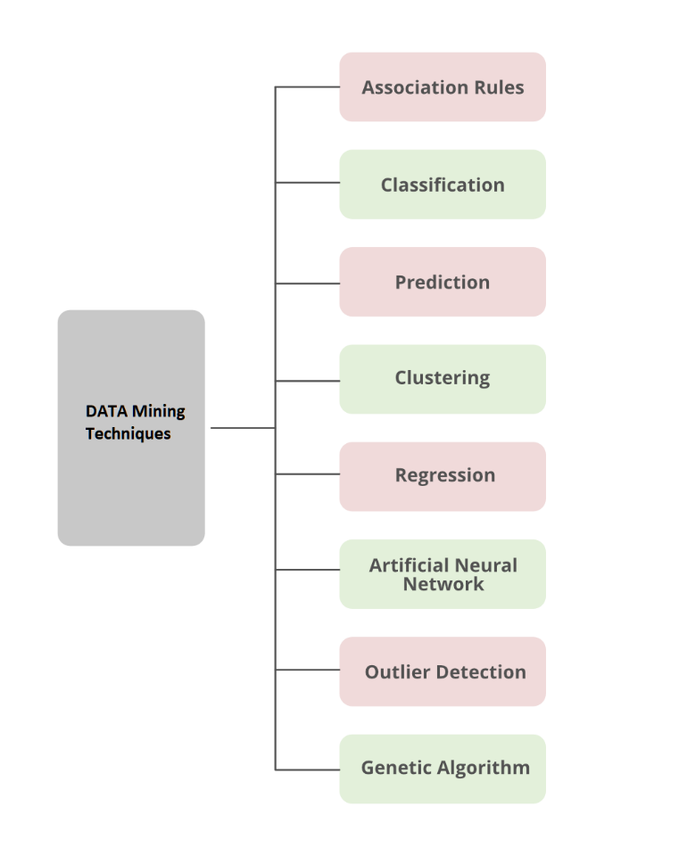
ASSOCIATION RULE:
Association analysis is the process of identifying attribute-value conditions that commonly co-occur in a set of data. Association analysis is widely used in market basket or transaction data analysis. Association rule mining is a significant and very dynamic area of data mining study. One sort of association-based categorization that comprises two steps is associative classification. In the main step, association instructions are generated using a modified version of the typical association rule mining technique called Apriori. The development of a classifier utilizing the determined association rules constitutes the second stage.
CLASSIFICATION:
Classification is the process of identifying a set of models (or functions) that explain and differentiate data classes or concepts in order to use a model to anticipate the class of objects whose class label is unknown. To identify the model, it is important to analyze a set of training data information—data objects whose class label is known. The resulting model can be represented in several ways, such as classification (if-then) rules, decision trees, and neural networks. In data mining, a separate classifier is employed.
- Decision Tree
- SVM(Support Vector Machine)
- Generalized Linear Models
- Bayesian Classification
- Classification by Backprpogation
- K-NN classifier
- Rule-Based Classification
- Frequent-Pattern Based Classification
- Rough set theory
- Fuzzy Logic
DECISION TREE:
A decision tree's structure is similar to a flowchart in that each node stands in for a test on an attribute value, each branch represents the outcome of the test, and the tree leaves represent classes or class distributions.. Classification rules can be simply created from decision trees. The nonparametric method of decision tree enlistment is used to create classification models. In other words, no presumptions about the sort of probability distribution that the class and other properties satisfy are necessary. Decision trees, particularly those of smaller sizes, are generally simple to read. For a considerably simpler data set, the accuracy of the trees is likewise equivalent to that of two other categorization methods.
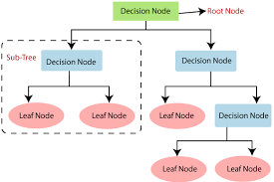
This graph was produced using data from the UCI machine repository's IRIS data collection. In essence, the data set has three separate class labels: Setosa, Versicolor, and Virginia.
SVM:
Support Vector Machines is a supervised learning method used for both classification and regression. When the output of the support vector machine is a continuous value, the learning process is said to be performing regression; when it properly predicts the category label of the input object, it is said to be performing classification. The independent variables may or may not be quantitative. Kernel equations are functions that, whenever instances are made linearly dilvidable, transfer information that is linearly non-separable in one domain into a different domain. Kernel equations can achieve this specific objective using Gaussian, linear, quadratic, or any other type of equation. One illustration of a linear classification strategy is a classifier that based its conclusions on a linear function of its inputs. By using the kernel equations, one can organize the information instances so that at certain points in the multi-dimensional space, there is a hyper-plane dividing knowledge instances of one sort from those of another. We can use Support Vector Machines to apply linear classification techniques to nonlinear knowledge since they have the advantage of employing specific kernels to change the problem. Once we have effectively separated the data into two distinct groups, our aim is to include the optimal hyper-plane to discriminate between the two types of instances.

GENERALIZED LINEAR MODELS:
GLM stands for "generalized linear models," which is a statistical technique for linear modeling. GLM provides extensive row diagnostics, coefficient statistics, and model statistics. Moreover, confidence limitations are supported.
BAYESIAN CLASSIFIER:

The Bayesian classifier is a statistical classifier. They are able to predict probabilities of class membership, such as the likelihood that a given sample will belong to a particular class. Bayesian classification is based on the Bayes theorem. Studies comparing classification algorithms have demonstrated that the naive Bayesian classifier, a simple Bayesian classifier, performs on par with decision tree and neural network classifiers. Bayesian classifiers have also proven high accuracy and speed when used to large databases. Naive Bayesian classifiers make the assumption that the precise attribute value for a given class is independent on the values of the other attributes. This supposition is known as class conditional independence. It is considered "naive" and was created to perform the necessary computations required similar. In contrast to naive Bayesian classifiers, Bayesian belief networks are graphical representations that allow the modeling of dependency among subsets of features. Classification can also be done using Bayesian belief.

CLASSIFICATION BY BACKPROPOGATION:
Backpropagation networks learn by continually examining a set of training samples and comparing their estimated class labels for each sample with the actual class labels. To lessen the mean squared error between the network's predicted class and the actual class, weights are modified for each training sample. The phrase "backpropagation" refers to the process of spreading changes in a "backward" direction, or from the output layer down through each hidden layer and to the first hidden layer. The knowledge process will end when the weights eventually converge, albeit this is not a guarantee.
K-NN CLASSIFIER:
The k-nearest neighbor (K-NN) classifier is regarded as an example-based classifier, which means that training documents are compared rather than employed as an exact representation of the classes, as are the class profiles used by other classifiers. As a result, there isn't a proper training section. The k closest matches (neighbors) are found when a new document needs to be classed; if enough of them are allocated to a certain class, the new document is also assigned to that class; otherwise, it is not. Finding the closest neighbors is expedited by using conventional classification algorithms.
RULE-BASED CLASSIFICATION:
If-Then rules are used in rule-based classification to describe the knowledge. An evaluation of a rule based on the classifier's precision and coverage. If more than one rule is triggered, rule-based classification requires conflict resolution. Conflicts can be resolved using three different parameters: size ordering, class-based ordering, and rule-based ordering. Among the advantages of rule-based classifiers are:
- Rules are easier to understand than a large tree.
- Rules are mutually axclusive and exhaustive.
- Each attribute-value pair along a forms conjuction:each leaf holds the class prediction.
FREQUENT-PATTERN BASED CLASSIFICATION:
Frequent pattern discovery, sometimes referred to as FP mining, FP discovery, or frequent itemset mining, is a component of data mining. The job at hand is to identify the most pervasive and relevant patterns in massive datasets. Transaction database mining was the initial idea put out. The term "frequently appearing subsets" (also known as "item sets, subsequences, or substructures") refers to subsets of a data collection whose frequency is greater than a user- or automatically-specified threshold.
ROUGH SET THEORY:
Rough set theory can be used to uncover structural correlations in noisy or unpredictable data for categorization. It covers characteristics with discrete values. Therefore, continuous-valued attributes must first be discrete in order to be employed. The construction of equivalence classes within the given training data is the basis of rough set theory. Since they are all equal in terms of the characteristics that describe the data, the samples of data that make up a similarity class cannot be differentiated from one another. In relevance analysis and feature reduction, each attribute's contributions or significance are assessed in relation to the classification goal using rough sets Aspects that don't help classify the provided training data can be found and eliminated through feature reduction. It is NP-hard to identify the lowest subsets (redacts) of attributes that can fully describe each notion in the supplied data set. However, methods for minimizing computing have been proposed. One method, for instance, stores the changes in attribute values for each pair of data samples in a discernibility matrix. Instead of looking at the entire training set, the matrix is analyzed to look for duplicated attributes.

FUZZY LOGIC:

Rule-based categorization methods have the disadvantage that they demand abrupt cut-offs for continuous attributes. Fuzzy logic is used in data mining frameworks that do grouping and categorization. Working at a high level of abstraction has many benefits. In rule-based systems, fuzzy logic is often applied in the following ways:
• Fuzzy values are used as attribute values.
• More than one fuzzy rule may be applicable for a certain new data collection or example. Every applicable rule casts a vote for a certain category's membership. The truth values for each predicted category are typically added.

KNOLEDGE DISCOVERY FROM DATA:
- Knowledge discovery from data (KDD), a multi-step method, is used to extract knowledge from data. The following steps make up the KDD method:
- Data Selection: The first step in the KDD process is selecting the relevant data for analysis. Finding the data sources and selecting the data needed for the study fall under this category.
- Data transformation: After data has been cleaned, it could be necessary to make it more useful for analysis. The data must be translated into a format that data mining algorithms can use in order to accomplish this.
- Data Mining: A variety of data mining techniques are used in this step to uncover patterns and relationships in the data. Models and algorithms that are appropriate for the data and the current scenario must be chosen in order to do this.
- Evaluation of Patterns: After the data mining stage, it's important to evaluate the patterns and correlations that were discovered in the data in order to determine how applicable they are. This involves examining the patterns to see if they are significant and can be used to predict or make decisions.
- Data preprocessing: The data collected from different sources may be in different forms and have errors and inconsistencies. During the data preprocessing stage, the data must be cleaned and changed in order to make it ready for analysis.
- Knowledge Representation: The data's connections and patterns must be displayed such that the user can understand them and use them. To do this, the data must be presented in a way that makes sense and can be used for decision-making.
- Knowledge refining: Additional refining may be needed to make the knowledge uncovered through the data mining method more useful. This means utilizing user feedback to improve the accuracy and relevance of the findings.
- Knowledge Dissemination: The final step in the KDD procedure comprises providing the end users with the knowledge that was gleaned from the analysis. To do this, the information must be presented in a way that is simple to understand and useful for making decisions.
ADVANTAGES OF MINING TECHNIQUES:
- Better Decision Making:
Large datasets can be mined for valuable information that can be utilized to inform and accurately predict future actions. Businesses can spot trends and predict outcomes that aid in improved decision-making by examining patterns and linkages in the data
- Improved Marketing:
Businesses may determine their target market and create efficient marketing plans with the aid of data mining. Businesses can establish targeted advertising campaigns, provide individualized products and services by analyzing consumer data to discover client preferences and behavior.
- Increased Efficiency:
By discovering inefficiencies and potential areas for development, data mining can assist firms in streamlining their processes. Businesses can discover bottlenecks and put solutions in place that increase efficiency and lower costs by examining data on production processes, supplier networks, and staff performance.
- Fraud Detection:
Fraudulent activity in financial transactions, insurance claims, and other areas can be found through data mining. Businesses can spot suspicious behavior and take action to stop fraud by studying patterns and linkages in the data.
- Customer Retention:
Businesses can use data mining to identify clients who are likely to leave and create retention plans for them. Businesses can discover the variables that contribute to customer turnover by evaluating customer data, and then take action to alleviate those factors.
- Competive Advantage:
By seeing new opportunities and developing patterns, data mining can provide businesses a competitive edge. Businesses can find ways to innovate and stand out from the competition by studying data on customer behavior, market trends, and rival activities.
- Improved Healthcare:
By examining patient data to find patterns and links, data mining can be utilized to enhance healthcare results. Healthcare professionals can discover risk factors, detect diseases earlier, and create more effective treatment options by analyzing medical records and other patient data.
DISADVANTAGES OF DATA MINING TECHNIQUES:
- Data Quality:
The quality of the data analyzed in data mining is crucial. The accuracy, consistency, or completeness of the data will have an impact on how dependable the analysis's findings are.
- Data Privacy and Security:
Data mining involves the analysis of huge volumes of data, some of which may contain sensitive information about specific people or organizations. If this information ends up in the wrong hands, it might be exploited maliciously for things like business espionage or identity theft.
- Ethical Considerations:
Data mining brings up moral concerns about surveillance, prejudice, and privacy. For instance, using data mining to target particular demographics for marketing or political ends may be perceived as discriminating or manipulative.
- Technical Complexity:
Knowledge in a variety of disciplines, including statistics, computer science, and domain knowledge, is necessary for data mining. Some enterprises and organizations may find it difficult to enter the market due to the procedure' technical intricacy.
- Interpretation of Results:
Large volumes of data are produced by data mining algorithms, which can be challenging to analyze. Finding meaningful patterns and relationships in the data may be difficult for businesses and organizations.
- Dependence on Technology:
Data mining is primarily dependent on technology, which might be dangerous. Data loss or corruption can result from technical issues like hardware or software problems.

CONCLUSION:
Techniques for data mining have established themselves as essential instruments in the current era of data-driven decision-making. These strategies help individuals and organisations gain a competitive edge, enhance business procedures, and make wise decisions by allowing them to extract useful patterns, insights and knowledge enormous amount of data. Among the many techniques included in data mining are classification, clustering, association rule mining, and anomaly detection. Each method has a distinct use and can be combined to produce elaborate data analysis plans. Data mining's strength rests in its ability to glean hidden connections, patterns, and prediction models from even the most complicated and unstructured datasets. Businesses that use these strategies can foresee market trends, discover client preferences, improve marketing efforts, and boost overall operational effectiveness.
The ethical ramifications and potential privacy issues related to data mining must be acknowledged, though. As data becomes more widely available and in-depth, it is crucial to follow responsible data usage procedures and guarantee that people's privacy rights are upheld. In addition, the discipline of data mining is always developing as new approaches and algorithms are created to address new problems and opportunities. Businesses and researchers looking to maintain a competitive edge in their respective fields will need to stay on top of these developments.
In conclusion, data mining methods have completely changed how we use and analyse data. Data mining will become more and more important in influencing industry, society, and scientific research as technology develops. It will allow us to fully utilise the enormous amount of data at our disposal while upholding our commitment to ethical and responsible data use.

