Dynamicity of Homoeopathy in Obstetric disorders with case illustrations.

Authors:

Dr. Anand Kabra
Dr. Anand Suresh Kabra, M.D. HOM. Paediatrics, Professor and HOD, Homeopathy Pharmacy Department, SSVP Homeopathic medical college and research institute, Hatta, Hingoli, Maharashtra.

Dr. Archana Mundra
Dr. Archana Brijmohan Mundra, PhD (Scholar), M.D.Hom.Psychiatry, Associate Professor and HOD, Department of Organon of medicine and Homoeopathic Philosophy, Government Homeopathy College and Hospital, Jalgaon, Maharashtra,

Introduction:
Homoeopathy is a dynamic science based on dynamic, natural universal laws. Being dynamic, does it hold true and scientific in today’s modern world? Today, the world demands evidences for authenticity. For ages homoeopathy has been ridiculed for its non-evidence basis and placebo effect. But with the advent of technology and its developments, recent studies have shown the presence of homoeopathic medications in form of nanoparticles in highly potentised homoeopathic dilutions as well. This is totally at par with the natural laws of physics which says ‘matter is indestructible’ and ‘Energy can neither be created or destroyed, it can only be converted from one form to another.’

What happens in the body during pregnancy? Dynamic forces act to bring together genomes of two different DNAs and a new cell structure is formed with a totally different genetic make-up. This dynamicity brings about a chain of events in the body of the gravida. A lot of pregnant women have uneventful pregnancies and bring new life to life in perfect health. Though a few come up with certain disorders due to identifiable and unidentifiable reasons. Identifiable reasons like iron-deficiency anaemia are easy to modify and help the pregnant woman to lead a healthy pregnancy. But other disorders like abortions, placental and cord abnormalities, fetal problems etc. to name a few, have a very huge impact on the growth and development of the budding life and on the mother as well. Do we have any systems to measure this dynamic influence of nature? Since each of these is natural and dynamic, we have limitations to treat these with mainstream treatment methods. For all such cases and others, homoeopathy stands tall with its dynamic natural laws which aims at regulating and balancing the energies of the affected mother and the new life developing in her womb. It aims at rectifying the unidentifiable dynamic causes for such disorders to occur and rectify them with its power of similarity.

Below are a few illustrations of the above claims made by us a homoeopathic physicians. Role of Homeopathy in the field of gynaecology and obstetrics may not be a much explored area, but these cases will definitely give us insights about the power of dynamic homoeopathic medicines to rectify energy imbalances and thus restore the sick to health.

DISORDERS DURING PREGNANCY
- Iron deficiency anemia
- Gestational diabetes
- Miscarriage
- Fetal problems
- Hypertension during pregnancy
- Infections
- Hyperemesis gravidarum
- Abnormalities of placenta and cord
- Pre-eclampsia
- Preterm labour
- Depression and anxiety

SCOPE OF HOMEOPATHY
- Miscarriage (abortions)
- Fetal problems
- Infections
- Placenta previa
- Placental abruption
- Depression and anxiety

ABORTION is the expulsion or extraction from its mother of an embryo or fetus weighing 500 gms or less when it is not capable of independent survival (WHO).
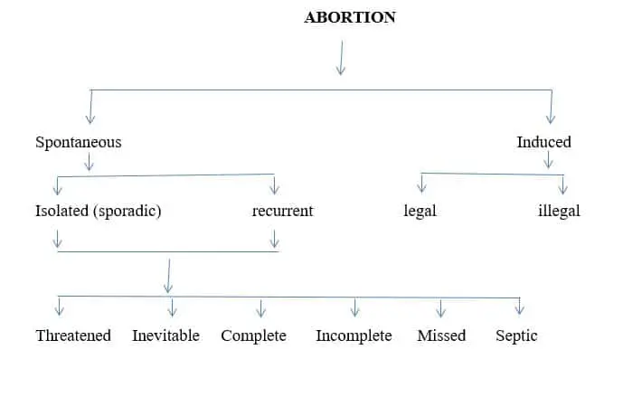
Fig.1: Classification of Abortion
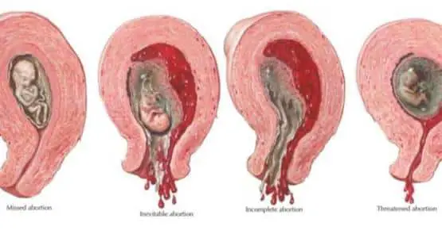
Fig.2: Diagrammatic Representation of Types of Abortions.

ETIOLOGY:
Genetic factors (50%)
Endocrine or metabolic factors (10-15%)
Anatomical factors (10-15%)
Infections (5%)
Immunological (5-10%)
Others
FIRST TRIMESTER: a. genetic factors
b. endocrine disorders (lutueal phase defect, Thyroid, diabetes)
c. Immunological disorders
d. Infections
e. Unexplained

SECOND TRIMESTER: Anatomical abnormality
a) cervical incompetence
b) Mullerian fusion defects (bicornuate uterus, bifid uterus, uterine synechiae
c) maternal medical illness
d) unexplained.

MECHANISM OF ABORTION
- In early weeks, death of ovum occurs first, followed by its expulsion. In later weeks, maternal environmental factors are involved leading to expulsion of the fetus which may have signs of life but is too small to survive.
- BEFORE 8 WEEKS: ovum surrounded by villi with the decidual covering, is expelled out intact. Sometimes os fails to dilate so entire mass accommodates in dilated cervical canal called cervical abortions
- 8-14 WEEKS: expulsion of fetus commonly leaving behind placenta & membranes. A part it partially separated with brisk hemorrhage or remains totally attached to uterine cavity
- BEYOND 14 WEEKS: like mini labour. Fetus followed by placenta after varying intervals.

BOH
- Bad Obstetric History (BOH) The term ‘Bad Obstetric History or BOH’ is applied to mothers in whom a previous poor pregnancy outcome is likely to have a bearing on the prognosis of her present pregnancy.
- The Habitual Abortion (HA) is defined as the emergence of a number of at least three consecutive spontaneous abortions.
- Habitual abortion affects 1-3 % of fertile couples.

Case No. 1
Mrs. MRB Date: 10/7/2019
Age: 22 yrs
Address: Jalgaon
C/O: Primigravida, LMP: 30/5/2019. Preg. 5weeks 5 days.
USG: early pregnancy with gestational age 5wks, 5 days, large sub chorionic hematoma is seen sized 3.1*0.9 cms.

• Female, reproductive system, cervix, vagina  since 5 days  Since 3 days | Leucorrhea – small quantity, swelling2, itching2, no burning.  Bleeding , light red colored

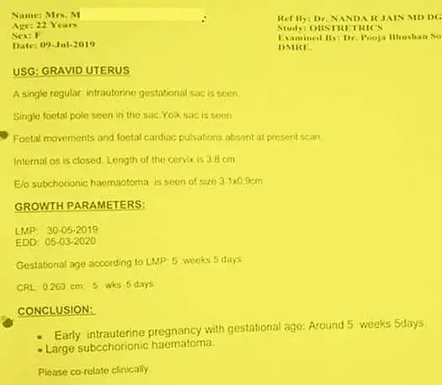
Fig.3: Ultrasonography Findings before Homoeopathic Treatment – Case-1

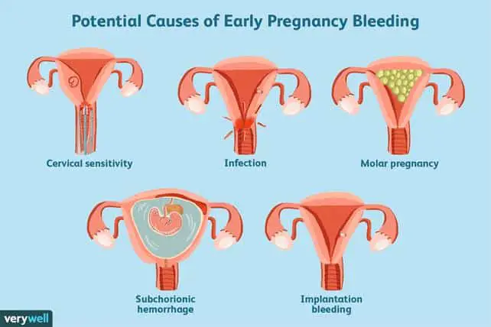
Fig.4: Potential Causes of Early Pregnancy Bleeding

ASSOCIATED COMPLAINTS

Skin since 3months  Left hand thumb and lumbar region  Skin of fingers  Face,on and off | Fungal infection,  Watery discharge  blackness  black spots | < brinjal  Rx allopathic treatment, injections taken for it

- PAST HISTORY: Father – NAD, Mother – hypothyroidism.
- P/G: App- less, nausea
Thirst: thirstless
Stool- normal
Urine- clear
Sleep – sound
Dreams- 0
Desires – rice2
Aversion -0
Perspiration – anxiety after
Thermals- HOT
MENTAL GENERALS:
– Studied till 10 std, scored 86% but no further study due to religious background, parents got her married.
– Husband is a fruit seller.
– After marriage stays in joint family.
– Fear – of everything, fear of dark, alone.
– Anxiety – future, worried about finances.
– Forgetfulness because of constant thinking.
– Extroverted And Expressive
– Irritability – when wronged, gets angry – stops talking, starts by herself after some time.
– Work speed is fast
– Fastidious wants everything neat and clean.
– Washing mania, wants cleanliness3,
– Clairoyance2
– Restlessness and hurried3
TOTALITY OF SYMPTOMS:
- Cleanliness3, washing 3
- Fear3, of dark, alone2,
- Restlessness and hurried
- Abortion in second month
- HOT
- Thirstlessness

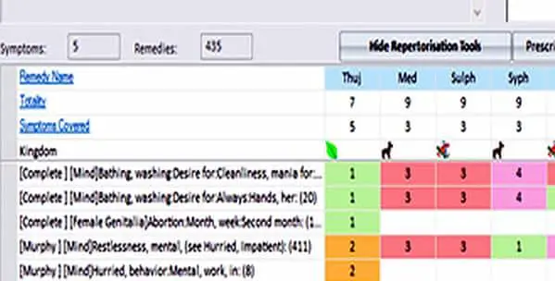
Fig.5: Repertorisation Chart – Case-1
Remedy differentiation:
THUJA and MEDORRHINUM.
– Strong sycotic traits
- Symptom similarity

Final Remedy: THUJA 200

Follow up: Date: 23/7/2019, bleeding stopped completely on the next day, leucorrhea >>, itching1>, hand eruptions >, feeling fresh, app- normal, thirsty, st- normal, urine- clear, sleep –sound

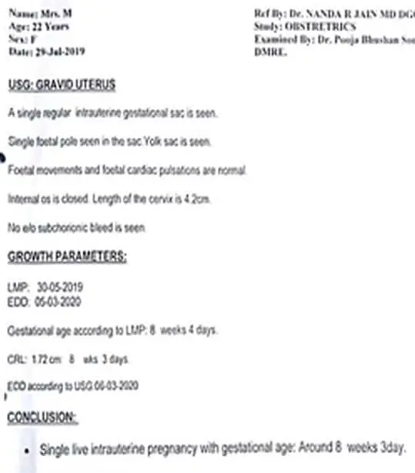
Fig.6: Ultrasonography Findings after Homeopathic Treatment – Case-1

Case no 2.
Mrs. PDW DATE: 29/8/2019
Age: 31 yrs
Address: JALGAON
C/0: USG shows 1-2 cms funneling, cervical length 1.6cm. G3P1L1A1. Preg. 6th month.
Right leg thigh from 2 months. | Pain2  Sudden, now increasing , so not able to walk | < walking, wake up, standing, slight movement. | Weakness3  Swelling all over body.
GIT since 4 months | Nausea | < fasting, coconut water, empty stomach, morning

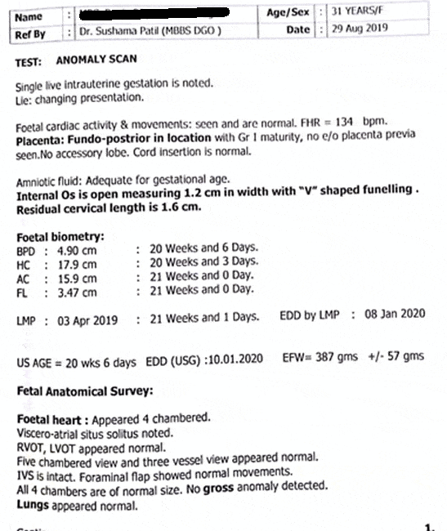
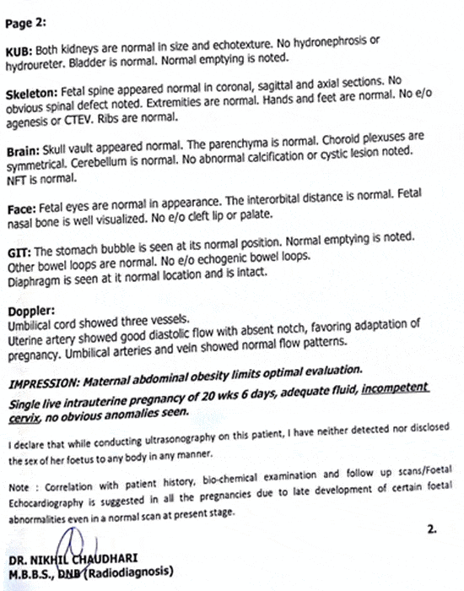
Fig.7: Ultrasonography findings before Homoeopathic Treatment – Case-2

Cervical funneling is a sign of cervical incompetence and represents the dilatation of the internal part of the cervical canal and reduction of the cervical length. Greater than 50% funneling before 25 weeks is associated with ~80% risk of preterm delivery.

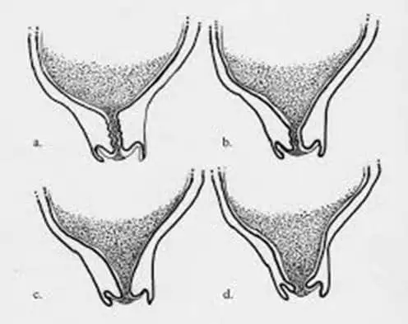
Fig.8: Stages of Funneling

P/H: 1 daughter 7yrs.
4 yrs back pregnancy aborted in 2nd month so D&C done.
Diagnosed with secondary infertility and IVF done
F/H: father- DM- police, Mother – house wife. 2 brothers. Patient is elder.
Education: BA, now housewife.
Husband: sales tax officer in GST bhavan.
P/G: App: good, easy satiety, Thirst: normal, stool- N, Urine: clear, Sleep: Disturbed due to pain in thigh. Dreams – 0,
Desires: sweets
Aversion: bitter,
Perspiration: scanty
Thermals: ambithermal
M/G: irritable, sudden mood changes.
Fastidious, wants everything neat and clean
Fear of hospital, injections
Impatience – wants to get over with pregnancy, problem should be solved.
Anticipatory anxiety2,
Introverted / inexpressive, express her feeling sometimes.
Childhood is good
Weeping while telling her symptoms about illness.
Totality
- Cervical os – half open
- Weeping while talking about illness
- Impatience
- pain in thigh < motion.

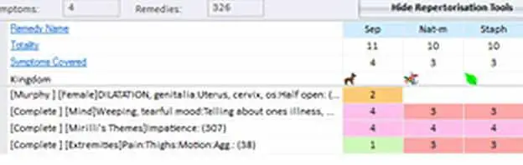

Fig.9: Repertorisation Chart – Case-2

Reference:
Female, dilatation, genitalia, , uterus, cervix, os, half open: remedies sepia 1, Secale cor 2
Sepia 200 single dose, with sepia 0/10, 5 drops, in half cup of water, three times a day and SL 4 pills bd after food for 15 days., with that her hormonal (allopathic) treatment is also continued.
FOLLOW UPS:
14/9/2019: palpitation & trembling of body3, thigh pain – sq, nausea>>, weakness>>, app- normal, thirst- normal, stool – N, Urine- Clear. – ct all for 15 days
30/9/2020: thigh pain – sq, nausea -0, weakness-0, palpitation & trembling of body – Sq, feeling fresh,
My thinking was everything is better but her thigh pain is –sq, so thought of giving constitutional medicine. Gave Lyco 200 single dose
16/10/2020: pain in abdomen left side, preg. 7 month started. Leucorrhea started from yesterday, palpitation & trembling is –SQ, thigh Pain –sq, p.g. good, except sleep- which is disturbed and less – so given sepia 0/10, TDS for 15 days again.
31/10/2019:leucorrhea -0, palpitation and trembling –sq, pain in abdomen-0, acidity-0. sleep improved. P.g. good, SL for 15 days
16/11/2019: palpitation-sq, sleep – less, no pain, acidity on & off, leucorrhea-0, fresh
USG: liquor is slighly less AFI-7cm, cervix is closed, placenta – postero-lateral. – sl given for 15 days
And stopped medicine. Pt delivered healthy baby boy on 19/12/19, normal delivery, 15 days early with no need of admission in NICU

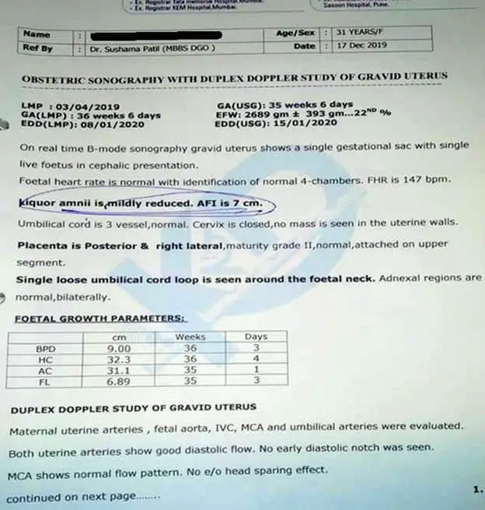
Fig.10: Ultrasonography findings after Homoeopathic Treatment – Case-2

CASE NO:3
Mrs. PG Date:22/4/2019
Age: 22 yrs
Add: Bhokardan. Dist- Jalna.
C/O: G5 P0 A4 L0 , LMP: 13/3/2019, UPT +ve but fetal pole not developed.
H/O BOH – Habitual abortions. (4 times). Inevitable abortions requiring D&C every time.
Each time, Patient complained of burning all over the body with pain in abdomen and sudden bleeding ,USG showing infant death.
1^{st –} 5 yrs back – 2nd month
2^{nd –} 4 yrs back – 2nd month
3^{rd –} 3 yrs back – 3rd month
4^{th –} 2 yrs back – 4th month
Married since 6yrs.
LMP: 13/3/2019

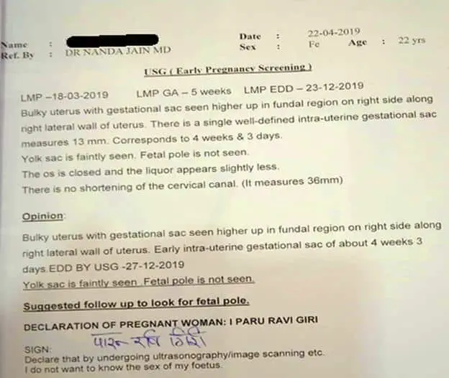
Fig.11: Ultrasonography findings before Homoeopathic treatment – Case-3

Family history:
Father- T.B. Rx. Allopathic, perfume seller
Mother- NAD
4 brother & 5 sisters, patient is 3rd sibling. 1 sister expired Due to measles.
Education 7th std.
Husband: perfume seller working in Mumbai. Love marriage, consanguineous. H/O: consanguineous marriages in family.
PHYSICAL GENERALS:
App- good,
Thirst: Thirsty.
Stool- normal
Urine- frequent since 8 days
Sleep: sound
Dreams- 0
Desires: potato3, rice2
Aversion: peanuts, coconut, dry fruits.
Agg: coconut water – headache.
Perspiration: scanty
Thermals: Hot
MENTALS:
ANGER3, irritabilty3. with desire to kill.
Anger expressed over anyone.
Anger stops talking- once incident she stopped talking for 5 months., stops taking meal. Others must listen her.
Talk – arrogant
Contradiction intolerance of3
Extroverted and expressive.
Tension of abortions – ghar kas chalnar, husband is only bread winner in family. FIL expired 6 yrs back.
Anxiety future about.
Superstitious.
Fear of dark3, shout loud if sudden darkness. Not able to be alone in dark.
Totality
- Fear of dark, alone.
- Anger, desires to kill
- Anxiety future about
- Superstitious
- Hot
- Thirsty
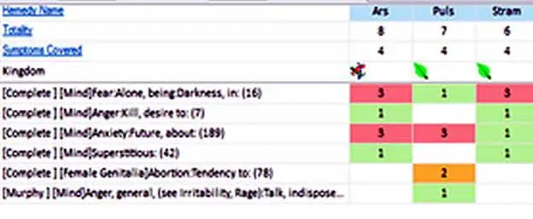
Fig.12: Repertorial Analysis – Case-3

Problems: USG was done very early with no fetal pole or cardiac activity seen in 5 weeks. Also, patient was not sure of LMP. As all we know it can take 6-8weeks for development of fetal pole, I was confused whether to wait or to start medicines. Patient has strong history of BOH, So thought of starting with constitutional medicine.
Remedy:
Stram. 200 single dose, 0/1 5 drops in half cup of water TDS for 15 days and come with repeat USG report.
FOLLOW UPS:
6/5/2019: no complaints, in mean time spotting which was reported by patient on phone. Her irritabilty >>, anger>>, patient is happy now. P.g.good- – stram 0/1 TDS continued for 1 month.

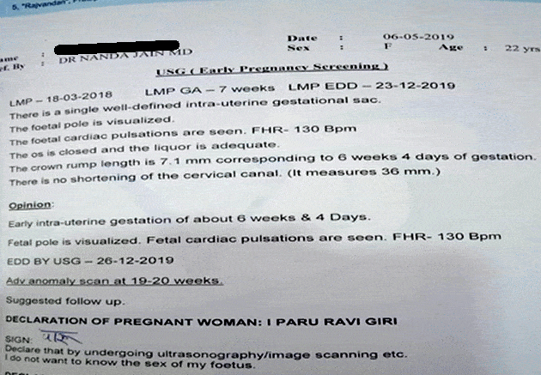
Fig.13: Ultrasonography findings after Homoeopathic treatment – Case-3

FOLLOW UP:
5/6/2019: nausea2, occasional spotting , irritabilty >>, p. g. good sl for 1 month

5/7/2019: vomiting since 2 days with nausea due to some food changes. Irritabilty>>, acne< with black spots. – sl
6/8/2019: vomiting today1, no nausea, usg – WNL

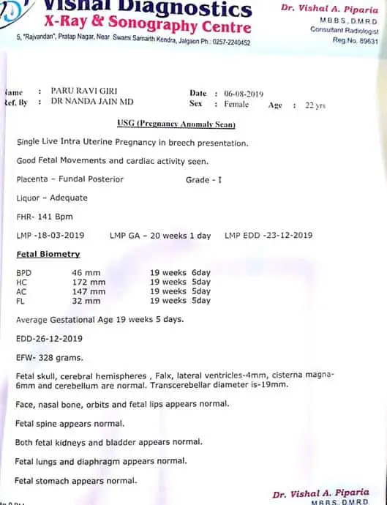

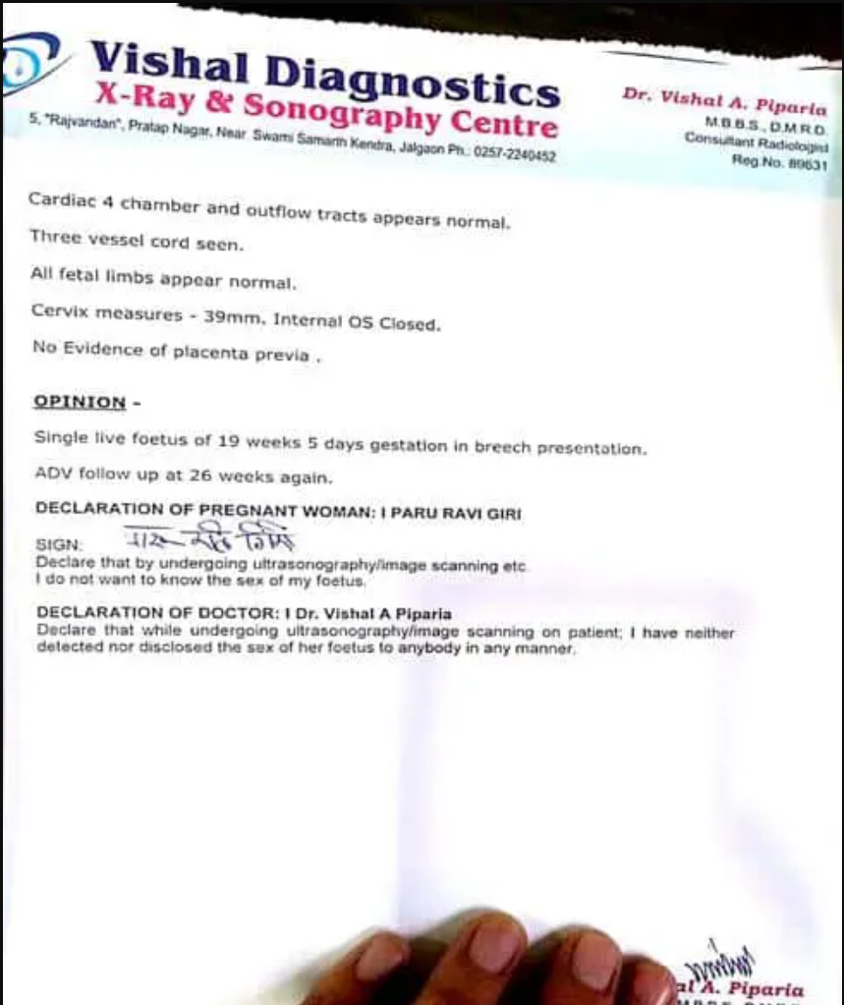

Fig.14: Ultrasonography Findings after Homoeopathic treatment – Case-3

9/9/2019: vomiting yesterday, pain in abdomen a/f outside food. Weakness1, p.g. good- sl Asked to stop medicine now.
Patient blessed with a healthy baby boy on 21/12/2019, FTND at hometown in government hospital.

Authors:

Dr. Anand Kabra
Dr. Anand Suresh Kabra, M.D. HOM. Paediatrics, Professor and HOD, Homeopathy Pharmacy Department, SSVP Homeopathic medical college and research institute, Hatta, Hingoli, Maharashtra.

Dr. Archana Mundra
Dr. Archana Brijmohan Mundra, PhD (Scholar), M.D.Hom.Psychiatry, Associate Professor and HOD, Department of Organon of medicine and Homoeopathic Philosophy, Government Homeopathy College and Hospital, Jalgaon, Maharashtra,

