CHAPTER TITLE: BIOSEPARATION: TECHNIQUES AND APPLICATIONS FOR PURIFICATION AND ANALYSIS IN BIOTECHNOLOGY
Keren Shona Simlai¹, Sanyukta Rai¹, Vandana D Prabhu¹, Sharada Devi J N²
¹Authors, Jyoti Nivas College, Autonomous, Bengaluru, Karnataka 560095.
²Corresponding author: Sharada Devi J N
Assistant Professor In Zoology
Nrupathunga University, Nrupathunga Road, Bengaluru, Karnataka 560001
sharada.gfgc@gmail.com

Introduction:
Bioseparation processes are dominated by chromatographic steps. The primary recovery is sometimes accomplished by chromatographic separation which uses a fluidized bed instead of a fixed bed. In this book, the action principles, the features of chromatography media regarding physical and chemical properties will be described.
Characteristics for bioseparation are the large pores and sizes of particles. To achieve sufficient capacity for ultra large molecules, such as plasmids, tiny particles, such as virus, monoliths are the media of choice. In such medias, the mass transport is accomplished by convection, hence, the low diffusivity can be overcome. The modern chromatography media which is common to all, is the fast operatise. The bioseparation technique deals with the scientific and engineering principles involved in large-scale separation and purification of biological products. This method is a key component of most chemical engineering/biotechnology/bioprocess engineering programmes.

Principles of Bioseparation:
1.1. Selectivity and Specificity: Similar to specificity, selectivity requires that each component in a mixture are mandatory. The capacity to assess an analyte clearly in the presence of components that could be anticipated to be present is known as specificity.[1]The terms “selectivity” or “specificity” are used interchangeably. This is unfortunate since specificity is seen as an absolute concept and cannot, therefore, be graded. A specific reaction or test is one that only happens when the substance of interest is present, whereas a selective reaction or test can also happen when other compounds are present but shows some preference for the substance of interest. While many reactions show selectivity, few reactions are specific. The goal of bioseparation techniques is to enable the separation of the target biomolecules from intricate biological matrices while reducing losses and contaminants.Selectivity from the detection system, also known as detection selectivity, is a common foundation for methods for identifying metals (such as atomic emission spectrometry).For all kinds of species, methods including chromatography, electrophoresis, and membrane separations frequently rely on selectivity in the separation process, also known as separation selectivity. When the need for selectivity is particularly strong, hyphenated techniques like liquid chromatography-mass spectrometry (LCMS), which combine selectivities with respect to separation and detection, can be used.When positive and impartial identification is necessary in legal settings, tandem mass spectrometry, as in liquid chromatography-mass spectrometry-mass spectrometry (LC-MS-MS), produces a selectivity that is rarely compromised.Arrays have been utilized in recent years to combine sensors of various types and levels of selectivity.The reactions are based on interactions typically assessed in a mathematical domain (chemometrics), providing what has been referred to as "computational selectivity". In reality, using a full spectrum spanning a variety of wavelengths rather than a single wavelength and processing the spectral data using chemometric methods improves selectivity.This method of handling near-infrared spectra is a very good illustration of the concept. Single sensors with various incorporated selectivities have also been described; these sensors have a multimode selectivity property that was developed to reduce interferences (for example, a spectroelectrochemical detector using charge positioning, electrolysis potential, and spectral wavelength). [2]

1.2. Affinity-based Interactions:

Many bioseparation techniques rely on particular interactions to produce selective binding and separations such as antigen-antibody, ligand-receptor, or enzyme-substrate interactions. It is predicated on incredibly precise biological interactions between two molecules, such as those between an enzyme and a substrate, a receptor and a ligand, or an antibody and an antigen. Understanding the interactions between the target molecule and the ligand is necessary for successful affinity purification since it will influence the choice of an appropriate affinity ligand and purification method. Many of the frequently utilized ligands coupled to affinity matrices are now readily available on the market thanks to the rising popularity of affinity purification. However, in other circumstances, it can be necessary to create new affinity chromatographic material by fusing the ligand to the matrix while preserving its unique affinity for the target molecule. Affinity purification can speed up the purifying process by hundreds of times or more. However, the effectiveness rely on the techniques. To separate one or more of the required biomolecules from their impurities, affinity-based bioseparations use a biological recognition phenomena that is reversible and specific. These processes call for steps like precipitation, chromatography, two phase extractions and membrane-based purifications. These can alternatively be categorized as
affinity chromatographic and non-chromatographic methods.Even while affinity bioseparations have been heavily sought after for the isolation of medicinal proteins, nothing is known about how they might be used to recover polymer-protein conjugates. Because of its high-resolution capabilities, chromatography will continue to be the favored approach for the purification of biopharmaceuticals, hence the shift in affinity qualities has primarily been addressed in chromatographic procedures. Even while affinity bioseparations have been heavily sought after for the isolation of medicinal proteins, nothing is known about how they might be used to recover polymer-protein conjugates. No matter the type of operation, the fundamental steps in a protein affinity-based bioseparation are: (1) the capture of the protein with the ligand (which can be free or linked to a specific matrix), (2) washing or separation of the contaminants of the mixture, and (3) elution or recovery of the target protein. The selective and effective purification process known as affinity chromatography (AC) is based on a highly precise biological interaction between a target and a ligand. High sample concentration, high sample selectivity, high level of purification (more than 1,000-fold), scalability, preservation of biological activity employing gentle processes, and time savings are the benefits attributed to AC.
Affinity chromatography has not been widely used for the purification of PEGylated proteins following a PEGylation procedure.

The purification of PEGylated proteins following a PEGylation procedure has not yet seen many applications of affinity chromatography. [4]

1.3. Physical Properties: A quality of matter which is known as a physical property is one that is unrelated to a change in its chemical makeup. Density, color, hardness, electrical conductivity and melting and boiling points, are a few common examples of physical qualities. Different physical characteristics including size, hydrophobicity, charge, and solubility are used in bioseparation procedures to make it easier to isolate biomolecules.[5] Important properties for bioseparation purposes include thermal stability, diffusivity, charge, solubility, and isoelectric pH. The ability or lability to change of most bio products is used extensively in process design.[6]

Bioseparation Techniques:

2.1 Chromatography: Chromatography is an important biophysical method allowing the separation, identification, and purification of the components of an aggregate for qualitative and quantitative evaluation. Russian botanist, Mikhail Tswett, invented adsorption chromatography in 1901 during his research on plant pigments. He separated coloured chlorophyll and carotenoid pigments of leaves by passing an extract of the leaves via a column of calcium carbonate, alumina, and sucrose, eluting them with petroleum ether/ethanol mixtures. He coined the term chromatography in a 1906 publication, from the Greek words chroma which means “colour” and graphos meaning “to write down.” Chromatography refers typically to the separation of additives in a sample by using distribution of the components among two phases—one that is desk bound and one which moves, commonly (but not always) in a column.
2.1.1. Gel Filtration Chromatography: When Size Exclusion Chromatography (SEC) is performed for the separation of proteins and different biomolecules, aqueous eluents are used and the method is frequently referred to as gel filtration chromatography (GFC). The earliest and nevertheless a dominant application region of SEC is in figuring out the molecular weight distribution of polymers. This method generally uses porous polymer stationary phases with natural solvents as eluents, regularly at an accelerated temperature it's miles broadly referred to as gel permeation chromatography (GPC) referring to polystyrene requirements, GPC columns with high-end MWexclusion limits as low as 1500 to as high as 2 × 108 are easily available[7]

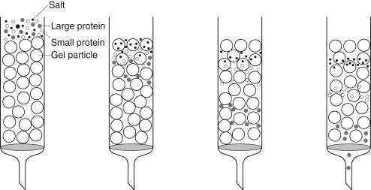

2.1.2. Ion Exchange Chromatography: Ion exchange chromatography the stationary phase is an exchange functionalities. This method of separation is based on the principle of ion exchange equilibria. Hydrophobic interactions play a strong role in most ion exchange separation methods, especially in anion exchange chromatography. In size exclusion chromatography, solvated molecules are separated according to their size by their ability to penetrate into porous pockets and passages in the stationary phase.[7]

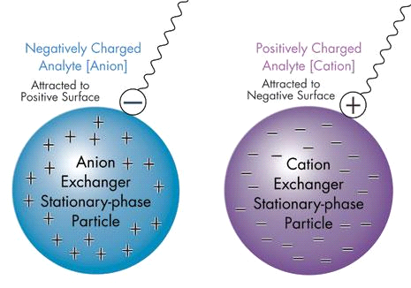.
2.1.3. Affinity Chromatography: Affinity chromatography is extensively used for the purification of biomolecules.The method is based on the highly unique binding among an analyte and its counterpart, as in antibody-antigen binding. The counterpart is immobilized on the stationary phase; this is referred to as the affinity column. while the desired analyte, together with any variety of other substances is passed via the column, only the analyte is retained on the column, everything else passes through. The analyte is then eluted as a pointy band with the aid of some eluent that is able to dislodging the analyte from its counterpart. at the same time as affinity purification is easy in principle, having an agent that binds the analyte particularly and with high affinity after which devising another agent that releases the analyte without denaturation is not constantly a trivial challenge.[7]

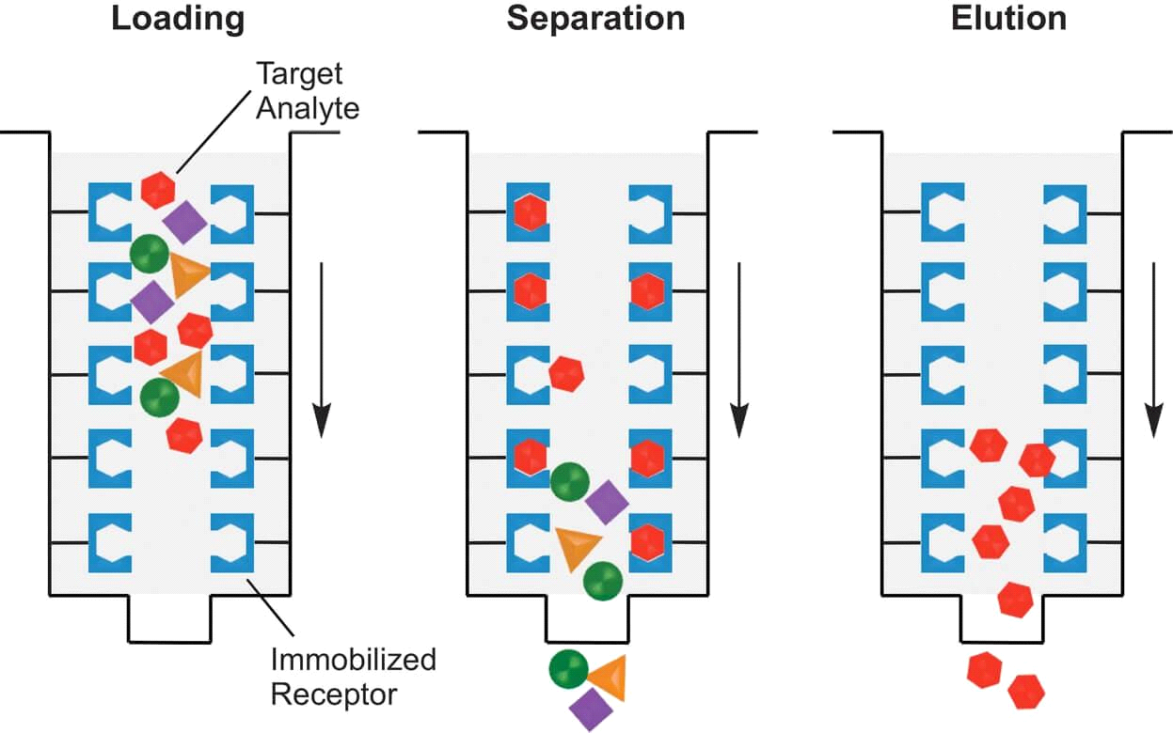

2.2. Electrophoresis: The word electrophoresis connotes the movement of a charged particle [Greek: electron + pherein (to carry)]. Electrophoretic techniques of separation as a consequence depend on variations inside the mobility of various charged substances in an electric field. Electrophoretic strategies of separation may be categorised in wide corporations, depending on the medium that it's miles conducted in. the first group involves separations in free solution, carried out typically in small diameter capillaries or microfabricated chips. The pattern is injected as a finite sector or band, after which in addition subdivides into individual zones. this is for this reason called capillary area electrophoresis (CZE) or without a doubt capillary electrophoresis (CE). Electrophoresis performed on a microchip may be very comparable. within the second case, the separation medium is a hydrogel, e.g., of agarose. With some massive biomolecules, e.g., DNA, the rate/length ratio remains almost constant irrespective of the molecular weight, as a consequence there is little or no difference in electrophoretic mobility in free solution. So DNA fragments cannot be separated with the aid of CZE. In a excessive viscosity gel medium, but, the mobility of those big molecules could be very a whole lot a feature of their tertiary structure allowing a separation. Gel-primarily based electrophoresis may be completed in a capillary (capillary gel electrophoresis, CGE) for excessive decision analytical separations of huge biomolecules[7]

2.2.1. SDS-PAGE (Sodium dodecyl sulfate-polyacrylamide gel electrophoresis separates): Electrophoresis in acrylamide gels is referred to as Polyacrylamide gel electrophoresis (PAGE). Polyacrylamide gels were first used for electrophoresis by Raymond &Weintraub (1959) as they are particularly stable and chemically inert.It is the most commonly used gel separation method for analyzing various proteins. This method is based on the separation of proteins according to size and can also be used to determine the relative molecular mass of proteins. SDS is an anionic detergent which binds strongly to and denatures proteins to produce linear polypeptide chains. [7]
The Polyacrylamide gel is cast as a separating gel topped by a stacking gel. The stacking gel has properties that cause the proteins in the sample to be concentrated into a narrow band at the top of the separating gel. This is achieved by utilizing differences in ionic strength and pH between the resolving buffer and the stacking gel and involves a phenomenon known as isotachophoresis. The stacking gel is of high porosity and buffered with Tris-cl buffer at pH 6.8, whereas separating gel contains high percentage of acrylamide and is cast in Tris-cl buffer at pH 8.8. The upper (and lower) electrophoresis buffers contain Tris at pH 8.3 with glycine as counter ion.[8]
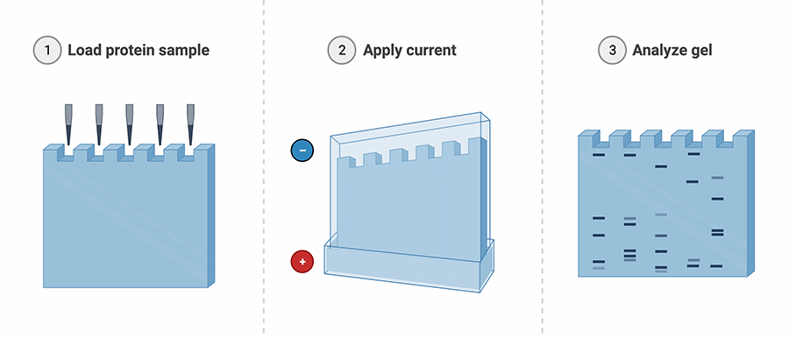
2.2.2. Capillary Electrophoresis: Stellan Hjerten pioneered the use of agarose gels in electrophoresis (and chromatography) and made his seminal contributions to monolithic columns. While Tiselius first showed that free solution electrophoresis can be used to separate proteins without the need for a gel medium, it was Hjerten who laid out the theoretical principles and demonstrated free solution ́zone electrophoresis in small (1–3 mm bore) quartz tubes in 1967. Detectors were not available to monitor separation in tubes any smaller; he minimized the effects of thermal convection by slowly rotating the tubes around their long axis. The potential of CE would not be fully realized until James Jorgenson (University of North Carolina at Chapel Hill, another luminary in the separation sciences, he is credited also with the invention of UHPLC), along with his student Lukacs, would demonstrate the immense power of this technique. Using 75 μm bore silica capillaries (fused silica is an excellent thermal conductor) and voltages up to 30 kV, they obtained plate counts in excess of 400,000 and performed separations in 10–30 minutes that were deemed unattainable at that time. In small capillaries, aside from electrophoretic movement, electroendosmosis (often just called electroosmosis) generates electroosmotic flow (EOF) of the bulk fluid in the capillary. The EOF can be large compared to electrophoretic movement, permitting both positively and negatively charged analytes to be detected by the same stationary detector.[7]
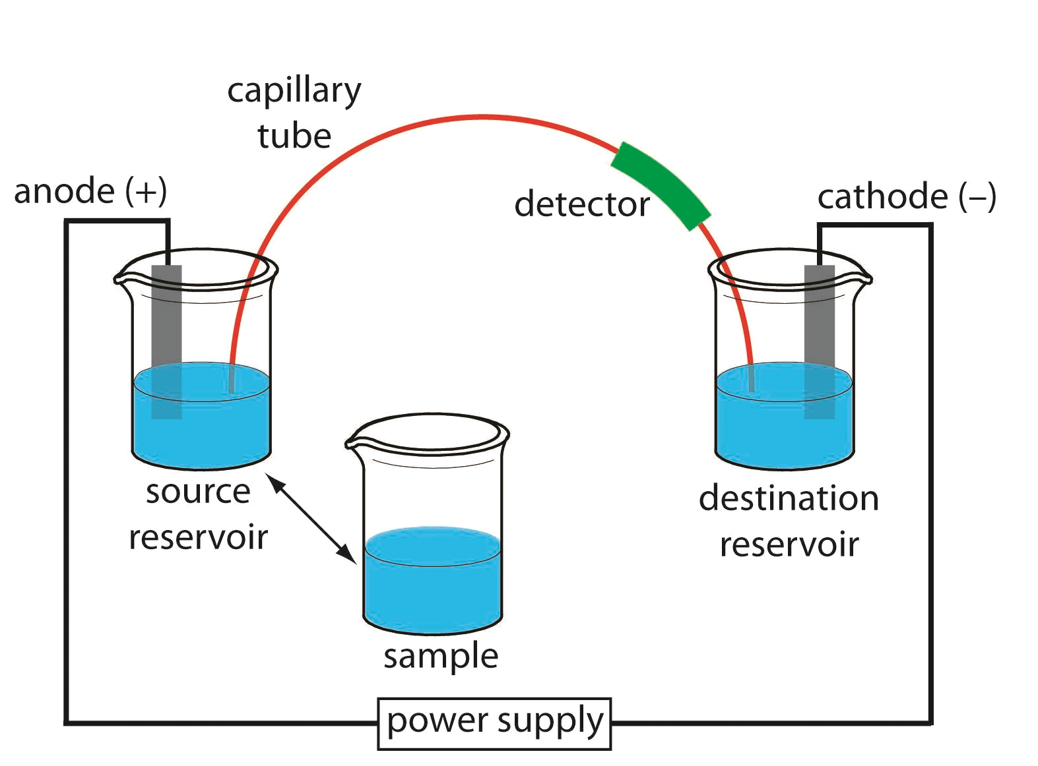

2.3. Filtration: Filtration is a process used to separate solids from liquids or gases using a filter medium. The fluid that passes through the filter is called the filtrate.

2.4. Centrifugation: Centrifugation is a technique that helps in the separation of particles from a solution based on their size, shape, density, medium viscosity, and rotor speed by applying centrifugal force. A centrifuge is the device used in this process.
A centrifuge works by using the principle of sedimentation: Under the influence of gravitational force (g-force), substances separate according to their density. Centrifugation techniques include differential centrifugation, gradient centrifugation, and ultracentrifugation.
Applications of centrifugation include milk separation, cheese production, production of yeast, separation of biological samples, etc.[9]
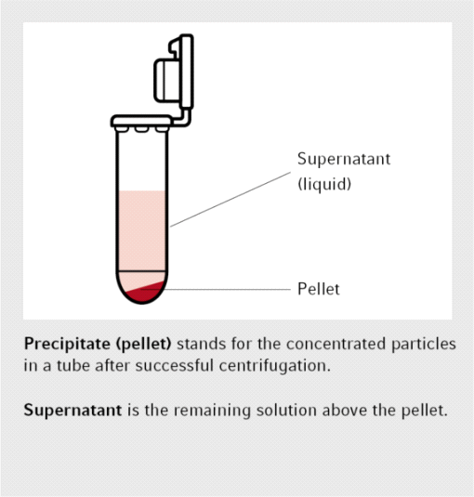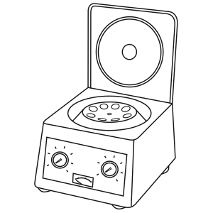

Applications of Bioseparation:
3.1. Biopharmaceutical Production:
Bioseparation is crucial in the production of therapeutic proteins, vaccines, and monoclonal antibodies, where high purity and activity are essential. Biopharmaceuticals are complex drugs synthesized from living tissues or organisms, frequently employing modern and advanced biotechnological techniques. They include blood and its components, somatic cells, gene therapies, vaccinations, recombinant therapeutic proteins, and live drugs used in cell therapy, which are distinct from pharmaceuticals that are entirely produced.[10] Since low-volume, high-purity products are desired, production costs and microbiological contamination (by bacteria, viruses, and mycoplasma) are significant challenges worth being concerned about. Hence, the expense of making such a medicine or biological product ready for commercial consumption includes a significant portion of Bioseparation and downstream processing equipment costs.[11] The high-dose demand for several Monoclonal Antibodies used to treat various types of cancer, rheumatoid arthritis, severe asthma, macular degeneration, multiple sclerosis, and other diseases, translates into annual production requirements for purified products in the metric ton range. The vast majority of the contaminant proteins are removed using a Protein-A affinity chromatography column, purifying a batch of material in four cycles. In the large-scale manufacture of recombinant protein products, the costs of purification and recovery can make up nearly 80% of the overall cost of production. For instance, items may need to be 99.9% pure during processing with virtually no DNA, viruses, or endotoxins remaining.[12] The biopharmaceutical market Bioseparation systems are dominated by chromatography systems, centrifuges, and membranes/filters because these are the most often used products. Although there are many different approaches or systems available for Bioseparation, there are not many options that can equal the yield and purity standards of chromatography, which is the principal technology utilized in the downstream purification of biopharmaceuticals and continues to be the industry standard. From establishing a list of possible drug candidates (using High Performance Liquid Chromatography) to assuring the quality of drug formulations, analyzing the efficacy and release time of innovative drug formulations to developing manufacturing processes, chromatography is employed throughout the drug development process. The global yearly market for downstream processing equipment is anticipated to have developed at a high rate of about 20% per year.[11] Because the key to lowering production costs is stressing advances in Bioseparation-downstream processing equipment, it is worthwhile to make an effort to better evaluate and comprehend the various aspects involved in downstream processing.

3.2. Biorefineries:
Bioseparation plays a vital role in the processing of biomass-derived feedstocks for the production of biofuels, biochemicals, and bio-based materials. Nature stores Solar energy as Biomass which is thought of as a renewable substitute for fossil fuels. In biorefineries, bioresources are sustainably processed to supply an array of commercial goods and energy. Surprisingly, nature is perfectly capable of functioning well with a mixture of reactants leading to a mixture of products. Nature, thus, does not provide mankind with pure chemicals. In contrast, the chemical industry has evolved along the lines of incorporating almost pure raw materials (derived through pre-treatment stages) that are transformed into a mix of products and then separated into pure components. Thus, purity is the most important factor to control these processes. In addition to the production of energy, fuels, and chemicals, a biorefinery may also produce bioproducts such as food and livestock. It is important to highlight that all separation technologies used in biorefineries involve a biomass pre-treatment step (mostly phase separations, but also size reduction, dirt/sand removal, and so on) that results in conditioned biomass which is then used on dedicated technological platforms where it is converted into products. For example; the production of ethanol fuel involves lignocellulosic biomass such as herbaceous crops (e.g. switchgrass), Agricultural residues (e.g., crop straws, sugar cane bagasse, maize residues), forestry wastes, wastepaper, wood, and municipal wastes, which are the most potential feedstock for ethanol. The fundamental process for converting cellulosic biomass to fuel ethanol consists of a few important steps like pretreatment and detoxification of feedstock, co-fermentation, product separation and purification, wastewater treatment, etc, which involve fluid mixture separation employing various methods (e.g., reactive separations, affinity chromatography, trigger-enhanced charge separations).[13] These are some of the separation technologies that can significantly improve biorefineries by streamlining operations with fewer equipment and minimizing operating costs with lower energy requirements, increasing the competitiveness of the biorefineries even in the absence of incentives. Since separations make up the bulk of total costs in biorefineries, any significant improvements in separations have the potential to make or break a business.

3.3. Environmental Remediation:
Bioseparation techniques are used in environmental cleanup processes to remove contaminants from water, soil, and air. Growing industrialization and technologies have increased the usage of chemicals and their discharge into the environment, jeopardizing ecosystems. Since biological treatment procedures like bioremediation, provide a practical and environmentally conscious alternative to traditional chemical treatments, they are currently gaining popularity for removing harmful pollutants from the environment. Treatment of oily waste has grown to be a major problem in today's world. Oily waste is hence, utilized as bases for the synthesis of industrially significant biosurfactants, which help in eliminating waste and mitigate the long-lastingly harmful environmental effects. In contrast, chemical surfactants, due to their badly controlled environmental discharge, constitute a serious hazardous threat. Through their interactions with cell membranes and disruption of cell structure, chemical surfactants have a negative impact on the microorganisms. Fish, which absorb chemicals via their skin, and other animals and people that consume meat begin to exhibit detrimental effects once the levels are high enough. As a result, in order to manufacture biosurfactants, affordable feedstock, competent microorganisms, and suitable bioengineering procedures like bioremediation are used. This allows them to compete economically with the harmful synthetic chemical surfactants. Although it has been challenging to generate these compounds at a competitive price due to inefficient bioprocessing and bioengineering. There is a dearth of research on creating ideal bioprocess approaches, and the potential for cost-effective biosurfactant synthesis, despite substantial investigation in this area. [14] In terms of air pollution, in order to gain a greater understanding on how the harmful particles present in air interact with it, scientists are using Gas chromatography to extract them from a mixture of polluted air. Researchers use various types of chromatography to study airborne particle matter and pinpoint the source of air pollution. Because authorities could target the sources of the particles if they knew their chemical makeup, researchers try to determine the nature of the particles. The researchers then try to understand the risks associated with these particles. Particle matter 10 micrometers, or PM10, is one sort of particle matter being examined by chromatography and is linked to diesel engines. PM10 also originates from industrial sources, lowering air quality.[15] A total of 3.3 billion tonnes of carbon dioxide releases into the atmosphere, and food waste is estimated to have a carbon footprint that makes up around 8% of those emissions. In order to reduce greenhouse gas emissions, the concepts of net-zero (carbon neutrality) are used. The balance between carbon released into the atmosphere and carbon absorbed from the environment through carbon sinks is referred to as carbon neutrality. Both refineries and the food processing sector generate substantial amounts of oily waste which promotes CO emission.[14] A higher carbon economy coupled with the breakdown of waste greatly increases greenhouse gas emissions and contributes to climate change. As a result, waste reduction, reuse, and recycling can support the production of novel, economical, and safe biosurfactants. To replace the prevailing "take, create, and discard" economic development narrative and implement environmental sustainability, the idea and principles of bio-economy have been established as a system model. In terms of water and soil pollution, the present soil remediation technologies, such as pump and treat systems and soil incineration, are either impractically expensive or difficult to implement. Using certain plants to absorb Poly- and perfluoroalkyl substances (PFASs) in situ followed by eliminating them through the process of incineration is a treatment method for PFAS-contaminated soil and groundwater, but it takes a lot of time.[16] The concepts of gas-liquid and high-performance liquid chromatography have been put together and critically analyzed and employed in water and soil research, environmental preservation, and so on. One such use has been in extraction of Herbicide residues from various matrices. Thus, all these chromatography Bioseparation techniques are extensively being researched by the scientists across the globe and used for extraction of pollutants from the ecosystem and to analyze their hazardous nature and the extent of danger they pose to the environment followed by creating new methods to get rid of these from the ecosystem.

3.4.Diagnostic and Analytical Applications:
Bioseparation is employed in diagnostic tests, immunoassays, and proteomics to isolate and analyze biomarkers and proteins. The need for bio-separation has increased due to the industry's enormous advances in life science and biotechnology. In order to meet new testing issues, it is constantly necessary to enhance the performance of the available diagnostic tests. The application of nanoparticles has the potential to advance in vitro diagnostics to a new level of effectiveness. For the purpose of detecting target biomolecules, these nanoparticles are coupled with recognition molecules like oligonucleotides or antibodies. Nanoparticles have been used in cellular imaging, DNA diagnostics, and bioseparation of particular cell cultures and immunoassays.[17] Based on mass spectrometry and magnetic nanoparticles, many brand-new and incredibly sensitive immunoassay techniques have been designed. These techniques have excellent potential for use in bio-separation and immunoassay. For instance, magnetic Fe2O3/Au core/shell nanoparticles are being used in bioseparation due to the simplicity of use and high separation efficiency of this efficient technology. Practically, nearly all of the antigens in the test solution are separated biologically using magnetic Fe2O3/Au core/shell nanoparticles. Through in vitro procedures and MRI tests, another type of nanoparticle, magnetite nanoparticles, were found to be harmless in clinical quantities. These nanoparticles are readily internalized by cancer cells due to their exceedingly small sizes and positively charged surfaces. These functional nanoparticles hence form a potential platform for future in vitro and in vivo tests because of all these advantageous characteristics.[18,19] A similar kind of approach is carried out where the antigen-antibody response that is incubated in a homogenous manner, tests large-molecular-weight antigens with sensitivities comparable to those of other non-isotopic heterogeneous immunoassays. For instance, the thermally precipitating synthetic polymer, poly-N-isopropylacrylamide (polyNIPAAm) which is soluble in water is combined with a monoclonal antibody (MAb) and used in a unique separation procedure for an immunoassay. Above a threshold temperature of 31°C, it precipitates out of water, allowing a polymer bound immune complex to be extracted from the solution. In addition to immunoassays, this basic technique is applied to a wide range of bioseparation procedures when a particular component in a body of water, biological fluid or industrial process stream needs to be isolated for analysis, recovery, or disposal.[20] This technology makes it feasible to remove pollutants or toxins as well as recover products. The present-day chromatographic and associated separation methods have thus advanced to the point that they can effectively separate complicated samples in the proteomics, pharmaceutical, and food industries. Enzymes are proteins that perform crucial biological reactions through their activity. The majority of enterprises use column chromatography, salt and solvent precipitation, electrophoresis, and other traditional procedures to treat distinct extracellular enzymes downstream. Thus, the development of an effective and affordable downstream processing technology is required in order to attain utmost enzyme purity, activity, and recovery levels. Hydrophilic interaction liquid chromatography (HILIC) is one such chromatographic technique which has its own advantages in facilitating the separation of hydrophilic or strongly polar molecules (such as glycopeptides, metabolites, etc.) due to the robust hydrophilic interactions. In the disciplines of proteomics, metabolomics, food science, and medicine, the combination of HILIC with various other separation techniques, presents great separation efficiency towards complicated samples.[21] The reverse micellar extraction (RME) technology is another technique which is being explored as an alternative to the other typical downstream processing procedures. The most exciting potential of reverse micelles is the separation and/or purification of proteins/enzymes in two quick and easy processes with a high degree of activity. Affinity based separations currently include membrane based purification, precipitation, and phase extractions. Besides affinity ligands that have a biological link (in vivo) with the target protein, a wide range of additional ligands are currently used in affinity-based separations. Chelated metal ions, dyes, and peptides are examples of them.[22] Enzymes catalyze all processes in living systems because of their biological affinity for their substrates. Drugs, like hormones, work by chemically recognizing receptors. Thus, the original concept of biological affinity was based on the in vivo connection of molecules. A single volume book cannot adequately cover the constantly growing body of research on affinity-based separations. It has actually taken on a variety of facets. The invention of next-generation medicines with decreased immunogenicity, enhanced safety, and increased efficacy is changing the biotech and pharmaceutical industries owing to the development of protein and peptide therapies. The most common application of modified proteins and monoclonal antibodies is in oncology. The study of gene and cellular functions at the protein level is called proteomics. Determining protein expression phases, post-translational changes, protein localisation, and protein-protein interactions are the objectives of proteomics. The development and detection of protein biomarkers for disease states is one of the significant objectives of proteomics that needs specific consideration in this context. Proteins pose the most challenges in bioseparations out of all the biomolecules.[23]
Emerging Trends and Future Perspectives:
4.1. Continuous Bioseparation: The development of continuous bioseparation processes reduces processing times, simplifies operations, and enhances productivity in biomanufacturing. The development of continuous bioseparation processes reduces processing times, simplifies operations, and enhances productivity in biomanufacturing. The value of continuous downstream bioprocessing is becoming clear, but connecting multiple processes and integrating upstream is still difficult. Facilities for downstream bioprocessing are subject to taxes like never before. Greater quantities of smaller batches and more product to purify due to rising monoclonal antibody (mAb) demand, expanding biosimilar research, and upstream yield advancements. Public uproar over medicine prices and the movement to lower the cost of goods are further drivers for ongoing bioseparation. The cost of downstream batch bioprocessing is substantially influenced by the use of multistep procedures, huge buffer volumes, and equipment like Protein A resins. Process intensification, which involves processing smaller volumes of material semi-continuously or constantly, is how suppliers and producers are resolving these issues. Chromatography systems and associated purification stages are being evaluated and scaled up to manufacturing scales.[24] To lessen the overall number of downstream processing steps required, biopharmaceutical producers and technology suppliers are examining continuous processes and merging various solutions. To make the continuous capture phase easier, numerous multi-column process technologies have been developed. It has been tried to use several smaller columns to achieve Static Binding Capacity (SBC) from Dynamic Binding Capacity (DBC) at a specific flow rate. Aqueous micellar two-phase systems (AMTPS) and functional magnetic particles are used in conjunction with continuous magnetic extraction (CME), a novel process idea, to continuously purify proteins. CME has been effectively used for protein purification in the past, and it has recently been suggested that it be used for enzymatic conversion processes. The ability of AMTPS to form two phases above the so-called lower critical solution temperature (LCST), which enables switching the system between a single phase and a two-phase regime employing a minor temperature shift, is a key property for the CME process. CME in conjunction with enzymatic conversion procedures guards against enzyme contamination of the product. The reaction can be easily regulated by removing the enzyme from the suspension quickly. The immobilized enzyme is more stable with respect to temperature, pH, and other factors and can be reused repeatedly by continuously recovering the immobilisates, maximizing their lifetime. Further investigation is necessary, nevertheless, to compare the smaller multiple columns' effectiveness with that of a single standard column.[25] In another research, a continuous magnetophoretic bioseparation chip is used for isolating cells from the peripheral blood, such as circulating tumor cells. The chip is made up of a continuous-flow microfluidic platform with gradients of magnetic fields that were specifically tailored locally. Since the magnets' high-gradient magnetic field is spatially irregular, magnetic particles moving through a fluidic channel are attracted to it.[26] Key forces like the magnetic and fluidic forces and their impact on design parameters for an efficient separation are taken into consideration by the computational model. Most scientific advancements use semi-continuous chromatography. The control strategy in place is insufficient to guarantee process robustness for continuous operations. Fundamental models based on thermodynamics and kinetics will be needed for continuous processes in the future in order to better understand the process and develop superior control strategies for online process monitoring.

REFERENCES
[1]https://mpl.loesungsfabrik.de/en/english-blog/method-validation/specificity-selectivity
[2]Selectivity in Analytical Chemistry (IUPAC Recommendations 2001)" Chemistry International -- Newsmagazine for IUPAC, vol. 24, no. 1, 2002, pp. 21-22.
[3]Urh M, Simpson D, Zhao K. Affinity chromatography: general methods. Methods Enzymol. 2009
[4]Luis Alberto Mejía-Manzano, Patricia Vázquez-Villegas, José González-Valdez, "Perspectives, Tendencies, and Guidelines in Affinity-Based Strategies for the Recovery and Purification of PEGylated Proteins", Advances in Polymer Technology, vol. 2020
[5]https://tricliniclabs.com/page-directory/materials-analysis-services/physchem-materials-characterization-techniques-services-from-triclinic-labs.html
[6]https://www.aiche.org/sites/default/files/cep/20141036a.pdf
[7]Analytical Chemistry 7th edition – Gary D. Christian, Purnendu K. Dasgupta and Kevin A. Schug
[8]https://www.iitg.ac.in/biotech/MTechLabProtocols/SDS%20PAGE.pdf
[9]https://handling-solutions.eppendorf.com/sample-handling/centrifugation/safe-use-of-centrifuges/basics-in-centrifugation/
[10]https://en.wikipedia.org/wiki/Biopharmaceutical
[11]https://www.europeanpharmaceuticalreview.com/news/172719/biopharmaceutical-bioseparation-systems-market-to-value-20bn/
[12]https://www.sciencedirect.com/sdfe/pdf/download/eid/1-s2.0-S0149639598800366/first-page-pdf Applications and economics of Bioseparation.
[13]https://pure.manchester.ac.uk/ws/portalfiles/portal/65100431/BiomassBioenergy_2016_95_296_309_Separation_technology_Making_a_difference_in_biorefineries.pdf Separation technology–Making a difference in biorefineries.
[14] Krishna Gautam, Poonam Sharma, Vivek Kumar Gaur, Pallavi Gupta, Upasana Pandey, Sunita Varjani, Ashok Pandey, Jonathan W.C. Wong, Jo-Shu Chang, Oily waste to biosurfactant: A path towards carbon neutrality and environmental sustainability, Environmental Technology & Innovation, Volume 30, 2023
[15]https://gentechscientific.com/chromatography-in-environmental-analysis/#:~:text=Chromatography%20is%20used%20to%20characterize,which%20the%20biodegrading%20is%20occurring. Applications of chromatography in environmental analysis.
[16] Mattias Sörengård, Dan B. Kleja, Lutz Ahrens, Stabilization and solidification remediation of soil contaminated with poly- and perfluoroalkyl substances (PFASs), Journal of Hazardous Materials, Volume 367, 2019
[17]Hassan M.E. Azzazy, Mai M.H. Mansour, In vitro diagnostic prospects of nanoparticles, Clinica Chimica Acta, Volume 403, Issues 1–2, 2009
[18] Fang Bao, Jian-Lin Yao, and Ren-Ao Gu, Synthesis of Magnetic Fe₂O₃/Au Core/Shell Nanoparticles for Bioseparation and Immunoassay Based on Surface-Enhanced Raman Spectroscopy, Langmuir, 2009, 25 (18), 10782-10787; DOI: 10.1021/la901337r
[19] Manasmita Das et al 2010 Nanotechnology 21 125103; DOI 10.1088/0957-4484/21/12/125103.
[20] Monji, N., Hoffman, A.S. A novel immunoassay system and bioseparation process based on thermal phase separating polymers. Appl Biochem Biotechnol 14, 107–120 (1987). https://doi.org/10.1007/BF02798429
[21] Qianying Sheng, Meiyan Liu, Minbo Lan, Guangyan Qing, Hydrophilic interaction liquid chromatography promotes the development of bio-separation and bio-analytical chemistry, TrAC Trends in Analytical Chemistry, Volume 165, 2023
[22]Kalyani Mondal, Munishwar N. Gupta, The affinity concept in bioseparation: Evolving paradigms and expanding range of applications, Biomolecular Engineering, Volume 23, Issues 2–3, 2006.
[23] David E. Garfin, Satinder Ahuja Bioseparations, Separation Methods in Proteomics, 2007; https://doi.org/10.1002/0471238961.biosahuj.a01
[24] A. Shanley, Continuous Bioseparations: Fitting the Pieces Together, BioPharm International 30 (5) 2017.
Golozar, M., Molki, M. & Darabi, J. Computational and performance analysis of a continuous magnetophoretic bioseparation chip with alternating magnetic fields. Microfluid Nanofluid 21, 73 (2017).
[25] Anja Paulus, Naomi Till, Matthias Franzreb, Controlling the partitioning behavior of magnetic micro-particles via hydrophobization with alkylamines: Tailored adsorbents for continuous bioseparation, Applied Surface Science,Volume 332,2015
[26] Golozar, M., Molki, M. & Darabi, J. Computational and performance analysis of a continuous magnetophoretic bioseparation chip with alternating magnetic fields. Microfluid Nanofluid 21, 73 (2017).

