REAL TIME DETECTION AND ANALYSIS OF INDIAN SIGN LANGUAGE USING AI & ML

Nishat Subaita Ummeaiman ¹
Department of ECE, SECAB Institute of Engineering and Technology, Vijayapur, India. ummeaimansoudagar35@gmail.com
Saba Fatima²
Department of ECE, SECAB Institute of Engineering and Technology, Vijayapur, India, fatimasaba_ec@secab.org

Abstract- The primary goal of real-time Indian sign language analysis and detection using AI&ML is to develop a useful method of hand motion conversation between normal and speech impaired people. The technique can be used in conjunction with a webcam or other built-in camera that detects and analyses signals for recognition. Additionally, when new gestures are introduced, the models must be more precise for which databases must be expanded up. In this study, a review of earlier models is conducted, and disadvantages such as environmental variables that influence detection accuracy, such as low light intensity and an uncontrolled backdrop, are observed. Based on the results of this poll, the project is created using a webcam or any built-in camera that can detect gestures. Creating a convolution neural network model for comprehending sign language is suggested as an optimized technique for training the datasets using Tensor Flow and OPENCV models.

Keywords--- Gesture Recognition, Convolution Neural Network (CNN), Sign Language Recognition.

- INTRODUCTION

Hand gestures and hand signals are used by persons who cannot speak to communicate. Regular individuals struggle to grasp their language. As a result, a system that identifies various signals and gestures and delivers information to ordinary people is required.

Sign languages were developed for deaf and dumb people as a means of communication. But when it comes to communication between normal and challenged person, it becomes difficult. Hence, with the advancement in technology much study has been conducted to assist deaf and dumb individuals.
Machine learning and artificial intelligence can be utilized to support the cause. While Indian sign language is not widely used, our initiative might be extremely beneficial to deaf and dumb people in interacting with others. The work represented here implements a sign detector that recognizes Indian sign language motions. This model is extended to a variety of hand gestures, including sign alphabets and phrases.

- LITERATURE SURVEY

It outlines the literature development and highlights potential directions of facial recognition systems that are obtained by breaking them down into their fundamental components [1].
An automatic sign language gesture recognition system in real time is developed using various tools in the paper " Sign language Recognition Using Machine Learning Algorithm " by Prof. Radha S. Shirbhate1, Mr. Vedant D. Shinde2, Ms. Sanam A. Metkari3, Ms. Pooja U. Borkar Ms. Mayuri A. Khandge, extending a step forward in this field by collecting a data set and then using various feature extraction techniques to extract useful information. It presented four-fold cross-validated findings. The validation set contains photographs of various people [2].
The neural network is used to classify which letter of the American sign language alphabet is being signed in the article " Neural network to categorise American sign language " by Anna Deza and Danial Hasan. It captures sign language interactions and translates them into written and vocal language. Neural networks can categorise signed ASL texts using basic pictures of hands captured with a personal device such as a laptop webcam [3].
Justin Chen's article "Sign language recognition using unsupervised feature learning" Implements an autonomous sign language gesture recognition system employing methods in computer vision and machine learning. The most effective skin masks were extracted using a rather simple skin segmentation model. It also identifies non-alphabet motions. By writing in C, it can even boost the speed of real-time systems [4].
A model is developed in this paper "Turkish journal of computer and mathematics education 994-1009 Research Article Sign language recognition " by Satwik Ram Kondandaram,N Pavan Kumar,Sunil G L to detect 0-9 digits and A-Z alphabets hand gestures but does not cover body gestures and other dynamic gestures. The model is more user-friendly for deaf individuals since it is divided into dynamic and static components. Deep neural networks were recognised using deep learning computer vision [5].

III. METHODOLOGY
3.1 OBJECTIVES
- To provide an efficient and accurate way to transfigure sign language into text.
- To provide workable method of sign language.
- Addressing environment drawbacks to provide accurate result.

3.2 PROBLEM STATEMENT
Dumb people use hand signs to communicate, hence normal people face problem in recognizing their language signs. Therefor to communicate between a deaf-dumb and normal person the system is trained to recognise and process the various signs of their language and translates the message to the normal people. This work aims to predict the 'alphanumeric' gesture of the ISL system.

3.3 PROPOSED METHOD
The proposed method is designed for recognizing the characters of hand gestures, which is specifically indicative of how well the system recognizes the signs and gestures and also the occurrence of other types of communication. It is implemented using convolutional neural networks (CNN) for recognition of input commands in the form of gestures, CNN is a special architecture of artificial neural networks for image classification.
Hardware Interfaces required are Camera, RAM (8GB+) and dedicated 4GB GPU,
Intel Pentium 4 or the one with higher configuration and HDD of minimum 10GB
Softwares utilized are OPENCV, KERAS, TENSERFLOW and NUMPY.
Open CV (Open Source Computer Vision Library) aimed for real-time computer vision. This library is cross-platform and free of cost for use under the open-source BSD license.

Language Model

Image Processing
Recognized Word
Input gesture or action

Training Data
Feature Extraction
Image Recognition
Pre Processing Image
Testing the data
Figure3.3: Block diagram for the proposed method- recognition of Indian Sign Language
OpenCV's are applied in 2D and 3D feature tool kits, Gesture recognition, Facial recognition system and as well Object identification. It includes a statistical machine learning library that contains: Support vector machine (SVM) and Convolution neural networks (CNN) which is used in the work carried out here.

KERAS is an open-source neural-network library written in Python and is user-friendly, modular, and extensible.
TENSERFLOW is also an open source artificial intelligence package that builds models using data flow.
NumPy is a library for the Python programming language. It supports huge multidimensional arrays and matrices.
Figure3.3 provides the design for proposed method.

3.4 IMPLEMENTATION PROCESS
The implementation process involves three stages:
A. Datasets Collection.
a) Downloaded datasets
b) Created datasets
B. Training the datasets with CNN approach.
a) Downloaded datasets
b) Created datasets
C. Predicting the gesture
a) Image detection
b) Real time detection

- Datasets Collection

In order to distinguish between the downloaded and created datasets, background's cumulative weighted average are computed and then subtract it from the frames that have a distinguishable moving objects in front of the background. To achieve this, the accumulated weight for a sample of frames is computed and then accumulated average for the background is calculated.
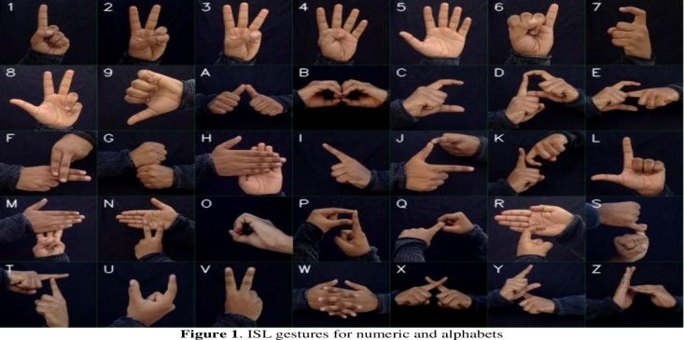
Figure3.4.1: Downloaded dataset for Numerics and Alphabets

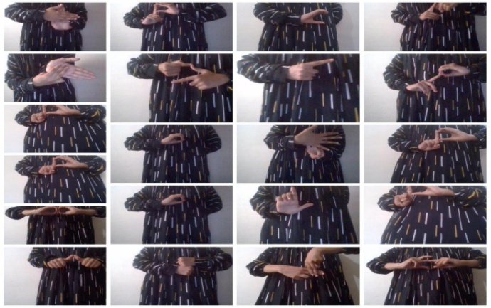
Figure3.4.2: Created dataset Gestures for Numeric and Alphabets

- Training the datasets with CNN approach.

The data is first loaded using ImageDataGenerator of KERAS, which allows employing the flow from directory function to load the train and test set data. The names of the number folders will be equal to the class names for the loaded images. After every epoch, the accuracy and loss are calculated using the validation datasets. The early stopping algorithm approach is used so that if the validation accuracy keeps on decreasing for some epochs then the training is stopped. Further next set of images will be retrieved from datasets and will evaluate model on test set to obtain the accuracy and loss.
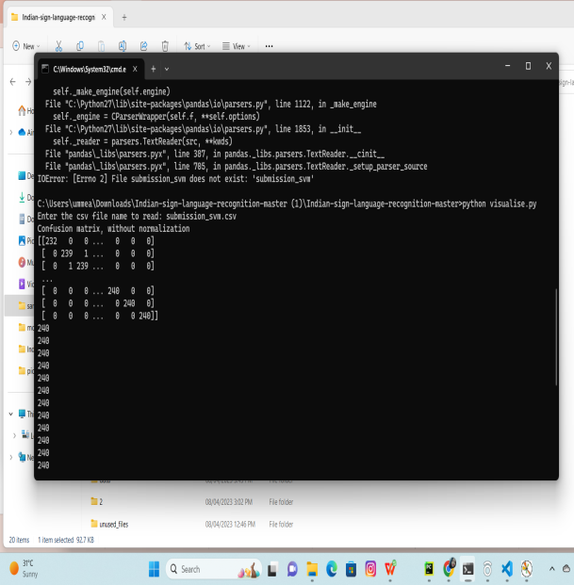

Figure3.4.3: Trained dataset with CNN approach

- Predicting the gesture

The previously created model is loaded after setting set some of the conditions which are required. For example: initializing the background variable. The previously saved model is loaded using keras.models.load_model and feed the images consisting of a hand gestures as an input to the model for prediction. The necessary imports are obtained for the model using model_for_gesture.py. Live hand gestures are detected via cam feed.

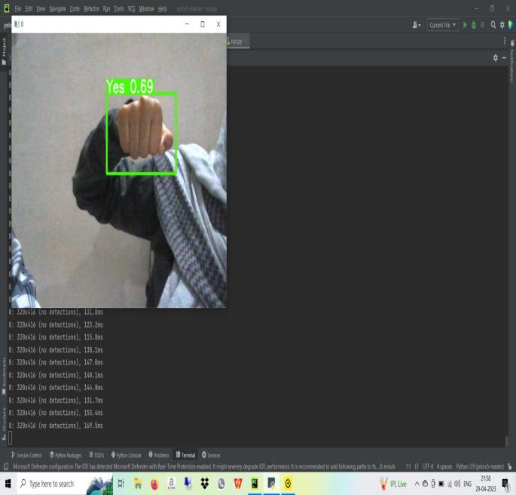
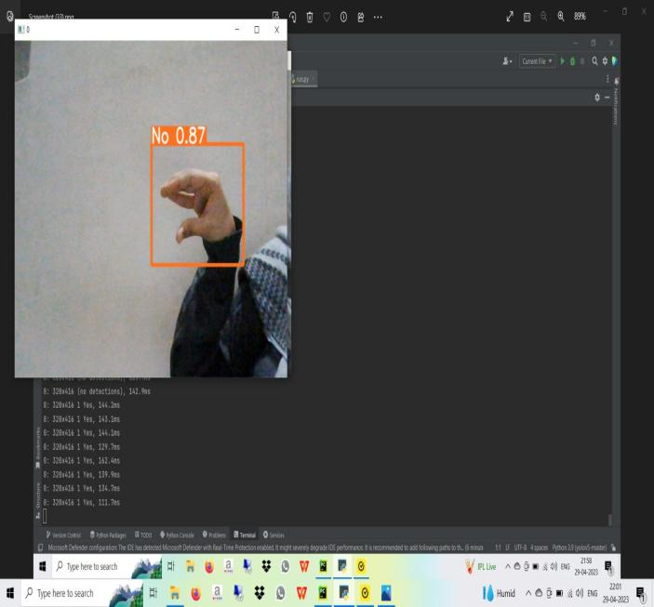

Figure 3.4.4:Real time Predicted gesture Yes and No.

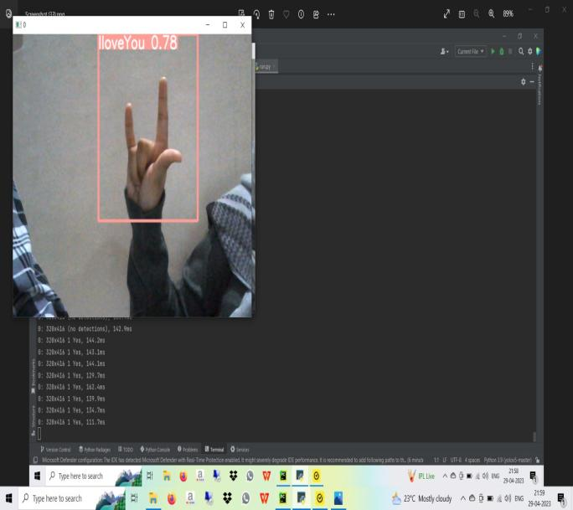

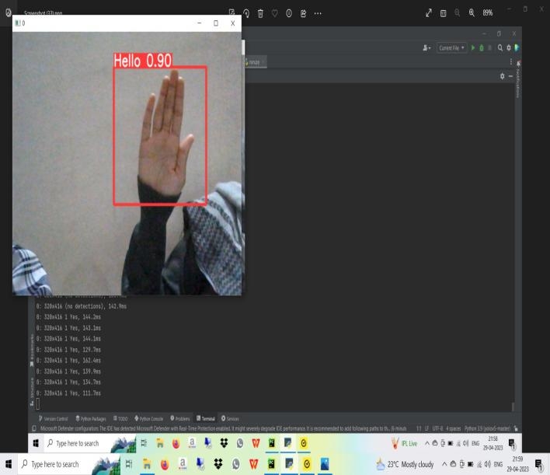
Figure 3.4.5: Real time Predicted gesture I Love You
and Hello

IV. RESULTS AND DISCUSSION
Upon training the image dataset of downloaded and created, the training accuracy has achieved (around 80-90%) as shown in figure 3.4.5. The real time performance varies sometimes. It predicts incorrectly at times when intensity of light (Brightness) varies because in real time while giving hand gestures proper background matters. In order to overcome this shortcoming the proposed model is trained by augmenting the created dataset. The training accuracy varies but the real-time predictions were predominantly correct.

V. CONCLUSIONS
Indian sign language motions may be expanded to variety of hand gestures. The primary purpose of a sign language detection system is to provide a practical technique. The most typical data collecting method is utilized with help of standard video camera to capture hand gestures from various people, angles, lighting, backdrops, and sizes. More photos can be trained and the model shall be tested to improve accuracy and reduce loss.

REFERENCES
- D. Bhavana, K. Kishore Kumarb, Medasani Bipin Chandra, P.V. Sai Krishna Bhargava, D. Joy Sanjanaa , G. Mohan Gopib “ Facial gesture recognition using CNN module ” Department of Electronics and Communication Engineering, Koneru Lakshmaiah Education Foundation, Guntur, 522502, India(2019)
- Prof. Radha S. Shirbhate1, Mr. Vedant D. Shinde2, Ms. Sanam A. Metkari3, Ms. Pooja U. Borkar Ms. Mayuri A. Khandge “ Sign language Recognition Using Machine Learning Algorithm”T)International Research Journal of Engineering and Technology (IRJET) e-ISSN: 2395-0056 Volume: 08 Issue: 08(2020)
- Anna Deza and Danial Hasan “Neural network to classify American sign language” https://www.eecg.utoronto.ca/~jayar/mie324/asl.pdf (2018)
- Chen, Justin et al. “Project Final Report Sign Language Gesture Recognition with Unsupervised Feature Learning.” (2011).
- Satwik Ram Kondandaram , N Pavan Kumar ,Sunil G L “Turkish journal of computer and mathematics education 994-1009 Research Article Sign language recognition Vol. 12 No. 14 (2021): Vol. 12 No. 14 (2021)

