**Studies on green synthesis of Silver nanoparticles for the Removal of Brilliant green dye from aqueous solution**

**N. ChittiBabu, LaguduPreethi, Kolluru Manaswini*, Y. Bhavani**

Department of Chemical Engineering, Andhra University, Visakhapatnam-3, India

*E-mail:kollurumanaswini@gmail.com, Mobile No: 9030832697

**ABSTRACT**

The present study aims to exploit the experimental determination of biosorptive potential of synthesized nano-particles with *Tecomastans* leaf extract for the removal of Brilliant Green dye from aqueous solution. The synthesized nanoparticles were characterized by XRD, FTIR, SEM and FESEM analysis. Batch runs were conducted to study the effects of agitation time, pH, and concentration of brilliant green (BG) dye, biosorbent dosage, and temperature on % removal of BG dye. The optimum conditions were obtained experimentally are compared with those of Response surface methodology (RSM) results. The experimental data was fitted into Temkin isotherm and follows pseudo first order kinetics. The thermodynamic studies give endothermic nature, thermodynamically feasible and spontaneous nature of biosorption. The results indicated that the Ag-TS-Np's can be used as good low cost biosorbent for treatment of effluents from aqueous solution.

**KEY WORDS:** Brilliant green, Tecoma stans, Isotherms, Kinetics, Thermodynamics, Response surface methodology, Ag-TS-Np's.

1. **INTRODUCTION**

Development of Science and technology contributes to society for better life but it also impact on the environment negatively. Treatment of industrial waste water is one of the issues in discharge water from industries. The effluent from textile industry, paper industry, carpet, leather and printing units may contain different dyes. Organic dyes are very difficult to biodegrade due to their complex nature and they are more stable. By absorbing sunlight, dyes can prevent photo synthesis in ecosystems. Brilliant green is toxic and carcinogenic, and due to its degradation and detoxification problems for environmental safety, it should be removed from water bodies. Brilliant Green dye (BG) is regarded as a biohazard substance [1-8]. In general chemical, biological, and physical processes are used to remove the dyes from waste water. In recent years, green synthesis by using plant extract or modified material has gained momentum compared to other processes. However, the commercial Solid State Technology and other chemical processes are quite expensive and has limited application. So the cost-effective alternative adsorbents are efficient to replace the chemical substances. Different authors studied the potentiality of using low cost materials like Carica Papaya[9], Micro algae coalastrella[1], carboxy methyl cellulose[10] ,Panus Tigrinus[11] Zno biosilica nano composite[12], Allium sativum[13], Fumariae Herba[14], ,Ulvalactuca [15], are used to remove dyes form waste water. The present work is an effort to search for the feasibility of using Tecomastans leaf extract to remove Brilliant Green dye from aqueous solution, because of the raw material available is plenty, harmless and cheap.

**Characterization of Nanoparticles:** The assessment of the surface functional groups of the [adsorbent](https://www.sciencedirect.com/topics/chemistry/adsorbent) material was carried out by FTIR spectrum analysis. The phase confirmation of the synthesized adsorbent was accomplished through investigating the X-ray diffract gram. The FESEM and SEM micrographs are verified that the particle size existed in the nano scale range and morphology.

1. **MATERIALS and METHODS:**

Analytical grade chemicals were used for the experimentation. The sources of dye used were Brilliant Green of analytical grade. Double distilled water is used to prepare all stock and synthetic solutions. The stock solution containing 1000 mg of Brilliant Green dye in 1.0 liter, by addition of 0.1M H2SO4 and 0.1M NaOH solutions the pH of dye solutions were adjusted to the desired value.

**Table-2.1 Experimental conditions investigated for dye**

|  |  |  |  |
| --- | --- | --- | --- |
| **S.No.** | **Parameter** |  | **Values Investigated** |
| 1 | contact time, t, min |  | 1, 3,5, 10,15, 20,25, 30, 40, 50, 60, 90, 120, 150 &180 |
| 2 | pH of aqueous solution |  | 2, 3, 4, 5, 6, 7 and 8 |
| 4 | Initial dye concentration, C0, mg/L |  | 20, 40, 60, 80 and 100 |
| 5 | dosage, w, g/L |  | 10, 20, 30, 40, 50 and 60 |
| 6 | Temperature, 0C |  | 30,40,50,60 and 70 |

**2.1 Preparation of the Broth solution and Nanoparticles formation:**

**2.1.1 Preparation of Tecoma Stans broth solution:**

In this process 10 gm of fresh and cleaned leaves of TS are taken in a magnetic stirrer and to this 110 ml of distilled water is added and it is heated at 60oC for 30min. After that the solution is filtered in 250 ml conical flask using whatmann’s filter paper and it is kept aside for further process. The broth obtained is in pale yellow colour.

**2.1.2 Preparation of Nano Particles:**

70 ml of broth solution and 230 ml of 1.0 mM (0.17g) Silver nitrate solution are added in a conical flask and is kept in a incubating shaker at a temperature of 30o C for 5 min in order to obtain nanoparticles. The colour of the solution changed from pale yellow to brown indicating the formation of silver nanoparticles. This solution was dried and used for various dye degradation process of different concentrations and different dosages.

**2.2 Equilibrium studies on dye decolourization:**

***2.2.1 Effect of contact time:***

20 ml of aqueous solution (initial concentration of dye was 20ppm) was taken in a test tube and 0.1 g of silver nanoparticles was added. This sample was taken and kept under the light for photosynthesis.Similarly,15 more samples were prepared in test tubes and exposed to varying contact times (1, 3, 5, 10, 20, 25, 30, 40, 50, 60, 90, 120, 150 and 180 min). These samples were analyzed in UV spectrophotometer to obtain final concentrations of dye. The equilibrium contact time was calculated from the data.

***2.2.2 Effect of pH of the aqueous solution:***

To study the influence of pH on BG dye decolorization, 20 ml of aqueous solution was taken in each of seven test tubes. The pH values of the solutions were adjusted to 2, 3, 4, 5, 6, 7 and 8 in separate test tubes by adding required amounts of 0.1N H2SO4 or 0.1N NaOH. 0.1g of NP's powder was added separately to these test tubes. This sample was taken and kept under the light for photosynthesis. Then samples were allowed to settle down and color change was observed for equilibrium contact time. The various dye concentrations are determined by using UV spectrophotometer.

***2.2.3 Effect of initial concentration of the dye in aqueous solution:***

20 ml of aqueous solution containing 20 mg/L dye was taken in test tubes and 0.1g (5 g/L) of silver NP's is added. This sample was taken and kept under the light for photosynthesis. The sample was allowed to settle and color change is observed. The final dye concentration of the sample is determined in an UV spectrophotometer. The same procedure was repeated for other initial concentrations of dye in aqueous solution (20, 40, 60, 80 and 100 mg/L).

***2.2.4 Effect of dosage of nanoparticles:***

The experiments were carried out for six more dosages (10, 20, 30, 40, 50 and 60g/L) for equilibrium contact time, from the data optimum biosorbent dosage was identified.

The percentage decolourization of dye is calculated as (Co-Ce) x 100/Co.

Where Co = Initial concentration of BG dye solution and Ce = Equilibrium concentration of BG dye solution

***2.2.5 Effect of temperature:***

In this process the known quantity of broth solution of different leaves is taken in a magnetic stirrer and the temperature is changed for every solution. At first the solution is heated at 30oC and is the solution is transferred to 250 ml conical flask by adding known quantity of NP's solution and this solution is kept on orbital shaker at room temperature and optimum time and temperature was maintained. The final (BG) dye concentration of the filtrate is determined in an UV Spectrophotometer. The same procedure is repeated for other temperatures (30, 40, 50, 60,70oC) for calculating optimum temperature.

1. **RESULTS AND DISCUSSIONS:**

In the present investigation, the experimental data are obtained for the batch studies to estimate the performance of nanoparticles for decolourization of brilliant Green dye present in aqueous solution. The effects of parameters on decolourization of BG dye are contact time, pH of the solution, initial concentration, dosage and temperature of the aqueous solution.

**3.1. Characterization studies**

***3.1.1 FESEM Analysis of Nano Particles***

FESEM (Field Emission Scanning Electron Microscope) image shown in fig.3.1 clearly indicates the small structures and different sizes of nanoparticles.

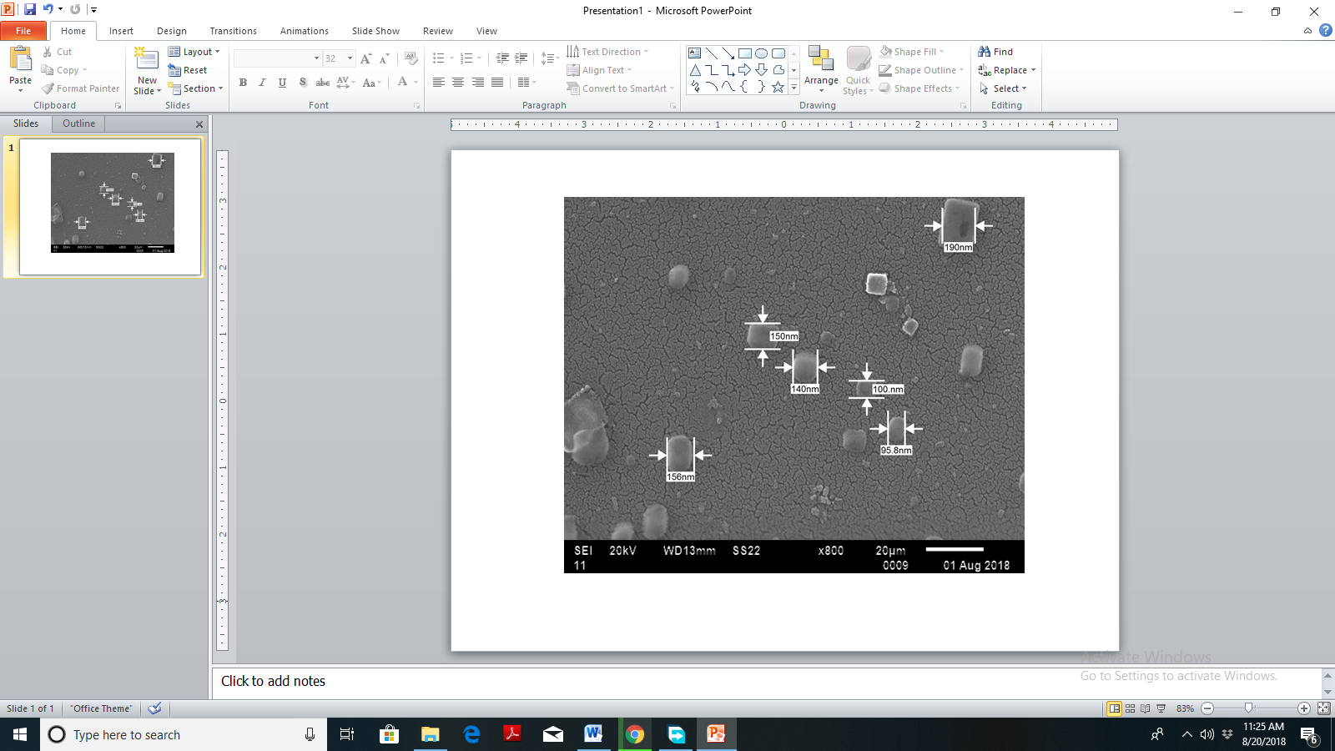

**Fig. 3.1 FESEM image of silver nanoparticles**

It provides high resolution and very high stable probe currents for optimum imaging. The nanoparticles produced were in the range of 95.8 to 190 nm.

***3.1.2 Fourier Transform Infra-Red Spectroscopy (FTIR)***

Infrared spectroscopy belongs to the group of molecular vibrational spectroscopies which are molecule-specific and give direct information about the functional groups, their kind of interactions and orientations. Its sampling requirements allow the gain of information from liquids and gases and in particular from solid surfaces. The shift of the bands and the changes in signal intensity allow the identification of the functional groups involved in dye sorption.

***3.1.2(a) FTIR spectrum of untreated powder***

FTIR spectrum of untreated Ag-TS-Np's powder is presented in fig. 3.2 the sharp peak at 1031.92 cm-1 denotes the involvement and participation of C=S stretching modes in biosorption. The band at 1238.30 cm-1 indicates the involvement of =C–H bend alkenes bond. The band at 2850.79 cm-1 assigns the Amine N–H stretch bond.



**Fig. 3.2 FTIR spectrum of BG dye untreated Ag-TS-Np's powder**

The peaks at 2918.30, 2956.87 and 3172.90 cm-1 in native biomass are also designates the presence of Amine N–H stretch bonds. The bands from 3215.34 and 3238.48 cm-1 denotes the presence of Asymmetric –CH2–, symmetric –CH3 and –CH2– stretching vibrations. The sharp peak at 3277.06 cm-1 denotes the presence of Amine N–H stretch bonds.

***3.1.2(b) FTIR spectrum of BG dye treated with Ag-TS-Np's powder***

FTIR measurements for BG dye loaded with Ag-TS-Np's are shown in fig. 3.3 the peaks at 459.06 indicates C–Br stretch bands from alkyl halides. 1031.92 cm-1 is shifted to 1041.56 cm-1 denoting the involvement and participation of C=S stretching bonds in biosorption. The shifting of band from 1238.30 cm-1 to 1251.80 cm-1 indicates the involvement of C–H bending alkenes. The band from 2850.79 cm-1 C=S stretching bonds are remains same in both treated and untreated powder. The peak shifting from 2918.30 to 2920.23 cm-1 represents the Amine N–H stretching bond. The peak at 3277.6 shifted to 3315.63 depicts the Amine N–H stretching vibrations. The bands at 3331.07, 3346.50 and 3903.92 cm-1 (assigned for the presence of aromatic C–H stretching or –NH2 stretching respectively) are not shown in untreated biomass.



**Fig. 3.3 FTIR spectrum of BG dye treated Ag-TS-Np's powder**

Further, three additional peaks at 1265.30, 1319.31 cm-1 denoting =C–H bend alkenes bonding and 1348.24 cm-1 for C=C stretching have suddenly appeared in BG dye treated biomass. The peak appearing at 1375.25, 1452.40 and 1629.85 cm-1 in BG dye treated powder is denoting Alkyl C–H stretch mode and is not seen in native biosorbent. The peak at 2312.65 cm-1 is obtained in treated biomass due to the involvement of the C≡C bands of the alkyne ligand. This may be due to the adjustment of pH and physical disruption of cell walls upon the vigorous shaking.

***3.1.3 Scanning electron microscopy (SEM)***

SEM is a useful technique in the study of both the natural sorbent morphology and its modification derived from sorbate interactions. SEM is an electron microscope which provides images of the sample surface by scanning it with a high energy beam of electrons.

***3.1.3(a) Scanning electron microscope for untreated Ag-TS-Np's powder***

The SEM images of Ag-TS-Np's powder before and after biosorption are analyzed. The SEM images in fig. 3.4 for untreated Ag-TS-Np's powder.

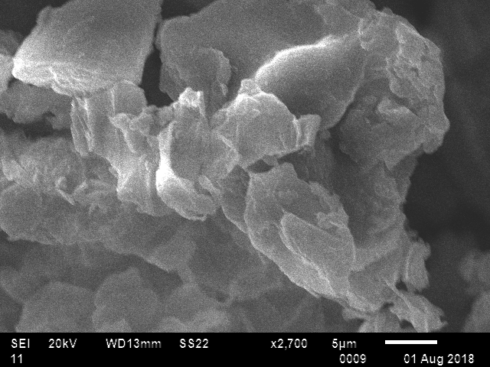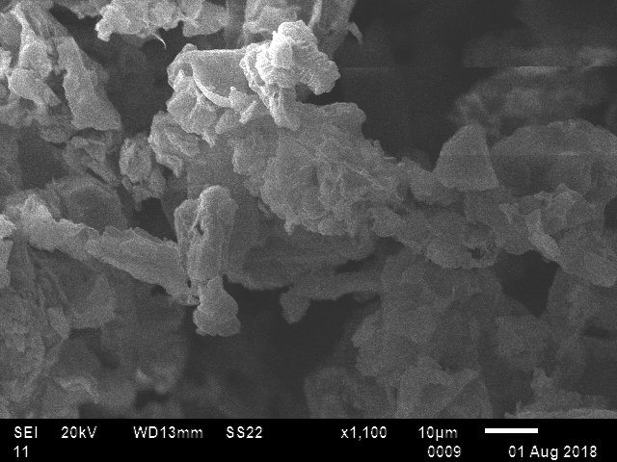

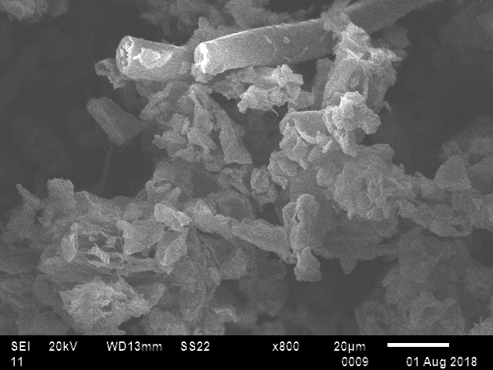

**Fig. 3.4 SEM image of untreated Ag-TS-Np's powder**

The physical structure of biosorbent surface was irregular and rough. This morphological structure provides a larger biosorption surface for the biosorption of heavy metal ions and it contains lots of pores.

***3.1.3(b) Scanning electron microscope image for treated Ag-TS-Np's powder***

After the binding of dye molecules, a significant change in the biosorbent surface was observed it became dull due to the coating of biosorbent particles with the dye molecules.

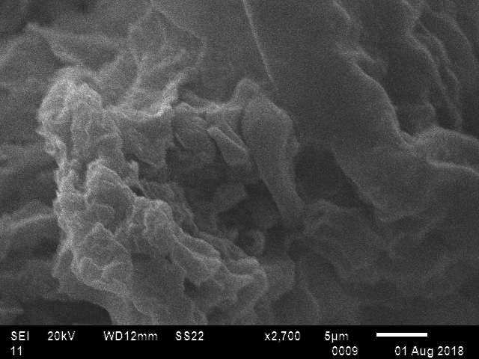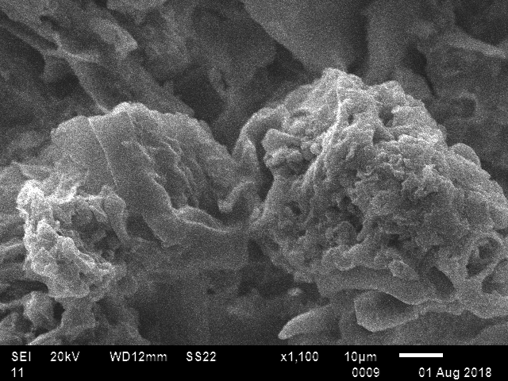

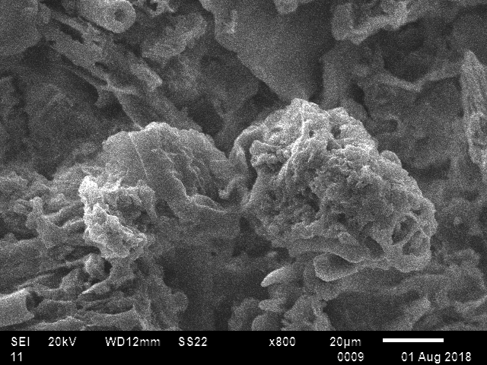

**Fig. 3.5 SEM image of treated Ag-TS-Np's powder**

One can clearly see significant morphological changes on the sample surfaces. The scanning electron micrographs clearly show the biosorbent coated by dye molecules over the whole surface.

***3.1.4 X-Ray Diffraction***

The X-Ray Diffractograms (XRD) of the powder samples are taken using a Rigaku Ultima model IV. Different phases of the samples are to be identified by comparing with a set of ‘d’ values and the corresponding intensities with the standards from the ICDD (International Center for Diffraction Data) files**.**

***3.1.4(a) XRD for BG dye untreated with Ag-TS-Np's powder***

XRD patterns of untreated powder are shown in fig. 3.6 indicate crystalline and exhibit little amorphous nature. The peaks at 2θ values of 0.1513, 0.1998, 0.4077 and 0.5886 corroborate the presence of AlO4P, O2Si, C2N2Zn and D2 (ICDD files). Their corresponding d-values are 0.1003, 0.0668, 0.4345 and 0.1337.

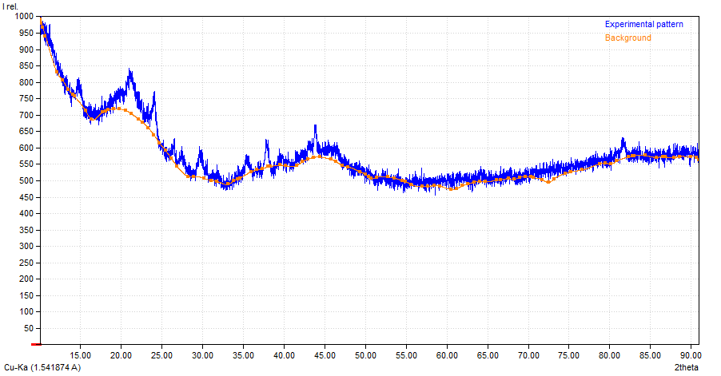

**Fig. 3.6 XRD pattern of BG dye untreated Ag-TS-Np's powder**

***3.1.4(b) XRD for BG dye treated with Ag-Ts-Np's powder***

XRD patterns for treated powder Fig. 3.7 exhibit good crystalline exhibit amorphous nature and increase in surface area and porosity. The peaks at 2θ values of 0.3988, 0.1766, 0.1487, 0.3529 and 0.6672 corroborate the presence of C16AlClN16S4, Bi38Mo5O15Rb15, F15Mo5O15Rb15, Al0.09Ca1.87K0.02, and F3.48Yb0.2Zr0.8. Their corresponding d-values are 0.0334, 0.0334, 0.1671, 0.0334 and 0.1003.

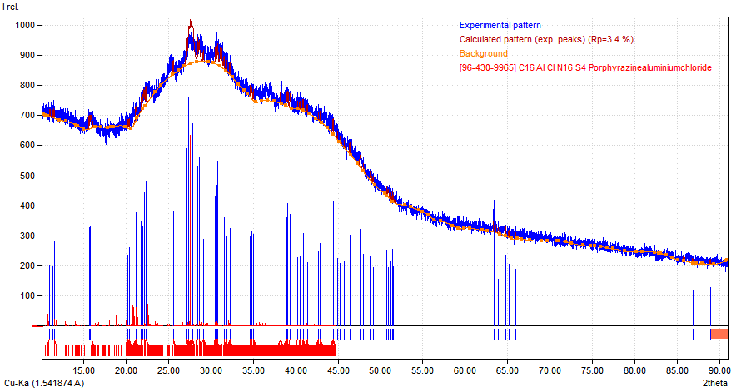

**Fig. 3.7 XRD pattern of BG dye treated Ag-TS-Np's powder**

**3.2. Equilibrium studies:**

***3.2.1 Effect of Agitation time***

Equilibrium biosorption is defined as the time required for dye concentration to reach a constant value during biosorption. The equilibrium contact time is determined by plotting the % biosorption of BG dye against contact time as shown in fig. 3.8 for the interaction time intervals between 1 to 180 min. The rate of biosorption is fast in the initial stages because adequate surface area of the biosorbent. As time increases, more amount of BG dye gets biosorbed onto the surface of the biosorbent due to forces of interaction. The biosorbate, normally forms a thin one molecule thick layer over the surface, when this monomolecular layer covers the surface the biosorbent capacity is exhausted. As the surface adsorption sites become exhausted, the uptake rate is controlled by the rate at which the adsorbate is transported from the exterior to the interior sites of the adsorbent particles. The maximum percentage removal (i.e50%) is attained at 60 minutes. Therefore, all other experiments are conducted at this optimum contact time.



**Fig. 3.8 Effect of contact time on % removal of BG dye**

***3.2.2 Effect of pH***

The variation in pH for the dye decolorization in the range of 2 to 8 is shown in fig. 3.9, in the initial stage the pH is varying from 2 to 6, It increased rapidly due to the free movement of H+ ions and at low pH depresses dye decolourization due to competition with H+ ions for appropriate sites on the adsorbent surface.



**Fig. 3.9 Effect of pH on decolourization of BG dye**

However, with increasing pH, this competition weakens and brilliant green molecules replace H+ ions which bound to the adsorbent, it causes a repulsive force between the dye and nanoparticles. The final optimum pH for BG dye is 6 and the percent removal is 64%. In this process the initial concentration and contact time were at 20 ppm and 60 min respectively.

***3.2.3 Effect of initial concentration of dye***

The influence of initial concentration on decolourization of the dye is represented in the Fig 3.12. The plot reveals that as the concentration increases the % removal of dye decreases in the concentration range of 20-100 ppm. It is due to the vacant pores on the Tecomastans broth have been occupied by the dye molecules. By increasing the dye concentration, the available adsorption sites are already occupied and consequent adsorption is not as efficient as in the beginning, it leads to decrease in % removal of dye. The biosorption percentage decrease may be due to lack of surface active sites of biosorbent to adsorb the dye molecules in the solution. Based on different concentrations (20-100 ppm) studied, the optimum concentration obtained for brilliant green dye is 20 ppm and the % removal is 64. Dye uptake curve is also represented in fig. 3.10.

Dye uptake increases with concentration in the range of variables studied.



**Fig. 3.10 Effect of BG dye initial concentration**

***3.2.4 Effect of nanoparticle dosage***

The effect of dosage on decolorization of dye is shown in fig. 3.11 from 10g to 60g/L of silver nanoparticles. The other parameters like initial concentration (20 mg/L), pH (6), contact time (60 min), temperature (303 K) are remained same in the whole process. The fig. 3.13 shows the variation of % removal of dye with increase in dosage. It reveals from the plots that as the dosage increases, the % removal of dye also increases. The increase in biosorption along with biosorbent dosage is due to increasing number of biosorbent particles thus, more surface areas were available for dye molecules attachment. It can be concluded that by increasing the adsorbent dose, the availability of the exchangeable sites or surface area increases and the removal efficiency increases. Dye uptake graph is also shown in the same figure and its trend is in the reverse to dosage effect. Based on these studies the optimum dosage for MG dye is 30 g/L and the % removal is 69.



**Fig. 3.11 Effect of nano**-**biosorbent dosage**

***3.2.5 Effect of Temperature (T, K)***

The effect of change in the temperature on % removal of dye is shown in fig. 3.12. The dye with the Ag-TS-Np's at different temperatures is taken and it is increasing from initial 30oC to 70oC and the % removal of the dyes is increased almost linearly. As increase in temperature diffusion rate across the external boundary layer and within the pores also increases. Furthermore, changing the temperature will modify the equilibrium capacity. The effect of temperature was investigated from batch experiments carried out at five constant temperatures: 303, 313, 323, 333 and 343 K. The optimum temperature for the Brilliant green dye is 30oC and the % removal is 69. By increasing temperature, % removal of BG dye increased to 82% at 70 0C.



**Fig. 3.12 Effect of temperature on decolourization of BG dye**

**3.3 ISOTHERMS**

The isotherms are characterized by the certain constants, as the values of which express the surface properties and affinity of the biosorbent and can also be used to compare biosorptive capacity of biosorbent for different dyes. Out of several isotherm model equations three model equations were applied in this study, they are Langmuir, Freundlich and Temkin isotherms.

***3.3.1 Langmuir Isotherm***

The Langmuir relationship is hyperbolic and the equation is,

**qe / qm =.....3.1**

Where,

Ce is the equilibrium concentration (mg/L), qe is the amount of dye biosorbed (mg/g), qm is for complete monolayer (mg/g), b is Sorption equilibrium constant

The linear form of Langmuir isotherm equation is

**Ce / qe = 1 / (b qm) + (1 / qm) Ce.....3.2**

Fig.3.13 is plot of [Ce] versus [Ce / qe] which is straight line with slope 1/qm and an intercept of 1/bqm.. The essential features of the Langmuir isotherm can be expressed in terms of a dimensionless constant separation factor or equilibrium parameter (RL) which is defined by the following equation,

**RL = 1 / (1+bC0) .....3.3**

Where,

RL = Dimensionless separation factor / equilibrium factor, which indicates sorption favourability, C0 = Initial concentration (mg/L), b = Langmuir constant

The conditions for RL are If RL>1 Unfavourable sorption; RL = 1; Linear 0< RL

Value of RL (0.8170) obtained in the present study are less than 1 which indicates the favorability of biosorption for Brilliant green onto silver NP's powder. Isotherm equation obtained for the present study is Ce/qe = 0.0689 Ce + 2.2162, R2 **=** 0.9933.



**Fig. 3.13 Langmuir isotherm for biosorption of BG dye**

***3.3.2 Freundlich Isotherm***

Freundlich Isotherm relationship is expressed by the following equation:

**qe= Kf Cen.....3.4**

Linear form of Equation is

**ln (qe) = n * ln (Ce) + lnKf...... 3.5**

Where Kf and n are isotherm constants. The obtained equation is

lnqe = 0.6284 ln Ce 0.23096, R2 = 0.9763

  
**Fig. 3.14 Freundlich isotherm for biosorption of BG dye**

***3.3.3 Temkin Isotherm***

Temkin isotherm relationship is expressed by the following equation:

**qe = (RT ln (AT Ce)) / bT .... 3.6**

The linear form of Temkin isotherm can be expressed as,

**qe = (RT / bT)lnCe + (RT / bT)ln (AT) .... 3.7**

The obtained equation is qe= 3.2455 ln Ce – 3.9445, R2 = 0.9962



**Fig. 3.15 Temkin isotherm for biosorption of BG dye**

**Table 3.1 Isotherm constants obtained for various models**

|  |  |  |
| --- | --- | --- |
| **Isotherm** | **Constants** | **R2** |
| Langmuir | qmax, mg/g = 14.51 | 0.9933 |
| b, L/g = 0.0311 |
| RL = 0.8170 |
| Freundlich | Kf = 0.7938 | 0.9763 |
| n = 0.6284 |
| Temkin | AT = 0.2966 | 0.9962 |
| bT= 776.1953 |

**Table – 3.2 Dye uptake capacities for different biosorbents**

|  |  |  |  |
| --- | --- | --- | --- |
| **Author** | **Dye Chosen** | **Biosorbent** | **qmax, mg/g** |
| Rabia Rehman et al [17] | Brilliant green | Eugenia jambolana leaves | 4.739 |
| Aadil Abbas et al [18] | Brilliant green | Peanut Shell | 19.92 |
| Mohamed A. Salem et al [19] | Brilliant green | Psidium guajava Leaves  Solanum tuberosum Peels | 1.075  1.173 |
| L.P. Thyagarajan et al [20] | Congo red | Silver Nanoparticles Synthesized from Bacillus sps | 2 |
| **Present study** | **Brilliant green** | **Silver nanoparticles synthesized from Tecomastans plant leaves** | **14.51** |

**3.4. KINETICS OF BIOSORPTION:**

***3.4.1 Pseudo first order kinetics***

The Lagergren first order equation is,

**(dq / dt) = K1 (qe- qt) ..... 3.8**

Where qt and qe are the amounts biosorbed at t (min) and equilibrium time and K1 is the rate constant of the pseudo first order biosorption [16].

The derived form is:

**log (qe- qt) = log qe - (K1 / 2.303) t ...... 3.9**

The Plot is drawn between the time (t) versus log (qe- qt) (fig.3.16) gives straight line for first order kinetics.

From Fig 3.16, the plot obtained represents the following model.

log(qe-qt) = -0.0231 t + 0.3282 t, R2 = 0.9797



**Fig. 3.16 Pseudo first order kinetics for % biosorption of BG dye**

***3.4.2 Pseudo second order kinetic equation***

If the experimental results do not follow the above equation, pseudo second order kinetic equation is (dq / dt) = K2 (qe- q)2 is applicable, where ‘K2’ is the second order rate constant.

If results do not follow the first order kinetics, then data fitted in to Pseudo second order kinetic equation,

**[dq/ (qe-q) 2] = K2 dt .... 3.10**

where ‘K2’ is the second order rate constant Final equation for pseudo second order is

**( t/qt ) = ( 1/K2qe2 ) + (1/qe) t ..... 3.11**

The Pseudo second order plot is shown in fig.3.17 is of time‘t’ versus (t/q).

The obtained equation is t/qt = 0.3887 t + 8.1280, R2 = 0.9559

Pseudo second order plot of time‘t’ versus (t/qt) shown in fig.3.17. From the results of kinetic data, the % biosorption of brilliant green onto silver tecomastans nano biosorbent powder data is well fitted with Pseudo first order kinetics.



**Fig. 3.17 Pseudo second order kinetics for % bisorption of BG dye**

**3.5. THERMODYNAMIC STUDIES**

The Gibbs free energy change of the sorption reaction given by the following equation:

**ΔG = - RT ln Ka .....3.12**

Where,

The ΔG (free energy change) signify the reaction spontaneity

The Van’tHoff equation is,

**log ( qe/ Ce) = - ΔH / ( 2.303 RT ) + ΔS / ( 2.303 R ) ...... 3.13**

Thermodynamic parameters for the biosorption process of brilliant green are computed from graph of a log (qe/Ce) versus 1/T **.** ΔH and ΔS values are calculated from the slope and intercept. From the data, Gibbs free energy change (∆G) is calculated to be –8.549 KJ/mol for biosorption of BG dye. The negative ∆G value indicates thermodynamically feasible and spontaneous nature of biosorption. The ∆H parameter is 15.1243 J/mol. The positive ∆H indicates the endothermic nature of biosorption. ∆S parameter is found to be 28.26 J/mol K for BG dye biosorption. The positive ∆S value suggests an increase in the randomness at the solid /solution interface during biosorption.



**Fig. 3.18 Vant Hoff’s plot for thermodynamics**

**3.6 Optimization using Response Surface Methodology (RSM):**

***3.6.1 Optimization using CCD***

CCD (Box and Wilson, 1951) was used to optimize the levels of these variables. Based on the results of the pH (X1,g/L), initial concentration (X2, mg/L),preliminary dosage (X3), and Temperature (X4, K) were considered as the input variables and % removal of BG dye (Y) is the dependent output variable. The experiments withpH = 4-7, different BG dye concentrations of 10-30 mg/L, dosage ranging from 10-50 g/L and different temperatures of 283- 323 K were coupled to each other and varied simultaneously to cover the combination of variables in the Central Composite Design. A Central Composite Design(CCD) was employed to analyse the interactive effects of these variables and to obtain optimum values. The following equation represents multiple regression analysis of the experimental data for the biosorption of BG dye

***Y* = *–*2719.98 + 43.36 *X*1 – 3.12 *X*2 + 128.78 *X*3 + 17.11 *X*4 – 3.68 *X*12 – 0.11 *X*22 –110.80 *X*32**

**– 0.03 *X*42 + 0.15 *X*1*X*2– 1.27*X*1*X*3 – 0.01 *X*1*X*4 + 0.07 *X*2*X*3+ 0.00 *X*2*X*4**

**- 0.02 *X*3*X*4 ------ (3.14)**

A positive/negative sign of the coefficient represents an increasing/ decreasing trend for the increase in effect.

The predicted optimal set of conditions for percentage biosorption of BG dye is pH of aqueous solution 5.9822, Initial BG dye concentration 20.15 mg/L, Biosorbent dosage 0.6010 g, Temperature 303.7894 K, %removal of BG dye 79.28000.

The Response surface plots for the interactive effect of dosage, Initial concentration, pH and Temperature were shown in figures 3.21-3.26. These plots represent different of combinations of two test variables keeping others at zero levels. The maximum percentage removal of BG dye is indicated by the smallest surface curve (Circular or elliptical) of the contour. Optimum values compared are shown in table 3.3.

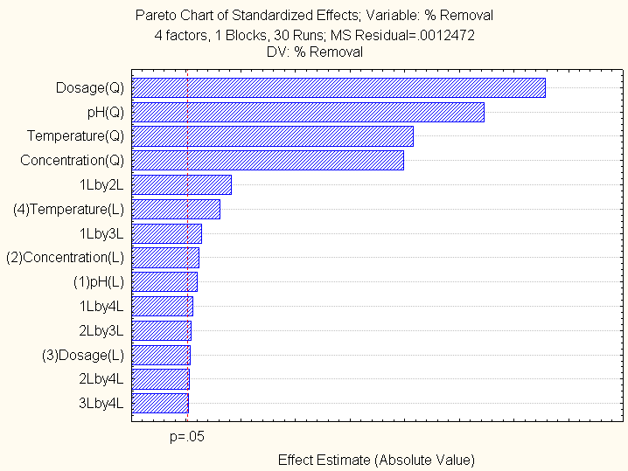

**Fig. 3.19 Pareto Chart**

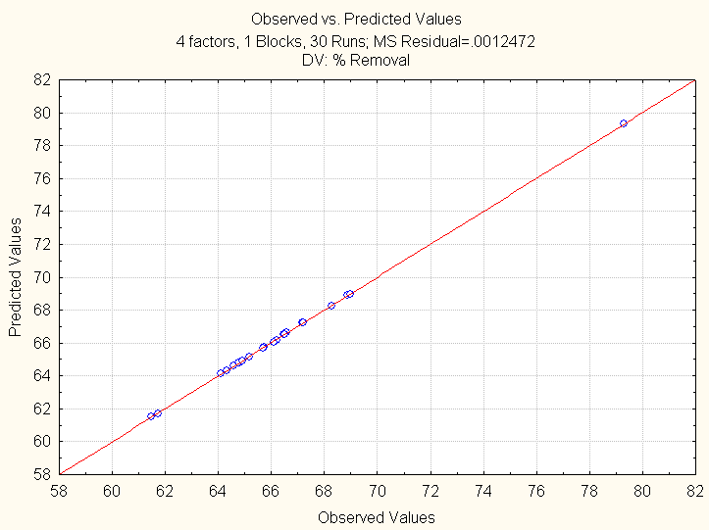

**Fig. 3.20 Normal probability plot for % biosorption of BG dye**

The optimal set of conditions obtained with CCD are shown in table-3.3 along with experimental values.

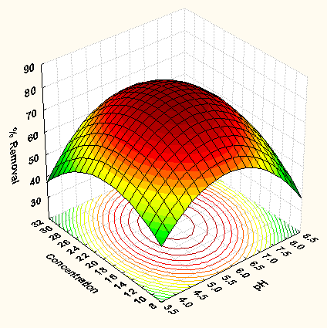 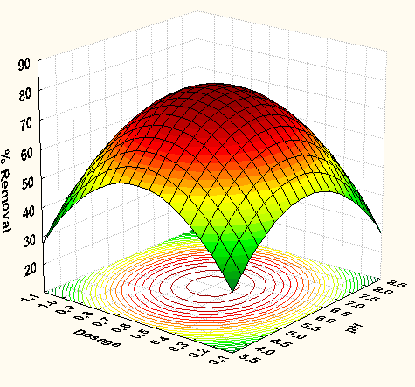

**Fig. 3.21 Surface contour plot for the effects Fig. 3.22 Surface contour plot for the**

**of pH and initial BG dye concentration effects of pH and dosage**

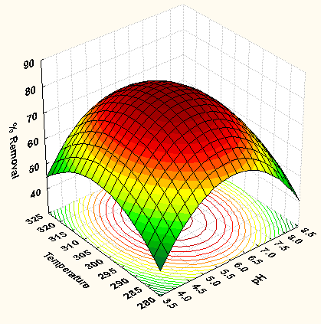 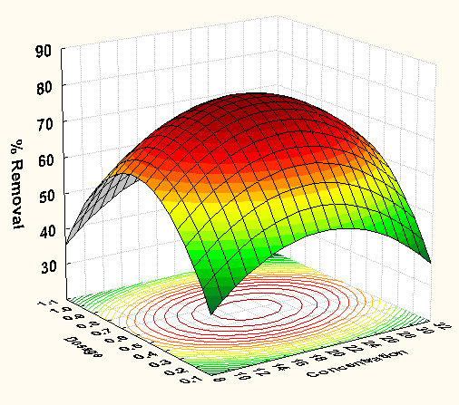

**Fig. 3.23 Surface contour plot for Fig. 3.24 Surface contour plot for the**

**effect of pH and temperature effects of initial concentration and dosage**

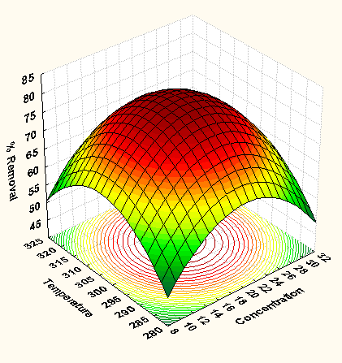 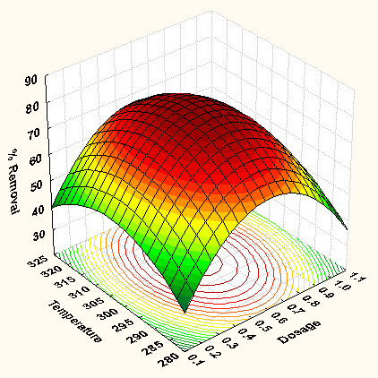

**Fig. 3.25 Surface contour plot for the effects Fig. 3.26 Surface contour plot for the**

**of initial concentration and Temperature effects of dosage and Temperature**

**Table – 3.3 Comparison between optimum values from CCD and experimentation**

|  |  |  |
| --- | --- | --- |
| **Variable** | **CCD** | **Experimental value** |
| pH of aqueous solution | 5.98 | 6 |
| Initial dye concentration, mg/L | 20.15 | 20 |
| Biosorption dosage, w, g | 0.6010 | 0.6 |
| Temperature, K | 303.78 | 303 |
| % biosorption | 79.32 | 69 |

1. **CONCLUSIONS:**

Investigations are carried out to find out the equilibrium conditions for the decolorization of brilliant green dye from an aqueous solution using silver tecomastans nanoparticles. The analysis of the experimental data results in the following conclusions,

Size of synthesized nanoparticles obtained by the analysis of FESEM was in range of 95.8 nm-190 nm.The equilibrium contact time obtained was 60 minutes. Percentage decolorization of dye or % removal of brilliant green dye from the aqueous solution changes significantly with pH of solution and the optimum obtained at a pH of 6 (64% removal). The maximum dye decolorization was obtained at a concentration of 20 mg/L. The optimum nano - biosorbent dosage (30 g/L) for removal of brilliant green dye from aqueous solution was 0.6 g (69 % removal).The percentage biosorption of brilliant green was increased with an increase in temperature of operation the maximum dye uptake obtained was 14.51 mg/g and the experimental data was well fitted in to Langmuir and Temkin models. The kinetics of the biosorption of BG dye on Ag-TS-NP's powder can be better described with pseudo first order kinetics. The study reveals that ΔH is positive it signifies endothermic nature of biosorption, ΔS is positive then it shows irreversible nature of biosorption and spontaneity of biosorption indicates by negative ΔG. The optimum variable values obtained in experimental analysis were very close agreement with that observed values in Response surface methodology.

**REFERENCES**

1. E. Baldev, D. Mubarak Ali, A. Ilavarasi, D. Pandiaraj, K.A. Sheik Syed Ishack, N. Thajuddin, "Degradation of synthetic dye, Rhodamine B to environmentally non-toxic products using microalgae", Colloids and Surfaces B: Biointerfaces, 105(2013) 207–214.
2. M. Simsíkova, M. Bartos, P. Kesa and T. Sikola, "Green approach for preparation of reduced graphene oxide decorated with gold nanoparticles and its optical and catalytic properties", Materials Chemistry and Physics, 177(2016) 339-345.
3. Kadriye Ozlem Hamaloglu, Ebru Sag, Ali Tuncela, "Bare, gold and silver nanoparticle decorated, monodisperse-porous titania microbeads for photocatalytic dye degradation in a newly constructed microfluidic, photocatalytic packed-bed reactor", Journal of Photochemistry and Photobiology A: Chemistry, 332 (2017) 60–65.
4. Niyaz Mohammad Mahmoodi, MokhtarArami, NargessYousefiLimaee, KamaladinGharanjig, FaramazDoulatiArdejani, "Decolorization and mineralization of textile dyes at solution bulk by heterogeneous nano photocatalysis using immobilized nanoparticles of titanium dioxide", colloids and surfaces A: Physico chem Eng aspects, 290 (2006) 125–131.
5. Virender K. Sharma, Ria A. Yngard, Yekaterina Lin, "Silver nanoparticles: Green synthesis and their antimicrobial activities”, Advances in Colloid and Interface Science, 145 (2009) 83– 96.
6. A.M. Al-Sabagh, Y.M. Moustafa, A. Hamdy, H.M. Killa, R.T.M. Ghanem, R.E. Morsi, "Preparation and characterization of sulfonated polystyrene/magnetite nanocomposites for organic dye adsorption", Egyptian journal of petroleum, 27 (3), (2018) 403-413.
7. A.R. Khataee, M. Safarpour, A. Naseri, M. Zarei, "Photoelectro-Fenton/nanophotocatalysisdecolorization of three textile dyes mixture: Response surface modeling and multivariate calibration procedure for simultaneous determination", Journal of Electro analytical Chemistry, 672 (2012) 53–62.
8. AgeethaVanamudan, P. Padmaja Sudhakar, "Biopolymer capped silver nanoparticles with potential for multifaceted applications", International Journal of Biological Macromolecules, 86 (2016) 262–268.
9. RenuSankar, PerumalManikandan, ViswanathanMalarvizhi, TajudeennasrinFathima, Kanchi Subramanian Shivashangari, VilwanathanRavikumar,"Green synthesis of photocatalytic dye degradation." Spectrochimica Acta. Part A: Molecular and Biomolecular Spectroscopy, 121 (2014)746–750.
10. Barun Kumar Ghosh, SubhenjitHazra, BhanudasNaik, Narendra Nath Ghosh, "Preparation of Cu nanoparticle loaded SBA-15 and their excellent catalytic activity in reduction of variety of dyes", Powder technology, 269 (2015) 371–378.
11. MonawarMunjid Mustafa, Parveen Jamal, Ma’anFahmiAlkhatib, SafaSenanMahmod, DzunNorainiJimat, Nurul NajhahIlyas, "Panustigrinus as a potential biomass source for Reactive Blue decolorization", Electronic journal of biotechnology, 26 (2017) 7-11.
12. RezaDarvishi CheshmehSoltani, SahandJorfi, HojjatallahRamezani, SudabehPurfadakari, "Ultrasonically induced ZnO–biosilicananocomposite for degradation of a textile dye in aqueous phase", Ultrasonics Sonochemistry, 28 (2017) 69–78.
13. Muthu Kumara Pandian, C. Karthikeyan, M. Rajasimman, "Isotherm and kinetic studies on nano-sorption of Malachite Green onto Allium sativum mediated synthesis of silver nano particles", Biocatalysis and Agricultural Biotechnology, 8 (2016) 171–181.
14. RenataDobrucka, "Biofabrication of platinum nanoparticles using Fumariaeherba extract and their catalytic properties", Saudi Journal of Biological Sciences, 26 (1) (2019) 31-37.
15. P. Kumar, M. Govindarajua, S. Senthamilselvi, K. Premkumar, "Photocatalytic degradation of methyl orange dye using silver (Ag) nanoparticles synthesized from Ulvalactuca", Colloids and Surfaces B: Biointerfaces, 103 (2013), 658–661.
16. NilofarYakubNadaf, ShivangiShivrajKanase, "Biosynthesis of gold nanoparticles by Bacillus marisflavi and its potential in catalytic dye degradation", Arabian Journal of Chemistry, 12 (8), (2019), 4806-4814.
17. Rabiarehman, Tariq mahmud, Jamil anwar and Muhammad salman, "Isothermal Modelling of Batch Biosorption of Brilliant Green Dye from Water by Chemically Modified Eugenia jambolana Leaves ", J.Chem.Soc.Pak.,34 (1), (2012),136-143.
18. Aadil Abbas, ShahzadMurtaza, Kashif Shahid, Muhammad Munir, RabiaAyub and SabaAkber "Comparative Study of Adsorptive Removal of Congo Red and Brilliant Green Dyes from Water Using Peanut Shell ", Middle-East Journal of Scientific Research, 11 (6) (2012) 828-832.
19. Mohamed A. Salem, Rehab G. Elsharkawy, Mahmoud F. Hablas, " Adsorption of Brilliant Green dye by polyaniline/silver nanocomposite: Kinetic, equilibrium, and thermodynamic studies ", European Polymer Journal, 75 (2016), 577-590.
20. Lakshmi Priya Thyagarajan, SwathiSudhakar and ThirumoorthyMeenambal, "Bioremediation of Congo-Red Dye by Using Silver Nanoparticles Synthesized from Bacillus sps ", Bioremediation and Sustainable Technologies for Cleaner Environment, (2017) 119-132.