Traversing Traditional to Modern: How AI is Reshaping HR

Dr.Kavita Shastri(kavita_shastri@globsyn.edu.in

1.Introduction
The recent developments in technology are playing a commendable impact on all facets in our social milieu, including the way that companies and non-profit government agencies manage their human resources (HR).The impact of these technological advances on employment patterns and the way businesses hire their workforce, influencing HR practices and the way they manage their employees, is critical. Artificial intelligence or AI, refers to a machine's capacity to carry out operations that ordinarily require human intellect, such as reasoning, learning, and problem-solving. In recent years, AI has been increasingly used in HR domain to streamline various processes and enhance decision-making. In case of talent acquisition AI-powered tools can help in candidate screening, shortlisting, and scheduling interviews, thereby reducing the time and effort required to find the right incumbents. AI-powered chatbots can be used to interact with candidates and answer their queries.AI is also used in performance management to evaluate employee performance by analyzing various metrics such as productivity, quality, and timeliness. In addition, AI-powered tools can personalize learning paths for employees based on their strengths and weaknesses, improving training and development. AI is also used to analyze employee feedback, survey responses, and social media posts to gauge employee satisfaction and engagement levels, and to predict employee turnover by analyzing various factors such as employee satisfaction levels, performance, and engagement. However, it is important to note that AI should not replace human judgment in HR. Human intervention and oversight are necessary to ensure that AI is being used ethically and in compliance with regulations.AI is pioneering so many industries at such a rapid pace that Sophia, an advanced AI robot, entered the panel and was inquired in during United Nations' convention on sustainable development.SARA (Semi-Autonomous Robot Avatar) is an AI-powered robot developed by the Saudi Arabian government to assist in various sectors, including HR. SARA is designed to automate routine HR tasks, such as onboarding, payroll, and benefits administration, and provide 24/7 customer service to employees. SARA can handle a wide range of HR-related queries and provide instant responses to employees. Artificial Intelligence (AI) refers to the use of algorithms and computer systems to perform tasks that normally require human intelligence, such as reasoning, learning, and problem-solving. In recent years, AI has become increasingly popular in the field of Human Resources (HR), as it has the potential to streamline HR processes and enhance decision-making.
Some of the applications of AI in HR include:
- Recruitment: AI can help in screening resumes, shortlisting candidates, and scheduling interviews. AI-powered chatbots can also be used to interact with candidates and answer their queries.
- Employee Engagement: AI-powered tools can analyze employee feedback, survey responses, and social media posts to gauge employee satisfaction and engagement levels.
- Performance Management: AI can assist in evaluating employee performance by analyzing various metrics such as productivity, quality, and timeliness.
- Training and Development: AI-powered tools can personalize learning paths for employees based on their strengths and weaknesses.
- Compensation and Benefits: AI can help in analyzing market trends, compensation data, and employee performance to arrive at appropriate compensation and benefits packages.
- Employee Retention: AI can assist in predicting employee turnover by analyzing various factors such as employee satisfaction levels, performance, and engagement.
Overall, the use of AI in HR has the potential to improve efficiency, reduce costs, and enhance employee experience. However, it is important to ensure that AI is being used ethically and in compliance with regulations.

  - 1.1 Background
The history of Artificial Intelligence (AI) dates back to the mid-20th century when computer scientists began exploring the idea of creating machines that could mimic human intelligence. The term "artificial intelligence" was first coined in 1956 by John McCarthy, who organized the Dartmouth Conference, which is considered to be the birthplace of AI. In the early years, AI researchers focused on developing rule-based systems that could perform tasks by following a set of pre-defined rules. These systems were limited in their ability to deal with ambiguity and uncertainty and were eventually replaced by more advanced systems based on machine learning and deep learning.In the 1990s, advances in computing power and the availability of large datasets enabled the development of machine learning algorithms such as neural networks, which could learn from data without being explicitly programmed. This led to significant breakthroughs in various AI applications such as image recognition, natural language processing, and speech recognition.In recent years, there has been a resurgence of interest in AI, driven by advances in deep learning, big data analytics, and cloud computing. In the early years of AI research, the focus was on developing algorithms and computer programs that could solve specific problems, such as playing chess or performing mathematical calculations. However, as computer processing power and data storage capacity increased, AI researchers began exploring more complex and sophisticated forms of AI, such as machine learning, neural networks, and deep learning. Machine learning is a type of AI that enables computers to learn from data without being specifically programmed.Instead, machine learning algorithms can identify patterns in data and use them to make predictions or decisions. Neural networks are a type of machine learning algorithm that is modeled after the structure of the human brain, with interconnected layers of nodes that can recognize patterns in data. Deep learning is a subset of machine learning that involves training neural networks with large amounts of data to recognize patterns and make decisions. Artificial intelligence (AI) applications like speech recognition, natural language processing, and image identification have all been developed using deep learning.Today, AI is being applied in a wide range of industries and domains, including healthcare, finance, transportation, and education. The increasing availability of data, coupled with advancements in computing power and AI algorithms, is fueling the growth of AI and opening up new possibilities for using AI to solve complex problems and improve human lives.
AI can solve complex problems and simplify human life in a variety of ways:
Automation: AI can automate many repetitive and time-consuming tasks, freeing up time for humans to focus on more complex and creative work.
Personalization: AI can analyze vast amounts of data to create personalized recommendations and solutions for individuals, whether in the context of personalized medicine or personalized shopping experiences.
Prediction: AI can use machine learning algorithms to make predictions about future events based on historical data, which can be used to prevent or mitigate potential problems before they occur.
Decision-making: AI can assist humans in decision-making by providing data-driven insights and recommendations.
Problem-solving: AI can solve complex problems that would be difficult or impossible for humans to solve on their own, such as analyzing large datasets or navigating complex systems.
Efficiency: AI can improve the efficiency of many processes, from supply chain management to customer service, by optimizing workflows and reducing waste.
Overall, AI can simplify human life by taking on many of the mundane and repetitive tasks that consume our time and energy, and by providing us with powerful tools for analyzing and solving complex problems.

  - 1.2 Problem Statement
The problem statement for research on AI in HR can be framed in several ways, but here are a few key challenges that researchers in this area might seek to address:
Ethical Concerns: As with any application of AI, there are ethical concerns around the use of AI in HR. For example, there may be concerns about bias and discrimination if the AI algorithms are not properly designed or trained, or if they are used in ways that disadvantage certain groups of people.
Technical Challenges: There are technical challenges associated with building AI systems that can effectively assist with HR tasks. For example, it can be difficult to train AI algorithms on HR-specific data, such as resumes or job descriptions, and to ensure that the algorithms are producing accurate and useful results.
Organizational Readiness: Implementing AI systems in HR may require significant changes to organizational structures, processes, and culture. HR professionals and other stakeholders may need to be trained on how to use and interpret AI-generated insights, and the organization may need to invest in new technology and infrastructure to support AI-powered HR processes.
Data Privacy and Security: As with any use of personal data, there are concerns around data privacy and security when using AI in HR. Organizations will need to ensure that they are complying with relevant regulations and protecting employee data from potential breaches or misuse.
Addressing these challenges will be critical for researchers in this area to develop effective AI-powered HR systems that are ethical, technically sound, and accepted by the organizations and individuals they are designed to support.The problem statement for research on AI in HR can be framed in several ways, but here are a few key challenges that researchers in this area might seek to address:
Ethical Concerns: As with any application of AI, there are ethical concerns around the use of AI in HR. For example, there may be concerns about bias and discrimination if the AI algorithms are not properly designed or trained, or if they are used in ways that disadvantage certain groups of people.
Technical Challenges: There are technical challenges associated with building AI systems that can effectively assist with HR tasks. For example, it can be difficult to train AI algorithms on HR-specific data, such as resumes or job descriptions, and to ensure that the algorithms are producing accurate and useful results.
Organizational Readiness: Implementing AI systems in HR may require significant changes to organizational structures, processes, and culture. HR professionals and other stakeholders may need to be trained on how to use and interpret AI-generated insights, and the organization may need to invest in new technology and infrastructure to support AI-powered HR processes.
Data Privacy and Security: As with any use of personal data, there are concerns around data privacy and security when using AI in HR. Organizations will need to ensure that they are complying with relevant regulations and protecting employee data from potential breaches or misuse.
Addressing these challenges will be critical for researchers in this area to develop effective AI-powered HR systems that are ethical, technically sound, and accepted by the organizations and individuals they are designed to support.

  - 1.3 Objectives
The objective of research on AI in HR is to develop effective, ethical, and impactful AI-powered tools and strategies that can improve HR processes and outcomes.
Develop Effective AI Tools: One objective of research on AI in HR is to develop AI-powered tools that can effectively assist with HR tasks, such as candidate screening, performance evaluation, and employee engagement.
Ensure Ethical Use of AI: Another objective of research on AI in HR is to ensure that the AI-powered tools being developed are ethically sound and do not perpetuate bias or discrimination. Improve HR Decision-Making: One objective of research on AI in HR is to identify how AI can be used to improve decision-making in HR and to develop methods for effectively communicating AI-generated insights to HR professionals.
Understand the Impact of AI on HR: As AI is integrated into HR processes, it is important to understand its impact on HR professionals, employees, and the organization as a whole. Identifying Opportunities: One purpose of research on AI in HR is to identify areas where AI can be applied to improve HR processes, such as candidate screening, performance evaluation, and employee engagement.
Improving Efficiency: Another purpose of research on AI in HR is to improve the efficiency of HR processes. AI-powered tools can automate repetitive tasks, freeing up HR professionals to focus on more strategic tasks such as talent development and organizational design.
Enhancing Objectivity One purpose of research on AI in HR is to identify areas where AI can be applied to improve HR processes, such as candidate screening, performance evaluation, and employee engagement.
Developing Ethical Frameworks: As AI is integrated into HR processes, it is important to develop ethical frameworks to ensure that AI is used in a responsible and ethical manner.
Improving Employee Experience: AI-powered tools can help personalize the employee experience by analyzing data on employee engagement, performance, and other factors. By developing tools that better understand employees' needs and preferences, researchers can improve employee satisfaction and retention.
Overall, the purpose of research on AI in HR is to develop innovative solutions that improve HR processes and outcomes, while ensuring that the use of AI is ethical, responsible, and beneficial for employees and the organization as a whole.

Literature Review

Intelligence generated artificial techniques and their subset, Computational Intelligence Strategies, are not new to the field of human resource management, and since their introduction, a wide range of recommendations on how to apply artificial intelligence, computer science, and information intelligence to HRM have accumulated. Although these contributions offer deep insights into specific application possibilities, there is an absence of a comprehensive picture. As a result, this chapter provides a preliminary examination of the broad potential of Artificial Intelligence Methods in Human Resource Management. To that purpose, a brief foundation based on the task-technology fit paradigm elaborates on the core capabilities of Artificial Intelligence Methods and the central needs of Human Resource Management. The potential of artificial intelligence in human resource management is then examined using six scenarios: employee self-service using interactive voice response, candidate search using knowledge-based search engines, staff rostering using genetic algorithms, HR sentiment analysis using text mining, résumé data acquisition using information extraction, and turnover prediction using artificial neural networks. The fundamental and exploratory results are discussed and summarized.(Piazza, 2015)These techniques, when used together or separately, are making it easier for human resources to anticipate a candidate's future performance with their firm. Artificial intelligence (AI) is completely altering the sector of human resources. The current study would shed some insight on artificial intelligence advancements and their consequences for HR.(Ahmed, 2018)While the usage of artificial intelligence (AI) in the workplace is growing, few people comprehend how it will impact our professions. Will it be an impediment? Is this a threat? Or is it the answer to the present productivity crisis? AI, like any new and mostly untested technology, carries with it both difficulties and potential that we must be aware of. It is our role in HR to guide business executives to the optimal business decisions, frequently via the use of technology. AI, like analytics before it, has enormous promise.What we do know is that the development of human potential has risen to the top of the list of global CEO objectives. Finding the correct individuals for the position is difficult in the UK due to acute skill shortages.(Hogg, 2019)The goal of this research is to look into the present use of artificial intelligence (AI) in candidate recruiting and selection. This study primarily explores the level, rate, and prospective adoption areas for AI-tools across the employment process. A two-step technique was used to achieve that goal. The recruitment and selection (R&S) procedure was thoroughly researched in the literature to identify potential AI application areas. Second, semi-structured theme interviews were conducted with various types of R&S professionals, including HR managers, consultants, and academics, to assess how much of the AI-applications areas highlighted in the literature study are being employed in practice. This research has a plethora of findings. This study tackles the significant research gap in AI in R&S, notably the unavailability and low quality of current academic literature. Additionally, this study gives a complete assessment of the state of AI in R&S, which will be useful for academics and practitioners seeking to quickly get a full grasp of AI in R&S.(Albert, 2019) The article's goal is to look into the development of the use of artificial intelligence (AI) in the field of human resources (HR). Using the quantitative descriptive analysis of journals and proceedings listed in the basis of the Library of Online Knowledge (B-on), between the years of 2000 and 2018, it gives a snapshot of the research that used AI in the field of HR. 32 research articles have been found that discuss the use of artificial intelligence in the field of human resources. The 18 years of study were separated into 3 time periods as a didactic aid and to make the analysis easier to understand (First decade, Reduction Period and Period of Growth).The study also brought up the dispersion and prevalence of AI application in HR-related areas. It was determined as a result that there are few studies on AI applied to human resources and that usage is spread. Further studies are anticipated to be prompted by the nine conclusions regarding the results given in this essay.(Teixeira, 2019)This article discusses the application of artificial intelligence in human resources as a result of technological advancements in the IT landscape. Virtually all businesses use artificial intelligence to improve the efficiency of human resources in the IT sector. The program begins with an automated recruitment procedure and continues through employee performance evaluation. Corporate leaders and human resource executives believe that incorporating artificial intelligence (AI) into HR tasks such as onboarding and benefit administration can improve the overall employee experience. In this essay, it cover both perspectives, since people see artificial intelligence as both a blessing and a danger to their careers. During the research, researcher examined some of the leading artificial intelligence businesses as references. It concentrated on the problems and limits of artificial intelligence in the current industry landscape. The research will also provide a brief overview of artificial intelligence's long-term goals.(Verma, 2019)Its goal is to clearly convey the difficulties that HR researchers encounter and for which computer scientists are looking for answers. It outlines the most modern and diverse methodologies, IT approaches, and technologies now in use while emphasizing those that incorporate artificial intelligence.(Labani, Berhil, & Benlahmar, 2020). Artificial intelligence is a human-like intellect that thinks like a person. It's also known as machine learning occasionally. It provides a possibility for an organization's workers to increase their working participation. Innovative technology development in the firm is the effective deployment of artificial intelligence applications. The fundamental goal of this research paper is to investigate the use of artificial intelligence and to assess the influence of artificial intelligence in human resources. Artificial intelligence in human resources is a new technology that may assist in handling many types of operations such as recruiting, retaining, and so on. This paper provides an overview of artificial intelligence application in HR and the challenges that the organizations faced for its effective implementation by collecting data from both primary and secondary sources, as well as suggestions for improving the performance of artificial intelligence in HR.(Usha & Ranjith, 2021)Artificial Intelligence (AI) integration into human resources procedures helped to improve firms since these programmers can examine, anticipate, and diagnose to aid HR departments in making better decisions. The purpose of this observation is to evaluate Artificial Intelligence in Human Resource Management. (HRM), as well as this paper, have emphasized the importance of artificial intelligence in Human Resources Management, Conceptual Artificial Intelligence (AI) Application Model for HRM, the Challenges of Adopting Artificial Intelligence, and the Benefits of Adopting Artificial Intelligence in Human Resources Management (HRM). This observation assisted policymakers in understanding the benefits and relevance of implementing Artificial Intelligence in Human Resource Management.(Vijai, Chueinwittaya, Wisetsri, & Jirayus, 2022)

  - 2.1 Knowledge Gap
Despite the growing interest in the use of AI in HR, there remains a significant gap in our understanding of how employees perceive and interact with AI-powered HR systems. While there have been several studies that have examined the impact of AI on HR outcomes such as recruitment, selection, and performance management, little research has been conducted on the employee experience of interacting with these systems. This gap in the literature is particularly important given the potential for AI-powered HR systems to shape employees' perceptions of fairness, transparency, and trust in the workplace. Therefore, future research should focus on investigating the factors that influence employees' perceptions and acceptance of AI in HR, as well as the potential ethical and social implications of these systems for employee well-being and job satisfaction. There is also a need for more longitudinal studies to understand the long-term effects of AI in HR on employees and organizations. Additionally, there is a lack of research on how different employee groups, such as those from diverse cultural backgrounds or with different levels of technology proficiency, perceive and interact with AI in HR systems. Addressing these gaps in the literature is essential for developing a comprehensive understanding of the benefits and challenges of AI in HR and for ensuring that the implementation of these systems is ethical, equitable, and effective. The use of AI in HR has gained significant attention in recent years, with organizations looking to leverage these technologies to streamline their HR processes and improve decision-making. However, despite the potential benefits, there are still many unknowns about how employees perceive and interact with AI-powered HR systems. For instance, there is a lack of understanding of the factors that influence employee trust in these systems, as well as their perceptions of fairness and transparency. This knowledge gap is particularly concerning given that employees' perceptions of these systems can impact their engagement, motivation, and overall well-being. Additionally, there is a need for more research on the potential ethical and social implications of AI in HR, such as how these systems could impact employee privacy and data security. Addressing these knowledge gaps is essential for ensuring that the implementation of AI in HR is ethical, equitable, and effective, and for maximizing the benefits of these technologies for both employees and organizations.
As AI technology continues to advance, it is becoming increasingly important to understand how it impacts the employee experience. However, despite the growing interest in the use of AI in HR, there is a significant gap in our knowledge regarding how employees perceive and interact with AI-powered HR systems. This knowledge gap is particularly concerning given the potential for these systems to shape employees' perceptions of fairness, transparency, and trust in the workplace. Without a comprehensive understanding of how employees perceive and interact with AI in HR, organizations may face challenges in effectively implementing these systems and ensuring that they are ethical and equitable. Therefore, it is critical that future research in this area focuses on investigating the factors that influence employee perceptions and acceptance of AI in HR, as well as the potential ethical and social implications of these systems for employee well-being and job satisfaction
1.While research on the impact of AI in HR has been extensive, there is a significant gap in our understanding of how employees experience and interact with these systems on a day-to-day basis.
3.The lack of research on employee perceptions of AI in HR is concerning given the potential for these systems to impact trust, transparency, and fairness in the workplace.
4.Without a deeper understanding of the employee experience with AI in HR, organizations run the risk of implementing systems that fail to meet employee needs or that have unintended negative consequences.
5.The gaps in the literature suggest a need for more research that takes a nuanced, employee-centered approach to understanding the effects of AI in HR on both individuals and organizations.
6.Addressing the knowledge gap in the literature will require a multi-disciplinary approach that draws on insights from psychology, sociology, and organizational behavior, among other fields.

3. Research Design

  - 3.1 Methodology
This study will use a mixed-methods approach to collect data through online surveys and literature review. The online survey will be used to gather data on employees' perceptions and experiences of Artificial Intelligence in Human Resources, while the literature review will provide a comprehensive overview of existing research on this topic.
  - 3.2 Sample
The respondents were selected randomly using convenient sampling technique and the primary data was collected from 50 respondents through a well-structured questionnaire.The sample will be drawn from a variety of industries and organizations to ensure diversity. To achieve a representative sample, participants were selected from each industry and organization.
  - 3.3 Data Collection
Data will be collected through an online survey that has been designed to capture employees' perceptions and experiences of AI in HR. The survey will consist of a mix of closed-ended and open-ended questions, and will cover topics such as employee perceptions of fairness, transparency, trust, and privacy. The survey will be distributed using online survey platforms such as Google Survey. The poll will be accessible for two weeks.
In addition to data collected through the survey, a comprehensive literature review will be conducted to provide an overview of existing research on AI in HR. The literature review will be conducted using online databases such as Google Scholar, Emerald Insight. Relevant keywords such as "AI in HR", "artificial intelligence in human resources", "AI-powered HR systems", and "employee perceptions of AI in HR" will be used to identify relevant studies. The literature review will be limited to studies published in English between 2015 and 2022.

4. Data Analysis

This chapter comprises mostly of a comprehensive study of the data obtained (primary data) from respondents via the survey. This is an important step in the research process; the research approach adopted here is extensive analysis. This analysis aids in drawing a major consequence from the data of the sample population. Nevertheless, the chapter only provides the end outcome of each investigation, which has been visualized using a pie chart and.
4.1 Findings & Analysis
Figure1 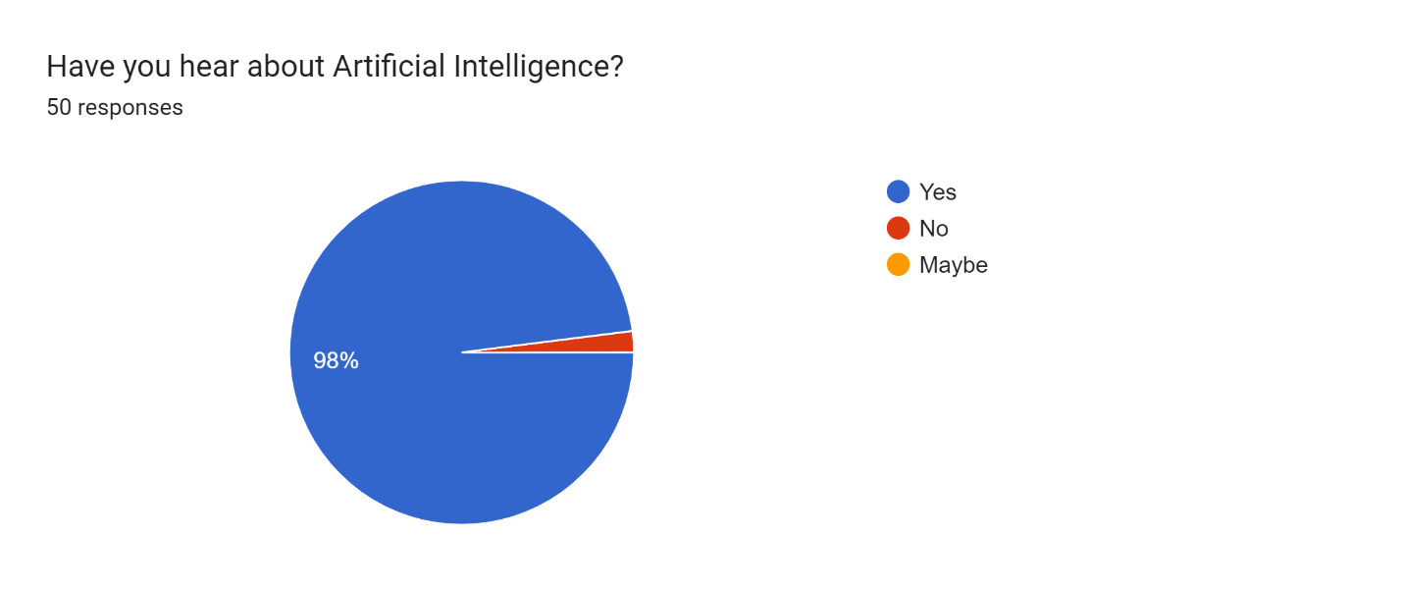
Figure 1: Have you heard about Artificial Intelligence

1.1 The survey question "Have you heard about Artificial Intelligence?" received responses from 50 participants. Out of the total respondents, 98% answered yes,while only 2% of the respondents answered no, indicating that they have not heard about Artificial Intelligence.

Figure : 2
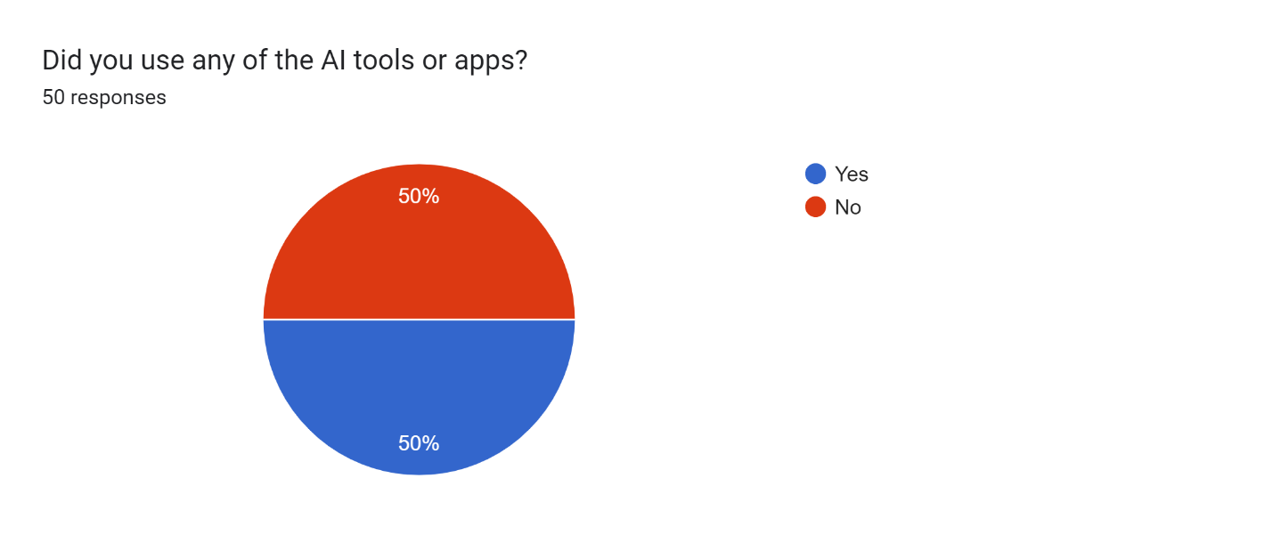
Figure 2: Did you use any of the AI tools or apps?
2.1The survey question "Did you use any of the AI tools or apps?" received responses from 50 participants. Out of the total respondents, 50% answered yes, indicating that they have used AI tools or apps. In contrast, the other 50% of the respondents answered no, indicating that they have not used AI tools or apps.

Figure 3
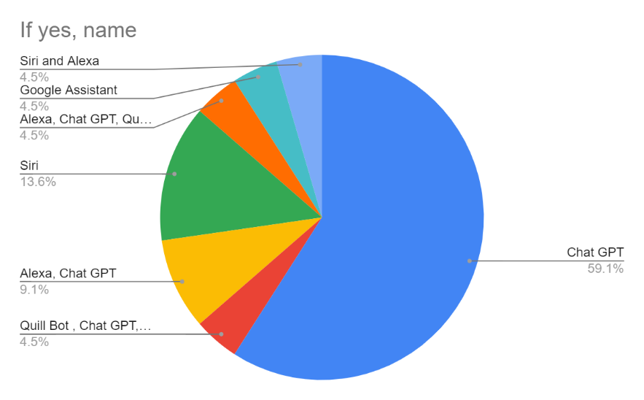
Figure 3: If yes, name
3.1 The last question of the survey asked respondents “Do you have used any AI tools or apps?”if Yes, name it. Out of the 50 respondents, 23 answered yes and provided the name of the AI tool they have used. Among these respondents, 59.1% named Chat GPT as the AI tool they have used. 13.6% of the respondents named Siri, while 9.1% named Alexa and Chat GPT. 4.5% of the respondents named Siri and Alexa, 4.5% named Google Assistance, and 4.5% named Quillbot and Chat GPT.

Figure 4
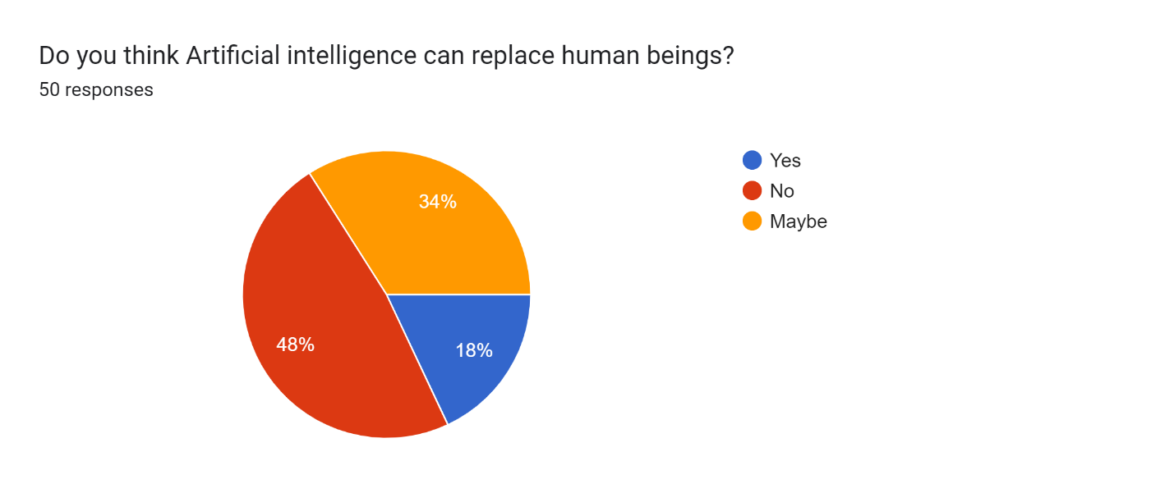
Figure 4: Do you think Artificial Intelligence can replace Human Beings?
4.1The survey question "Do you think Artificial intelligence can replace human beings?" received responses from 50 participants. Out of the total respondents, 18% answered yes, indicating that they believe that AI can replace human beings. In contrast, 48% of the respondents answered no, indicating that they do not believe that AI can replace human beings. Finally, 34% of the respondents answered "maybe", indicating that they are uncertain about the potential of AI to replace human beings.
Figure 5
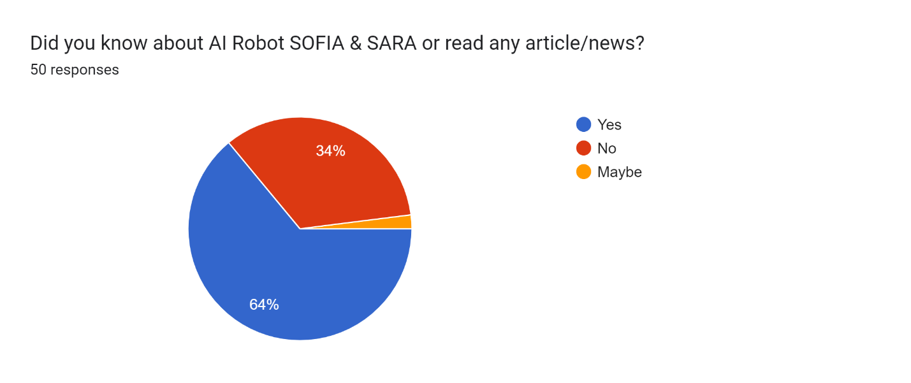
Figure 5: Did you know about AI Robot SOFIA & SARA or read any article/news?
5.1The survey question "Did you know about AI Robot SOFIA & SARA or read any article/news?" received responses from 50 participants. Out of the total respondents, 64% answered yes, indicating that they have heard about AI robots SOFIA and SARA or read about them in an article or news. In contrast, 34% of the respondents answered no, indicating that they have not heard about them, while 2% of the respondents answered maybe.

Figure 6
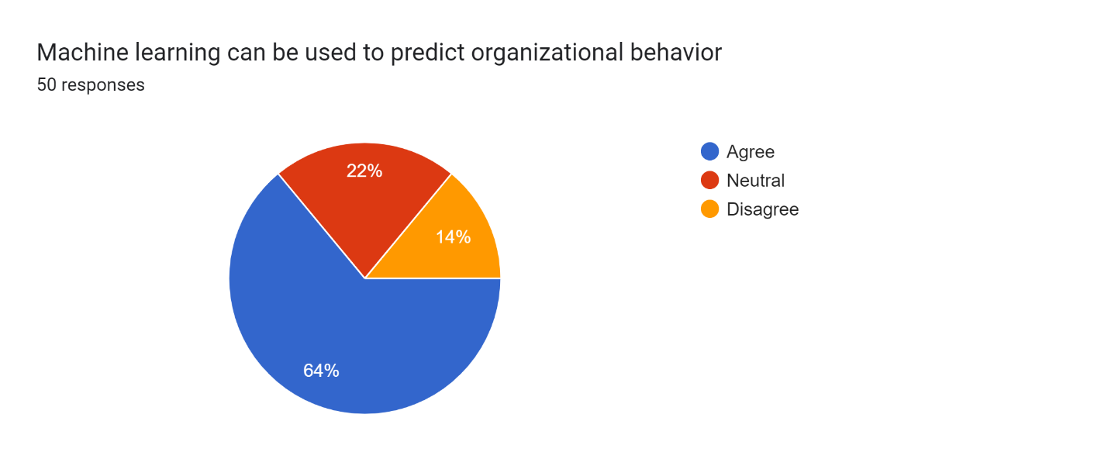
Figure 6: Machine learning can be used to predict organizational behavior
6.1 On the statement, "Machine learning can be used to predict organizational behaviour". Out of the 50 respondents, 64% agreed with the statement, 22% were neutral, and 14% disagreed with the statement.
The responses to the survey question suggest that a majority of the participants agree that machine learning can be used to predict organizational behavior. This finding highlights the potential of machine learning in providing valuable insights into the behavior and patterns of organizations. The fact that a significant percentage of respondents were neutral or disagreed with the statement suggests that there may be differing views or perspectives on the effectiveness and ethical implications of using machine learning to predict organizational behavior.
All in all, the responses to the survey question provide insight into the opinions and attitudes of the survey participants towards the use of machine learning in predicting organizational behavior. Further research could explore the reasons for the differing views and perspectives among the survey respondents and the potential implications of using machine learning in this context.
Figure7 7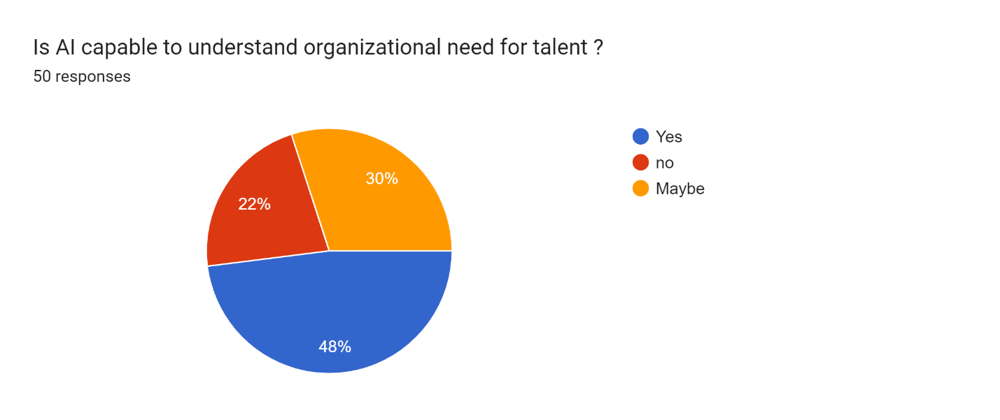
Figure 7: Is AI capable to understand organizational need for talent?
7.1 The survey question, "Is AI capable of understanding organizational needs for talent?" received responses from 50 participants. Out of the total respondents, 48% answered yes, indicating that they believe AI is capable of understanding organizational needs for talent. In contrast, 22% of the respondents answered no, indicating that they do not think AI is capable of understanding such needs, while 30% of the respondents answered maybe.
Figure8 8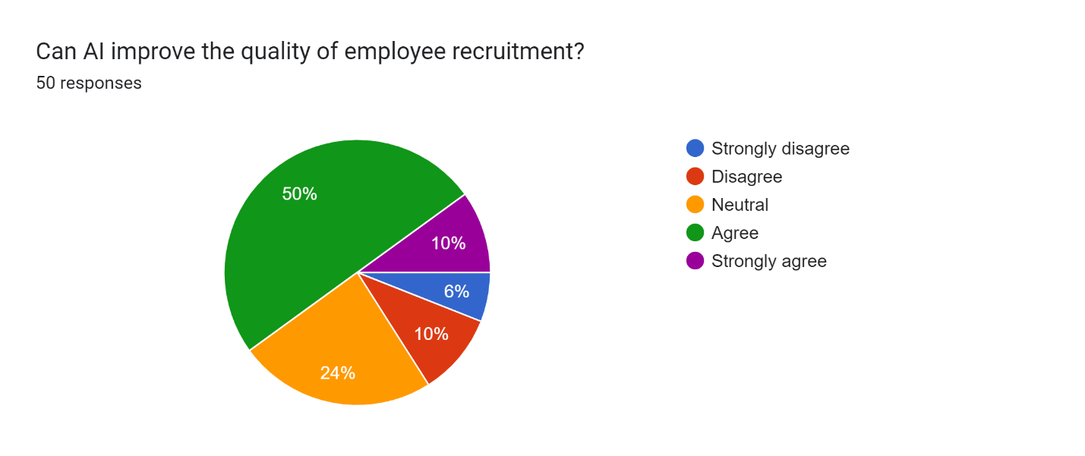
Figure 8: Can AI improve the quality of employee recruitment?
8.1 The survey question, "Can AI improve the quality of employee recruitment?" received responses from 50 participants. Out of the total respondents, 50% agreed and 10% strongly agreed, indicating that they believe AI can improve the quality of employee recruitment. In contrast, 10% of the respondents disagreed and 6% strongly disagreed, indicating that they do not think AI can improve the quality of employee recruitment. Additionally, 24% of the respondents answered neutrally.
.
Figure9 9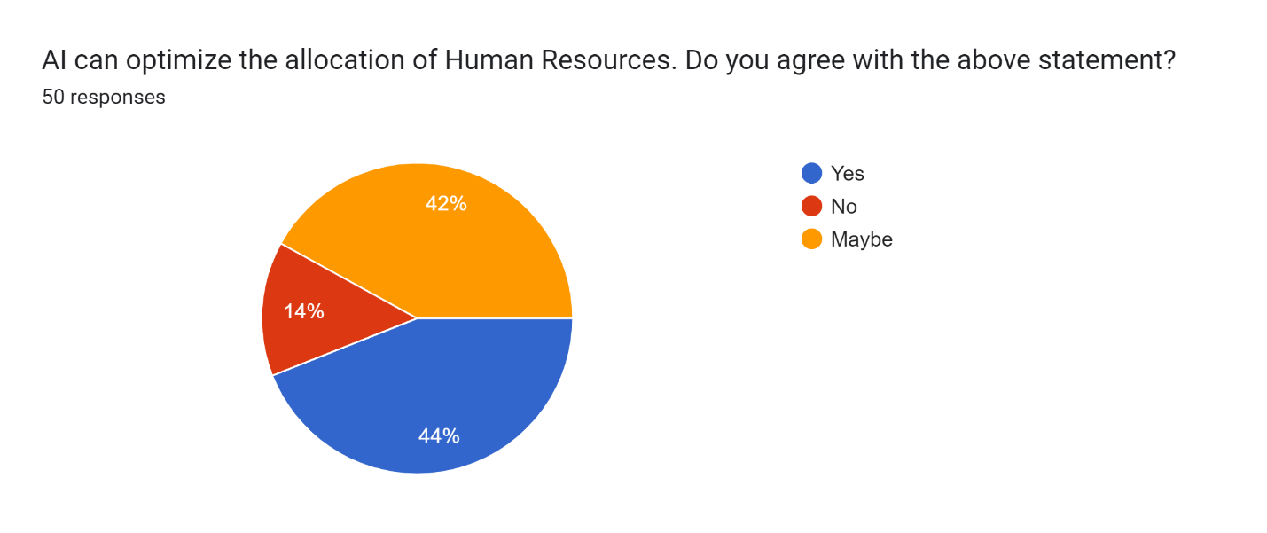
Figure 9: AI can optimize the allocation of Human Resources. Do you agree with the above statement?

9.1 The survey statement, "AI can optimize the allocation of Human Resources. Do you agree with?" received responses from 50 participants. Out of the total respondents, 44% answered yes, indicating that they believe AI can optimize the allocation of human resources. In contrast, 14% of the respondents answered no, indicating that they do not think AI can optimize the allocation of human resources. Additionally, 42% of the respondents answered maybe with the statement.
Figure10 10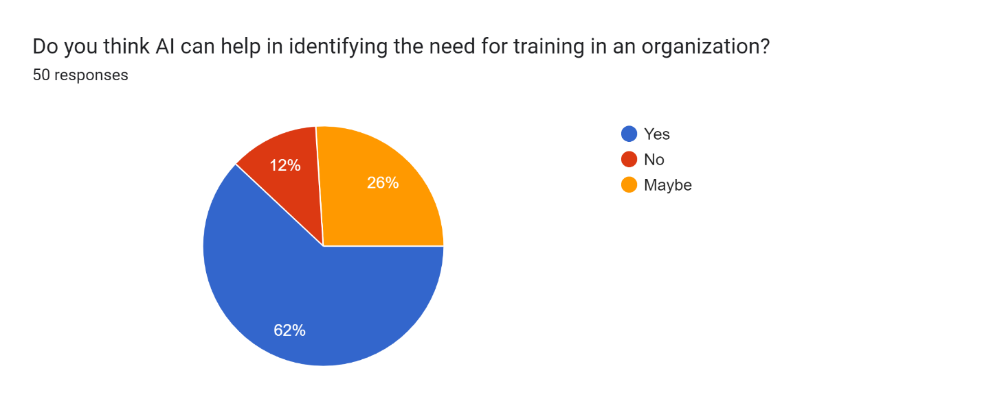
Figure 10: Do you think AI can help in identifying the need for training in an organization?
10.1 Based on a survey of 50 respondents, 62%of them believed that AI can help in identifying the need for training in an organization. On the other hand, 12% of the respondents did not agree with the statement. Meanwhile, 26% of the respondents were unsure or neutral in their response.

5. Conclusion

  - 5.1 Conclusion
In conclusion, the survey responses on the use of AI in HR suggest that there is a growing awareness and interest in leveraging AI tools and applications to enhance HR practices. While some respondents expressed skepticism about the capabilities of AI in certain areas, such as understanding organizational needs for talent or optimizing HR allocation, a majority of respondents viewed AI as having the potential to improve employee recruitment, identify training needs, and predict organizational behavior.
Furthermore, the survey responses suggest that some specific AI tools and applications, such as Chat GPT and Siri, are more widely recognized and used than others, such as Quillbot or AI robots SOFIA and SARA. This may reflect a need for more education and awareness-building around the range of AI tools and applications available in the HR domain.
the objectives and purpose of research on AI in HR are to develop effective, ethical, and impactful AI-powered tools and strategies that can improve HR processes and outcomes. The objectives include developing effective AI tools, ensuring ethical use of AI, improving HR decision-making, and understanding the impact of AI on HR. Meanwhile, the purpose of the research includes identifying opportunities, improving efficiency, enhancing objectivity, developing ethical frameworks, and improving employee experience.
In summary, the research on use of Artificial Intelligence on Human Resources provides an opportunity to leverage cutting-edge technology to improve HR processes and outcomes, while ensuring that the use of AI is ethical, responsible, and beneficial for employees and the organization as a whole. On the other hand,the survey responses highlight the importance of continued research and development in use of AI, as well as the need for organizations to carefully consider the potential benefits and limitations of AI before implementing it in their HR practices.

  - 5.2 Limitations
Limitations are a natural part of any research project and should be acknowledged to provide context and to give readers a clear understanding of the study's potential weaknesses. In this research, some limitations were present that may have impacted the validity and generalizability of the findings.
- Sample size: The sample size of 50 participants may not be large enough to make definitive conclusions about the attitudes and opinions of a broader population.
- Sampling bias: The participants who completed the survey may not be representative of the overall population of interest, as they may be more likely to have experience or interest in AI.
- Self-reported data: The data collected through the online survey is self-reported, which means that participants may not have provided accurate or complete information.
- Limited scope: The survey only focused on a few specific aspects of AI in HR, which means that it may not provide a comprehensive understanding of the topic.
- Generalizability: The findings of this study may only be applicable to the specific population and context in which the survey was conducted and may not be generalizable to other populations or contexts.
- Time constraints: Due to time constraints, the survey was limited to a single administration, which may not provide a complete picture of the attitudes and opinions of the population of interest.
- Response rate: The response rate of the survey is not reported, which makes it difficult to assess the representativeness of the sample.
- Potential for measurement error: There may be measurement error associated with the survey questions, which may have impacted the accuracy of the responses.
  - 5.3 Scope for future research
The findings of this research provide some valuable insights into the perceptions and attitudes of individuals towards the impacts of artificial intelligence on human resource management. Based on the limitations identified, there are several potential areas for future research.Firstly, future studies could focus on exploring the use of AI in more specific areas of HR management, such as employee engagement, performance management, and career development.Secondly, future research could investigate the impact of AI on employee experience and well-being. There is growing concern that the use of AI in HR management may have negative effects on employee well-being, such as increased stress and job insecurity. Thirdly, as AI technology continues to advance rapidly, it is important to examine the ethical implications of AI in HR management. This includes issues such as privacy, bias, and fairness, which may have significant implications for employee rights and social justice. Future research could focus on developing ethical frameworks for the use of AI in HR management and identifying ways to ensure that the technology is used in a responsible and ethical manner.Finally, as the use of AI in HR management becomes more widespread, it will be important to examine the role of HR practitioners in managing the technology and ensuring its effective use. This includes developing training and development programs for HR practitioners, and identifying the competencies and skills required to effectively manage AI in HR.
In conclusion, while this research provides some valuable insights into the perceptions and attitudes of individuals towards the use of AI in HR management, there are several areas for future research. By addressing these areas, future research can provide more nuanced and practical insights into the use of AI in HR management and help organizations to leverage the potential benefits of this technology while mitigating any potential risks.

References

Ahmed, D. (2018). ARTIFICIAL INTELLIGENCE IN HR.
Albert, E. (2019). AI in talent acquisition: a review of AI-applications used in recruitment and selection.
Hogg, P. (2019). Artificial Intelligence: HR friend or foe?
Khatri, S., Penkar, D., Pandey, S., & Ramani, J. (2019). Impact of Artificial Intelligence on Human Resource. . In Data Management, Analytics and Innovation: Proceedings of ICDMAI, 365-376.
Labani, N., Berhil, S., & Benlahmar, H. (2020). A review paper on artificial intelligence at the service of human resource management. Indonesian Journal Of Electrical Engineering and Computer Science, 32-40.
M., Kumar, K., & Elangovan, R. (2021). To study impact of Artificial Intelligence on HR Practices.
Pant, M., & Tewari, I. (2020). Artificial Intelligence reshaping human resource management. IEEE international conference on advent trends in multi-disciplinary research and innovation, 1-4.
Piazza, F. (2015). Artificial intelligence techniques in human resource management- a conceptual exploration. Intelligent Techniques in Engineering Management:Theory and Applications. 149-172.
Smith, C. (2019). An employee's best friend? Hoe AI can boost employee engagement and performance.
Teixeira, J. (2019). Evolution of artificial intelligence research in human resource. Procedia Computer Science, 137-142.
Thomas, M., & George, G. (2019). Integration of artificial intelligence in Humna Resource. Int. J. Innov. Technology Explor. Eng., 5069-5073.
Usha, K., & Ranjith, S. (2021). A study on application of Artificial Intelligence and its challenges in HR.
Verma, R. (2019). Artificial Intelligence & Human Resource Management in Indian IT Sector.
Vijai, C., Chueinwittaya, K., Wisetsri, W., & Jirayus, P. (2022). Artificial Intelligence in Human Resources Management. 2688-2693.
Vrontis, D., Christofi, M., Pereira, V., Tarba, S., Makrides, A., & Trichina, E. (2022). Artificial Intelligence, robotics, advanced technologies and Human Resource Management: a systematic review. The International Journal Of Human Resource Management, 1237-1266.

Annexure

Sl.no | Questions
1 | Name
2 | Age
3 | Have you heard about Artificial Intelligence?
4 | Did you use any of the AI tools or apps?
5 | If yes, name
6 | Do you think Artificial intelligence can replace human beings?
7 | Did you know about AI Robot SOFIA & SARA or read any article/news?
8 | Machine learning can be used to predict organizational behavior
9 | Is AI capable to understand organizational need for talent ?
10 | Can AI improve the quality of employee recruitment?
11 | AI can optimize the allocation of Human Resources.  Do you agree with the above statement?
12 | Do you think AI can help in identifying the need for training in an organization?

Table of Figures

Figure 1: Have you heard about Artificial Intelligence 24
Figure 2: Did you use any of the AI tools or apps? 25
Figure 3: If yes,name 26
Figure 4: Do you think Artificial Intelligence can replace Human Beings? 27
Figure 5: Did you know about AI Robot SOFIA & SARA or read any article/news? 28
Figure 6: Machine learning can be used to predict organizational behavior 29
Figure 7: Is AI capable to understand organizational need for talent? 30
Figure 8: Can AI improve the quality of employee recruitment? 31
Figure 9: AI can optimize the allocation of Human Resources. Do you agree with the above statement? 32
Figure 10: Do you think AI can help in identifying the need for training in an organization? 33

