Geospatial Technology for Sustainable Development – A case of Keonjhar District of Odisha
Dr. Adikanda Ojha Dr. Jajnaseni Rout
State Project Officer Assistant Professor
MGNREGS Society Dept. of Geography
Dept. of Panchayatiraj and Drinking Water Ravenshaw University
Odisha Odisha
Abstract
The 2030 agenda for SD points out that sustainability has three dimensions: economic, social and environment. Impact on natural resources by society can be monitored by identifying those activities that will interact with ecosystem mechanisms. Geospatial technology for detecting the community level development works and synthesizes the yield of SD at a district level. The main objective of the study is to show the impact of implementation of SDGs on the development of community livelihood and overall infrastructure Development. The study area has been taken the Keonjhar district of Odisha which was one of the vulnerable district of Odisha. Public works under MGNREGA have progressed well in all the 13 blocks of the Keonjhar district. Dashboard (2019) indications that a total number of 2267 village clusters have actively participated in this program. A total of 575708 Lakhs workers were elaborate in MGNREGA program in this district. The study area contains more than 26389 assets over an area of 653900 Ha of land. The total number of assets developed from the year 2009 till 2019. It is obvious that mostly the assets were for irrigation, water conservation, water harvesting, and drought proofing works. From the year 2017 and 2018, there is demand and increase in rural sanitation works in the study area
Key words - SDG, MGNREGA, Geospatial, conservation, ecosystem
Introduction
The Millennium Development Goals (MDGs) approved during the UN Millennium Summit on 8th September 2000 was the first united stand of the world to rid the world of poverty and increase the lot of humanity. Execution of MDGs was up to 31st December, 2015, and from 1ST January, 2016 SDGs are in force. SD addresses the root cause of poverty, the requirements of the society and security of the planet without destroying the resources needed for future generations. The 2030 agenda for SD points out that sustainability has three dimensions: economic, social and environment. Impact on natural resources by society can be monitored by identifying those activities that will interact with ecosystem mechanisms. Earth Observation (EO) system gathers the information about the lithosphere, hydrosphere, biosphere, atmosphere and their interactions using Remote-Sensing principles, supplemented by in-situ and survey data. Geospatial technologies embed a range of modern tools along with EO data, Global Position Systems (GPS), Geographic Information Systems (GIS) and the Internet to facilitate online mapping and analysis of the Earth and human societies (AAAS,

2018). Geospatial technology for detecting the community level development works and synthesizes the yield of SD at a district level. The study has harnessed the transparency provisions provided by using ICTs to retrieve the information about the assets (infrastructure at rural communities and household level) that are developed under MGNREGA program. This article relies on logic that the economy contributes necessary thrust to the society so that it progresses well within the sphere of the environment and hence proactive conservation of natural resources.
Figure 1 shows the conversation of dividends between the three pillars of sustainability due programs like MGNREGA. SD can be formed when there is a balanced integration of environment, society and economy because, the economy is controlled by society and society is depended on the environment. There are 260 combinations of works which are permissible under MGNREGA, mostly these works are related to natural resource management, water facilitation works, agriculture-related, infrastructure development, rural connectivity and sanitation, and other allied activities (MGNREGA Guide, 2019).
The main objective of the study is to show the impact of implementation of SDGs on the development of community livelihood and overall infrastructure Development.

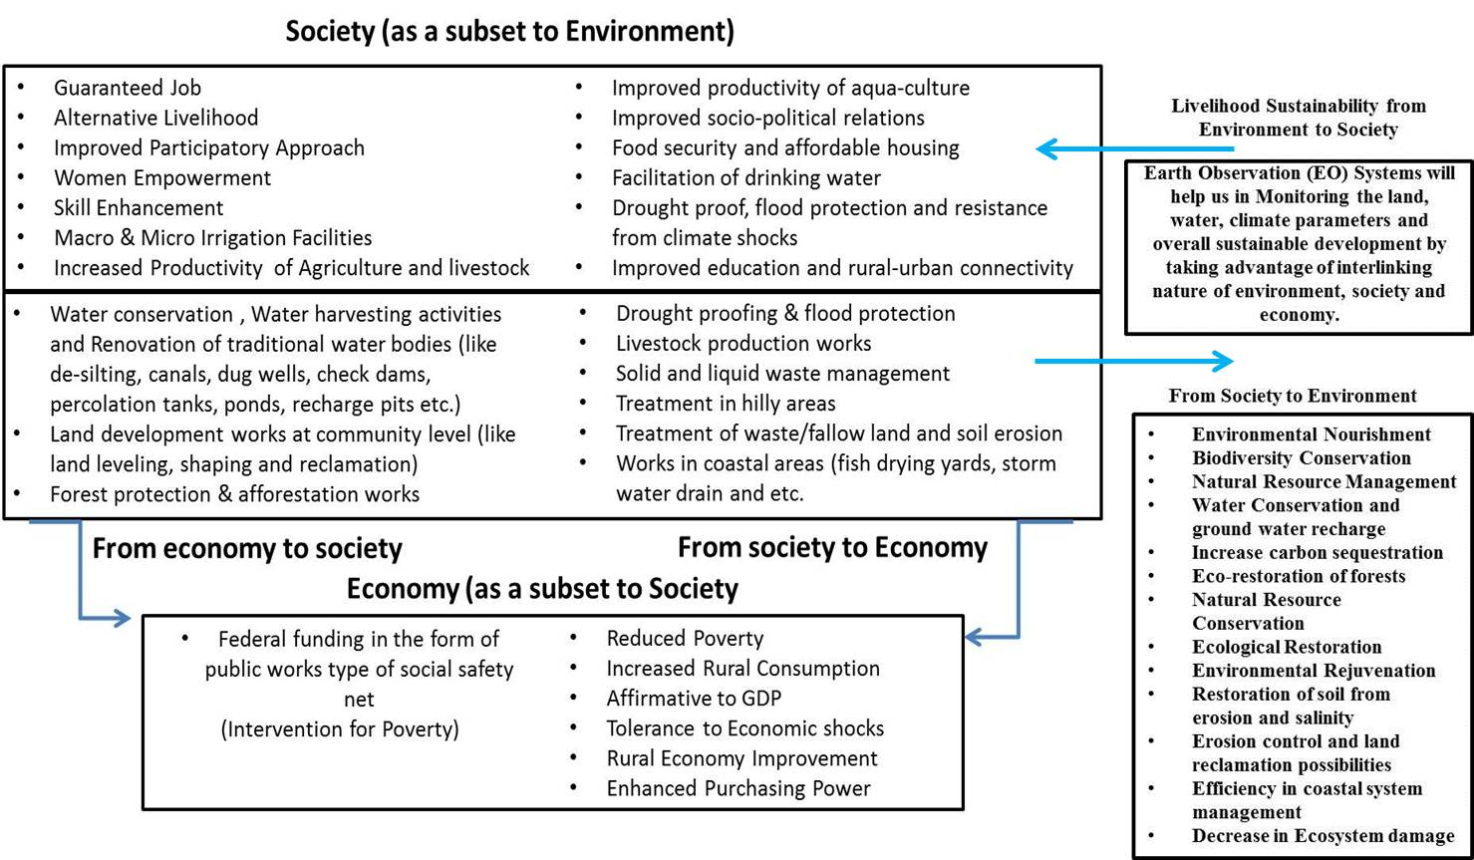
Figure 1 A depiction of interactions between the three pillars of Sustainable Development due to the interventions like public works on Natural Resources.

ICT was identified as a tool that would enable the transparency in the process of MGNREGA due to the large size of the programme, geographical extent, financial implication, beneficiaries and stakeholders. ICT confirms transparency and supports in information dissemination, facilitates online monitoring and evaluation of the programme (Reddy, 2013). A dedicated web portal exists for the social reporting of project proceedings and to support the ‘Right to Information’ act. The portal offers brief information about the active works, completed works and growth of assets. The backend management information system (MIS) facilitates reporting of benefits accrued in the NREGA program (NREGA Web Portal, 2019). The geo-tagged assets have been put in the public domain under a portal titled GeoMGNREGA which is built on Bhuvan platform developed by Indian Space Research Organisation’s (ISRO). Bhuvan provides necessary online geospatial support to MGNREGA project through an integrated view of asset information. In GeoMGNREGA, there are supplies to visualize assets at the state, district and block level. Assets can be visualized based on the work category. The dashboard available at GeoMGNREGA provides statistical records of the Geo-tagged assets (MGNREGA Dashboard, 2018; GeoMGNREGA Dashboard, 2018; ISRO, 2016). Figure 2 represents the glimpse of Geo-portal which disseminates geo-tagged asset information to the public under MGNREGA project.
Study Area
MGNREGA execution is for the entire country with the sole exception of the urban population. Phase I was first implemented in 2006 in the 200 poorest districts in India. These districts were specifically targeted by the Planning Commission of India based on their backward status of Indian districts.

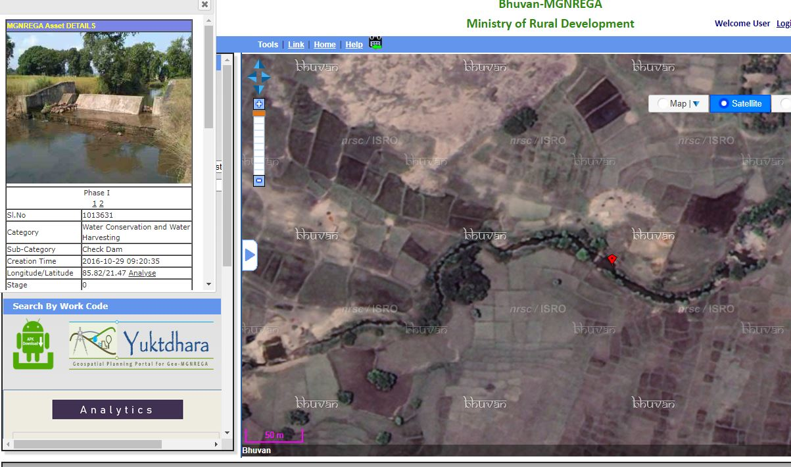
Figure 2 A screenshot of GeoMGNREGA web-portal, which facilitates the MGNREGA with evidence of a geo-tagged photograph of the asset. (Citizen view mode from GeoMGNREGA web portal)

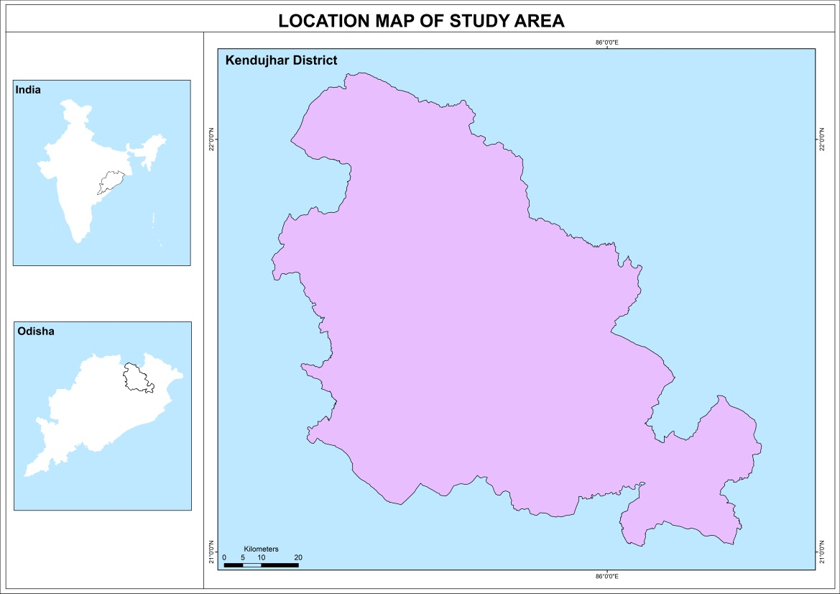

Figure 3. Keonjhar district of Odisha State, India

Kendujhar District is an administrative district of Odisha. The district is one of the fifth Scheduled Areas of Odisha. The town of Kendujhar (or Kendujhargarh) is the district headquarters. The district has three sub-divisions, Anandapur, Champua, and Kendujhar. On the eastern half of the district are the plains of Anandapur. To the west is a range of hills containing peaks such as Gandhamardan (3477 ft), Mankadnacha (3639 ft), Gonasika (3219 ft) and Thakurani (3003 ft). About half of the area of this district is covered by forests of Northern tropical deciduous type trees which include Sal, Asan, Jamu, Arjuna, Kusum, Kangada, Mahua, Mango, Kendu. The highlands contain of clusters of rugged crags and the mountain tops appear to be sharply ridged or peaked, they have extensive tablelands on their summits. In some areas, isolated hills rise abruptly from the plains but most areas have a general elevation of over 600m. The highlands form the watershed for a number of rivers, comprising the Baitarani River. On the eastern half of the district are the plains of Anandapur. To the west is a range of hills covering peaks such as Gandhamardan (3477 ft), Mankadnacha (3639 ft), Gonasika (3219 ft) and Thakurani (3003 ft).
The Geographical area of the district is 8,303 km^{2.} The district situated between 21° 0'46.44"N to 22° 9'34.61"N latitude and 85°11'3.49"E to 86°21'30.93"E longitude. About half of the area of this district is covered by forests of Northern tropical deciduous type trees which include Sal, Asan, Jamu, Arjuna, Kusum, Kangada, Mahua, Mango, Kendu. The highlands involve of clusters of rugged crags and the mountain tops appear to be sharply ridged or peaked. They have extensive tablelands on their summits. In some areas, isolated hills rise abruptly from the plains, but most areas have a general elevation of over 600m. The highlands form the watershed for a number of rivers, comprising the Baitarani River. The temperature in the district begins to rise rapidly in the spring with the highest temperatures recorded in the month of May usually go up to 38 °C. The maximum recorded temperature however is 43.3 °C. The weather cools during the monsoon in June and remains cool until the end of October. The temperature in the month of December can drop down to 7°C. The minimum temperature recorded was 1°C. The average annual rainfall is 1910.1 mm. According to the 2011 census, Kendujhar district has a population of 1,801,733. It is the 264th most populous district in India. The district has a population density of 217 inhabitants per square kilometre (560/sq mi). The concentration of Scheduled Tribes is the highest in the Keonjhar subdivision and lowest in the Anandapur subdivision. The majority of Scheduled Tribes members are employed in agriculture, mining or quarrying.
Database and Methodology
EO systems allow capturing the data from space, storing/archiving, managing and disseminating Remotely Sensed data via web-based GIS. The recent trend of EO technology has the capacity to progress the living standards of human beings, development of social economy and contribution to the SDGs (Paganini, & Petiteville, 2018). EO satellites obtains Very High Spatial Resolution (VHSR) images that are extensively exploited to create land cover maps to deal with agricultural, ecological and socio-economic issues as well as assessing ecosystems status, monitoring biodiversity and provide inputs to social problems (Gaetano, Ienco, Ose, & Cresson, 2018). Visual interpretation of high-resolution Remote Sensing (RS) data will able to detect activities like rural connectivity (new roads), rural sanitation facilities (toilets), irrigation works, drought proofing works like afforestation and tree plantation activities, land development activities, water conservation and harvesting activities. One of the derivable from EO data is the land use and land cover (LULC) change map which can be produced at required intervals, will not only essay the general view of land cover changes but also can best serve as a planning, monitoring, and evaluation tool. Table 1 shows some of the activities of MGNREGA that interact with the environment and also the geospatial evaluator of the interaction.

Table 1 Public works of MGNREGA that interact with Natural Resources and related Geospatial Evaluator
Activity under public works of MGNREGA | Interaction with Natural Resources | Geospatial Evaluator
- Works related to water conservation and water harvesting.  (Construction of check dams, stop dam, boulder check, underground dyke, farm bunds, earthen dam, mini percolation tanks, sub surface dam, sunken pond, water absorption trench, and etc.).  - Watershed management works.  (Construction of contour trench, contour bund, terracing, boulder check, gabion structures, sunken pond, spring-shed treatment, and etc.).  - Renovation of traditional water  bodies. (De-silting of the water-bodies, removing/cleaning of encroachments, removal of aquatic weeds, and etc.). | - Augments and improves groundwater recharge.  - Reduces, arrests soil erosion.  - Improves soil moisture profile.  - Controls the runoffs and reduces rate of siltation.  - Improves facilitation of drinking water.  - Improves water facility for livestock.  - Improves bio-mass production.  - Reduces the impact of low rainfall events on agriculture, livestock and drinking water.  - Increases the storage capacity of water bodies.  - Increases the water spread area.  - Increases the flow of water to downstream. | - During the construction phase these activities can be monitored using high resolution satellite data. Geoportals will enable to upload geo-tagged photographs during the construction from the field, and in turn will provide status of the work.  - The effects of water conservation and water harvesting structures on groundwater recharge and soil erosion can be studies using RS methods.  - Soil erosion studies can be done using RS methods. Microwave RS studies have proven to be predicting realistic estimations of soil moisture.  - The effects of soil moisture can be correlated with vegetation growth and hence this phenomenon can be monitored using NDVI techniques.  - National Remote Sensing Centre (NRSC)  monitors the status of all water bodies (nearly two lakh in count) in the country using multi-resolution satellite images. The estimated water spread area on the date of image is published in dedicated Water Body Information System (WBIS, 2019).
- Construction and renovation of micro and minor irrigation works (like canals, distributary and minor routing canals, lining of canals, correction of water conveyance system, correction of system deficiencies about outlet upto distributaries, and etc.). | - Facilitates water to agriculture purpose.  - Reduces the impact of  low rainfall events on the agriculture. | - Before and during the construction phase these activities can be monitored using high resolution satellite data.  - Studies related to water stress on agriculture can  be done using RS.
- Drought proofing works. Examples include eco-restoration of forest, reforestation, tree plantation, block plantation, avenue plantation, afforestation, grass land development, bio-drainage, plantation in government lands, and etc. | - Local natural and human production resource base should able to provide a certain desirable amount of food, fuel, fodder, drinking water and livelihood resources during a drought. | - Impacts of these studies can be done using RS  Indices along with drought prediction models.  - Studies related to eco-restoration of forest, afforestation, grass land development can be done using RS data along with socio-economic data.
- Springshed development (in mountain regions) like trenching, planting of trees, fodder grasses or hedges and gull plugging. | - To create source of water supply systems, enhance rainfall infiltration, recharge springs, revive dysfunctional traditional water harvesting systems. | - In the mountainous regions, most of the consumable water originates from springs. The uncertainty can be monitored using RS methods along with digital elevation models.  - Climatic factors, anthropogenic causes and the topography, vegetation cover, soil and geology of an area also affects the water availability in a region. These factors control the rainfall runoff and groundwater recharge and storage. Hence RS data can be used to monitor springshed management along with other in-situ data.
- Construction of Poultry shelter, goat shelter, fodder trough.  - Construction of buildings (like houses, food grain storage and etc.). | - Accrue of community level infrastructure.  - Housing facility for marginal and vulnerable groups and etc.,  - Food storage, security and other need based infrastructure. | - Can be seen in high resolution RS data using change detection techniques. Information systems will able to accumulate the filed photographs using controlled crowd sourcing methods.
- Fisheries (tanks, water harvesting ponds, landscaping of the bed and fish drying yards. | - Helps in boosting fisheries occupation. | - Can be monitored using RS data with high resolution and multi resolution data for coastal area development applications.
- Rural drinking water (soak pits, recharge pits), rural sanitation, solid and liquid waste management, flood management related, irrigation related (like canal, channel). | - To solve drinking water problems, facilitate irrigation facilities, and control the flood like events. | - Can be monitored using high resolution RS data. Water spread areas can be detected and mapped in RS data using multispectral data.
- Pro-forest activities like tree plantation, grass lands, nursery, afforestation activities, and etc. | - Increases forest cover and aids in conversion of wastelands to cultivable lands. | - Can be mapped using RS data. Portal titled Global Forest Watch can be used to monitor the forest lost and gain events.

Hence monitoring the food security struggles or agriculture activities is one of the important indicators for evaluating Social Safety Nets (SSNs). Land development works, drought proofing activities, soil conservation methods and irrigation facilitation will result in developed agriculture productivity. The measurement of vegetation signatures using RS sources has become a dangerous way to measure the effects of regional and global-scale agricultural production. The most common method for this is the Normalized Difference Vegetation Index (NDVI) technique. NDVI represents the belongings of climate and water on vegetation in terms of its absorptive capacity in visible light but little in the near-infrared spectrum. The difference between visible and near-infrared reflectance represents photosynthetically active vegetation. This information is recycled to construct a vegetation index. The lower value of the vegetation index indicates moisture pressure in vegetation, causing from prolonged water deficiency. Higher NDVI values might reflect ideal growing conditions if vegetation greenness is higher than that encountered in other years. Maximum NDVI gives the maximum NDVI value of the rising season and represents peak vegetation photosynthetic activity. Maximum NDVI contributes the trend of vegetation health for the studies which span over some years (Burgan, & Hartford, 1993; Bhatt et al., 2017).
Modern RS and GIS techniques are very useful for water resources management and conservation plans (Shakoor, Shehzad, & Asghar, 2006). Satellite-based Water Body Information Systems (WBIS) provides timely information about the water spread area and other resulting information. Usual forms of water bodies are canals, rivers, lakes, aquaculture/pisciculture (natural/man-made) based water bodies, reservoirs, ponds, irrigation facilities (like wells, tanks, and etc.) (WBIS, 2019). Most of the water from the water bodies is primarily used for agriculture, drinking water, cottage industries, and livestock production purposes in the rural areas.
The Rural population usually draw upon the outputs of trees and forest in their locality for various reasons like direct use by the household, such as fuel and food; inputs into the agricultural system, such as fodder and protection, sources of income and employment (Wackernagel, & Rees, 1998). Soil conservation works, afforestation, tree plantation, boundary plantation, agro-forestry, block plantation and agro horticulture works comprises in the program of this SSN. They have positive effects on the forest conservation by directly giving adequate purchasing power and dropping the dependency on forest resources. Hence forest area monitoring gives a suggestion of the need of the peri-rural population on the forest. Figure 4 shows the forest theme based web-GIS portal based called ‘Global Forest Watch’. These types of portals are highly valuable to monitor the changes in the forest areas.

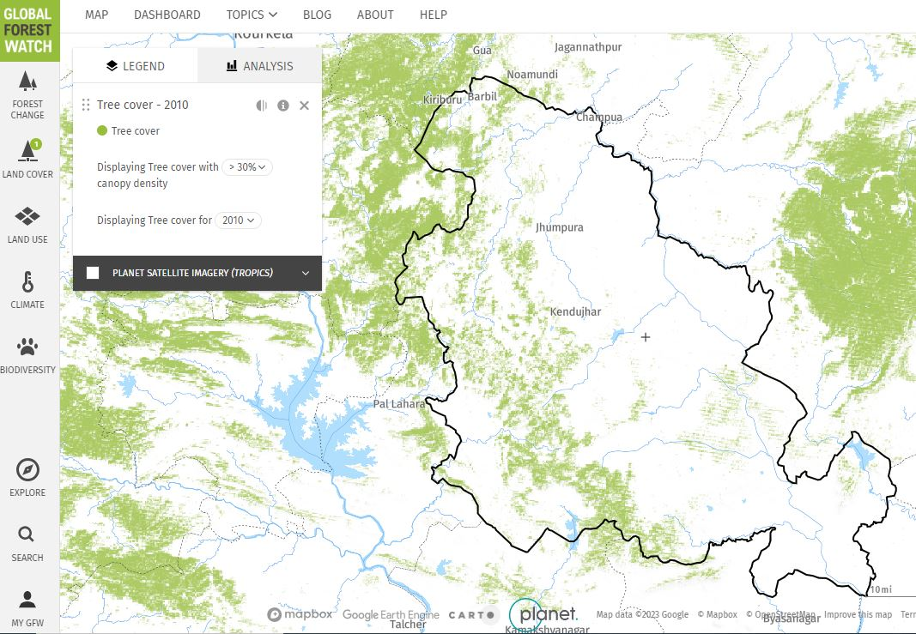
Figure 4 A screenshot showing Keonjhar district and surroundings in Global Forest Watch geo-portal Methodology

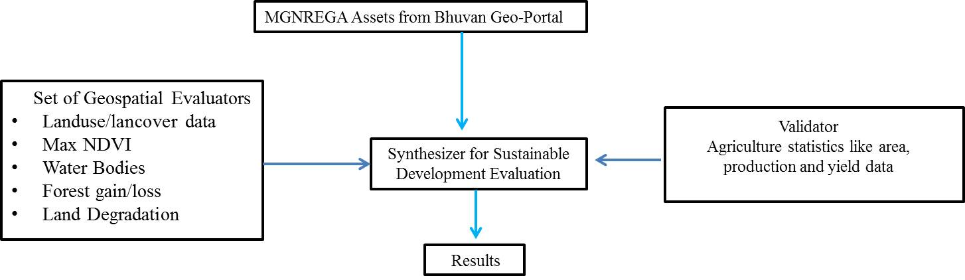

Figure 5. Methodology for rapid evaluation of sustainable development using Geospatial evaluators and agriculture outputs parameters as validators

- Maximum of NDVI (Max-NDVI) has been derived at agriculture fields from the RS imagery from the year 2009-2019 during cropping seasons, where the density of the assets is quite important and seems to be a hotspot.
• Analysis of water bodies was carried out in the study area from the year 2009 till 2019 to check for the indication of changes due to water harvesting and water conservation activity which has funded for enhanced ground water levels and increased water disposal for irrigation.
• Land degradation maps were produced for the years 2009 and 2019.
• The forest loss/gain was used as an indicator to measure the forestry component from global forest watch geo-portal.
Discussion
Public works under MGNREGA have progressed well in all the 13 blocks of the Keonjhar district. Dashboard (2019) indications that a total number of 2267 village clusters have actively participated in this program. A total of 575708 Lakhs workers were elaborate in MGNREGA program in this district. The study area contains more than 26389 assets over an area of 653900 Ha of

land. Table 2 depicts the total number of assets developed from the year 2009 till 2019. It is obvious that mostly the assets were for irrigation, water conservation, water harvesting, and drought proofing works. From the year 2017 and 2018, there is demand and increase in rural sanitation works in the study area.

Table 2. Year-wise MGNREGA assets details in the Keonjhar District

Year | No. of Assets | Dominant Asset Type
2009-10 | 1646 | Water Conservation and Water Harvesting, Renovation of traditional water bodies
2010-11 | 2832 | Farm Pond, Renovation of traditional water bodies, Bharat Nirman Sewa Kendra
2011-12 | 3725 | Works on Individuals Land (Category IV), Bharat Nirman Sewa Kendra, Water Conservation and Water Harvesting
2012-13 | 2901 | Works on Individuals Land (Category IV), Water Conservation and Water Harvesting, Renovation of traditional water bodies
2013-14 | 4697 | Works on Individuals Land (Category IV), Water Conservation and Water Harvesting, Renovation of traditional water bodies
2014-15 | 1135 | Works on Individuals Land (Category IV), Water Conservation and Water Harvesting
2015-16 | 15466 | Works on Individuals Land (Category IV), Land Development, Drought Proofing
2016-17 | 9587 | Works on Individuals Land (Category IV), Drought Proofing, Renovation of traditional water bodies
2017-18 | 34103 | Works on Individuals Land (Category IV), Drought Proofing, Renovation of traditional water bodies
2018-19 | 24600 | Works on Individuals Land (Category IV), Drought Proofing, Water Conservation and Water Harvesting

Source: MGNREGA Dashboard 2018; GeoMGNREGA dashboard 2018

Figure 6 depicts the LULC map for the year 2009 and 2019. On exploring the temporal LULC maps it sanctions that conversion of pockets of wastelands to agriculture practices. Figure 7 shows the Max-NDVI derived from the sampled areas at the hotspots that are having high intensity of land development activities, irrigation facilities and soil fertility development works. The Max-NDVI values over 250 samples show steep progress in the vegetation in the study area. The values of Max-NDVI have improved from 0.40 to 0.52 over a span of 10 years. Approximately 150 water bodies in the study area were analysed. Figure 7 represents the screenshot of GeoMGNREGA portal to retrieve the hotspots information of the works done under MGNREGA. Figure 7 represents the category wise hotspots for various assets at block level.

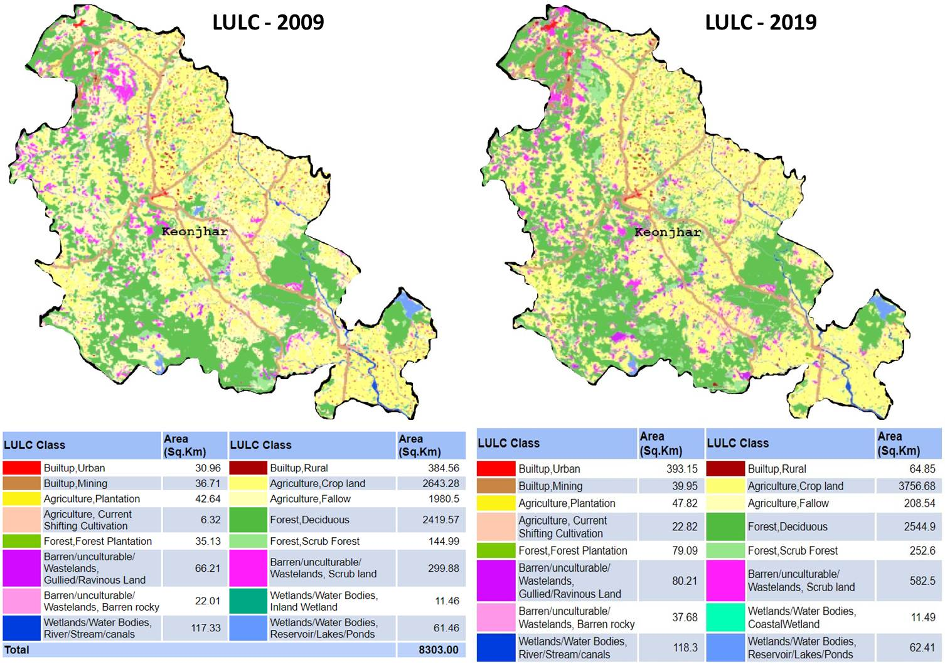
Figure 6. Land Use Land Cover (LULC) maps of Keonjhar district for the years 2009 and 2019

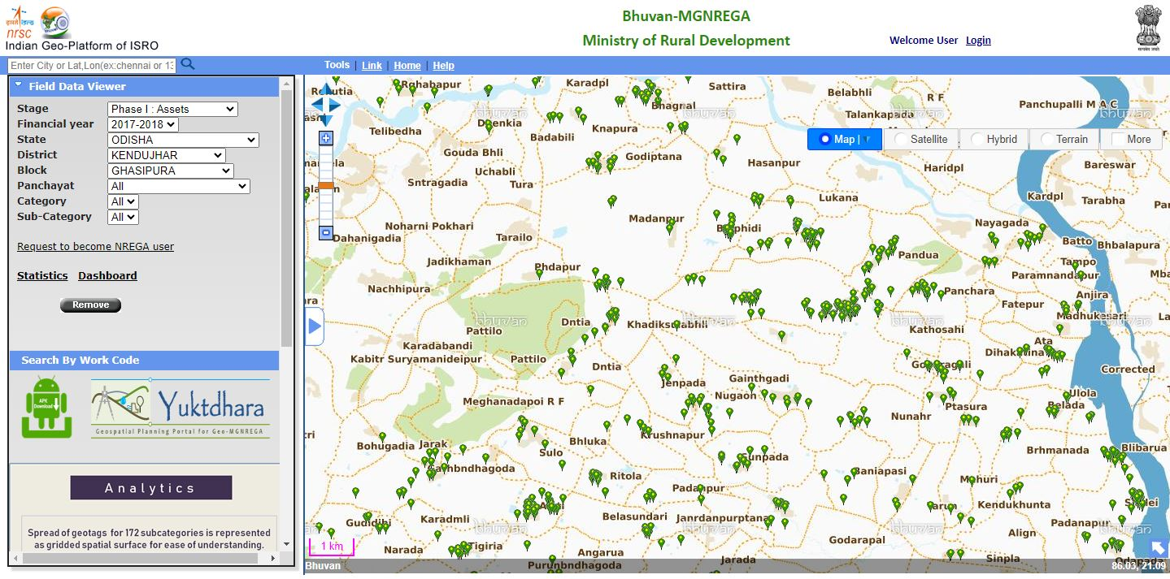
Figure 7. Spatial distribution of assets in the study area for the year 2017-2018 in block Ghasipura (figure captured in citizen view mode)
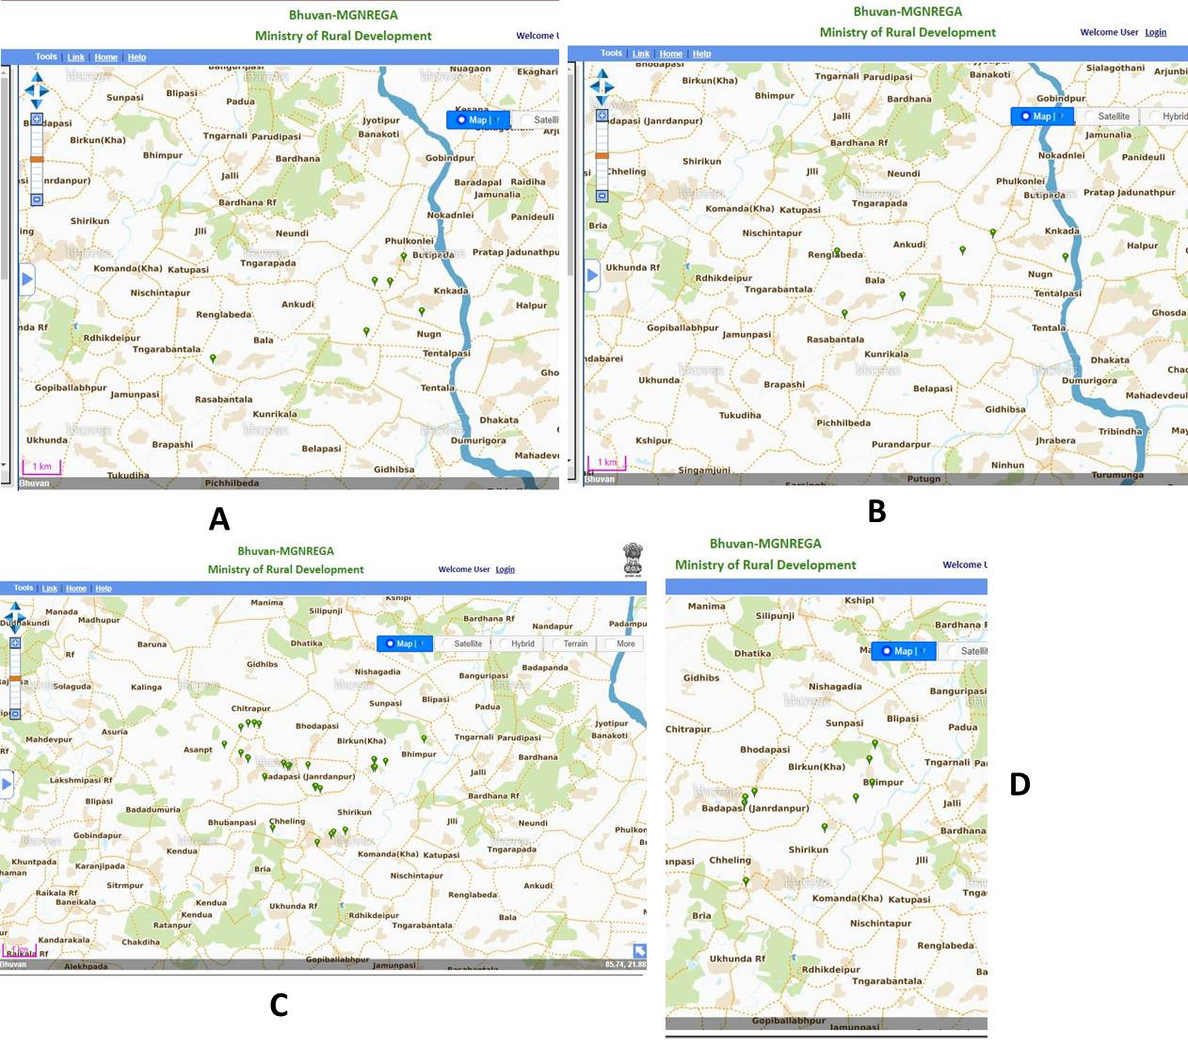
Figure 8. Hotspots of MGNREGA assets in Ghasipura block of Keonjhar district. A - Assets pertaining to Rural drinking water work. B - Assets pertaining to Drought proofing. C - Renovation of traditional water bodies. D - Water conservation and water harvesting

Table 3. Observation of changes from the geospatial evaluators in Keonjhar district from 2009 till 2019
Indicator | Observation
Satellite based LULC maps for the year 2009 and 2019 | From LULC derived through satellite data there is indication of changing wastelands regions into agriculture.
Max NDVI at peak cropping season | Max NDVI values over 250 sample points indications steep improvement in the vegetation. The values NDVI has improved from 0.40 to 0.52 over the span of 10 years.
Interpretation of waterbodies | Approximately 150 water bodies in the study area where analyzed. The reflection is that majority of water bodies’ exhibits excellent recharge and water spread area.
Interpretation of Forest cover from Global forest watch portal | There is no change in the forest cover. For the year 2009 the area of the forest cover is 2420 Ha and the figure is 2545 same for 2019 also.
Land degradation and erosion | Traces of enhancement in land degradation and erosion were detected in the temporal analysis of land degradation data.
Agriculture Productivity | From the statistics of agriculture productivity it is detected that there is significant growth in total cropped area, net area irrigated (through canals and tanks). There is growth in total area for food grain and also its productions. The area of principal crop (rice), production and yield were also improved significantly.

Table 4. Agriculture statistics (2009 – 2019) for Keonjhar district

Year | Gross Cropped Area '000 Ha. | Gross Area Irrigated ' 000 Ha. | Gross Area used for food grains '000 ha. | Production in '000 Tonnes | Food grain- Yield Kg per Ha. | Gross area for Rice '000 ha. | Production of Rice in '000 tonnes | Rice - Yield Kg per Ha.
2009-10 | 426.26 | 73.86 | 299.74 | 360.17 | 1202 | 195.51 | 282.17 | 1443
2010-11 | 414.28 | 96.26 | 211.32 | 245.41 | 1161 | 181.38 | 191.57 | 1052
2011-12 | 394.63 | 74.37 | 269.63 | 331.74 | 1675 | 171.46 | 293.73 | 1713
2012-13 | 426.26 | 114.23 | 275.14 | 333.01 | 1675 | 170.65 | 283.99 | 1664
2013-14 | 393.33 | 123.55 | 275.6 | 375.84 | 1364 | 175.37 | 272.65 | 1664
2014-15 | 400.27 | 138.33 | 277.89 | 510.62 | 1837 | 175.8 | 412.75 | 2348
2015-16 | 391.92 | 135.55 | 277.29 | 312.06 | 1125 | 182.9 | 206.98 | 1132
2016-17 | 407.43 | 178.22 | 291.6 | 530.67 | 1820 | 192.84 | 422.25 | 2190
2017-18 | 400.29 | 136.62 | 283.35 | 503.44 | 1777 | 188.36 | 395.04 | 2097
2018-19 | 363.68 | 185.55 | 251.36 | 473.69 | 1885 | 160.69 | 367.34 | 2286

Table 3 shows the results achieved for the study. It is detected that there is an improvement in terms of land development for agriculture productivity. Results also confirm that water harvesting activities have a positive impact in the study area for providing drinking water and irrigation facilities. The farmers, who used to face water crisis during drought, are now happy after digging the farm ponds in this region. The farm ponds assisted in storing rainwater and increasingly raised the groundwater level in surrounding areas. The essential moisture for the fields is available throughout the year. Although farmers were aware of the concept, many were unable to implement the impression given the cost of digging ponds earlier, but through MGNREGA this was made possible. From the visual interpretation of high-resolution satellite data, there is indication of enhancement in the renovation of degraded and eroded lands.
Numerous water renovation works were happened in MGNREGA project in Keonjhar district. The results are evident in the VHSR Remote Sensing data, one example is shown in figure 9 where the restoration works have influenced the water spread area. Similarly it shows an area where sustainable land use pattern have overcome due to land development activities.

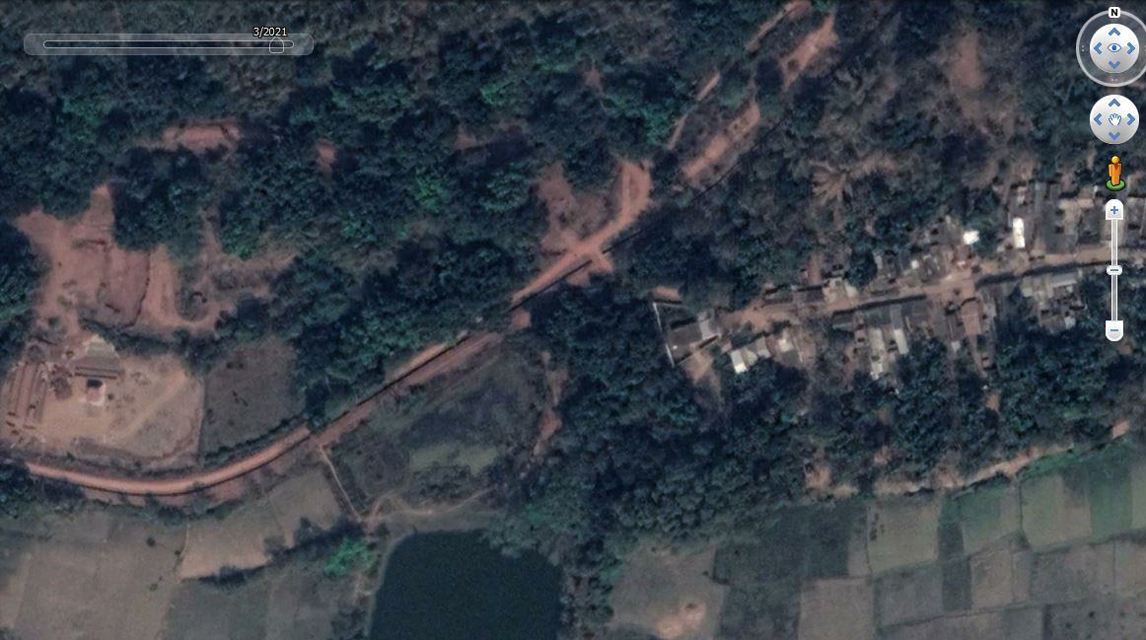
A
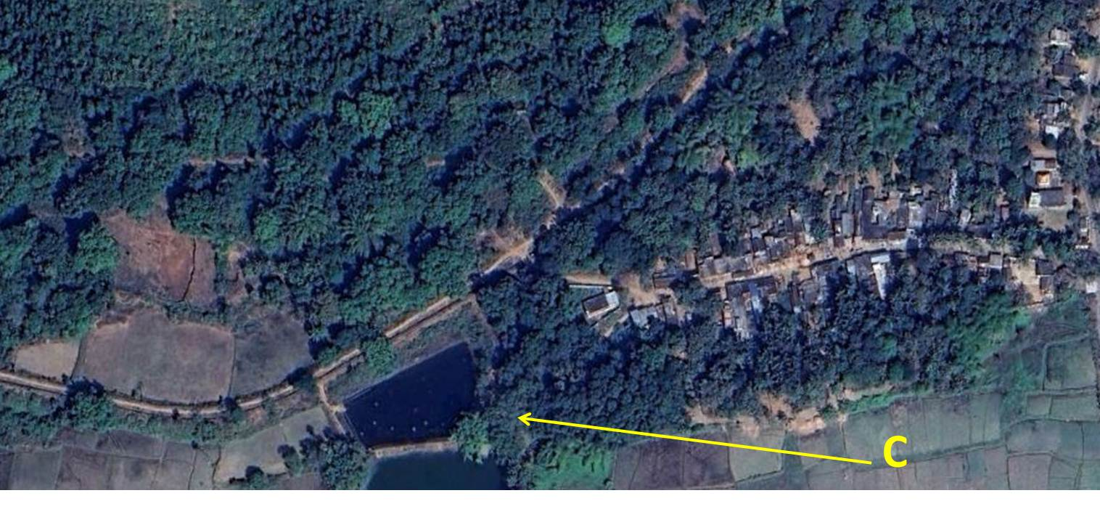
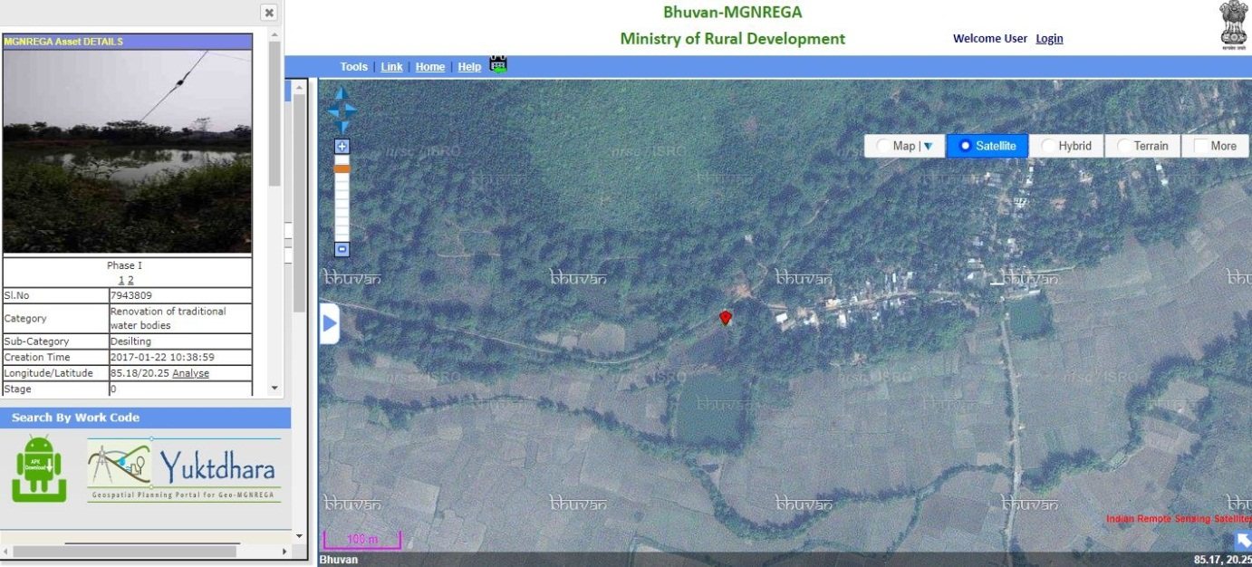
B

Figure 9. Restoration of minor irrigation tank through MGNREGA public work in Keonjhar District. (A) Satellite data of date March 2017 showing the reservoir with less water spread area. (B) GeoMGNREGA application showing details of assets at the reservoir. (C) Satellite data of date March 2018 showing the reservoir with more water spread area.

Conclusion
The study concludes that the benefits that are increased due to assets of MGNREGA public works. The results approve that MGNREGA assets are successfully aiding for educating sustainable living and exhibits positive impact on the natural resources. Activities like water conservation and water harvesting have caused in facilitating irrigation and drinking water in the study area. Renovation procedure of traditional water bodies and water harvesting structures have led to improved water availability and hence growth in area under irrigated crop production. Most of the minor irrigation tanks have been renovated to their actual capability. The results of this leading scheme have helped green revolution and blue revolution in this part of the study area. The study explains that the public works under MGNREGA are generous the positive results in all three dimensions of SD in the form of durable rural infrastructure in the dimension of society, improves the sustainable eco-restoration procedure for the environmental dimension and spend-ability by rural section increases the economic dimension at the national scale. The study confirmed the usage of geospatial technology to measure the benefits that are accrued in terms of environment and socio-economic levels from the public works of MGNREGA.

References

- Allen, P. (1999), “Reweaving the food security safety net: Mediating entitlement and entrepreneurship,” Agriculture and Human values, 16(2), pp:117-129.
- Basiago, A. D. (1998), “Economic, Social, and Environmental Sustainability in Development theory and Urban Planning practice”, Environmentalist, 19(2), pp:145-161.
- Beegle, K., Coudouel, A., & Monsalve, E. (2017), “Realizing the Full Potential of Social Safety Nets in Africa”, World Bank, Washington, DC.
- Bello, O. M., & Aina, Y. A. (2014), “Satellite remote sensing as a tool in disaster management and sustainable development: towards a synergistic approach”, Procedia - Social and Behavioral Sciences, 120, pp: 365-373, https://doi.org/10.1016/j.sbspro.2014.02.114.
- Bhatt, U. S., Walker, D. A., Raynolds, M. K., Bieniek, P. A., Epstein, H. E., Comiso, J. C. … Zhang, J. (2017), “Changing seasonality of panarctic tundra vegetation in relationship to climatic variables”, EnvironmentalResearch Letters, 12(5). https://doi.org/10.1088/1748-9326/aa6b0b.
- Bose, N. (2017), “Raising consumption through India’s national rural employment guarantee scheme”, World Development, 96, pp:245-263. https://doi.org/10.1016/j.worlddev.2017.03.010.
- Burgan, R. E., & Hartford, R. A. (1993), “Monitoring vegetation greenness with satellite data”, General Technical Report INT-297. Ogden, UT: US Department of Agriculture, Forest Service, Intermountain Research Station (13).
- Campagna, M. (2005), “GIS for sustainable development”, CRC Press, Boca Raton.
- Desai, S., Vashishtha, P., & Joshi, O. (2015), “Mahatma Gandhi National Rural Employment Guarantee Act: A Catalyst for Rural Transformation” National Council of Applied Economic Research, (7259), New Delhi.
- Devuyst, D. (2000), “Linking impact assessment and sustainable development at the local level: the introduction of sustainability assessment systems”, Sustainable development, 8(2), pp:67-78. https://doi.org/10.1002/(SICI)1099-1719(200005)8:2<67::AID-SD131>3.0.CO;2-X
- Esteaves, T., Rao, K. V., Sinha, B., & Roy, S. S. (2013), “Environmental Benefits and Vulnerability Reduction Through Mahatma Gandhi NREGS: A Synthesis Report”, Ministry of Rural Development, Government of India and Deutsche GIZ, New Delhi.
- Gaetano, R., Ienco, D., Ose, K., & Cresson, R. (2018), “MRFusion: A Deep Learning architecture to fuse PAN and MS imagery for land cover mapping”, arXiv preprint arXiv:1806.11452.
- Giribabu, D., Mohapatra, C., Reddy, C. S., & Prasada Rao, P. V. V. (2019), “Holistic Correlation of World’s Largest Social Safety Net and its Outcomes with Sustainable Development Goals”, International Journal of Sustainable Development & World Ecology, 26(2), pp:113-128.https://doi.org/10.1080/13504509.2018.1519492.
- Grosh, M.E., Del Ninno, C., Tesliuc, E., & Ouerghi, A. (2008), “For protection and promotion: The design and implementation of effective safety nets”, The World Bank. Washington, DC.
- Indian Planning Commission. (2007), “Eleventh Five Year Plan. Government of India”, OUP, New Delhi. Vol. III.
- ISRO (2016), Retrieved from https://www.isro.gov.in/isros-geo-portal-bhuvan-gateway-to-indian-earth-observation.
- MGNREGA Dashboard (2018), Retrieved from http://mnregaweb4.nic.in/netnrega/nrega-reportdashboard/.
- MGNREGA Guide (2019), “Master Circular - A Guide for Programme Implementation FY 2018-2019” Retrieved from http://nrega.nic.in/Netnrega/WriteReaddata/Circulars/AMC_2018-19_nk_v3_21.03.18.pdf.
- Narain, P., Rai, S. C., & Bhatia, V. K. (1999), “Inter district variation of development in southern region”, Journal of the Indian Society of Agricultural Statistics, 52, pp:106-120.
- Nayyar, R. (2005), “Planning for the Development of Backward Districts (2005)”, Chronic Poverty Research Centre Working Paper. https://dx.doi.org/10.2139/ssrn.1756833.
- Paganini, M., & Petiteville, I. (2018), “Satellite Earth Observations in Support of the Sustainable Development Goals”, European Space Agency.
- Raju, N. A. (2015), “Land capability and suitability in Vizianagaram district of Andhra Pradesh using Remote Sensing and GIS techniques”, IOSR Journal of Humanities and Social Science, 20(7), pp:56-64.
- Ranaware, K., Das, U., Kulkarni, A., & Narayanan, S. (2015), “MGNREGA Works and their impacts”, Economic & Political Weekly, 50(13).
- Rao, S. N. (2014), “Economic restructuring programme: Naidus developmental experiment in Andhra Pradesh, 1995 to 2001” Centre for Political Studies, Jawaharlal Nehru University.
- Shakoor, A., Shehzad, A., & Asghar, M. N. (2006), “Application of remote sensing techniques for water resources planning and management”, In Advances in Space Technologies, 2006. International Conference, IEEE, pp:142-146.
- Singh, R. K., Murty, H. R., Gupta, S. K., & Dikshit, A. K. (2009), “An overview of sustainability assessment methodologies. Ecological indicators”, 9(2), pp: 189-212. https://doi.org/10.1016/j.ecolind.2008.05.011.
- Subbarao, K., Del Ninno, C., Andrews, C., & Rodríguez-Alas, C. (2012), “Public works as a Safety Net: Design,Evidence, and Implementation” The World Bank, Washington, DC.
- Tiwari, R. et al. (2011), “MGNREGA for Environmental Service Enhancement and Vulnerability Reduction : Rapid Appraisal in Chitradurga district, Karnataka”, Economic & Political Weekly, 46(2).

