Fenton Oxidation process for treatment of waste water containing dyes

Seema Shrivastava Sumita N. Rao
Department of Applied Chemistry Department of Applied Chemistry
Priyadarshini College of Engineering, Priyadarshini College of Engineering,
Nagpur, India Nagpur, India
seemashrivastava@rediffmail. sumita2000@rediffmail.com

I INTRODUCTION
Dyeing is one of the most important process in textile industry, which imparts colour to the fabric and makes it attractive. Since ancient times, natural fabric dyes were used all over the world. Several plants and animals were used to produce various natural dyes for the fabrics. In 1070 BC the Tai Kang of the Xia Dynasty used purple dye, which was obtained from the tropical Murex Snails. Large amount of snails was needed to produce an ounce of dye. In 1856, William Henry Perkin discovered the first synthetic dye, mauveine. Since then many acid, basic, reactive, mordant, vat, azoic, sulfure dyes were synthesized and found numerous applications in dyeing industries.
Synthetic dyes are mainly classified on the basis of their applications and structures. They consist of different functional groups which are responsible for colours and are known as chromophores. These dyes contain complex aromatic amide groups with alkyl, halogen, nitro, hydroxyl, sulfonic acid, substituent(s), and inorganic sodium salts (1). Industrial dyes contain azo, anthraquinone, sulfur, triphenylmethyl, and phatalocianine groups in their structure which are generally toxic and carcinogenic.
Textile industries are known for their high water consumption as well as the quantity and variety of chemicals used throughout the different operations. The common textile processing technology consists of desizing, scouring, bleaching, mercerizing and dyeing processes ((2), which consumes a large volume of water at every step. Estimation shows that approximately 100 L of wastewater / kilogram of textile product are generated (3). In dyeing process, several other chemicals along with dyes are also used to improve the affinity between dye and the fabric. The unfixed reactive dyes are highly soluble in water and contain a significant non bio-degradable colour causing residues.
The effluents of dye houses are characterized by high organic matter, colour, COD, different breakdown products and byproducts. World wide growth of textile industries is responsible for large volumes of liquid dye waste discharge. This causes a serious adverse impact on all forms of life and severely affects the aesthetic properties of aquatic environments. This is the reason for the legislative binding on dye houses to treat their discharges at the source prior to release into nearby water bodies. Various treatment methods viz., chemical, physical and biological processes (4) were explored to waste water discharged from textile industry but due to its complex nature it is difficult to treat using a single treatment method, hence these treatment methods are generally used in combinations.
Each treatment process has its own advantages and disadvantages, which makes their application limited. Different technological approaches for the tretament of such recalcitrant wastes have been investigated in detail and classical chemical treatments and Advanced Oxidation Processes (AOPs) are found to be most effective. Oxidation by ozone of various organic compounds has been reported by different investigators (5, 6]. Ozone has proved to be a suitable reagent for effective color removal. Waste waters containing several types of reactive dyes were pretreated or treated using ozone oxidation to increase the biodegradibility of colour imparting toxic wastes (7-8). Serdar Dogruel, at., el. (9) reported complete colour removal from cotton finishing textile effluent containing dyes using ozone oxidation technique. Oxidation with Ozone is proven to be more efficient in reduction of colour as compared to reduction in Chemical oxygen demand (COD) (10). The major advantage of ozonolysis is that there is no generation of sludge but it is very expensive when applied to large volumes of waste water.
Since past 30 years, lot of research is being done to explore the efficiency of AOPs in treating different wastewaters that contain refractory and toxic pollutants (11Balcıoğlu et al. 2003). N. Azbar at el conducted a comparative study of various AOPs (O3, O3/UV, H2O2/UV, O3/H2O2/UV, Fe2+/H2O2) and chemical treatment methods using Al2(SO4)3 · 18H2O, FeCl3 and FeSO4 for the degradation and decolorisation of polyester and acetate fiber dyeing effluent. The process was found to be better with 98% decolorisation and 99% degradation, which is 50% and 60% respectively in case of other chemical treatment processes (12). The study showed that Fe2+/H2O2 was more economical choice for the acetate and polyester fiber dyeing effluent in the removal of color and reduction in COD.
Fenton process is capable of completely degrading contaminants and converting them into harmless compounds (13). An effective destruction of chromophoric structure of Azo dyes and its degradation by this process depends upon on the structure and nature of auxiliary groups attached to the aromatic nuclei of the dyes. The limitations of Fenton’s process include high chemical consumption of Fe ions, pH dependence (effective in the range of pH 2–4), use of costly H₂O₂, generation of Fe sludge, necessity of post-treatment, and neutralization necessity of the treated sample before disposal (14-16).
Continuous research is in progress to modify the conventional Fenton method for enhancing the oxidation efficiency and reduction in operative costs. Homogeneous Photo-Fenton and photo Fenton-like processes have been widely reported for the treatment of colored effluents, due to the generation of strong ·OH to destroy organic pollutants considerably (17-19), still the sludge processing cost and the narrow pH range of the treatment system remain the limiting factors. To some extent the photo Fenton with heterogeneous catalyst (20- 21) is found capable to achieve the reduction in consumption of Fe ions and avoid generation of metal containing sludge, which require costly post treatment of treated effluent (22-25).
A wide range of toxic and recalcitrant organic contaminants is treated using Electrochemical AOPs, which is emerging, as a promising field of dye waste treatment (26). Advantages of this process includes its compactness, simplicity, easy operation, energy efficient, versatility, cost effectiveness, amenability to automation, and environment friendly nature (27-30).
Based upon the extensive research work carried on AOPs, they are found to be better options for pretreatment and advanced treatment process for the decolorisation and mineralization of various types of textile wastewaters. Reagents used in the process are readily available, easy to store, safe to handle, and not harmful to the environment. The process can also be performed at ambient temperature and pressure without a complex system.
A case study on treatment of synthetic dye bath waste using Fenton method is discussed. The experiments were conducted to study the feasibility of use of pickling waste as a source of iron catalyst. The present case is not only exploring the alternative source of costly FeSO4, but also offers a treatment solution of effluent produced by two major industries, which are textile and steel mills (31).

Case study: Use of pickling waste as an inexpensive iron source for fenton oxdidtion of synthetic dye bath waste
In the present case study, the well-known Fenton’s oxidation method has been employed with the use of waste pickle liquor as the source of iron catalyst. Pickling waste has been generally considered as an alternative to conventional coagulants in effluent treatment [32]. Its application as a source of catalyst was first time reported in the study.

II Materials and methods:
Reactive Blue 4 (RB4, Color Index No.: 61205) and Reactive Orange 16 (RO16, Color Index No.: 17757) used for the study, Pickling waste was obtained from the pickling operations at a steel plant. Analytical grade H₂O₂ (30% w/v), NaCl, Na₂CO₃, NaOH, Urea, Sulfuric acid (98%) and Ferrous sulfate were procured from E. Merck India Pvt. Ltd.
Synthetic dye bath wastewater was prepared according to the cotton fiber dyeing procedure typically applied in the factories [9]. The composition of dye bath wastewater was as follows: RB4-100 mg/l, RO16-25 mg/l, NaCl-50 g/l, Na₂CO₃-5 g/l, NaOH-2 g/l and urea-1.5 g/l. Initially the dyes were dissolved separately in hot water (65 ⁰C) and then mixed with the appropriate amounts of NaCl, NaOH, Na₂CO₃ and urea. The initial chemical oxygen demand (COD) of the simulated dye bath waste was found to be 420 ±10mg/L. Prior to use, total iron content in the pickling liquor was determined as 79–81 g/L which was present as Fe²⁺ (64 ± 0.05 g/L) and Fe³⁺ (16 ± 0.03 g/L).
Fenton’s oxidation experiments using pickling liquor as a source of iron catalyst were performed in a 4-beaker (1 L) Jar Testing apparatus (KI-89 Flocculator). Test solutions were stirred at 100 rpm, keeping pH at 3.5–4.0. After the experiment the test samples were collected, pH adjusted to >7.0 to remove soluble iron catalyst as sludge and the supernatants were analyzed for different parameters; COD and concentrations of the RB4 and RO16. Different set of experiments were done to optimize contact time and the doses of Fe²⁺ and H₂O₂.

III Analysis of samples
Concentrations of RB4 and RO16 were determined by measuring absorbance at λ_{max} 599 and 493nm, respectively, using Systronics 166 UV–VIS spectrophotometer. Tests for COD were performed according to Standard Methods [32]. The COD results reported are within 5% batch-to-batch error.

IV Results and discussion
A. Optimization of contact time:
Degradation and de-colorization of reactive dyes RB4 and RO16 present in synthetic dye waste in the experiment using pickling liquor were studied at different time intervals i.e., 30, 60, 90, and 120 min, at 1.79mM of Fe²⁺ dose and 26.4 mM H₂O₂.Table 1 shows the residual concentration of dyes and COD at different contact times with corresponding percentage removal. Although decrease in colour is observed at each case but maximum decrease is observed at 120 min. RB4 shows a decrease in concentration by 23.2% whereas RO16, decreases by 16% with 40% of decrease in COD values. Rate constant [k] values obtained from the plots 􏰂−log [(C₀ − C_{t})/C₀] versus time (Fig. 1) for the de-colorization of the dyes in the synthetic dye bath waste are 8.6 x10⁻³ and 2.4 x 10 ⁻³min⁻¹for RO16 and RB4, respectively. The result indicates that RO16 decolorizes four times faster than RB4. −Simultaneously, about 40% reduction in COD concentration is obtained. The corresponding k value obtained from the plot of 􏰂−log [(COD₀−COD_{t})/COD₀] versus time (Fig. 2) is 5.7 x 10⁻³ min⁻¹.

Table 1: Optimization of contact time
Time  (min) | RB4 C₀= 100 ppm |  |  |  | RO16 C₀ = 25 ppm |  |  |  | COD₀ = 420 ppm
 | (Ct)  (ppm) | Cª | -log C | %R^{b} | (Ct)  (ppm) | C | -log C | %R | C_{t} (ppm) | X | -log X | %R
30 | 87.9 | 0.12 | 0.91 | 12.1 | 24.29 | 0.028 | 1.54 | 02.84 | 368 | 0.124 | 0.906 | 12.4
60 | 81.0 | 0.19 | 0.72 | 19.0 | 22.11 | 0.115 | 0.93 | 11.86 | 352 | 0.162 | 0.79 | 16.2
90 | 80.0 | 0.20 | 0.69 | 20.0 | 22.00 | 0.120 | 0.92 | 12.00 | 320 | 0.238 | 0.623 | 23.8
120 | 76.8 | 0.23 | 0.63 | 23.2 | 21.65 | 0.160 | 0.79 | 16.00 | 250 | 0.40 | 0.392 | 40.0

a) C= C₀−C_{t}/C₀,
b) %R = percent removal, X = COD₀ −COD_{t} / COD₀, Fe dose: 1.79 mM; H2O2 dose: 26.4 mM.

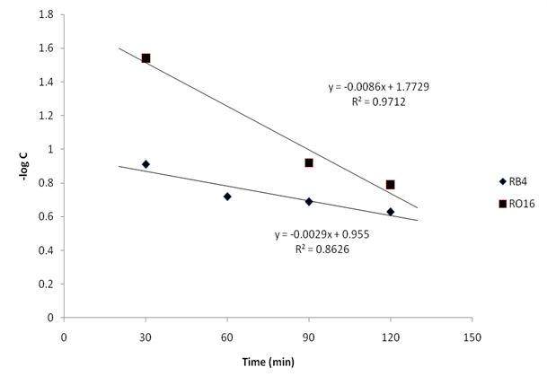

Figure 1: Effect of time on de-colorization of RO16 and RB4

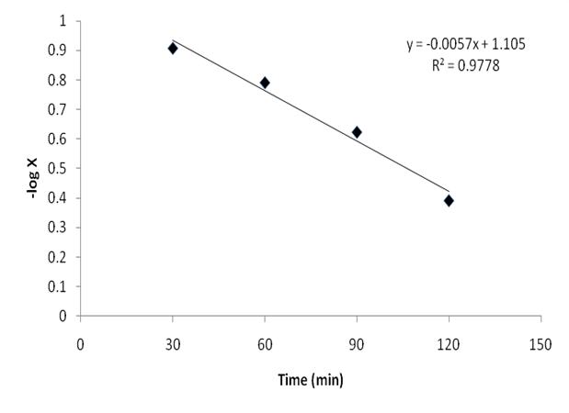

Figure 2: Effect of time on degradation of RO16 and RB4

B. Optimization of Fe dose:
Doses of Fe ²⁺ play an important role in de-colorization and degradation of dyes present in wastewater. In this case study the doses of Fe ²⁺ varied from 1.79 to 8.95 mM at a fixed dose of 26.4 mM H2O2 and the runs are carried out for 2 h. Observed values of de-colorization and degradation are shown in the Table 2. The plot of
[(C₀ − C_{t})/C₀] versus Fe dose shows the maximum colour removal, at 8.95mM of Fe²⁺ dose, which are 86% (RB4) and 92.5%(RO16). A plot of COD₀ − COD/COD₀ versus Fe dose indicates that initially there was little change in COD values with increase in Fe dose but about 56% COD is removed at 8.95 mM of Fe²⁺ (Fig. 4).

Table2: Optimization of Fe dose

Fe (ppm) | SVª (ml/l) | RB4 C₀= 100 ppm |  |  | RO16 C₀ = 25 ppm |  |  | COD₀ = 420 ppm
 |  | C_{t}(ppm) | C^{b} | %R^{c} | C_{t} (ppm) | C | %R | COD_{t}(ppm) | X | %R
100 | 60 | 76.8 | 0.232 | 23.2 | 21.65 | 0.16 | 16.0 | 250 | 0.404 | 40.4
200 | 150 | 34.7 | 0.653 | 65.3 | 13.8 | 0.448 | 44.8 | 260 | 0.38 | 38.0
300 | 190 | 27.7 | 0.723 | 72.3 | 13.8 | 0.448 | 44.8 | 247 | 0.411 | 41.10
400 | 250 | 19.4 | 0.81 | 80.6 | 1.87 | 0.925 | 92.5 | 238 | 0.433 | 43.30
500 | 260 | 13.8 | 0.862 | 86.2 | 1.87 | 0.925 | 92.5 | 184 | 0.562 | 56.2

a) SV = Sludge volume. b) C = C₀ −􏰂C_{t} / C0., c) %R = percent removal, X = COD₀ −COD_{t} / COD₀ (mL/L), Time: 2 h; H2O2: 26.4 mM

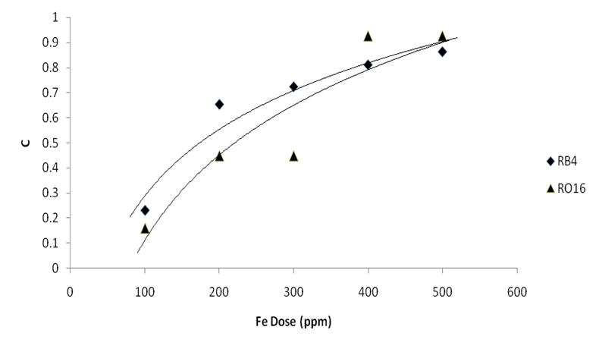

Figure 3: Effect of Fe dose on de-colorization of RO16 and RB4

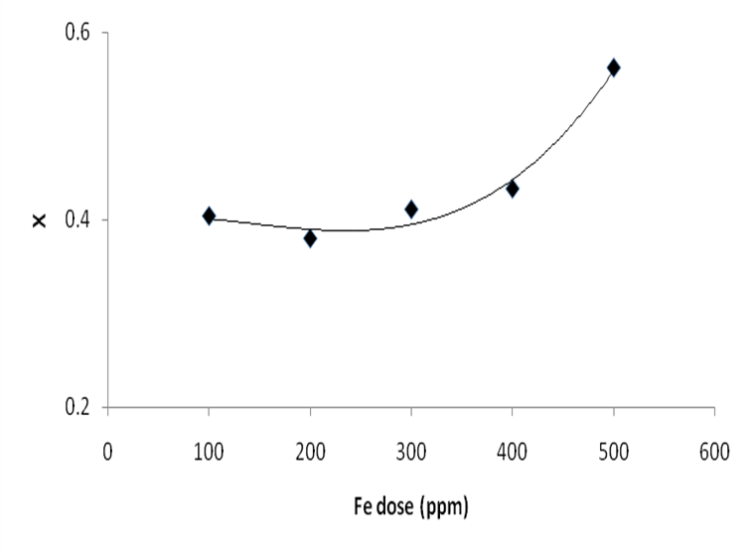

Figure 4: Effect of Fe dose on degradation of RO16 and RB4

C. Optimization of H₂O₂ dose:
Experiments conducted by varying the doses of H₂O₂ (3 to 11 mL/L), (26.4–97.0 mM), with fixed doses of 8.95 mM Fe²⁺ and 2h. contact time. Experimental values (Table3) clearly show a maximum percentage decrease in concentration of RB4 and RO16 in the treated samples is 90 and 98%. From the plots of [(C₀ − C_{t})/C₀] versus H₂O₂ dose (Fig. 5) and COD₀ – COD_{t} /COD₀ versus H₂O₂ dose (Fig. 6), it is observed that when H₂O₂ dose is increased there is an increase in the de-colorization and degradation of dyes initially. However, at higher H2O2 doses there is not much change. The optimum dose of H₂O₂ is found to be 7 mL/L (61.8 mM) at which a maximum of 62% reduction in COD is observed.

Table 3: Optimization of H₂O₂ dose; Time: 2 h; Fe dose: 8.95 mM.

H₂O₂  (mM) | RB4 C₀= 100 ppm |  |  | RO16 C₀ = 25 ppm |  |  | COD₀ = 420 ppm
 | C_{t} ppm | Cª | %R^{b} | C_{t} ppm | C | %R | (C_{t}) ppm | X | %R
26.4 | 13.8 | 0.862 | 86.2 | 1.87 | 0.925 | 92.5 | 184 | 0.562 | 56.2
44.1 | 12.5 | 0.88 | 88.0 | 1.35 | 0.946 | 94.6 | 172 | 0.59 | 59.0
61.8 | 10.4 | 0.90 | 90.0 | 1.0 | 0.96 | 96.0 | 160 | 0.62 | 62.0
79.4 | 8.02 | 0.91 | 91.0 | 0.85 | 0.97 | 97.0 | 180 | 0.57 | 57.0
97.0 | 7.05 | 0.92 | 92.0 | 0.50 | 0.98 | 98.0 | 185 | 0.56 | 56.0

ªC = C₀-Ct/C₀, ^{b} %R = percent removal, X = COD₀-COD_{t}/COD₀

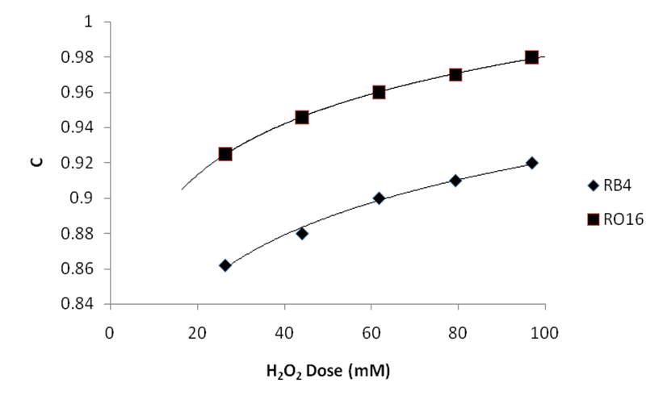

Figure 3: Effect of H₂O₂ dose on de-colorization of RO16 and RB4

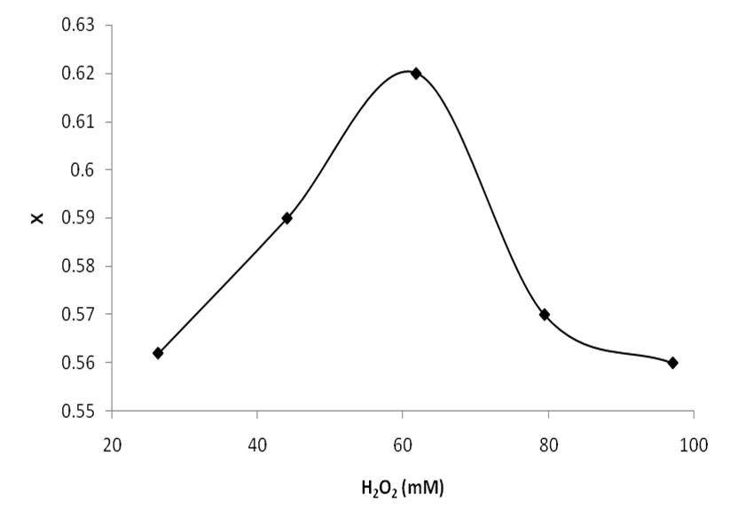

.

Figure 4: Effect of H₂O₂ dose on degradation of RO16 and RB4

V Comparison of pickling waste with FeSO₄
Comparable results are obtained by performing the experiment with FeSO₄, instead of pickling liquor, using optimized doses of time (2 h.), Fe²⁺ (8.95 mM) and H₂O₂ (61.8 mM). Observed values of degradation and de-colorization are given in Table 4. At the applied doses of Fe²⁺ and H₂O₂, use of pickling waste results in slightly higher sludge volume compared to FeSO₄, but the residual iron concentration in treated wastewater was slightly less when pickling waste was used. The comparative study shows that the pickling liquor can be used effectively as a source of iron catalyst in conventional Fenton’s oxidation for dye waste treatment.
It is significant from the linearity of plot of −log[(COD0 −CODt)/COD0] versus time (Fig. 2), with R2 > 0.97 that the oxidation reaction follows first order reaction kinetics [34].
H₂O + Fe²⁺ →∙OH + OH⁻ + Fe³⁺ (1)
Ferric ions produced in Eq. (1) react with hydrogen peroxide to produce hydroperoxyl radicals (∙OOH) and ferrous ions:
H₂O₂ + Fe³⁺ →∙OOH + H⁺ + Fe²⁺ (2)

Table 4: Comparison of pickling waste with FeSO₄

Fe²⁺ | Time  (min) | RB4 C₀= 100 ppm |  | RO16 C₀ = 25 ppm |  | COD₀= 420ppm
 |  | C_{t}(ppm) | %R | (C_{t})(ppm) | %R | COD_{t}(ppm) | %R
Pickling waste | 120 | 10.4 | 90 | 1.0 | 96.0 | 160 | 62
FeSO₄ |  | 10.4 | 90 | 0.9 | 96.4 | 200 | 52

(Fe2⁺dose: 8.95 mM; H2O2 dose: 61.8 mM)
Investigation on percentage decolorisation and degradation of RO16 and RB 4 dyes indicate that it increases with increasing both iron and hydrogen peroxide doses, however, it is observed that there is an optimum ratio of Fe^{2+/}H₂O₂ at which maximum de-colorization and COD reduction in 2 h can be obtained. Initially, when H₂O₂ dose was increased an increase in percent de-colorization was found, but the percent COD removal showed a maximum at 61.8 mM H₂O₂. At concentrations higher than 61.8 mM H₂O₂the degradation of dyes appears to be hindered as can be seen from Fig. 6. Earlier It has been reported that at higher concentrations, H₂O₂ reacts with available hydroxyl radicals to form water and oxygen in a wasteful reaction step [35], when a concentration higher than the critical concentration is used, the degradation rate of organic compounds decreases as a result of scavenging reactions (3), (4), (5) given below.
H₂O₂ + ∙OH → H₂O + HO₂ ∙ (3)
HO₂ ∙ + OH → H₂O + O₂ (4)
∙OH + ∙OH → H₂O₂ (5)
VI Conclusions
Based on the results obtained it is clear that the degradation and de-colorization of RO16 and RB4 by Fenton’s oxidation with pickling liquor as a source of iron catalyst is possible. The optimum doses of Fe^{2+/} and H₂O₂ conforming to 1:7 ratio achieved about 90 and 97% de-colorization of RB4 and RO16, and 62% reduction in COD was also found simultaneously. The experimental investigations clearly demonstrate that utilization of pickling liquor (steel industry waste) can provide a low cost alternative to FeSO₄ and a waste of one industry can be utilized to treat the waste of other industry.

References

[1] Technology of Synthetic Dyes, Pigments and Intermediates. New Delhi, Delhi: Engineers India Research Institute, 2005
[2] D. Rajkumar, Kim J, “Oxidation of various reactive dyes with in situ electro-generated active chlorine for textile dyeing industry wastewater treatment,” J Hazard Mater. ,136 (2), 2006, pp 203–212.
[3] FM Amaral, MT Kato, L Florêncio, S Gavazza. “Color, organic matter and sulfate removal from textile effluents by anaerobic and aerobic processes,” Bioresour Technol; 163, 2014, pp364–369.
[4] Y Anjaneyulu, N.S. Chary, and D.S.S. Raj, “Decolorisation of industrial effluents–available methods and emerging technologies–a review,” Reviews in Environmental Science and Bio/Technology, 4(4): 2005, pp 245-273.
[5] Jan Pertowski, lech Kos and Stanisaw Ledakowicz, “Application of Ozone in textile wastewater treatment; Ozone: Science and .engineering,: the journal of the international ozone association, 2008, pp73-85.
[6] R Hoda. Guendy, “Ozone treatment of textile waste water relevant to toxic effect elimination in marine environment,” Egyptian journal of Aquatic research, 33(1), 2007, pp98-115.
[7] S. Liakou ; S. Pavlou ; G. Lyberatos “Ozonation of azo dyes,” Water Sci. Technol. 35(4), pp 279–286.
[8] G. Ciardelli, G. Capanelli, and A. Bottino, “Ozone treatment of textile wastewaters for reuse,” Water Science and Technology, ,44 (5) 2001, pp 61–67.
[9] Serdar Dog ˇ ruel, Fatos¸ Germirli-Babuna, Is¸ık Kabdas¸lı, Gu¨clu¨Insel and Derin Orhon journal of chemical technology and biotechnology, 78, 2002, pp6–14.
[10] J. I Torregrasa, L. F. Navarro, P. Lopez, S. C. Cardona, A. Abad, and L. Capablanca, “Study of the ozonation of a dye using kinetic information reconstruction,” Ozone: Science and Engineering, 30, 2008, pp344-355.
[11] IA Balcioglu, I. Arslan, “Treatment of textile waste water by heterogeneous photocatalytic oxidation processes,” Environ Technol., 18, 1997, pp1053–1059.
[12] N. Azbar, T. Yonar, K. Kestioglu, Chemosphere, vol. 55, issue 1, April2004, pp35-43
[13] FJ Rivas, F Beltrán, O Gimeno, F Carvalho. “Fenton-like oxidation of landfill leachate,” J Environ Sci Health Pt A, 38, 2003, pp371–379.
[14] B Iurascu, I Siminiceanu, D Vione, MA Vicente, A Gil. “Phenol degradation in water through a heterogeneous photo-Fenton process catalyzed by Fe-treated laponite,” Water Res, 43, 2009, pp1313–1322.
[15] A Babuponnusami, K. Muthukumar, “Removal of phenol by heterogeneous photo electro Fenton-like process using nano-zero valent iron,” Separ Purif Technol., 98, 2012, pp130–135.
[16] Ali MEM, TA. Gad-Allah, MI. Badawy, “Heterogeneous Fenton process using steel industry wastes for methyl orange degradation,” Appl. Water Sci. 3, 2013, pp263–270.
[17] K. Wu, Y. Xie, J. Zhao, H. Hidaka, “Photo-Fenton degradation of a dye under visible light irradiation,” J Mol. Catal. A 144, 1999, pp77–84.
[18] TM Elmorsi, YM Riyad, ZH Mohamed, El Abd, HM. Bary, “Decolorization of Mordant Red 73 azo dye in water using H2O2/UV and photo-Fenton treatment,” J Hazard Mater, 174, 2010, pp352–358.
[19] B Archina, AR Abdul Aziz, WD Wan, Mohd Ashri, “Degradation performance and cost implication of UV-integrated advanced oxidation processes for wastewater treatments,” Rev Chem. Eng., 31, 2015, pp263–302.
[20] JJ Pignatello, E Oliveros, A MacKay, “Advanced oxidation processes for organic contaminant destruction based on the Fenton reaction and related chemistry,” Crit. Rev Environ Sci. Technol., 36, 2006, pp1–84.
[21] De la Cruz N, Gimenez J, Esplugas S, Grandjean D, de Alencastro L F, Pulgarin C. “Degradation of 32 emergent contaminants by UV and neutral photo-Fenton in domestic wastewater effluent previously treated by activated sludge,” Water Res, 46, 2012, pp1947–1957.
[22] Y Zhang, X Dou, J Liu, M Yang, L Zhang, Y Kamagata, “Decolorization of Reactive Brilliant Red X-3B by heterogeneous photo-Fenton reaction using an Fe-Ce bimetal catalyst,” Catal Today b, 126, 2007, pp387–393.
[23] M Tekbaş, HC Yatmaz, N Bektaş, “Heterogeneous photo-Fenton oxidation of reactive azo dye solutions using iron exchanged zeolite as a catalyst,” Microporous Mesoporous Mater, 115, 2008, pp594–602.
[24] Q Chen, P Wu, Y Li, N Zhu, Z Dang, “Heterogeneous Photo-Fenton photo degradation of Reactive Brilliant Orange X-GN over iron-pillared montmorillonite under visible irradiation,” J Hazard Mater, 168, 2009a, pp901–908.
[25] J An, L Zhu, Y Zhang, H. Tang, “Efficient visible light photo-Fenton-like degradation of organic pollutants using in situ surface-modified BiFeO3 as a catalyst,” J Environ Sci. (China), 25, 2013, pp1213–1225.
[26] Pipi ARF, I Sirés, AR De Andrade, E Brillas, “Application of electrochemical advanced oxidation processes to the mineralization of the herbicide diuron,” Chemosphere, 109, 2014, pp49–55.
[27] MC Gutiérrez, M. Crespi, “A review of electrochemical treatments for colour elimination,” J Soc Dyers Colour, 115, 1999, pp342–345.
[28] CA Martínez-Huitle, E Brillas, “Decontamination of wastewaters containing synthetic organic dyes by electrochemical methods: a general review,” Appl Catal B, 87, 2009, pp105–145.
[29] E Brillas, CA. Martínez-Huitle, “Decontamination of wastewaters containing synthetic organic dyes by electrochemical methods. An updated review,” Appl Catal B, 166–167, 2015, pp603–643.
[30] A Fernandes, MJ Pacheco, L Ciriaco, A Lopes, “Review on the electrochemical processes for the treatment of sanitary landfill leachates: present and future,” Appl. Catal. B, 176: 2015, pp183–200.
[31] F. A. Steward, W. J. McLay, “Waste Minimization and Alternate Recovery Technologies,” Alcoa Separations Technology, Inc., Warren dale, PA 1985.
[32] APHA, “Standard Methods for the Examination of Water and Wastewater,” 21st ed., APHA, Washington, DC 2005.
[34] N. P. Tantak, S. Chaudhari, “Degradation of Azo Dyes by Sequential Fenton’s Oxidation and Aerobic Biological Treatment,” J. Hazard. Mater., B136, 2006, pp698.
[35] C. G. Namboodri, W. K. Walsh, “Ultraviolet Light/Hydrogen Peroxide System for Decolorizing Spent Reactive Dye Bath Waste Water,” Am. Dyestuff Reporter, 85, 1996, pp15-25.

