CONCEPTUALIZATION OF KHARALIYA RASAYAN AS CORNERSTONE AMONG AYURVEDIC MEDICINES
CONTENTS-
- WHAT IS KHARALIYA RASA/ RASAYANA
- INTRODUCTION
- SUPERIORITY OF KHARALIYA RASAYAN AMONG OTHER RASAYAN
- PRINCIPLE OF KHARALIYA RASAYAN
- MECHANISM OF MARDAN & BHAVNA (TRITURATION)
- RATIONALITY BEHIND SELECTION OF LIQUIDS FOR BHAVANA
- CHARACTERSTICS OF SUBHAVITA & DURBHAVITA BHAVNA
- IMPACT & BENEFITS OF BHAVNA
- KEY FACTORS RESPONSIBLE FOR FORMATION OF NEW COMPOUND IN KHARALIYA RASAYAN
- GENERAL PREPARATION METHOD OF KHARALIYA RASAYANA
- ANCIENT INSTRUMENTS & MODERN EQUIPMENTS USED FOR KHARALIYA RASAYAN
- SIGNIFICANCE OF KHARALIYA RASAYANA
- EXAMPLES OF KHARALIYA RASAYAN
- CONCLUSION
- IMAGES OF ANCIENT & MODERN EQUIPMENTS
WHAT IS KHARALIYA RASA/ RASAYANA
Kharaliya means “a stone” used for grinding drugs, while Rasayana means “a medicine meant to prevent old age and sustain life with an elixir.” So, by combining the two words above, we get “Kharaliya Rasayan” which includes all medicines made by using Khalwa Yantra, a hand grinder that has been specially designed, this ready-made compound is a tonic that helps live long, monitor aging process, and treat diseases.
INTRODUCTION
Kharaliya Rasayan is one of the Rasaousadhi’s form (Mercurial preparation) considered to be the oldest form of Rasayan. These formulations are entirely prepared in Khalwa Yantra by adopting vigorous trituration process & final product which is achieved is referred as “Kharaliya” or “Khalviya Rasayana”. Here Khalwa Yantra which is used is similar to a “Mortar and Pestle” and this helps to grind the ingredients to make medicine. There are many different mercurial preparations, but most of them contains Kajjali (Black sulphide of Mercury). Kajjali which is the base of majority formulations has Sodhita Parad (Mercury) & Sodhita Gandhak (Sulphur) as ingredients. In addition it may also include dry herbs in powder form & other metals and minerals either in purified or incinerated form. So with inclusion of variety of ingredients, and mixing with appropriate amounts of fresh juices of various plants following Bhavna process repeatedly, an effective and new formulation can be devised. Thus the specialty of Kharaliya Rasayan is based on combining numerous drugs into a single entity and there by diminishing its dose along with reinforcing its response in body. Here dosage form is mostly in form of pills or tablets and sometimes powder.
SUPERIORITY OF KHARALIYA RASAYAN AMONG OTHER RASAYAN
Among other Rasayan like Parpati, Pottali, & Kupipakwa Rasayan, Kharaliya Rasayan holds a remarkable position due to its demand, extensive utility for therapeutic purpose and moreover its convenient way of preparation which doesn’t involves fire. If one dives through classical texts it can be found that Kharaliya Rasayan are countless while Parpati, Kupipakwa & Pottali Rasayan are nominal in their numbers. Another important point to be noted that on the basis of ingredients, other formulations like Parpati, Kupi Pakwa Rasayan and Bhasma can be itself one of the ingredients in Kharaliya Rasayan e.g. 1) Chandanadi Gutika contains Rasapushpa 2) Kravyada Rasa and Sudhasara Rasa contain Parpati 3) Vasantakusmakar Rasa contains Swarna bhasma, Abhraka bhasma, Mukta bhasma, Vidrum bhasma, Rasa Sindoora .
PRINCIPLE OF KHARALIYA RASAYAN
Mardana and Bhavana (Trituration) are the foundation on which Kharaliya Rasayana is prepared. Mardana is the procedure of breaking down drugs to reach a state of splitting, with or without a prescribed liquid while Bhavana is the procedure of grinding drug powders to a soft mass with liquid media and permit it for drying. Then further Bhavna cycles for number of times are continued as per classical text.
a) BHAVNA
(R.T 2/49) Yachchurnitasya Dhatuvadedravyahei sampesiya sosonam
Bhavnam tanmatam vigyabhavna cha nigadiyate ||
The fine powder of any drug material (i.e Dhatu etc Dravya) followed with specified liquid i.e. enough only to soak the above drug is taken in a clean Khalva Yantra. Then the process of trituration is continued until the soaked wet powder becomes dry again. This entire procedure is called as Bhavna or one Bhavna.
b) QUANTITY OF LIQUID FOR BHAVNA
In Bhavna, only required quantity of liquid that is enough to completely soak the fine powder of drugs is added and triturated until the powder becomes dry. If any Kwatha (decoction) is specified as Bhavna Dravya, the Kwatha has to be prepared by taking coarse powder of the Kwatha Dravya equal to that of Aousadha Curna whose Bhavna is to be given. (R.T 2/50-51)
Note-Preparation of Kwatha for Bhavna-The Kwatha Dravya along with 8 times water is taken in a clean vesselVessel subjected to mild fireBoiled till liquid reduced to 1/8 thLater the reduced liquid is filtered through a clothThis filterate used as decoction for Bhavna purpose.
(Srg.Samhita Ch-6/6) Dravena Yavta Samyak Churnam sarvam plutam bhavet
Bhavnayaha pramanam tu----------||
Quantity of Drava for Churna should be the total quantity of Churna gets submerged with liquid.
MECHANISM OF MARDAN & BHAVNA (TRITURATION)
The concept of "trituration" comes from the Latin verb "trituratio," which means to rub. When a drug is triturated with any liquid medium, the procedure entails achieving drug particles in such a minute condition that they easily break and there is a reunion of bonds in the substance generating the development of a completely new compound at the conclusion of the trituration method. Khalwa Rasayan grows all bodily tissues while tending to numerous secretarial organs and endocrine glands. The ingredients selected for a formulation are thoroughly triturated in Khalwa Yantra facilities to accomplish these goals.
RATIONALITY BEHIND SELECTION OF LIQUIDS FOR BHAVANA:
In classical writings, one or more Bhavna Dravyas are frequently included in the formulation of a Kharaliya Rasayan. The phytochemical ingredients and therapeutic efficacy of distinct Bhavna Dravyas determine the parameters used in Kharaliya formulations. Each drug's properties, as well as the disease state in which it must be used, are thoroughly examined, and a specific Bhavana Dravya or collection of Bhavana Dravyas are indicated for a given preparation. As a result, compound formulations are created on this basis, and they are established in clinical use through multiple trial and error combination methods. Some of the possible explanations for the preceding-
- Synergism- In this activity, when two or more medications with similar qualities are combined and processed, they amplify one another's action to produce an impact that would not have been feasible with any of the implicated substances alone For example, Jambiri Nimbu Rasa has been used as a single Bhavna Dravya for several compound formulations such as Agni Kumar Rasa and Sannipata Bhairavo Rasa, which display magnificent Jwaraghna (Anti-pyretic) property by amplifying each other's effect. While in the case of Gandhak Rasayan, several Bhavna Dravyas (11 dravyas) supplement just one ingredient, Suddha Gandhaka, to make it useful in a wide range of medical circumstances.
2.Antagonism- In this activity, when two or more drugs having opposing properties are mixed and processed, the negative effects of one another are reduced, and so the Gurvadi Guna (Heavyness etc.properties) of one another is neutralised. In many circumstances, the Tikshanta (sharpness character) of the drugs is significantly reduced. Amlatakra (Butter milk), for example, is utilised as Bhavna Dravya for Maricha(Black pepper) Sodhana; here, Maricha's Laghu (lightness)-Tikshna Guna (sharpness property), Katu Rasa (Pungent taste) Katu Vipaka (Post digestion taste is pungent), and Ushna Virya (Hot potency) are balanced by the exact opposite characteristics of Amlatakra, which have Amla-(Madhura (sweet) Rasa and Sheeta Virya (Cold potency) .As a result, there is some appetiser action.
- Bhavana Dravya counteracts the venomous impacts of Visha (Poisnous) Dravyas. Sunthi Swarasa's Bhavana, for example, cleans the hazardous drug Ahiphena (Papaversomniferum) 21 times.
2) As Bhavna dravya, Nimbu Swarasa, Adraka Swarasa, or Agastya Patra can be utilised to purify Manahshila. 3) The usage of Nimbu swarasa as Bhavna Dravya to cleanse Tuttha (Copper sulphate) aids in the enhancement of its harmful effects such as Vanti and Bhranti Dosa (vomiting and giddiness).
Bhavana Dravyas also aids in the removal of any bad taste or aroma from the finished product. Ex.1) Bhavna Dravya, such as Jambira Nimbu Swarasa, makes Anandabhairava Rasa more appealing.2) In the instance of Vasanta Malati Rasa, the Bhavana Dravya added is Draksha Kwatha, which aids in palatability, and Nimbu Swarasa, which adds a nice flavour to the final result, to the combination of five herbo-mineral drugs.3) Chichaphala (Tamarind juice) Rasa, utilised as Bhavna Dravya in Ramabana Rasa, neutralises the bitterness.4)The addition of Madhu (Honey) as Bhavna Dravya to Candramrita Rasa makes it some extent palatable with Madhura Rasa (Sweet) and Karpura Gandha.5) Similarly, the addition of Dhatri (Amlaki) Swarasa as Bhavna Dravya to Kamadugdha Rasa improves its palatability with Amla-Kasaya Rasa (Sour-Astringent).6)Bhavna Dravya, such as Adraka Swarasa (Ginger juice), contributes to the taste and scent of Kaphaketu Rasa.
SUBHAVITA AND DURBHAVITA BHAVNA CHARACTERS
After completion of Bhavna procedure, Subhavita (Proper Bhavna) has following characteristics like-
- Bhavita Curna can be made into a small round like mass.
- While giving pressure with fingers to Bhavita material, it gets pressed
- Touch (Sparsa)-Mridu (Soft)
Durbhavita (Improper Bhavna) has following characteristics`-
- Small round like mass of Bhavita material cannot be well formed
- While giving pressure to it, there will be seen cracks in boundary.
- Touch (Sparsa)-Khara (Rough)
IMPACT & BENEFITS OF BHAVNA
- Asaousadhies are absolutely non-toxic as a result.
- By enduring Samskaras such as Bhavna, Mardana, and others, the characteristics of Rasa Dravyas are changed and subsequently converted to fine particle size (reduction of particle size) so that it can be easily absorbed via the intestinal mucosa.
- Dravya is transformed from Nirendriya to Sendriya state (inorganic to organometallic complex) by changing its bio-assimilation, which serves as the foundation for a new target organ medical delivery method
- All of this is achievable due to process of Bhavna of Rasaaosadhies of plant/animal origin.
- Enhances therapeutic efficacy so that it can be given in tiny dosages;
- Improves medicine palatability; broadens therapeutic utility;
- Hardness is been reduced along with inclusion of qualities of Bhavna Dravya.
- Marana's Poorva Karma (pre-procedure).
KEY FACTORS RESPONSIBLE FOR FORMATION OF NEW COMPOUND IN KHARALIYA RASAYAN
- The mass, size, and nature of the drug particles;
- Amount of liquid to be added;
- The pressure and rhythm retained during the trituration process.
- Trituration time and surface area, humidity and room temperature, and so forth.
GENERAL PREPARATION METHOD OF KHARALIYA RASAYANA: .
STEP 1: Raw materials such as Rasaadi Dravya (Metals & Minerals), Vanoushadhi (Herbal Drugs), and Bhavana Dravya (Liquid media for trituration) are used.
STEP 2- In the initial phase of majority preparation, processing is done in the order of Kajjali (Black Sulphide of Mercury) Nirmana.
STEP-3- All other pharmaceuticals are added to produce a homogeneous combination with Bhavana- Niragni Samskara (Process without fire)
STEP-4-As needed, Vati & Guti(tablet form) Curna(powder) form, etc. and are done. This should be collected, dried, and stored in an airtight container for future medical use.
ANCIENT INSTRUMENTS & MODERN EQUIPMENTS USED FOR KHALWI RASAYANA
KHALWA YANTRA-
Khalwa Yantra is a trituration and levigation tool that includes a Mortar and Pestle. It is made of high-quality stone in a variety of sizes and forms. Activities like pounding/triturating various herbs and minerals in order to create new formulations are carried out here. This gadget can also be used to combine medications.
2 types of Khalwa Yantra is generally used for majority of pharmaceutical procedures they are-A) Vartulakara (Circular) Khalwa Yantra B) Dronirupa (Elliptical) Khalwa Yantra.
UTILITY OF K.Y-
Pounding or triturating different types of herbal (leaves, roots, tubers etc.) and mineral (Rasoparasa, Loha etc) drugs.
TAPTA KHALWA YANTRA-It is a mortar which comes in a variety of sizes and shapes, such as round, oblong and might be shallow or deep. It is generally built of iron/granite. During drug preparation, the mortar is usually kept over fire.
TAPTA K.Y’s UTILITY-Used for Parad Asta Samskara (8 pharmaceutical procedures of Parada), Sodhan of Rasa Dravyas (Purification of Parad).
MODERN EQUIPMENTS- Refinement is required in preparing Khalvi Rasayan to save man, money, and material power in the modern era. Fine particles, adequate mixing, consistent weight tablets, and the absence of moisture are all significant considerations while preparing on a large scale. Because drug bioavailability is directly proportional to particle size, various Samskara play a crucial effect.
LIST OF EQUIPMENTS WITH USE
Sl.No. | EQUIPMENT NAME | FUNCTION
1. | Disintegrator | Size of raw material are been reduced by using Disintegrator. Impact and grinding have an impact on size reduction .Nux-vomica seeds, ginger etc .Toughest medicaments can be grounded to small particle size.
2. | Pulverizer | Heavy materials, raw medicines are been grinded by using pulverizer. Here fineness of product ranges from mesh size 60 to 325. Heavy and sturdy construction, specially developed for medium fine and fine size reduction.
3. | Ball mill | It is highly useful for wet grinding smooth aqueous or oily dispersions. Here particle size which are produced are of micron size or even smaller.
4. | End Runner Mill | End Runner Mill can be compared to a mechanical mortar and pestle. Here pestle's bottom is flat rather than rounded and the mortar is shallow.
5 | Edge runner Mill | Highly difficult and fibrous material are converted into a very fine powder in Edge runner mill.
6 | Sieve shaker | Sieve shaker is utilized to segregate fine powder from coarse powder using the necessary number of sieves. Decreasing sequence are maintain to set up the sieves .Mechanical or electromagnetic devices are used to shake the sieves so that particles travel through these sieves easily.
7 | Polishing pan | Design of Polishing Pan is made out of a circular metal pan fixed on a stand in an angular fashion and a motor turns it on its horizontal axis. Tablets, Vati, Gutika, etc. gets its appropriate shine by its use.
8 | Pill Making machine | Pill making machine helps to maintain steady weight of pills.
9 | Mixer | Two or more ingredients are properly combine by using mixer, thus guarantees compositional uniformity.
10 | Grinder | Grinder is utilized when it is necessary to achieve both correct mixing and particle size reduction. In this case, size reduction is accomplished using the impact, blow, shear, or abrasion method. Here continuous pressure helps to breaks apart the particle.
11 | Vacuum drier, silica gel packs, air tight containers | Moisture can be avoided.

SIGNIFICANCE OF KHARALIYA RASAYANA

- Shelf life of herbal formulations can be extended.
- Dosage can be reduced
- Shorter treatment times.
- Safety and effectiveness for both mercury and botanicals are all possible.
- Increase the effectiveness of treatment
EXAMPLES OF KHARALIYA RASAYAN
Some common Kharaliya Rasayan- Arogya Vardhini Gutika, Kasturibhairava Rasa, Kumar Kalyan Rasa, Chandraprabha vati, Chandramrita rasa, Anandabhairava Rasa, Laxmivilash Rasa, Hinguleswari rasa, Vatavidhvamsa rasa, Kamdugdha Rasa, Laghusutashekar rasa ,Vasanta Kusmakar Rasa, Vasanta Malati Rasa, Yogendra rasa etc.
CONCLUSION-
Kharaliya Rasayanas are actually the cornerstone of Ayurvedic medicine, consisting of multiple independent components added with precise calculations on the basis of Dosha-Dhatu-Agni modifications needed to treat certain illness. They are abundant in various classics and their genuine therapeutic use depends on the physician's choice and many factors as per ancient classical texts.
Author-
Dr. Ranjita Kar, Associate Professor, Dept. of Rasa Shastra & Bhaisajya Kalpana
Dr. Abhaya Kumar Mishra, Professor & Head , Dept. of Rasa Shastra & Bhaisajya Kalpana
Dr. Pradip Kumar Panda, Dean, Sri Sri College of Ayurvedic Science & Research Hospital

IMAGES OF ANCIENT & MODERN EQUIPMENTS

Khalwa Yantra (Droni rupa-boat shape) Tapta Khalwa Yantra

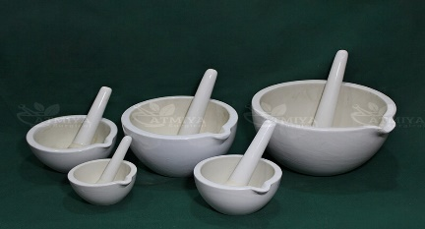
Khalwa Yantra ( Vartula-Round shape)

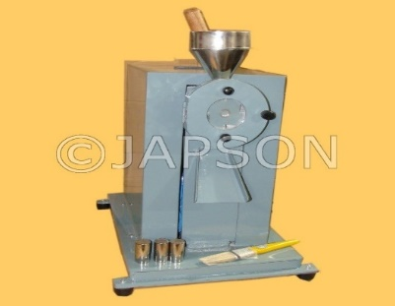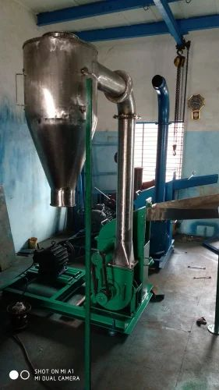
Disintegrator (Hammer mill) Pulveriser

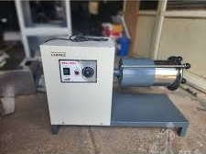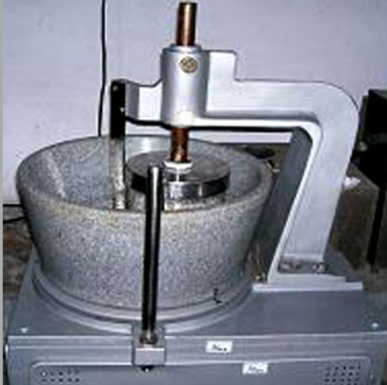
Ball Mill End Runner Mill
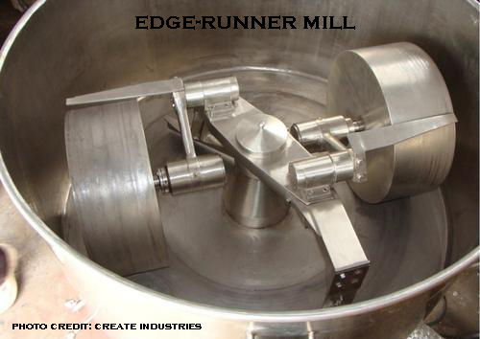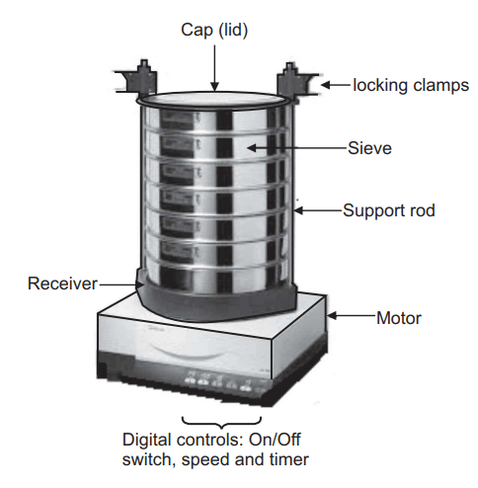
Edge Runner Mill Sieve Shaker

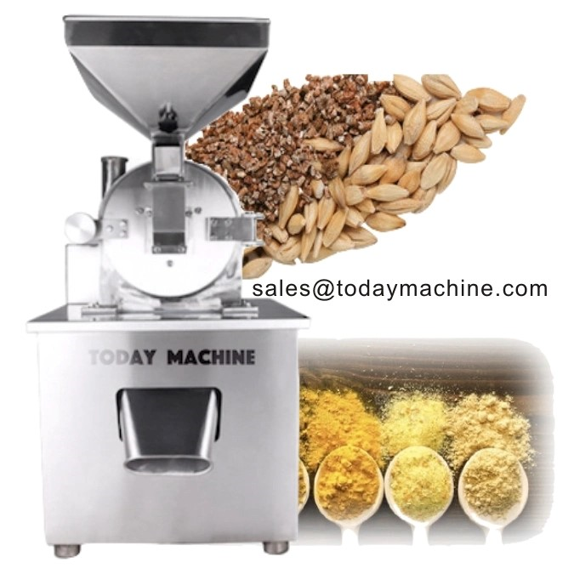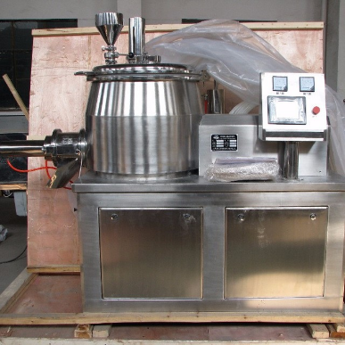
Grinder Mixer

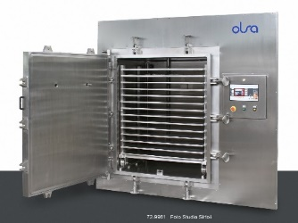 Vacuum drier Pill Making Machine
Silica gel packs Air tight Container

Reference
- Manglakanta Jha , Prashant Kumar Singh –Kharaliya Rasayna used in clinical Ayurveda practice –A Conceptual Review (Review Article) April 13th 2022, (ISSN:2456-9909)
- Dr. Debasis Panigrahi PPt KHALVI RASA
- Dr. Smt. Sailaja Srivatav –(Srg.Samhita 6/6), Sarangadhar SamhitaChowkhamba Orientalia
- Pt. Kashinath Shastri- Rasa Tarangini , (R.T 2/50-51) , 2021, Motilal Banarasi Dass Publishers

