**BIOPLASTICS: THE GREEN PLASTICS FOR SUSTAINABLE EARTH**

Amiya Ranjan Panda

Department of Chemistry,

Kabi Samrat Upendra Bhanja College,

Bhanjanagar, India

Email: [arpanda90@gmail.com](mailto:arpanda90@gmail.com)

**ABSTRACT**

Conventional (petroleum-based) plastics find wide range of applications and on the other side they have serious disadvantages too. They produce high amount of greenhouse gases which is a threaten to the climatic conditions. Their biodegradability causes various environmental problems. So it is need of the hour to develop a green plastic, and the concept of “bioplastics” comes from it. As they are formed from renewable sources, bioplastics are ecofriendly and have a wide range of applications. More researches are going on to minimize the disadvantages of bioplastics and to develop bioplastics more in numbers so that it becomes helpful for sustainable earth.

**Keywords---** Bioplastics; conventional; petroleum-based; biodegradable; sources; bio-based; renewable; eco-friendly; applications

1. **INTRODUCTION**

About half a century ago, plastics were developed and today these become most used, most usable and most available materials. In 2022, the annual production of plastics exceeded 390 million tons [1]. Due to the properties like durability, cost-effectiveness, easy to use, resistivity and excellent thermal properties, plastics become the most essential part of human life. The daily used plastics are generally petrochemical based plastics, e.g. Poly Ethylene Terephthalate (PET), Polyethylene, Polypropylene, Polystyrene, Poly Vinyl Chloride (PVC) etc. They found applications in multidirections. They are used as toys, utensils, furniture, building and construction materials, medical instruments, in industries and in many more ways. But due to their high content of carbon footprint, they are not eco-friendly. The biggest advantage of plastics, their durability, becomes the biggest problem to the society and the environment. These are not easily biodegradable i.e. their rate of degradation is too low that they might persist in the environment for hundreds of years or longer. Estimation says that human race produces about 34 million tons of plastics per annum; only 7% of this can be recycled then what about the rest 93%? These 93% plastics are used on landfills or thrown into oceans and seas which make them garbage, cause pollution and becomes a serious habitat problem for organisms. Burning of plastics emits toxic gases such as carbon dioxide and methane which cause greenhouse effect and ultimately threatens the climatic conditions. Due to fragmentation, plastics form microplastics (size of a few µm and < 5nm) which is harmful for microorganisms. Consumption of microplastics is toxic and carcinogenic. Chemical additives used during plastic production are carcinogenic too and can cause hormonal disturbances.

After the implementation of Green Chemistry in the late 20th century, the scientists are constantly trying to develop plastics from biological bodies commonly known as “Bioplastics”. According to ICIS, the petrochemical market information provider, “The emergence of bio-feedstocks and bio-based commodity polymers production, in tandem with increasing oil prices, rising consumer consciousness and improving economics, has ushered in a new and exciting era of bioplastics commercialization. However factors such as economic viability, product quality and scale of operation will still play important roles in determining a bioplastic’s place on the commercialization spectrum.” [2]

1. **BIOPLASTICS**

Bioplastics are not single materials rather they are a group of materials having different properties and uses. According to Industry Association European Bioplastics, “Bioplastics are the polymers that are bio-based, biodegradable or both.” [2]

**Bio-based:** The term ‘bio-based’ indicates the products are derived from organic sources (biomass) such as potato starch, corn starch, sugarcane, sugar beets, milk, vegetables, fibers obtained from pineapple, jute, banana peels, newspaper pulp, waste paper, citrus waste and many others.

**Biodegradable:** The biochemical process in which the microorganisms present in a particular environment convert the material into carbon dioxide, water and biomass is called biodegradation process and the materials are called biodegradable. This process depends on the environmental conditions (like temperature, humidity etc.) and on the nature of the material.

A substance is bio-based that doesn’t mean it must be biodegradable: it may or may not. The property of biodegradability depends mainly on its chemical structure not on its resource basis. After formation of polymer the chemical structure changes which may or may not allow biodegradation. Here comes a term **fossil-based** bioplastics which are of fossil origin and are biodegradable [3].

1. **TYPES OF BIOPLASTICS**

On the basis of source and biodegradability, bioplastics are of three types [3].

1. Bio-based or partly bio-based and non-biodegradable
2. Both bio-based and biodegradable
3. Fossil-based and biodegradable
4. **Bio-based or partly bio-based and non-biodegradable plastics:**

Industry standard plastics like PE (Polyethylene), PP (Polypropylene) and PET (Poly Ethylene Terephthalate) can also be produced from renewable resources like sugarcane waste or plant oil residue. The most widely used commodity polymer PE can be produced from biomass. PE made from biomaterials is already produced in significant quantities and can be available in a number of packaging solutions. The second most used commodity polymer is PP. Similar to its conventional equivalent, bio-based PP can be utilized for technical objects as well as plastic containers. The third most common commodity polymer is PET. Although bio-based polyester PET can be used to make renewable textile fibers, it is most frequently utilized in food packaging, including beverage bottles. Currently, the majority of bio-based PET in the market is only partly bio-based. However, it is generally possible to create 100% bio-based PET, and it might perhaps appear in the market in the future. These products are also referred to as "drop-in" bioplastics.

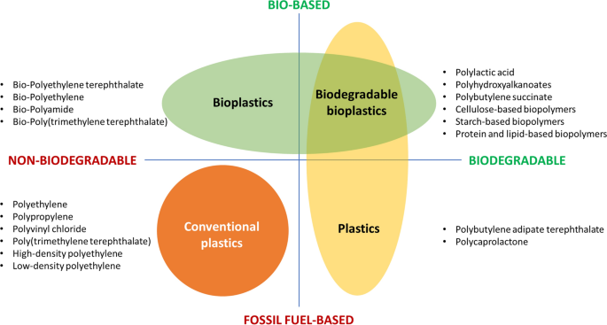

**Figure-1: Identification and coordinate system of Bioplastics [4]**

1. **Both bio-based and biodegradable plastics:**

This category consists of bioplastics produced from starch mixtures and other renewable biomass, e.g. Thermoplastic Starch (TPS), various biodegradable polymers, and cutting-edge polyesters like Polylactic Acid (PLA) or Polyhydroxyalkanoates (PHAs). These are prepared by converting the sugar present in plants into plastic. That’s why this kind of bioplastic is biodegradable, renewable and eco-friendly. PLA and PHA are now produced in large quantities because these are most-used bioplastics and the reason is their high compostability. PLA can be produced from corn kernels. The corn kernels are milled and a sugar called dextrose is extracted from these, the dextrose is fermented by bacteria or yeast and lactic acid is formed which acts as repeating unit to form PLA. The biodegradability of PLA plastics can easily be understood from the figure-2.



**Figure-2: Biodegradation of a disposable cup made from PLA.**

**Time sequence: 1, 15 and 30 days (top); 45 and 58 days (bottom) [2]**

1. **Fossil-based and biodegradable plastics:**

These are a relatively small group and are typically combined with PLA or other biodegradable plastics since they improve the performance for the particular application through enhanced mechanical characteristics. Fossil fuel is mainly used to make these bio-degradable plastics. Few examples are PBAT (Polybutylene adipate terephthalate), polycaprolactone etc. [3]

On the basis of their biological source only, we can classify bioplastics into several types. These include:

1. **Starch-based**: Bioplastics made from corn starch.
2. **Cellulose-based**: Made from cellulose esters and cellulose derivatives.
3. **Protein-based**: Made from proteins like casein, milk etc.
4. **Organic polyethylene**: produced from fermentation of raw crops like sugarcane, corn etc.
5. **Aliphatic polyesters**: Bio-based polyesters like polyhydroxyhexanoate (PHH), polylactic acid (PLA) etc.
6. **Aliphatic polyamides**: Bio-based polyamides like PA 6, PA 66, and PA 11 etc.
7. **BIO-BASED ADDITIVES**

We know additives are added with polymers to improve the properties of plastics. Some examples are plasticizers, colour pigments, flame retardants, UV stabilizers etc. which may be organic or inorganic. Some additives are problematic which include heavy metals, hazardous chemicals, and leaching/migrating additives. Renewable alternatives can also be used in place of conventionally generated organic additives.

Few examples are:

1. Air release chemicals those are renewable.
2. Lubricants made from biomaterials.
3. Dimethyl succinate (DMS) is a renewable solvent and a source of pigments and UV stabilizers.
4. Glucose esters are used as bio-based plasticizers in PVC.
5. **COMPOSTING AND RECYCLING BIOPLASTICS**

We all know that fossil fuel-based plastics are non-compostable. Unlike those, a variety of bioplastics, including those manufactured from PLA are compostable. If they are given adequate heat, moisture, and microbes, the microbes will decompose them into plant material, carbon dioxide and water [5].

Instead of being composted, almost all compostable bioplastic is dumped in landfills. As conventional plastics, bioplastics remain intact, buried in the oxygen-free atmosphere of landfills. However, it is a matter of concern for scientists that over many years, bioplastics will decompose slowly and release carbon dioxide and methane gas, which is the main cause for greenhouse effect.

Recycling offers an alternative. Recycling of bioplastics can be done by physical, biological and chemical methods [2]. Physical recycling method is an established technology which ends up with landfilling or composting. Biological recycling can be done in aerobic and anaerobic methods with temperature regulation. Chemical recycling technique can be done by hydrolysis or solvolysis, hydrothermal depolymerization and enzymatic depolymerization. Carbon dioxide is formed as the end product in these processes. The formation of carbon dioxide is in a lesser amount in comparison to the recycling of petrochemical (fossil fuel-based) plastics and can be utilized by the green plants (figure-3).

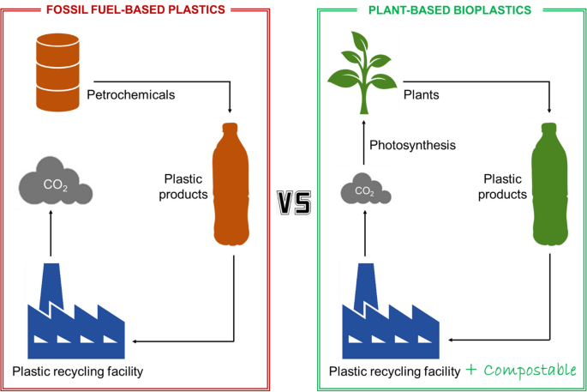

**Figure-3: Recycling of fossil fuel-based plastics Vs bio-based plastics**

**showing utilization of CO2 gas [4].**

1. **APPLICATIONS**

Similar to the uses of traditional plastics, bioplastics have a wide range of applications. Some of the applications are discussed below:

1. **Food packaging:**

Starch-based, cellulose-based, PLA made and PHA made bioplastics are used as food packaging materials, e.g. milk chocolates are packaged in corn-based (starch-based) bioplastics, organic pasta is packaged in cellulose-based biopolymers, sweets and potato chips are packaged in metallized cellulose films, PLA biopolymers are used in packaging of beverages, read and fresh salads [6].

1. **Medical applications:**

Polymers play a vital role in many medical applications. Cellulose can be used as the primary green bioplastic in several biomedical fields. It is nontoxic, nonmutagenic, and biocompatible. Hence it is used in several medical fields like neural engineering, implants and pharmaceutical fields. Bacterial cellulose is used for tissue repair. Nanocellulose and their composites are used for dental, orthopedic and biomedical treatments. Nano-cellulosic membrane is used for wound dressing.

PHAs are ideal for medical applications because of their biocompatibility and are used in cancer detection, wound healing dressings, post-operative ulcer treatment, bone tissue engineering, heart valves, and artificial blood vessels. Biopolymers self-assembled into nanocarriers and act as drug delivery systems (DDS), e.g. PHA based nanocarriers are used as DDS in cancer treatment.

1. **Agricultural applications:**

PHA-based bioplastics are used in nets, grow bags, and mulch films for agricultural purposes. High-density polyethylene, which is typically used in crop fields to protect it from birds, insects, and winds, can be substituted with bioplastics-based nets. Grow bags or seeding bags made of PHAs are biodegradable, root-friendly, and non-toxic to nearby water bodies and substitute growbags made of low density polyethylene. Polymer mulching film is used to cover the seeded regions to safeguard growing plants from pests, low temperature and to maintain humidity. Traditionally used mulching films made of black PE can now be replaced by bioplastic mulching films which will decompose and are ecofriendly.

1. **In cosmetics:**

Several cosmetic products including toothpaste, shower gels, and facial scrubs contain plastic microbeads. Now-a-days these are replaced by biodegradable alternatives such as alginate, chitosan and gelatin microbeads.

1. **Applications in automotive industry:**

The automotive sector is also attempting to use bioplastics. Toyota claims as the first car manufacturer to use sugarcane-based PET in some interior surfaces and vehicle liners. Fiat has utilized polyamides made from castor oil and polyurethanes made from soybeans for use in car components. Soybean-based foam is used in the headrests of 75% of Ford vehicles produced each year [2].

1. **Other applications:**

One of the most often used materials for 3D printing is PLA [7]. PHA-based lignin composites have also recently been used as films in 3D printing because of their shear-thinning profile, which improved layer adhesion and decreased warpage [8]. Bio-based foam composites can be used as fillers and fibers, e.g. lignocellulosic fillers, soybean or wood-based bio-fibers, fillers from papers etc.

1. **ADVANTAGES AND DISADVANTAGES**

The primary environmental pollutant is plastic which is used every day and everywhere. So instead of using items made of petrochemicals, we should use bioplastics to reduce environmental pollution. Numerous environmental problems can be resolved in this way.

The distinctive qualities of bioplastics and some of its **advantages** are:

1. Produced from renewable resources.
2. Biodegradable- usually requires 3-6 months to completely biodegrade under controlled microbial composting conditions.
3. Recyclability- can be recycled mechanically.
4. Monomer recovery- Monomers can be efficiently recovered, e.g. 99% lactic acid can be recovered from PLA or PLA products [9].
5. Reduced carbon foot print.
6. Ecofriendly- Bioplastics are produced from renewable resources which reduces environmental pollution.
7. Less energy requirement- Bioplastic manufacturing requires less energy, so increases their production.

Using bioplastics is not completely problem-free. Some **disadvantages** of bioplastics are:

1. High cost- The cost of production of bioplastics is almost double than for the conventional plastics.
2. Recycling problems- Maximum bioplastics typically end up in landfills like conventional plastics undergo slow degradation and forms greenhouse gas methane which is threaten to the environment.
3. Competition for food sources increases by rising bioplastic demand which creates the world food crisis.
4. Mechanical strength of bioplastics is low.
5. Thermal instability- Most bioplastics have less heat resistance than petroleum-based plastics.

**VIII. BIOPLASTICS MARKETING**

The usage of bioplastics ranges from food packaging, electronics, cosmetics, cars, agriculture, and toys to textiles and a host of other areas in developing industries. Many researchers have created tools to aid in choosing the right plastic and “Plastic spectrum” is one of them.

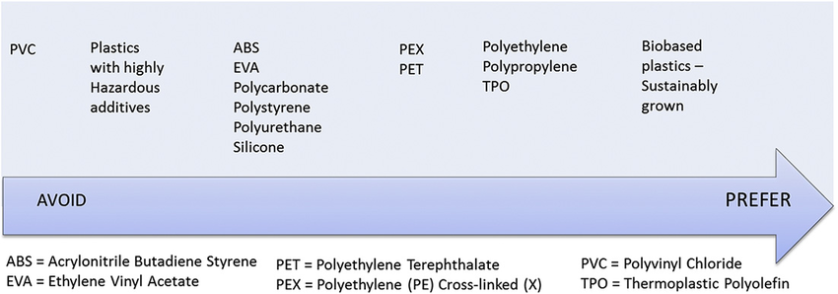

**Figure-4: Plastic spectrum or Environmental plastic preference spectrum**

The spectrum indicates bioplastics are more preferable. Global bioplastics production capacity are expected to rise from roughly 2.2 million tons in 2022 to nearly 6.3 million tons in 2027, according to the most recent market data compiled by European Bioplastics in collaboration with the Nova-Institute [1]. For practically every type of conventional plastic and its associated use, bioplastic alternatives exist. Within the next five years, manufacturing capabilities will continue to rise dramatically and diversify due to the significant development of bio-polymers such polyhydroxyalkanoates (PHA), polylactic acid (PLA), polyamides (PA) and polypropylene (PP). The global production capacities of bioplastics (by material type) in 2022 is shown in Table 1 and depicted in the chart (Figure-5).

**Table 1: Global Production Capacities of Bioplastics 2022 (by material type)**

|  |  |  |  |  |  |  |  |  |  |  |  |  |  |
| --- | --- | --- | --- | --- | --- | --- | --- | --- | --- | --- | --- | --- | --- |
| Bioplastics | PBAT | PBS | PLA | PHA | Starch  Blends | Cellulose  films | PE | PET | PA | PP | PTT | PEF | Others |
| Percentage | 4.5 | 0.9 | 20.7 | 3.9 | 17.9 | 3.6 | 14.8 | 4.2 | 11.1 | 3.9 | 13.3 | 0 | 1.1 |

**Figure-5: Global Production Capacities of Bioplastics 2022 (by material type)**

The data says that biodegradable biopolymers (PBAT, PBS, PLA, PHA, starch blends, cellulose films) constitute 51.5% of the global bioplastic production and non-biodegradable biopolymers (PE, PET, PA, PP, PTT, PEF and others) constitute 48.5%. It indicates in the later years more biodegradable bioplastics are expected to be manufactured. The chart shows production of PLA and starch-based biopolymers is maximum and this is because of their large applications.

**IX. CONCLUSION**

Bioplastics are better than traditional plastics since they have the potential for microbial degradation. In doing so, they lessen the amount of plastic garbage. To avoid all the disadvantages of petroleum-based plastics, we should move to bioplastic because it is sustainable, renewable, biodegradable, and environmentally beneficial. Some of the concerns about bioplastics are high production cost, less consumer consciousness and to reduce the formation of greenhouse gases during composting. Researches are going on eying these concerns and challenges and to develop newer and safer bioplastics so that in coming years bioplastics will completely substitute conventional counterparts.

**REFERENCES**

[1] “Bioplastics Market Update 2022,” European Bioplastics, pp. 1-2, December 2022.

[2] M. Lackner, “Bioplastics,” Kirk-Othmer Encyclopedia of Chemical Technology, pp. 1-41, September 2015.

[3] “What are bioplastics,” European Bioplastics Factsheet, pp. 1-4, October 2022.

[4] S. Nanda, B.R. Patra, R. Patel, J. Bakos, A.K. Dalai, “Innovations in applications and prospects of bioplastics and biopolymers: a review,” Environmental Chemistry Letters, vol. 20, pp. 379-395, 2022.

[5] C. Washam, “Bioplastics,” Chemmatters, pp. 10-12, April 2010.

[6] .M. Shah, S. Rajhans, H.A. Pandya and A.U. Mankad, “Bioplastic for future: A review then and now,” World Journal of Advanced Research and Reviews, vol. 09(02), pp. 056-067, 2021.

[7] T. Narancic, F. Cerrone, N. Beagan, K.E. O’Conner, “Recent Advances in Bioplastics: Application and Biodegradation,” Polymers, vol. 12(4), 920, pp. 1-38 2020.

[8] G. Coppola, M.T. Gaudio, C.G. Lopresto, V. Calabro, S. Cursio, S. Chakraborty, “Bioplastic from Renewable Biomass: A Facile Solution for a Greener Environment,” Earth Systems and Environment, vol. 5, pp. 231-251, 2021.

[9] .Y. Sarkingobir, A.A. Lawal, “Bioplastics: Their Advantages and Concerns,” Journal of Materials and Metallurgical Engineering, vol. 11(1), pp. 13-18, 2021.