Recent advances in radiation in breast carcinoma

Breast cancer has taken over cervical cancer to become the most common cancer in India amongst women , accounting to 14% of all cancers in women. The incidence rate begins to rise in early 30s and peaks at the age of 50-64 years . Despite availability of early screening tests and effective treatment options , one of two newly diagnosed women dies in India. There by necessitating further research in this area to fight this disease effectively .

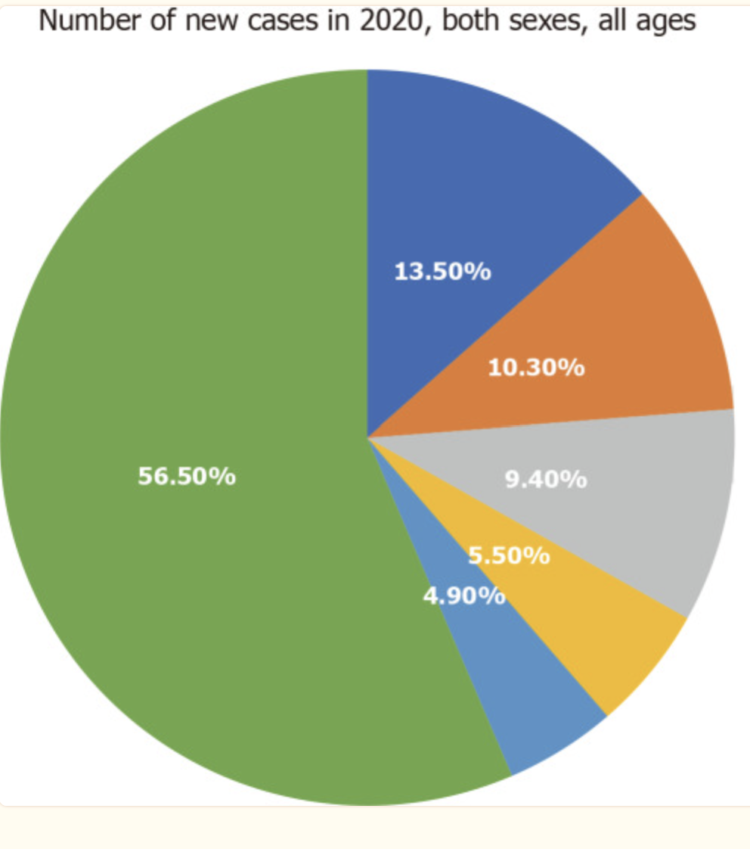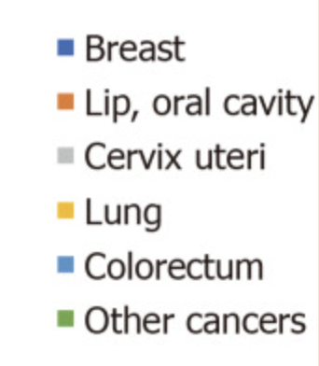

Radiation is an integral part of treatment of breast cancer in both early and late stages as well as in palliative cases. Advancements in the delivery techniques from 2 dimensional to 3 dimensional have not only reduced the overall treatment time but also have increased the therapeutic advantage by reducing the treatment field there by decreasing both acute and chronic toxicities. In this chapter we will discuss the recent advancement in radiation in breast cancer

Fractioantion schedule

With a long follow up of more than 20 years multiple randomized control studies have beyond doubt demonstrated that Breast conservation therapy is equivalent to mastectomy in terms of both local control and overall survival beyond doubt. These studies mostly used standard fractionation regimen with daily dose of 1.8-2 Gy per fraction for 5 to 7 weeks . The recent advancements have reduced this treatment duration by means of reduction of target size or increase in daily radiation dose.

Different options for delivering breast irradiation post BCS have been enumerated below.

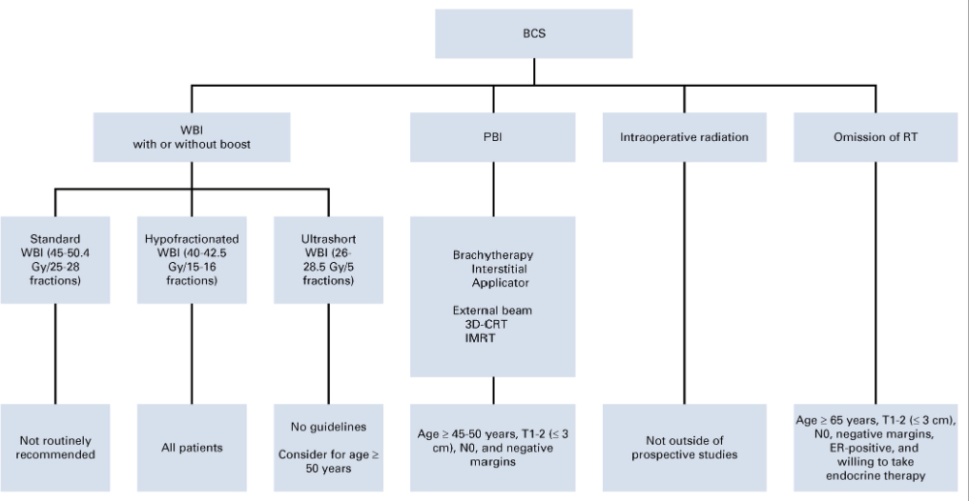

Multiple randomized controlled trials which have compared whole breast radiation via standard fractionation vs hypofractionation after a long term follow up have also shown similar survival and local control with comparable toxicity profile. Infact hypofractionation is now a standard practice in clinic these days for the treatment of both early and advanced cases as it is now incorporated in the treatment guidelines. A list of trials comparing standard fractionation to hypofractionation is as shown below

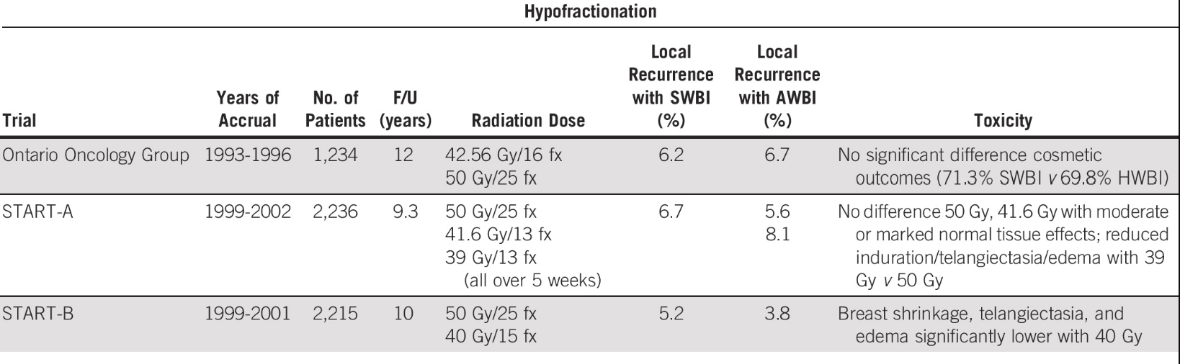

After inclusion of hypofractionation in the guidelines further research is being done in even shorter treatment regimens. FAST trial randomized patients with early breast cancer into standard fractionation group and ultra hypofractionation group . Patients in ultrahypofractionation group received 28.5 Gy or 30 Gy in five fraction delivered once weekly without tumor bed boost.The three arms had comparable results with more toxicity in 30 Gy arm.Subsequently FAST forward trial which compared to standard hypofractionation to ultrahypofractionation (26-27Gy in 5 fractions over 5 days ) also found ultrahypofractionation to have similar tumour control as well as normal tissue effects . So the treatment delivery has shortened from around 2 months (as im conventional fractionation) to 5 days (ultrahypofractionation ). Though a longer follow up is needed to study the result of ultrahypofractionation

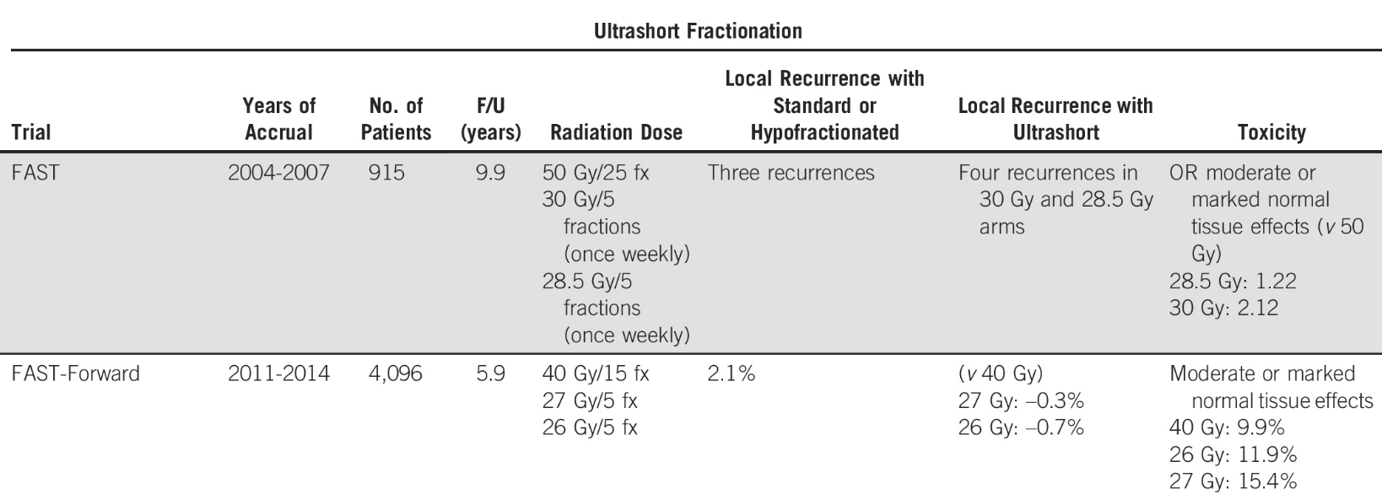

Treatment target

Apart from Whole breast radiation partial breast radiation are also under study which aiims at reducing the treatment area . Prospective trails have been done to compare WBI to PBI amongst which many have shown non significant difference in tumour control with Partial breast irradiation. The trials have been enumerated in the below mentioned table

PBI delivered via brachytherapy has better cosmetic outcome than that delivered by external beam radiation as was seen in the RAPID trial , however no such difference was seen in subsequent trails (IMPORT low/NSABP-B39). In light of these findings selected patient subgroups are being Partial breast irradiation

Radiation for the management of regional nodes
Historically all patients having clinically negative axilla after undergoing sentinel L.N biopsy when were found to have positive lymph nodes underwent complete axillary node dissection . however this paradigm was changed by AMAROS and ACOSOG ZOO11 trials and till date it is not advised for the omission of regional nodal irradiation even if a single node is found to be positive
In patients who achieve complete response after Neoadjuvant chemotherapy are found to have lower local recurrence rate. NSABP51 trial aims to study omission of RNI in such patients . However the results are expected in years to come

Future Directions

Despite extensive study being done in breast cancer treatment we have not been yet able to identify the set of patients in whom radiation could be completely omitted post Breast conservation surgery .The study of interplay of radiation and genetics may shed a light in this regard

